RESILIENT APPROACHES IN NATURAL RANGELAND ECOSYSTEMS (RANGE).
Quarterly Progress Report.
Reporting Period: July - September 2025 (Q3-2025)
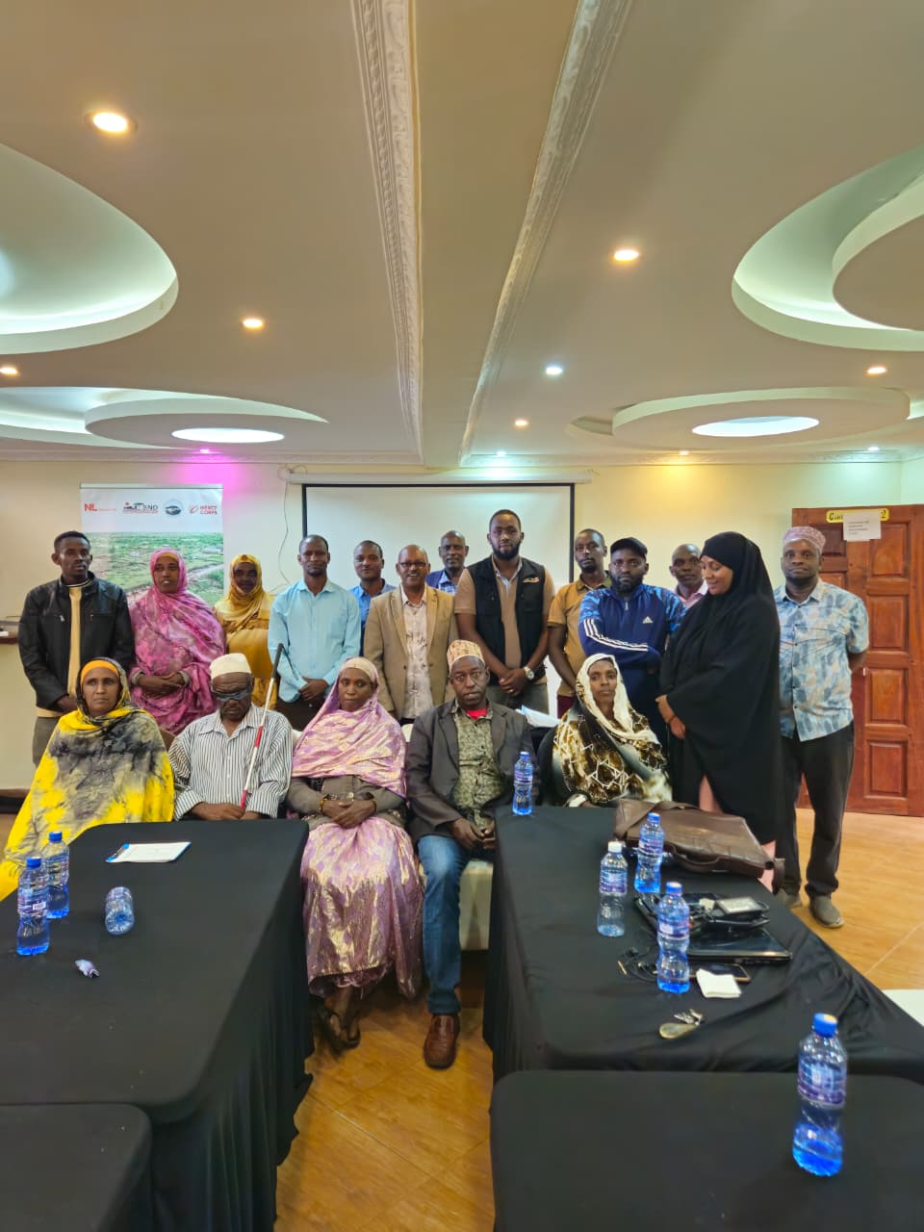
SND’s RANGE project team posing for a group photo with the Sagante/Jaldesa WDC members capacity building and training at Ebisa Hotel Marsabit on 19th September 2025.
- Executive Summary
During the reporting quarter (July–September 2025), Strategies for Northern Development (SND), under the Resilient Approaches in Natural Rangeland Ecosystems (RANGE) program, successfully implemented a series of strategic capacity strengthening, planning and coordination activities across the wards of Sagante/Jaldesa and Golbo in Marsabit County.
In July 2025, SND RANGE implementing team participated in quarterly review meeting which provided an opportunity to enhancing learning through practical field visit and collaboration with key stakeholders. In addition, SND’s RANGE program manager participated in the Market System Development (MSD) training that enhanced technical capacity to align interventions effectively to Market System Development approach. RANGE project was also presented during the County Steering Group which greatly influenced project visibility and enhanced coordination with line departments and other local partners.
In August 2025, SND participated in the Year 3 planning workshop held in Isiolo. The workshop reviewed Year 2 progress and lessons, informed the Year 3 learning agenda and developed integrated work plans and consolidated budget for year three alongside the Gantt chart, it also clarified partner roles, strengthened risk management and enhanced joint monitoring and accountability systems across the three counties. The exercise reinforced program coherence, partner ownership and adaptive management capacity, laying a strong foundation for effective Year 3 implementation. During the month, SND participated in LIP onboarding session which crucial aspects of the program was discussed including deliverables and donor expectations. Additionally, SND convened a Sub-County Steering Group (CSG) inception meeting in Moyale on 28th August 2025. The meeting brought together government line departments and non-state actors to establish a shared understanding of RANGE project objectives, components and geographical scope. Key outcomes included consensus on integrating RANGE interventions with existing local initiatives, creation of coordination mechanisms and identification of sub-county contact points to strengthen feedback loops and collaborative implementation.
In September 2025, SND facilitated a three-day integrated capacity strengthening exercise targeting Ward Development Committees (WDCs) in Golbo and Sagante/Jaldesa wards. The sessions combined capacity assessments with trainings on governance, financial management, inclusive planning, conflict resolution, resource mobilization, and climate change adaptation. A total of 40 participants, with 40% women and youth representation. This activity was conducted in collaboration with the County Government of Marsabit and the Frontier Counties Development Council (FCDC), marked a significant milestone in promoting inclusive grassroots governance and strengthening decision-making structures. No major challenges were encountered apart from delays in concept note approval.
The quarter was marked by significant progress in strengthening grassroots governance, building partnership, local ownership and enhancing program coherence and establishing strong multi-stakeholder collaboration platforms with both state and non-state actors.

- Progress and Planned Activities
Outcome 1: Improved rangeland management repairs ecosystem health and increases food, nutrition and water security.
Progress against Indicators/Activities.
All the activities planned within the reporting period were implemented as scheduled. The activities contribute to Output 1.1: Formal and informal governance systems of land management, protection and restoration are strengthened. This output is measured through the Indicator: Number of Ward Development Committees (WDCs) with enhanced inclusive representation, trained on governance and planning, and formally integrated with traditional governance systems. The project activities implemented within the quarter include;
Activity 1.1.0: One-off Moyale Sub-county Steering Group Meeting to Introduce the RANGE Project
Activity 1.1.1: Strengthen 30 (Golbo 15 and Sagante/Jaldesa 15) existing Ward Development Committees members (WDCs) through inclusive representation enhancement, ensuring at least 40% representation of women, youth, and marginalized groups
Activity 1.1.2: Train 2 existing WDCs based on capacity assessment results, focusing on governance, financial management, inclusive planning, and conflict resolution
On the outcome level, these activities directly contributed to outcome 1 by strengthening grassroots governance, enhancing coordination among stakeholders and building inclusive decision-making structures. By equipping Ward Development Committees (WDCs) with governance and resource management skills and establishing coordination platforms at the sub-county level, the groundwork has been laid for stronger, more accountable local systems to sustainably manage rangelands and related natural resources. These systems are essential for restoring degraded ecosystems, improving water access, and enhancing household food and nutrition security.
In September 2025, SND facilitated a three-day capacity strengthening and training workshop targeting WDCs in Golbo and Sagante/Jaldesa wards of Marsabit County. The sessions built the committees’ ability to govern inclusively, manage resources responsibly, and integrate climate change adaptation into ward-level planning. Through participatory exercises, WDC members drafted and developed action plans that provide a roadmap for managing, protecting and restoring shared land resources, resolving conflicts, and mobilizing communities. A total of 40 members (24 male, 16 female, including 13 youth under 35 years) participated, surpassing the indicator target and meeting the inclusivity threshold of 40% women and youth. Strengthened WDCs are now better positioned to lead community-driven resource management, a critical step toward sustainable rangeland use and improved ecosystem health.
In August 2025, SND contributed to the Year 3 planning workshop in Isiolo, which consolidated lessons from Year 2 and aligned consortium partners around resilience priorities. The workshop produced integrated Year 3 work plans and a resource-efficient budget, embedding resilience and cross-cutting themes. By clarifying roles, enhancing accountability mechanisms, and reinforcing risk management systems, the workshop laid a foundation for coherent, well-coordinated interventions that will promote sustainable land use and climate resilience across Marsabit, Isiolo, and Samburu counties. This shared vision directly supports long-term outcomes of improved food and water security through better-coordinated rangeland management efforts.
Also in August, SND convened the Sub-County Steering Group (CSG) inception meeting in Moyale. The meeting brought together government line departments and non-state actors to create a shared understanding of RANGE objectives and agree on integration with existing local programs. Consensus was reached on the need to align RANGE interventions with county and community priorities to maximize impact and avoid duplication. Importantly, coordination mechanisms and contact points were established to strengthen feedback loops and ensure accountability at the sub-county level. These mechanisms will ensure that rangeland interventions are community-driven, better coordinated, and responsive to local needs, thereby contributing to healthier ecosystems and improved access to food, water and nutrition.
Deviations from Expected Progress.
During the quarter, no major deviations were recorded in the delivery of activities under Outcome 1. Minor delays were experienced due to extended approval processes for concept notes and the limited availability of some stakeholders during the Moyale sub-county inception meeting. These factors slightly affected the timing of planned activities but did not compromise overall implementation. Corrective actions were taken, including rescheduling sessions and strengthening engagement with county structures and consortium to fast-track approvals. As a result, all activities were completed within the reporting period and contributed effectively to the intended outcome of strengthening rangeland management and enhancing food, nutrition, and water security.
Outcome 2: Sustainable livestock and alternative livelihood production and competitiveness of markets strengthened within an improved policy environment.
Progress against Indicators/Activities.
During the reporting quarter, no direct activities were implemented under this outcome. However, significant preparatory work was undertaken to lay the foundation for upcoming interventions. In particular, stakeholder mapping and engagement exercises were conducted with key actors, including the Ward Development Committees (WDCs), Natural Resource Management (NRM) committees, county departments and other relevant technical working groups like county NRM forums where SND is an active member.
Below is the planned activities.
Facilitate 5 days participatory range land and resource mapping focused on seasonal resources and mobility patterns, integrating indigenous knowledge with GIS tools in collaboration with NRM and WDC team.
Deviations from Expected Progress.
Although activities under this outcome have not yet been implemented during the reporting period, proactive measures have been established to minimize any potential deviation from the targeted results. Key preparatory steps, including stakeholder engagement, coordination with the WDC and NRM teams and detailed activity planning have been undertaken to ensure timely and effective execution in the subsequent quarter.

- Risks and Bottlenecks
The project operates within a complex risk environment in Marsabit County, particularly in the Golbo and Sagante/Jaldesa wards, where climate variability, socio-political dynamics, institutional capacity gaps and market limitations converge to shape community vulnerability. Erratic rainfall patterns, recurrent droughts and shifting weather conditions continue to threaten rangeland restoration and water management efforts. These climatic stresses have led to reduced pasture availability, drying of traditional water points and increased livestock pressure on fragile ecosystems.
Beyond environmental factors, persistent resource-based conflicts between different clans over access to grazing areas and water sources remain a significant threat to project implementation and community cohesion. Such conflicts often intensify during prolonged dry seasons when resources become scarce. The situation is further compounded by the emerging political tensions and polarization linked to the approaching 2027 electioneering period, which may influence local dynamics, decision-making and inter-community relations.
Overview of Risk Management.
The project operates within a complex risk environment shaped by climate variability, socio-political dynamics, institutional capacity gaps and market constraints. Erratic rainfall patterns and the looming threat of drought posed significant risks to rangeland restoration and water management activities, though mitigated through climate-smart practices and livelihood diversification is planned in the subsequent quarter. Marsabit County is synonyms with Perennial sporadic tensions over grazing land and water access also highlighted the persistent risk of resource-based conflict, which the project is alive to and planned series of engagement with peace committees, community leader’s through the FCDC outcome three component. Weak institution and fragmented local structures that hinder effective service delivery are mitigated through strengthening local governance structures like ward development committees to improve institutional capacity within the targeted two wards to enhance effective coordination through targeted capacity-building and mentorship support. Limited and unstable market access for livestock and alternative livelihoods further underscored economic risks, prompting the project to apply market systems approaches and facilitate private sector linkages.
Additionally, risks of social exclusion around special interest group that is women, youth and People living with disability. This is addressed through deliberate and proactive application of the Gender, Equity and Social Inclusion (GESI) policy to ensured broader representation in project activities.
Key Risks Identified
The project document highlights several key risks that continue to influence implementation in Marsabit County, particularly within Golbo and Sagante/Jaldesa wards. These include;
- Climate Variability and Drought Frequent droughts and erratic rainfall patterns continue to threaten rangeland restoration, pasture availability and water resources, undermining community livelihoods dependent on livestock.
- Resource-Based Conflicts Competition over grazing areas and water sources among different clans remains a major source of tension, occasionally disrupting mobility routes and planned project activities.
- Weak Institutional Capacity Limited coordination and technical capacity among local governance structures hinder effective service delivery and resource management.
- Market Limitations Poor infrastructure and unstable livestock markets restrict household income and slow adoption of alternative livelihood options.
- Social Exclusion Risk of marginalization of women, youth and persons with disabilities in decision-making and access to project benefits persists despite ongoing inclusion efforts.
Emerging Risks.
During the reporting period, two additional risks were noted;
- Political Tensions Linked to the Upcoming 2027 Electioneering Period Emerging political mobilization and clan-based alignments pose potential threats to community cohesion and project continuity.
- Heightened Resource Pressure Due to In-Migration The movement of pastoralists from drought-affected neighboring counties like Wajir into Golbo ward is increasing strain on already scarce pasture and water resources and potentially exacerbating local conflicts.
Materialization of Risks
Drought and erratic rainfall were experienced across Marsabit, severely affecting pasture and water availability in Golbo and Sagante/Jaldesa wards. This led to increased livestock mobility in search of grazing areas, heightening tension over shared resources. Despite these challenges, institutional capacity improved through the successful registration of the Sagante/Jaldesa Ward Development Committee (WDC), a key milestone attributed to the RANGE project’s continued engagement. This Established system strengthens local governance and coordination mechanisms essential for managing emerging resource based conflict.-
Mitigation Measures
In response to the prolonged drought and resource pressures in Golbo and Sagante/Jaldesa wards, SND under RANGE project plan to support series of climate-smart rangeland restoration activities and supported community contingency planning to guide livestock mobility and reduce conflict over scarce grazing areas through intergraded Land use planning training under the RANGE project. Peace committees and local leaders were engaged to strengthen early conflict resolution mechanisms, while institutional capacity was enhanced through training and mentorship of Ward Development Committees (WDCs). The registration of the Sagante/Jaldesa WDC marked a key achievement, improving local governance and coordination.
Adjustments to Risk Analysis.
No major revisions were made to the project’s risk matrix during the quarter. However, the early signs of political realignments ahead of the 2027 elections were noted. To address these, the project will strengthen and promote conflict-sensitive engagement and enhance coordination with county authorities to safeguard interrupted implementation of the project.
- Project Spin-offs
As this was the first quarter of project implementation, no significant spill over or policy-level effects have been realized. However, some early positive indications were observed. The WDC capacity strengthening sessions in Golbo and Sagante/Jaldesa wards generated strong community ownership and accelerating the registration of Sagante Jaldesa ward development committees with the department of social service which previously exist as an unregistered entity. Collaboration with county line departments and FCDC also fostered early institutional linkages that may enhance coordination and ownership as the project progresses. No negative unintended effects were reported during the period, though the team noted rising community expectations for continued external support, which will be managed through consistent messaging on sustainability and local ownership.
- Cross-cutting Interventions
Gender
Gender mainstreaming across all project activities, ensuring equitable participation and benefits for both youth, women and men. Gender considerations were integrated at every stage from planning to implementation through targeted mobilization, inclusive selection criteria and gender-sensitive facilitation approaches. Women’s participation was actively promoted in Ward Development Committee (WDC) engagements in both wards. As a result, women made up a significant proportion of participants in training sessions, community consultations and decision-making forums.
In addition, sessions on leadership, financial literacy and climate change placed special emphasis on empowering women to take up leadership roles and improve their economic resilience. The project also ensured that meeting venues, timing and facilitation styles were sensitive to the needs of both women and men, fostering an inclusive learning environment.
Furthermore, gender-disaggregated data was collected and analyzed to monitor participation trends and inform future interventions. This has helped the project identify areas needing improvement—particularly in enhancing youth and women’s representation in technical and governance structures at the community level.
Climate Change
Climate change was mainstreamed as cross-cutting themes in Ward Development Committee (WDC) engagements. While the implementation of specific climate-smart agricultural interventions is planned for subsequent quarters, the foundational training conducted this period enhanced awareness of sustainable rangeland management, drought preparedness and ecosystem conservation. These initial efforts have positioned the WDCs to integrate climate adaptation and environmental stewardship into local planning processes, laying the groundwork for more targeted climate-resilience actions in the coming phases.
- SEAH (Safeguarding)
During the quarter, deliberate measures were undertaken to safeguard participants and prevent harm across all project activities. A toll-free line was shared in every session, providing participants with a confidential and accessible channel to report any form of misconduct, abuse or concerns. Reporting procedures were clearly explained, with emphasis on confidentiality, non-retaliation and timely follow-up to build trust and encourage reporting.
To strengthen these measures, SND also leveraged its other ongoing projects to enhance community safeguarding structures through Community Response and feedback Mechanism (CRFM) clinics and the establishment of a Gender Help Desk. These platforms extend beyond individual activities to ensure continuous community engagement, accountability and protection throughout the project life and beyond.
In addition, informed consent was sought from all participants whenever photos, videos or personal stories were documented. This process ensured that participants were fully aware of the purpose and use of their images or information and that they retained the right to decline without any negative consequences.
No safeguarding cases were reported during this period, and the presence of multiple reporting and engagement mechanisms has reinforced participants’ sense of safety and accountability. However, a key gap identified is the need for continuous sensitization, especially for new participants who may not yet be fully familiar with the reporting and referral procedures. Addressing this gap will be prioritized to ensure consistent awareness and effective application of safeguarding measures in all future sessions.
- Sustainability
Activities implemented during the quarter have a lasting impact by strengthening grassroots governance, enhancing local ownership and improving institutional sustainability. Ward Development Committees (WDCs) were empowered with practical skills in financial oversight, resource mobilization and participatory planning, positioning them to gradually achieve greater independence and attract resources. The development of ward-level action plans aligned with county frameworks ensures integration of community priorities into local policies, reinforcing ownership and accountability. In addition, WDCs are being encouraged to actively participate in public participation forums organized by county and national governments and to serve as stewards of all development initiatives within their wards, ensuring alignment, transparency and accountability. Closer collaboration with the County Government of Marsabit and FCDC has further strengthened coordination mechanisms and institutional systems, laying a solid foundation for sustainable rangeland management and community resilience beyond the life of the project.
- Lessons Learned
During the reporting quarter, several important lessons emerged from the implementation of project activities across Golbo and Sagante/Jaldesa wards. These lessons provide valuable insights into what worked well, what challenges were encountered, and what adaptations are necessary to strengthen future interventions.
Partnerships enhance quality and delivery.
One of the strongest lessons from the quarter is the value of partnerships in improving both the quality and effectiveness of project delivery. Close collaboration with FCDC, county line departments and trained TOTs ensured that the trainings were not only well facilitated but also aligned with county development priorities. This joint approach created an enabling environment that encouraged active participation and ownership among WDC members. Partnerships of this nature stand out as a best practice and should be maintained and scaled up in future activities.
Institutional gaps hinder effectiveness.
The contrast observed between the fully registered Golbo WDC and the unregistered Sagante/Jaldesa WDC highlighted a key institutional gap. Registration, proper documentation and the establishment of governance frameworks emerged as critical factors for ensuring accountability and effective participation. Without these foundations, WDCs face limitations in influencing local planning processes and accessing resources. Addressing such gaps is therefore vital for strengthening the institutional effectiveness of unregistered committees.
Ownership and leadership are critical
Another important lesson is the role of leadership and accountability in sustaining progress. Clear assignment of responsibilities to WDC leaders, such as tasking the Sagante/Jaldesa Chair to spearhead the registration process, reinforces ownership and encourages members to take responsibility for institutional strengthening. This approach ensures that improvements are driven from within the community, promoting sustainability beyond external support.
- Annexes
Annex 1: Photos
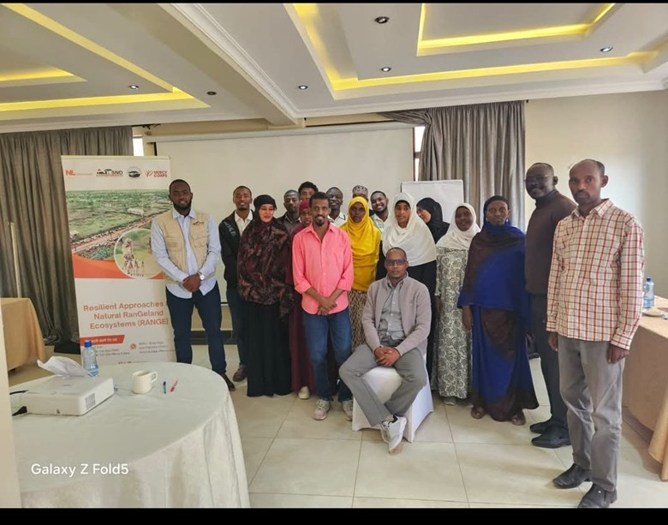
Participants of the Sub County Steering Group Meeting held at Tulla Regency Hotel on 28th August 2025 in Moyale
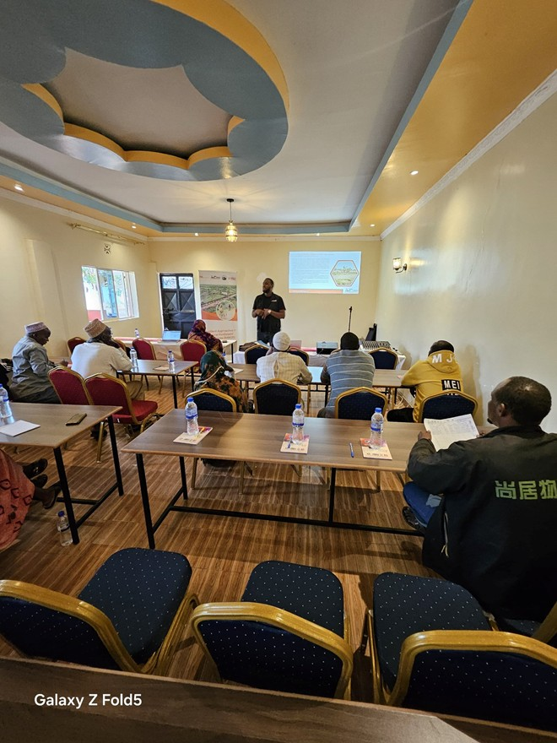
SND’s RANGE Program Manager speaking during capacity strengthening and training of WDC members at Biqila Gardens Hotel in Golbo Ward on 10th September 2025.
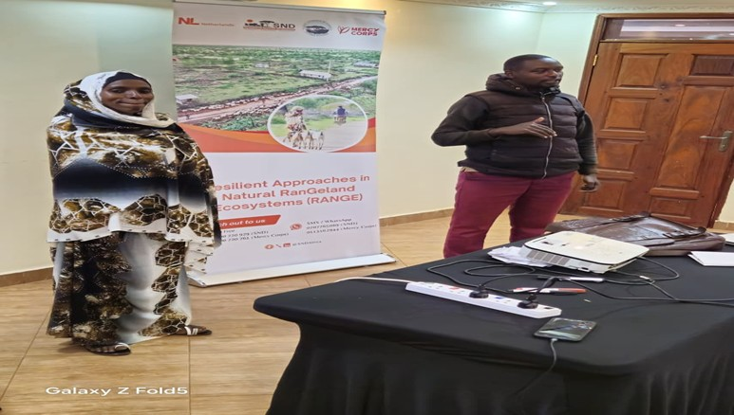
Two Sagante/Jaldesa WDC members presenting their group work during the WDCs capacity assessment and training held at Ebisa Hotel in Marsabit on 18th September 2025
- Annex 2: Participant Lists
- Annex 3: IATI Report
- Annex 4: Quarterly Participant Data

