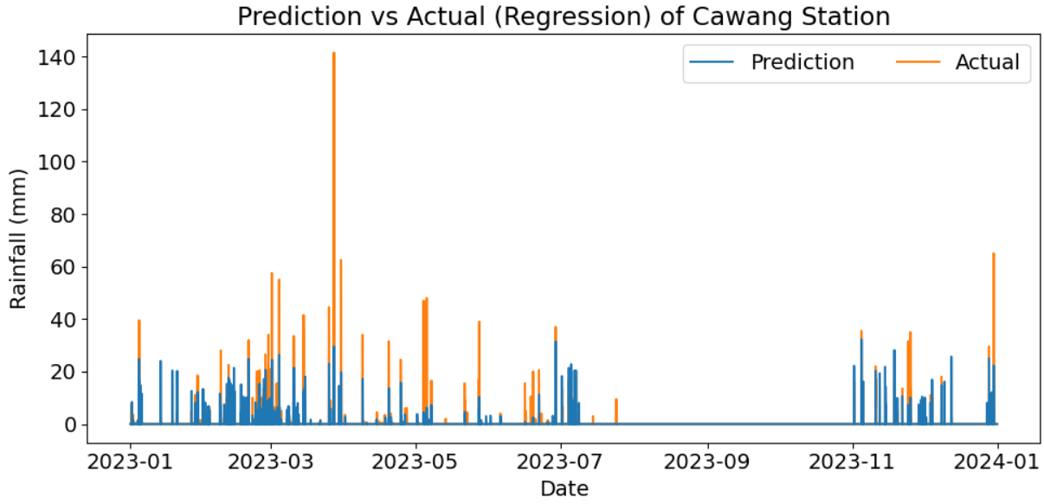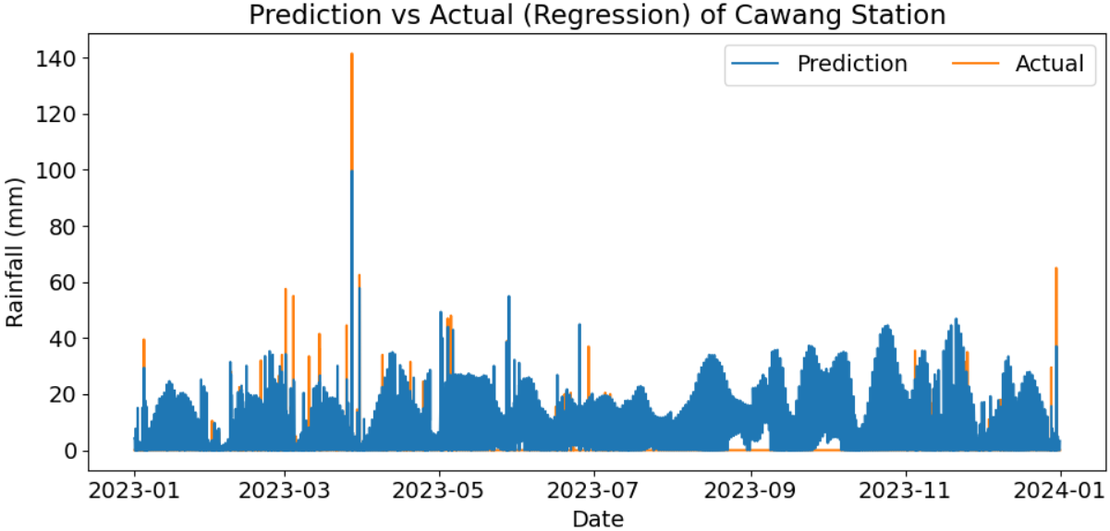

Visual comparison of hybrid model (top) vs pure regression model (bottom) prediction