Release Notes V1

The app was designed to refresh the feed once the user drags the screen down.

The images will get loaded and cached as the user scrolls (Lazily). The Glide library from Google helps us in this regard. (Please note: Additional cashing settings are available.) If an image was not able to load, an error placeholder image will get displayed as user feedback. (Please note: Error images can easily be replaced with required designs).

## Git commit history:

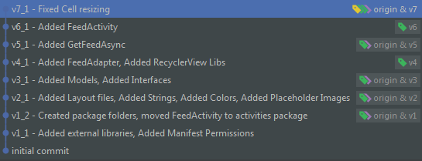

## Code base:

<https://drive.google.com/drive/folders/1c_2w-miWhe0zAgLBFRcYoMB5kM9UZxNO?usp=sharing>

Please get in contact with the person submitting the code, if access to the repository is required.