Assessment Design A10: ICASS Mark Calculation System

1. Learning Outcomes
- Outcome 1: Demonstrate the ability to capture user input, convert data types, and apply arithmetic operations to calculate weighted totals in Python.

- Outcome 2: Display formatted output including precise decimal formatting, custom headers, and string cleaning.

- Outcome 3: Analyse code logic, error handling, and variable data types through short reasoning.

Test Data (Three Sets: Normal, Boundary, Invalid)

Test Set | Input Data | Expected Output | Actual Output | Status
Set 1 (Normal) | Name: " Sipho Zulu "  FT1: 60.0  FT2: 70.0  ICE: 80.0  PAT1: 50.0  PAT2: 90.0 | Student: SIPHO ZULU  ICASS Score: 72.00% | Recorded during run | Pass/Fail
Set 2 (Boundary) | Name: "Anna Smith"  FT1: 0.0  FT2: 100.0  ICE: 100.0  PAT1: 0.0  PAT2: 100.0 | Student: ANNA SMITH  ICASS Score: 65.00% | Recorded during run | Pass/Fail
Set 3 (Invalid) | Name: "John Doe"  FT1: "eighty" (non-numeric string) | ValueError: could not convert string to float: 'eighty' | Crashes on string-to-float conversion (Expected behavior) | Pass/Fail

2. Model Solution (icass_calculator.py)

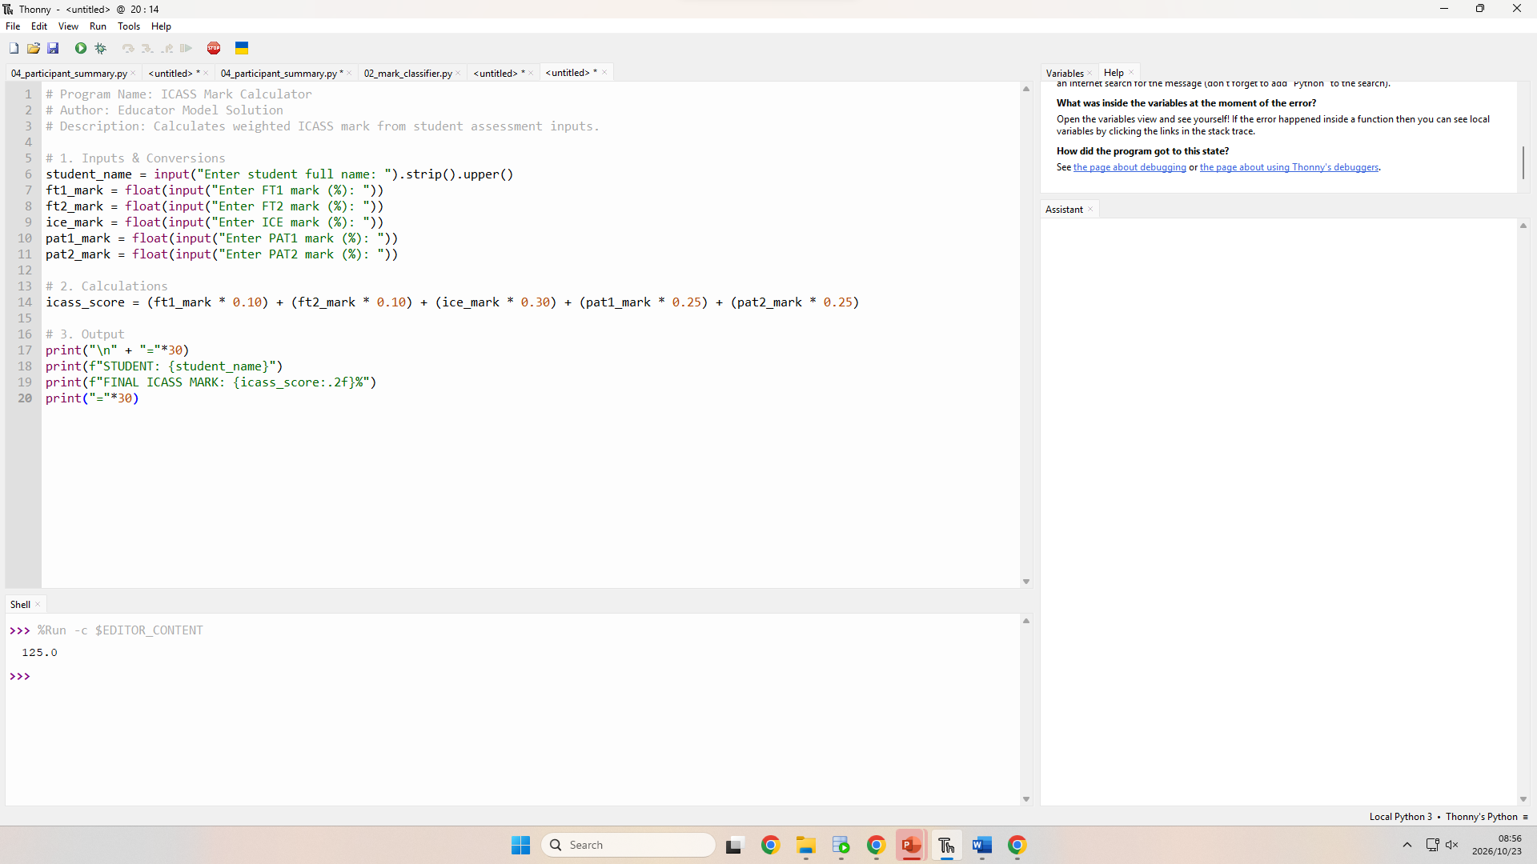
Python

3. Reasoning Question & Model Answer

Question:
a) A learner writes the calculation line as follows:

icass_score = ft1_mark * 10 / 100 + ft2_mark * 10 / 100 + ice_mark * 30 / 100 + pat1_mark * 25 / 100 + pat2_mark * 25 / 100

Explain why operator precedence in Python guarantees that multiplication and division will occur before addition, giving the correct result without brackets. (2 marks)

b) If a student enters "eighty" instead of 80.0 for FT1, what specific Python exception is raised, and why does Python raise a TypeError or ValueError during execution? (3 marks)

Model Answer:
- a) In Python's operator precedence rules, multiplication (*) and division (/) share higher priority than addition (+). Therefore, Python evaluates all multiplication and division operations from left to right first before carrying out any addition operations, ensuring the formula calculates correctly even without parentheses. (2 marks)

- b) Python raises a ValueError. This happens because the float() conversion function expects a string containing numeric digits (e.g., "80.0"), and cannot parse text words like "eighty" into float representations. (3 marks)

4. Marking Guide (Total: 25 Marks)

Section | Marks | Criteria / Sub-allocations
Plan (IPO Chart) | 4 | • 1 mark: Inputs listed with units (%) and data types (str, float)  • 2 marks: Formulas clearly stated using exact variable names  • 1 mark: Outputs specified with units and expected formatting
Input & Conversion | 5 | • 2 marks: All 5 input prompts include clear units (%)  • 2 marks: All 5 mark inputs correctly converted to float  • 1 mark: Text input cleaned (.strip()) and assigned meaningful variable names
Calculations | 4 | • 2 marks: Correct weightings applied (10%, 10%, 30%, 25%, 25%)  • 2 marks: Correct syntax using variables without hardcoded values
Output | 4 | • 1 mark: Text formatting (uppercase student name)  • 2 marks: Score formatted strictly to 2 decimal places  • 1 mark: Clear layout with units (%) displayed
Documentation | 1 | • 1 mark: Header comment included with program title, author, and description
Testing | 2 | • 1 mark: Normal, boundary, and invalid test data recorded  • 1 mark: Expected vs actual outputs explicitly recorded
Reasoning Question | 5 | • 2 marks: Correct explanation of operator precedence (* and / over +)  • 3 marks: Identification of ValueError and explanation of invalid float literal conversion
TOTAL | 25

5. Self-Review Checklist

- [x] Two or three outcomes are named (3 outcomes defined)
- [x] Every input and output has a unit and type (str, float, % specified)
- [x] Three test data sets: normal, boundary, invalid
- [x] The model solution runs in Thonny on every set
- [x] Marks total 20 to 30 (25 marks), each tied to one outcome
- [x] One reasoning question with a model answer
- [x] Only input, conversion, arithmetic, output: no if, no loops
- [x] A neighbor can follow it without asking you

