# Delft Research Controller for wind turbines

## Introduction

The Bladed-style Delft Research Controller (DRC) is developed at Delft University of Technology. The controller is open-source and written in the FORTRAN 90 language, and provides a convenient baseline to test new control algorithms and implementations. The DRC includes the DISCON subroutine which is called in every controller iteration and uses the swap array avrSWAP for data exchange. Currently, the DRC consists of the following components:

* Variable speed torque controller (PI-control in region 2.5)
* Collective pitch controller, gain scheduled
* Individual pitch controller for blade fatigue load reduction
* Yaw control, multiple implementations:
  + By individual pitch control (yaw-by-IPC), free-yaw
  + Yaw rate control, active-yaw

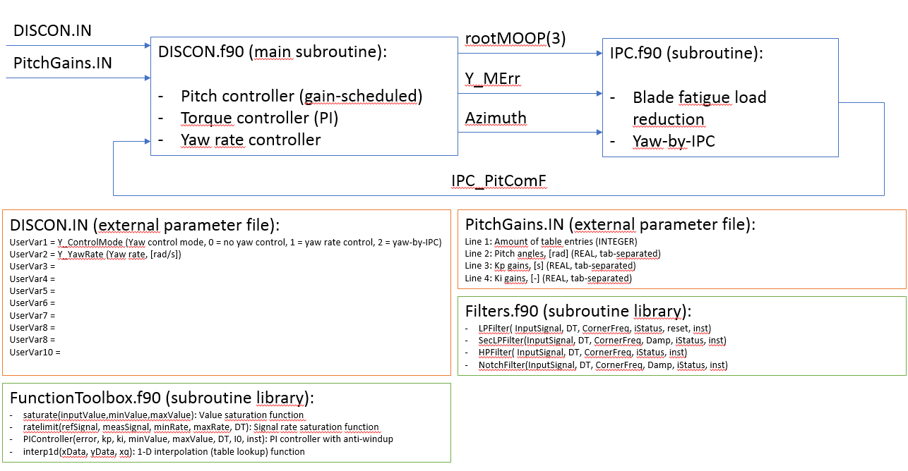

The procedures described in this manual are focused on Windows, but can also be used on Linux systems with some minor changes.

## File description and schematic overview

A short description of the files provided in this section, together with a schematic overview of the controller structure.

* CONSTSteps_MPS.wnd: uniform stepped input wind file. Can be adjusted.
* DISCON.IN: used to pass user-defined parameters to the external controller and avrSWAP
* PitchGains.IN: Table including the gain-scheduled pitch controller gains.
* \Debug
  + CompileRunAndDebug.cmd: compiles the external controller , executes test 18 and copies the debug files to specified debug folder.
  + CompileRunAndPause.cmd: compiles the external controller and executes test 18. After that is pauses so command window output can be read.
  + plotDebugData.m: plots debug data in matlab
  + saveFigs.m: saves all figures that are opened into the most recent debug folder
* \Scripts
  + CompileDISCON.cmd: compiles the DISCON dll
  + plotTest18.m: plots data from the Test18.out file
  + RunTest18.cmd: executes test 18
* \Source
  + DISCON.f90: main controller file
  + Filter.f90: module that contains different filters
  + FunctionToolbox.f90: module that contains different functions
  + IPC.f90: Subroutine that executes Individual Pitch Control

# Manuals

## Fixing the yaw rate control bug in ServoDyn

In FAST v8.16.00a-bjj, a bug in ServoDyn prevents using yaw rate control commands from an external controller, see: <https://github.com/OpenFAST/openfast/issues/25>. Currently, the yaw position reference is set to the neutral yaw position (yaw spring force equals 0 at this yaw position) in each time step. This effectively eliminates the yaw spring stiffness, resulting in large yaw excursions.

This bug can be solved by adding a couple lines of code to the CalculateStandardYaw subroutine in the source file ServoDyn.f90 and recompiling FAST. The following code has to be added in the previously mentioned subroutine:

REAL(4), SAVE :: YawPosComInt ! Internal variable that integrates the commanded yaw rate

INTEGER(4), SAVE :: FirstTime = 1 ! Integer to see whether this is the first time

IF (FirstTime == 1) THEN

YawPosComInt = u%Yaw

FirstTime = 0

END IF

CASE ( ControlMode_DLL ) ! User-defined yaw control from Bladed-style DLL

YawPosComInt = YawPosComInt + m%dll_data%YawRateCom*p%DT

YawPosCom = YawPosComInt

YawRateCom = m%dll_data%YawRateCom

Subsequently, FAST can be recompiled with use of gfortran included in MinGW. To avoid out-of-memory errors during compiling, set BITS, FFLAGS and LDFLAGS to the following values in \Compiling\makefile:

BITS = 32

FFLAGS = -O0 -m$(BITS) -fbacktrace -ffree-line-length-none -x f95-cpp-input -g -pg

LDFLAGS = -O0 -m$(BITS) -fbacktrace -g -pg

Open a command prompt, navigate to the \Compiling\makefile directory and execute mingw32-make to recompile FAST.

## Compile the DRC to a DLL in Windows

Tested with FAST v8.16.00a-bjj and Windows 10 Home

* Download FAST v8 from the NREL <https://nwtc.nrel.gov/FAST8>
* Execute FAST_v8.16.00a-bjj.exe and extract the zip to C:\FAST preferably
* Download the compiler MinGW from their <http://www.mingw.org/download/installer?>
* Install MinGW to C:\MinGW preferably
* Add FAST and MinGW to your Path: go to Control Panel 🡪 System and Security 🡪 System 🡪 Advanced system settings 🡪 Environment Variables. (In Dutch: Configuratiescherm 🡪 Systeem en beveiliging 🡪 Systeem 🡪 Geavanceerde systeeminstellingen 🡪 Omgevingsvariabelen.) Under system variables double click Path and add the following paths:
  + C:\FAST\bin
  + C:\MinGW\bin
* Make sure to click OK on every opened window and then log off and on or restart the computer
* By typing path in a command prompt window you can check if the paths are correctly added
* Copy the files from the provided DISCON_DLL directory to their correct location:
  + Copy all files in DISCON_DLL\Scripts to FAST\
  + Copy DISCON.IN to FAST\CertTest
  + Copy PitchGains.IN to FAST\CertTest
  + Copy CONSTSteps_MPS.wnd to FAST\CertTest\5MW_Baseline\Wind
  + Copy all files in DISCON_DLL\Source to FAST\CertTest\5MW_Baseline\ServoData\Source. Replace the DISCON.f90 file.
* In FAST\Compiling in the makefile_DISCON_DLLmake sure the following parameters are set:
  + Line 13: BITS = 32
  + Line 20: DLL_DIR = ../CertTest/5MW_Baseline/ServoData/Source
  + Line 22: SOURCE_FILE = FunctionToolbox.f90 Filters.f90 IPC.f90 DISCON.f90
* Rename makefile to makefile_FAST (or something different) and rename makefile_DISCON_DLL to makefile
* By executing CompileDISCON.cmd in FAST\ the DISCON dll is compiled

## Custom uniform stepped wind input

By default, the Test18 simulation uses a 60 seconds near-rated turbulent wind input-file. For evaluation of control performance, a uniform stepped wind profile can be defined:

* In FAST\CertTest\5MW_Baseline\NRELOffshrBsline5MW_InflowWind_12mps.dat:
  + Line 5: change WindType from 3 to 2
  + Line 16: set Filename to Wind/CONSTSteps_MPS.wnd
* CONSTSteps_MPS.wnd (in FAST\CertTest\5MW_Baseline\Wind) can be modified to get the desired wind profile.
* In FAST\CertTest\Test18.fst:
  + Line 6: set TMax to the required simulation time
* Execute RunTest18.cmd in FAST\

## Run NREL5MW - Land-based simulation (Test18.fst)

Test 18 is a standard test for the NREL5MW wind turbine using an external controller. Execute the following steps to run the simulation:

* In FAST\CertTest\Test18.fst
  + Line 39: set OutFileFmt to 1
* In FAST\CertTest\5MW_Baseline\NRELOffshrBsline5MW_Onshore_ServoDyn.dat, replace the ----BLADED INTERFACE---- section with the contents in ServoDynBladedInterface_NREL5MW.dat.
* Run the test by executing RunTest18.cmd in FAST\

## Plot results in Matlab

The Matlab script plotTest18.m in FAST\ imports and plots data from Test18. The data is imported in a structure and plots can easily be added when needed.

## Enable active yaw control

To enable active yaw control from the DRC, the following settings need to be changed:

FAST\CertTest\5MW_Baseline\NRELOffshrBsline5MW_Onshore_ServoDyn.dat:

* + Line 52: set YCMode to 5
  + Line 53: set TYCOn to 0
* In FAST\CertTest\5MW_Baseline\NRELOffshrBsline5MW_Onshore_ElastoDyn.dat:
  + Line 16: make sure that YawDOF is set to True

Note that in FAST v8.16.00a-bjj, a bug prevents active yaw rate control commands using an external controller. Refer to section *Fixing the yaw rate control bug in ServoDyn* for a procedure to fix this bug.

## Enable debugging

If the external controller is developed further and it gets tested often, a debug archive can be set up. There is support to automatically put test results in a separate folder with a timestamp and plot them if needed:

* Create a new directory for the debug file on your computer
* Copy the content of DISCON_dll\Debug to the debug file directory
* In CompileRunAndDebug.cmd:
  + Line 7: set FASTdir to the absolute path of the FAST directory
  + Line 11: set ArchiveDir to the absolute path of the debug file directory
* In CompileRunAndPause.cmd:
  + Line 6: set FASTdir to your FAST directory
* In DISCON.f90 in FAST\CertTest\5MW_Baseline\ServoData\Source:
  + Line 123: set DbgOut to .TRUE.
* Now by executing CompileRunAndDebug.cmd, Test18 is run and the test data is stored in a new folder in the debug file directory
* To plot data from a certain test plotDebugData.m can be used. Make sure that data from the correct folder gets plotted. In plotDebugData.m:
  + Line 12: change timeStamp to the name of the folder the debug files are in
* By executing saveFigs.m afterwards, all opened figures get saved in the folder the debug files are located.

# Data exchange records: avrSWAP

For the sake of convenience, the definition of the avrSWAP records are given below. See also Bladed User Manual Version 4.2 from Garrad Hassan & Partners Ltd, appendix A.

|  |  |  |  |  |  |
| --- | --- | --- | --- | --- | --- |
| **Record** | **Data** | **Data** |  | **See** |  |
| **number** | **flow8** | **type9 Description** | | **note(s** | **Units** |
|  |  |  |  | **)** |  |
| 1 | in | I | See Section A.2 |  | - |
| 2 | in | R | Current time |  | s |
| 3 | in | R | Communication interval |  | s |
| 4 | in | R | Blade 1 pitch angle |  | rad |
| 5 | in | R | Below-rated pitch angle set-point | 1 | rad |
| 6 | in | R | Minimum pitch angle | 1 | rad |
| 7 | in | R | Maximum pitch angle | 1 | rad |
| 8 | in | R | Minimum pitch rate (most negative value allowed) |  | rad/s |
| 9 | in | R | Maximum pitch rate |  | rad/s |
| 10 | in | I | 0 = pitch position actuator, 1 = pitch rate actuator |  | - |
| 11 | in | R | Current demanded pitch angle |  | rad |
| 12 | in | R | Current demanded pitch rate |  | rad/s |
| 13 | in | R | Demanded power | 2 | W |
| 14 | in | R | Measured shaft power | 3 | W |
| 15 | in | R | Measured electrical power output |  | W |
| 16 | in | R | Optimal mode gain | 3,5 | Nm/(rad/s)2 |
| 17 | in | R | Minimum generator speed | 3 | rad/s |
| 18 | in | R | Optimal mode maximum speed | 3 | rad/s |
| 19 | in | R | Demanded generator speed above rated | 1,3 | rad/s |
| 20 | in | R | Measured generator speed |  | rad/s |
| 21 | in | R | Measured rotor speed |  | rad/s |
| 22 | in | R | Demanded generator torque above rated | 3 | Nm |
| 23 | in | R | Measured generator torque | 3 | Nm |
| 24 | in | R | Measured yaw error | 4 | rad |
| 25 | in | I | Start of below-rated torque-speed look-up table =R | 3,5 | Record no. |
| 26 | in | I | No. of points in torque-speed look-up table =N | 3,5 | - |
| 27 | in | R | Hub wind speed | 4 | m/s |
| 28 | in | I | Pitch control: 0 = collective, 1 = individual |  | - |
| 29 | in | I | Yaw control: 0 = yaw rate control, 1 = yaw torque control |  | - |
| 30-32 | in | R | Blade 1-3 root out of plane bending moment | 18 | Nm |
| 33 | in | R | Blade 2 pitch angle |  | rad |
| 34 | in | R | Blade 3 pitch angle |  | rad |
| 35 | both | I | Generator contactor | 10 | - |
| 36 | both | I | Shaft brake status: 0=off, 1=Brake 1 on | 19 | - |
| 37 | in | R | Nacelle angle from North |  | rad |
| 38-40 | out |  | Reserved |  |  |
| 41 | out | R | Demanded yaw actuator torque | 13,21 | Nm |
| 42 | out | R | Demanded blade 1 individual pitch position or rate | 12,14 | rad or rad/s |
| 43 | out | R | Demanded blade 2 individual pitch position or rate | 12,14 | rad or rad/s |
| 44 | out | R | Demanded blade 3 individual pitch position or rate | 12,14 | rad or rad/s |
| 45 | out | R | Demanded pitch angle (Collective pitch) | 12 | rad |
| 46 | out | R | Demanded pitch rate (Collective pitch) | 12 | rad/s |
| 47 | out | R | Demanded generator torque |  | Nm |
| 48 | out | R | Demanded nacelle yaw rate | 13,21 | rad/s |
| 49 | out | I | Message length OR -M0 | 15 | - |
| 49 | in | I | Maximum no. of characters allowed in the “MESSAGE” | 6 | - |
| 50 | in | I | No. of characters in the “INFILE” argument | 6 | - |

....continued overleaf....



|  |  |  |  |  |  |
| --- | --- | --- | --- | --- | --- |
| **Record** | **Data** | **Data** |  | **See** |  |
| **number** | **flow8** | **type9 Description** | | **note(s** | **Units** |
|  |  |  |  | **)** |  |
| 51 | in | I | No. of characters in the “OUTNAME” argument | 6 | - |
| 52 | in | I | DLL interface version number (reserved for future use) | 6 | - |
| 53 | in | R | Tower top fore-aft acceleration |  | m/s2 |
| 54 | in | R | Tower top side to side acceleration |  | m/s2 |
| 55 | out | I | Pitch override | 16 | - |
| 56 | out | I | Torque override | 16 | - |
| 57-59 | out |  | Reserved |  |  |
| 60 | in | R | Rotor azimuth angle |  | rad |
| 61 | in | I | No. of blades |  | - |
| 62 | in | I | Max. number of values which can be returned for logging | 7 | - |
| 63 | in | I | Record number for start of logging output | 7 | - |
| 64 | in | I | Max. no. of characters which can be returned in | 7 | - |
|  |  |  | “OUTNAME” |  |  |
| 65 | out | I | Number of variables returned for logging | 17 | - |
| 66-68 | in | R | Reserved |  |  |
| 69-71 | in | R | Blade 1-3 root in plane bending moment | 18 | Nm |
| 72 | out | R | Generator start-up resistance |  | ohm/phase |
| 73 | in | R | Rotating hub My (GL co-ords) | 18 | Nm |
| 74 | in | R | Rotating hub Mz (GL co-ords) | 18 | Nm |
| 75 | in | R | Fixed hub My (GL co-ords) | 18 | Nm |
| 76 | in | R | Fixed hub Mz (GL co-ords) | 18 | Nm |
| 77 | in | R | Yaw bearing My (GL co-ords) | 18 | Nm |
| 78 | in | R | Yaw bearing Mz (GL co-ords) | 18 | Nm |
| 79 | out | I | Request for loads | 18 | - |
| 80 | out | I | 1 = Variable slip current demand at position 81 | 11 | - |
| 81 | both | R | Variable slip current demand | 11 | A |
| 82 | in | R | Nacelle roll acceleration | 18 | rad/s2 |
| 83 | in | R | Nacelle nodding acceleration | 18 | rad/s2 |
| 84 | in | R | Nacelle yaw acceleration | 18 | rad/s2 |
| 85-89 |  |  | Reserved |  |  |
| 90 | in | R | Real time simulation time step |  | s |
| 91 | in | R | Real rime simulation time step multiplier |  | - |
| 92 | out | R | Mean wind speed increment | 20 | m/s |
| 93 | out | R | Turbulence intensity increment | 20 | % |
| 94 | out | R | Wind direction increment | 20 | rad |
| 95-96 |  |  | Reserved |  |  |
| 97 | in | I | Safety system number that has been activated |  | - |
| 98 | out | I | Safety system number to activate |  | - |
| 99 | in | I | Reserved |  |  |
| 100 | in | I | Reserved |  |  |
| 101 | in | R | Reserved |  |  |
| 102 | out | I | Yaw control flag | 21 | - |
| 103 | out | R | Yaw stiffness if record 102 = 1 or 3 | 21 | - |
| 104 | out | R | Yaw damping if record 102 = 2 or 3 | 21 | - |
| 105 | in | R | Reserved |  |  |
| 106 | in | R | Reserved |  |  |
| 107 | out | R | Brake torque demand | 19, 22 | Nm |

....continued overleaf....



|  |  |  |  |  |  |
| --- | --- | --- | --- | --- | --- |
| 108 | out | R | Yaw brake torque demand |  | Nm |
| 109 | in | R | Shaft torque (= hub Mx for clockwise rotor) | 18 | Nm |
| 110 | in | R | Hub Fixed Fx | 18 | N |
| 111 | in | R | Hub Fixed Fy | 18 | N |
| 112 | in | R | Hub Fixed Fz | 18 | N |
| 113 | in | R | Network voltage disturbance factor |  | - |
| 114 | in | R | Network frequency disturbance factor |  | - |
| 115-116 |  |  | Reserved |  |  |
| 117 | in | I | Controller state | 23 | - |
| 118 | in | R | Settling time (time to start writing output) |  | s |
| 119 |  |  | Reserved |  |  |
| 120-129 | both | R | User-defined variables 1 to 10 | 24 |  |
| 130-142 |  |  | Reserved |  |  |
| 143 | in | R | Teeter angle |  | rad |
| 144 | in | R | Teeter velocity |  | rad/s |
| 145-160 |  |  | Reserved |  |  |
| 161 | in | I | Controller failure flag |  | - |
| R | in | R | First generator speed in look-up table | 3,5 | rad/s |
| R+1 | in | R | First generator torque in look-up table | 3,5 | Nm |
| R+2 | in | R | Second generator speed in look-up table | 3,5 | rad/s |
| R+3 | in | R | Second generator torque in look-up table | 3,5 | Nm |
| ... |  | ... | ... etc., until ... |  | ... |
| R+2N-2 | in | R | Last generator speed in look-up table | 3,5 | rad/s |
| R+2N-1 | in | R | Last generator torque in look-up table | 3,5 | Nm |
| M0 | out | I | Message length, only if record 49 < 0 | 15 |  |
| M1 - Mn | out | C | Message text, 4 characters per record | 15 | - |
| L1 onwards | out | R | Variables returned for logging output | 17 | SI |

Notes:

1. Pitch regulated case only.
2. Not for variable speed pitch regulated case.
3. Variable speed case only.
4. Based on free wind at hub position - no modelling of actual nacelle anemometer or wind vane.
5. If the look-up table option is selected for the optimal mode below rated control, then record 16 is zero, record 25 contains the record number (R) of the start of the look-up table, and record 26 contains the number of points in the table (N).
6. DLL case only: see Sections 5.9.2 and A.3.
7. DLL case only: see Section A.5.
8. in = data supplied by simulation, which may be used but not changed by the external controller.  
   out = data supplied by the external controller to the simulation.  
   both = data which is written by the simulation but which may be changed by the external controller.
9. Record type for EXE case. I = integer, R = real (floating point), C = character. In the DLL case, all records are actually passed as 4-byte real (floating point) numbers.
10. 0 = off, 1 = main (high speed) or variable speed generator, 2 = low speed generator.
11. Only used with the variable slip generator electrical model. Set record 80 to 1 if using record 81 to send a rotor current demand. If record 80 is 0 (default), then the torque demand (record 47) will be used to control the generator.
12. See record 28.
13. See record 29.
14. Depending on record 10.
15. EXE case only: see Section A.3.
16. See Section A.4.
17. DLL case only; see Section A.5.
18. Record 79 is used to request additional measured loads and accelerations to be provided by the simulation:



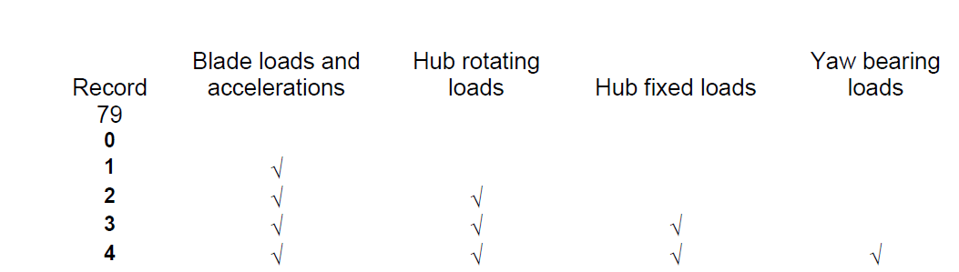

1. For shaft brake 1; to apply additional brakes, this is a binary flag: specify a value of

$\sum_{i}{2^{i-1}}B_{i}$

where Bi = 1 if the brake with index number i is applied, otherwise 0. The brake index numbers are as follows:

|  |  |
| --- | --- |
| Index number | Brake description |
| **1** | **Shaft brake 1** |
| **2** | **Shaft brake 2** |
| **3** | **Generator brake** |
| **4** | **Shaft brake 3** |
| **5** | **Brake torque set in record 107** |

1. For the Real Time Test facility, it is useful for the user to be able to change the wind conditions manually during a simulation from code in the external controller. Bladed will increase the mean wind speed, turbulence intensity (of all components) and wind direction by the value set in the respective field.
2. Yaw control flag in record 102 (affects the flexible yaw model only):

0: Default (record 48 sets the yaw rate demand).

1: As 0 but change the linear yaw stiffness according to record 103 (no effect on hydraulic accumulator model).

2: As 0 but change the yaw damping according to record 104.

3: As 1 but also change the yaw damping according to record 104.

4: Use record 41 (yaw torque demand) to override the yaw spring and damper.

1. Brake torque demand used for brake index 5 (see note 19).
2. Controller state flag is set by the Bladed internal controller as follows:

0: Power production

1: Parked

2: Idling

3: Start-up

4: Normal stop

5: Emergency stop

1. May be used to share information between user-defined DLLs for different turbine components.