Verslagsken Dinsdag

<https://cloud.google.com/appengine/docs/standard/python/tools/setting-up-eclipse>

In eclipse window> pref, dan links klikt ge PyDev open en klikt ge onder interpreters op Python interpreters

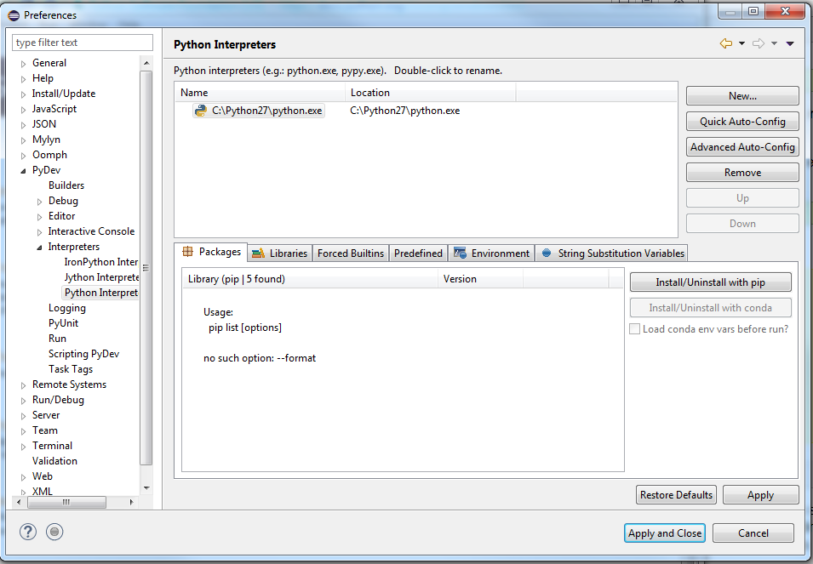

Python in environment variables steken: [https://docs.python.org/2/using/windows.html#excursus-setting-environment-variables](https://docs.python.org/2/using/windows.html%23excursus-setting-environment-variables)

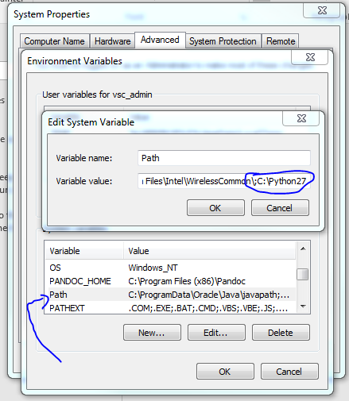

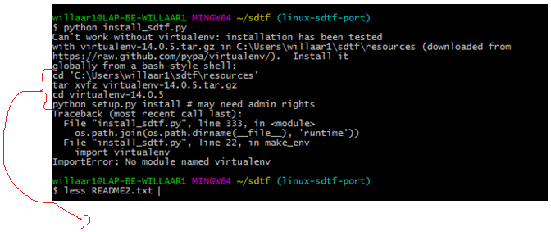

Copy-paste this in command line