
CATHOLIC UNIVERSITY OF EASTERN AFRICA

SCHOOL OF SCIENCE
DEPARTMENT OF COMPUTER SCIENCE

SCI 400: RESEARCH PROJECT

PROJECT PROPOSAL FOR FINAL YEAR STUDY IN
BACHELOR OF SCIENCE IN COMPUTER SCIENCE

BY

MOSES MARANGA (1050896)

PROJECT TITLE

Design and Implementation of a Web-Based Student Marketplace

DATE: SEPTEMBER, 2026

TERMS AND ABBREVIATIONS
LIST OF FIGURES
LIST OF TABLES
CHAPTER 1: INTRODUCTION
1.1 Background
1.2 Problem Statement
1.3 Aim of Research
1.4 Objectives
1.5 Justification
1.6 Scope
1.7 Research Organization
CHAPTER 2: REVIEW OF RELATED WORK
2.1 Chapter Introduction
2.2 History of Online Marketplaces
2.3 Review of Related Systems
2.4 Comparative Analysis
2.5 Emerging Trends and Patterns
2.6 Chapter Summary
CHAPTER 3: RESEARCH METHODOLOGY
3.1 Chapter Introduction
3.2 Methodology for Literature Review
3.3 Methodology for Requirements Specification
3.4 Methodology for System Analysis
3.5 Methodology for System Design
3.6 Methodology for System Implementation
3.7 Methodology for System Testing
3.8 Methodology for System Deployment
3.9 Chapter Summary
7.6 Final Conclusion
7.5 Recommendations for Future Work
7.4 Challenges Encountered
7.3 Conclusion
7.2 Findings
7.1 Introduction
CHAPTER 7: CONCLUSIONS, FINDINGS AND RECOMMENDATIONS
6.6 Chapter Summary
6.5 Evaluation Plan
6.4 Testing Plan
6.3 Selected System Screens
6.2 System Implementation
6.1 Introduction
CHAPTER 6: SYSTEM IMPLEMENTATION AND TESTING
5.7 Chapter Summary
5.6 Input and Output Design
5.5 Database Design
5.4 Process Design
5.3 Conceptual Architecture
5.2 Description of the Proposed System
5.1 Introduction
CHAPTER 5: SYSTEM DESIGN OF THE PROPOSED SYSTEM
4.6 Chapter Summary
4.5 System Analysis and Process Logic
4.4 Requirements Analysis
4.3 Feasibility Study
4.2 Description of the Current System
4.1 Introduction
CHAPTER 4: SYSTEM ANALYSIS
REFERENCES
APPENDICES

TERMS AND ABBREVIATIONS
API | Application Programming Interface
CRUD | Create, Read, Update, Delete
CUEA | Catholic University of Eastern Africa
DFD | Data Flow Diagram
ERD | Entity Relationship Diagram
GPS | Global Positioning System
HTTP | Hypertext Transfer Protocol
ICT | Information and Communication Technology
ML | Machine Learning
NF | Normal Form
NLP | Natural Language Processing
ORM | Object Relational Mapper
SQL | Structured Query Language
TCP | Transmission Control Protocol
UI/UX | User Interface / User Experience
URL | Uniform Resource Locator
VPS | Virtual Private Server
WWW | World Wide Web

LIST OF FIGURES
Figure 2.1: Machine Learning – Neural Network Architecture
Figure 2.2: Artificial Intelligence – Processing Pipeline
Figure 2.3: Electronic Payments – M-Pesa STK Push Flow
Figure 2.4: Blockchain – Decentralised Transaction Ledger
Figure 2.5: Cloud Computing – Scalable Infrastructure Architecture
Figure 2.6: Geolocation – Proximity-Based Buyer-Seller Matching
Figure 2.7: Recommender Systems – Collaborative Filtering Matrix
Figure 4.1: Context diagram of the current informal student marketplace system
Figure 4.2: Level 1 data-flow diagram of the current informal student marketplace
Figure 4.3: Flowchart of the current selling process
Figure 4.4: Flowchart of the current buying process
Figure 5.1: Conceptual architecture of the proposed UniMarket system
Figure 5.2: Proposed UniMarket context diagram
Figure 5.3: Proposed UniMarket Level 1 data-flow diagram
Figure 5.4: Principal UniMarket use cases
Figure 5.5: Sequence flow for an order and M-Pesa STK Push
Figure 5.7: Core entity-relationship design for UniMarket
Figure 5.8: Mock-up of the home page and listing feed
Figure 5.9: Mock-up of the login and account access screen
Figure 5.10: Mock-up of the buyer dashboard
Figure 5.11: Mock-up of the administrator console
Figure 6.1: UniMarket public landing page
Figure 6.2: UniMarket buyer dashboard
Figure 6.3: UniMarket seller hub
Figure 6.4: UniMarket superadministrator console

LIST OF TABLES
Table 2.1: Comparative Analysis of Existing Marketplace Systems
Table 3.1: System Implementation Technology Stack
Table A.1: Project Gantt Chart
Table B.1: Project Budget
Table 4.1: Weaknesses of the current informal student marketplace system
Table 4.2: Feasibility study summary
Table 4.3: Functional requirements
Table 4.4: Non-functional requirements
Table 4.5: Data requirements
Table 5.1: Selected process rules
Table 5.2: Core data dictionary
Table 6.1: Implementation environment
Table 6.2: Functional test plan
Table 6.3: Non-functional testing plan
Table 6.4: Evaluation plan
Table 7.1: Challenges encountered and responses

CHAPTER ONE: INTRODUCTION

1.1 Background
Information and Communication Technology (ICT) refers to the convergence of technologies that enable the acquisition, storage, processing, retrieval, and transmission of digital information through electronic means. It encompasses hardware infrastructure such as computers, servers, and networking equipment; software systems including operating systems and applications; and communication networks such as the internet and mobile telephony. ICT has evolved from a narrow set of computing tools in the mid-twentieth century into a pervasive ecosystem that underpins virtually every dimension of modern society. The proliferation of internet access, affordable smartphones, and cloud infrastructure has transformed the way individuals and institutions communicate, transact, and share information. Governments, businesses, and academic institutions have increasingly embraced digital solutions to streamline their operations and improve service delivery, making ICT literacy and digital infrastructure central components of national development agendas across the globe.
The automation of processes through digital platforms has had far-reaching impacts across numerous sectors. In the retail sector, e-commerce platforms such as Amazon and Jumia have disrupted traditional brick-and-mortar businesses by enabling buyers and sellers to transact across geographic boundaries at unprecedented scale. In the financial sector, mobile money platforms such as M-Pesa have transformed how millions of people in East Africa access financial services, demonstrating the transformative power of technology in serving underserved populations (Mas & Radcliffe, 2010). In healthcare, telemedicine platforms have made medical consultations accessible to patients in remote areas. These examples collectively illustrate that the digitisation of commerce and services creates significant value for communities.
Within university environments, students frequently engage in informal peer-to-peer trade. Academic textbooks, electronic gadgets, clothing, event tickets, and tutoring services are routinely exchanged between students through informal channels such as WhatsApp groups, physical notice boards, and word of mouth. This informal economy, while active, suffers from significant inefficiencies: lack of a centralised discovery mechanism, absence of trust signals, no structured negotiation process, and no accountability system for buyers or sellers.
Online marketplace platforms represent a well-established solution to these inefficiencies. Platforms such as eBay, Craigslist, and Facebook Marketplace have demonstrated that digital peer-to-peer marketplaces can significantly reduce transaction friction and increase market efficiency. However, these general-purpose platforms are not tailored to the specific needs, trust requirements, or social context of university student communities. A student-specific marketplace, anchored within a known institution, provides an inherently safer and more relevant trading environment.
This research proposes UniMarket: a web-based university student marketplace platform developed as a case study at the Catholic University of Eastern Africa (CUEA). UniMarket is designed as a scalable, institution-agnostic solution that can be adopted by any university, with CUEA serving as the initial deployment environment. The platform will provide a centralised, secure, and feature-rich digital space through which university students can list, discover, and trade goods and services within their campus community.

1.2 Problem Statement
University students across Kenya and the broader East African region currently lack a dedicated, trustworthy digital platform through which to buy, sell, and exchange goods and services within their campus communities. The absence of such a platform gives rise to several interconnected problems that negatively affect the student experience and economic wellbeing.
The most immediate problem is the absence of a centralised discovery mechanism. Students who wish to sell textbooks, electronics, or other items must rely on informal channels such as WhatsApp groups and physical notice boards, which offer limited reach and no searchability. This fragmentation means that willing buyers and sellers frequently fail to find each other, resulting in missed economic opportunities on both sides. In addition, there is no structured process for price negotiation, meaning that transactions often stall or fall apart due to the absence of a clear offer-and-counter-offer mechanism.
Trust is a further significant barrier. In the absence of a reputation system, students have no reliable way to assess whether a seller is trustworthy or whether a listed item matches its description. This lack of accountability exposes buyers to the risk of fraud and misrepresentation, and discourages participation in informal trade. Furthermore, there is no mechanism for students offering services such as tutoring or photography to build a verifiable track record within the university community.
These problems collectively point to a clear gap: a need for a dedicated, university-anchored digital marketplace that provides structured listings, verified user accounts, in-platform messaging, price negotiation, and a ratings system. This research addresses that gap through the design and implementation of UniMarket, piloted at CUEA.

1.3 Aim of Research
The aim of this research is to design and implement a web-based university student marketplace platform, piloted at the Catholic University of Eastern Africa, that enables students to list, discover, and trade goods and services in a secure, structured, and scalable digital environment.

1.4 Objectives
The following objectives have been derived from the aim of this research:
1. 1. To review existing literature on peer-to-peer marketplace platforms, web application security, and student-centred digital commerce in order to identify best practices and research gaps.
2. 2. To collect and analyse requirements from university students and administrators through structured questionnaires and interviews in order to establish the functional and non-functional requirements of the system.
3. 3. To analyse the current informal student trading environment using data flow diagrams and contextual analysis in order to identify inefficiencies and system requirements.
4. 4. To design the proposed UniMarket system including database schema, data flow diagrams, user interface prototypes, and system architecture.
5. 5. To test the implemented system using functional, usability, and security testing techniques in order to evaluate its correctness, performance, and robustness.
6. 6. To deploy the system and evaluate its effectiveness in addressing the identified student marketplace needs, using CUEA as the pilot institution.

1.5 Justification
The development of a dedicated student marketplace platform is justified on multiple grounds. From an economic perspective, peer-to-peer trade within university communities represents a significant informal market that currently operates without structure or oversight. Research by Einav et al. (2016) demonstrates that digital marketplace platforms substantially increase market efficiency by reducing search costs and information asymmetry between buyers and sellers. By digitising this informal market, UniMarket has the potential to generate real economic value for university students across Kenya.
From a security and trust perspective, the absence of a reputation system in informal student trade exposes participants to fraud risk. Resnick and Zeckhauser (2002) demonstrate that online reputation systems significantly increase trust and transaction rates in peer-to-peer marketplaces. UniMarket's integrated ratings and reviews system directly addresses this gap by enabling students to build verifiable reputations within their university community.
From a scalability and broader social impact perspective, UniMarket is designed as an institution-agnostic platform whose architecture allows it to be configured and deployed at any university with minimal adaptation. The successful pilot at CUEA will serve as a proof of concept demonstrating the viability and value of a university-anchored digital marketplace in the East African context. This positions UniMarket not merely as a single-institution tool but as a replicable model for addressing a shared challenge faced by student communities across the region, contributing to a growing ecosystem of student-centred digital solutions for African higher education institutions.

1.6 Scope
This research is limited in scope to the design and implementation of a web-based university student marketplace platform, with CUEA serving as the pilot institution. The scope is defined across four dimensions:
Target Organisation: The Catholic University of Eastern Africa, Nairobi, Kenya, serves as the primary case study institution. The platform is designed to be configurable and deployable at any university, with CUEA providing the initial user base and operational context.
Target Users: Three user types will be supported: Student users (who act as both buyers and sellers), Staff users (who will also act as both buyers and sellers), and Admin users (who manage the platform and resolve disputes).
Features to be Implemented: The platform will include user registration and authentication, product listings across five categories (textbooks and notes, electronics and gadgets, clothes and accessories, event tickets, and services), full CRUD operations on listings, buyer-to-seller messaging, price negotiation and offer management, a wishlist feature, a ratings and reviews system, listing reporting, geolocation-based listing discovery, and an administrative dashboard.
Timeline: The research and development will be conducted over thirty weeks, from March 2026 to September 2026. Aspects excluded from scope include mobile application development, payment gateway integration at this stage, and multi-institution simultaneous deployment.

1.7 Research Organization
This proposal is organised into three chapters. Chapter One presents the introduction, covering the background, problem statement, aim, objectives, justification, and scope of the research. Chapter Two presents a review of related work, examining the history of online marketplaces, reviewing existing systems, identifying emerging trends including cloud computing, geolocation, and recommender systems, and establishing the research gap this project addresses. Chapter Three presents the research methodology, detailing the approaches to be used for literature review, requirements gathering, system analysis, system design, implementation, testing, and deployment.

CHAPTER TWO: REVIEW OF RELATED WORK

2.1 Chapter Introduction
This chapter presents a comprehensive review of literature and related work relevant to the development of a web-based university marketplace. The chapter begins by tracing the historical evolution of online marketplaces. It then examines five existing marketplace systems, ranging from global platforms to local Kenyan implementations, analysing the strengths and weaknesses of each. The chapter further explores emerging trends including machine learning, artificial intelligence, electronic payments, blockchain, cloud computing, geolocation, and recommender systems. Finally, the chapter summarises the findings and establishes the context for the proposed platform.

2.2 History of Online Marketplaces
The concept of online marketplaces emerged in the mid-1990s alongside the commercialisation of the internet. The earliest known online transaction occurred in 1994 when a customer purchased a music CD through NetMarket, marking the beginning of consumer-to-consumer and business-to-consumer electronic commerce (Laudon & Traver, 2021). Shortly thereafter, eBay was founded in 1995 by Pierre Omidyar, pioneering the auction-based marketplace model. In the same year, Amazon was launched as an online bookstore before evolving into the world's largest e-commerce marketplace.
Throughout the early 2000s, online marketplaces expanded rapidly, driven by improvements in internet infrastructure, secure payment gateways such as PayPal, and growing consumer trust in digital transactions. The introduction of broadband internet, smartphones, and mobile applications between 2007 and 2012 marked a turning point, as marketplaces became accessible to billions of users worldwide (Evans & Schmalensee, 2016).
In Africa, the rise of online marketplaces was closely tied to the proliferation of mobile money services, particularly M-Pesa in Kenya, which launched in 2007 (Suri & Jack, 2021). Kenyan marketplaces such as OLX, PigiaMe, and Jumia emerged in the 2010s. More recently, social media platforms such as Facebook Marketplace and WhatsApp Business have blurred the line between social networking and commerce. Despite this evolution, university-specific marketplaces remain largely underdeveloped in the East African region.

2.3 Review of Related Systems

2.3.1 eBay
eBay is one of the oldest and most established online marketplaces in the world, founded in 1995 and currently serving over 130 million active buyers globally (eBay Inc., 2023). The platform operates on a consumer-to-consumer and business-to-consumer model, enabling users to list items for sale either at fixed prices or through auctions. Buyers browse listings, place bids, or purchase items directly, with payments processed through eBay's integrated system and feedback exchanged between parties upon completion.
Strengths:
A large global user base, strong buyer protection mechanisms, a well-established trust and reputation system, and a mature dispute resolution process.
Weaknesses:
High seller fees, a complex listing process for new users, limited support for local payment methods such as M-Pesa, and lack of community focus suitable for niche groups such as university students.
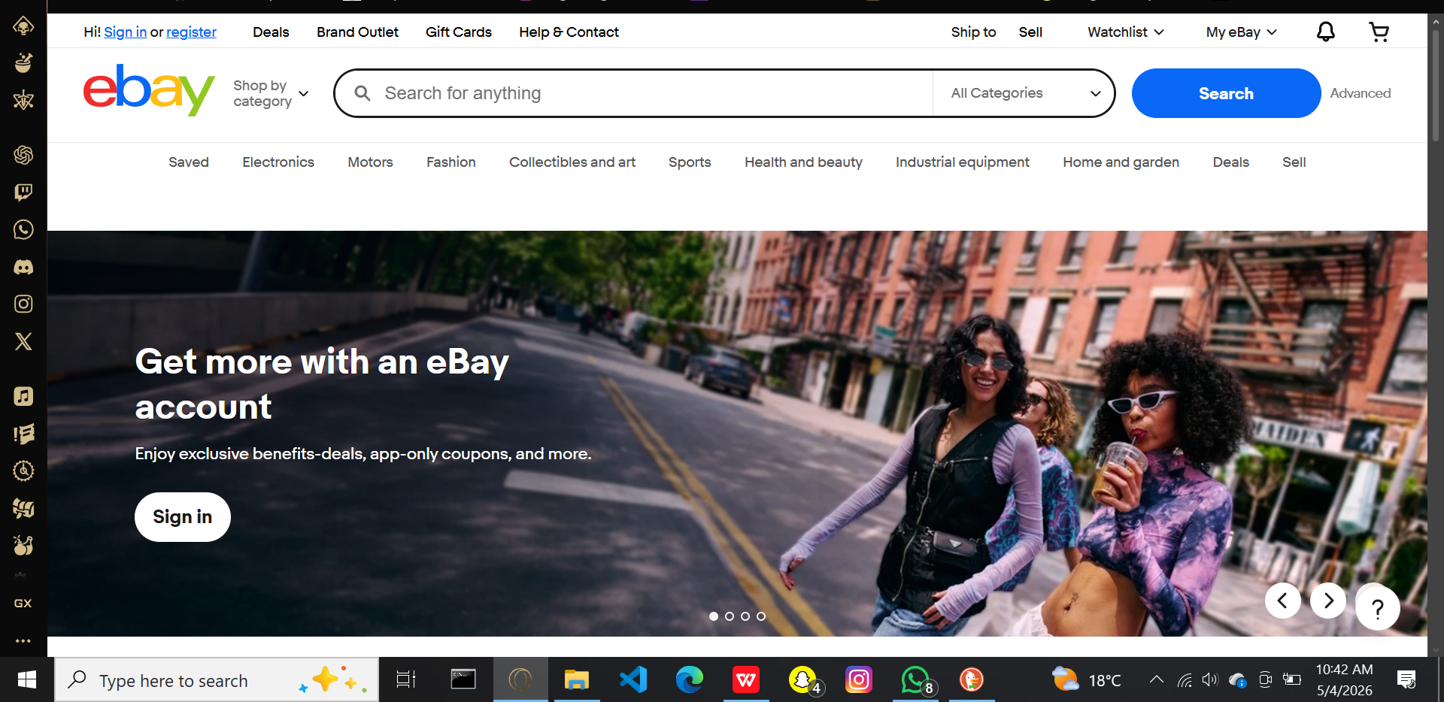

2.3.2 Amazon Marketplace
Amazon Marketplace is a third-party selling platform integrated within Amazon's larger e-commerce ecosystem, launched in 2000. It allows independent sellers to list products alongside those sold directly by Amazon, reaching a customer base of over 300 million globally (Amazon, 2023). Sellers may choose between fulfilling orders themselves or using Fulfilment by Amazon, where Amazon handles storage, shipping, and customer service.
Strengths:
Massive customer reach, robust logistics infrastructure, sophisticated AI-driven product recommendations, and strong brand trust.
Weaknesses:
High competition among sellers, significant commission fees, complex onboarding for small sellers, and limited presence in the Kenyan market with no support for M-Pesa.
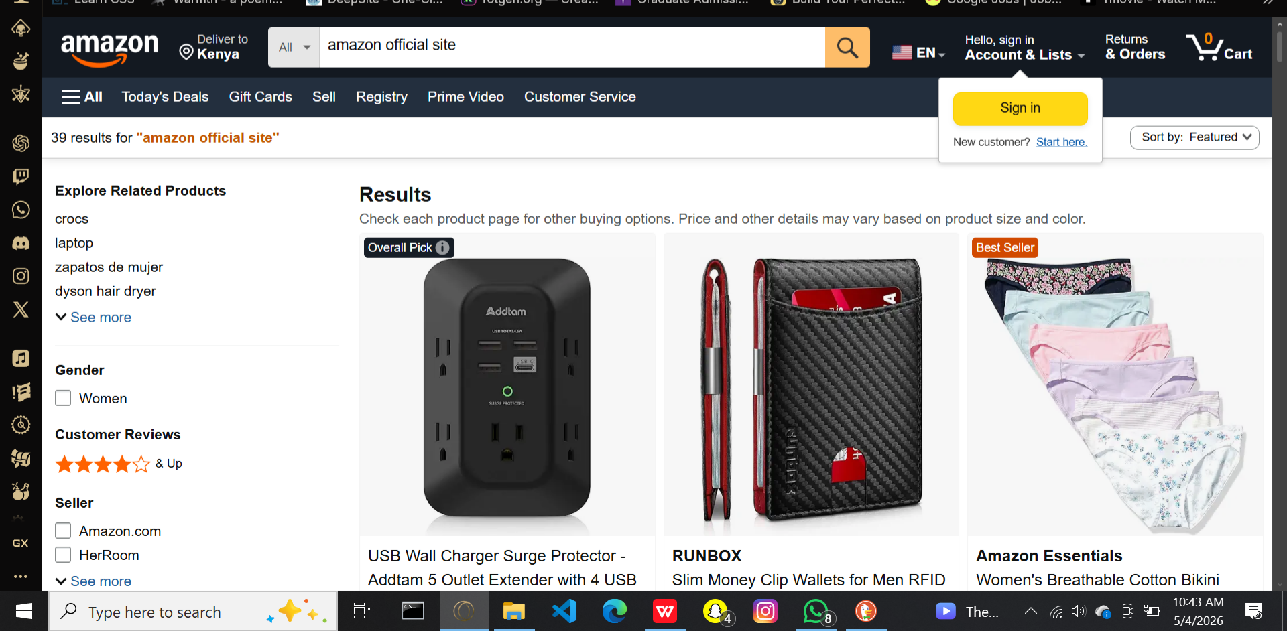

2.3.3 Jumia Kenya
Jumia, often referred to as the "Amazon of Africa," was founded in 2012 and operates across multiple African countries including Kenya. The platform combines a direct retail model with a third-party marketplace and handles last-mile delivery through its own logistics network (Jumia Group, 2023).
Strengths:
Localised for the Kenyan and African markets, supports M-Pesa payments, robust delivery infrastructure, and a trusted regional brand.
Weaknesses:
High vendor commissions, complex onboarding, focus on commercial sellers rather than peer-to-peer exchanges, and unsuitability for small-scale student transactions.
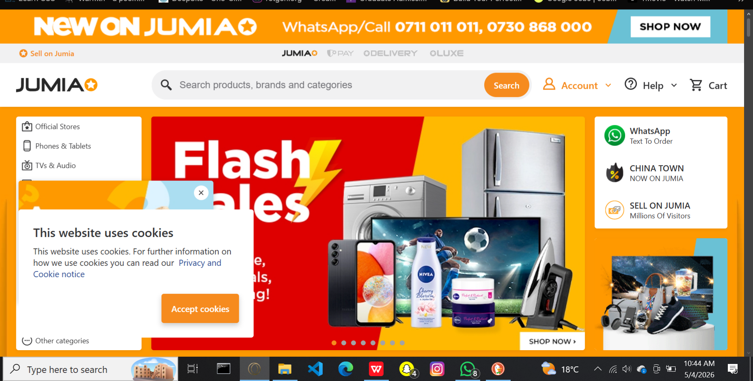

2.3.4 Jiji Kenya
Jiji Kenya is a leading classifieds marketplace that acquired OLX Kenya's operations in 2019. The platform connects individual buyers and sellers across categories such as electronics, vehicles, real estate, and services through free advertisement posting and in-app communication (Jiji Kenya, 2023).
Strengths:
Free for basic users, supports peer-to-peer transactions, strong local presence in Kenya, and a wide range of categories including services and rentals.
Weaknesses:
No integrated payment system, limited buyer protection, prevalence of fraudulent listings, lack of community-specific filtering, and difficulty verifying user authenticity.
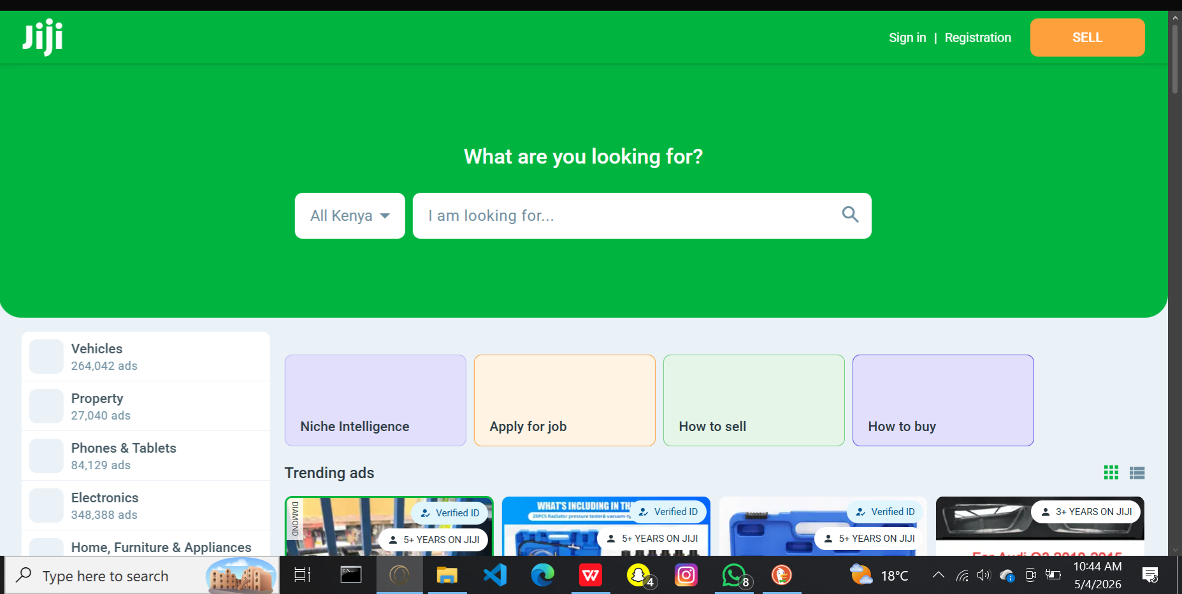

2.3.5 Facebook Marketplace
Facebook Marketplace, launched in 2016 by Meta Platforms, integrates buying and selling functionality directly into the Facebook social network, leveraging its over 2.9 billion active users globally (Meta, 2023). It is widely used in Kenya as an informal channel for student transactions, with users connecting through Messenger and transacting offline.
Strengths:
Massive user base, leverages existing social networks for trust, free and easy to use, and supports community-based selling through groups.
Weaknesses:
No integrated payments, no formal buyer or seller protection, prevalence of scams, no rating or review system, and dependence on a Facebook account which not all university students actively use.
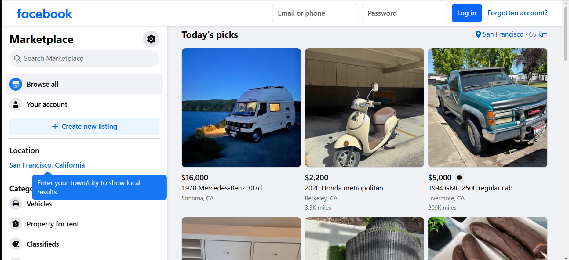

2.4 Comparative Analysis of Related Systems
Table 2.1 below presents a comparative summary of the five reviewed systems against the key features required for a university-focused marketplace.
Table 2.1: Comparative Analysis of Existing Marketplace Systems
Feature | eBay | Amazon | Jumia | Jiji | Facebook MP | UniMarket
University-Specific Focus | ✗ | ✗ | ✗ | ✗ | ✗ | ✓
M-Pesa Integration | ✗ | ✗ | ✓ | ✗ | ✗ | ✓
Institutional Email Verification | ✗ | ✗ | ✗ | ✗ | ✗ | ✓
In-App Chat | ✓ | ✓ | ✗ | ✓ | ✓ | ✓
Ratings & Reviews | ✓ | ✓ | ✓ | Limited | ✗ | ✓
Service Provider Listings | ✗ | ✗ | ✗ | ✓ | ✗ | ✓
Off-Campus Rental Listings | ✗ | ✗ | ✗ | ✓ | ✗ | ✓
Geolocation Discovery | ✗ | ✗ | ✗ | ✗ | ✗ | ✓
Recommender System | ✓ | ✓ | ✗ | ✗ | ✗ | ✓
Free for Users | Limited | ✗ | ✗ | ✓ | ✓ | ✓
Report Suspicious Listings | ✓ | ✓ | ✓ | ✓ | ✓ | ✓
Admin Oversight Dashboard | ✓ | ✓ | ✓ | ✓ | ✓ | ✓

2.5 Emerging Trends and Patterns in the Research Area

2.5.1 Machine Learning in Marketplaces
Machine learning (ML) is a branch of artificial intelligence that enables computer systems to learn from data and improve their performance over time without being explicitly programmed (Mitchell, 1997). In the context of online marketplaces, ML has become a fundamental component, enabling personalised user experiences through product recommendations, fraud detection, and dynamic pricing (Aggarwal, 2020). Platforms such as Amazon and eBay employ collaborative filtering algorithms to recommend items based on user browsing and purchasing behaviour. ML algorithms are also used to detect anomalies in user activity that may indicate fraudulent listings or accounts, thereby enhancing platform security.
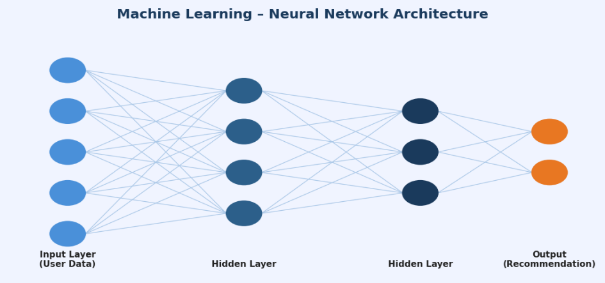
Figure 2.1: Machine Learning – Neural Network Architecture

2.5.2 Artificial Intelligence
Artificial intelligence (AI) refers to the simulation of human intelligence processes by computer systems, encompassing reasoning, learning, problem-solving, and language understanding (Russell & Norvig, 2021). AI extends beyond machine learning to include natural language processing, computer vision, and intelligent chatbots. In marketplaces, AI is used to power customer support chatbots, automatically categorise listings based on image recognition, and translate listings across multiple languages. AI-driven moderation systems can automatically detect inappropriate content, counterfeit goods, and prohibited items, significantly reducing the burden on human moderators.
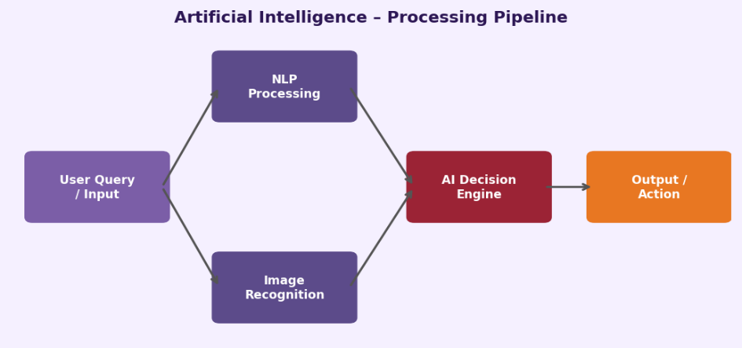

Figure 2.2: Artificial Intelligence – Processing Pipeline

2.5.3 Electronic Payments
Electronic payment systems have transformed the way marketplaces handle transactions. An electronic payment system is a digital mechanism that facilitates the transfer of monetary value between parties over a network without the need for physical currency (Laudon & Traver, 2021). In Kenya, M-Pesa has become the dominant mobile money platform, with over 30 million active users and integration into thousands of digital platforms (Communications Authority of Kenya, 2023). The M-Pesa Daraja API enables developers to integrate STK Push, C2B, and B2C payment flows directly into web applications, providing seamless payment experiences for users. Other emerging trends include digital wallets, contactless payments, and buy-now-pay-later schemes.
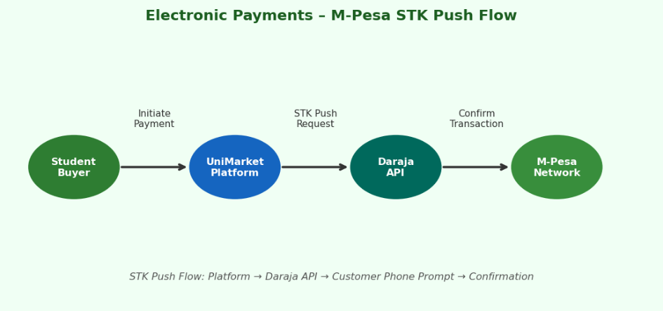

Figure 2.3: Electronic Payments – M-Pesa STK Push Flow

2.5.4 Blockchain Technology
Blockchain is a distributed, decentralised ledger technology that records transactions across a network of computers in a way that makes them immutable and transparent (Nakamoto, 2008; Tapscott & Tapscott, 2018). In online marketplaces, blockchain offers promising applications in establishing trust, securing transactions, and enabling decentralised commerce. Smart contracts can automate escrow services, ensuring that funds are only released to sellers once buyers confirm receipt of goods. Blockchain also enables transparent reputation systems where user ratings cannot be tampered with. While adoption remains limited due to scalability and usability challenges, its potential for future integration in university marketplaces is significant.
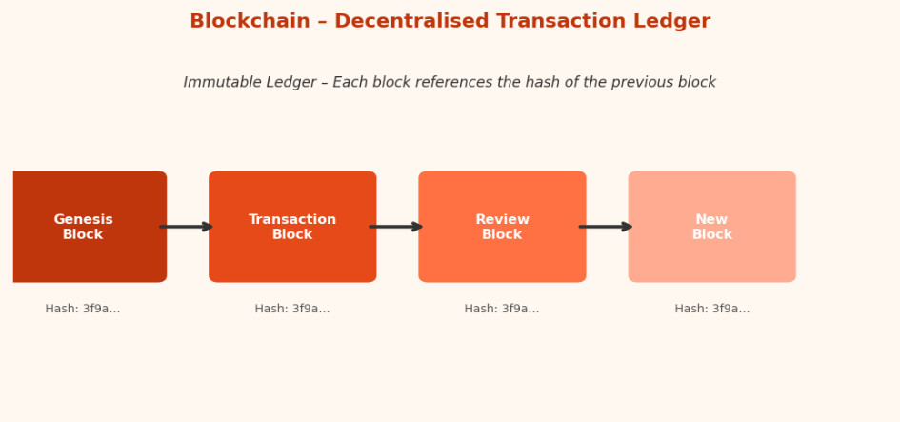

Figure 2.4: Blockchain – Decentralised Transaction Ledger

2.6 Chapter Summary
This chapter reviewed the historical evolution of online marketplaces from the early 1990s to the present, highlighting their growth from simple auction sites to sophisticated AI-driven platforms. Five existing systems were examined in detail — eBay, Amazon Marketplace, Jumia Kenya, Jiji Kenya, and Facebook Marketplace — with each system's strengths and weaknesses analysed. The chapter further explored seven emerging trends in the marketplace domain: machine learning, artificial intelligence, electronic payments, blockchain, cloud computing, geolocation, and recommender systems. The comparative analysis confirms the absence of a dedicated university-focused marketplace in the Kenyan context, establishing the need for the UniMarket platform developed in this research. The next chapter outlines the research methodology to be employed in designing, developing, and deploying the proposed system.

CHAPTER THREE: RESEARCH METHODOLOGY

3.1 Chapter Introduction
This chapter describes the methodologies that will be employed throughout the research project. It covers the approaches to literature review, requirements specification, system analysis, system design, implementation, testing, and deployment. For each methodology, a definition is provided, followed by an explanation of how it will be employed and why it has been selected for this research.

3.2 Methodology for Literature Review
A systematic literature review will be conducted to establish the theoretical and empirical foundation of the research. A systematic literature review is a structured and replicable method of identifying, evaluating, and synthesising all available evidence relevant to a specific research question (Kitchenham, 2004). The review will draw on academic journals, conference proceedings, books, and credible online sources published within the last ten years (2015–2026), with exceptions made for seminal works where historical context demands it.
The primary keywords to be used when searching for materials will include: online marketplace platforms, peer-to-peer e-commerce, student marketplace systems, web application security, OWASP, database design, HTTP server implementation, and digital commerce in East Africa. Search sources will include Google Scholar, IEEE Xplore, ACM Digital Library, and Springer Link. Materials will be selected based on relevance to the research objectives, recency, and citation credibility. This methodology has been chosen because it provides a rigorous, transparent, and reproducible approach to building the theoretical foundation of the research.

3.3 Methodology for Requirements Specification
Requirements will be gathered using two primary data collection techniques: structured questionnaires and semi-structured interviews. Both techniques are standard methods in information systems research for eliciting user needs and system requirements (Creswell & Creswell, 2018).

3.3.1 Questionnaires
A questionnaire is a research instrument consisting of a set of questions designed to collect standardised information from a group of respondents (Oppenheim, 2000). Questionnaires are particularly suited to collecting quantitative data from large samples in a structured and time-efficient manner.
Types of Questionnaires:
Three types of questions will be incorporated in the instrument: closed-ended questions (offering predefined response options such as Yes/No or multiple choice), Likert scale questions (measuring attitudes and preferences on a five-point scale from "strongly agree" to "strongly disagree"), and ranking questions (asking respondents to order features or categories by priority). Open-ended questions will be used sparingly where richer qualitative insight is needed.
How the Questionnaire will be Administered:
The questionnaire will be administered electronically using Google Forms. A shareable link will be distributed to the target sample via WhatsApp groups, university email, and student notice boards. The electronic format enables efficient data collection, automatic response aggregation, and eliminates data entry errors associated with paper-based forms. Respondents will complete the questionnaire anonymously at their own convenience within a designated two-week data collection window.
Sample Size:
A sample of fifty university students, selected through stratified random sampling across faculties, will be targeted to ensure representative coverage of different student populations.
How Feedback will be Incorporated:
Quantitative results from the questionnaire will be analysed using descriptive statistics. Response frequencies and Likert averages will be used to rank feature priorities and identify the most significant pain points in current student trading behaviour. These findings will directly inform the functional requirements specification for UniMarket, ensuring that the platform addresses real, evidence-based user needs.

3.3.2 Interviews
An interview is a direct, purposive conversation between a researcher and a respondent, designed to elicit detailed qualitative information about a subject (Kvale, 2009). Interviews allow for in-depth exploration of issues that questionnaires cannot fully capture.
Types of Interviews:
Three principal interview types exist: structured interviews (in which the interviewer follows a fixed set of questions in a predetermined order), semi-structured interviews (which use a question guide but allow the interviewer to probe and follow up on unexpected responses), and unstructured interviews (which are entirely open and conversational). This research will employ semi-structured interviews, as this approach combines the consistency of a prepared question guide with the flexibility to explore nuanced issues in depth.
How Interviews will be Carried Out:
Interviews will be conducted face-to-face with five to eight key informants, including CUEA student representatives, the university ICT officer, and a member of the university administration. Each interview will last approximately thirty to forty-five minutes and will be conducted in a private, comfortable setting to encourage candid responses. With the interviewee's consent, sessions will be audio-recorded and subsequently transcribed. The interviewer will use an open-ended question guide as a reference (see Appendix D), while allowing follow-up questions to explore emerging themes.
How Feedback will be Incorporated:
Interview transcripts will be subjected to thematic analysis, in which recurring themes and concerns are identified and coded. The resulting qualitative insights will complement the quantitative questionnaire data, providing richer context for non-functional and administrative requirements such as content moderation policies, dispute resolution procedures, and institutional integration requirements. Combined findings from both instruments will form the basis of the system requirements specification.

3.4 Methodology for System Analysis
Structured Systems Analysis will be employed to analyse the current informal student trading environment at CUEA. This methodology uses Data Flow Diagrams (DFDs) to model the flow of information between processes, data stores, and external entities.

3.4.1 Data Flow Diagrams (DFDs)
A Data Flow Diagram (DFD) is a graphical representation that depicts the flow of data through a system, showing how data is input, processed, stored, and output by various components (Yourdon, 1989). DFDs use four standard symbols: external entities (representing sources or destinations of data outside the system), processes (representing transformations applied to data), data stores (representing repositories where data is held), and data flows (arrows representing the movement of data between components). DFDs are hierarchically structured, beginning at the highest level of abstraction (the Context Diagram or Level 0 DFD) and progressively decomposing into greater detail.
Why DFDs are Used:
DFDs provide a clear, technology-neutral visual representation of system behaviour that is accessible to both technical and non-technical stakeholders. They enable the analyst to identify data inputs and outputs, trace information flows across the system, and pinpoint inefficiencies or bottlenecks in current processes without prescribing a specific implementation solution.
Information to be Extracted:
The DFD analysis of the current informal marketplace will extract the following information: the external entities involved in student trading (buyers, sellers, and university administration); the data flows between them (listing information, negotiation messages, payment confirmations, and complaint reports); the processes that transform data (listing creation, search, negotiation, and transaction completion); and the data stores in use (WhatsApp message histories, physical notice boards, and informal records). This information will directly inform the design of the proposed system's architecture and data model.
Why DFDs have been Chosen:
Structured systems analysis using DFDs has been chosen because it provides a rigorous, visual, and well-established framework for understanding information flows that is well-suited to the transaction-oriented nature of a marketplace platform. It facilitates communication between the researcher and non-technical stakeholders, and its outputs directly feed into the system design phase.

3.4.2 Database Normalisation
Database normalisation is the process of organising a relational database schema to reduce data redundancy and improve data integrity through the application of a series of normal forms (Codd, 1970). The proposed database schema will be normalised to Third Normal Form (3NF). The normalisation process will progress through First Normal Form (1NF), eliminating repeating groups; Second Normal Form (2NF), eliminating partial dependencies; and Third Normal Form (3NF), eliminating transitive dependencies. This methodology has been chosen because it ensures the database is free from anomalies during insert, update, and delete operations, and reduces storage overhead.

3.5 Methodology for System Design
The proposed UniMarket system will be designed using a combination of data flow diagrams, flowcharts, user interface prototypes, and an entity relationship diagram. Each design technique is defined below alongside an explanation of how it will be employed and why it has been selected.

3.5.1 DFDs for the Proposed System
A Data Flow Diagram (DFD) is a graphical model that represents the flow of data through a system (Yourdon, 1989). For the proposed system, context, Level 1, and Level 2 DFDs will be produced for UniMarket, modelling the flow of data between the platform's components and its users. These will mirror the structure of the analysis DFDs but reflect the proposed automated system rather than the current manual processes. DFDs have been chosen for system design because they provide a clear, technology-neutral overview of system behaviour that bridges the gap between requirements specification and detailed technical design.

3.5.2 Flowcharts
A flowchart is a diagrammatic representation of an algorithm or process, using standardised symbols to depict the sequence of steps, decisions, and actions involved in completing a task (Chapin, 1970). Flowcharts will be used to model the control flow of key system processes, including user registration and authentication, listing creation and submission, the offer negotiation cycle, and the review submission process. Flowcharts have been chosen because they clearly communicate procedural logic to both technical and non-technical stakeholders, making them an effective tool for validating process designs before implementation.

3.5.3 User Interface Design
User Interface (UI) design is the process of creating the visual layout and interactive elements through which users interact with a digital system, with the goal of producing an experience that is intuitive, efficient, and satisfying (Norman, 1988). User interface prototypes will be developed using Figma to create high-fidelity wireframes of all major screens including the landing page, listings browse page, individual listing detail page, seller profile, inbox, offer management panel, wishlist, and admin dashboard. The prototypes will be iteratively refined based on feedback from a small group of student evaluators before implementation begins. UI design has been chosen as a methodology because early prototyping allows usability issues to be identified and resolved before development, reducing costly rework.

3.5.4 Database Design
Database design is the process of defining the structure, relationships, and constraints of a database to efficiently support an application's data storage and retrieval requirements (Elmasri & Navathe, 2015). An Entity Relationship Diagram (ERD) is the primary tool used in conceptual database design, representing entities (objects of interest), their attributes, and the relationships between them. An ERD will be designed to model the database schema, including all entities, attributes, primary keys, foreign keys, and relationships. The core entities will include User, Listing, Message, Offer, Wishlist, Review, and Report. Database design using ERDs has been chosen because it provides a clear, structured blueprint for the database that can be validated against requirements before implementation.

3.6 Methodology for System Implementation
UniMarket will be implemented using the following technology stack, selected on the basis of educational value, alignment with development goals, and suitability for a web-based platform.
Table 3.1: System Implementation Technology Stack
Layer | Technology & Justification
Backend | Python 3 using the built-in socket module for raw TCP HTTP server implementation. Chosen for its readability, extensive standard library, and suitability for systems-level programming without frameworks.
Frontend | Vanilla HTML5, CSS3, and JavaScript. No frontend frameworks. Chosen to demonstrate competence in core web technologies and to avoid framework-imposed abstractions.
Database | SQLite 3 with raw SQL queries. No ORM. Chosen for its zero-configuration deployment, file-based architecture suitable for a single-server deployment, and the educational value of writing explicit SQL.

3.7 Methodology for System Testing
A multi-layered testing strategy will be employed to evaluate the correctness, usability, security, and performance of the UniMarket system. For each testing phase, the sample size, testing environment, conduct of testing, and incorporation of feedback are described below.

3.7.1 Functional Testing
Functional testing verifies that each feature of the system behaves in accordance with its specified requirements, ensuring that all inputs produce the expected outputs (Myers et al., 2011).
Sample Size:
All system features and user stories documented in the requirements specification will be covered. There is no participant sample for this phase — the developer serves as the tester.
Testing Environment Setup:
Functional tests will be conducted on a dedicated local development machine running the UniMarket server at localhost. A clean test database will be initialised before each test cycle to ensure consistent, reproducible results.
How Testing will be Conducted:
Test cases will be written for all user stories prior to implementation and executed after each development phase. Each test case will specify the input conditions, the steps to execute, and the expected output. Actual outcomes will be recorded against expected outcomes in a structured test log.
How Feedback will be Utilised:
Any test case that fails will be logged as a defect with a description, severity level, and steps to reproduce. Defects will be prioritised and resolved before the next development phase commences, ensuring that each module is fully functional before integration.

3.7.2 Usability Testing
Usability testing evaluates the ease with which target users can learn and use the system to achieve their goals effectively and efficiently (Nielsen, 1994).
Sample Size:
Five to ten CUEA student volunteers will be recruited to participate in usability testing, selected to represent diverse faculties and levels of digital literacy. Nielsen (1994) demonstrates that five users are sufficient to uncover approximately 85% of usability issues.
Testing Environment Setup:
Usability sessions will be conducted in a quiet, controlled environment, either in the university computer laboratory or using the participant's personal device connected to the local development server. The researcher will be present to observe but will not intervene unless a participant is entirely unable to proceed.
How Testing will be Conducted:
Participants will be asked to complete a set of defined tasks on the platform — such as creating a listing, making an offer, and sending a message — using the think-aloud protocol, in which they verbalise their thought process as they interact with the system. Sessions will be timed and any navigation errors or points of confusion noted by the researcher.
How Feedback will be Utilised:
After each session, participants will complete a post-task questionnaire based on the System Usability Scale (SUS). Think-aloud observations and SUS scores will be analysed to identify recurring usability issues. Findings will be compiled into a usability report and prioritised for resolution before final deployment.

3.7.3 Security Testing
Security testing involves a systematic evaluation of the platform against known vulnerability categories to ensure that user data and platform integrity are protected (OWASP Foundation, 2021).
Sample Size:
Security testing is conducted against the system itself rather than a participant sample. All OWASP Top 10 vulnerability categories will be tested systematically.
Testing Environment Setup:
Security testing will be conducted on an isolated local server instance, separate from the development environment, to prevent accidental damage to development data. Testing tools including Burp Suite Community Edition and browser developer tools will be used.
How Testing will be Conducted:
Manual testing will be performed for SQL injection, cross-site scripting (XSS), cross-site request forgery (CSRF), broken authentication, and insecure file uploads, following the OWASP Testing Guide methodology. Each vulnerability category will be tested with crafted payloads designed to expose weaknesses, and results will be documented.
How Feedback will be Utilised:
Identified vulnerabilities will be classified by severity (critical, high, medium, or low) and remediated in a dedicated security hardening sprint before final deployment. A post-remediation security re-test will confirm that all identified issues have been resolved.

3.7.4 Performance Testing
Performance testing measures the system's responsiveness and stability under expected and peak load conditions (Molyneaux, 2014).
Sample Size:
Simulated concurrent user loads of 10, 25, and 50 users will be tested to cover expected normal usage and stress conditions for a university deployment.
Testing Environment Setup:
A local server environment mirroring the intended production configuration will be established. The server will be monitored for CPU usage, memory consumption, and response times during load tests.
How Testing will be Conducted:
Python scripts using the concurrent.futures module will simulate concurrent users sending HTTP requests to the platform's most frequently accessed endpoints, including the listings browse page and the search API. Response times and error rates will be logged for each concurrency level.
How Feedback will be Utilised:
Bottlenecks identified in the server's threading model or database query performance will be addressed through targeted optimisation — such as query indexing, response caching, and thread pool tuning — before production deployment.

3.8 Methodology for System Deployment
A phased deployment approach will be adopted, in which the system is introduced to a limited group of users before a broader rollout. This approach minimises risk by allowing issues to be identified and resolved with a small user base before the platform is opened to the wider university student community. Phased deployment has been chosen because it balances the need for thorough validation with the practical constraints of academic timelines.
In Phase 1, the platform will be deployed to a local server accessible within the CUEA campus network and made available to a pilot group of twenty students and two administrators for a period of two weeks. Feedback from the pilot will be analysed and incorporated into the system before Phase 2.
In Phase 2, the platform will be deployed to a publicly accessible server and made available to all CUEA students. A user training session will be conducted to familiarise students with the platform's features. Data migration will not be required as the system will be deployed with an empty database, and users will register and create listings from scratch. The architecture has been designed to accommodate future multi-institution deployment with minimal reconfiguration.

3.9 Chapter Summary
This chapter described the methodologies to be employed across all phases of the research, including systematic literature review, questionnaire and interview-based requirements gathering with electronic administration and structured feedback incorporation, structured systems analysis using DFDs and normalisation, system design using ERDs, flowcharts, and UI prototypes, web-based implementation using a defined technology stack, multi-layered testing covering functional, usability, security, and performance dimensions, and phased deployment. These methodologies collectively provide a rigorous and comprehensive framework for the design, implementation, and evaluation of the UniMarket platform.

CHAPTER FOUR: SYSTEM ANALYSIS
4.1 Introduction
4.2 Description of the Current System
4.3 Feasibility Study
4.4 Requirements Analysis
4.5 System Analysis and Process Logic
4.6 Chapter Summary
CHAPTER FIVE: SYSTEM DESIGN OF THE PROPOSED SYSTEM
5.1 Introduction
5.2 Description of the Proposed System
5.3 Conceptual Architecture
5.4 Process Design
5.5 Database Design
5.6 Input and Output Design
5.7 Chapter Summary
CHAPTER SIX: SYSTEM IMPLEMENTATION AND TESTING
6.1 Introduction
6.2 System Implementation
6.3 Selected System Screens
6.4 Testing Plan
6.5 Evaluation Plan
6.6 Chapter Summary
CHAPTER SEVEN: CONCLUSIONS, FINDINGS AND RECOMMENDATIONS
7.1 Introduction
7.2 Findings
7.3 Conclusion
7.4 Challenges Encountered
7.5 Recommendations for Future Work
7.6 Final Conclusion
REFERENCES

CHAPTER FOUR
SYSTEM ANALYSIS

4.1 Introduction
This chapter analyses the current student trading process at the Catholic University of Eastern Africa (CUEA) and establishes the requirements that inform the design of UniMarket. The current process is treated as an informal socio-technical system because it combines student actions, communication channels, physical meetings and payment practices rather than operating through one dedicated application. The analysis covers the current system, its strengths and weaknesses, feasibility, requirements, data inputs and outputs, actors, and process logic. The chapter uses the diagrams in Figures 4.1 to 4.4 to show the current system boundary and the flow of information.
The analysis is deliberately separated from the proposed design. This distinction makes it possible to demonstrate the gap that UniMarket addresses and prevents features of the proposed system from being presented as if they already exist in the current process.

4.2 Description of the Current System
Student buying and selling at CUEA is mainly conducted through WhatsApp groups, Facebook groups or Marketplace, physical notice boards and word-of-mouth referrals. These channels are useful communication spaces, but they were not designed to manage structured listings, identity verification, transaction records, moderation or delivery status. A seller normally photographs an item, writes a short description, adds a price and shares a contact number. Interested buyers respond through a message or phone call, after which the parties negotiate and agree on a meeting place and payment method.
The buying process begins when a student identifies a need and searches message histories, social-media posts or notice boards. If no suitable item is found, the student asks peers or posts a request in a group. The process is therefore dependent on timing, group membership and the continued visibility of a message. A listing may remain visible after an item has been sold, while a genuine listing may be missed because it was posted in a different group.
Service providers face an additional challenge because services such as tutoring, photography, graphic design and hairdressing do not have a consistent directory or category. Providers repeatedly advertise in groups, and buyers have no common place to compare service descriptions, prices, availability or feedback. Figure 4.1 summarises the boundary of this informal system and the external parties that interact with it.
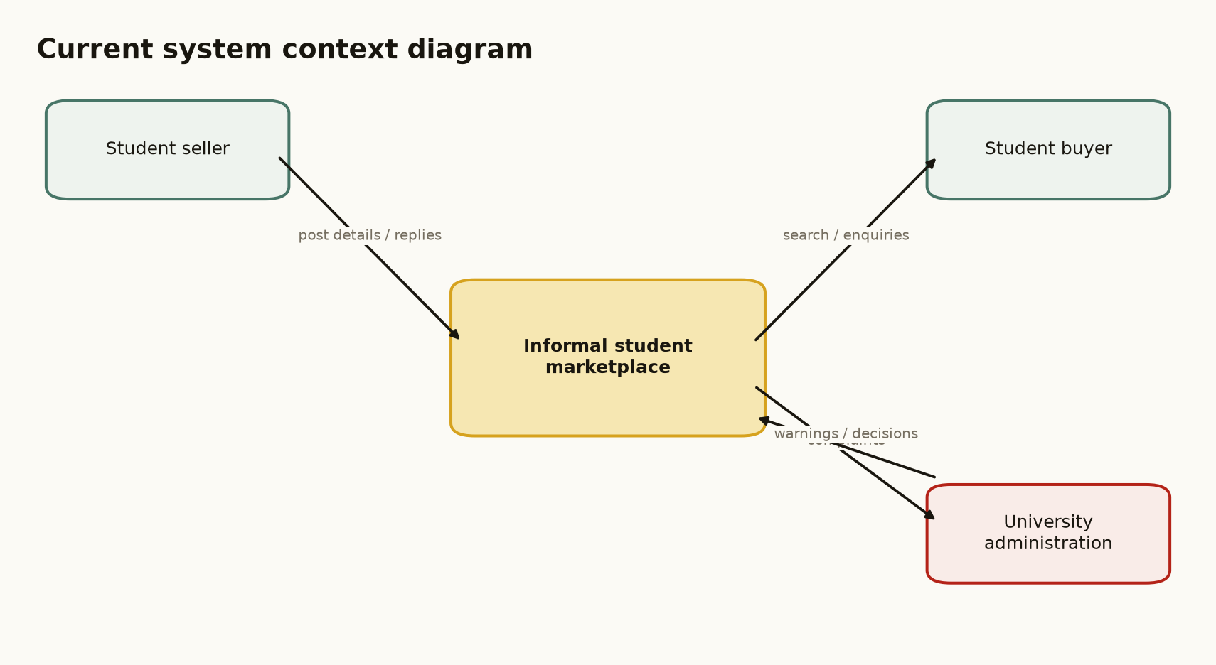
Figure 4.1: Context diagram of the current informal student marketplace system.
The figure is cited here because it identifies the current system boundary, the student seller, the student buyer and university administration as the main external entities.

4.2.1 Strengths of the Current System
• Low entry barrier: students can participate using communication tools they already have, without creating a new account.
• Familiarity: WhatsApp, Facebook and physical notice boards are already known to the target users, reducing the learning required at the start.
• Rapid communication: interested parties can contact one another immediately and can arrange urgent exchanges quickly.
• Social familiarity: shared groups and peer referrals provide an informal trust signal, although this does not replace formal verification or transaction records.
• Low direct operating cost: the current process does not require students to pay for a dedicated marketplace service.

4.2.2 Weaknesses of the Current System
The strengths above explain why the current process continues to be used, but they do not remove its structural weaknesses. The weaknesses are summarised in Table 4.1 and provide the direct justification for a dedicated student marketplace.
Table 4.1: Weaknesses of the current informal student marketplace system
Weakness | Effect on users
Fragmented discovery | Buyers search across several groups and channels, making relevant listings difficult to find.
No structured listing data | Descriptions, prices, locations and item conditions are inconsistent and incomplete.
Stale advertisements | Sold items may remain visible because there is no shared sold or expired status.
Limited accountability | Identity, reviews, complaints and transaction history are not managed in one place.
Unlinked conversations | Negotiation messages are separated from the listing and may be lost in busy group histories.
Weak moderation | There is no consistent process for reporting, reviewing and restricting abusive accounts or listings.
Poor service discoverability | Service providers have no common directory, category or reputation record.
Unclear payment evidence | M-Pesa or cash payments are not systematically linked to an order or item.

4.3 Feasibility Study
The feasibility study evaluates whether UniMarket can be developed and used within the project constraints. The assessment covers technical, economic, operational and schedule feasibility. The conclusion is based on the implemented prototype, the selected technologies, the identified users and the project schedule, rather than on an assumption that a full commercial marketplace can be delivered by one student.

4.3.1 Technical Feasibility
UniMarket is technically feasible because the selected technologies are accessible and adequate for a prototype. The backend uses Python 3 and the standard library, SQLite provides local relational persistence, and the interface uses HTML5, CSS3 and limited JavaScript. The application supports role-based access, listing management, messaging, orders, reporting and administrative moderation. The M-Pesa component is implemented around the Daraja OAuth and STK Push flow, but production operation depends on valid Safaricom credentials, a registered Paybill or Till and a public HTTPS callback URL. Render provides a suitable deployment target for the prototype. The technical conclusion is therefore positive, with production payment configuration treated as an external dependency.

4.3.2 Economic Feasibility
The prototype is economically feasible because Python, SQLite, HTML, CSS and JavaScript do not require licensing fees. The main project costs are internet access, data collection, testing, deployment-related services if required, transport and printing. The estimated project budget is presented in Appendix B of the complete report. The expected benefit is a structured marketplace that reduces the time required to discover items and provides a clearer record of interactions than the current process.

4.3.3 Operational Feasibility
The system is operationally feasible because the target users are already familiar with web and mobile services. UniMarket uses role-based dashboards and a consistent page shell to separate buyer, seller, administrator and superadministrator activities. University administrators can access seller information for their own institution, while superadministrators retain cross-institution oversight. Adoption will still require user onboarding, clear acceptable-use rules and a responsible process for handling complaints and personal data.

4.3.4 Schedule Feasibility
The project is schedule-feasible within the academic development period because its scope is bounded to the core marketplace workflow. The completed scope includes authentication, listings, search and filtering, buyer-seller Chat, orders, delivery status, reviews, reporting and administration. M-Pesa is included as a configured integration path and sandbox-ready flow; a real production transaction is not claimed until the external Go Live approval, credentials and deployment variables have been completed.

4.3.5 Feasibility Conclusion
The feasibility study concludes that UniMarket is suitable as an academic prototype and as a foundation for controlled institutional piloting. It is technically achievable, economically manageable, operationally appropriate for the target users and deliverable within the project schedule. A wider production rollout would require stronger infrastructure, formal institutional governance, backup procedures and completed payment-provider approval.
Table 4.2: Feasibility study summary
Dimension | Evidence | Conclusion
Technical | Python, SQLite, HTML/CSS/JavaScript, Render deployment and Daraja integration structure. | Feasible for prototype; production payments depend on external approval and credentials.
Economic | Open-source stack and manageable data collection, deployment and printing costs. | Feasible within the student project budget.
Operational | Digitally familiar users, role-specific dashboards and campus-oriented workflows. | Feasible subject to onboarding and governance.
Schedule | Bounded feature set and phased implementation plan. | Feasible within the academic project period.

4.4 Requirements Analysis
The requirements below were derived from the weaknesses of the current process, the project objectives and the implemented UniMarket prototype. They define what the proposed system must do, the quality conditions it must meet and the data required to support its operations.

4.4.1 Functional Requirements
Table 4.3: Functional requirements
ID | Requirement
FR1 | The system shall allow users to register, log in, verify an email address and reset a forgotten password.
FR2 | The system shall support buyer, seller, administrator and superadministrator access privileges.
FR3 | The system shall allow sellers to create, edit, view and mark listings as sold.
FR4 | The system shall allow buyers to browse, search and filter listings by category, university and price.
FR5 | The system shall support listing-specific conversations, offers, counters and offer expiry.
FR6 | The system shall create orders that separately record payment and delivery status.
FR7 | The system shall initiate an M-Pesa STK Push when the Daraja environment is correctly configured and shall update the order from the provider callback.
FR8 | The system shall support private delivery location sharing for authorised order participants.
FR9 | The system shall allow users to submit reviews and report suspicious listings.
FR10 | The system shall provide administrator moderation, seller visibility, admin-request review and CSV reports.
FR11 | Superadministrators shall view documents submitted with admin requests, while ordinary users shall not access those documents.
FR12 | University administrators shall view seller information and recent seller activity only for their own university; superadministrators may view all universities.

4.4.2 Non-Functional Requirements
Table 4.4: Non-functional requirements
Quality attribute | Requirement
Security | Passwords shall be hashed; protected actions shall use sessions, role checks and CSRF validation; sensitive credentials shall be stored as environment variables.
Privacy | Admin-request documents and order location data shall be restricted to authorised users.
Usability | Pages shall use consistent navigation, visible labels, clear status messages and responsive layouts.
Performance | Common page requests shall return without unnecessary external calls; the callback shall acknowledge quickly.
Reliability | Payment settlement shall depend on the provider callback and avoid duplicate updates.
Maintainability | Business functions, schema definitions and static assets shall remain separated and documented.
Scalability | The design shall identify SQLite and the thread-per-connection server as prototype constraints.

4.4.3 Data Requirements
Table 4.5: Data requirements
Data group | Examples | Purpose
Identity data | Name, email, phone, university, role, password hash. | Authentication, authorisation and institutional scoping.
Listing data | Title, category, description, price, condition, location, images, status. | Discovery and presentation of goods and services.
Communication data | Conversations, messages, offers, counter-offers. | Negotiation and buyer-seller accountability.
Transaction data | Buyer, seller, listing, amount, payment status, receipt, delivery status. | Order lifecycle and reconciliation.
Administration data | Reports, admin requests, application documents, review status. | Moderation, access approval and auditability.
Location data | Latitude, longitude, label and update time. | Private delivery tracking for an authorised order.

4.5 System Analysis and Process Logic
The current system is analysed using structured data-flow notation. The external entities are the student buyer, student seller and university administration. The system inputs include listing details, search queries, messages, offers, payment confirmations and complaints. The outputs include listing posts, replies, negotiated prices, exchanged items, informal payment evidence and administrative decisions.

4.5.1 Level 1 Data-Flow Analysis
Figure 4.2 decomposes the current system into posting, discovery, negotiation, exchange and complaint handling. Its data stores are not formal databases; they are communication channels and physical records. The diagram therefore shows both the presence of information and the absence of a central source of truth.
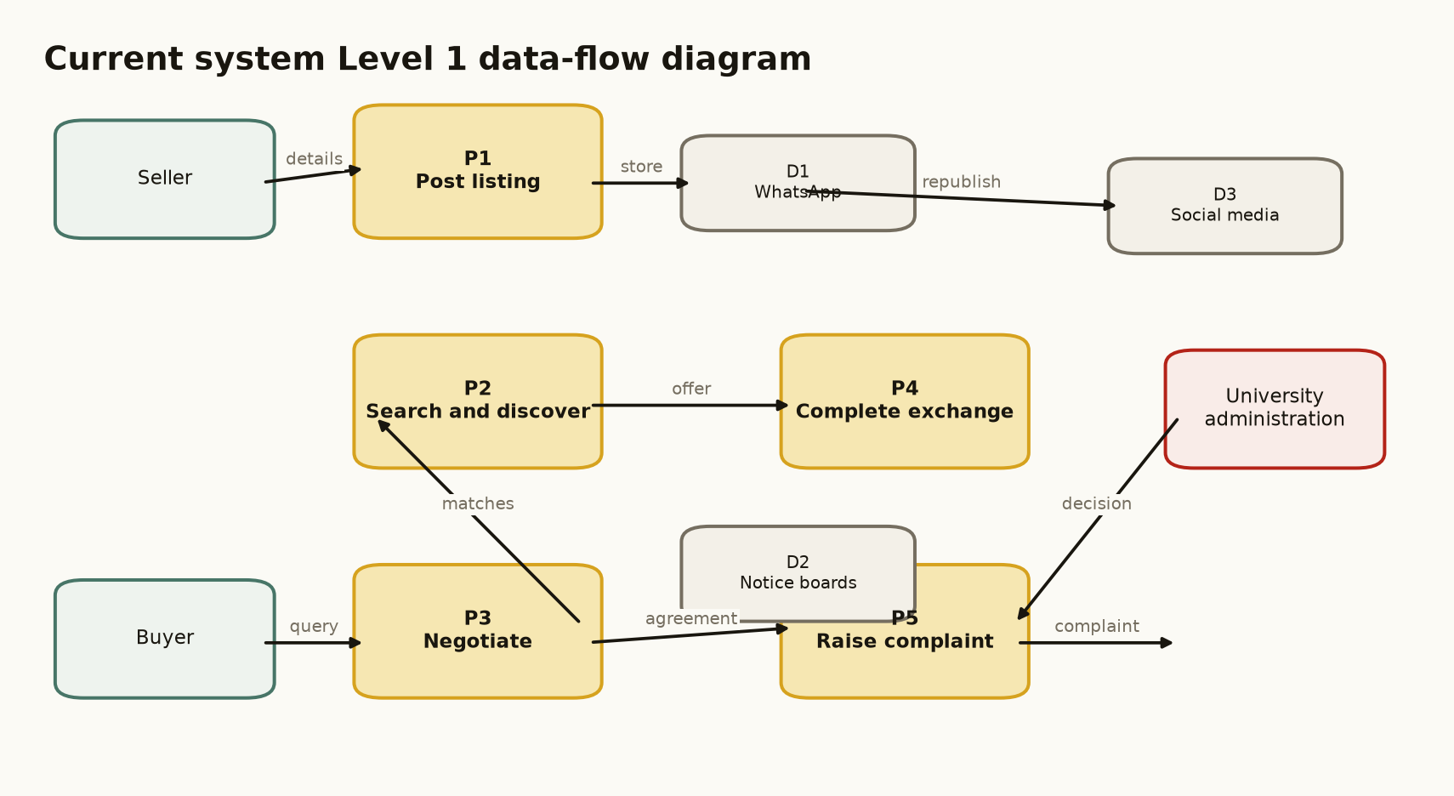
Figure 4.2: Level 1 data-flow diagram of the current informal student marketplace.
Figure 4.2 is cited here to show how the current process distributes listing information across several independent channels.

4.5.2 Current Selling Process
Figure 4.3 shows that the seller repeatedly moves between preparing a listing, posting it, waiting and responding. The loop is caused by the absence of a shared listing status, searchable catalogue and structured notification mechanism.
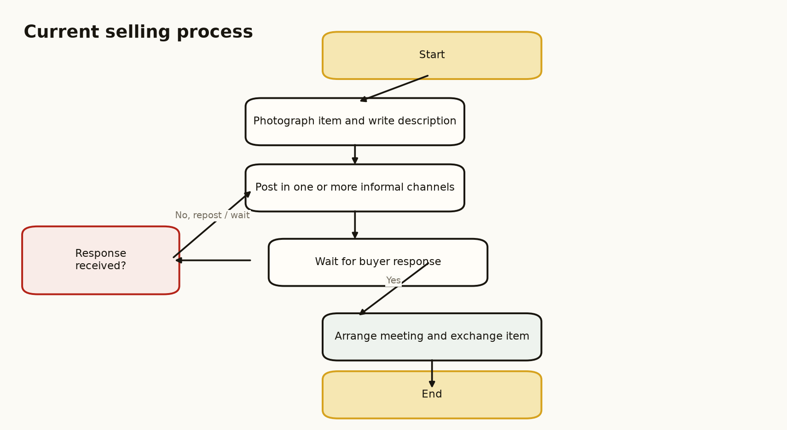
Figure 4.3: Flowchart of the current selling process.
The flowchart is cited in the discussion because it identifies the waiting and reposting loop that UniMarket is intended to reduce.

4.5.3 Current Buying Process
Figure 4.4 shows that the buyer searches several channels, broadens the search when no item is found and may retry the process when a seller is unavailable or an advertisement is stale. The process places the burden of coordination on the buyer and does not guarantee a complete record of the transaction.
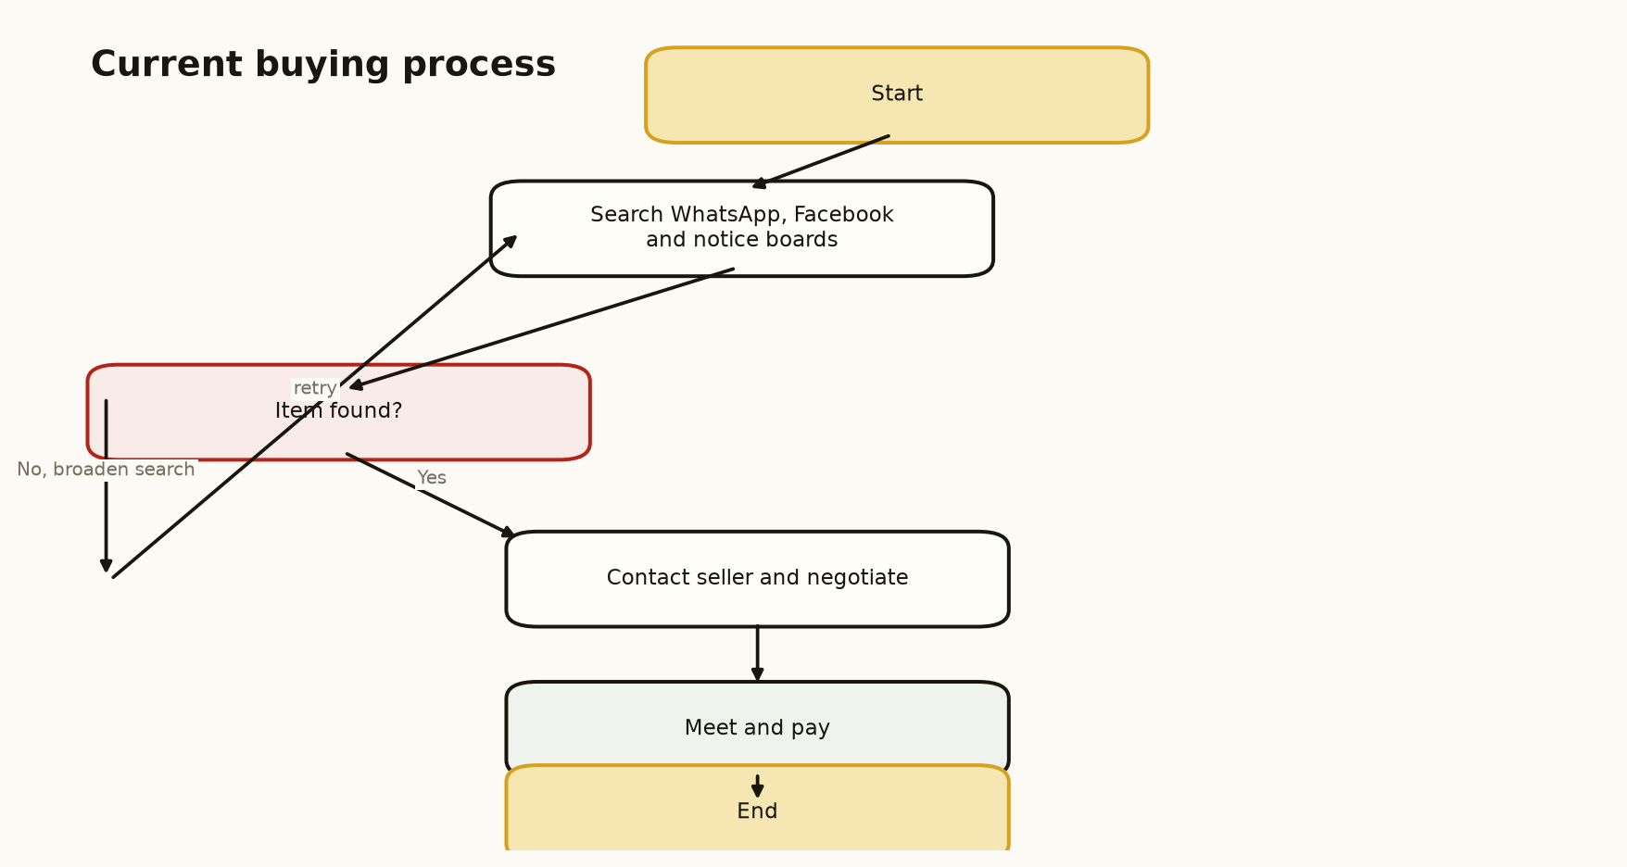
Figure 4.4: Flowchart of the current buying process.
The flowchart is cited here because it demonstrates the fragmented discovery path and the absence of a reliable completion state.

4.6 Chapter Summary
This chapter analysed the informal student marketplace at CUEA. The current system benefits from familiarity, low entry cost and rapid communication, but it is fragmented, difficult to search, weakly moderated and unable to maintain dependable links between listings, conversations, payments and complaints. The feasibility study found that UniMarket is appropriate as a bounded academic prototype. Functional, non-functional and data requirements were then defined, and the current process was modelled through a context diagram, a Level 1 DFD and two flowcharts. These findings provide the basis for the proposed system design in Chapter Five.

CHAPTER FIVE
SYSTEM DESIGN OF THE PROPOSED SYSTEM

5.1 Introduction
This chapter presents the design of UniMarket, the proposed web-based marketplace for university communities. The design responds directly to the weaknesses and requirements identified in Chapter Four. It specifies the proposed system, its strengths and limitations, conceptual architecture, process logic, database structure and input/output design. The design also incorporates the project decisions made during implementation: role-based administration, university-scoped seller visibility, protected admin-request documents, order-linked M-Pesa handling and responsive public information pages.

5.2 Description of the Proposed System
UniMarket is a server-rendered web application that allows university users to discover, list and exchange goods and services in a structured environment. A buyer can browse listings, save items, message a seller, submit an offer, place an order and monitor delivery status. A seller can create listings, manage offers and follow received orders. Administrators can moderate reports and review marketplace activity. Superadministrators can review admin applications and access the submitted identity documents. A regular university administrator sees seller information for the administrator’s own university only; this rule is enforced in the data queries rather than only in the interface.
The payment design supports Safaricom Daraja Lipa Na M-Pesa Express. The application obtains an OAuth token, creates the STK Push request, stores the CheckoutRequestID and waits for the asynchronous callback before marking the order as paid. The system is not described as a live payment service until production credentials, a registered shortcode, a public HTTPS callback and Safaricom approval are available.

5.2.1 Strengths of the Proposed System
• Centralised discovery through searchable, categorised listings.
• Improved accountability through authenticated roles, listing ownership, messages, offers, orders, reviews and reports.
• Institutional control through administrator and superadministrator functions.
• Privacy-aware access control for admin-request documents, order locations and university-scoped seller information.
• Low deployment complexity through a lightweight Python process and SQLite database.
• Clear payment lifecycle in which an STK Push acknowledgement is not treated as proof of payment; the provider callback is the settlement signal.

5.2.2 Weaknesses and Limitations
• SQLite is appropriate for a prototype but may become a write bottleneck at larger scale.
• The hand-written HTTP server and thread-per-connection model require replacement with a production-grade server for heavy traffic.
• The current server-rendered design does not provide a dedicated REST API for mobile clients.
• Email notifications depend on SMTP configuration, and payment operation depends on external Safaricom approval and credentials.
• Location tracking depends on user permission and should not be treated as continuous GPS monitoring.

5.3 Conceptual Architecture of the Proposed System
UniMarket follows a layered two-tier client-server architecture. The browser is the client tier and is responsible for presenting HTML and running limited progressive-enhancement JavaScript. The Python application is the server tier and handles transport, sessions, CSRF checks, routing, business rules and data access. SQLite provides persistence. Daraja, SMTP and map services are external integrations. Figure 5.1 shows the conceptual architecture and the direction of communication between its components.
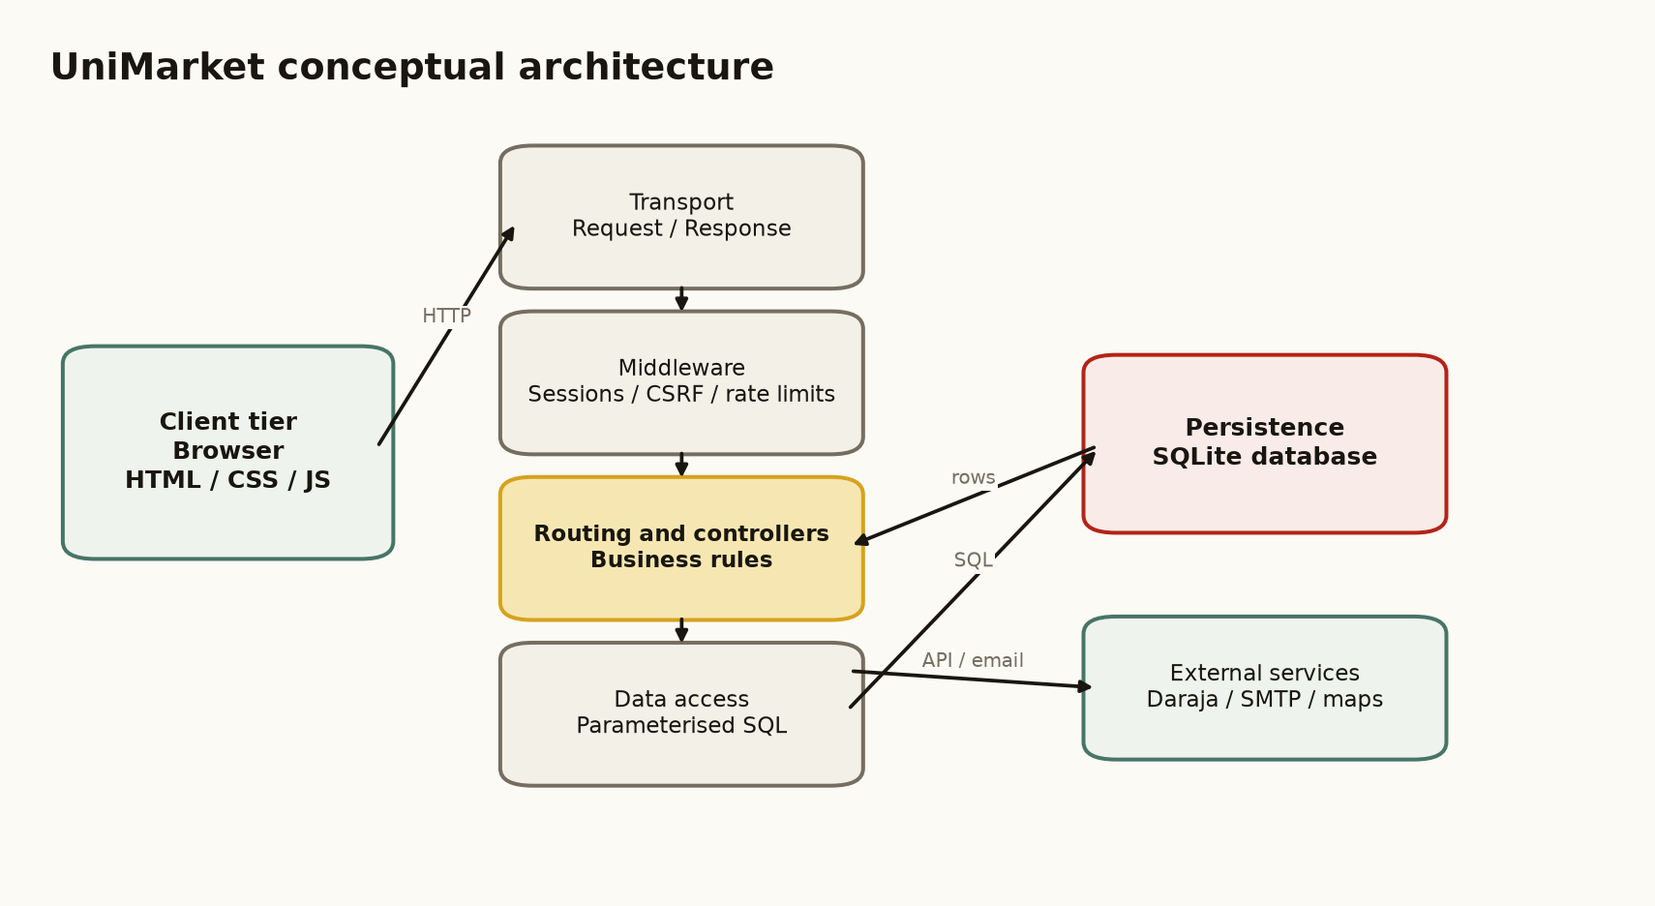
Figure 5.1: Conceptual architecture of the proposed UniMarket system.
The figure is cited here because it distinguishes the browser, application layers, database and external services.

5.4 Process Design

5.4.1 Proposed Context Diagram
In the proposed context diagram, buyers and sellers interact with UniMarket through structured accounts, listings, conversations and orders. Administrators provide moderation and approval decisions. Daraja exchanges payment requests and callback results with the application. Figure 5.2 defines the system boundary and the main external data flows.
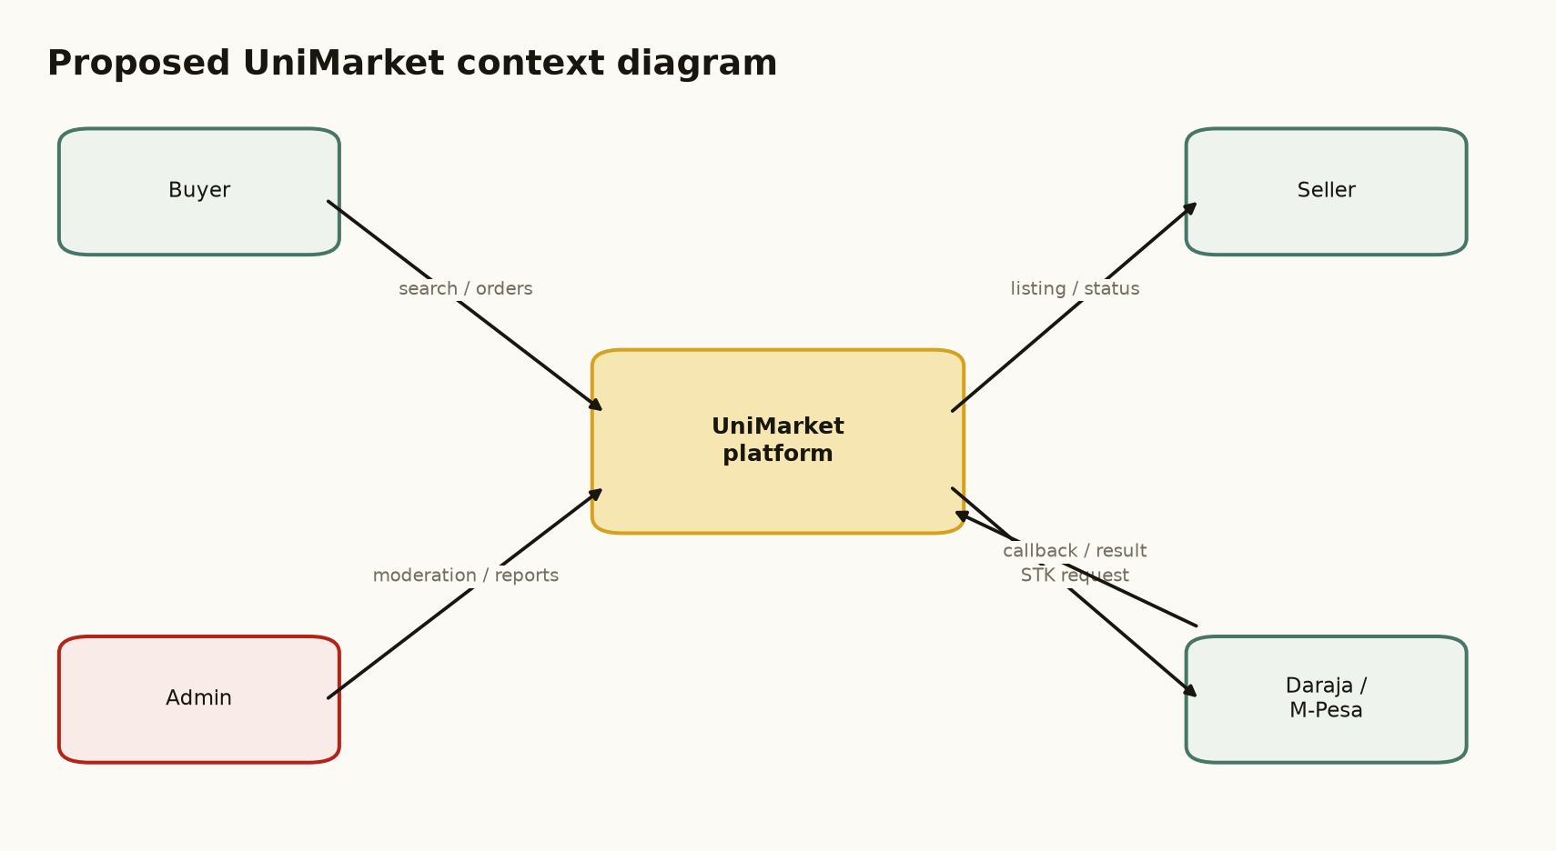
Figure 5.2: Proposed UniMarket context diagram.
Figure 5.2 is cited here to identify the external actors and services that exchange data with UniMarket.

5.4.2 Proposed Level 1 Data-Flow Diagram
The proposed Level 1 DFD decomposes UniMarket into five processes: account and access management; listing management; chat and offers; orders and payments; and moderation and reporting. Persistent data stores preserve the relationships that are missing from the current system. Figure 5.3 shows these processes and their main data flows.
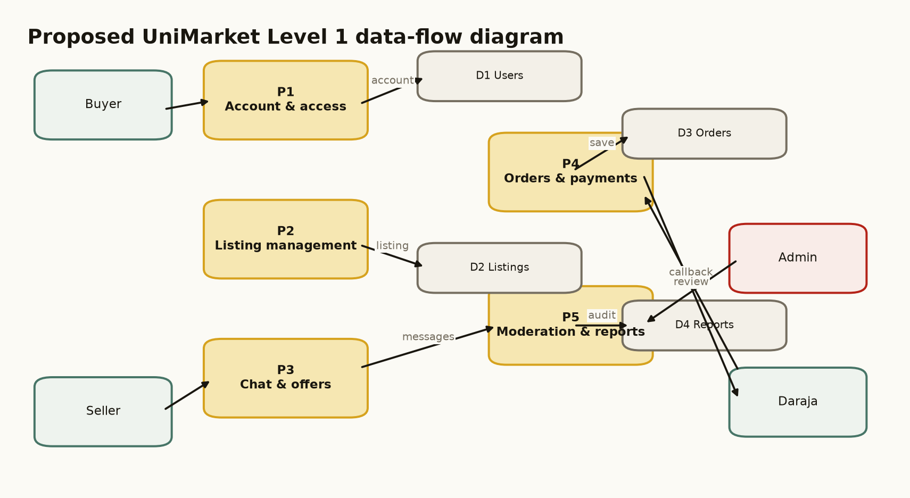
Figure 5.3: Proposed UniMarket Level 1 data-flow diagram.
The figure is cited here because it maps functional areas to persistent data stores and external interactions.

5.4.3 Use-Case Design
The main actors are the buyer, seller, administrator and superadministrator. A buyer registers, browses, communicates, makes offers, places orders, pays and reviews. A seller manages listings, responds to buyers and fulfils orders. An administrator manages reports and institution-scoped seller information. A superadministrator performs global administration and reviews administrator applications and their documents. Figure 5.4 presents the principal use cases.
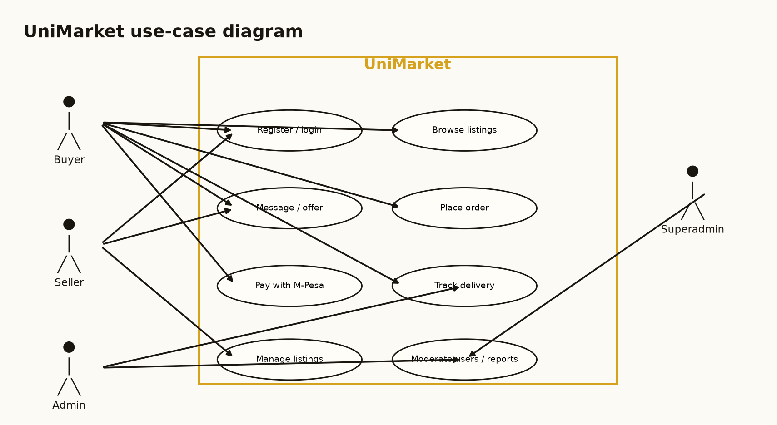
Figure 5.4: Principal UniMarket use cases.
The figure is cited here because it connects each actor to the services available within the system boundary.

5.4.4 Sequence Design for Ordering and Payment
The representative sequence begins when a buyer submits an order. UniMarket validates the buyer and order, requests an OAuth token from Daraja and sends an STK Push request. The application stores the CheckoutRequestID returned by Daraja. The buyer then receives a phone prompt and enters the PIN through Safaricom’s interface, not through UniMarket. Safaricom sends the result to the callback endpoint, after which UniMarket updates the payment and delivery state. Figure 5.5 presents this sequence. A successful STK Push response means that the prompt was accepted, not that the payment has been completed.
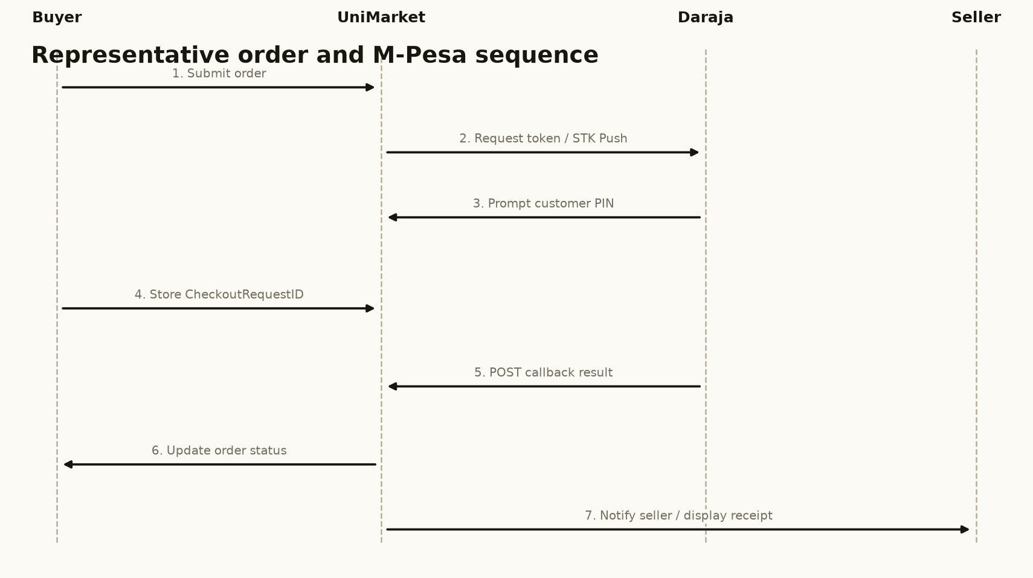
Figure 5.5: Sequence flow for an order and M-Pesa STK Push.
The sequence is cited here because it distinguishes request acceptance from confirmed payment.

5.4.5 Process Rules
Table 5.1: Selected process rules
Process | Rule
Authentication | Protected pages require a valid session; sensitive POST actions require CSRF validation.
Listing ownership | Only the listing owner can edit, bump or mark a listing as sold.
Offer lifecycle | Offers are pending until accepted, declined, cancelled or expired; a counter-offer retains the negotiation context.
Payment settlement | An order becomes paid only after a successful Daraja callback includes a receipt.
Document access | Admin-request documents are accessible only to superadministrators.
Institutional scope | A university admin’s seller queries include only sellers whose university matches the admin’s university.
Location privacy | Order location is shown only to authorised order participants and superadministrators.

5.5 Database Design
The database is implemented in SQLite and is created or migrated when the application starts. The design uses a central users table and related tables for listings, images, conversations, messages, offers, orders, reviews, reports, saved searches, sessions, admin requests and report requests. Figure 5.7 focuses on the core relationships. A complete data dictionary should be included in the final bound report if the department requires every supporting table to be documented.
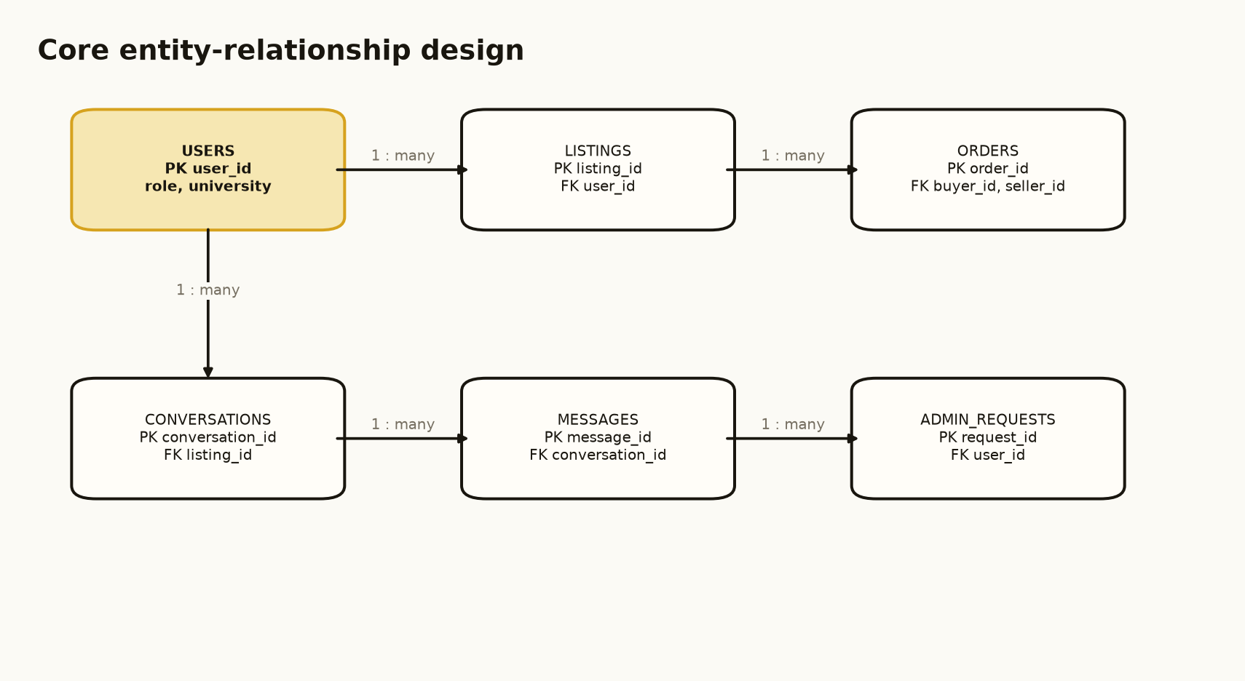
Figure 5.7: Core entity-relationship design for UniMarket.
The figure is cited here because it shows the primary one-to-many relationships between users, listings, orders, conversations, messages and admin requests.

5.5.1 Normalisation
The relational design follows Third Normal Form for the core entities. First Normal Form is supported by atomic fields and separate rows for listing images. Second Normal Form is supported by full dependence on the key in associative tables such as wishlist and recently viewed. Third Normal Form is supported by storing seller and buyer details in users and referencing them from listings and orders rather than duplicating personal details in every row. The offers table intentionally stores a counter price and note on the same negotiation row to represent the limited two-step offer workflow of this prototype.

5.5.2 Core Data Dictionary
Table 5.2: Core data dictionary
Entity | Key attributes | Purpose
users | user_id, name, email, phone, university, role, is_superadmin | Stores identity, role and institution information.
listings | listing_id, user_id, title, category, price, status, location | Stores goods and services offered by sellers.
conversations | conversation_id, listing_id, buyer_id, seller_id | Links a listing to one buyer-seller conversation.
messages | message_id, conversation_id, sender_id, receiver_id, body | Stores individual Chat messages.
offers | offer_id, listing_id, buyer_id, seller_id, amount, status | Stores price negotiations and counter-offers.
orders | order_id, listing_id, buyer_id, seller_id, amount, payment_status, delivery_status, receipt | Stores the transaction lifecycle and payment evidence.
admin_requests | request_id, user_id, staff_number, documents, status | Stores applications for administrator privileges.

5.6 Input and Output Design
The interface design uses a consistent public header, authenticated sidebar and footer. Inputs are collected through labelled forms with validation for required fields, phone format, prices, passwords and uploads. Outputs are returned as listing cards, dashboards, status chips, tables, reports and feedback messages. The following four mock-ups represent the main input/output surfaces and are suitable for Chapter Five. They are design-stage mock-ups; the implemented system screenshots are presented separately in Chapter Six.
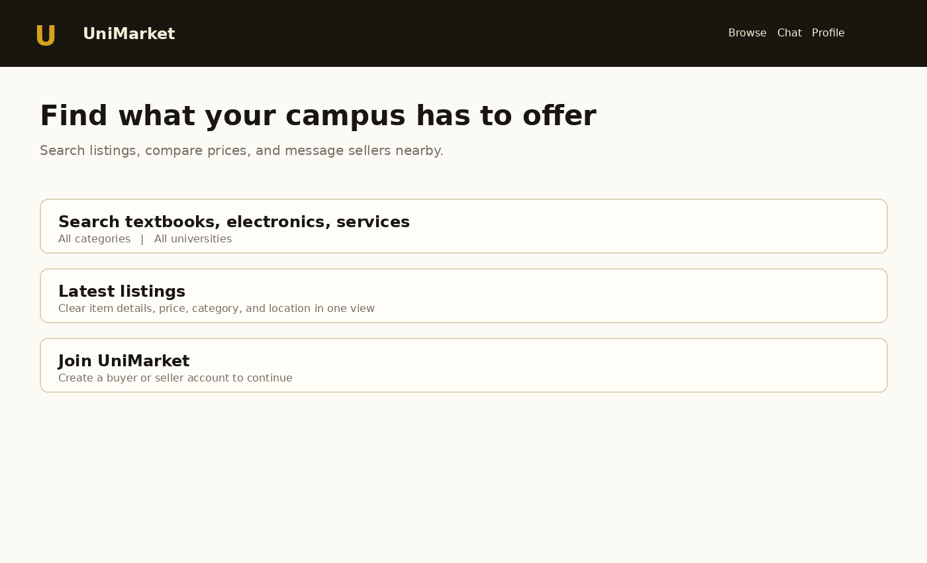
Figure 5.8: Mock-up of the home page and listing feed.
This screen prioritises discovery and the first buyer action.
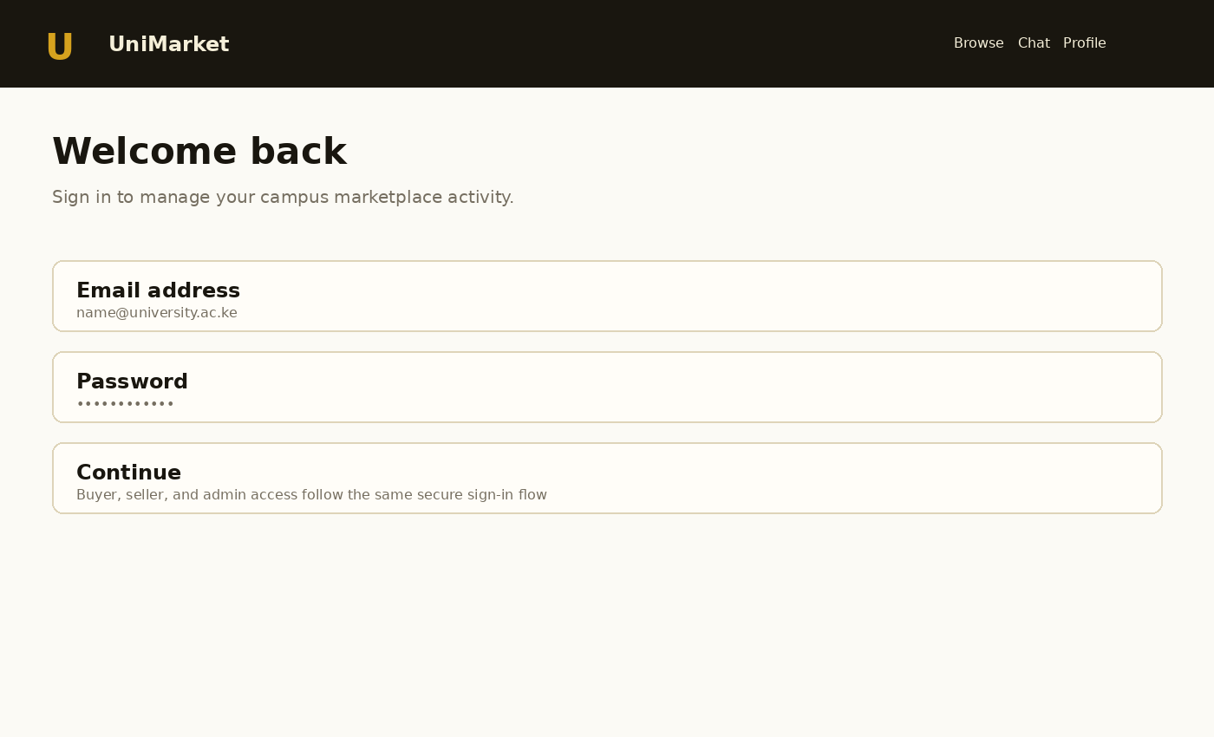
Figure 5.9: Mock-up of the login and account access screen.
This screen provides a clear entry point for role-based access.
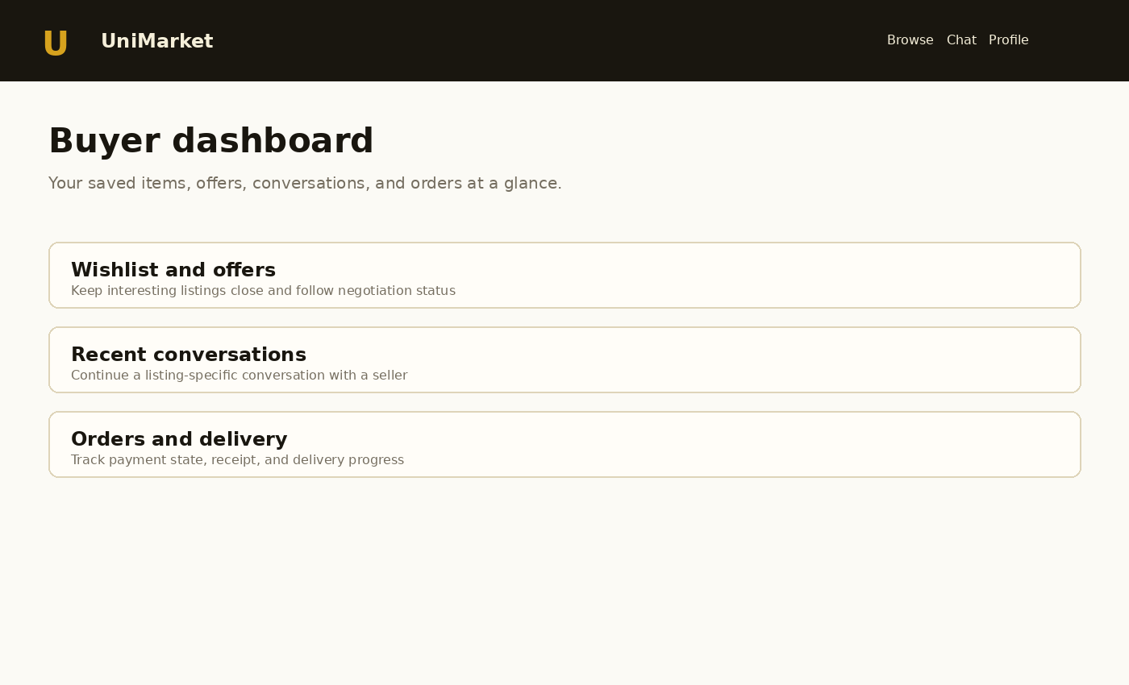
Figure 5.10: Mock-up of the buyer dashboard.
This screen groups saved items, conversations and orders by task.
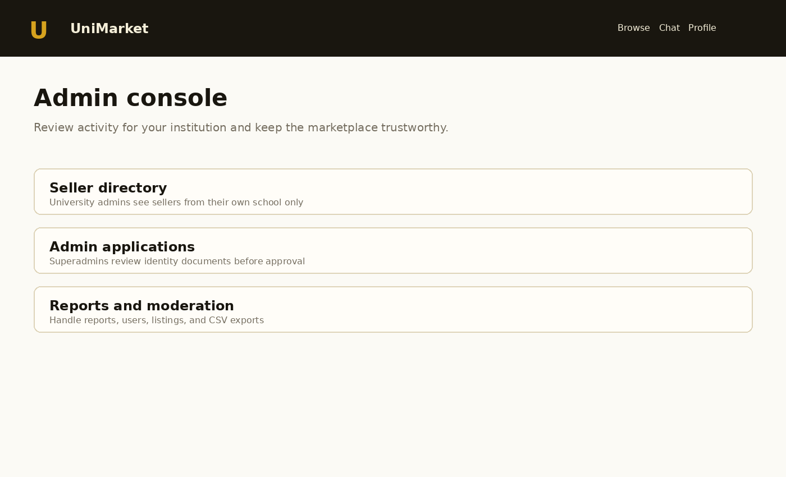
Figure 5.11: Mock-up of the administrator console.
This screen makes institutional scope and moderation actions visible.

5.7 Chapter Summary
This chapter designed UniMarket as a structured university marketplace. It described the proposed system, evaluated its strengths and limitations, defined its architecture and process logic, documented its core database design and separated design-stage mock-ups from implementation screenshots. The design gives particular attention to payment confirmation, privacy of submitted documents and university-scoped seller information. Chapter Six presents the implemented system and its testing evidence.

CHAPTER SIX
SYSTEM IMPLEMENTATION AND TESTING

6.1 Introduction
This chapter explains how the design in Chapter Five was implemented and tested. It summarises the technology environment, implemented modules, selected system screens, functional testing, non-functional checks and the proposed evaluation plan. The application was developed as a working academic prototype. Where an outcome depends on an external service, such as live Safaricom payment processing or SMTP delivery, the chapter distinguishes implemented code from externally pending operational configuration.

6.2 System Implementation

6.2.1 Implementation Environment
The backend is implemented in Python 3 using standard-library facilities for the HTTP server, socket handling, request parsing, sessions, password hashing, email notification and SQLite access. The schema is defined in database/schema.sql and safe migrations are applied during initialisation. HTML is assembled through a shared layout function. CSS defines the responsive UniMarket visual language, and JavaScript provides focused client-side validation and password visibility controls. The application reads the deployment port and host from environment variables and includes a health endpoint for deployment checks.
Table 6.1: Implementation environment
Component | Technology | Implementation role
Backend | Python 3 standard library | Routing, authentication, business rules, payment requests and server-side rendering.
Database | SQLite | Relational persistence for accounts, listings, communication, orders and administration.
Frontend | HTML5, CSS3 and JavaScript | Forms, responsive layouts, navigation, validation and progressive enhancement.
Payment integration | Safaricom Daraja Lipa Na M-Pesa Express | OAuth token, STK Push request, CheckoutRequestID storage and callback settlement.
Deployment | Render Web Service | Runs the Python process, exposes HTTPS and provides a health check.
Location display | OpenStreetMap embed | Displays the last authorised order location when available.

6.2.2 Implemented Modules
• Account and access module: registration, email verification, login, password reset, sessions and role-based dashboards.
• Listing and discovery module: listing creation, categories, search, filters, images, wishlist, recently viewed items and saved alerts.
• Communication module: listing-specific conversations, unread counts, messages, offers, counters and offer expiry.
• Commerce module: order creation, payment and delivery statuses, M-Pesa STK Push, callback receipt storage and private location tracking.
• Trust and administration module: reviews, reports, user suspension, seller directory, admin applications, protected documents and CSV reports.
• Public information module: About, Support, Contact, FAQ, Terms, Privacy, Returns and Safety pages selected from the supplied reference screenshot but rewritten for UniMarket.

6.2.3 Security and Privacy Controls
The implementation uses salted PBKDF2-HMAC-SHA256 password hashing, server-side session checks, role checks, CSRF tokens for state-changing forms, parameterised SQL and output escaping. Admin-request documents are served through a superadministrator-only route rather than being exposed as unrestricted upload links. University administrator seller queries are filtered using the authenticated administrator’s university. M-Pesa credentials are read from environment variables, and the application does not request or store an M-Pesa PIN.

6.3 Selected System Screens
The documentation guideline limits Chapter Six to a maximum of four screenshots. Figures 6.1 to 6.4 therefore show the highest-value screens captured from the running application: the public landing page, the buyer dashboard, the seller hub and the superadministrator console. They should be replaced with higher-resolution browser captures from the final deployed URL if the screenshots are resized during Word export.
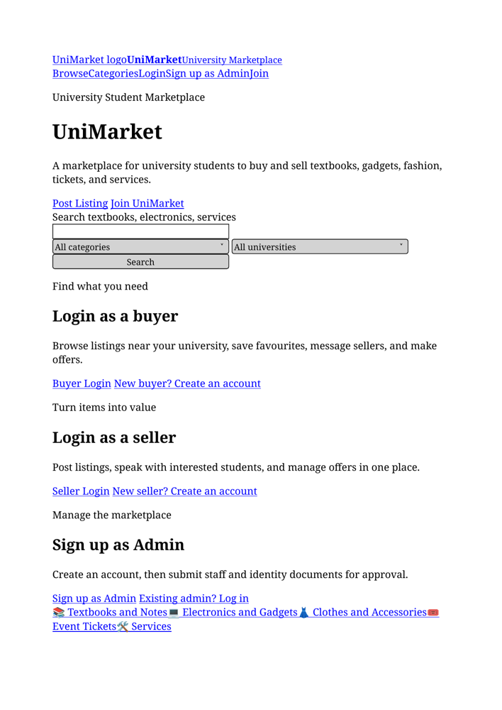
Figure 6.1: UniMarket public landing page.
The landing page supports browsing, category discovery and account entry.
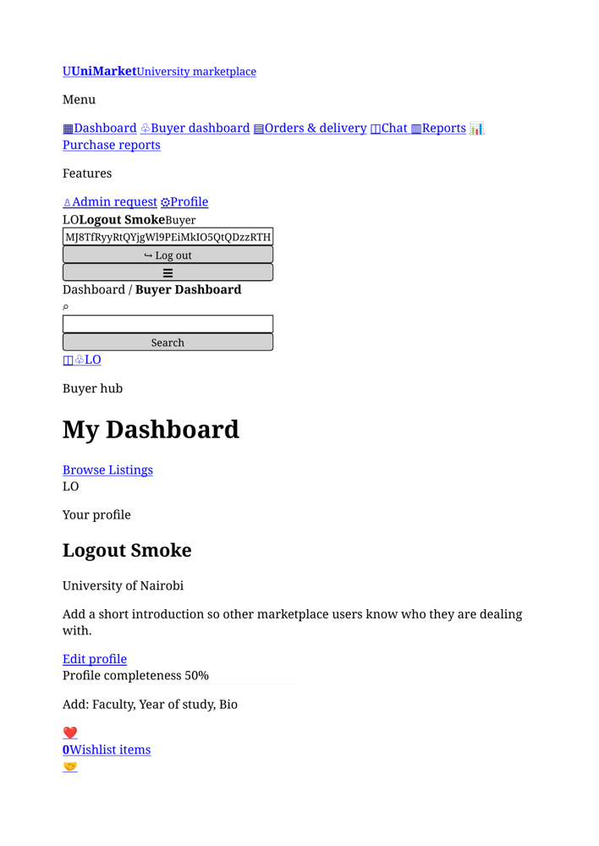
Figure 6.2: UniMarket buyer dashboard.
The buyer dashboard groups wishlist, offers, messages and orders.
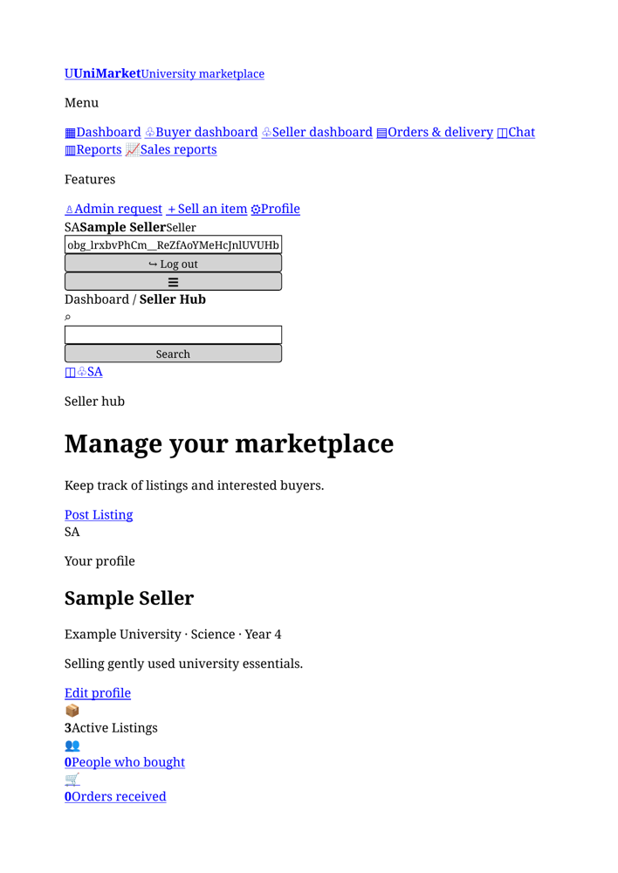
Figure 6.3: UniMarket seller hub.
The seller hub presents listing and transaction activity for the authenticated seller.
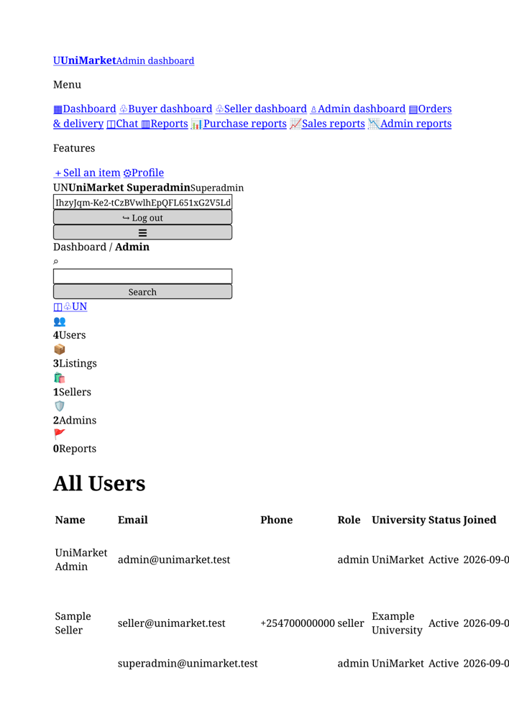
Figure 6.4: UniMarket superadministrator console.
The console provides global administration, seller visibility and admin-request review.

6.4 Testing Plan
Testing was organised around the functional and non-functional requirements. Each test records a precondition, procedure, expected result and observed result. Basic route smoke tests and Python syntax checks were performed against the implementation package. Payment-provider testing is split into application-level configuration checks and a real transaction test, which remains dependent on external sandbox or production credentials.
Table 6.2: Functional test plan
ID | Test procedure | Expected result | Observed result
T01 | Open the public home page and categories page. | Pages load and navigation links work. | Pass: public routes returned HTTP 200 during smoke testing.
T02 | Register or authenticate a buyer account. | User is validated and routed to the buyer dashboard. | Pass: account and role routes are implemented and smoke-tested.
T03 | Create and view a seller listing. | Listing is stored and appears in the feed and detail page. | Pass: listing workflow is implemented and verified locally.
T04 | Send a listing-specific message. | A conversation is created and the message is visible to its participants. | Pass: conversation and message workflow is implemented.
T05 | Submit and update an offer. | Offer status changes to accepted, declined, cancelled or expired as appropriate. | Pass: offer lifecycle is implemented.
T06 | Place an order. | An order is created with pending payment and delivery state. | Pass: order workflow is implemented.
T07 | Post a Daraja callback payload. | Callback returns HTTP 200 and updates a matching unpaid order once. | Pass: callback acknowledgement and duplicate-settlement guard verified.
T08 | Open admin-request documents as a non-superadmin and as a superadmin. | Non-superadmin is denied; superadmin can open the document. | Pass: protected document route enforces superadmin access.
T09 | Open the admin dashboard as a university admin. | Seller directory and recent seller activity show only the admin’s university. | Pass: query scope is applied server-side.
T10 | Generate a CSV report. | The report downloads with the selected date range and data scope. | Pass: report routes and CSV generation are implemented.

6.4.1 Non-Functional Tests
Table 6.3: Non-functional testing plan
Area | Test | Acceptance criterion | Result / status
Security | Submit a POST form without a valid CSRF token. | Request is rejected. | Pass in implementation review.
Security | Attempt parameter injection through form values. | Values are bound as parameters and not executed as SQL. | Pass in code review; parameterised SQL used.
Privacy | Request another university’s seller data as a university admin. | Rows from other universities are absent. | Pass in query review and local scope test.
Privacy | Request an admin-request document without superadmin access. | Access is denied or redirected. | Pass in protected-route test.
Reliability | Replay a successful callback for a paid order. | No duplicate settlement occurs. | Pass in callback logic review.
Usability | Open the application on a narrow viewport. | Navigation and forms remain usable without horizontal overflow. | Pass in responsive layout review.
External integration | Send a real sandbox or production STK Push. | Provider accepts the request and callback updates the order. | Pending external credentials and controlled transaction.

6.5 Evaluation Plan
A controlled pilot should be conducted before institutional deployment. The pilot should include representative buyers, sellers and university administrators using test accounts and sample listings. Participants should complete tasks such as finding an item, contacting a seller, creating a listing, reviewing an order, reporting a listing and reviewing an admin request. The evaluation should measure completion rate, time on task, error frequency, perceived ease of use, trust and administrator workload.
Table 6.4: Evaluation plan
Dimension | Method | Success indicator
Task effectiveness | Observation checklist for representative buyer, seller and admin tasks. | At least 80% of pilot tasks completed without facilitator intervention.
Usability | Short post-task questionnaire using a five-point scale. | Average ease-of-use rating of at least 4 out of 5.
Trust and safety | Questions on identity, reporting, payment status and document privacy. | Participants understand how to report problems and where payment confirmation comes from.
Performance | Record response time for common pages during the pilot. | Common pages remain responsive under the pilot load.
Administration | Admin review of seller scope, reports and applications. | Administrators can complete review tasks without seeing unauthorised institutions or documents.

6.6 Chapter Summary
This chapter documented the implementation of UniMarket using Python, SQLite, HTML, CSS and JavaScript. It described the account, listing, communication, commerce, trust and administration modules, and documented the security and privacy controls. Four selected screenshots were used in line with the guideline. Functional and non-functional testing demonstrates that the core prototype workflows are implemented, while a real M-Pesa transaction remains an external validation step requiring valid provider credentials and a controlled test environment. The evaluation plan provides the next evidence needed for institutional pilot assessment.

CHAPTER SEVEN
CONCLUSIONS, FINDINGS AND RECOMMENDATIONS

7.1 Introduction
This chapter presents the findings and conclusions of the UniMarket project. It relates the implemented system to the original problem of fragmented student trading, identifies the challenges encountered during development and recommends improvements for future work and institutional deployment.

7.2 Findings of the Study
The study found that informal student trading is convenient but fragmented. WhatsApp groups, social-media posts, notice boards and referrals enable communication, yet they do not provide a searchable catalogue, consistent listing fields, reliable status updates or a central transaction record. The current process therefore places a large coordination burden on buyers and sellers.
The project also found that a university-focused marketplace can centralise the core workflow without requiring a complex client application. UniMarket demonstrates that listings, seller information, conversations, offers, orders, delivery status, reviews and reports can be connected through a relational database and a role-aware web interface.
A further finding concerns institutional governance. Administrative access cannot be treated as a single unrestricted role. The implemented design separates ordinary university administrators from superadministrators: university admins receive seller information for their own schools, while superadmins retain global oversight and can review the identity documents submitted by applicants for administrator access. This supports the principle of least privilege and reduces unnecessary exposure of personal data.
The project found that M-Pesa integration has two distinct dimensions: technical integration and operational readiness. The application can generate the OAuth and STK Push requests and process the callback, but real payments additionally require Safaricom approval, a valid shortcode and passkey, secure deployment variables and a public HTTPS callback. A prompt being sent to a phone must not be confused with confirmed payment.

7.3 Conclusion
The aim of designing and implementing a web-based student marketplace was achieved through the UniMarket prototype. The system provides a structured alternative to fragmented student trading by bringing discovery, communication, negotiation, orders, payment status, delivery tracking, feedback and moderation into one application. It also demonstrates how institution-scoped permissions can be incorporated into a marketplace rather than relying only on a global administrator model.
The chosen architecture is appropriate for an academic prototype because it is understandable, inexpensive to deploy and sufficient for demonstrating the required workflows. Its limitations are clearly identified: SQLite and the lightweight server are not the final answer for a high-volume service, while production payment operation depends on an external provider and institutional controls. Within the project scope, however, the system provides a credible and testable foundation for a campus marketplace.

7.4 Challenges Encountered
Table 7.1: Challenges encountered and responses
Challenge | Effect | Response / lesson
Fragmented current process | Requirements were initially difficult to express because there was no single current system. | Modelled the current process as a socio-technical system using actors, data flows and process loops.
Payment-provider dependency | Live M-Pesa testing could not be claimed without provider credentials and callback deployment. | Separated sandbox, configuration and production readiness; avoided marking orders paid before callback confirmation.
Sensitive administrator documents | Identity documents require tighter access than ordinary listing images. | Added a superadmin-only document route and removed unrestricted document access.
Institutional data scope | A global admin view could expose sellers from unrelated universities. | Applied the authenticated administrator’s university as a server-side query filter.
Prototype scalability | A single Python process and SQLite database have concurrency limits. | Documented the limitation and recommended a production server and scalable database for future work.
Evidence presentation | The guideline restricts Chapter Six to four screenshots. | Selected only four high-value screens and moved design mock-ups to Chapter Five.

7.5 Recommendations for Future Work
• Complete Safaricom Daraja Go Live approval and perform a controlled low-value production transaction only after verifying the shortcode, passkey, callback URL and settlement record.
• Add a payment reconciliation and STK Query process for transactions whose callbacks are delayed, and maintain a secure audit trail for payment events.
• Replace SQLite with PostgreSQL and deploy the application behind a production-grade WSGI or ASGI server when usage grows.
• Introduce university-approved governance covering administrator responsibilities, document retention, acceptable use, incident response, account suspension and data deletion.
• Add stronger university identity verification, verified seller badges and clearer dispute-resolution workflows.
• Provide real-time notifications and a documented API for future mobile clients while preserving the server-side authorisation rules.
• Add automated backups, monitoring, structured logs, rate-limit persistence and security review before wider deployment.
• Conduct the proposed pilot evaluation and use evidence from students and administrators to prioritise future releases.

7.6 Final Conclusion
UniMarket demonstrates that a focused university marketplace can address practical weaknesses in informal student trading. Its main contribution is not simply an online list of items; it is the connection of identity, listings, conversations, offers, orders, payment status, delivery information, feedback and moderation within a controlled workflow. The prototype meets the academic project purpose and provides a clear path toward a governed, scalable and payment-enabled campus service.

CHAPTER
REFERENCES
Communications Authority of Kenya. (2023). ICT sector statistics report. CA Kenya.
Creswell, J. W., & Creswell, J. D. (2018). Research design: Qualitative, quantitative, and mixed methods approaches (5th ed.). SAGE Publications.
Kendall, K. E., & Kendall, J. E. (2019). Systems analysis and design (10th ed.). Pearson.
Kreibich, J. A. (2010). Using SQLite. O’Reilly Media.
Laudon, K. C., & Laudon, J. P. (2020). Management information systems: Managing the digital firm (16th ed.). Pearson.
Mas, I., & Radcliffe, D. (2010). Mobile payments go viral: M-PESA in Kenya. World Bank Publications.
Myers, G. J., Sandler, C., & Badgett, T. (2011). The art of software testing (3rd ed.). Wiley.
OWASP Foundation. (2021). OWASP Top Ten. https://owasp.org/www-project-top-ten/
Pressman, R. S., & Maxim, B. R. (2020). Software engineering: A practitioner’s approach (9th ed.). McGraw-Hill.
Safaricom PLC. (2026). Daraja developer portal and API documentation. https://developer.safaricom.co.ke/
Stair, R., & Reynolds, G. (2018). Principles of information systems (13th ed.). Cengage.
W3C. (2022). Geolocation API specification. World Wide Web Consortium.
Yourdon, E. (1989). Modern structured analysis. Prentice-Hall.

APPENDIX NOTE
The complete bound report should retain the approved appendices from the original project documentation, including the questionnaire, interview guide, project schedule, budget and any code excerpts required by the department. Include only evidence that was actually collected or implemented, and keep sample code within the guideline limit of two pages.

