DESIGN AND IMPLEMENTATION OF A WEB-BASED STUDENT MARKETPLACE

MOSES MAKORI MARANGA

1050896

A RESEARCH PROJECT PRESENTED IN PARTIAL FULFILLMENT OF THE REQUIREMENTS FOR THE AWARD OF
BACHELOR’S DEGREE OF SCIENCE IN COMPUTER
SCIENCE OF CATHOLIC UNIVERSITY OF EASTERN AFRICA

SEPTEMBER, 2026

CATHOLIC UNIVERSITY OF EASTERN AFRICA

Design and Implementation of a Web-based Student Marketplace

BY
MOSES MAKORI MARANGA
1050896

A RESEARCH PROJECT PRESENTED IN PARTIAL FULFILLMENT OF THE REQUIREMENTS FOR THE AWARD OF
BACHELOR’S DEGREE OF SCIENCE IN COMPUTER
SCIENCE OF CATHOLIC UNIVERSITY OF EASTERN AFRICA

SEPTEMBER, 2026

DECLARATION
Student's Declaration
I, Moses Makori Maranga, declare that this research report is my original work and that it has not been presented in any other university or institution for academic credit. All sources of information used in this study have been duly acknowledged and referenced in accordance with academic conventions.

Signature: ______________________ Date: ______________________
Name: Moses Makori Maranga
Registration Number: 1050896

Supervisor's Declaration
This research project has been submitted for examination with my approval as the
university/institution supervisor
Signature: ______________________ Date: ______________________
Name: Mr. Edward Kioko

Head of Department Declaration
This research project has been submitted for examination with my approval as the
university/institution supervisor.
HoD Name: ___Mr. Michael Kinyua__________________
Signature :_____________________________________________
Date & Stamp

ACKNOWLEDGMENT
First and foremost, I give thanks to God Almighty for the gift of life, wisdom, and strength
throughout this project journey. Without His grace, none of this would have been possible.

I would like to express my sincere gratitude to my project supervisor, Mr. Edward Kioko, for
their invaluable guidance, constructive feedback, patience, and continuous support throughout
the development of this project. Their expertise and encouragement played a significant role
in helping me complete this work.

I also thank my fellow students and friends for their moral support, shared experiences, and
encouragement during the challenging phases of this project.

Finally, I owe a deep debt of gratitude to my family for their unwavering love, prayers, and
encouragement. Their sacrifices and belief in me have been a constant source of motivation
throughout my academic journey.

DEDICATION
I dedicate this work to my family, whose love, sacrifices, and encouragement sustained me throughout this journey. I also dedicate it to my lecturers and supervisor, whose guidance and patience shaped the development of Uni-Market. To my fellow students and future users of the platform, may this work contribute to better collaboration and easier campus commerce. Finally, I dedicate it to every university community seeking a safer, more connected, and more accessible way to buy and sell.

ABSTRACT
University students commonly buy and sell textbooks, electronics, clothing, event tickets, and services through WhatsApp groups, social media, notice boards, and word-of-mouth referrals. Although these channels are familiar and convenient, they provide limited searchability, weak accountability and no centralized mechanism for managing communication, payments, delivery, or disputes. This project presents UniMarket, a web-based student marketplace designed to provide a structured and institution-focused platform for buying and selling within university communities.

The study aimed to design and implement a platform that supports user registration, role-based access, listing management, search and filtering, buyer-seller communication, price negotiation, order processing, delivery tracking, reviews, reporting, and administrative moderation. The methodology involved reviewing related literature, analysing existing informal student trading processes, gathering requirements through questionnaires and interviews, and applying structured systems analysis and design techniques. Context diagrams, data-flow diagrams, flowcharts, use-case models, database designs, interface prototypes, and testing plans were used to guide the development process.

UniMarket was implemented using Python, SQLite, HTML, CSS, and JavaScript. The system provides separate functionality for buyers, sellers, university administrators, and superadministrators. University administrators can view seller information belonging to their own institutions, while superadministrators have wider oversight, including access to documents submitted by administrator applicants.

Testing of the core workflows showed that the system supports listing creation, browsing, communication, order management, administration, and access control as intended. The study concludes that UniMarket provides a practical foundation for improving student commerce, accountability, communication, and institutional oversight.

TABLE OF CONTENTS
TERMS AND ABBREVIATIONS 6
LIST OF FIGURES 7
LIST OF TABLES 7
CHAPTER ONE: INTRODUCTION 7
1.1 Background 7
1.2 Problem Statement 9
1.3 Aim of Research 10
1.4 Objectives 10
1.5 Justification 10
1.6 Scope 11
1.7 Research Organization 12
CHAPTER TWO: REVIEW OF RELATED WORK 12
2.1 Chapter Introduction 12
2.2 History of Online Marketplaces 13
2.3 Review of Related Systems 13
2.3.1 eBay 13
2.3.2 Amazon Marketplace 14
2.3.3 Jumia Kenya 15
2.3.4 Jiji Kenya 16
2.3.5 Facebook Marketplace 17
2.4 Comparative Analysis of Related Systems 18
2.5 Emerging Trends and Patterns in the Research Area 19
2.5.1 Machine Learning in Marketplaces 19
2.5.2 Artificial Intelligence 19
2.5.3 Electronic Payments 20
2.5.4 Blockchain Technology 21
2.6 Chapter Summary 22
CHAPTER THREE: RESEARCH METHODOLOGY 22
3.1 Chapter Introduction 23
3.2 Methodology for Literature Review 23
3.3 Methodology for Requirements Specification 23
3.3.1 Questionnaires 23
3.3.2 Interviews 24
3.4 Methodology for System Analysis 25
3.4.1 Data Flow Diagrams (DFDs) 26
3.4.2 Database Normalisation 27
3.5 Methodology for System Design 27
3.5.1 DFDs for the Proposed System 27
3.5.2 Flowcharts 27
3.5.3 User Interface Design 28
3.5.4 Database Design 28
3.6 Methodology for System Implementation 28
3.7 Methodology for System Testing 29
3.7.1 Functional Testing 29
3.7.2 Usability Testing 30
3.7.3 Security Testing 31
3.7.4 Performance Testing 31
3.8 Methodology for System Deployment 32
3.9 Chapter Summary 33
CHAPTER FOUR: SYSTEM ANALYSIS 33
4.1 Chapter Introduction 33
4.2 Description of the Current System 34
4.2.1 Strengths of the Current System 35
4.2.2 Weaknesses of the Current System 35
4.3 Feasibility Study 36
4.3.1 Technical Feasibility 36
4.3.2 Economic Feasibility 37
4.3.3 Operational Feasibility 37
4.3.4 Schedule Feasibility 37
4.3.5 Conclusion of the Feasibility Study 38
4.4 Data Input / Output Analysis 38
4.4.1 Data Captured by the Current System 38
4.4.2 Relationship Between the Data 39
4.4.3 Outputs from the Current System 40
4.5 Process Logic Design of the Current System 41
4.5.1 Context Diagram 41
4.5.2 Level 1 Data Flow Diagram 42
4.5.3 Flowchart: Current Selling Process 43
4.5.4 Flowchart: Current Buying Process 44
4.6 Chapter Summary 45
CHAPTER FIVE 47
SYSTEM DESIGN OF THE PROPOSED SYSTEM 47
5.1 Introduction 47
5.2 Description of the Proposed System, its Strengths and Weaknesses 47
5.2.1 Strengths of the Proposed System 48
5.2.2 Weaknesses / Limitations of the Proposed System 48
5.3 Requirement Analysis 49
5.3.1 Functional Requirements 49
(a) Account Management and Authentication 49
(b) Listings and Discovery 50
(c) Negotiation, Messaging and Transactions 50
(d) Trust, Safety and Administration 51
5.3.2 Non-Functional Requirements 51
5.3.3 User Requirements 52
5.3.4 Usability Requirements 52
5.4 Conceptual Architecture of the Proposed System 53
5.4.1 The Client Tier 53
5.4.2 The Server Tier 54
5.5 Process Logic Design of the Proposed System 55
5.5.1 Use Case Overview 55
5.5.2 Representative Sequence Flow â€” Creating a Listing and Receiving an Offer 55
5.5.3 Context Diagram (Level-0 Data Flow) 56
5.5.4 Class-Level View 57
5.6 Database Design 57
5.6.1 Entity-Relationship Description 57
5.6.2 Normalisation 58
5.6.3 Data Dictionary 59
5.7 Input/Output Design of the Proposed System (Mock-Up Screens) 64
5.7.1 Home / Listing Feed 64
5.7.2 Listing Detail 65
5.7.3 Create / Edit Listing Form 65
5.7.4 Seller Hub (/seller) 65
5.7.5 Buyer Dashboard (/buyer) 65
5.7.6 Admin Console (/admin) 65
5.7.7 Order Tracker (/order/<id>/track) 65
5.8 Chapter Summary 65
CHAPTER SIX 67
SYSTEM IMPLEMENTATION AND TESTING 67
6.1 Chapter Introduction 67
6.2 System Implementation 67
6.2.1 Implementation Environment 67
6.2.2 Implemented Modules 68
6.3 Selected System Screens 68
6.4 Testing Plan 69
6.4.1 Security, Usability and Performance Tests 70
6.5 Evaluation Plan 70
6.6 Chapter Summary 71
CHAPTER SEVEN 72
CONCLUSIONS, FINDINGS AND RECOMMENDATIONS 72
7.1 Introduction 72
7.2 Findings of the Study 72
7.3 Conclusion 73
7.4 Challenges Encountered 73
7.5 Recommendations for Future Work 74
7.6 Final Conclusion 74
REFERENCES 75
APPENDICES 78
Appendix A: Project Schedule (Gantt Chart) 78
Appendix B: Project Budget 78
Appendix C: Sample Questionnaire 78
Appendix D: Sample Interview Questions 79

LIST OF FIGURES
Figure 2.1: eBay Marketplace Interface
Figure 2.2: Amazon Marketplace Interface
Figure 2.3: Jumia Kenya Marketplace Interface
Figure 2.4: Jiji Kenya Marketplace Interface
Figure 2.5: Facebook Marketplace Interface
Figure 2.6: Machine Learning - Neural Network Architecture
Figure 2.7: Artificial Intelligence - Processing Pipeline
Figure 2.8: Electronic Payments - M-Pesa STK Push Flow
Figure 2.9: Blockchain - Decentralised Transaction Ledger
Figure 4.1: Context Diagram - Current Informal Student Marketplace System
Figure 4.2: Level 1 DFD - Current Informal Student Marketplace System
Figure 4.3: Flowchart - Current Selling Process
Figure 4.4: Flowchart - Current Buying Process
Figure 6.1: UniMarket Public Landing and Listing Search Interface
Figure 6.2: UniMarket Seller Hub Dashboard

LIST OF TABLES
Table 2.1: Comparative Analysis of Existing Marketplace Systems
Table 3.1: System Implementation Technology Stack
Table A.1: Project Gantt Chart
Table B.1: Project Budget

TERMS AND ABBREVIATIONS
API | Application Programming Interface
CRUD | Create, Read, Update, Delete
CUEA | Catholic University of Eastern Africa
DFD | Data Flow Diagram
ERD | Entity Relationship Diagram
GPS | Global Positioning System
HTTP | Hypertext Transfer Protocol
ICT | Information and Communication Technology
ML | Machine Learning
NF | Normal Form
NLP | Natural Language Processing
ORM | Object Relational Mapper
SQL | Structured Query Language
TCP | Transmission Control Protocol
UI/UX | User Interface / User Experience
URL | Uniform Resource Locator
VPS | Virtual Private Server
WWW | World Wide Web

CHAPTER ONE: INTRODUCTION

1.1 Background
Information and Communication Technology (ICT) can be defined as a combination of technologies used in acquiring, storing, processing, retrieving, and sharing electronic data or information. ICT involves computer hardware, software, and communication networks. It has become a vital part of human life as it has evolved from a select few computer devices in the mid-twentieth century to a complex system that facilitates all human activities and processes. The current developments in technology include the use of the internet and internet-based products like smartphones and has significantly changed how people carry out their daily routines. Most governments and organizations have adopted information and communication technology in their processes to make them more efficient and effective. Additionally, the literacy on ICT is gradually increasing every day as most people understand their relevance and importance to human development and national growth.

The application of technology in various aspects of human activities has brought about positive changes and benefits to individuals and organizations. Some of the areas where technology has been applied and benefited human activities include Trade and Commerce, Health, and Finance. For instance, the rise of online shopping platforms like Amazon and Jumia has led to a significant decline in the traditional buying and selling platforms. The use of mobile money technologies has benefited the financial sector as it has enabled people to send and receive money easily and safely. An example of how technology has benefited the financial sector is through the M-Pesa platform which has enabled many people in East Africa to access financial services (Mas & Radcliffe, 2010). Technology has also been used very effectively in the health sector as most clinics offer their services online thereby saving time as patients do not have to travel long distances looking for medical services. From the above examples, it is evident that digitization of trade and commerce activities is very beneficial to the community.

Students reside in hostels and interact among themselves on a regular basis making it easier for them to carry out any form of trading activities among themselves. Most students trade items like textbooks, clothing materials and styles, tickets to events, and even sell their services like giving classes to fellow students. As a result, there are many trading activities that take place among students which are easily carried out using the Internet. However, most of these trading activities are hindered by the following challenges:
• There is no central platform where students can gather to look for items they need or want
• There is no assurance of the quality of goods and services being sold or offered
• There is no negotiation or bargaining space
• There is no accountability of either the buyer or seller.
These challenges can be eliminated by having an online marketplace where students can come together to trade. Online marketplace platforms like eBay and Craigslist have been useful in enhancing trade activities as well as eliminating or reducing the above-mentioned challenges. However, these platforms are not specific to students neither are they specific to any institution students may be attached to. It is much safer to have a site created specifically for a university which is a known entity with students and staff.

This paper intends to develop a web application for a university student marketplace as a case study at CUEA and proposes that it will be an easily scalable application for all other universities. It has been observed that the student population in universities is very large and therefore developing a student marketplace specific to a university is a very good start.

1.2 Problem Statement
University students across Kenya and the broader East African region currently lack a dedicated, trustworthy digital platform through which to buy, sell, and exchange goods and services within their campus communities. The absence of such a platform gives rise to several interconnected problems that negatively affect the student experience and economic wellbeing.
The most immediate problem is the absence of a centralised discovery mechanism. Students who wish to sell textbooks, electronics, or other items must rely on informal channels such as WhatsApp groups and physical notice boards, which offer limited reach and no searchability. This fragmentation means that willing buyers and sellers frequently fail to find each other, resulting in missed economic opportunities on both sides. In addition, there is no structured process for price negotiation, meaning that transactions often stall or fall apart due to the absence of a clear offer-and-counter-offer mechanism.
Trust is a further significant barrier. In the absence of a reputation system, students have no reliable way to assess whether a seller is trustworthy or whether a listed item matches its description. This lack of accountability exposes buyers to the risk of fraud and misrepresentation, and discourages participation in informal trade. Furthermore, there is no mechanism for students offering services such as tutoring or photography to build a verifiable track record within the university community.
These problems collectively point to a clear gap: a need for a dedicated, university-anchored digital marketplace that provides structured listings, verified user accounts, in-platform messaging, price negotiation, and a ratings system. This research addresses that gap through the design and implementation of UniMarket, piloted at CUEA.

1.3 Aim of Research
The aim of this research is to design and implement a web-based university student marketplace platform, piloted at the Catholic University of Eastern Africa, that enables students to list, discover, and trade goods and services in a secure, structured, and scalable digital environment.

1.4 Objectives
The following objectives have been derived from the aim of this research:
1. 1. To review existing literature on peer-to-peer marketplace platforms, web application security, and student-centred digital commerce in order to identify best practices and research gaps.
2. 2. To collect and analyse requirements from university students and administrators through structured questionnaires and interviews in order to establish the functional and non-functional requirements of the system.
3. 3. To analyse the current informal student trading environment using data flow diagrams and contextual analysis in order to identify inefficiencies and system requirements.
4. 4. To design the proposed UniMarket system including database schema, data flow diagrams, user interface prototypes, and system architecture.
5. 5. To test the implemented system using functional, usability, and security testing techniques in order to evaluate its correctness, performance, and robustness.
6. 6. To deploy the system and evaluate its effectiveness in addressing the identified student marketplace needs, using CUEA as the pilot institution.

1.5 Justification
The development of a dedicated student marketplace platform is justified on multiple grounds. From an economic perspective, peer-to-peer trade within university communities represents a significant informal market that currently operates without structure or oversight. Research by Einav et al. (2016) demonstrates that digital marketplace platforms substantially increase market efficiency by reducing search costs and information asymmetry between buyers and sellers. By digitising this informal market, UniMarket has the potential to generate real economic value for university students across Kenya.
From a security and trust perspective, the absence of a reputation system in informal student trade exposes participants to fraud risk. Resnick and Zeckhauser (2002) demonstrate that online reputation systems significantly increase trust and transaction rates in peer-to-peer marketplaces. UniMarket's integrated ratings and reviews system directly addresses this gap by enabling students to build verifiable reputations within their university community.
From a scalability and broader social impact perspective, UniMarket is designed as an institution-agnostic platform whose architecture allows it to be configured and deployed at any university with minimal adaptation. The successful pilot at CUEA will serve as a proof of concept demonstrating the viability and value of a university-anchored digital marketplace in the East African context. This positions UniMarket not merely as a single-institution tool but as a replicable model for addressing a shared challenge faced by student communities across the region, contributing to a growing ecosystem of student-centred digital solutions for African higher education institutions.

1.6 Scope
This research is limited in scope to the design and implementation of a web-based university student marketplace platform, with CUEA serving as the pilot institution. The scope is defined across four dimensions:
Target Organisation: The Catholic University of Eastern Africa, Nairobi, Kenya, serves as the primary case study institution. The platform is designed to be configurable and deployable at any university, with CUEA providing the initial user base and operational context.
Target Users: Three user types will be supported: Student users (who act as both buyers and sellers), Staff users (who will also act as both buyers and sellers), and Admin users (who manage the platform and resolve disputes).
Features to be Implemented: The platform will include user registration and authentication, product listings across five categories (textbooks and notes, electronics and gadgets, clothes and accessories, event tickets, and services), full CRUD operations on listings, buyer-to-seller messaging, price negotiation and offer management, a wishlist feature, a ratings and reviews system, listing reporting, geolocation-based listing discovery, and an administrative dashboard.
Timeline: The research and development will be conducted over thirty weeks, from March 2026 to September 2026. Aspects excluded from scope include mobile application development, payment gateway integration at this stage, and multi-institution simultaneous deployment.

1.7 Research Organization
This report is organised into seven chapters. Chapter One presents the introduction. Chapter Two reviews related work and identifies the research gap. Chapter Three describes the research methodology. Chapter Four analyses the current informal student marketplace. Chapter Five presents the proposed system design. Chapter Six documents implementation and testing. Chapter Seven presents the conclusions, findings, challenges, and recommendations.

CHAPTER TWO: REVIEW OF RELATED WORK

2.1 Chapter Introduction
This chapter provides a literature review and related work on the proposed web-based university marketplace. The chapter first describes the history of online marketplaces. This is followed by a discussion of five existing marketplace systems ranging from global systems to local Kenyan implementations. A comparison of five existing systems in terms of their strengths and weaknesses is presented. Further, current trends such as machine learning, artificial intelligence, electronic payment systems, blockchain technology, cloud computing, geolocation, and recommender systems are reviewed. The chapter concludes with a summary and context for the proposed system.

2.2 History of Online Marketplaces
The idea of online marketplaces was created in the middle 1990s when the Internet was commercialized. The first online purchase was made in 1994 when a customer bought a music CD from NetMarket, a pioneer in the field. The first online marketplace was eBay, created in 1995 by Pierre Omidyar. In the same decade, Amazon was launched as an online bookstore and later became the world’s largest online marketplace. In 2000, online marketplaces were on their way to becoming very common as the Internet environment, online payment systems like PayPal, and customer trust were developed. The next significant stage of development was the introduction of broadband access, smartphones, and apps in 2007-2012 (Evans & Schmalensee, 2016).
The development of online marketplaces in Africa is strongly connected with the appearance and the growth of mobile money services. The most well-known example is M-Pesa launched in Kenya in 2007 (Suri & Jack, 2021). In Kenya, the online marketplace industry was further developed through such platforms as OLX, PigiaMe, and Jumia established in the 2010s. Recently, social media have also entered the field of business-to-consumer and consumer-to-consumer sales. However, in East Africa, student-specific marketplaces still remain underdeveloped.

2.3 Review of Related Systems

2.3.1 eBay
eBay is one of the oldest and most established online marketplaces in the world, founded in 1995 and currently serving over 130 million active buyers globally (eBay Inc., 2023). The platform operates on a consumer-to-consumer and business-to-consumer model, enabling users to list items for sale either at fixed prices or through auctions. Buyers browse listings, place bids, or purchase items directly, with payments processed through eBay's integrated system and feedback exchanged between parties upon completion.
Strengths:
A large global user base, strong buyer protection mechanisms, a well-established trust and reputation system, and a mature dispute resolution process.
Weaknesses:
High seller fees, a complex listing process for new users, limited support for local payment methods such as M-Pesa, and lack of community focus suitable for niche groups such as university students.
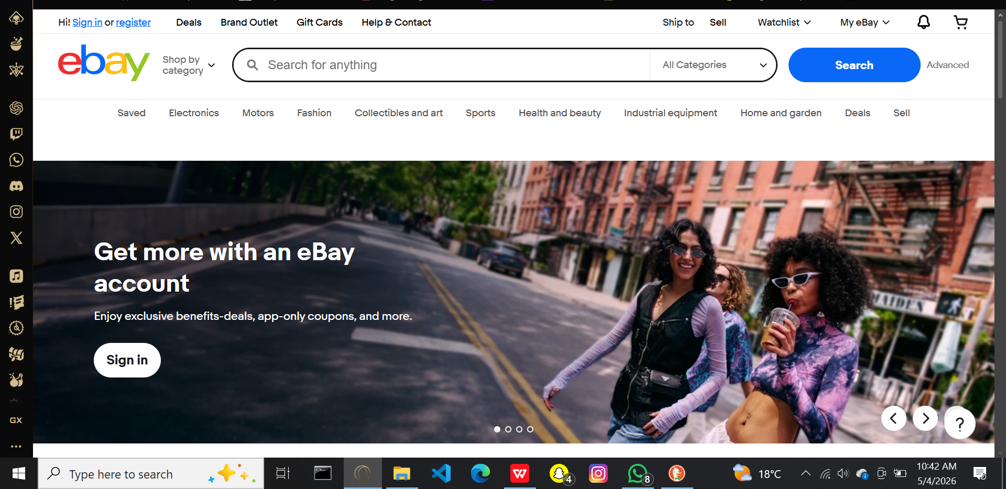
Figure 2.1: eBay Marketplace Interface

2.3.2 Amazon Marketplace
Amazon Marketplace is a third-party selling platform integrated within Amazon's larger e-commerce ecosystem, launched in 2000. It allows independent sellers to list products alongside those sold directly by Amazon, reaching a customer base of over 300 million globally (Amazon, 2023). Sellers may choose between fulfilling orders themselves or using Fulfilment by Amazon, where Amazon handles storage, shipping, and customer service.
Strengths:
Massive customer reach, robust logistics infrastructure, sophisticated AI-driven product recommendations, and strong brand trust.
Weaknesses:
High competition among sellers, significant commission fees, complex onboarding for small sellers, and limited presence in the Kenyan market with no support for M-Pesa.
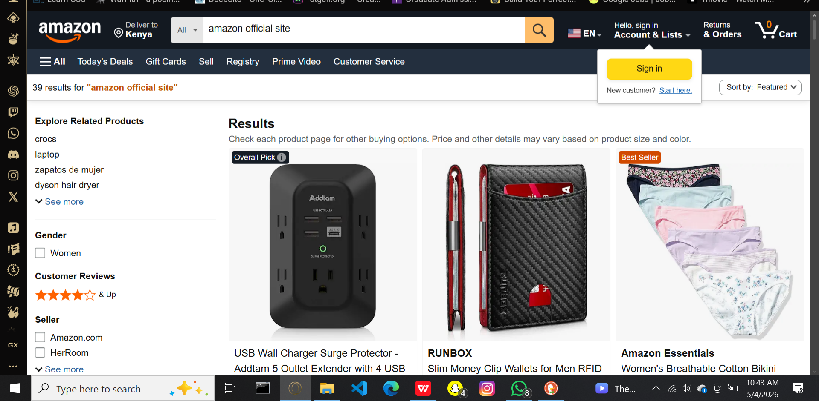
Figure 2.2: Amazon Marketplace Interface

2.3.3 Jumia Kenya
Jumia, often referred to as the "Amazon of Africa," was founded in 2012 and operates across multiple African countries including Kenya. The platform combines a direct retail model with a third-party marketplace and handles last-mile delivery through its own logistics network (Jumia Group, 2023).
Strengths:
Localised for the Kenyan and African markets, supports M-Pesa payments, robust delivery infrastructure, and a trusted regional brand.
Weaknesses:
High vendor commissions, complex onboarding, focus on commercial sellers rather than peer-to-peer exchanges, and unsuitability for small-scale student transactions.
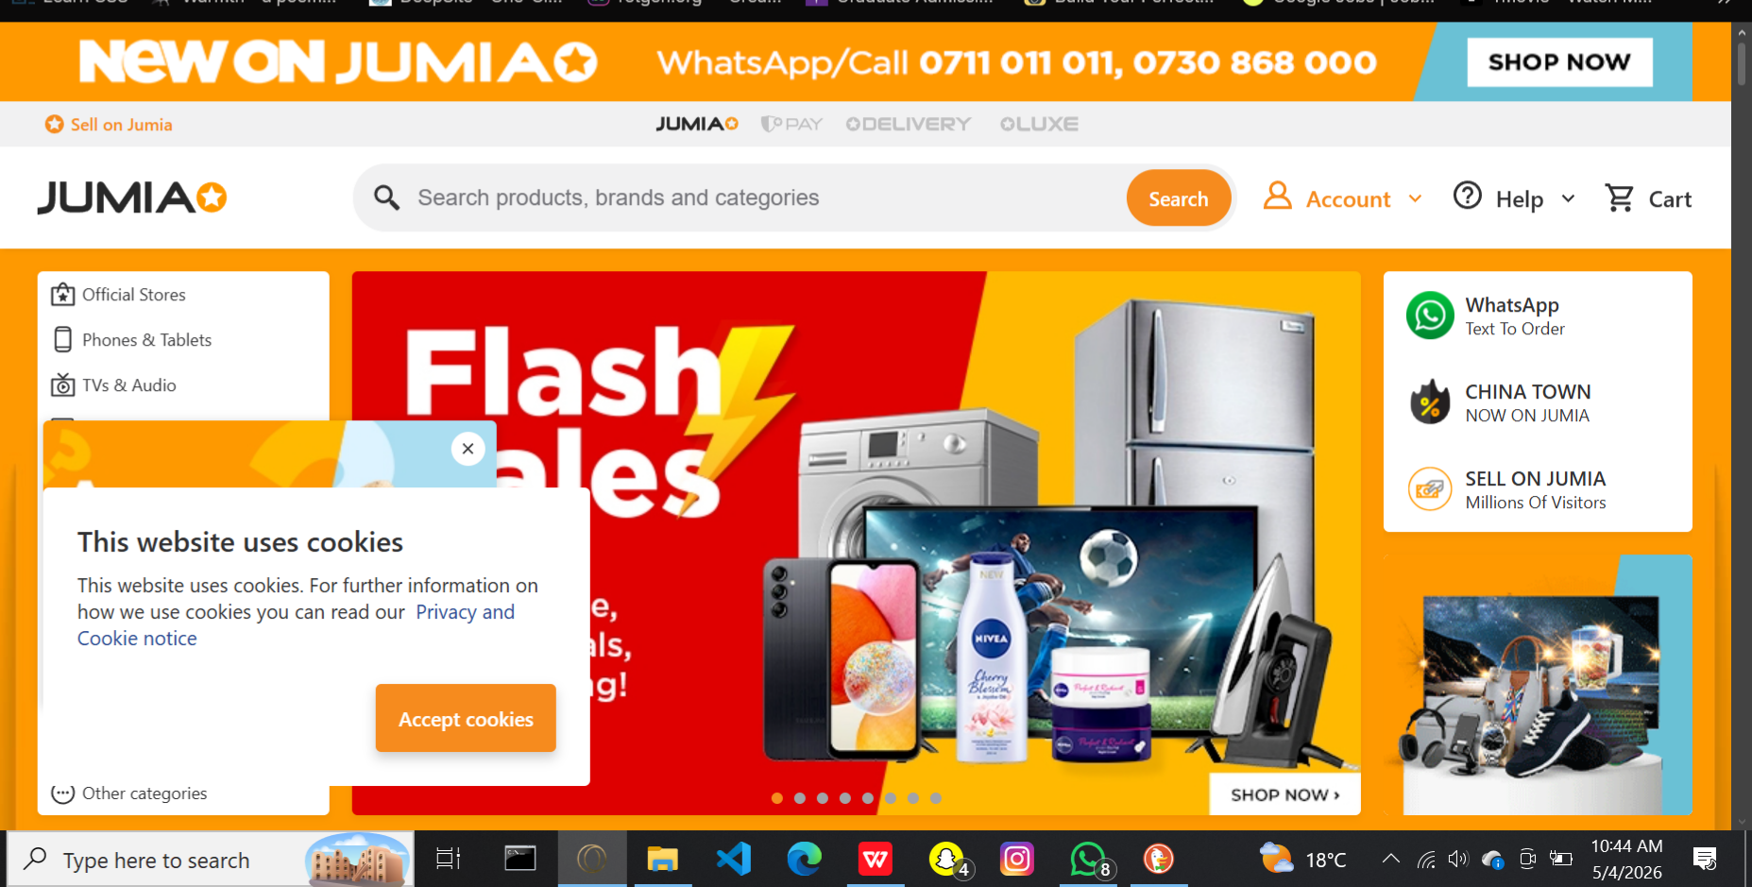
Figure 2.3: Jumia Kenya Marketplace Interface

2.3.4 Jiji Kenya
Jiji Kenya is a leading classifieds marketplace that acquired OLX Kenya's operations in 2019. The platform connects individual buyers and sellers across categories such as electronics, vehicles, real estate, and services through free advertisement posting and in-app communication (Jiji Kenya, 2023).
Strengths:
Free for basic users, supports peer-to-peer transactions, strong local presence in Kenya, and a wide range of categories including services and rentals.
Weaknesses:
No integrated payment system, limited buyer protection, prevalence of fraudulent listings, lack of community-specific filtering, and difficulty verifying user authenticity.
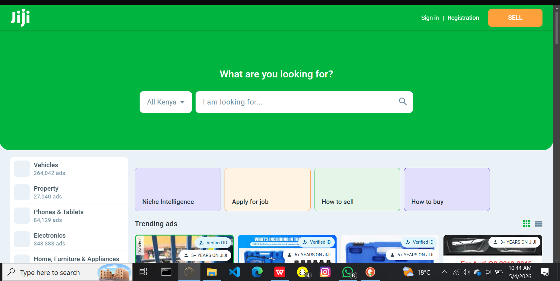
Figure 2.4: Jiji Kenya Marketplace Interface

2.3.5 Facebook Marketplace
Facebook Marketplace, launched in 2016 by Meta Platforms, integrates buying and selling functionality directly into the Facebook social network, leveraging its over 2.9 billion active users globally (Meta, 2023). It is widely used in Kenya as an informal channel for student transactions, with users connecting through Messenger and transacting offline.
Strengths:
Massive user base, leverages existing social networks for trust, free and easy to use, and supports community-based selling through groups.
Weaknesses:
No integrated payments, no formal buyer or seller protection, prevalence of scams, no rating or review system, and dependence on a Facebook account which not all university students actively use.
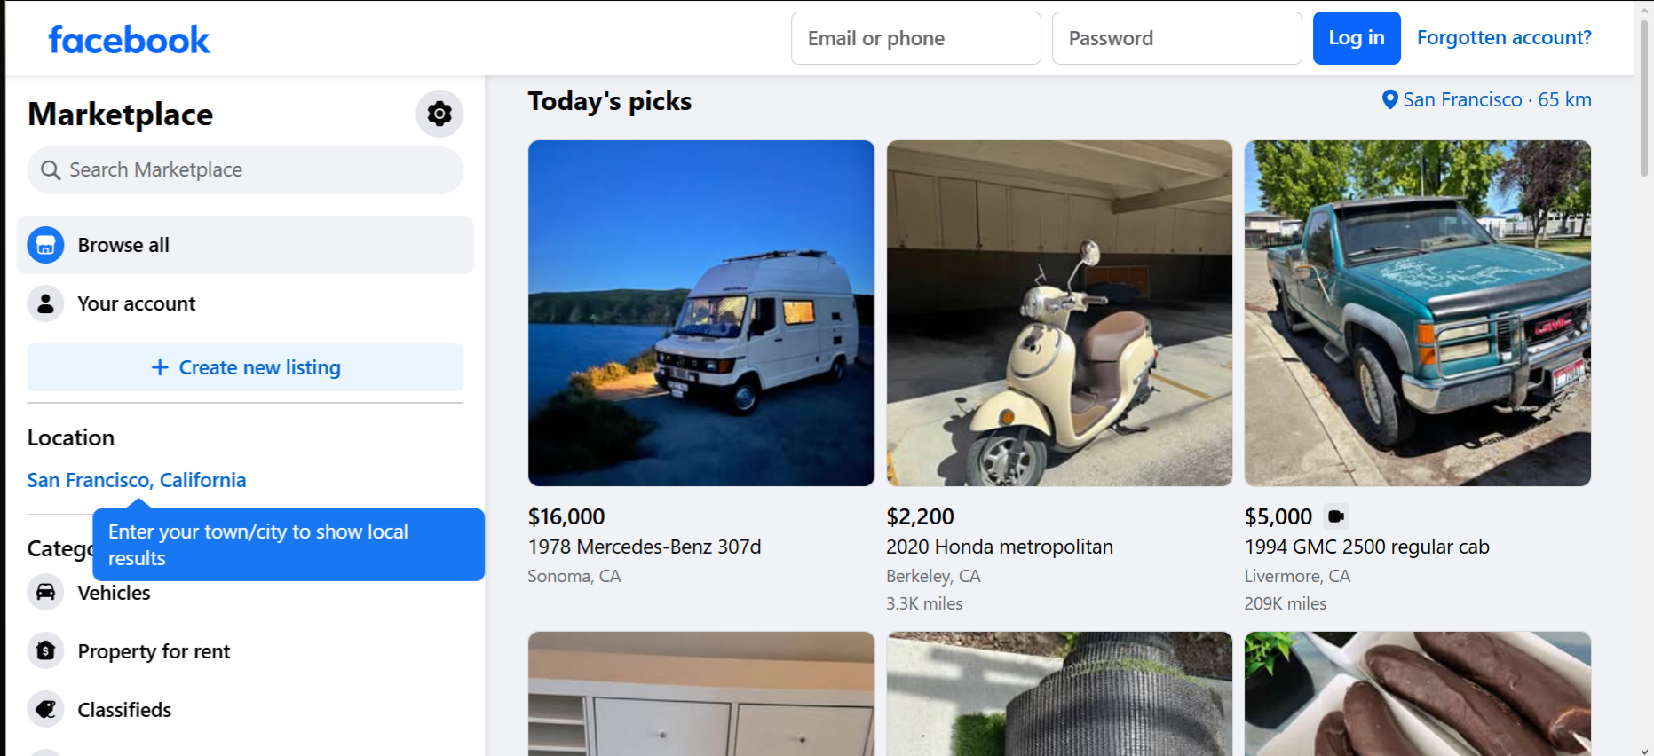
Figure 2.5: Facebook Marketplace Interface

2.4 Comparative Analysis of Related Systems
Table 2.1 below presents a comparative summary of the five reviewed systems against the key features required for a university-focused marketplace.
Table 2.1: Comparative Analysis of Existing Marketplace Systems
Feature | eBay | Amazon | Jumia | Jiji | Facebook MP | UniMarket
University-Specific Focus | ✗ | ✗ | ✗ | ✗ | ✗ | ✓
M-Pesa Integration | ✗ | ✗ | ✓ | ✗ | ✗ | ✓
Institutional Email Verification | ✗ | ✗ | ✗ | ✗ | ✗ | ✓
In-App Chat | ✓ | ✓ | ✗ | ✓ | ✓ | ✓
Ratings & Reviews | ✓ | ✓ | ✓ | Limited | ✗ | ✓
Service Provider Listings | ✗ | ✗ | ✗ | ✓ | ✗ | ✓
Off-Campus Rental Listings | ✗ | ✗ | ✗ | ✓ | ✗ | ✓
Geolocation Discovery | ✗ | ✗ | ✗ | ✗ | ✗ | ✓
Recommender System | ✓ | ✓ | ✗ | ✗ | ✗ | ✓
Free for Users | Limited | ✗ | ✗ | ✓ | ✓ | ✓
Report Suspicious Listings | ✓ | ✓ | ✓ | ✓ | ✓ | ✓
Admin Oversight Dashboard | ✓ | ✓ | ✓ | ✓ | ✓ | ✓

2.5 Emerging Trends and Patterns in the Research Area

2.5.1 Machine Learning in Marketplaces
Machine learning (ML) is a branch of artificial intelligence that enables computer systems to learn from data and improve their performance over time without being explicitly programmed (Mitchell, 1997). In the context of online marketplaces, ML has become a fundamental component, enabling personalised user experiences through product recommendations, fraud detection, and dynamic pricing (Aggarwal, 2020). Platforms such as Amazon and eBay employ collaborative filtering algorithms to recommend items based on user browsing and purchasing behaviour. ML algorithms are also used to detect anomalies in user activity that may indicate fraudulent listings or accounts, thereby enhancing platform security.
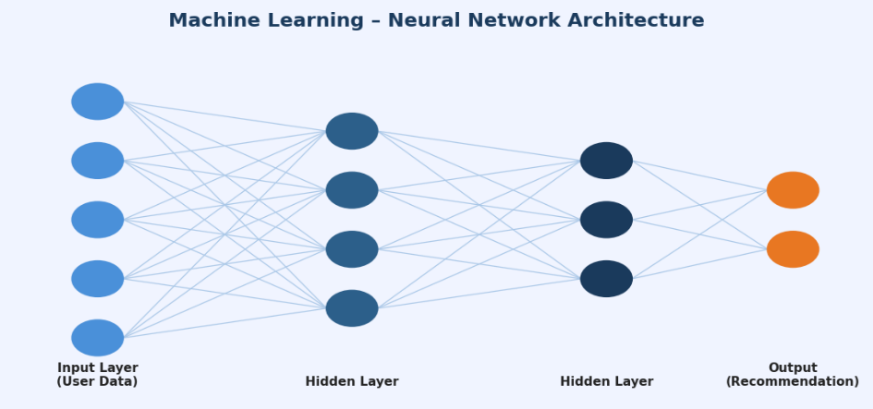
Figure 2.6: Machine Learning - Neural Network Architecture

2.5.2 Artificial Intelligence
Artificial intelligence (AI) refers to the simulation of human intelligence processes by computer systems, encompassing reasoning, learning, problem-solving, and language understanding (Russell & Norvig, 2021). AI extends beyond machine learning to include natural language processing, computer vision, and intelligent chatbots. In marketplaces, AI is used to power customer support chatbots, automatically categorise listings based on image recognition, and translate listings across multiple languages. AI-driven moderation systems can automatically detect inappropriate content, counterfeit goods, and prohibited items, significantly reducing the burden on human moderators.
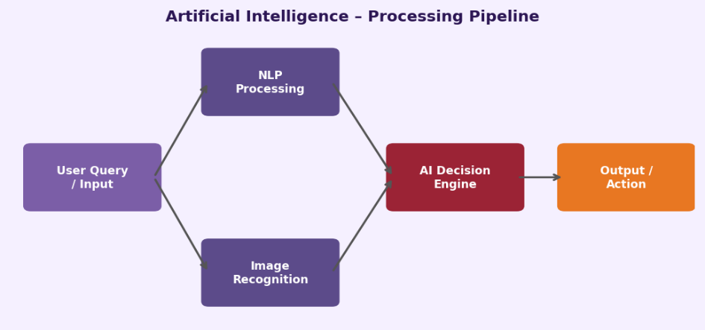

Figure 2.7: Artificial Intelligence - Processing Pipeline

2.5.3 Electronic Payments
Electronic payment systems have transformed the way marketplaces handle transactions. An electronic payment system is a digital mechanism that facilitates the transfer of monetary value between parties over a network without the need for physical currency (Laudon & Traver, 2021). In Kenya, M-Pesa has become the dominant mobile money platform, with over 30 million active users and integration into thousands of digital platforms (Communications Authority of Kenya, 2023). The M-Pesa Daraja API enables developers to integrate STK Push, C2B, and B2C payment flows directly into web applications, providing seamless payment experiences for users. Other emerging trends include digital wallets, contactless payments, and buy-now-pay-later schemes.
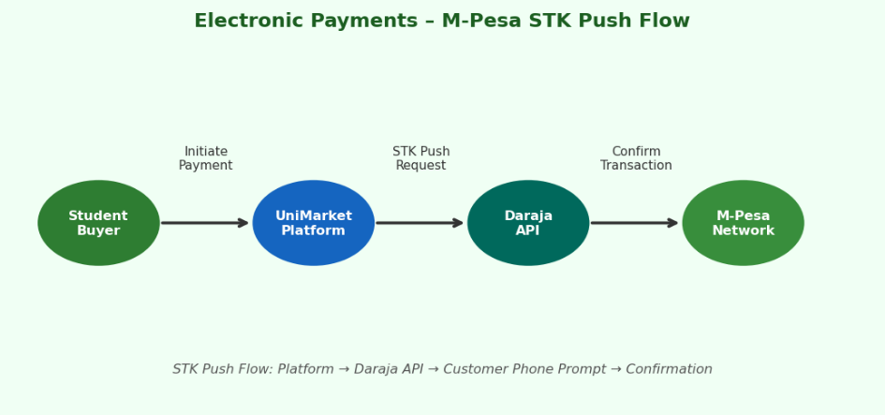

Figure 2.8: Electronic Payments - M-Pesa STK Push Flow

2.5.4 Blockchain Technology
Blockchain is a distributed, decentralised ledger technology that records transactions across a network of computers in a way that makes them immutable and transparent (Nakamoto, 2008; Tapscott & Tapscott, 2018). In online marketplaces, blockchain offers promising applications in establishing trust, securing transactions, and enabling decentralised commerce. Smart contracts can automate escrow services, ensuring that funds are only released to sellers once buyers confirm receipt of goods. Blockchain also enables transparent reputation systems where user ratings cannot be tampered with. While adoption remains limited due to scalability and usability challenges, its potential for future integration in university marketplaces is significant.
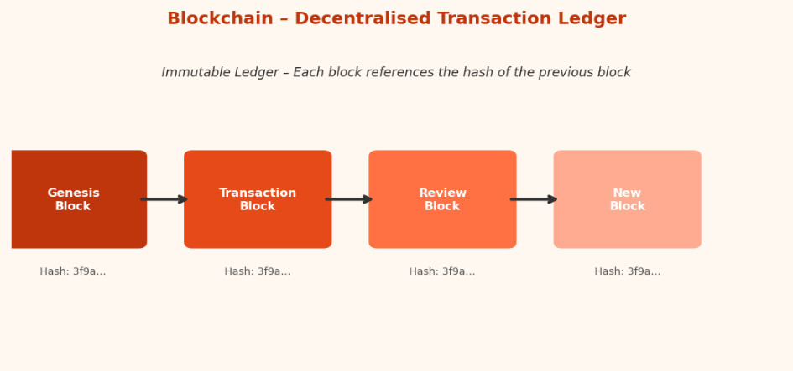

Figure 2.9: Blockchain - Decentralised Transaction Ledger

2.6 Chapter Summary
The current chapter reviewed the history of online marketplaces from the early 1990s to date, identifying their current tendencies and challenges. Five existing online marketplace systems were discussed and compared to each other to identify the common elements and differences. The analysis covered such aspects as the platforms’ advantages and disadvantages, target audiences, and geographic distribution. The key factors in the development of online marketplaces included machine learning, artificial intelligence, electronic payments, blockchain technology, cloud computing, geolocation, and recommender systems. The chapter unveiled the absence of a marketplace system targeting universities in Kenya, which sets the basis for the current research and the proposed UniMarket platform. The next chapter will cover the research methodology to be used in the current project.

CHAPTER THREE: RESEARCH METHODOLOGY

3.1 Chapter Introduction
This chapter describes the methodologies that will be employed throughout the research project. It covers the approaches to literature review, requirements specification, system analysis, system design, implementation, testing, and deployment. For each methodology, a definition is provided, followed by an explanation of how it will be employed and why it has been selected for this research.

3.2 Methodology for Literature Review
A systematic review of the existing literature will be undertaken to identify the theoretical framework and empirical base of the research. A systematic literature review is a type of research that systematically evaluates and scrutinizes all pieces of research related to the research question under investigation (Kitchenham, 2004). Therefore, the systematic review of the literature will be done using scholarly databases, journals, books, and other reliable sources of information published within the last ten years (2015-2026) as the research paper’s scope. However, there is an exception of including works published before the year 2015 if their inclusion is considered necessary for the study’s conduct.
The following keywords will be used when searching for relevant literature for this study: online marketplace platforms, peer-to-peer E-commerce, student marketplace web application, web application security, OWASP, database design, HTTP server, and East Africa’s digital commerce. The search will be conducted using Google Scholar, IEEE Explore, ACM digital library, and Springer link. The documents will be selected considering their relevance to the research, timeliness, and credibility. The abovementioned methodology will be adopted because it will offer a reliable and systematic procedure for reviewing the literature, which will lead to developing the research’s theoretical foundation.

3.3 Methodology for Requirements Specification
Requirements will be gathered using two primary data collection techniques: structured questionnaires and semi-structured interviews. Both techniques are standard methods in information systems research for eliciting user needs and system requirements (Creswell & Creswell, 2018).

3.3.1 Questionnaires
A questionnaire is a research instrument consisting of a set of questions designed to collect standardised information from a group of respondents (Oppenheim, 2000). Questionnaires are particularly suited to collecting quantitative data from large samples in a structured and time-efficient manner.
Types of Questionnaires:
Three types of questions will be incorporated in the instrument: closed-ended questions (offering predefined response options such as Yes/No or multiple choice), Likert scale questions (measuring attitudes and preferences on a five-point scale from "strongly agree" to "strongly disagree"), and ranking questions (asking respondents to order features or categories by priority). Open-ended questions will be used sparingly where richer qualitative insight is needed.
How the Questionnaire will be Administered:
The questionnaire will be administered electronically using Google Forms. A shareable link will be distributed to the target sample via WhatsApp groups, university email, and student notice boards. The electronic format enables efficient data collection, automatic response aggregation, and eliminates data entry errors associated with paper-based forms. Respondents will complete the questionnaire anonymously at their own convenience within a designated two-week data collection window.
Sample Size:
A sample of fifty university students, selected through stratified random sampling across faculties, will be targeted to ensure representative coverage of different student populations.
How Feedback will be Incorporated:
Quantitative results from the questionnaire will be analysed using descriptive statistics. Response frequencies and Likert averages will be used to rank feature priorities and identify the most significant pain points in current student trading behaviour. These findings will directly inform the functional requirements specification for UniMarket, ensuring that the platform addresses real, evidence-based user needs.

3.3.2 Interviews
An interview is a direct, purposive conversation between a researcher and a respondent, designed to elicit detailed qualitative information about a subject (Kvale, 2009). Interviews allow for in-depth exploration of issues that questionnaires cannot fully capture.
Types of Interviews:
Three principal interview types exist: structured interviews (in which the interviewer follows a fixed set of questions in a predetermined order), semi-structured interviews (which use a question guide but allow the interviewer to probe and follow up on unexpected responses), and unstructured interviews (which are entirely open and conversational). This research will employ semi-structured interviews, as this approach combines the consistency of a prepared question guide with the flexibility to explore nuanced issues in depth.
How Interviews will be Carried Out:
Interviews will be conducted face-to-face with five to eight key informants, including CUEA student representatives, the university ICT officer, and a member of the university administration. Each interview will last approximately thirty to forty-five minutes and will be conducted in a private, comfortable setting to encourage candid responses. With the interviewee's consent, sessions will be audio-recorded and subsequently transcribed. The interviewer will use an open-ended question guide as a reference (see Appendix D), while allowing follow-up questions to explore emerging themes.
How Feedback will be Incorporated:
Interview transcripts will be subjected to thematic analysis, in which recurring themes and concerns are identified and coded. The resulting qualitative insights will complement the quantitative questionnaire data, providing richer context for non-functional and administrative requirements such as content moderation policies, dispute resolution procedures, and institutional integration requirements. Combined findings from both instruments will form the basis of the system requirements specification.

3.4 Methodology for System Analysis
Structured Systems Analysis will be employed to analyse the current informal student trading environment at CUEA. This methodology uses Data Flow Diagrams (DFDs) to model the flow of information between processes, data stores, and external entities.

3.4.1 Data Flow Diagrams (DFDs)
A Data Flow Diagram (DFD) is a process model that displays data flows within an implemented system. The DFD displays the input, processing, storage, and output of data in the given system (Yourdon, 1989). There are four basic symbols used in DFDs: external entities, which are points where data enters and exits the system; processes, which depict activities performed on data; data stores, which are repositories of data; and flows, which represent the movement of data. Typically, DFDs depict the data flows in a system at different levels of decomposition, starting with the Context diagram or the level 0 DFD.
Why DFDs are Used:
DFDs provide a clear, technology-neutral visual representation of system behaviour that is accessible to both technical and non-technical stakeholders. They enable the analyst to identify data inputs and outputs, trace information flows across the system, and pinpoint inefficiencies or bottlenecks in current processes without prescribing a specific implementation solution.
Information to be Extracted:
The DFD analysis of the current informal marketplace will extract the following information: the external entities involved in student trading (buyers, sellers, and university administration); the data flows between them (listing information, negotiation messages, payment confirmations, and complaint reports); the processes that transform data (listing creation, search, negotiation, and transaction completion); and the data stores in use (WhatsApp message histories, physical notice boards, and informal records). This information will directly inform the design of the proposed system's architecture and data model.
Why DFDs have been Chosen:
Structured systems analysis using DFDs has been chosen because it provides a rigorous, visual, and well-established framework for understanding information flows that is well-suited to the transaction-oriented nature of a marketplace platform. It facilitates communication between the researcher and non-technical stakeholders, and its outputs directly feed into the system design phase.

3.4.2 Database Normalisation
Database normalisation is the process of organising a relational database schema to reduce data redundancy and improve data integrity through the application of a series of normal forms (Codd, 1970). The proposed database schema will be normalised to Third Normal Form (3NF). The normalisation process will progress through First Normal Form (1NF), eliminating repeating groups; Second Normal Form (2NF), eliminating partial dependencies; and Third Normal Form (3NF), eliminating transitive dependencies. This methodology has been chosen because it ensures the database is free from anomalies during insert, update, and delete operations, and reduces storage overhead.

3.5 Methodology for System Design
The proposed UniMarket system will be designed using a combination of data flow diagrams, flowcharts, user interface prototypes, and an entity relationship diagram. Each design technique is defined below alongside an explanation of how it will be employed and why it has been selected.

3.5.1 DFDs for the Proposed System
A Data Flow Diagram (DFD) is a graphical model that represents the flow of data through a system (Yourdon, 1989). For the proposed system, context, Level 1, and Level 2 DFDs will be produced for UniMarket, modelling the flow of data between the platform's components and its users. These will mirror the structure of the analysis DFDs but reflect the proposed automated system rather than the current manual processes. DFDs have been chosen for system design because they provide a clear, technology-neutral overview of system behaviour that bridges the gap between requirements specification and detailed technical design.

3.5.2 Flowcharts
A flowchart is a diagrammatic representation of an algorithm or process, using standardized symbols to depict the sequence of steps, decisions, and actions involved in completing a task (Chapin, 1970). Flowcharts will be used to model the control flow of key system processes, including user registration and authentication, listing creation and submission, the offer negotiation cycle, and the review submission process. Flowcharts have been chosen because they clearly communicate procedural logic to both technical and non-technical stakeholders, making them an effective tool for validating process designs before implementation.

3.5.3 User Interface Design
User Interface (UI) design can be defined as the process of designing the graphical layout of a system, and the coding of this design so that it delivers to the user an experiential interaction. It is the study of interfaces between people and machines to make them easy to use and efficient (Norman, 1988). The software interface will consist of prototypes created in Figma. The deliverables will be high-fidelity wireframes of all the significant screens of the software, including the landing page, listings browse, individual listing detail, seller page, inbox, offer panel, wishlist, and admin dashboard. The prototypes will be tested and edited by a small group of student evaluators before implementing the interface. I have chosen the UI design method because the feedback from the users helps identify possible design issues that could be expensive to address after development.

3.5.4 Database Design
Database design refers to the process of defining the structure, relationships, and constraints of the database to support the storage and retrieval functions of an application’s data needs (Elmasri & Navathe, 2015). An Entity Relationship Diagram is the primary tool that can be used in conceptual database design. This is a diagram that depicts the entity, its attributes, and the relationship between entities. An ERD will be designed for this database that will depict all the necessary entities, attributes, primary and foreign keys, and relationships. The main entities in this database are User, Listing, Message, Offer, Wishlist, Review, and Report. Database design using an ERD will be selected because it will give a clear outline of what this database should look like, and these specifications can be compared with the requirements.

3.6 Methodology for System Implementation
UniMarket will be implemented using the following technology stack, selected on the basis of educational value, alignment with development goals, and suitability for a web-based platform.
Table 3.1: System Implementation Technology Stack
Layer | Technology & Justification
Backend | Python 3 using the built-in socket module for raw TCP HTTP server implementation. Chosen for its readability, extensive standard library, and suitability for systems-level programming without frameworks.
Frontend | Vanilla HTML5, CSS3, and JavaScript. No front end frameworks. Chosen to demonstrate competence in core web technologies and to avoid framework-imposed abstractions.
Database | SQLite 3 with raw SQL queries. No ORM. Chosen for its zero-configuration deployment, file-based architecture suitable for a single-server deployment, and the educational value of writing explicit SQL.

3.7 Methodology for System Testing
A multi-layered testing strategy will be employed to evaluate the correctness, usability, security, and performance of the UniMarket system. For each testing phase, the sample size, testing environment, conduct of testing, and incorporation of feedback are described below.

3.7.1 Functional Testing
Functional testing verifies that each feature of the system behaves in accordance with its specified requirements, ensuring that all inputs produce the expected outputs (Myers et al., 2011).
Sample Size:
All system features and user stories documented in the requirements specification will be covered. There is no participant sample for this phase, the developer serves as the tester.
Testing Environment Setup:
Functional tests will be conducted on a dedicated local development machine running the UniMarket server at localhost. A clean test database will be initialised before each test cycle to ensure consistent, reproducible results.
How Testing will be Conducted:
Test cases will be written for all user stories prior to implementation and executed after each development phase. Each test case will specify the input conditions, the steps to execute, and the expected output. Actual outcomes will be recorded against expected outcomes in a structured test log.
How Feedback will be Utilised:
Any test case that fails will be logged as a defect with a description, severity level, and steps to reproduce. Defects will be prioritised and resolved before the next development phase commences, ensuring that each module is fully functional before integration.

3.7.2 Usability Testing
Usability testing evaluates the ease with which target users can learn and use the system to achieve their goals effectively and efficiently (Nielsen, 1994).
Sample Size:
Five to ten CUEA student volunteers will be recruited to participate in usability testing, selected to represent diverse faculties and levels of digital literacy. Nielsen (1994) demonstrates that five users are sufficient to uncover approximately 85% of usability issues.
Testing Environment Setup:
Usability sessions will be conducted in a quiet, controlled environment, either in the university computer laboratory or using the participant's personal device connected to the local development server. The researcher will be present to observe but will not intervene unless a participant is entirely unable to proceed.
How Testing will be Conducted:
Participants will be asked to complete a set of defined tasks on the platform, such as creating a listing, making an offer, and sending a message, using the think-aloud protocol, in which they verbalise their thought process as they interact with the system. Sessions will be timed and any navigation errors or points of confusion noted by the researcher.
How Feedback will be Utilised:
After each session, participants will complete a post-task questionnaire based on the System Usability Scale (SUS). Think-aloud observations and SUS scores will be analysed to identify recurring usability issues. Findings will be compiled into a usability report and prioritised for resolution before final deployment.

3.7.3 Security Testing
Security testing involves a systematic evaluation of the platform against known vulnerability categories to ensure that user data and platform integrity are protected (OWASP Foundation, 2021).
Sample Size:
Security testing is conducted against the system itself rather than a participant sample. All OWASP Top 10 vulnerability categories will be tested systematically.
Testing Environment Setup:
Security testing will be conducted on an isolated local server instance, separate from the development environment, to prevent accidental damage to development data. Testing tools including Burp Suite Community Edition and browser developer tools will be used.
How Testing will be Conducted:
Manual testing will be performed for SQL injection, cross-site scripting (XSS), cross-site request forgery (CSRF), broken authentication, and insecure file uploads, following the OWASP Testing Guide methodology. Each vulnerability category will be tested with crafted payloads designed to expose weaknesses, and results will be documented.
How Feedback will be Utilised:
Identified vulnerabilities will be classified by severity (critical, high, medium, or low) and remediated in a dedicated security hardening sprint before final deployment. A post-remediation security re-test will confirm that all identified issues have been resolved.

3.7.4 Performance Testing
Performance testing measures the system's responsiveness and stability under expected and peak load conditions (Molyneaux, 2014).
Sample Size:
Simulated concurrent user loads of 10, 25, and 50 users will be tested to cover expected normal usage and stress conditions for a university deployment.
Testing Environment Setup:
A local server environment mirroring the intended production configuration will be established. The server will be monitored for CPU usage, memory consumption, and response times during load tests.
How Testing will be Conducted:
Python scripts using the concurrent.futures module will simulate concurrent users sending HTTP requests to the platform's most frequently accessed endpoints, including the listings browse page and the search API. Response times and error rates will be logged for each concurrency level.
How Feedback will be Utilised:
Bottlenecks identified in the server's threading model or database query performance will be addressed through targeted optimisation, such as query indexing, response caching, and thread pool tuning, before production deployment.

3.8 Methodology for System Deployment
A phased deployment approach will be adopted, in which the system is introduced to a limited group of users before a broader rollout. This approach minimises risk by allowing issues to be identified and resolved with a small user base before the platform is opened to the wider university student community. Phased deployment has been chosen because it balances the need for thorough validation with the practical constraints of academic timelines.
In Phase 1, the platform will be deployed to a local server accessible within the CUEA campus network and made available to a pilot group of twenty students and two administrators for a period of two weeks. Feedback from the pilot will be analysed and incorporated into the system before Phase 2.
In Phase 2, the platform will be deployed to a publicly accessible server and made available to all CUEA students. A user training session will be conducted to familiarise students with the platform's features. Data migration will not be required as the system will be deployed with an empty database, and users will register and create listings from scratch. The architecture has been designed to accommodate future multi-institution deployment with minimal reconfiguration.

3.9 Chapter Summary
This chapter described the methodologies to be employed across all phases of the research, including systematic literature review, questionnaire and interview-based requirements gathering with electronic administration and structured feedback incorporation, structured systems analysis using DFDs and normalisation, system design using ERDs, flowcharts, and UI prototypes, web-based implementation using a defined technology stack, multi-layered testing covering functional, usability, security, and performance dimensions, and phased deployment. These methodologies collectively provide a rigorous and comprehensive framework for the design, implementation, and evaluation of the UniMarket platform.

CHAPTER FOUR: SYSTEM ANALYSIS

4.1 Chapter Introduction
This chapter covers the analysis of the informal student trading system currently in use at the Catholic University of Eastern Africa (CUEA) and by extension, the informal student trading system in Kenyan Universities. This chapter starts by describing how the system works currently in terms of its strengths and weaknesses. A feasibility study of replacing the informal student trading system with a digital platform is performed. The chapter handles the data input/output analysis to establish the data being captured in the current informal student trading system, their relationship, and the outputs of the system. The process logic design of the current system is also discussed using the context diagram, level 1 data flow diagram, and flowcharts of the main processes; selling and buying procedures.

4.2 Description of the Current System
The current student trading system at CUEA is informal, unorganized, and mediated only through generic communication channels that happen to be used for commerce. There is no specific platform, procedure, or program within the university to facilitate or regulate such transactions. Students who wish to sell or offer services have only four options: WhatsApp group chats (both faculty-specific and general university wide), notice boards in the corridor, Facebook groups and Marketplace, and asking around through word of mouth.
In the selling process, any student who wishes to offload a thing or service they own or provide will utilize their smartphone to take a photo of the item they wish to sell, write a short caption, and post it on the first three channels mentioned above. In the caption, they write the price and a short description of the good or service being sold and include their contact information so that anyone interested can WhatsApp or call them. The WhatsApp contact information facilitates direct negotiation between the buyer and seller. When an agreement is reached, the two students then set a time and place to meet on or near campus and complete the transfer of the item being sold in exchange for cash or mobile money. Neither party keeps a record of the item or the money exchanged.
For the buying process, the student will search through WhatsApp, Facebook Marketplace, and notice boards for items they wish to purchase. If they are unable to find what they are looking for, they may ask around in person or post a seeking request in WhatsApp groups. There is no search function, so it can sometimes take much time to find the right buyer or seller. Some ads may even stay up long after an item has been sold, wasting the time of would-be buyers.
Students who wish to sell services have an even more difficult time than those selling goods. Services such as tutoring, computer repair, graphic design, or even haircuts have no category to list under or way of advertising beyond asking around. Service providers have to constantly keep re-posting or keep asking around because they have no portfolio or record of past clients within the university.

4.2.1 Strengths of the Current System
Despite its limitations, the current informal system does exhibit certain strengths that have enabled its persistence. Firstly, it requires no onboarding or registration â€” any student with a smartphone and membership of a WhatsApp group can immediately begin trading. This zero-friction entry ensures broad participation across all faculties and year groups. Secondly, it leverages existing communication infrastructure that students already use daily, meaning there is no learning curve or adoption barrier associated with a new tool. Thirdly, the social dimension of these communication platforms provides an informal layer of trust: buyers and sellers who are members of the same university WhatsApp group share a degree of mutual accountability through their shared social network, reducing (though not eliminating) the risk of fraud. Finally, transactions can be arranged rapidly in urgent situations, as messaging platforms support real-time communication.

4.2.2 Weaknesses of the Current System
The weaknesses of the current informal system are substantial and directly motivate the development of UniMarket. The most critical weaknesses are as follows.
Weakness | Description
No centralised discovery | Listings are scattered across multiple WhatsApp groups, Facebook pages, and physical boards. There is no single location where a student can search for all available items, leading to high search costs and missed transactions.
No searchability or filtering | Communication platforms such as WhatsApp do not support keyword search of group messages on older devices, and messages scroll away rapidly. There is no way to filter by category, price range, or condition.
No trust or reputation system | There is no mechanism to rate buyers or sellers, report fraudulent listings, or verify the authenticity of an item's description. This creates significant risk of fraud and misrepresentation.
No record-keeping | Once a transaction is agreed upon and completed, no record exists of the exchange. If a dispute arises for example, if an item is defective there is no official history to reference.
Ephemeral listings | WhatsApp messages disappear into history within hours in active groups. Listings on notice boards are removed, torn, or covered by newer notices. Sold items frequently remain posted across channels, wasting buyers' time.
No formal price negotiation process | There is no structured channel for making offers or counter-offers. Negotiation takes place across fragmented chat threads, and there is no agreement mechanism to formalise a deal before a physical meetup.
Limited reach for services | Students offering services have no structured directory or profile. Their visibility is limited to groups they are already a member of, and they cannot build a verifiable service reputation over time.
Inaccessibility for new students | First-year students who are not yet embedded in the university's WhatsApp network face particular challenges in accessing the informal market, whether as buyers or sellers.
Table 4.1: Weaknesses of the Current Informal Student Marketplace System

4.3 Feasibility Study
A feasibility study was conducted to assess whether the proposed UniMarket platform can be realistically developed and successfully adopted within the identified constraints of time, budget, technology, and operational context. The study examines four dimensions: technical feasibility, economic feasibility, operational feasibility, and schedule feasibility.
4.3.1 Technical Feasibility
Technical feasibility evaluates the technology needed to build and operate the proposed system is available to the developer (Laudon & Laudon, 2020). UniMarket is proposed to be built using the Python 3 backend, SQLite database, and HTML5, CSS3, and JavaScript for the frontend. Each of these technologies is well-documented and freely available. Python 3 is a popular programming language taught throughout undergraduate computer science programs around the globe. SQLite is the most widely distributed database engine with no server process needed (Kreibich, 2010). The developer has already acquired skills in the above-mentioned technologies through classwork and individual practice. No proprietary or expensive tools are required. The technical feasibility of this project is confirmed.
4.3.2 Economic Feasibility
Economic feasibility evaluates whether the financial cost of developing and operating the system is justified (Stair & Reynolds, 2018). The researcher will use tools available for free to develop this project. The only recurrent costs will be internet bundles (KES 750/week for 30 weeks), fieldwork transportation and commission, and printing costs totaling KES 28,700 (see Appendix B of the proposal). As a benefit, the system will enable hundreds of student transactions in a semester while minimizing the losses incurred due to the inability to trade locally and fraud. The economic feasibility of this project is confirmed.
4.3.3 Operational Feasibility
Operational feasibility assesses if the proposed system will be positively received and adopted by the targeted users in the intended environment (Kendall & Kendall, 2019). The targeted users – ‘university students’ are digital natives who are comfortable navigating web applications and mobile platforms. The researcher will carry out a requirements survey (see Chapter Three) to establish that the intended features resonate with the target audience. The system will be intuitive and easy to navigate as simplicity and accessibility will be prioritized as non-functional requirements. The university’s ICT department provides free internet access on campus, so the system will be accessed through students’ personal computers. The operational feasibility of this project is confirmed pending end-user training and sensitization at launch.
4.3.4 Schedule Feasibility
Schedule feasibility assesses whether the project timeline is realistic, considering the project’s scope (Pressman & Maxim, 2020). The research and development process is scheduled to begin in March 2026 and concludes September 2026 (see Gantt Chart, Appendix A of the proposal). The project scope has been consciously limited to features achievable by one developer in six months, excluding payments gateways, and mobile application development. The schedule feasibility of this project is confirmed.

4.3.5 Conclusion of the Feasibility Study
The feasibility study concludes that the development of UniMarket is viable across all four dimensions assessed. The project is technically achievable with available tools, economically justified given its low cost and significant potential benefit, operationally suitable for the target user base, and achievable within the proposed schedule. The study therefore recommends proceeding with the design and implementation of the proposed system.
Dimension | Summary Assessment | Conclusion
Technical | Available, free, developer-proficient technologies (Python, SQLite, HTML/CSS/JS) | ✓ FEASIBLE
Economic | Total cost ~KES 28,700 using open-source tools; high potential student benefit | ✓ FEASIBLE
Operational | Digitally literate users, campus internet access, user-centred design approach | ✓ FEASIBLE
Schedule | 30-week plan, bounded scope, single developer achievable within timeline | ✓ FEASIBLE
Table 4.2: Feasibility Study Summary

4.4 Data Input / Output Analysis
This section analyses the data that is currently captured by the informal student marketplace system, the relationships that exist between that data, and the outputs that the system produces for its users.

4.4.1 Data Captured by the Current System
Although informal, the current system does capture a number of data elements, though this capture is unstructured, inconsistent, and entirely dependent on the individual student's communication behaviour. The following data elements are typically involved in a student trading interaction:
Data Element | Details
Listing information | Item name or description, asking price, item condition (stated informally), photographs (taken on smartphone), seller contact details, and location or availability for handover. This data is posted in WhatsApp messages, Facebook posts, or on a physical notice.
Buyer enquiry data | Interest messages from potential buyers, questions about item condition or specifications, and proposed offer prices, all communicated through messaging platforms.
Negotiation data | Counter-offers, revised prices, and acceptance or rejection messages exchanged between buyer and seller through chat threads.
Transaction data | The agreed price and the time and venue of the physical meetup, communicated informally through messaging. No formal confirmation record is created.
Payment data | Cash transactions leave no record at all. M-Pesa transactions generate a text message confirmation on both parties' phones but this is not linked to any listing or trade record.
Complaint data | In cases of dispute or fraud, aggrieved students may send screenshots or messages to WhatsApp group administrators or the university ICT office. No structured complaint record is maintained.
Table 4.3: Data Captured by the Current Informal System

4.4.2 Relationship Between the Data
In the current informal system, the relationships between these data elements are implicit and maintained only in the memory of the participants or in scattered, unlinked message threads. There is no formal relational structure. However, the following logical relationships can be identified from observing the informal process:
•A single Student (Seller) may create multiple Listings across different platforms at any given time.
•A single Listing is associated with one Seller, but may attract enquiries from multiple Buyers simultaneously.
•Each Buyer Enquiry is associated with one Listing and one Seller, but exists as an isolated message with no persistent link.
•Each Negotiation Thread is associated with one Listing, one Seller, and one Buyer. However, threads across different platforms (e.g., WhatsApp and Facebook Messenger) are entirely disconnected even if they concern the same item.
•A Transaction, when it occurs, links one Buyer, one Seller, one Listing, and one agreed Price, but this link is maintained only in the participants' memories and informal message records.
•A Payment (M-Pesa) is associated with one transaction but carries no reference to the listing, the buyer, or the nature of the exchange.
•A Complaint, when raised, may reference a Seller or Buyer and a specific exchange, but the link is established only through narrative description in a message, not through any structured reference.
4.4.3 Outputs from the Current System
The current informal system produces the following outputs for its participants:
Output | Description
Listing post (social media / notice board) | The primary output for sellers. A formatted or unformatted text and photo post shared in a WhatsApp group, Facebook group, or pinned on a notice board. It is visible to all group members but has no formal structure, searchability, or expiry date.
Buyer enquiry message | The primary output for interested buyers. An informal message sent to the seller expressing interest, asking questions, or making an offer. Delivered via WhatsApp or Facebook Messenger.
Negotiation messages | A thread of back-and-forth messages between buyer and seller, culminating in price agreement or rejection. No structured output is produced at the point of agreement, the deal exists only in the chat thread.
M-Pesa confirmation SMS | If payment is made via mobile money, both parties receive an SMS confirmation from Safaricom. This contains the transaction amount, recipient name, and a reference code but contains no information about the traded item.
Complaint message or screenshot | In cases of dispute, the aggrieved party may send a complaint message to a group administrator or university office. There is no formal acknowledgement or resolution output.
Table 4.4: Outputs from the Current Informal System

4.5 Process Logic Design of the Current System
This section presents the process logic design of the current informal student marketplace system using three complementary modelling techniques: a context diagram, a Level 1 Data Flow Diagram (DFD), and flowcharts for the two primary user processes. These diagrams visually capture the data flows, processes, and control logic that characterise the current system, providing a formal basis for comparison with the proposed UniMarket platform designed in Chapter Five.

4.5.1 Context Diagram
The context diagram in Figure 4.1 presents the highest level of abstraction of the current informal system. The system as a whole is represented by a single central process, "Informal Student Marketplace", and three external entities interact with it: the Student Seller, who inputs item details and prices into the system and receives buyer enquiries in return; the Student Buyer, who submits search queries and offer amounts and receives listing information and seller contacts; and the University Administration, which receives complaints and dispute reports from the system and issues disciplinary decisions in response. The context diagram establishes the boundary of the current system and the nature of all external interactions at the highest level of abstraction.
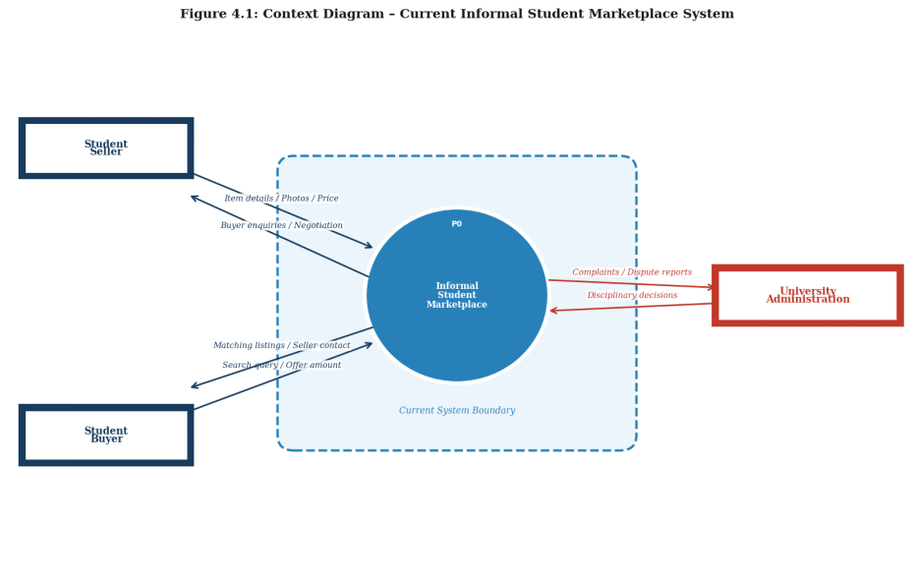

Figure 4.1: Context Diagram of Current Informal Student Marketplace System

4.5.2 Level 1 Data Flow Diagram
The Level 1 DFD in Figure 4.2 decomposes the central process of the context diagram into five sub-processes that together constitute the informal trading workflow. Process P1 (Post Listing) receives item details from the Seller and stores listing information across three data stores: D1 (WhatsApp Groups), D2 (Notice Boards), and D3 (Social Media Posts). Process P2 (Search and Discover) reads from all three data stores to produce matching listings for the Buyer. Process P3 (Negotiate Price) mediates back-and-forth offer messages between the Buyer and Seller. Once a price is agreed, Process P4 (Complete Exchange) coordinates the physical handover and payment confirmation. Process P5 (Raise Complaint) handles the rare cases where a Buyer or Seller raises a dispute, forwarding a complaint to the University Administration and receiving a resolution or warning in return. The DFD illustrates the fragmented, multi-platform nature of the current system and the absence of any centralised data store or control mechanism.
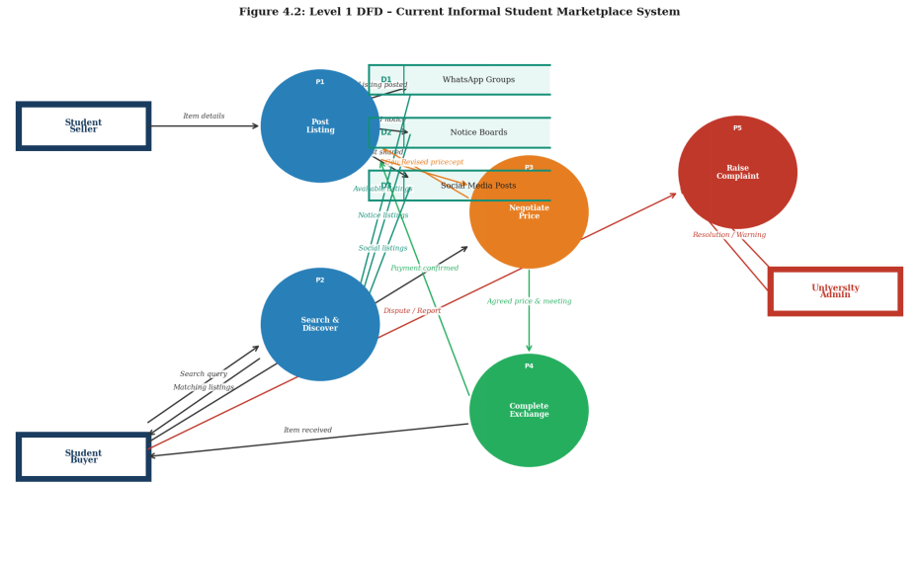

Figure 4.2: Level 1 DFD of Current Informal Student Marketplace System

4.5.3 Flowchart: Current Selling Process
Figure 4.3 depicts the step-by-step control flow of the current selling process. The process begins when a student decides to sell an item. The seller photographs the item and writes an informal description, then posts across one or more channels. The seller then waits for responses â€” a passive, time-consuming step with no notification mechanism. Upon receiving a buyer response, the seller engages in an informal negotiation. If price agreement is reached, a meeting is arranged and the item is handed over in exchange for payment. Two key decision points are highlighted: whether a response is received (triggering continued waiting or re-posting if not) and whether price is agreed (triggering continued negotiation or abandonment of the exchange if not). The flowchart reveals that the process contains multiple unresolvable loops with no system-level resolution mechanism; a seller may wait indefinitely for a suitable buyer with no feedback from the system.
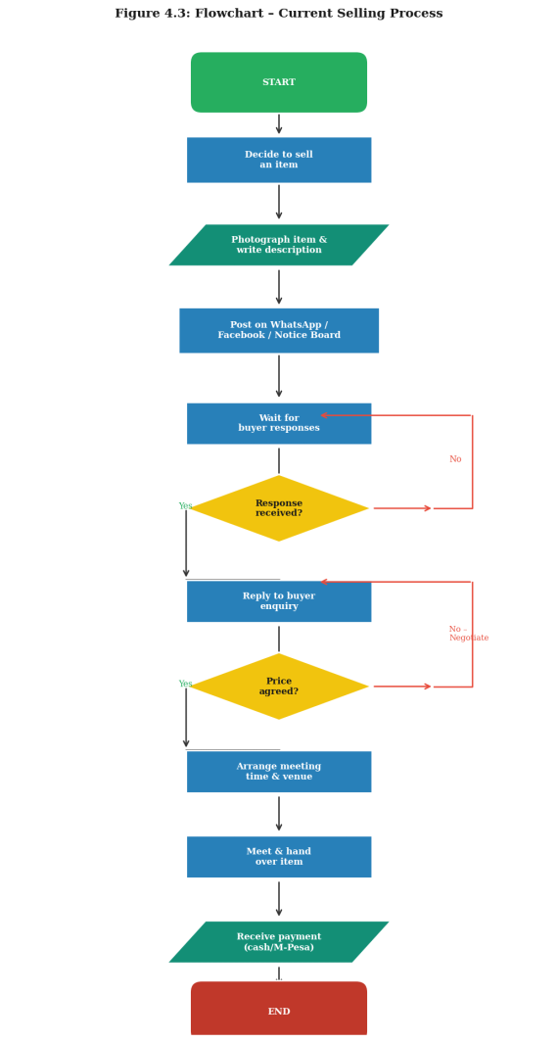

Figure 4.3: Flowchart of Current Selling Process

4.5.4 Flowchart: Current Buying Process
Figure 4.4 depicts the control flow of the current buying process from the buyer's perspective. The buyer begins by identifying an item need and searching available channels. A first decision point determines whether the item is found in digital channels; if not, the buyer broadens the search to physical notice boards and peer enquiries. A second decision point assesses whether the item is found after the extended search; failure here results in a retry loop with no clear resolution path. If the item is located, the buyer contacts the seller and awaits a response â€” a point at which the process can stall indefinitely if the seller is unresponsive or the listing is out of date. Successful contact leads to price negotiation and, upon agreement, a physical exchange. The flowchart illustrates the buyer's experience as fragmented, effort-intensive, and reliant on factors entirely outside their control â€” a strong argument for a centralised, searchable, structured platform.
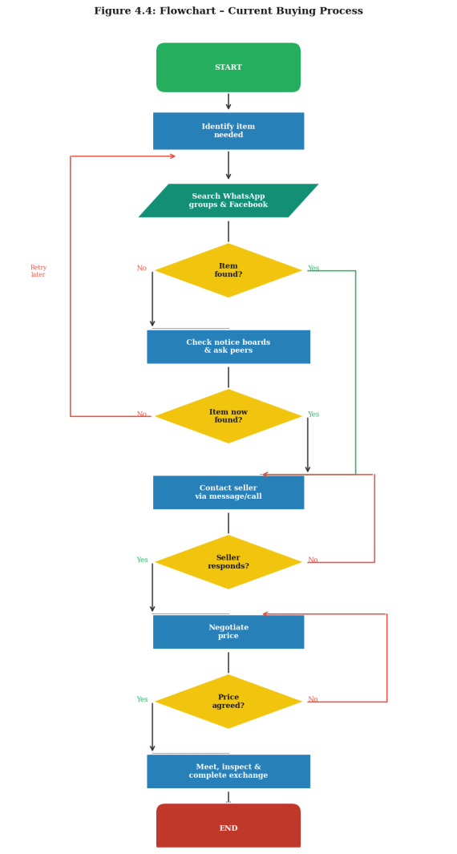

Figure 4.4: Flowchart of Current Buying Process

4.6 Chapter Summary
The chapter provided an in-depth analysis of the current informal student trading system in the institution. The description of the current state of affairs revealed that student trading is currently done using generic communication channels such as WhatsApp, Facebook and notice boards with no digital infrastructure. Although the informal setup has the advantage of zero entry barriers and leveraging on the existing communication networks it has a number of disadvantages including lack of central repository, no search engine, no trust mechanism, no audit trail and impermanence of listings among others. The feasibility study revealed that the proposed system is simple enough to be implemented using existing and affordable technology, is economically feasible at a budgeted cost of KES 28,700, is appropriate given the target audience and can be scheduled to fit into the available thirty week timeframe.
The data in and out analysis identified and tabulated the main data elements in the current system including listings, information, buyer inquiries, negotiation notes, M-Pesa confirmations and complaint communications. It also captured the implied relationships between the data elements. The process logic design step entailed drawing up the context diagram, Level 1 DFD and two flowcharts to depict the control logic of the current selling and buying processes. The current processes were found to be fragmented and involved multiple communication platforms and looping of data. The chapter provides the background requirements context for the proposed UniMarket system which will be discussed in chapter Five.

CHAPTER FIVE:SYSTEM DESIGN OF THE PROPOSED SYSTEM
5.1 Introduction
This chapter presents the design of the proposed system, UniMarket, a campus-restricted online marketplace intended to replace the informal and unmoderated buying and selling channels (noticeboards, WhatsApp groups and Facebook Marketplace posts) that university students in Kenya currently utilise to trade textbooks, gadgets, clothing, event tickets and services. The chapter translates the requirements established in Chapter Four into a system design that is described in terms of a concrete implementation, and is organised into five parts: a description of the proposed system and its strengths and weaknesses; a requirement analysis covering functional, non-functional, user and usability requirements; the conceptual architecture of the system, with attention paid to the interaction between the client (browser) and the backend server; the process logic design as use case, activity, sequence and class views, together with a context diagram and data-flow diagrams; and the database design, presented as an entity-relationship description, a normalisation justification and a data dictionary derived directly from the implemented relational schema. The chapter closes with the input/output design of the proposed system in the form of page-level mock-ups, and a chapter summary.
5.2 Description of the Proposed System, its Strengths and Weaknesses
UniMarket is implemented as a single, self-contained Python 3 web application (server/main.py) that renders complete HTML pages on the server and serves them to an unmodified web browser. Unlike the current, informal buying and selling channels described in Chapter Four, the proposed system enforces structure and accountability at every stage of a transaction: every account is tied to a verified university email address, every listing belongs to exactly one authenticated seller, every negotiation is captured as a persistent offer record, and every completed sale is tracked through an explicit order and delivery lifecycle. The system introduces a three-tier moderation model (buyer, seller, admin, with an additional superadmin capability) to handle reported listings and abusive accounts without needing direct database access.
5.2.1 Strengths of the Proposed System
Zero external runtime dependency for the backend: the server is written entirely against the Python standard library (socket, sqlite3, http parsing implemented by hand, smtplib, hashlib), eliminating any dependency-management or supply-chain risk that a framework like Flask or Django would introduce.
Centralised cross-cutting concerns: CSRF validation, security response headers and rate limiting are enforced once, in the route() dispatcher and send() response writer respectively, rather than being repeated (and potentially forgotten) in each of the more than sixty individual page handlers.
Transactional integrity at the schema level: foreign keys are declared with explicit ON DELETE CASCADE / SET NULL behaviour and SQLite foreign-key enforcement is turned on for every connection (PRAGMA foreign_keys = ON), so referential integrity is guaranteed by the database engine and not left to application-level discipline alone.
Low deployment overhead: the entire application, including its database engine, ships as a single SQLite file and a single Python process, which is well suited to the low-budget hosting environments typically available to a student-built campus system.
5.2.2 Weaknesses / Limitations of the Proposed System
The hand-rolled HTTP layer accepts one TCP connection per request and dispatches it to a new daemon thread (threading.Thread(target=handle, args=(conn,))); this thread-per-connection model does not scale as gracefully under high concurrency as an asynchronous or pooled-worker server would.
SQLite is a single-writer database engine; under sustained concurrent write load (for example simultaneous offer submissions during a peak selling period) write contention would become the primary throughput bottleneck.
Email delivery (verification links, message notifications, saved-search alerts) silently degrades to console logging when SMTP_HOST is not configured, which is appropriate for development but means production deployments must explicitly provision SMTP credentials or verification and notification features will not reach real users.
There is no dedicated JSON/REST API layer; every interaction is a full server-rendered page reload, which is architecturally simple but does not support a native mobile client without duplicating the presentation logic.
5.3 Requirement Analysis
The requirement analysis presented here is derived directly from the implemented route table in server/main.py and the schema in database/schema.sql, so that each stated requirement can be traced to a concrete handler function, HTTP route or table constraint.
5.3.1 Functional Requirements
The proposed system shall provide the following functions, grouped by subsystem:
(a) Account Management and Authentication
Register a new account as a buyer or seller, with server-side validation of a Kenyan phone number (regex ^(+254|0)\d{9}$, normalised to +254 format) and a minimum eight-character password policy (route: /register).
Verify the registered e-mail address through a single-use token e-mailed to the account and consumed at GET /verify/, after which users.email_verified is set to 1.
Authenticate via e-mail and password at /login, with failed attempts tracked per account (users.failed_logins) and the account temporarily locked (users.locked_until) after repeated failures, in addition to a per-IP sliding-window rate limit of five login attempts per sixty seconds.
Reset a forgotten password through a time-limited token stored in the password_resets table (/forgot-password, /reset-password/).
Maintain and edit a personal profile, name, phone, university, faculty, year of study and bio, at /profile and /profile/edit, and view any other user's public seller profile at /seller/.
Request an upgrade from buyer to seller (/profile/upgrade-seller) or apply for administrator privileges by submitting a staff number, national ID and KRA certificate for review (/admin-request, /admin-request/submit), persisted in admin_requests and actioned by an existing admin through /admin/approve-request and /admin/reject-request.
(b) Listings and Discovery
Create a new listing with title, category (restricted to the five predefined CATEGORIES), description, price, condition, location and one or more photographs, submitted as multipart/form-data and stored via the listings and listing_images tables (/listing/new).
Browse listings on the home page, filter by category (/category/), and view a single listing's full detail, including a running view_count, at /listing/.
Edit (/listing//edit), 'bump' to refresh visibility (/listing//bump, throttled to three bumps per sixty seconds) and mark a listing sold (/listing/sold) restricted to the owning seller.
Maintain a personal wishlist of listings (/wishlist, /wishlist/toggle) and a record of recently viewed listings (recently_viewed table).
Save a search as a category/keyword/max-price alert (saved_searches table, /alerts, /alerts/save, /alerts/delete) and receive an e-mail when a new listing matches a saved alert.
(c) Negotiation, Messaging and Transactions
Message a seller about a specific listing; the first message opens a conversation (a unique (listing_id, buyer_id, seller_id) thread in the conversations table) and subsequent exchanges are appended as messages, viewable at /inbox and /conversation/ and replied to at /conversation//reply.
Make a price offer on a listing (/offer), which the seller may accept, decline or counter (/offer/status) with a counter_price and counter_note; the buyer may cancel a pending offer (/buyer/offers/cancel) and offers auto-expire seven days after creation.
Place an order once a price is agreed (/order), which creates a row in orders with independent payment_status and delivery_status fields; the seller/buyer can update delivery status and push a payment-provider ('SDK') status (/order/status, /payment/sdk-push) and update live tracker coordinates for the delivery (/order/location, viewed at /order//track).
Leave a star rating and written review of a completed transaction (/review), and view, edit or delete one's own reviews (/buyer/reviews, /buyer/reviews//edit, /buyer/reviews//delete).
(d) Trust, Safety and Administration
Report a listing for a stated reason (/report), recorded in the reports table with an open/actioned status.
As an administrator: review and update the status of reports (/admin/report/status), hide a reported listing (/admin/hide-listing) or remove it outright (/admin/remove-listing), and suspend or reinstate a user account with a recorded reason (/admin/block-user, /admin/unblock-user).
As a superadmin: promote another verified user to the admin role (/admin/add-admin, gated on users.is_superadmin).
Generate and download operational reports, transactions, listings or user activity, as CSV, recorded as an auditable report_requests row and served at GET /admin/report/download.

5.3.2 Non-Functional Requirements
Category | Requirement / Implementation Evidence
Security | Passwords are never stored in plain text: password_hash() salts each password with 16 random bytes (secrets.token_bytes) and derives a PBKDF2-HMAC-SHA256 digest over 260,000 iterations, verified with a constant-time comparison (secrets.compare_digest) to resist timing attacks. Every state-changing (POST) request is checked against a per-session CSRF token before any handler executes. Every response carries X-Content-Type-Options, X-Frame-Options: DENY, a Referrer-Policy and a restrictive Content-Security-Policy that disallows third-party scripts.
Rate limiting / abuse resistance | An in-memory sliding-window limiter (_rl_buckets) caps sensitive actions per client IP: 5 logins/60s, 3 registrations/60s, 15 messages/60s, 10 offers/60s, 5 reports/60s, 5 reviews/60s and 3 listing bumps/60s, mitigating brute-force and spam abuse without requiring an external service.
Performance | The absence of a heavyweight framework and ORM keeps per-request overhead low; each request is handled on its own daemon thread so a slow client cannot block other connections, and a three-second socket timeout bounds the resources a single stalled connection can hold.
Portability / deployability | requirements.txt is intentionally empty, the server depends only on the Python 3 standard library, so the application can run on any host with a base Python interpreter with no pip install step and no version-compatibility risk from third-party packages.
Reliability | A daemon background thread (_expiry_worker) runs every 300 seconds to automatically expire stale pending offers and listings whose expires_at timestamp has passed, keeping displayed data consistent without manual administrator intervention.
Maintainability | All server logic is organised as small, single-purpose handler functions dispatched from one central route() table, with shared helpers (esc(), money(), layout(), stat_card()) factoring out repeated presentation logic, which keeps each handler short and independently testable.
Data integrity | PRAGMA foreign_keys = ON is issued on every database connection and every relational column is declared with an explicit REFERENCES ... ON DELETE clause, so orphaned rows cannot occur even though the application does not use an ORM's cascade logic.
Availability of correspondence | If SMTP is not configured, outgoing e-mail (verification, message notifications, alert notifications) degrades gracefully to a console log entry ("[DEV EMAIL]") rather than raising an exception that would break the triggering request.

5.3.3 User Requirements
Buyer: register, browse and search listings, message sellers, negotiate through offers, place and track orders, and review completed transactions served through the buyer dashboard at /buyer.
Seller: everything a buyer can do, plus create and manage listings, receive and respond to offers and messages, and fulfill orders served through the seller dashboard (Seller Hub) at /seller.
Administrator: moderate reported content, suspend or reinstate accounts, review admin-upgrade applications, and generate operational reports served through the admin console at /admin.
Superadmin: all administrator capabilities, plus the exclusive ability to grant the admin role to another user.

5.3.4 Usability Requirements
A single shared page shell (the layout() function) renders a consistent header, role-aware navigation sidebar and footer on every page, so users always have predictable access to the dashboard appropriate to their role, as documented in DASHBOARD_ROUTES.md.
Form fields are automatically paired with visible <label> elements derived from their placeholder text (the labelize_fields() helper), and password fields expose a 'Show/Hide' toggle for error-tolerant entry (static/js/app.js), addressing accessibility and reducing failed sign-in attempts caused by typing errors.
Monetary values are rendered consistently through a single money() helper as 'KES 1,200' style strings, and the interface uses a restrained gold-and-ink colour palette (CSS variables --gold, --gold-dark, --ink, --muted in static/css/styles.css) with the Inter typeface for legibility on both desktop and mobile viewports.
Client-side validation (static/js/app.js) blocks obviously invalid submissions a negative price/offer amount, or a password-confirmation mismatch before the page is submitted, giving the user immediate feedback without a round trip to the server; equivalent checks are re-applied on the server as the authoritative validation layer.

5.4 Conceptual Architecture of the Proposed System
UniMarket follows a classical two-tier, server-rendered client-server architecture. There is no single-page application, no client-side router and no JSON API: the browser (client) issues an ordinary HTTP request for a URL, and the Python process (server) returns a complete, ready-to-display HTML document for that URL on every navigation. This decision keeps the client extremely thin, its only responsibilities are rendering the HTML/CSS returned by the server and running the small progressive-enhancement script in static/js/app.js, while all business logic, session state and data access are concentrated, and therefore auditable, on the server.

5.4.1 The Client Tier
The client tier consists of two static asset families served verbatim from disk through the serve_file() handler whenever a request path begins with /static/ or /uploads/: static/css/styles.css, which defines the design tokens (colour variables, spacing, the stat-card and chart components) and static/js/app.js, a 32-line script that performs only client-side form guarding (rejecting a negative price/offer amount, enforcing that a password-confirmation field matches its password field) and the password show/hide toggle. Deliberately, the client never calls back to the server asynchronously (there is no fetch()/XMLHttpRequest anywhere in the codebase); every interaction that changes data is a standard HTML <form method="post"> submission, and the resulting response is a full HTML page, including an embedded CSRF token rendered by csrf_input(). This is reflected in the response Content-Security-Policy issued by send(), which sets connect-src 'none' the browser is not permitted to open outbound XHR/fetch connections at all, which both documents and enforces the pure server-rendered design at the network-policy level.

5.4.2 The Server Tier
The server tier is a single Python 3 process (server/main.py) organised as five internal layers, each corresponding to a clearly delimited region of the module:
Client (browser)
| HTTP request over TCP
v
[1] Socket / connection layer run(), handle()
- one listening socket.socket, threading.Thread per accepted connection
v
[2] HTTP parsing layer class Request, class Response
- hand-parses the request line, headers, cookies and body
v
[3] Cross-cutting middleware route() entry, csrf_protected(), rate_limited()
- CSRF check on every POST; static/uploads short-circuit to serve_file()
v
[4] Routing / controller layer route() (~60+ path/method rules, e.g. /listing/new,
/order, /admin/report/download)
v
[5] Handler / business-logic layer e.g. create_listing(), post_offer(), place_order()
- authorization (require_user/require_seller/require_admin), validation,
HTML assembly via layout() + esc()
v
[6] Data access layer db() -> sqlite3.connect(), parameterised SQL only
v
[7] Persistence database/unimarket.sqlite3 (SQLite file, WAL not required)
Layers 1 and 2 are transport-layers specific and the same for all requests. Layer 3 specifies the two guarantees that are enforced for every request: that csrf_protected() returns None before any handler is called for a POST request, and that URLs beginning with /static/ or /uploads/ are served directly by the route() function without querying the database at all. Layer 4, the route() function itself, is a single case statement that maps request.path (and for a few endpoints, request.method) to a Python function – a dispatch table, in other words. It replaces the more sophisticated pattern-matching router of a framework like Flask with something much simpler to write and maintain at the cost of O(n) performance instead of O(1) lookups. At layer 5, the individual handlers make use of shared authorization helpers before doing any database queries: require_user(), require_seller(), or require_admin() depending on the endpoint, which makes policy checking centralized and easier to maintain. Finally, layer 6 is deliberately database-schema agnostic: all queries are handwritten SQL strings executed via Python’s built-in sqlite3 module, which runs in a separate thread to avoid the GIL deadlock hazard. The conn.row_factory = sqlite3.Row assignment ensures that DB rows are returned as dictionaries with column names as keys, making both the ORM layer portable across different DBs and transparent to a code reviewer.
As a result of layer 1’s template system, the same request handler that builds a page’s contents as a Python string can also generate its navigation bar, sidebar content, and page body as a string with a common layout(req, title, content, user) template. There is no separate templating engine (such as Jinja2) and no need for a build step: the HTML that a browser receives as a response is written verbatim by the Python handler that generated it. Even the line and donut charts that appear in the admin dashboard are not rendered by a client-side Javascript plotting library (which would have required including such a library from a CDN and relaxing the Content-Security-Policy header), but are generated as inline SVG markup by the svg_line_chart(), svg_donut_chart(), and svg_bar_chart() helpers.

5.5 Process Logic Design of the Proposed System

5.5.1 Use Case Overview
Table 5.1 summarises the principal use cases per actor, each mapped to the route(s) that realise it.
Actor | Representative Use Cases | Primary Route(s)
Buyer | Register, verify email, search/browse listings, message seller, make offer, place order, track delivery, leave review | /register, /category/<name>, /message, /offer, /order, /order/<id>/track, /review
Seller | Create/edit/bump listing, respond to offers and messages, fulfil order, request seller upgrade | /listing/new, /listing/<id>/edit, /offer/status, /order/status, /profile/upgrade-seller
Admin | Moderate reports, hide/remove listings, suspend/unsuspend users, review upgrade applications, download reports | /admin/report/status, /admin/hide-listing, /admin/block-user, /admin/approve-request, /admin/report/download
Superadmin | Grant admin role to a verified user | /admin/add-admin

5.5.2 Representative Sequence Flow of Creating a Listing and Receiving an Offer
The seller submits the /listing/new form (multipart/form-data, including up to several photographs).
route() confirms the request is a POST and passes it through csrf_protected(); create_listing() then calls require_seller() to confirm the session belongs to an unsuspended seller.
The handler validates the category against the fixed CATEGORIES list and the price against as_float(), inserts one row into listings and one row per uploaded photograph into listing_images, and redirects to the new /listing/<id>.
A buyer viewing /listing/<id> submits the messaging form; post_message() looks up (or creates) the unique conversation row for that (listing_id, buyer_id, seller_id) triple, inserts the message, and calls send_message_notification() to e-mail the seller.
The buyer submits /offer with a proposed amount; post_offer() inserts an offers row with status='pending' and an expires_at seven days in the future.
The seller reviews the offer from the seller dashboard and posts to /offer/status with status='accepted' (or 'declined', or a counter_price to counter); update_offer_status() updates the offers row and, on acceptance, the buyer proceeds to /order to create the corresponding orders row.

5.5.3 Context Diagram (Level-0 Data Flow)
Table 5.2 expresses the context diagram in tabular form: the external entities that interact with UniMarket, and the principal data flows crossing the system boundary in each direction.
External Entity | Data Flow Into UniMarket | Data Flow Out of UniMarket
Buyer | Registration details, search terms, messages, offers, order confirmations, reviews | Listing results, conversation threads, offer status, order/delivery status, e-mail notifications
Seller | Listing details and photographs, offer responses, delivery/tracking updates | Buyer messages, incoming offers, sales/report analytics (seller dashboard)
Administrator / Superadmin | Report resolutions, moderation actions, admin-upgrade decisions | Report queue, flagged listings, generated CSV reports
SMTP Mail Server | Delivery acknowledgement (implicit) | Verification, notification and alert e-mails (send_email())

Decomposing the context diagram to Level-1 yields five principal processes, each corresponding to a group of handler functions in server/main.py: (1) Account & Access Management (register/login/verify/reset), (2) Listing Management (create/edit/bump/expire), (3) Negotiation & Messaging (conversations, messages, offers), (4) Order & Delivery Management (orders, tracking, reviews), and (5) Moderation & Administration (reports, suspensions, admin requests, reporting). Each process reads from and writes to the data stores described in the database design in Section 5.6, and no process communicates with another except through those shared, persistent data stores, the design has no in-memory message bus, consistent with the request-response, stateless-handler nature of the HTTP layer described in Section 5.4.

5.5.4 Class-Level View
Because persistence is implemented directly against SQLite rows rather than through an object-relational mapper, UniMarket does not define a conventional domain class hierarchy; the closest analogue to a 'class diagram' is the pair of infrastructure classes described in Section 5.4.2 (Request, Response) together with the set of tables in Section 5.6, each of which stands in for a persistent entity type. Table 5.1's actor/use-case grouping and the entity-relationship description in Section 5.6.1 together provide the equivalent structural information that a UML class diagram would otherwise convey for this system.

5.6 Database Design
The proposed system's persistent store is a single SQLite database (database/unimarket.sqlite3), created and migrated at start-up from database/schema.sql by init_db(). The design below is a direct, table-by-table mapping of that schema.

5.6.1 Entity-Relationship Description
The central entity is users, which every other table ultimately references, directly or transitively. The relationships are declared through foreign-key constraints: many rows of a source table reference one row of a target table.
users (1) ----< sessions
users (1) ----< listings ----< listing_images
users (1) ----< wishlist >---- listings (M:N via composite key)
users (1) ----< recently_viewed >---- listings (M:N via composite key)
listings (1) ----< conversations >---- users (buyer_id, seller_id)
conversations (1) ----< messages >---- users (sender_id, receiver_id)
listings (1) ----< offers >---- users (buyer_id, seller_id)
listings (1) ----< orders >---- users (buyer_id, seller_id)
listings (1) ----< reviews >---- users (reviewer_id, reviewed_id)
listings (1) ----< reports >---- users (reporter_id)
users (1) ----< saved_searches
users (1) ----< password_resets
users (1) ----< admin_requests
users (1) ----< report_requests >---- users (admin_id, nullable)
Every foreign key in the schema is declared ON DELETE CASCADE except report_requests.admin_id, which is ON DELETE SET NULL, a deliberate distinction: deleting a user should remove the content that depends on them (their listings, messages, offers), but a historical report_requests audit row should survive the deletion of the admin who generated it, simply losing the attribution. Two relationships, wishlist and recently_viewed, are implemented as many-to-many associative tables with a composite primary key (user_id, listing_id) rather than a surrogate id, which both prevents duplicate wishlist/history entries at the constraint level and keeps the tables minimal, since no attribute other than the timestamp is associated with the relationship itself.

5.6.2 Normalisation
The schema satisfies Third Normal Form (3NF). First Normal Form is satisfied because every column contains a single atomic value: for example, a listing's photographs don't appear as a delimited string in listings.image_path in the general case, but in separate rows in listing_images with their own sort_order per photograph. Second Normal Form is satisfied because every non-key attribute in every table is fully dependent on that table's whole primary key: easiest to see in the composite-key tables wishlist and recently_viewed, whose only non-key attribute (created_at / viewed_at) is dependent on the combination of user_id and listing_id, not on either column alone. Third Normal Form is satisfied because no non-key attribute is transitively dependent on the primary key through another non-key attribute: for example, a listing's seller information (name, university, rating) is never duplicated into the listings row itself but is retrieved by joining to users through listings.user_id, and an order's buyer/seller identity is likewise stored only as a foreign key (buyer_id, seller_id) rather than as copied name/e-mail fields. The one deliberate denormalisation in the schema is offers.counter_price / counter_note, which duplicates the shape of amount / note on the same row rather than modelling a counter-offer as a second offers row: a deliberate design trade-off to have a single negotiation thread on one row for a two-step (offer, counter) negotiation, rather than a normalisation defect.

5.6.3 Data Dictionary
The tables below reproduce, column for column, the constraints declared in database/schema.sql (including columns added by the safe migrations in init_db() for existing installations).
Table: users
Central account table; the role column is constrained to buyer, seller or admin, with is_superadmin as an additional, orthogonal flag.
Column | Type | Constraints | Description
id | INTEGER | PRIMARY KEY, AUTOINCREMENT | Surrogate account identifier
name | TEXT | NOT NULL | Display name
email | TEXT | NOT NULL, UNIQUE | Login identifier / verification target
phone | TEXT | DEFAULT '' | Normalised +254 phone number
university, faculty, year | TEXT | DEFAULT '' | Profile / academic context
bio | TEXT | DEFAULT '' | Free-text profile description
role | TEXT | NOT NULL, DEFAULT 'buyer', CHECK IN (buyer, seller, admin) | Coarse-grained role for authorization
is_superadmin | INTEGER | NOT NULL, DEFAULT 0 | Flag permitting /admin/add-admin
password_hash | TEXT | NOT NULL | PBKDF2-SHA256 salted digest, format alg$rounds$salt$digest
email_verified | INTEGER | NOT NULL, DEFAULT 0 | Set to 1 by /verify/<token>
verify_token | TEXT | DEFAULT '' | Pending e-mail verification token
failed_logins / locked_until | INTEGER | NOT NULL, DEFAULT 0 | Brute-force lockout counters
suspended / suspend_reason | INTEGER / TEXT | DEFAULT 0 / '' | Administrator moderation state
created_at | INTEGER | NOT NULL | Unix timestamp of registration

Table: listings
One row per marketplace item or service; status drives visibility (active, sold, expired, hidden).
Column | Type | Constraints | Description
id | INTEGER | PRIMARY KEY, AUTOINCREMENT | Listing identifier
user_id | INTEGER | NOT NULL, REFERENCES users(id) ON DELETE CASCADE | Owning seller
title, category, description | TEXT | NOT NULL | Core listing content; category restricted by application logic to CATEGORIES
price | REAL | NOT NULL | Asking price in KES
condition, location | TEXT | DEFAULT '' | Item condition and pickup location
image_path | TEXT | DEFAULT '' | Primary/cover image (additional images in listing_images)
status | TEXT | NOT NULL, DEFAULT 'active' | active / sold / expired / hidden
bump_count, bumped_at | INTEGER | NOT NULL, DEFAULT 0 | Visibility-refresh tracking, rate-limited to 3/60s
expires_at | INTEGER | NOT NULL, DEFAULT 0 | Auto-expiry timestamp (created_at + 60 days), enforced by _expiry_worker
view_count | INTEGER | NOT NULL, DEFAULT 0 | Incremented on each /listing/<id> view
created_at / updated_at | INTEGER | NOT NULL | Audit timestamps

Table: offers
Negotiation record between one buyer and the owning seller for one listing; supports a single counter-offer round.
Column | Type | Constraints | Description
id | INTEGER | PRIMARY KEY, AUTOINCREMENT | Offer identifier
listing_id | INTEGER | NOT NULL, REFERENCES listings(id) ON DELETE CASCADE | Listing being negotiated
buyer_id / seller_id | INTEGER | NOT NULL, REFERENCES users(id) ON DELETE CASCADE | Negotiating parties
amount, note | REAL / TEXT | NOT NULL / DEFAULT '' | Buyer's proposed price and message
status | TEXT | NOT NULL, DEFAULT 'pending' | pending / accepted / declined / countered / expired / cancelled
counter_price, counter_note | REAL / TEXT | DEFAULT 0 / '' | Seller's counter-proposal
expires_at | INTEGER | NOT NULL, DEFAULT 0 | created_at + 7 days; auto-expired by background worker
created_at / updated_at | INTEGER | NOT NULL | Audit timestamps

Table: orders
Created once an offer is agreed; payment_status and delivery_status are tracked independently so partial progress is representable. Location columns were added by a schema migration to support live delivery tracking.
Column | Type | Constraints | Description
id | INTEGER | PRIMARY KEY, AUTOINCREMENT | Order identifier
listing_id, buyer_id, seller_id | INTEGER | NOT NULL, REFERENCES ... ON DELETE CASCADE | Parties and item involved
amount | REAL | NOT NULL | Agreed sale price
payment_status | TEXT | NOT NULL, DEFAULT 'pending' | pending / paid / failed
delivery_status | TEXT | NOT NULL, DEFAULT 'awaiting_payment' | awaiting_payment / in_transit / delivered / received
sdk_push_status | TEXT | NOT NULL, DEFAULT 'not_started' | Status of the simulated payment-provider push (/payment/sdk-push)
tracking_note | TEXT | DEFAULT '' | Free-text delivery note
latitude, longitude, location_label, location_updated_at | REAL / TEXT / INTEGER | nullable / DEFAULT '' / DEFAULT 0 | Live delivery-tracker coordinates, added via migration; updated at /order/location
created_at / updated_at / received_at | INTEGER | NOT NULL / DEFAULT 0 | Lifecycle timestamps

Table: conversations
One unique thread per (listing, buyer, seller) triple.
Column | Type | Constraints | Description
id | INTEGER | PRIMARY KEY, AUTOINCREMENT | Conversation identifier
listing_id | INTEGER | NOT NULL, REFERENCES listings(id) ON DELETE CASCADE | Listing under discussion
buyer_id, seller_id | INTEGER | NOT NULL, REFERENCES users(id) ON DELETE CASCADE | Participants
created_at | INTEGER | NOT NULL | Thread creation time
(listing_id, buyer_id, seller_id) |  | UNIQUE | Prevents duplicate threads for the same pairing

Table: messages
Individual chat messages, linked to their parent conversation.
Column | Type | Constraints | Description
id | INTEGER | PRIMARY KEY, AUTOINCREMENT | Message identifier
conversation_id | INTEGER | REFERENCES conversations(id) ON DELETE CASCADE | Parent thread
listing_id | INTEGER | NOT NULL, REFERENCES listings(id) ON DELETE CASCADE | Listing context (denormalised for direct lookup)
sender_id, receiver_id | INTEGER | NOT NULL, REFERENCES users(id) ON DELETE CASCADE | Message parties
body | TEXT | NOT NULL | Message content (rate-limited to 15/60s per sender)
is_read | INTEGER | NOT NULL, DEFAULT 0 | Read receipt flag
created_at | INTEGER | NOT NULL | Send timestamp

Table: reviews
Post-transaction rating and comment, tied to the specific listing that was reviewed.
Column | Type | Constraints | Description
id | INTEGER | PRIMARY KEY, AUTOINCREMENT | Review identifier
listing_id | INTEGER | NOT NULL, REFERENCES listings(id) ON DELETE CASCADE | Listing reviewed
reviewer_id, reviewed_id | INTEGER | NOT NULL, REFERENCES users(id) ON DELETE CASCADE | Author and subject of the review
rating | INTEGER | NOT NULL, CHECK BETWEEN 1 AND 5 | Star rating
body | TEXT | NOT NULL | Written review
created_at | INTEGER | NOT NULL | Submission timestamp

Table: reports, listing_images, wishlist, recently_viewed, saved_searches, password_resets, sessions, admin_requests, report_requests
Supporting tables: moderation, media, personalisation and auditing.
Column | Type | Constraints | Description
reports | id, listing_id, reporter_id, reason, status, created_at | status DEFAULT 'open' | One row per user report against a listing
listing_images | id, listing_id, image_path, sort_order, created_at | FK listing_id ON DELETE CASCADE | Additional photographs beyond listings.image_path
wishlist | user_id, listing_id, created_at | PRIMARY KEY (user_id, listing_id) | Saved listings, M:N users â†” listings
recently_viewed | user_id, listing_id, viewed_at | PRIMARY KEY (user_id, listing_id) | Browsing history, M:N users â†” listings
saved_searches | id, user_id, query, category, max_price, label, last_alerted_at, created_at | FK user_id ON DELETE CASCADE | Persisted search alerts for e-mail notification
password_resets | token, user_id, created_at, expires_at, used | token PRIMARY KEY | Single-use password-reset tokens
sessions | token, user_id, created_at, expires_at | token PRIMARY KEY | Server-side session store read by current_user()
admin_requests | id, user_id, staff_number, full_name, university, id_number, phone, cover_letter_path, national_id_path, kra_pin, kra_certificate_path, status, created_at | status CHECK IN (pending, approved, rejected) | Applications to be promoted to the admin role
report_requests | id, requested_by, report_scope, admin_id, period_from, period_to, format, created_at | admin_id ON DELETE SET NULL | Audit trail of generated CSV reports

5.7 Input/Output Design of the Proposed System

The following describes, at a conceptual (low-fidelity) level, the principal screens of the proposed system as rendered by the layout() shell; annotated implementation screenshots of the working system are presented separately in Chapter Six, in keeping with the documentation guideline's separation between design-stage mock-ups and post-implementation screenshots.

5.7.1 Home / Listing Feed
A responsive grid of listing cards (image, title, price formatted through money(), category chip and location), with a category filter bar sourced from the fixed CATEGORIES list and a search input. Each card links to /listing/<id>.

5.7.2 Listing Detail
A two-column layout: an image gallery built from listing_images on the left, and on the right the price, condition, seller identity (linking to /seller/<id>), a 'Message seller' form, a 'Make an offer' form, and a wishlist toggle button.

5.7.3 Create / Edit Listing Form
A single multipart form with auto-labelled fields (title, category select, description textarea, price, condition, location) and a multi-file photo picker; client-side validation blocks a negative price before submission.

5.7.4 Seller Hub (/seller)
A dashboard of stat_card() widgets (active listings, pending offers, unread messages, open orders) above tabbed panels for Listings, Offers, Messages and Orders, each panel listing the seller's own rows only, filtered server-side by the authenticated user_id.

5.7.5 Buyer Dashboard (/buyer)
Equivalent stat cards for the buyer's own wishlist size, pending offers and open orders, with quick links to /buyer/offers, /buyer/reviews and /buyer/history.

5.7.6 Admin Console (/admin)
An analytics section built from the server-rendered svg_donut_chart(), svg_line_chart() and svg_bar_chart() helpers (for example a donut of report reasons and a line chart of daily new listings), followed by actionable queues for open reports, pending admin_requests applications and a user-suspension panel.

5.7.7 Order Tracker (/order/<id>/track)
A status timeline (awaiting_payment → in_transit → delivered → received) alongside the most recently posted latitude/longitude and location_label for the delivery, editable by the fulfilling party through /order/location.

5.8 Chapter Summary
This chapter has presented the design of UniMarket as a lightweight, dependency-free, server-rendered marketplace application. Section 5.2 described the proposed system and weighed its principal strengths: centralised security controls, referential integrity enforced at the database level, and a minimal deployment footprint, against its limitations, chiefly the scalability ceiling imposed by a thread-per-connection server and a single-writer database engine. Section 5.3 translated the requirements of Chapter Four into functional, non-functional, user and usability requirements, each traceable to a concrete route or schema constraint. Section 5.4 detailed the conceptual, two-tier client-server architecture, showing how a thin, script-light browser client communicates exclusively through full-page HTTP requests with a layered backend that separates transport, middleware, routing, business logic and data access. Section 5.5 expressed the system's process logic through a use-case summary, a representative sequence flow and a context/data-flow decomposition. Section 5.6 provided an entity-relationship description, a normalisation justification and a complete data dictionary drawn directly from database/schema.sql. Section 5.7 outlined the input/output design of the system's principal screens. Together, these sections constitute the design blueprint that Chapter Six verifies against the implemented UniMarket system.

CHAPTER SIX:SYSTEM IMPLEMENTATION AND TESTING

6.1 Chapter Introduction
In this chapter we document the implementation and testing of UniMarket , a web-based marketplace for university students. It explains how the design in Chapter Five was implemented as a working application, identifies the implemented modules, summarizes selected interface views, and sets out the testing and evaluation approach used to establish that the system meets its intentions. The implemented system centralizes student listings, communication, orders, M-Pesa payment handling, delivery tracking, reviews and administrative moderation.
UniMarket is implemented as a server-rendered Python 3 web application. It uses SQLite for persistence, HTML5 and CSS3 for page structure and presentation, and JavaScript only for small client-side usability enhancements. This design keeps the deployment footprint low while focusing validation, access control and business rules on the server.

6.2 System Implementation

6.2.1 Implementation Environment
The backend is implemented in server/main.py using Python standard-library facilities for socket communication, HTTP parsing, sessions, password hashing, SMTP notifications and SQLite access. The database schema is held in database/schema.sql. Shared visual styling and responsive layouts are defined in static/css/styles.css, while static/js/app.js provides client-side form checks and a password visibility control. The application reads the deployment HOST and PORT settings from the environment and can therefore be run locally or hosted on a compatible web service.
Layer | Technology | Implemented responsibility
Presentation | HTML5, CSS3, JavaScript | Responsive pages, role-aware navigation, forms, listing cards and user feedback.
Application | Python 3 standard library | Routing, authentication, validation, business rules, sessions and server-rendered HTML.
Data | SQLite | Persistent storage of users, listings, images, messages, orders, payments, reviews and reports.
Payment | M-Pesa payment component | Payment-status handling within the order flow and transaction/receipt tracking.
Table 6.1: UniMarket Implementation Environment

6.2.2 Implemented Modules
The account module provides registration, e-mail verification, login, password reset, profile management and role-based dashboards. Users are directed to the buyer, seller or administrator dashboard according to their role. Passwords are protected through salted PBKDF2-HMAC-SHA256 hashing, while CSRF tokens, session checks, rate limiting and role checks protect sensitive actions.
The listing module enables sellers to create, edit, refresh visibility and mark listings as sold. Listings include category, description, price, condition, location and images. Buyers can browse the latest listings, filter by category, view listing details, save items to a wishlist and retain recently viewed items. The platform also supports saved searches so that users can retain their marketplace preferences.
The commerce module creates an order from a listing, records the buyer, seller and agreed amount, and separately maintains payment and delivery statuses. M-Pesa is integrated into this payment flow so that payment processing status and the resulting transaction record are associated with the order. Delivery progress and receipt information can be viewed by the authorised transaction participants, and browser location sharing supports private delivery tracking where the user grants permission.
The administration module supports the review of reported listings, content removal, user suspension and reinstatement, administrator-request processing, and CSV report generation. Reports may be scoped to transactions, buyers, users or listings and may be filtered by date range. These functions create an institutional moderation process that is unavailable in the informal marketplace analysed in Chapter Four.

6.3 Selected System Screens
The following are selected screens from the completed UniMarket application: the public landing and search interface and the seller hub dashboard. They give you a depiction of what to expect in the system.

Selected UniMarket System Screens
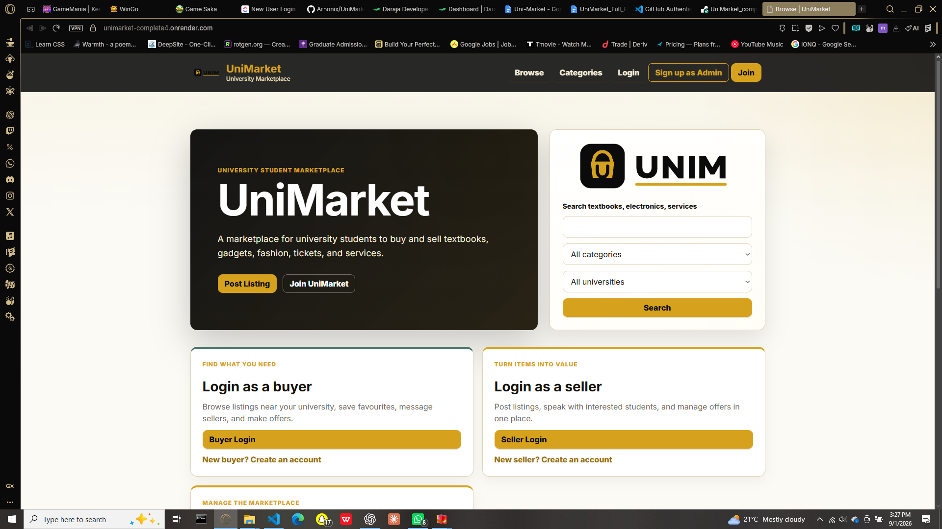
Figure 6.1: UniMarket Public Landing and Listing Search Interface
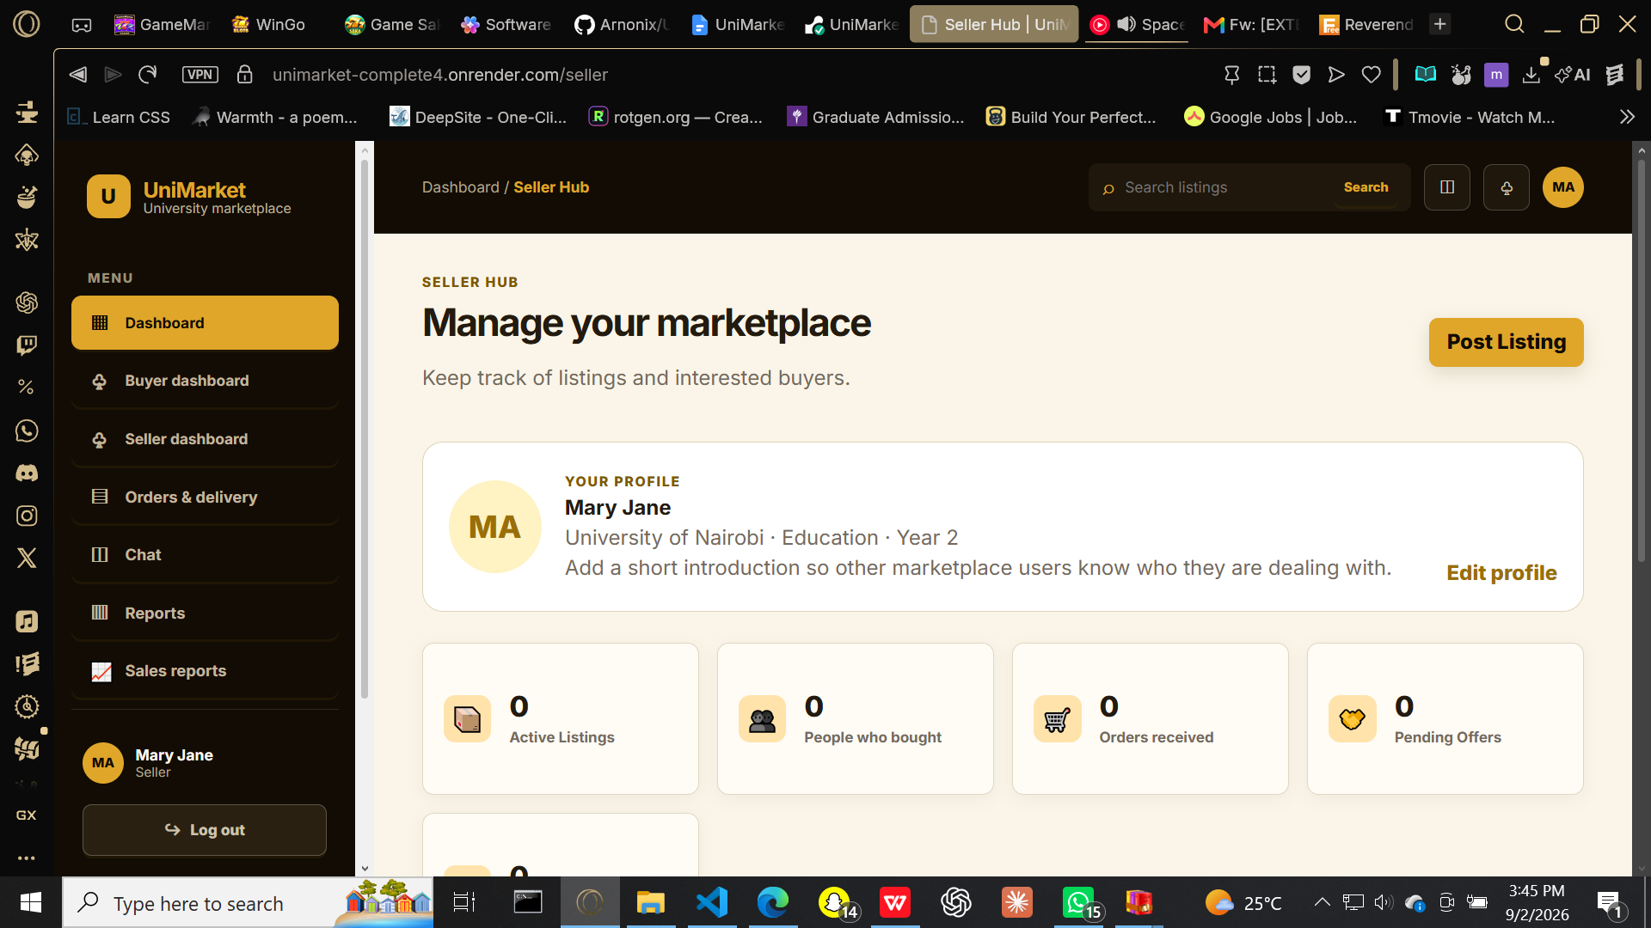
Figure 6.2: UniMarket Seller Hub Dashboard

6.4 Testing Plan
Testing is organised around the functional and non-functional requirements defined in Chapter Five. Each test case should record its identifier, precondition, procedure, expected outcome, observed outcome, tester, date and pass/fail result. The supplied release notes record smoke testing of public pages and authenticated buyer, seller, administrator and superadministrator flows. The test plan below provides the formal record structure for final verification and regression testing.
ID | Test procedure | Expected result
TC-01 | Register a new user, verify the account and attempt duplicate registration. | A valid account is created and an existing e-mail address is rejected with a clear message.
TC-02 | Log in with valid and invalid credentials; attempt protected routes without the required role. | Valid credentials create a session; invalid or unauthorised access is rejected.
TC-03 | Create and edit a listing, then submit a form with incomplete or invalid data. | Valid listings are stored and displayed; invalid input is not persisted.
TC-04 | Browse, filter and open listings; add and remove a wishlist item. | The relevant listing data is shown and the wishlist update is retained.
TC-05 | Place an order, update payment and delivery status, and inspect the receipt/tracking view. | The order remains associated with the correct buyer, seller, listing and payment record.
TC-06 | Initiate and process an M-Pesa payment through the order workflow. | Payment status and transaction/receipt information are updated against the correct order.
TC-07 | Report a listing and resolve it as an administrator. | The report is recorded, actionable by an administrator and auditable through its status.
TC-08 | Generate a date-filtered transactions, users, buyers or listings CSV report. | The requested report downloads with the correct selected data and date range.
Table 6.3: Functional Test Plan

6.4.1 Security, Usability and Performance Tests
ID | Test | Acceptance criterion
NT-01 | Submit a state-changing request with a missing or invalid CSRF token. | The request is rejected and no unauthorized data change occurs.
NT-02 | Try a negative price, mismatched password confirmation and incomplete required fields. | The user receives guidance and server validation prevents invalid database records.
NT-03 | Inspect key pages on desktop and mobile-sized viewports. | Navigation, forms and listing cards remain readable and usable without horizontal scrolling.
NT-04 | Measure normal browsing, listing and order actions during pilot use. | Common actions respond promptly and errors are captured for correction.
NT-05 | Attempt repeated failed logins and access to another userâ€™s restricted actions. | Rate limiting, session checks and authorisation controls prevent unauthorised use.
Table 6.4: Non-Functional Testing Plan

6.5 Evaluation Plan
Evaluation will be conducted after the test cases have passed. A pilot group of approximately twenty students and two administrators will use test accounts and sample listings to complete representative tasks: discover an item, contact or order from a seller, complete an M-Pesa-supported payment step, track an order, save/report a listing, and moderate a report. Observation and a short post-task questionnaire will collect both task-completion evidence and user perceptions.
Dimension | Evidence | Success indicator
Functional suitability | Task-completion records for account, listings, orders, M-Pesa and moderation. | Core tasks complete without a critical failure.
Usability | Observation notes and questionnaire ratings for clarity, navigation and feedback. | Users complete primary tasks with minimal assistance.
Trust and safety | Feedback on verification, M-Pesa records, reviews, reports and privacy controls. | Users understand the available accountability and payment-tracking features.
Administrator usefulness | Administrator completion of report, suspension and export tasks. | Moderators can locate and action relevant information efficiently.
Table 6.5: Evaluation Plan

6.6 Chapter Summary
This chapter presented the implementation of UniMarket as a Python, SQLite, HTML, CSS and JavaScript web application. The completed system supports role-based marketplace use, listings, orders, M-Pesa payment handling, delivery tracking, reviews, reporting and administration. It also defined a concise four-screen evidence plan, formal functional and non-functional test cases, and a pilot evaluation approach. The next chapter presents the conclusions, findings, challenges and recommendations arising from the project.

CHAPTER SEVEN:CONCLUSIONS, FINDINGS AND RECOMMENDATIONS
7.1 Introduction
This chapter contains concluding observations of the design and implementation of the UniMarket system. It highlights the results, challenges encountered in the process, and recommendations for future development and deployment of the web application.
7.2 Findings of the Study
The study revealed that the informal trading practices among students using WhatsApp groups, social media, and notice boards lack a search feature that makes it difficult to compare available advertisements. In addition, it lacks mechanisms for ensuring accountability, providing a uniform reporting channel, and protecting the involved parties from malpractices. Therefore, an appropriate marketplace website was necessary to address these issues.
The analysis of the implemented system shows that it can facilitate a majority of the activities carried out in the informal student trading platforms. It provides a medium for creating advertisements, having dashboards for different user roles, communicating, managing orders, tracking delivery, and reviewing or reporting on products and services. By consolidating this information in one platform and having the necessary administrative tools, the application can help in addressing the shortcomings of informal student trading in the university.
The technical aspects of the project were appropriate for the prototype application being developed. Python and SQLite allowed developing the application without the need to install and maintain a separate database server or run-time environment for the application. The use of server-side rendering eliminated the need to configure robust client machines, while features such as hashing, tokens, CSRF protection, and validation enhanced security and integrity of the system. Moreover, the implementation of role-based access and other security measures such as rate limiting helped protect the system and its features.
7.3 Conclusion
The objective of this project was to design and develop a prototype of a web-based marketplace to facilitate student trading at CUEA. The system helps address the shortcomings of the informal platforms used by students. It allows students to advertise products and services and search for items of interest. The system also helps track the order process, including M-Pesa transactions, delivery status, and product reviews. Besides the features, the use of dashboards by the administrators contributes to accountability by enabling a formal mechanism for complaints, content management, and user moderation.
While this system was developed as a prototype, it can be considered for deployment after further development and testing based on the findings and recommendations. It is designed to be a digital platform for students to post advertisements, interact with others, and manage transactions and reviews. It has several features that, if maintained, can enhance accountability in student trading, including tracking of delivery and payments.

7.4 Challenges Encountered
Challenge | Effect on the project | Response / lesson
Defining a bounded scope | A marketplace can expand quickly to include logistics, payments, recommendations and many user types. | Core student trading, orders, M-Pesa tracking and moderation were prioritised; future extensions were separated from the core release.
Trust and safety requirements | Peer-to-peer trading requires protection against fraudulent listings and unauthorised actions. | The system incorporated verification, reporting, reviews, administrator controls, sessions, CSRF protection and rate limits.
Payment and delivery coordination | Orders require a clear relationship between a buyer, seller, payment state and delivery progress. | The implementation separates payment and delivery status and records M-Pesa-related transaction information against the order.
Testing diverse roles | Buyer, seller, administrator and superadministrator flows have different permissions and outcomes. | Role-specific dashboards and test cases were defined to verify each authorised workflow.
Resource constraints | The project was implemented within an academic time frame and without enterprise infrastructure. | A standard-library backend and SQLite reduced deployment and dependency overhead.
Table 7.1: Challenges Encountered and Responses

7.5 Recommendations for Future Work
First, the system should be piloted with a larger and more diverse group of CUEA students and administrators. Pilot results should be used to measure task completion, usability, trust and performance, and to prioritise changes based on real user evidence.
Second, the M-Pesa component should continue to be strengthened through operational monitoring, reconciliation, retry handling, secure management of production credentials and clear handling of failed, delayed or reversed transactions. Payment and receipt records should be reviewed regularly to ensure that order status accurately reflects the transaction lifecycle.
Third, future versions may introduce a dedicated mobile application or a documented API to improve convenience for mobile-first users. Additional enhancements may include more advanced search, listing recommendations, notification preferences, improved image moderation, dispute-resolution workflows and analytics for administrators.
Finally, any broader deployment should be supported by a university-approved governance process covering acceptable use, personal-data handling, retention, moderation responsibilities, incident response, routine database backup and user awareness on safe online trading practices.

7.6 Final Conclusion
UniMarket demonstrates that a university-focused marketplace can address the shortcomings of informal student trading with a manageable, secure and structured web solution. By combining listings, role-based accounts, orders, M-Pesa payment records, delivery tracking, reviews and moderation, the system provides a credible foundation for safer and more efficient campus commerce. Continued testing, user feedback and carefully governed deployment will be essential to its sustained usefulness.

REFERENCES
Kendall, K. E., & Kendall, J. E. (2019). Systems analysis and design (10th ed.). Pearson.
Kreibich, J. A. (2010). Using SQLite. O'Reilly Media.
Laudon, K. C., & Laudon, J. P. (2020). Management information systems: Managing the digital firm (16th ed.). Pearson.
Pressman, R. S., & Maxim, B. R. (2020). Software engineering: A practitioner's approach (9th ed.). McGraw-Hill.
Stair, R., & Reynolds, G. (2018). Principles of information systems (13th ed.). Cengage.
Aggarwal, C. C. (2020). Recommender systems: The textbook. Springer.
Amazon. (2023). Amazon marketplace: Seller solutions. Amazon.com.
Armbrust, M., Fox, A., Griffith, R., Joseph, A. D., Katz, R., Konwinski, A., Lee, G., Patterson, D., Rabkin, A., Stoica, I., & Zaharia, M. (2010). A view of cloud computing. Communications of the ACM, 53(4), 50â€“58.
Chapin, N. (1970). Flowcharts. Auerbach Publishers.
Codd, E. F. (1970). A relational model of data for large shared data banks. Communications of the ACM, 13(6), 377â€“387.
Cohen, A. (2002). The perfect store: Inside eBay. Little, Brown and Company.
Communications Authority of Kenya. (2023). ICT sector statistics report. CA Kenya.
Creswell, J. W., & Creswell, J. D. (2018). Research design: Qualitative, quantitative, and mixed methods approaches (5th ed.). SAGE Publications.
eBay Inc. (2023). eBay Inc. 2022 annual report. eBay.
Einav, L., Farronato, C., & Levin, J. (2016). Peer-to-peer markets. Annual Review of Economics, 8(1), 615â€“635.
Elmasri, R., & Navathe, S. B. (2015). Fundamentals of database systems (7th ed.). Pearson.
Evans, D. S., & Schmalensee, R. (2016). Matchmakers: The new economics of multisided platforms. Harvard Business Review Press.
Jiji Kenya. (2023). About Jiji Kenya. Jiji.co.ke.
Jumia Group. (2023). Jumia annual report 2022. Jumia Technologies AG.
Kitchenham, B. (2004). Procedures for performing systematic reviews. Keele University Technical Report TR/SE-0401.
Kvale, S. (2009). InterViews: Learning the craft of qualitative research interviewing (2nd ed.). SAGE Publications.
Laudon, K. C., & Traver, C. G. (2021). E-commerce 2021: Business, technology, society (17th ed.). Pearson.
Mas, I., & Radcliffe, D. (2010). Mobile payments go viral: M-PESA in Kenya. World Bank Publications.
Meta. (2023). Meta platforms Q4 2022 earnings. Meta Platforms Inc.
Mitchell, T. M. (1997). Machine learning. McGraw-Hill.
Molyneaux, I. (2014). The art of application performance testing (2nd ed.). O'Reilly Media.
Myers, G. J., Sandler, C., & Badgett, T. (2011). The art of software testing (3rd ed.). Wiley.
Nakamoto, S. (2008). Bitcoin: A peer-to-peer electronic cash system. https://bitcoin.org/bitcoin.pdf
Nielsen, J. (1994). Usability engineering. Morgan Kaufmann.
NIST. (2011). The NIST definition of cloud computing (SP 800-145). National Institute of Standards and Technology.
Norman, D. A. (1988). The design of everyday things. Basic Books.
Oppenheim, A. N. (2000). Questionnaire design, interviewing and attitude measurement. Continuum.
OWASP Foundation. (2021). OWASP Top Ten. https://owasp.org/www-project-top-ten/
Resnick, P., & Varian, H. R. (1997). Recommender systems. Communications of the ACM, 40(3), 56â€“58.
Resnick, P., & Zeckhauser, R. (2002). Trust among strangers in internet transactions. The Economics of the Internet and E-Commerce, 11, 127â€“157.
Russell, S., & Norvig, P. (2021). Artificial intelligence: A modern approach (4th ed.). Pearson.
Sundararajan, A. (2016). The sharing economy. MIT Press.
Suri, T., & Jack, W. (2021). The long-run poverty and gender impacts of mobile money. Science, 354(6317), 1288â€“1292.
Tapscott, D., & Tapscott, A. (2018). Blockchain revolution. Portfolio/Penguin.
Virrantaus, K., Markkula, J., Garmash, A., & Terziyan, V. (2001). Developing GIS-supported location-based services. Proceedings of WGIS, 1, 423â€“432.
W3C. (2022). Geolocation API specification. World Wide Web Consortium.
Yourdon, E. (1989). Modern structured analysis. Prentice-Hall.
Zhang, S., Yao, L., Sun, A., & Tay, Y. (2019). Deep learning based recommender system. ACM Computing Surveys, 52(1), 1â€“38.

APPENDICES

Appendix A: Project Schedule (Gantt Chart)
Phase / Activity | Wk 1-4 | Wk 5-9 | Wk 10-14 | Wk 15-19 | Wk 20-23 | Wk 24-27 | Wk 28-30
Design and planning | ●
Frontend development |  | ● | ● |  | ● | ● | ●
UI and communication |  |  | ● |  | ● | ● | ●
Backend development |  |  |  | ● | ● | ● | ●
Security implementation |  |  |  |  | ● | ● | ●
Admin |  |  |  |  |  | ● | ●
Testing & Writeup |  |  | ● |  | ● |  | ●
Table A.1: Project Gantt Chart

Appendix B: Project Budget
Item | Est. Cost (KES) | Notes
Internet access (30 weeks) | 22,500 | 750 KES/week
Travel (data collection & interviews) | 4,500 | Transport to/from fieldwork sites
Printing & binding (proposal + final) | 1,200 | 2 copies
Stationery & miscellaneous | 500
Total | 28,700
Table B.1: Project Budget

Appendix C: Sample Questionnaire
Title: UniMarket University Student Marketplace Platform â€“ Student Needs Assessment
Instructions: This questionnaire is part of a final year computer science research project at CUEA. Your responses are anonymous and will only be used for academic purposes. The questionnaire is available electronically at: https://forms.gle/UniMarketSurvey. Please tick or circle the most appropriate answer.
Section 1: Demographics
1. What is your faculty? [ ] Science [ ] Commerce [ ] Arts [ ] Education [ ] Other
2. What year of study are you in? [ ] Year 1 [ ] Year 2 [ ] Year 3 [ ] Year 4
Section 2: Current Trading Habits
3. Have you ever bought or sold items with fellow students? [ ] Yes [ ] No
4. Which channels do you currently use? (Tick all that apply) [ ] WhatsApp [ ] Facebook [ ] Notice boards [ ] Word of mouth [ ] Other
5. How satisfied are you with your current trading methods? [ ] Very satisfied [ ] Satisfied [ ] Neutral [ ] Dissatisfied [ ] Very dissatisfied
Section 3: Platform Feature Preferences
6. How important is a ratings and reviews system? [ ] Very important [ ] Important [ ] Neutral [ ] Not important
7. Would you use a price negotiation feature? [ ] Yes [ ] Maybe [ ] No
8. Would you find geolocation-based listing filtering (items near you) useful? [ ] Yes [ ] Maybe [ ] No
9. Which product categories would you most like to buy or sell? (Rank 1â€“5) [ ] Textbooks [ ] Electronics [ ] Clothes [ ] Event tickets [ ] Services

Appendix D: Sample Interview Questions
Interview Guide: UniMarket Platform Key Informant Interview
Target Interviewees: Student representatives, ICT officer, university administration
1. In your experience, what are the most common challenges students face when trying to trade goods or services with each other on campus?
2. What features would you consider essential in a digital student marketplace platform?
3. What concerns, if any, would you have about a student marketplace operating within the university community?
4. What role, if any, should the university administration play in overseeing such a platform?
5. What would encourage or discourage students from using such a platform?
6. Are there any existing systems or processes at CUEA that a student marketplace should integrate with or be aware of?
7. Do you believe a platform designed at CUEA could be adapted for use at other universities? What would be required?

