CATHOLIC UNIVERSITY OF EASTERN AFRICA
SCHOOL OF SCIENCE
DEPARTMENT OF COMPUTER SCIENCE
REVISED PROJECT DOCUMENTATION
CHAPTERS FOUR TO SEVEN
DESIGN AND IMPLEMENTATION OF A WEB-BASED STUDENT MARKETPLACE
Prepared by: Moses Maranga (1050896)
September 2026
Revised to align with the supplied institutional documentation guidelines.

CONTENTS
This document contains revised Chapters Four to Seven for insertion into the complete project report. The chapter sequence follows the supplied guidelines: system analysis; system design; implementation and testing; and conclusions, findings and recommendations. When the complete report is assembled, update the automatic table of contents, list of figures and list of tables in Microsoft Word.
CHAPTER FOUR: SYSTEM ANALYSIS
4.1 Introduction
4.2 Description of the Current System
4.3 Feasibility Study
4.4 Requirements Analysis
4.5 System Analysis and Process Logic
4.6 Chapter Summary
CHAPTER FIVE: SYSTEM DESIGN OF THE PROPOSED SYSTEM
5.1 Introduction
5.2 Description of the Proposed System
5.3 Conceptual Architecture
5.4 Process Design
5.5 Database Design
5.6 Input and Output Design
5.7 Chapter Summary
CHAPTER SIX: SYSTEM IMPLEMENTATION AND TESTING
6.1 Introduction
6.2 System Implementation
6.3 Selected System Screens
6.4 Testing Plan
6.5 Evaluation Plan
6.6 Chapter Summary
CHAPTER SEVEN: CONCLUSIONS, FINDINGS AND RECOMMENDATIONS
7.1 Introduction
7.2 Findings
7.3 Conclusion
7.4 Challenges Encountered
7.5 Recommendations for Future Work
7.6 Final Conclusion
REFERENCES

CHAPTER FOUR
SYSTEM ANALYSIS

4.1 Introduction
This chapter analyses the current student trading process at the Catholic University of Eastern Africa (CUEA) and establishes the requirements that inform the design of UniMarket. The current process is treated as an informal socio-technical system because it combines student actions, communication channels, physical meetings and payment practices rather than operating through one dedicated application. The analysis covers the current system, its strengths and weaknesses, feasibility, requirements, data inputs and outputs, actors, and process logic. The chapter uses the diagrams in Figures 4.1 to 4.4 to show the current system boundary and the flow of information.
The analysis is deliberately separated from the proposed design. This distinction makes it possible to demonstrate the gap that UniMarket addresses and prevents features of the proposed system from being presented as if they already exist in the current process.

4.2 Description of the Current System
Student buying and selling at CUEA is mainly conducted through WhatsApp groups, Facebook groups or Marketplace, physical notice boards and word-of-mouth referrals. These channels are useful communication spaces, but they were not designed to manage structured listings, identity verification, transaction records, moderation or delivery status. A seller normally photographs an item, writes a short description, adds a price and shares a contact number. Interested buyers respond through a message or phone call, after which the parties negotiate and agree on a meeting place and payment method.
The buying process begins when a student identifies a need and searches message histories, social-media posts or notice boards. If no suitable item is found, the student asks peers or posts a request in a group. The process is therefore dependent on timing, group membership and the continued visibility of a message. A listing may remain visible after an item has been sold, while a genuine listing may be missed because it was posted in a different group.
Service providers face an additional challenge because services such as tutoring, photography, graphic design and hairdressing do not have a consistent directory or category. Providers repeatedly advertise in groups, and buyers have no common place to compare service descriptions, prices, availability or feedback. Figure 4.1 summarises the boundary of this informal system and the external parties that interact with it.
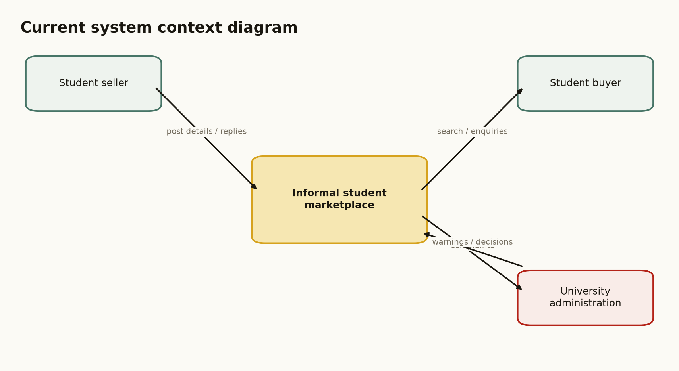
Figure 4.1: Context diagram of the current informal student marketplace system.
The figure is cited here because it identifies the current system boundary, the student seller, the student buyer and university administration as the main external entities.

4.2.1 Strengths of the Current System
• Low entry barrier: students can participate using communication tools they already have, without creating a new account.
• Familiarity: WhatsApp, Facebook and physical notice boards are already known to the target users, reducing the learning required at the start.
• Rapid communication: interested parties can contact one another immediately and can arrange urgent exchanges quickly.
• Social familiarity: shared groups and peer referrals provide an informal trust signal, although this does not replace formal verification or transaction records.
• Low direct operating cost: the current process does not require students to pay for a dedicated marketplace service.

4.2.2 Weaknesses of the Current System
The strengths above explain why the current process continues to be used, but they do not remove its structural weaknesses. The weaknesses are summarised in Table 4.1 and provide the direct justification for a dedicated student marketplace.
Table 4.1: Weaknesses of the current informal student marketplace system
Weakness | Effect on users
Fragmented discovery | Buyers search across several groups and channels, making relevant listings difficult to find.
No structured listing data | Descriptions, prices, locations and item conditions are inconsistent and incomplete.
Stale advertisements | Sold items may remain visible because there is no shared sold or expired status.
Limited accountability | Identity, reviews, complaints and transaction history are not managed in one place.
Unlinked conversations | Negotiation messages are separated from the listing and may be lost in busy group histories.
Weak moderation | There is no consistent process for reporting, reviewing and restricting abusive accounts or listings.
Poor service discoverability | Service providers have no common directory, category or reputation record.
Unclear payment evidence | M-Pesa or cash payments are not systematically linked to an order or item.

4.3 Feasibility Study
The feasibility study evaluates whether UniMarket can be developed and used within the project constraints. The assessment covers technical, economic, operational and schedule feasibility. The conclusion is based on the implemented prototype, the selected technologies, the identified users and the project schedule, rather than on an assumption that a full commercial marketplace can be delivered by one student.

4.3.1 Technical Feasibility
UniMarket is technically feasible because the selected technologies are accessible and adequate for a prototype. The backend uses Python 3 and the standard library, SQLite provides local relational persistence, and the interface uses HTML5, CSS3 and limited JavaScript. The application supports role-based access, listing management, messaging, orders, reporting and administrative moderation. The M-Pesa component is implemented around the Daraja OAuth and STK Push flow, but production operation depends on valid Safaricom credentials, a registered Paybill or Till and a public HTTPS callback URL. Render provides a suitable deployment target for the prototype. The technical conclusion is therefore positive, with production payment configuration treated as an external dependency.

4.3.2 Economic Feasibility
The prototype is economically feasible because Python, SQLite, HTML, CSS and JavaScript do not require licensing fees. The main project costs are internet access, data collection, testing, deployment-related services if required, transport and printing. The estimated project budget is presented in Appendix B of the complete report. The expected benefit is a structured marketplace that reduces the time required to discover items and provides a clearer record of interactions than the current process.

4.3.3 Operational Feasibility
The system is operationally feasible because the target users are already familiar with web and mobile services. UniMarket uses role-based dashboards and a consistent page shell to separate buyer, seller, administrator and superadministrator activities. University administrators can access seller information for their own institution, while superadministrators retain cross-institution oversight. Adoption will still require user onboarding, clear acceptable-use rules and a responsible process for handling complaints and personal data.

4.3.4 Schedule Feasibility
The project is schedule-feasible within the academic development period because its scope is bounded to the core marketplace workflow. The completed scope includes authentication, listings, search and filtering, buyer-seller Chat, orders, delivery status, reviews, reporting and administration. M-Pesa is included as a configured integration path and sandbox-ready flow; a real production transaction is not claimed until the external Go Live approval, credentials and deployment variables have been completed.

4.3.5 Feasibility Conclusion
The feasibility study concludes that UniMarket is suitable as an academic prototype and as a foundation for controlled institutional piloting. It is technically achievable, economically manageable, operationally appropriate for the target users and deliverable within the project schedule. A wider production rollout would require stronger infrastructure, formal institutional governance, backup procedures and completed payment-provider approval.
Table 4.2: Feasibility study summary
Dimension | Evidence | Conclusion
Technical | Python, SQLite, HTML/CSS/JavaScript, Render deployment and Daraja integration structure. | Feasible for prototype; production payments depend on external approval and credentials.
Economic | Open-source stack and manageable data collection, deployment and printing costs. | Feasible within the student project budget.
Operational | Digitally familiar users, role-specific dashboards and campus-oriented workflows. | Feasible subject to onboarding and governance.
Schedule | Bounded feature set and phased implementation plan. | Feasible within the academic project period.

4.4 Requirements Analysis
The requirements below were derived from the weaknesses of the current process, the project objectives and the implemented UniMarket prototype. They define what the proposed system must do, the quality conditions it must meet and the data required to support its operations.

4.4.1 Functional Requirements
Table 4.3: Functional requirements
ID | Requirement
FR1 | The system shall allow users to register, log in, verify an email address and reset a forgotten password.
FR2 | The system shall support buyer, seller, administrator and superadministrator access privileges.
FR3 | The system shall allow sellers to create, edit, view and mark listings as sold.
FR4 | The system shall allow buyers to browse, search and filter listings by category, university and price.
FR5 | The system shall support listing-specific conversations, offers, counters and offer expiry.
FR6 | The system shall create orders that separately record payment and delivery status.
FR7 | The system shall initiate an M-Pesa STK Push when the Daraja environment is correctly configured and shall update the order from the provider callback.
FR8 | The system shall support private delivery location sharing for authorised order participants.
FR9 | The system shall allow users to submit reviews and report suspicious listings.
FR10 | The system shall provide administrator moderation, seller visibility, admin-request review and CSV reports.
FR11 | Superadministrators shall view documents submitted with admin requests, while ordinary users shall not access those documents.
FR12 | University administrators shall view seller information and recent seller activity only for their own university; superadministrators may view all universities.

4.4.2 Non-Functional Requirements
Table 4.4: Non-functional requirements
Quality attribute | Requirement
Security | Passwords shall be hashed; protected actions shall use sessions, role checks and CSRF validation; sensitive credentials shall be stored as environment variables.
Privacy | Admin-request documents and order location data shall be restricted to authorised users.
Usability | Pages shall use consistent navigation, visible labels, clear status messages and responsive layouts.
Performance | Common page requests shall return without unnecessary external calls; the callback shall acknowledge quickly.
Reliability | Payment settlement shall depend on the provider callback and avoid duplicate updates.
Maintainability | Business functions, schema definitions and static assets shall remain separated and documented.
Scalability | The design shall identify SQLite and the thread-per-connection server as prototype constraints.

4.4.3 Data Requirements
Table 4.5: Data requirements
Data group | Examples | Purpose
Identity data | Name, email, phone, university, role, password hash. | Authentication, authorisation and institutional scoping.
Listing data | Title, category, description, price, condition, location, images, status. | Discovery and presentation of goods and services.
Communication data | Conversations, messages, offers, counter-offers. | Negotiation and buyer-seller accountability.
Transaction data | Buyer, seller, listing, amount, payment status, receipt, delivery status. | Order lifecycle and reconciliation.
Administration data | Reports, admin requests, application documents, review status. | Moderation, access approval and auditability.
Location data | Latitude, longitude, label and update time. | Private delivery tracking for an authorised order.

4.5 System Analysis and Process Logic
The current system is analysed using structured data-flow notation. The external entities are the student buyer, student seller and university administration. The system inputs include listing details, search queries, messages, offers, payment confirmations and complaints. The outputs include listing posts, replies, negotiated prices, exchanged items, informal payment evidence and administrative decisions.

4.5.1 Level 1 Data-Flow Analysis
Figure 4.2 decomposes the current system into posting, discovery, negotiation, exchange and complaint handling. Its data stores are not formal databases; they are communication channels and physical records. The diagram therefore shows both the presence of information and the absence of a central source of truth.
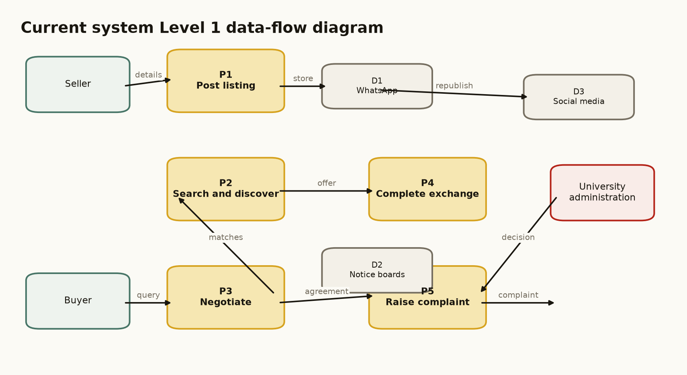
Figure 4.2: Level 1 data-flow diagram of the current informal student marketplace.
Figure 4.2 is cited here to show how the current process distributes listing information across several independent channels.

4.5.2 Current Selling Process
Figure 4.3 shows that the seller repeatedly moves between preparing a listing, posting it, waiting and responding. The loop is caused by the absence of a shared listing status, searchable catalogue and structured notification mechanism.
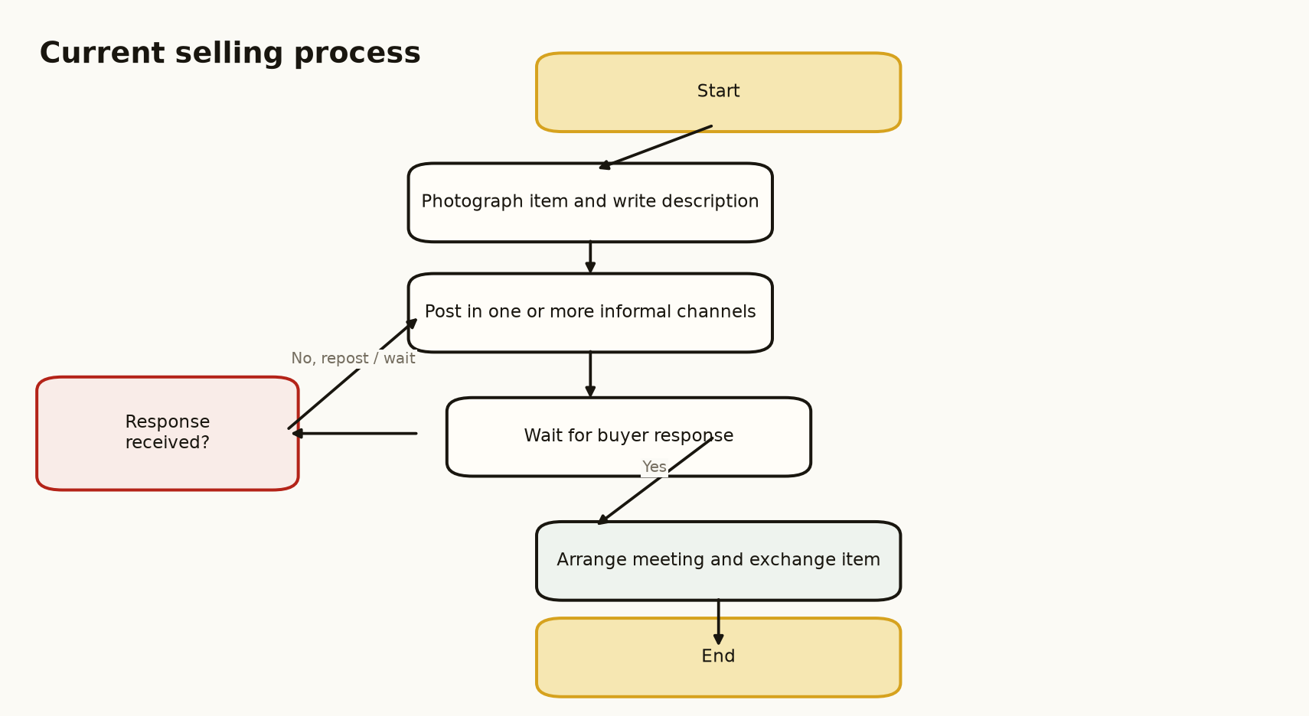
Figure 4.3: Flowchart of the current selling process.
The flowchart is cited in the discussion because it identifies the waiting and reposting loop that UniMarket is intended to reduce.

4.5.3 Current Buying Process
Figure 4.4 shows that the buyer searches several channels, broadens the search when no item is found and may retry the process when a seller is unavailable or an advertisement is stale. The process places the burden of coordination on the buyer and does not guarantee a complete record of the transaction.
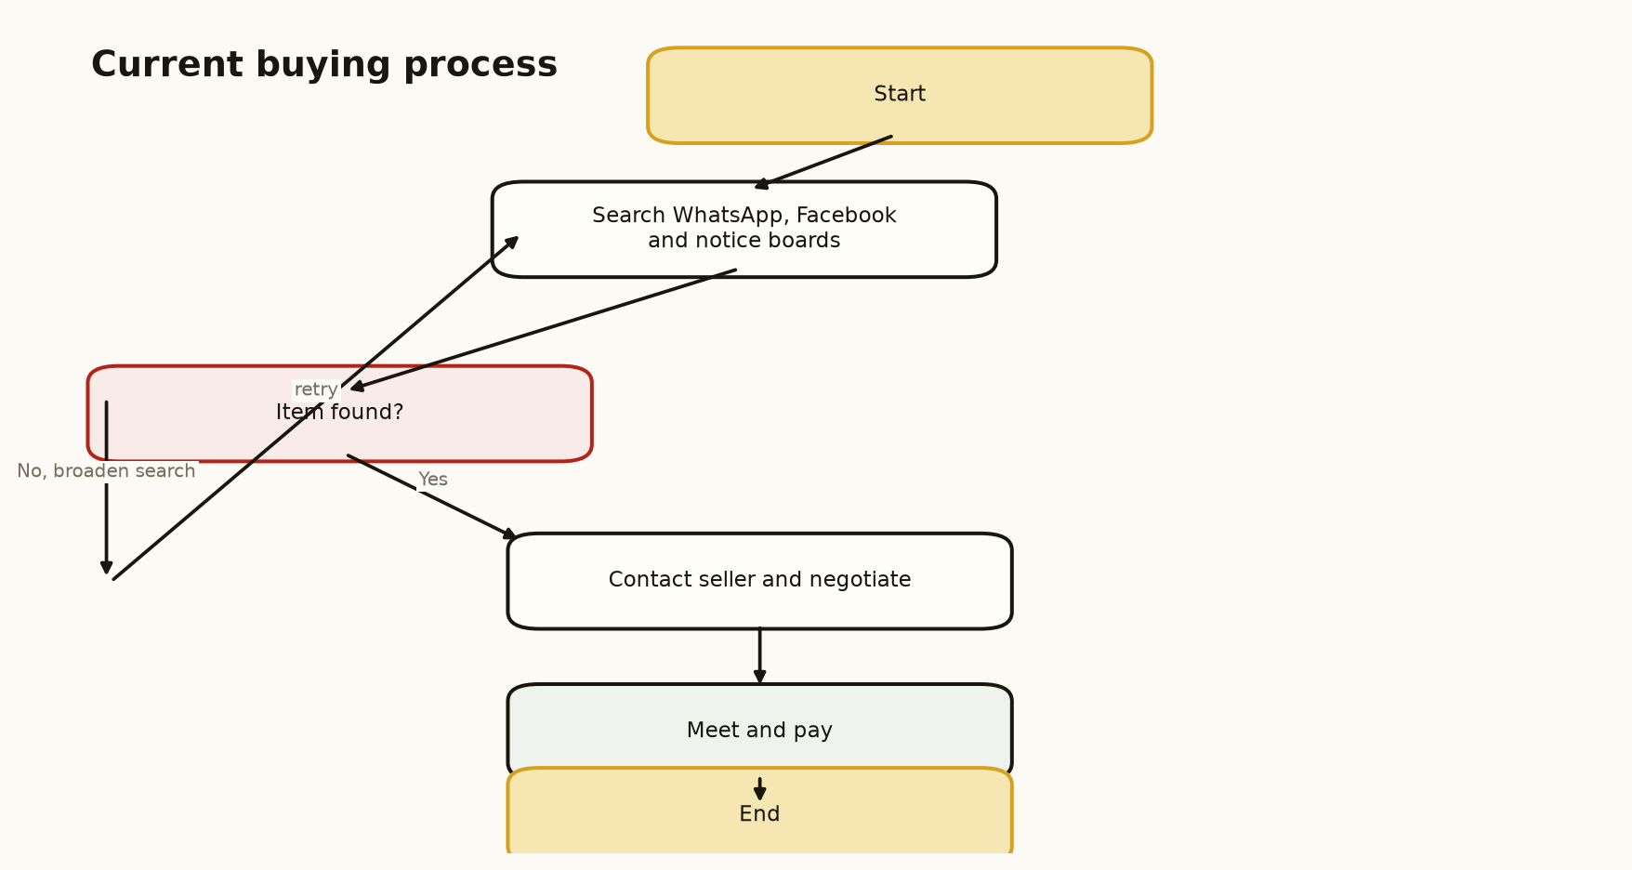
Figure 4.4: Flowchart of the current buying process.
The flowchart is cited here because it demonstrates the fragmented discovery path and the absence of a reliable completion state.

4.6 Chapter Summary
This chapter analysed the informal student marketplace at CUEA. The current system benefits from familiarity, low entry cost and rapid communication, but it is fragmented, difficult to search, weakly moderated and unable to maintain dependable links between listings, conversations, payments and complaints. The feasibility study found that UniMarket is appropriate as a bounded academic prototype. Functional, non-functional and data requirements were then defined, and the current process was modelled through a context diagram, a Level 1 DFD and two flowcharts. These findings provide the basis for the proposed system design in Chapter Five.

CHAPTER FIVE
SYSTEM DESIGN OF THE PROPOSED SYSTEM

5.1 Introduction
This chapter presents the design of UniMarket, the proposed web-based marketplace for university communities. The design responds directly to the weaknesses and requirements identified in Chapter Four. It specifies the proposed system, its strengths and limitations, conceptual architecture, process logic, database structure and input/output design. The design also incorporates the project decisions made during implementation: role-based administration, university-scoped seller visibility, protected admin-request documents, order-linked M-Pesa handling and responsive public information pages.

5.2 Description of the Proposed System
UniMarket is a server-rendered web application that allows university users to discover, list and exchange goods and services in a structured environment. A buyer can browse listings, save items, message a seller, submit an offer, place an order and monitor delivery status. A seller can create listings, manage offers and follow received orders. Administrators can moderate reports and review marketplace activity. Superadministrators can review admin applications and access the submitted identity documents. A regular university administrator sees seller information for the administrator’s own university only; this rule is enforced in the data queries rather than only in the interface.
The payment design supports Safaricom Daraja Lipa Na M-Pesa Express. The application obtains an OAuth token, creates the STK Push request, stores the CheckoutRequestID and waits for the asynchronous callback before marking the order as paid. The system is not described as a live payment service until production credentials, a registered shortcode, a public HTTPS callback and Safaricom approval are available.

5.2.1 Strengths of the Proposed System
• Centralised discovery through searchable, categorised listings.
• Improved accountability through authenticated roles, listing ownership, messages, offers, orders, reviews and reports.
• Institutional control through administrator and superadministrator functions.
• Privacy-aware access control for admin-request documents, order locations and university-scoped seller information.
• Low deployment complexity through a lightweight Python process and SQLite database.
• Clear payment lifecycle in which an STK Push acknowledgement is not treated as proof of payment; the provider callback is the settlement signal.

5.2.2 Weaknesses and Limitations
• SQLite is appropriate for a prototype but may become a write bottleneck at larger scale.
• The hand-written HTTP server and thread-per-connection model require replacement with a production-grade server for heavy traffic.
• The current server-rendered design does not provide a dedicated REST API for mobile clients.
• Email notifications depend on SMTP configuration, and payment operation depends on external Safaricom approval and credentials.
• Location tracking depends on user permission and should not be treated as continuous GPS monitoring.

5.3 Conceptual Architecture of the Proposed System
UniMarket follows a layered two-tier client-server architecture. The browser is the client tier and is responsible for presenting HTML and running limited progressive-enhancement JavaScript. The Python application is the server tier and handles transport, sessions, CSRF checks, routing, business rules and data access. SQLite provides persistence. Daraja, SMTP and map services are external integrations. Figure 5.1 shows the conceptual architecture and the direction of communication between its components.
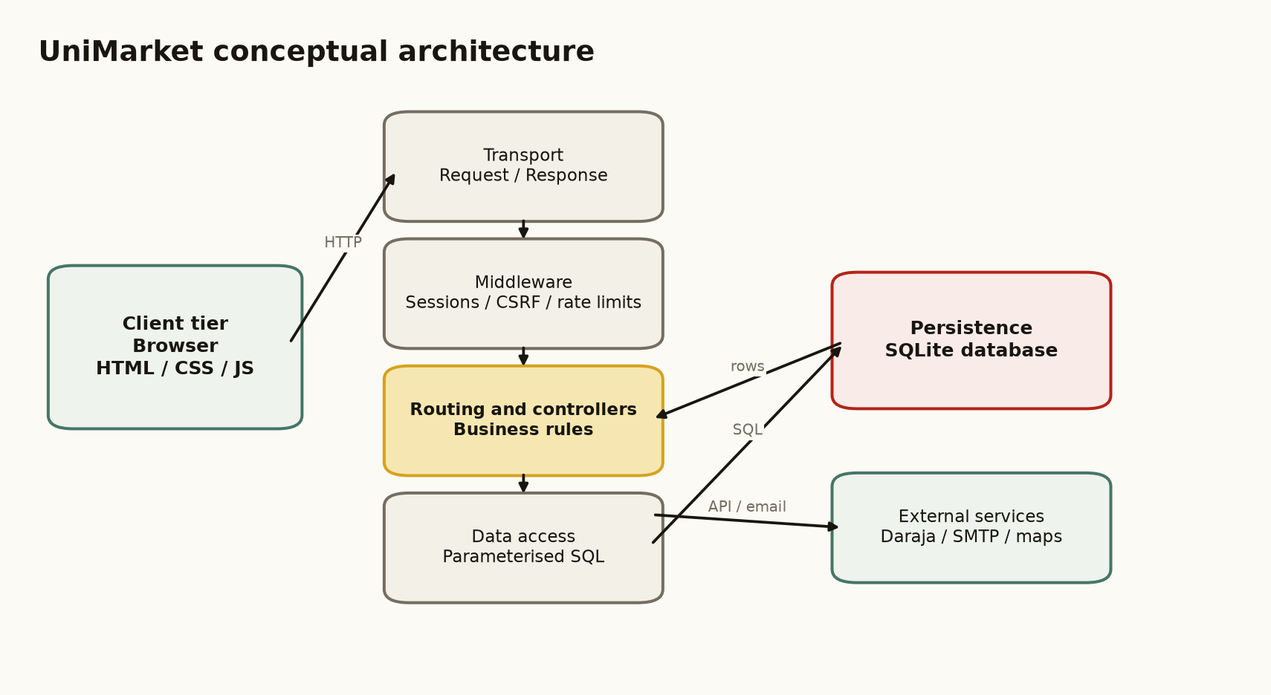
Figure 5.1: Conceptual architecture of the proposed UniMarket system.
The figure is cited here because it distinguishes the browser, application layers, database and external services.

5.4 Process Design

5.4.1 Proposed Context Diagram
In the proposed context diagram, buyers and sellers interact with UniMarket through structured accounts, listings, conversations and orders. Administrators provide moderation and approval decisions. Daraja exchanges payment requests and callback results with the application. Figure 5.2 defines the system boundary and the main external data flows.
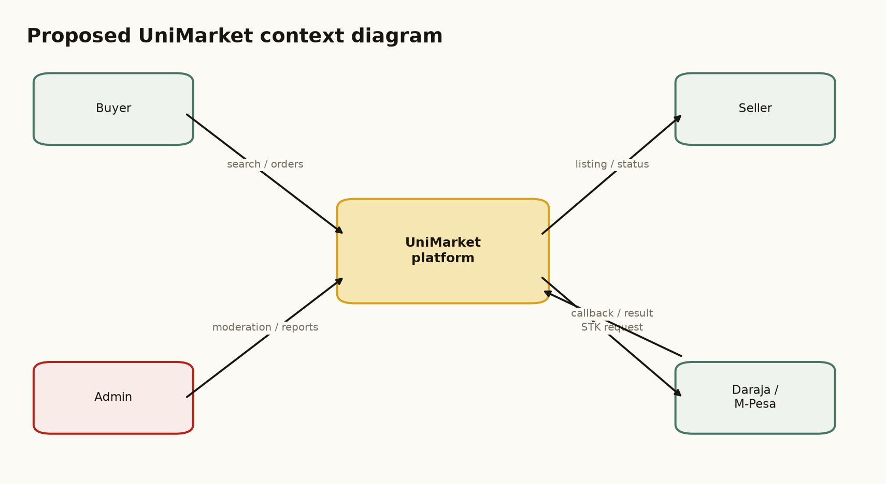
Figure 5.2: Proposed UniMarket context diagram.
Figure 5.2 is cited here to identify the external actors and services that exchange data with UniMarket.

5.4.2 Proposed Level 1 Data-Flow Diagram
The proposed Level 1 DFD decomposes UniMarket into five processes: account and access management; listing management; chat and offers; orders and payments; and moderation and reporting. Persistent data stores preserve the relationships that are missing from the current system. Figure 5.3 shows these processes and their main data flows.
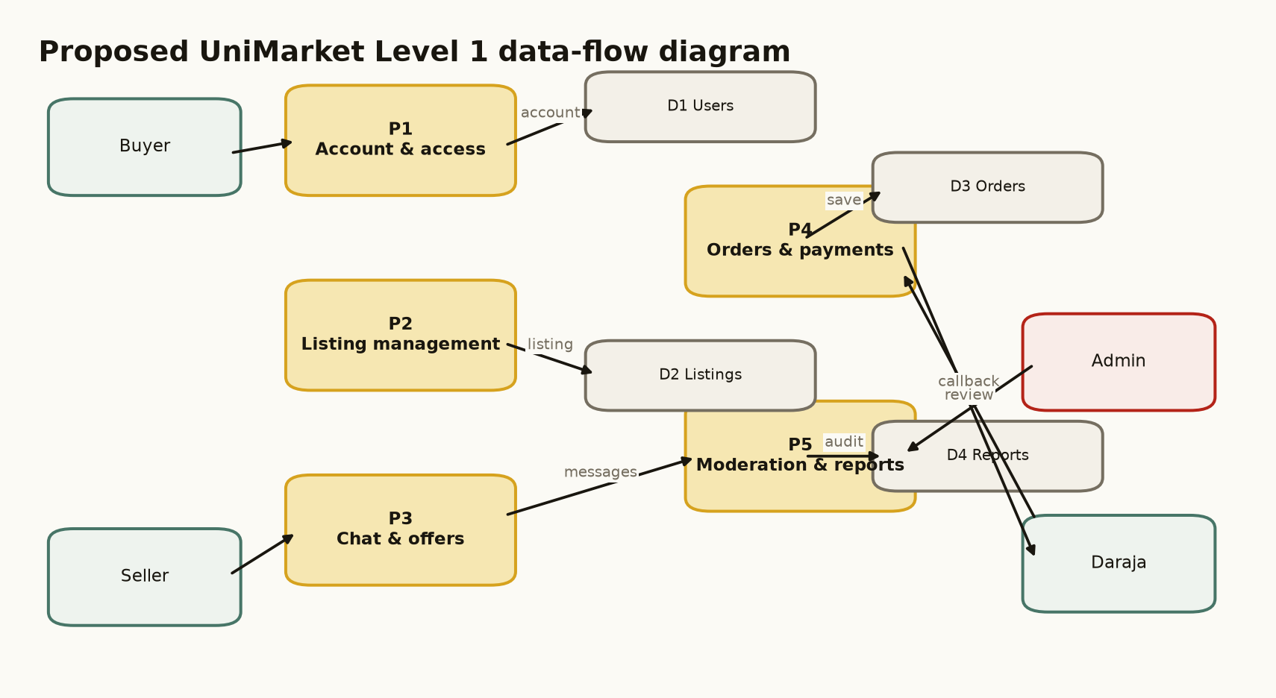
Figure 5.3: Proposed UniMarket Level 1 data-flow diagram.
The figure is cited here because it maps functional areas to persistent data stores and external interactions.

5.4.3 Use-Case Design
The main actors are the buyer, seller, administrator and superadministrator. A buyer registers, browses, communicates, makes offers, places orders, pays and reviews. A seller manages listings, responds to buyers and fulfils orders. An administrator manages reports and institution-scoped seller information. A superadministrator performs global administration and reviews administrator applications and their documents. Figure 5.4 presents the principal use cases.
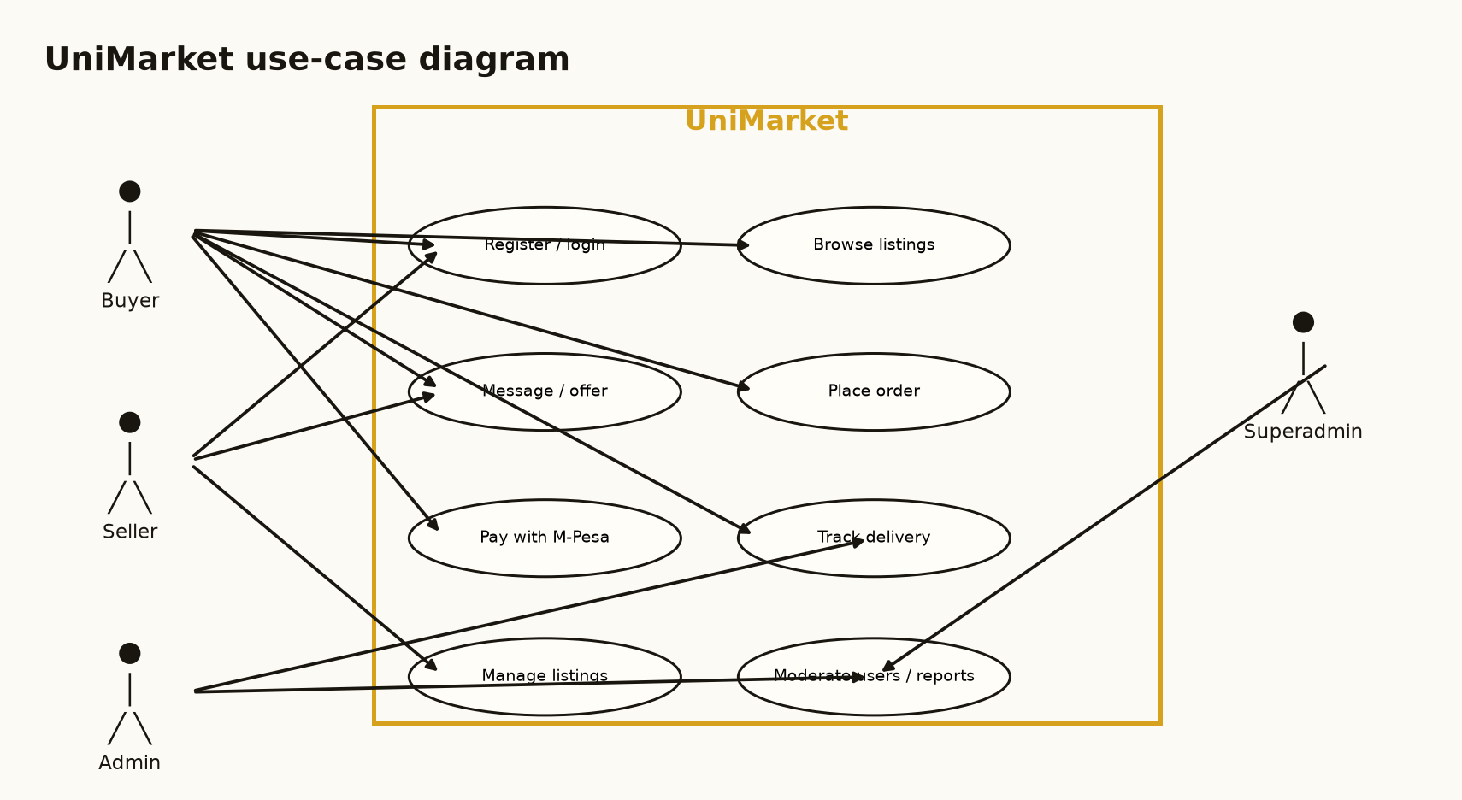
Figure 5.4: Principal UniMarket use cases.
The figure is cited here because it connects each actor to the services available within the system boundary.

5.4.4 Sequence Design for Ordering and Payment
The representative sequence begins when a buyer submits an order. UniMarket validates the buyer and order, requests an OAuth token from Daraja and sends an STK Push request. The application stores the CheckoutRequestID returned by Daraja. The buyer then receives a phone prompt and enters the PIN through Safaricom’s interface, not through UniMarket. Safaricom sends the result to the callback endpoint, after which UniMarket updates the payment and delivery state. Figure 5.5 presents this sequence. A successful STK Push response means that the prompt was accepted, not that the payment has been completed.
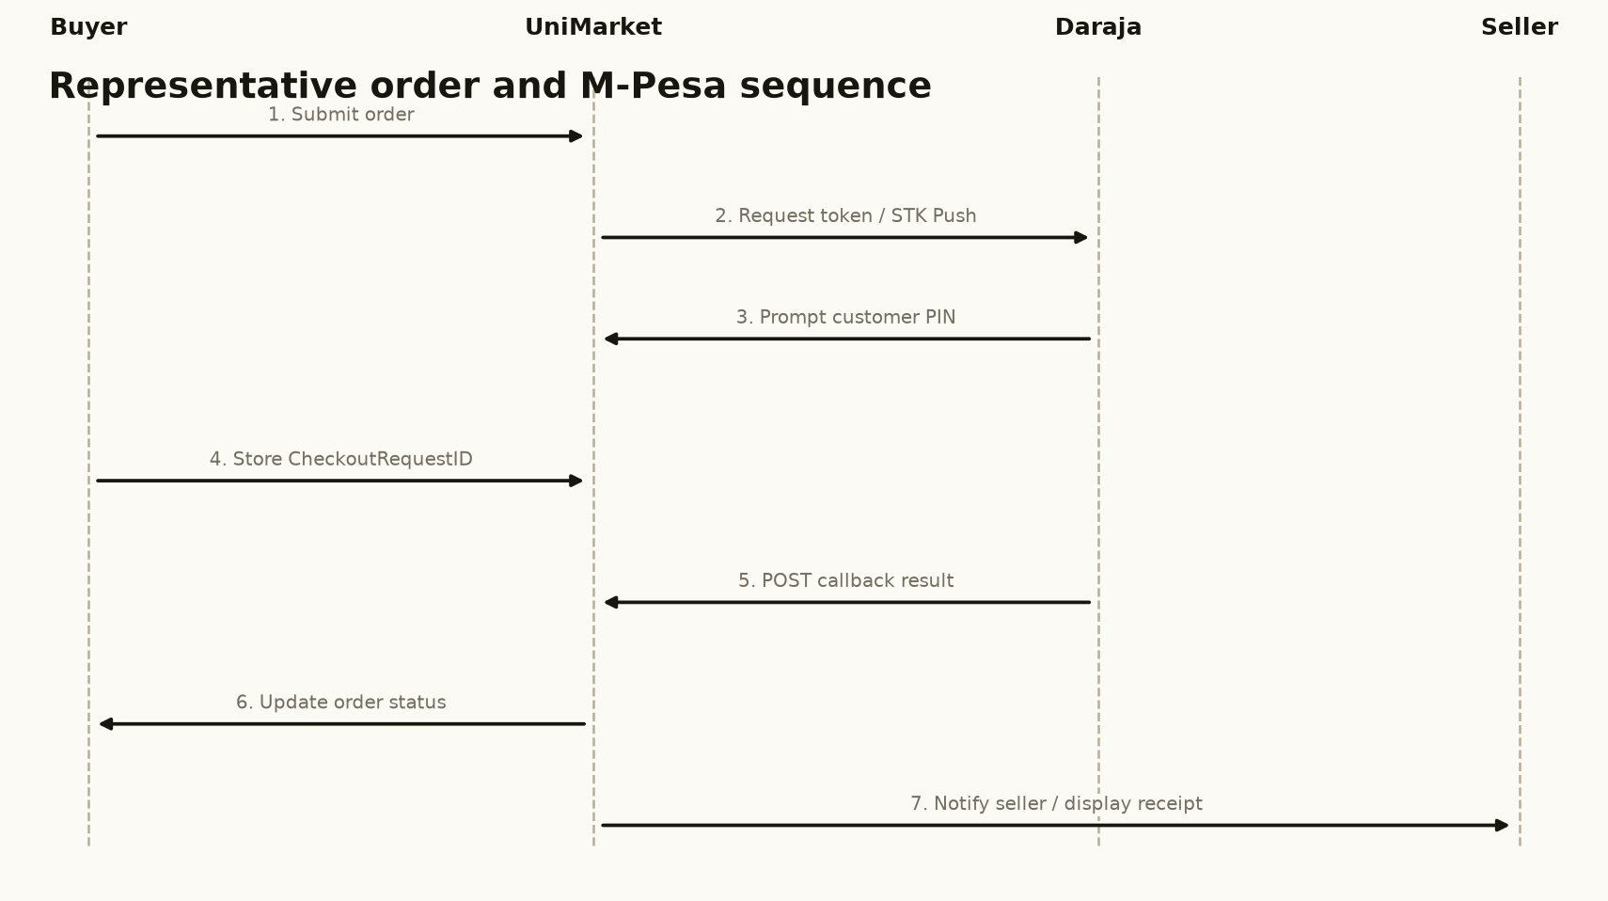
Figure 5.5: Sequence flow for an order and M-Pesa STK Push.
The sequence is cited here because it distinguishes request acceptance from confirmed payment.

5.4.5 Process Rules
Table 5.1: Selected process rules
Process | Rule
Authentication | Protected pages require a valid session; sensitive POST actions require CSRF validation.
Listing ownership | Only the listing owner can edit, bump or mark a listing as sold.
Offer lifecycle | Offers are pending until accepted, declined, cancelled or expired; a counter-offer retains the negotiation context.
Payment settlement | An order becomes paid only after a successful Daraja callback includes a receipt.
Document access | Admin-request documents are accessible only to superadministrators.
Institutional scope | A university admin’s seller queries include only sellers whose university matches the admin’s university.
Location privacy | Order location is shown only to authorised order participants and superadministrators.

5.5 Database Design
The database is implemented in SQLite and is created or migrated when the application starts. The design uses a central users table and related tables for listings, images, conversations, messages, offers, orders, reviews, reports, saved searches, sessions, admin requests and report requests. Figure 5.7 focuses on the core relationships. A complete data dictionary should be included in the final bound report if the department requires every supporting table to be documented.
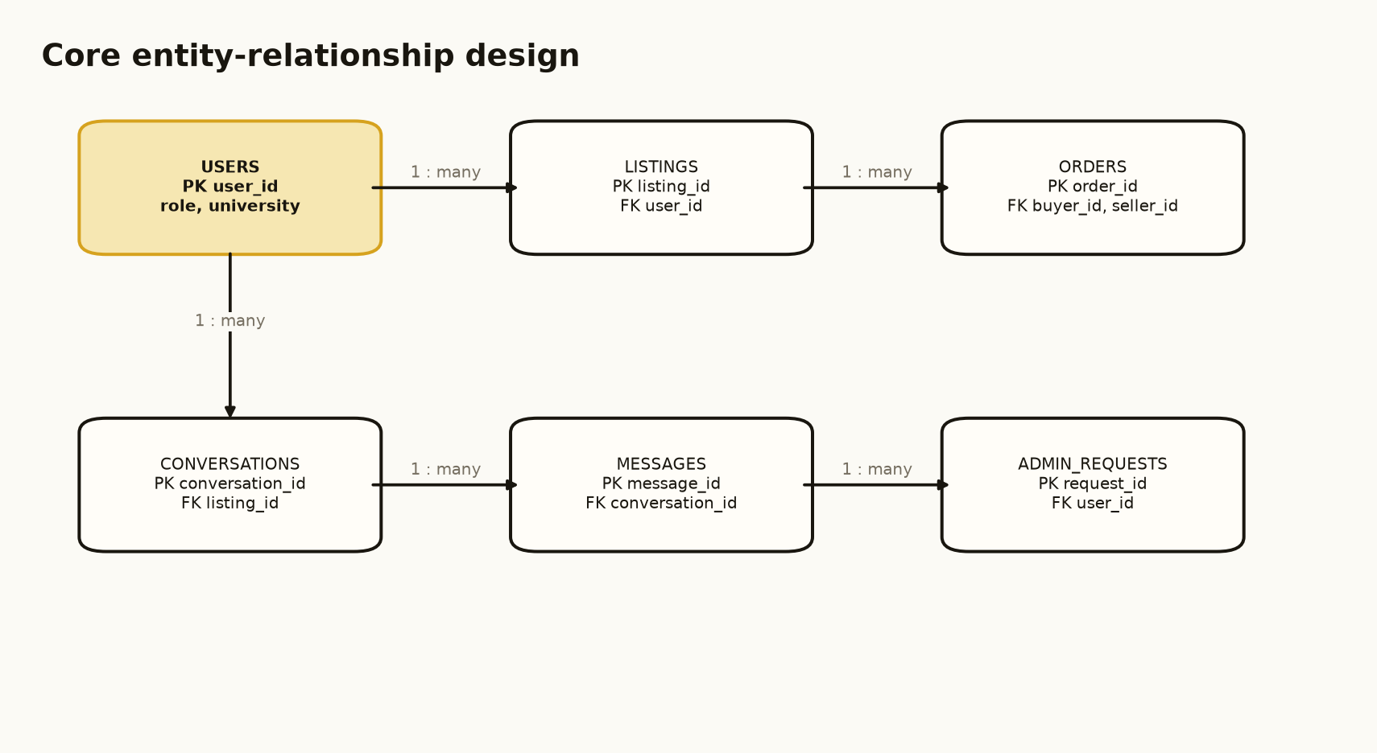
Figure 5.7: Core entity-relationship design for UniMarket.
The figure is cited here because it shows the primary one-to-many relationships between users, listings, orders, conversations, messages and admin requests.

5.5.1 Normalisation
The relational design follows Third Normal Form for the core entities. First Normal Form is supported by atomic fields and separate rows for listing images. Second Normal Form is supported by full dependence on the key in associative tables such as wishlist and recently viewed. Third Normal Form is supported by storing seller and buyer details in users and referencing them from listings and orders rather than duplicating personal details in every row. The offers table intentionally stores a counter price and note on the same negotiation row to represent the limited two-step offer workflow of this prototype.

5.5.2 Core Data Dictionary
Table 5.2: Core data dictionary
Entity | Key attributes | Purpose
users | user_id, name, email, phone, university, role, is_superadmin | Stores identity, role and institution information.
listings | listing_id, user_id, title, category, price, status, location | Stores goods and services offered by sellers.
conversations | conversation_id, listing_id, buyer_id, seller_id | Links a listing to one buyer-seller conversation.
messages | message_id, conversation_id, sender_id, receiver_id, body | Stores individual Chat messages.
offers | offer_id, listing_id, buyer_id, seller_id, amount, status | Stores price negotiations and counter-offers.
orders | order_id, listing_id, buyer_id, seller_id, amount, payment_status, delivery_status, receipt | Stores the transaction lifecycle and payment evidence.
admin_requests | request_id, user_id, staff_number, documents, status | Stores applications for administrator privileges.

5.6 Input and Output Design
The interface design uses a consistent public header, authenticated sidebar and footer. Inputs are collected through labelled forms with validation for required fields, phone format, prices, passwords and uploads. Outputs are returned as listing cards, dashboards, status chips, tables, reports and feedback messages. The following four mock-ups represent the main input/output surfaces and are suitable for Chapter Five. They are design-stage mock-ups; the implemented system screenshots are presented separately in Chapter Six.
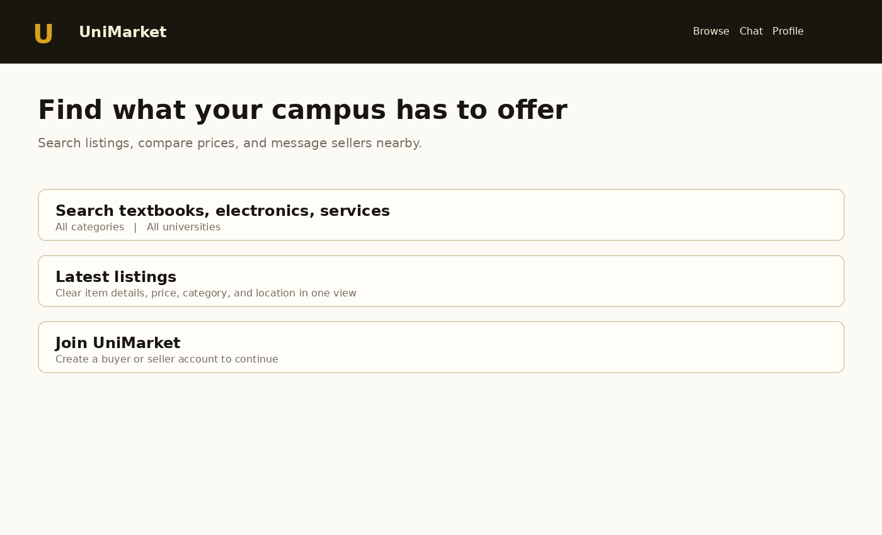
Figure 5.8: Mock-up of the home page and listing feed.
This screen prioritises discovery and the first buyer action.
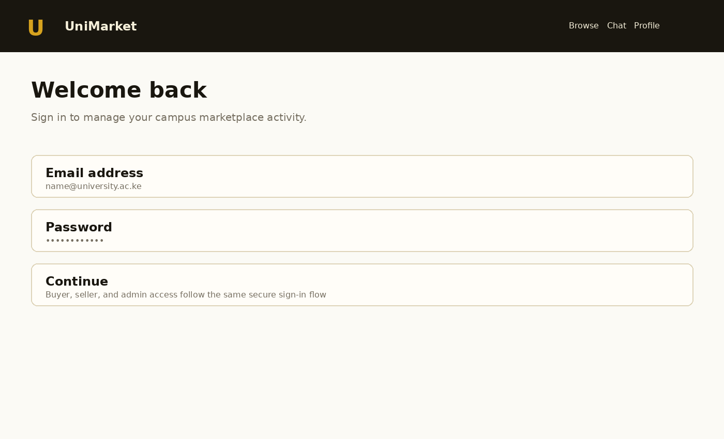
Figure 5.9: Mock-up of the login and account access screen.
This screen provides a clear entry point for role-based access.
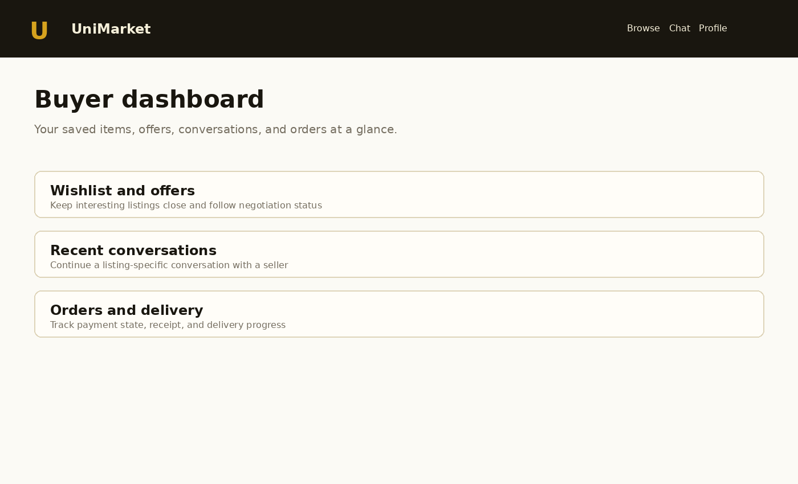
Figure 5.10: Mock-up of the buyer dashboard.
This screen groups saved items, conversations and orders by task.
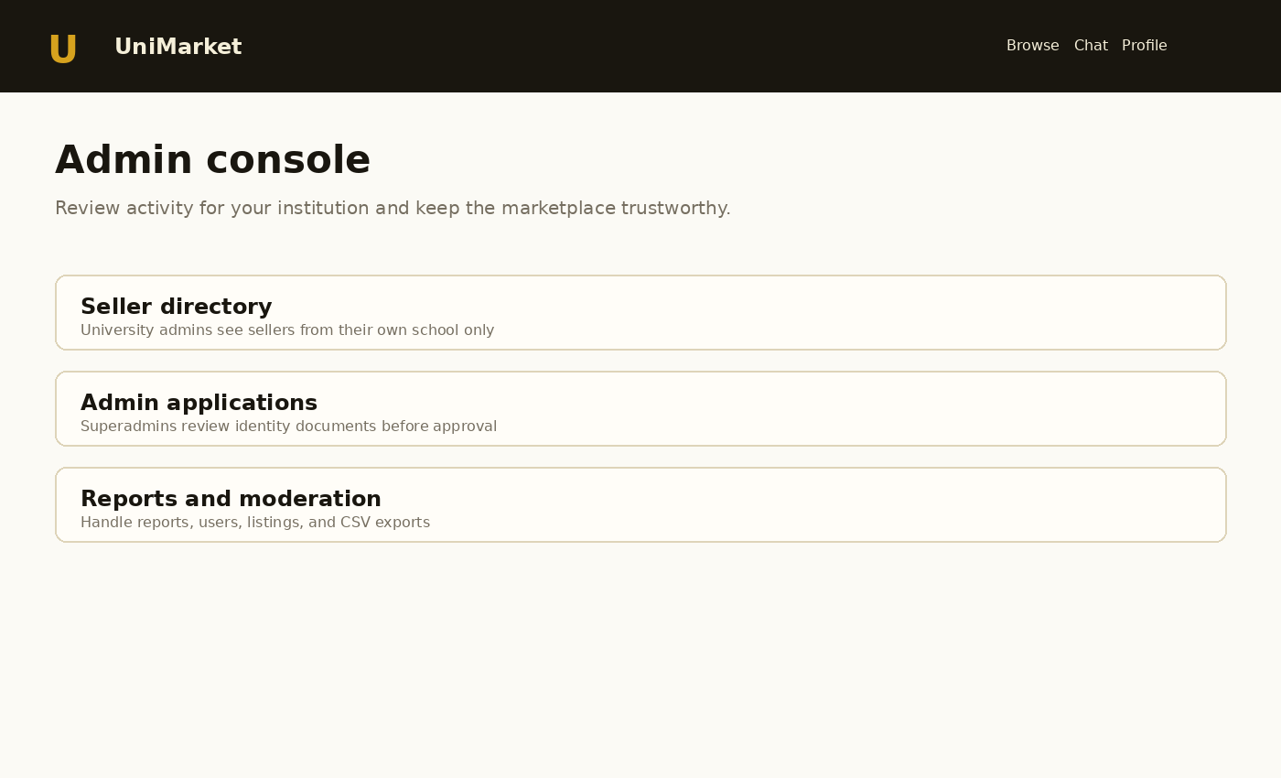
Figure 5.11: Mock-up of the administrator console.
This screen makes institutional scope and moderation actions visible.

5.7 Chapter Summary
This chapter designed UniMarket as a structured university marketplace. It described the proposed system, evaluated its strengths and limitations, defined its architecture and process logic, documented its core database design and separated design-stage mock-ups from implementation screenshots. The design gives particular attention to payment confirmation, privacy of submitted documents and university-scoped seller information. Chapter Six presents the implemented system and its testing evidence.

CHAPTER SIX
SYSTEM IMPLEMENTATION AND TESTING

6.1 Introduction
This chapter explains how the design in Chapter Five was implemented and tested. It summarises the technology environment, implemented modules, selected system screens, functional testing, non-functional checks and the proposed evaluation plan. The application was developed as a working academic prototype. Where an outcome depends on an external service, such as live Safaricom payment processing or SMTP delivery, the chapter distinguishes implemented code from externally pending operational configuration.

6.2 System Implementation

6.2.1 Implementation Environment
The backend is implemented in Python 3 using standard-library facilities for the HTTP server, socket handling, request parsing, sessions, password hashing, email notification and SQLite access. The schema is defined in database/schema.sql and safe migrations are applied during initialisation. HTML is assembled through a shared layout function. CSS defines the responsive UniMarket visual language, and JavaScript provides focused client-side validation and password visibility controls. The application reads the deployment port and host from environment variables and includes a health endpoint for deployment checks.
Table 6.1: Implementation environment
Component | Technology | Implementation role
Backend | Python 3 standard library | Routing, authentication, business rules, payment requests and server-side rendering.
Database | SQLite | Relational persistence for accounts, listings, communication, orders and administration.
Frontend | HTML5, CSS3 and JavaScript | Forms, responsive layouts, navigation, validation and progressive enhancement.
Payment integration | Safaricom Daraja Lipa Na M-Pesa Express | OAuth token, STK Push request, CheckoutRequestID storage and callback settlement.
Deployment | Render Web Service | Runs the Python process, exposes HTTPS and provides a health check.
Location display | OpenStreetMap embed | Displays the last authorised order location when available.

6.2.2 Implemented Modules
• Account and access module: registration, email verification, login, password reset, sessions and role-based dashboards.
• Listing and discovery module: listing creation, categories, search, filters, images, wishlist, recently viewed items and saved alerts.
• Communication module: listing-specific conversations, unread counts, messages, offers, counters and offer expiry.
• Commerce module: order creation, payment and delivery statuses, M-Pesa STK Push, callback receipt storage and private location tracking.
• Trust and administration module: reviews, reports, user suspension, seller directory, admin applications, protected documents and CSV reports.
• Public information module: About, Support, Contact, FAQ, Terms, Privacy, Returns and Safety pages selected from the supplied reference screenshot but rewritten for UniMarket.

6.2.3 Security and Privacy Controls
The implementation uses salted PBKDF2-HMAC-SHA256 password hashing, server-side session checks, role checks, CSRF tokens for state-changing forms, parameterised SQL and output escaping. Admin-request documents are served through a superadministrator-only route rather than being exposed as unrestricted upload links. University administrator seller queries are filtered using the authenticated administrator’s university. M-Pesa credentials are read from environment variables, and the application does not request or store an M-Pesa PIN.

6.3 Selected System Screens
The documentation guideline limits Chapter Six to a maximum of four screenshots. Figures 6.1 to 6.4 therefore show the highest-value screens captured from the running application: the public landing page, the buyer dashboard, the seller hub and the superadministrator console. They should be replaced with higher-resolution browser captures from the final deployed URL if the screenshots are resized during Word export.
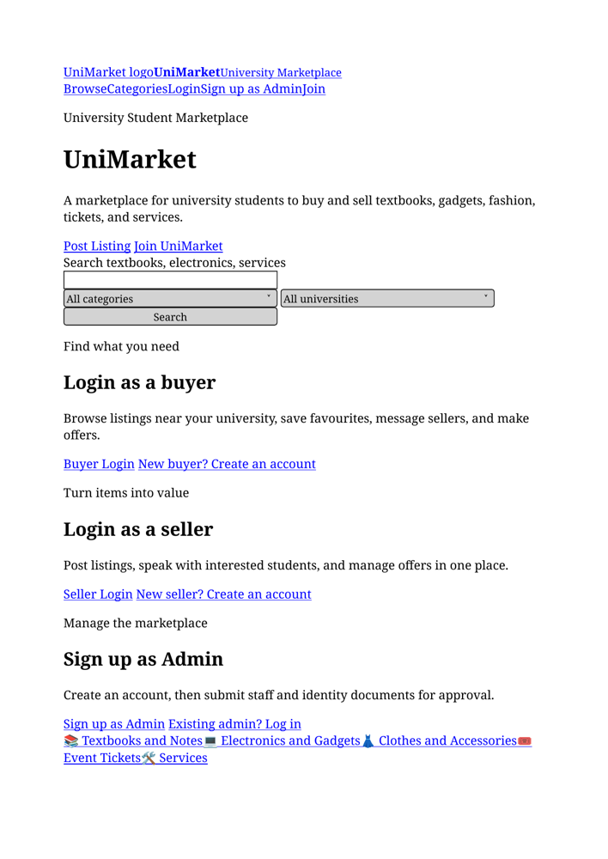
Figure 6.1: UniMarket public landing page.
The landing page supports browsing, category discovery and account entry.
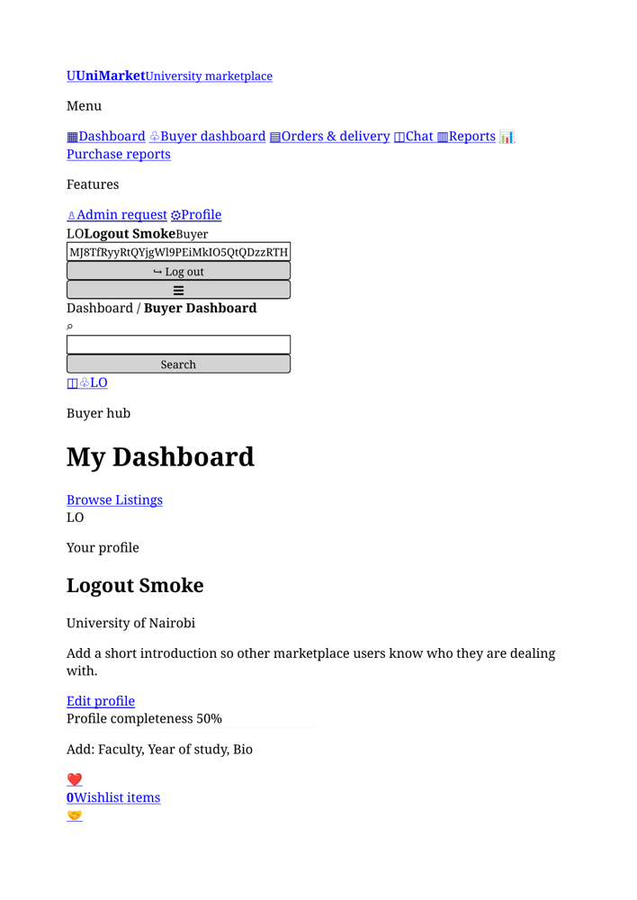
Figure 6.2: UniMarket buyer dashboard.
The buyer dashboard groups wishlist, offers, messages and orders.
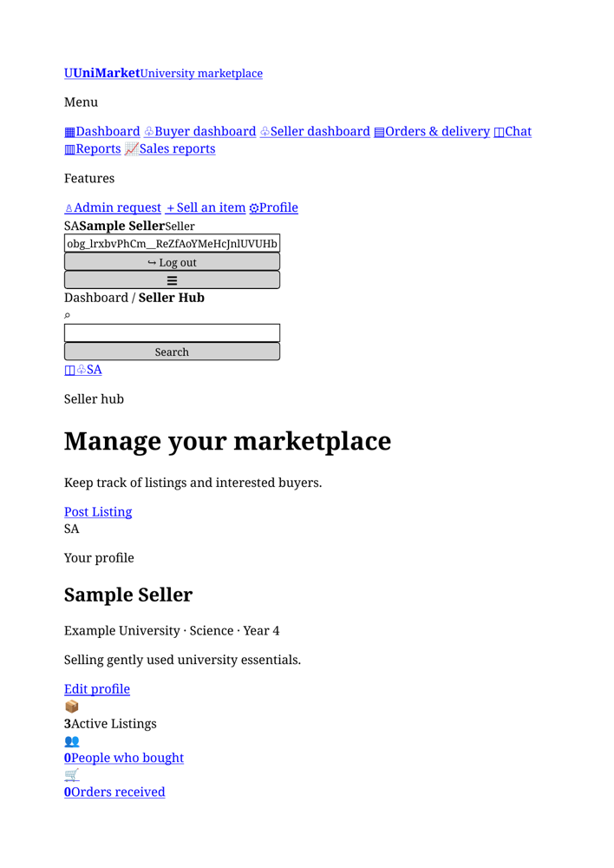
Figure 6.3: UniMarket seller hub.
The seller hub presents listing and transaction activity for the authenticated seller.
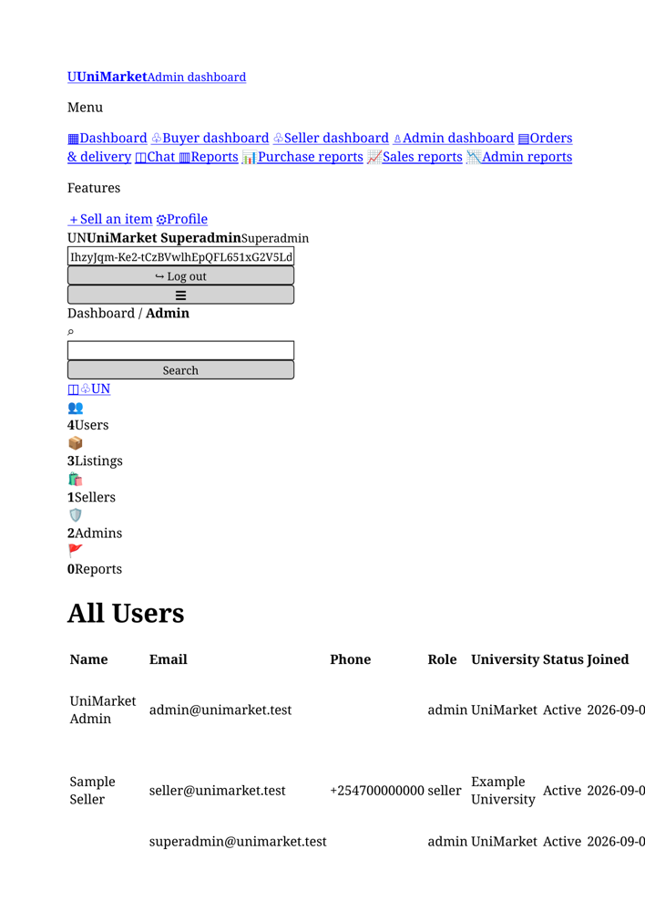
Figure 6.4: UniMarket superadministrator console.
The console provides global administration, seller visibility and admin-request review.

6.4 Testing Plan
Testing was organised around the functional and non-functional requirements. Each test records a precondition, procedure, expected result and observed result. Basic route smoke tests and Python syntax checks were performed against the implementation package. Payment-provider testing is split into application-level configuration checks and a real transaction test, which remains dependent on external sandbox or production credentials.
Table 6.2: Functional test plan
ID | Test procedure | Expected result | Observed result
T01 | Open the public home page and categories page. | Pages load and navigation links work. | Pass: public routes returned HTTP 200 during smoke testing.
T02 | Register or authenticate a buyer account. | User is validated and routed to the buyer dashboard. | Pass: account and role routes are implemented and smoke-tested.
T03 | Create and view a seller listing. | Listing is stored and appears in the feed and detail page. | Pass: listing workflow is implemented and verified locally.
T04 | Send a listing-specific message. | A conversation is created and the message is visible to its participants. | Pass: conversation and message workflow is implemented.
T05 | Submit and update an offer. | Offer status changes to accepted, declined, cancelled or expired as appropriate. | Pass: offer lifecycle is implemented.
T06 | Place an order. | An order is created with pending payment and delivery state. | Pass: order workflow is implemented.
T07 | Post a Daraja callback payload. | Callback returns HTTP 200 and updates a matching unpaid order once. | Pass: callback acknowledgement and duplicate-settlement guard verified.
T08 | Open admin-request documents as a non-superadmin and as a superadmin. | Non-superadmin is denied; superadmin can open the document. | Pass: protected document route enforces superadmin access.
T09 | Open the admin dashboard as a university admin. | Seller directory and recent seller activity show only the admin’s university. | Pass: query scope is applied server-side.
T10 | Generate a CSV report. | The report downloads with the selected date range and data scope. | Pass: report routes and CSV generation are implemented.

6.4.1 Non-Functional Tests
Table 6.3: Non-functional testing plan
Area | Test | Acceptance criterion | Result / status
Security | Submit a POST form without a valid CSRF token. | Request is rejected. | Pass in implementation review.
Security | Attempt parameter injection through form values. | Values are bound as parameters and not executed as SQL. | Pass in code review; parameterised SQL used.
Privacy | Request another university’s seller data as a university admin. | Rows from other universities are absent. | Pass in query review and local scope test.
Privacy | Request an admin-request document without superadmin access. | Access is denied or redirected. | Pass in protected-route test.
Reliability | Replay a successful callback for a paid order. | No duplicate settlement occurs. | Pass in callback logic review.
Usability | Open the application on a narrow viewport. | Navigation and forms remain usable without horizontal overflow. | Pass in responsive layout review.
External integration | Send a real sandbox or production STK Push. | Provider accepts the request and callback updates the order. | Pending external credentials and controlled transaction.

6.5 Evaluation Plan
A controlled pilot should be conducted before institutional deployment. The pilot should include representative buyers, sellers and university administrators using test accounts and sample listings. Participants should complete tasks such as finding an item, contacting a seller, creating a listing, reviewing an order, reporting a listing and reviewing an admin request. The evaluation should measure completion rate, time on task, error frequency, perceived ease of use, trust and administrator workload.
Table 6.4: Evaluation plan
Dimension | Method | Success indicator
Task effectiveness | Observation checklist for representative buyer, seller and admin tasks. | At least 80% of pilot tasks completed without facilitator intervention.
Usability | Short post-task questionnaire using a five-point scale. | Average ease-of-use rating of at least 4 out of 5.
Trust and safety | Questions on identity, reporting, payment status and document privacy. | Participants understand how to report problems and where payment confirmation comes from.
Performance | Record response time for common pages during the pilot. | Common pages remain responsive under the pilot load.
Administration | Admin review of seller scope, reports and applications. | Administrators can complete review tasks without seeing unauthorised institutions or documents.

6.6 Chapter Summary
This chapter documented the implementation of UniMarket using Python, SQLite, HTML, CSS and JavaScript. It described the account, listing, communication, commerce, trust and administration modules, and documented the security and privacy controls. Four selected screenshots were used in line with the guideline. Functional and non-functional testing demonstrates that the core prototype workflows are implemented, while a real M-Pesa transaction remains an external validation step requiring valid provider credentials and a controlled test environment. The evaluation plan provides the next evidence needed for institutional pilot assessment.

CHAPTER SEVEN
CONCLUSIONS, FINDINGS AND RECOMMENDATIONS

7.1 Introduction
This chapter presents the findings and conclusions of the UniMarket project. It relates the implemented system to the original problem of fragmented student trading, identifies the challenges encountered during development and recommends improvements for future work and institutional deployment.

7.2 Findings of the Study
The study found that informal student trading is convenient but fragmented. WhatsApp groups, social-media posts, notice boards and referrals enable communication, yet they do not provide a searchable catalogue, consistent listing fields, reliable status updates or a central transaction record. The current process therefore places a large coordination burden on buyers and sellers.
The project also found that a university-focused marketplace can centralise the core workflow without requiring a complex client application. UniMarket demonstrates that listings, seller information, conversations, offers, orders, delivery status, reviews and reports can be connected through a relational database and a role-aware web interface.
A further finding concerns institutional governance. Administrative access cannot be treated as a single unrestricted role. The implemented design separates ordinary university administrators from superadministrators: university admins receive seller information for their own schools, while superadmins retain global oversight and can review the identity documents submitted by applicants for administrator access. This supports the principle of least privilege and reduces unnecessary exposure of personal data.
The project found that M-Pesa integration has two distinct dimensions: technical integration and operational readiness. The application can generate the OAuth and STK Push requests and process the callback, but real payments additionally require Safaricom approval, a valid shortcode and passkey, secure deployment variables and a public HTTPS callback. A prompt being sent to a phone must not be confused with confirmed payment.

7.3 Conclusion
The aim of designing and implementing a web-based student marketplace was achieved through the UniMarket prototype. The system provides a structured alternative to fragmented student trading by bringing discovery, communication, negotiation, orders, payment status, delivery tracking, feedback and moderation into one application. It also demonstrates how institution-scoped permissions can be incorporated into a marketplace rather than relying only on a global administrator model.
The chosen architecture is appropriate for an academic prototype because it is understandable, inexpensive to deploy and sufficient for demonstrating the required workflows. Its limitations are clearly identified: SQLite and the lightweight server are not the final answer for a high-volume service, while production payment operation depends on an external provider and institutional controls. Within the project scope, however, the system provides a credible and testable foundation for a campus marketplace.

7.4 Challenges Encountered
Table 7.1: Challenges encountered and responses
Challenge | Effect | Response / lesson
Fragmented current process | Requirements were initially difficult to express because there was no single current system. | Modelled the current process as a socio-technical system using actors, data flows and process loops.
Payment-provider dependency | Live M-Pesa testing could not be claimed without provider credentials and callback deployment. | Separated sandbox, configuration and production readiness; avoided marking orders paid before callback confirmation.
Sensitive administrator documents | Identity documents require tighter access than ordinary listing images. | Added a superadmin-only document route and removed unrestricted document access.
Institutional data scope | A global admin view could expose sellers from unrelated universities. | Applied the authenticated administrator’s university as a server-side query filter.
Prototype scalability | A single Python process and SQLite database have concurrency limits. | Documented the limitation and recommended a production server and scalable database for future work.
Evidence presentation | The guideline restricts Chapter Six to four screenshots. | Selected only four high-value screens and moved design mock-ups to Chapter Five.

7.5 Recommendations for Future Work
• Complete Safaricom Daraja Go Live approval and perform a controlled low-value production transaction only after verifying the shortcode, passkey, callback URL and settlement record.
• Add a payment reconciliation and STK Query process for transactions whose callbacks are delayed, and maintain a secure audit trail for payment events.
• Replace SQLite with PostgreSQL and deploy the application behind a production-grade WSGI or ASGI server when usage grows.
• Introduce university-approved governance covering administrator responsibilities, document retention, acceptable use, incident response, account suspension and data deletion.
• Add stronger university identity verification, verified seller badges and clearer dispute-resolution workflows.
• Provide real-time notifications and a documented API for future mobile clients while preserving the server-side authorisation rules.
• Add automated backups, monitoring, structured logs, rate-limit persistence and security review before wider deployment.
• Conduct the proposed pilot evaluation and use evidence from students and administrators to prioritise future releases.

7.6 Final Conclusion
UniMarket demonstrates that a focused university marketplace can address practical weaknesses in informal student trading. Its main contribution is not simply an online list of items; it is the connection of identity, listings, conversations, offers, orders, payment status, delivery information, feedback and moderation within a controlled workflow. The prototype meets the academic project purpose and provides a clear path toward a governed, scalable and payment-enabled campus service.

CHAPTER
REFERENCES
Communications Authority of Kenya. (2023). ICT sector statistics report. CA Kenya.
Creswell, J. W., & Creswell, J. D. (2018). Research design: Qualitative, quantitative, and mixed methods approaches (5th ed.). SAGE Publications.
Kendall, K. E., & Kendall, J. E. (2019). Systems analysis and design (10th ed.). Pearson.
Kreibich, J. A. (2010). Using SQLite. O’Reilly Media.
Laudon, K. C., & Laudon, J. P. (2020). Management information systems: Managing the digital firm (16th ed.). Pearson.
Mas, I., & Radcliffe, D. (2010). Mobile payments go viral: M-PESA in Kenya. World Bank Publications.
Myers, G. J., Sandler, C., & Badgett, T. (2011). The art of software testing (3rd ed.). Wiley.
OWASP Foundation. (2021). OWASP Top Ten. https://owasp.org/www-project-top-ten/
Pressman, R. S., & Maxim, B. R. (2020). Software engineering: A practitioner’s approach (9th ed.). McGraw-Hill.
Safaricom PLC. (2026). Daraja developer portal and API documentation. https://developer.safaricom.co.ke/
Stair, R., & Reynolds, G. (2018). Principles of information systems (13th ed.). Cengage.
W3C. (2022). Geolocation API specification. World Wide Web Consortium.
Yourdon, E. (1989). Modern structured analysis. Prentice-Hall.

APPENDIX NOTE
The complete bound report should retain the approved appendices from the original project documentation, including the questionnaire, interview guide, project schedule, budget and any code excerpts required by the department. Include only evidence that was actually collected or implemented, and keep sample code within the guideline limit of two pages.

