Collapse, Not Decay: Uncertainty-Driven Monitoring and Label Triage for Cross-Testbed Intrusion Detection
Arnav Gupta (23BCE1878)
Computer Science, Vellore Institute of Technology, Chennai

Abstract—Flow-based intrusion detectors are routinely evaluated by chaining CIC-IDS2017, CSE-CIC-IDS2018 and CIC-DDoS2019 in chronological order and treating the result as a temporal drift stream. This paper shows that the transition between these benchmarks is a discrete regime change rather than a gradual process, and that the unsupervised drift statistics commonly recommended for monitoring deployed detectors cannot anticipate the resulting failure. A random forest reaching F₁ = 0.9966 on held-out 2017 traffic recovers 0.0036 of attacks on the 2019 evaluation day and at most 0.0808 of any 2018 attack family, despite every family appearing in its training labels. Collapse is architecture-independent: a multilayer perceptron and a logistic regression fail comparably once false-positive rates are matched. We evaluate five families of drift signal—unbounded divergences, bounded divergences, model-aware weighting, exponentially weighted dynamics and output-space uncertainty—across 145 fifteen-minute windows. The Population Stability Index exceeds its conventional 0.25 alarm threshold in 100% of windows on a median of 44 of 56 features, with no monotonic temporal trend (Spearman ρ = 0.028). Bounded divergences retain range but track workload composition rather than performance. We introduce UDM-T, an uncertainty-driven monitoring and triage procedure, and show that output-space uncertainty yields a weak but statistically robust leading signal (partial ρ = −0.296, bootstrap 95% CI [−0.445, −0.118]) where input-space statistics yield none, while 25 labelled flows per attack family establish failure with certainty.
Index Terms—intrusion detection, concept drift, domain shift, model monitoring, uncertainty quantification, active labelling, Apache Spark

I. INTRODUCTION

A. Basic Introduction
Network intrusion detection has shifted decisively toward flow-level machine learning. Rather than matching packet payloads against signatures, a flow-based detector summarises each connection as a vector of statistical descriptors—duration, packet-length moments, inter-arrival times, header flag counts, directional byte totals—and learns a decision boundary separating benign from malicious traffic. The appeal is practical: flow records are compact, they survive payload encryption, and they are produced natively by the monitoring infrastructure most networks already operate. A model trained on a few million labelled flows can reach F₁ scores above 0.99 on held-out traffic from the same capture, and a large literature reports exactly this [1].
That figure is measured in distribution. A deployed detector does not operate in distribution for long. Traffic composition changes as applications are adopted and retired, as user populations grow, and as the network itself is reconfigured; attackers change tooling continuously, and new exploit families appear that the training data never represented. The gap between the distribution a model learned and the distribution it is scored on is the subject of concept drift research [2], and in the intrusion detection setting it is usually modelled as a process: the deployed distribution diverges progressively from the training distribution, detector performance degrades correspondingly, and a monitoring system that watches the input distribution can raise an alarm before the degradation becomes operationally serious.
Monitoring is necessary because labels are the scarce resource. A production sensor observes millions of flows per hour and ground truth for essentially none of them; an analyst can adjudicate perhaps dozens per day. Performance therefore cannot be measured directly in deployment, and the field has converged on unsupervised proxies computed from the input features alone. The Population Stability Index [21], which compares a current window’s binned feature distribution against a fixed training reference, is the most widely used, conventionally with a threshold near 0.25 taken to indicate significant shift. Wasserstein distance [22], Kolmogorov–Smirnov statistics and related divergences serve the same role. All share one premise: that a measurable change in the input distribution precedes, and therefore predicts, a change in detector performance.
Evaluating this premise requires traffic captured over time. Because longitudinal labelled traffic from a single network is rarely available publicly, researchers commonly construct an evaluation stream by chaining the Canadian Institute for Cybersecurity benchmarks—CIC-IDS2017 [23], CSE-CIC-IDS2018 and CIC-DDoS2019 [24]—in chronological order, training on the earliest and evaluating forward. The chain is convenient, the labels are of good quality, the feature extractor is nominally common across them, and the attack taxonomies overlap substantially. It has become a default experimental protocol for drift-aware intrusion detection.
This paper examines what that protocol actually measures. The three datasets were captured on different physical testbeds, in different years, with different tooling and different benign traffic generators. The transition between them is therefore not a sample from a temporal process but a change of environment—a domain shift concentrated entirely at the dataset boundary. We show that this distinction is not academic. It determines whether a detector decays or collapses, whether drift statistics carry information or saturate, and whether proactive monitoring is possible at all.

B. Research Gap
Four gaps motivate this study, and each corresponds to an assumption that the drift-aware intrusion detection literature makes without testing.
The temporal premise is assumed rather than verified. Work that chains benchmark datasets and reports drift adaptation treats the resulting sequence as a temporal stream, but we are not aware of a study that first establishes the chained transition behaves like a process. If drift arrives fully formed at the dataset boundary, then a forecasting method evaluated on such a chain is being validated against a step function, and conclusions about lead time transfer to no real deployment.
Drift metrics are reported as detectors, not as rankings. The conventional PSI threshold answers a binary question—has the distribution shifted—and under severe shift the answer is trivially yes. What a monitoring system actually needs is a ranking: which windows, or which attack classes, have become undetectable. A metric can fire correctly in every window and still carry no information about where the detector has failed. The saturation regime, in which an unbounded divergence exceeds its alarm threshold everywhere, is not characterised in this literature.
Apparent monitoring skill is rarely ablated against workload composition. A window containing proportionally more attack traffic yields a higher F₁ for arithmetic reasons unrelated to drift, and attack share itself varies with the distribution being measured. Unless a reported association between a drift statistic and detector performance is ablated against class balance, it cannot be distinguished from this confound. Such ablations are uncommon.
Input-space and output-space monitoring are not compared on common ground. Drift statistics computed on features, and uncertainty statistics computed on model outputs [4], [5], address different quantities: the former measures change in P(X), the latter is sensitive to the relationship P(Y | X) the detector encodes. A change in the conditional distribution with the marginal preserved is invisible to any input-space statistic by construction. Which of the two carries usable signal under severe cross-testbed shift has not, to our knowledge, been measured on identical windows against identical targets.

C. Motivation
This study began as an attempt to build a proactive decay forecaster. The intended design followed the structure the literature suggests: train a static detector on 2017, measure its per-window performance across 2018 and 2019 to obtain a decay target, run an adaptive online learner over the same windows as a reactive baseline, and fit a regressor from unsupervised drift vectors to the measured decay so that degradation could be predicted before labels arrived. Lead time over the reactive baseline was to be the headline result.
The forecaster could not be built, and the reasons turned out to be more informative than the artefact would have been. The decay target had almost no variance, because the detector did not decay. Recast as binary degradation, the target was 96% positive. Recast as next-window prediction, every model scored at chance. The one formulation that appeared to work—regressing current-window performance on drift aggregates, cross-validated R² = 0.609—dissolved under ablation, with 0.957 of the fitted model’s feature importance attributable to the window’s attack fraction rather than to any drift statistic.
Each failure pointed at the same underlying property. Drift in this setting is not a quantity that grows; it is a condition that is already maximal when measurement begins. That is a statement about how benchmark chains are constructed, and it has consequences for anyone who uses them to validate a monitoring method.
The practical motivation is operational. Security teams are being advised to deploy distribution monitoring as an early-warning system for detector decay, on the understanding that it substitutes for the labels they cannot obtain. If that monitoring saturates under exactly the conditions where a detector is most at risk, the advice is harmful: it provides an alarm that is always on, consumes analyst attention, and licenses a false sense of coverage. Establishing where the signal actually lives, and what it costs to obtain, is therefore worth more than another detector with a high in-distribution score.

D. Key Contributions
- A measurement of collapse rather than decay. Using 15-minute tumbling windows over 35.3 million flows, we show that a detector scoring F₁ = 0.9966 in distribution falls below F₁ = 0.5 in 108 of 112 CSE-CIC-IDS2018 windows and recovers 0.0036 of attacks on the CIC-DDoS2019 evaluation day. Median survival is one window, the shortest interval the instrument can resolve. We further show the failure is per-attack-family and that label parity does not imply behavioural parity: two consecutive denial-of-service days, both drawn from families present in training, differ in recall by a factor of 55.
- A characterisation of drift-metric saturation. PSI exceeds its conventional 0.25 alarm threshold in 100% of 145 windows, on a median of 44 of 56 usable features, with a minimum window mean of 0.519—twice the threshold—and Spearman correlation of 0.028 against window order. We distinguish saturation from the degeneracy it is often mistaken for: the predictor’s variance is high (σ = 1.455), and what is degenerate is its relationship to performance.
- A five-family comparative evaluation of drift signals on identical windows against identical targets, spanning unbounded divergences, bounded divergences, importance-weighted statistics, exponentially weighted dynamics and output-space uncertainty, each ablated against attack-fraction confounding. Bounded divergences are shown to retain range while still tracking workload rather than performance.
- UDM-T, an uncertainty-driven monitoring and triage procedure, combining an output-space leading indicator with a label-budget confirmation stage. We establish that detector failure is silent rather than uncertain—mean predicted attack probability on true attack flows ranges from 0.017 to 0.143 across families—and that uncertainty nonetheless supplies a weak but statistically robust leading signal (partial ρ = −0.296 after controlling for attack fraction and current performance, moving-block bootstrap 95% CI [−0.445, −0.118], replicating independently at ρ = −0.414 in 2018 and ρ = −0.442 in 2019).
- A quantified label budget. Twenty-five labelled attack flows per family establish detector failure with certainty across 2,000 resampling trials; by the rule of three [30], observing no detections in 60 flows bounds recall below 0.05 at 95% confidence. Set against contribution 3, this gives an explicit exchange rate between labelling effort and unsupervised monitoring, and argues for spending scarce analyst capacity on stratified sampling rather than distribution surveillance.

E. Organization of the Paper
Section II surveys recent work on concept drift in intrusion detection, online and adaptive learning for streaming network traffic, unsupervised drift measurement, uncertainty quantification for security models, and label-efficient adaptation, and consolidates the surveyed studies in Table I. Section III presents the proposed methodology: after the system architecture of Fig. 1, it develops five modules and states Algorithm 1 (Chronological Collapse Measurement) and Algorithm 2 (UDM-T), defining equations (1)–(32). Section IV reports experimental setup, datasets, measured results, baseline comparison, ablation studies and hyperparameter selection. Section V concludes and identifies future work.

II. LITERATURE SURVEY
This section reviews twenty recent studies in five groups: broad surveys that establish where the field believes its gaps lie; uncertainty quantification as a monitoring signal; conformal and label-free drift estimation; adaptive and label-efficient detectors evaluated on the CIC benchmark chain; and drift-response mechanisms whose reported gains are explicitly qualified. Table I consolidates all twenty.

A. Surveys and Position Reviews
Xu et al. [1] survey deep-learning intrusion detection across the full workflow, from data collection and log parsing through graph summarisation to attack detection and investigation, arguing that earlier surveys treat deep learning as secondary. They review 131 papers drawn from Web of Science, IEEE Xplore and Scopus, filtered by venue impact, and tabulate roughly 50 detection approaches, 12 investigation approaches and 14 graph summarisation approaches. They report that the deep-learning share of intrusion detection publications rose from near zero in 2016 to 65.7% in 2024, that CVE records reached approximately 30,000 in 2024, and that 40% of catalogued vulnerabilities are high or critical risk. They note that some studies report detection accuracy above 90% while others reach only about 50%, and they propose dataset quality dimensions covering benign coverage, malicious scenarios, ground-truth labels, granularity and operating-system coverage. Their open-challenge section identifies poor data quality and a reliability versus generalisability trade-off, but concept drift appears only in passing, which is itself informative: the dominant survey of the field does not treat cross-testbed transfer as a primary concern.
Shyaa et al. [2] survey concept drift and feature dynamics in machine- and deep-learning intrusion detection specifically, covering studies published between 2019 and 2024. They argue that prior work either treats drift in general terms or ignores feature dynamics altogether, leaving a fragmented understanding of how the two interact, and they organise the literature into a drift-aware framework spanning feature selection, adaptive learning and continuous monitoring. The survey compares detection and adaptation approaches within that framework and identifies under-explored areas, proposing a multi-layered architecture incorporating reinforcement learning as a research direction. The authors defer experimental validation of their proposed framework to later work, which they state explicitly. For the present paper the relevant observation is that the survey organises monitoring as a continuous activity assumed to precede degradation, without asking whether the measured signal retains discriminative power under severe shift.
Ghayoumi et al. [3] present a structured review of trustworthy deep learning for cybersecurity across detection, robustness, privacy, explainability and deployment. Working from a de-duplicated bibliography of 115 references, they organise the literature along five axes: security task, data modality, model family, trustworthiness property and deployment environment. Their central claim is that accuracy is necessary but not sufficient, and that deployment readiness additionally requires adversarial robustness, privacy protection, explainability, uncertainty calibration, drift handling, reproducibility and computational feasibility. They identify persistent gaps in temporal validation, cross-dataset testing, analyst-centred explanation and secure pipelines. They present the work as a narrative rather than a PRISMA-counted systematic review. Their first two named gaps—temporal validation and cross-dataset testing—are precisely the two the present paper instruments, and their framing supports the position that an uncalibrated monitoring signal is a deployment defect rather than a tuning problem.

B. Uncertainty Quantification as a Monitoring Signal
Talpini et al. [4] argue that intrusion detection classifiers issue overconfident scores on misclassified inputs and on attacks of unseen classes, and that accurate uncertainty quantification would support closed-set classification, active learning and open-set recognition simultaneously. They compare energy-based scores, Deep Deterministic Uncertainty, Bayesian neural networks, random forests and the Energy-based Flow Classifier against a custom uncertainty-calibrated BNN on NF-ToN-IoT-v2 and CIC-IDS2017, under scenarios withholding 30%, 60% and 80% of classes. On CIC-IDS2017 their model reaches 98.91% accuracy and 97.13 macro F₁ against 98.99% and 97.25 for random forest; averaged over scenarios its out-of-distribution AUROC is 0.92 on ToN-IoT and 0.73 on CIC-IDS. Under active learning it attains full-dataset macro F₁ from roughly 9–11% of labels, against about 35% for non-Bayesian baselines, at a test cost of 20 µs per sample against 1 µs for random forest. Their accuracy-versus-rejection curves show non-Bayesian networks losing accuracy at their highest confidences, which is the same confidently-wrong behaviour this paper measures per attack family.
Gawlikowski et al. [5] provide the standard reference survey on uncertainty in deep neural networks, spanning 77 journal pages. They separate sources of uncertainty into reducible model uncertainty and irreducible data uncertainty, and organise estimation methods into four families: single deterministic networks, Bayesian neural networks, network ensembles and test-time data augmentation. For each family they review measures, calibration methods, baselines and available implementations, illustrating requirements through medical imaging, robotics and earth observation. Their central technical observation is that plain networks are poorly calibrated, exhibiting both over- and under-confidence, and that calibration is a property distinct from accuracy. They close by discussing limitations of uncertainty quantification specifically in mission- and safety-critical settings. The survey supplies the vocabulary this paper uses for its output-space family but, being domain-general, does not address whether predictive uncertainty survives a change of capture environment.
Yang et al. [6] target the operational consequence of poor calibration, namely the volume of false-positive alerts analysts must process. They investigate Bayesian autoencoders for uncertainty quantification in anomaly detection and propose modelling heteroscedastic aleatoric uncertainty jointly with epistemic uncertainty, placing the aleatoric component at the autoencoder’s latent layer and deriving it through the variational lower bound. The resulting framework is verified on UNSW-NB15 and CIC-IDS2017. Their motivating argument is that uncertainty estimates give decision makers explicit guidance on whether to accept a detection, converting a binary alert into a graded one. Their evaluation remains within each dataset, so the behaviour of the latent-space uncertainty estimate across capture environments is not established; the present work measures exactly that for a simpler output-space statistic.
Ren et al. [7] address trust in deterministic networks from the diagnostics side, observing that opacity rather than accuracy limits adoption in safety-critical deployments. They propose SAEU, which estimates aleatoric and epistemic uncertainty within a deterministic network using a multivariate Gaussian output rather than the full machinery of a Bayesian neural network, and build it into UU-DLF, a unified uncertainty-aware framework supporting human-in-the-loop intervention and traceability-based model improvement. Validation uses gearbox and aeroengine bevel-gear vibration data. The architectural point transfers directly to intrusion detection: a cheap uncertainty estimate obtained from an existing deterministic model, combined with a human adjudication stage, is the same structure as the monitor-plus-triage arrangement proposed here, and their framing of human intervention as a first-class component rather than a fallback anticipates this paper’s argument about label budgets.

C. Conformal and Label-Free Drift Estimation
Tziouvaras et al. [8] state the premise this paper tests: that a model deployed in a changing environment can lose accuracy silently, that without labels there is no error signal, and that an external drift detector operating on unlabelled operational data should therefore drive an MLOps retraining actuator. They propose two detectors, Confidence-Filtered Pseudo-Label Transfer and TabAutoDrift, each combining representation learning with statistical testing to emit an expected-utility score indicating whether retraining is warranted without post-deployment labels. Evaluation covers two label-scarce wireless domains, fingerprint-based outdoor localisation and link anomaly detection, against ADWIN, DDM and CUSUM. Drift-detection F₁ reaches 0.88–0.94 for fingerprinting and 0.80–1.00 for link anomaly, up to 0.24 above the best classical detector. The result is strong evidence that label-free drift detection works where the shift is temporal within one environment, and is the appropriate contrast case for the cross-testbed regime examined here.
Barrett et al. [9] address the computational cost of drift monitoring rather than only its accuracy, arguing the problem is acute in IoT settings where device populations change continuously. Cross-conformal evaluation gives principled drift signals but requires repeated model training. Their FADES framework unifies prediction-space conformal evaluation with representation-space detection in one pipeline and introduces Approx-CCE, which preserves disjoint calibration partitions while sharing a single underlying model, together with an adaptive chunking controller trading responsiveness against cost. Evaluation spans a laboratory IoT corpus and its drift variant, with UNSW-NB15 and CSE-CIC-IDS2018 for cross-dataset transfer, across 375 simulations. Approx-CCE matches full cross-conformal evaluation within 0.1% on accuracy and F₁ while reducing runtime by approximately 13.9% in-domain and 60–64% under transfer; contrastive-autoencoder baselines failed to complete a single run within a seven-day limit. They also report retraining in 1.59% of attack-containing chunks against 2.30% of chunks without attacks, indicating retraining was not driven by attack presence.
Barrett et al. [10] extend the same line to intrusion response with FIRCE, which pairs a two-layer feedforward classifier with four conformal evaluators and an adaptive chunking controller tracking an exponential moving average of the drift rate, halving the chunk size above 0.2 and growing it below 0.05. Evaluation uses a ten-device IoT testbed with its drift variant plus UNSW-NB15 and CICIDS2018. On CICIDS2018 Approx-CCE attains 0.9952 accuracy and 0.9816 F₁ in 6,021 s against 0.9811 F₁ in 16,584 s for full cross-conformal evaluation; on UNSW-NB15 the adaptive controller needs 7 calibrations against 3,133 at unit chunk size, cutting runtime from 204,752 s to 1,793 s. The authors list binary-only scope, label bias inherited during sustained drift and an evaluation emphasising DoS-style attacks among their limitations. Crucially, calibration and evaluation occur within each corpus, so the near-perfect CICIDS2018 figures describe in-testbed operation rather than the cross-testbed transfer studied here.

D. Adaptive and Label-Efficient Detection on the CIC Chain
Gupta et al. [11] tackle drift and class imbalance jointly, noting that uncertainty-based active learning tends to miss minority attack samples when the benign majority is itself drifting. Their NetGuard framework combines density-aware prior selection, scoring unlabelled samples by the difference of log-likelihoods under Gaussian mixtures fitted to the unlabelled and labelled sets, with diversity-aware conditional generative augmentation for classes below a 5% threshold, filtered by a benign-versus-attack logistic classifier and validated by Wasserstein-2 distance. Evaluation covers CIC-IDS 2017 and 2018 bidirectionally plus UGR’16. They report overall F₁ rising from 0.60 without adaptation to 0.86 with it, and rare-attack F₁ improving from 0.001 to 0.30 for Infiltration, 0.04 to 0.50 for Web Attack and 0.00 to 0.71 for FTP-BruteForce. Their motivating measurement—CIC-IDS F₁ falling from 0.99 to 0.61 across the year boundary, and UGR’16 from 0.96 to 0.687 across one month—is the same transition this paper measures, and the difference in severity is attributable to their class-balanced resampling.
Jeon and Kim [12] ask the sharpest operational question in this group: what the cheapest response is that restores a degraded detector, and when enough target data has arrived to support it. They define a three-level escalation policy—threshold recalibration, buffered few-shot source-target retraining, and full target-only retraining as terminal fallback—governed by time-ordered cross-validation, with a diversity precondition withholding deployment when fewer than 20 distinct exact-duplicate groups are available. Replaying CSE-CIC-IDS2018 chronologically against a CIC-IDS2017 source across four classifiers and ten partitions, their policy meets a 0.90 recall target in 24 of 28 classifier-shift pairs, against 9 for threshold recalibration alone, 8 for unrestricted online active learning and 0 for CORAL. Their DDoS case is directly comparable to the present results: at a 50-label budget, test recall is 0.002 using the earliest arrivals and 0.992 using a 48-hour buffer, and the diversity precondition withholds 24 of 30 false deployments among 216 accepted cases.
Lara-Gutiérrez et al. [13] argue that concept drift, feature drift and adversarial perturbation share one effect, namely distributional misalignment between training and operational data, and that existing frameworks do not handle the first two together while remaining resilient to the third. Their HDDAF framework combines Hoeffding drift detection with information-gain recomputation for feature drift, a generative module simulating new drifts after retraining, and RONI-based adversarial filtering over KMeans-flagged samples, feeding a neural network into a random forest and LightGBM ensemble. On CIC-IDS2017 the full stack reaches 0.9989 accuracy and macro F₁, with information-gain selection cutting training from 285.4 s to 62.5 s, and up to 90% of poisoned samples removed. Under simulated drift, accuracy falls from about 99.9% to 94.0–98.2% and recovers within one to four batches. Under abrupt mixing with CIC-IDS2018 and UNSW-NB15, however, accuracy falls below 50%, and a single retraining of 60–65 s is required to restore it above 85%—a result consistent with the collapse reported here.
Hu et al. [14] observe that general-purpose drift detectors such as ADWIN, DDM and HDDM were not designed for network traffic, and propose DWOIDS, pairing a Hoeffding tree with DAWMA, a dual-adaptive-window moving average over per-packet error indicators in which a fast and a slow window are offset by a fixed lag and drift is declared when the sign of their momentum difference flips, with window sizes growing under stability and shrinking under frequent drift. Evaluation uses an improved CIC-IDS2017 with 2,090,564 traces at a 50,000-sample window and NSL-KDD at 7,000. Their failure criterion, a window whose accuracy falls below 90% of the mean, is directly analogous to the operational floor used here: DAWMA reduces failing windows from 18 to 5 of 41 on CIC-IDS2017 and from 5 to 0 of 17 on NSL-KDD. DWOIDS attains 0.9608 accuracy and 0.9653 F₁ on CIC-IDS2017 against 0.9383 and 0.9532 for ARF with ADWIN, whose recall of 0.9972 nonetheless exceeds their 0.9969.
Zha et al. [15] argue that intrusion detection research routinely assumes training and test data are identically distributed even though drift is inevitable, and that increasingly complex models are impractical to deploy at line rate. Their A-NIDS architecture pairs a main detection task, implemented as a fully connected shallow network, with two bypass tasks: a clustering-based module that detects drift without labels, and a stacked conditional tabular GAN that regenerates samples resembling earlier data to limit catastrophic forgetting without storing history. Experiments use CICIDS-2017 and CSE-CICIDS-2018—the same pairing examined here—and the authors report a detection-module latency of approximately 5 µs, with code released publicly. The design is notable for treating unsupervised drift detection and memory preservation as separable concerns handled by separate modules, which is the arrangement this paper’s Modules 3 and 5 adopt.
Xavier et al. [16] move drift detection into the forwarding path, noting that P4 supports neither floating-point arithmetic nor loops. They implement an EWMA control chart over per-packet error indicators with ARL₀ = 400, approximating λ = 0.0003 as a sum of five bit-shifts yielding 0.0002995, computing division by binary long division, and replacing the variance term with a two-bit right shift justified by a relation holding in 97.4% of their data. A decision tree trained on the control plane is compiled to match-action tables, and a drift signal returns control for retraining. Using 2,674,468 samples from CIC-IDS2017 Wednesday and Thursday captures with attack bursts injected over roughly 8,000 s, the data-plane estimator tracks the Python reference to within 0.000279 on average. Per-class F₁ reaches 0.99 for DoS Hulk and 0.98 for benign but 0.47 for BruteForce and 0.00 for SQL injection and XSS, and the evaluation runs on a BMv2 emulator without throughput measurement.

E. Drift Response with Qualified Gains
Drago et al. [17] identify three gaps in online intrusion detection: real-time expert labelling is expensive, detectors signal that drift occurred without indicating which features are responsible, and adaptation is triggered continuously rather than when needed. Their UME CDD detector stores a reference feature-importance profile for the current concept, computes a dissimilarity score as the mean normalised absolute importance difference over the union of top-N features, and feeds that scalar to a KSWIN test, obtaining importances label-free through SHAP or unsupervised permutation importance; adaptation then runs for a bounded three-batch period during which labels are requested. On NSL-KDD in 1,000-record batches, pairing the detector with Adaptive XGBoost and ARF yields 0.933 and 0.966 mean accuracy at 5.4% labelling cost, against 0.978 and 0.989 at 100%—a 94.6% reduction in labels for 2.3 to 4.5 accuracy points. Their importance-profile construction is the closest published relative of the importance-weighted statistic evaluated in Section IV.
Shyaa et al. [18] address feature drift, where the relevance of individual features changes over time even when the marginal distribution is otherwise stable. Their Incremental Feature Drift-Aware Genetic Programming Combiner extends an earlier incremental combiner with dynamic feature selection driven by a multi-agent system, in which a voting-enhanced Deep Q-Network reconciles conflicting agent assessments of feature relevance before selection. Evaluation spans KDD Cup ’99, CIC-IDS2017, HIKARI-2021 and ISCX2012 under both evolving and non-evolving scenarios, with comparison on accuracy, F₁, recall and AUC; the derived model reaches 93% accuracy on CIC-IDS2017. The relevance to this paper is the explicit separation of feature-relevance change from feature-distribution change: a detector can fail because the features it relies on are displaced, which motivates weighting divergences by model importance, a construction evaluated and found inconclusive here.
Rivas et al. [19] model detection as a two-player coevolving game in which a red agent perturbs malicious packets through fragmentation flags, TTL, window size, MSS and window scale, while a blue agent selects among online learning, active learning, continual learning and pseudo-labelling to restore accuracy. The blue agent’s state includes accuracy, false-positive and false-negative rates, feature-mean differences, KL divergence and Wasserstein distance; data is divided into 120 sequential batches used alternately. On CIC-IDS2017 and the ACI IoT 2023 corpus, red-agent perturbation drives classifier accuracy from roughly 97% to 64–69%, and blue-agent response recovers accuracy by about 30 points using two to three adaptation steps of 25–30 samples each. Average per-action reward is 0.216 for active learning and 0.153 for online learning against −1.47 for continual learning and −4.66 for pseudo-labelling, and ablation shows removing data-characteristic state features costs 8–17 accuracy points more than removing model-characteristic features. Their 25–30 sample figure independently corroborates the label budget derived in Section IV.
Yuan et al. [20] report the most directly comparable finding in this survey, and they report it as a qualified one. Their ADAWU-IDS framework combines a Multi-Scale Drift Index for estimating drift severity with an adaptive weight-updating mechanism that adjusts ensemble member contributions according to recent predictive behaviour, drift severity and temporal relevance, with candidate response configurations calibrated on a held-out validation stream and then frozen before chronological testing. Critically, the authors position the drift index as an auxiliary signal rather than a standalone detector. On CICIDS2017 the calibrated configuration shows only modest gains over a static LSTM and a weighted ensemble in weighted and attack F₁, not statistically significant at p < 0.05, though it consistently improves attack recall or reduces false negatives; classical online ensemble baselines achieve higher raw performance under the same protocol. Their ablation shows mandatory hierarchical retraining over-adapts to short-term chunk behaviour and harms attack detection, leading them to reformulate response as an optional calibration-selected action.

F. Positioning
Three patterns emerge. First, the strongest reported drift-monitoring results are obtained either within a single capture environment [9], [10], [17] or in domains where shift is genuinely temporal [8]; no surveyed study establishes that an unsupervised input-space statistic retains discriminative power across capture environments, and two surveys name cross-dataset testing as an open gap [2], [3]. Second, where cross-corpus transfer is measured, severe degradation is reported consistently—F₁ from 0.99 to 0.61 [11], accuracy below 50% [13], DDoS recall of 0.002 from early arrivals [12]—but it is treated as a problem to be repaired by adaptation rather than as a measurement to be characterised. Third, the studies that quantify label cost converge on small budgets: 25–30 samples per adaptation step [19], 50 labels per attack class [12], 5.4% of the stream [17], and 9–11% under Bayesian active learning [4]. The present work differs in three respects. It characterises the saturation regime of unsupervised divergences rather than reporting them as detectors; it compares input-space and output-space signals on identical windows against identical targets with explicit confound ablation, which no surveyed study performs; and it reports a negative monitoring result alongside a bounded label budget, in the spirit of the qualified reporting of [20].

TABLE I
CONSOLIDATED SURVEY OF REVIEWED WORK
Ref. | Dataset | Methodology | Application | Advantages | Limitations
[1] | Survey of 131 papers | Structured review of DL-IDS workflow; dataset quality dimensions | Scoping deep-learning IDS research | Broadest workflow coverage; quantifies 65.7% DL share by 2024 | Concept drift treated only in passing; no cross-dataset synthesis
[2] | Survey, 2019–2024 studies | Drift-aware framework: feature selection, adaptive learning, monitoring | Concept and feature drift in IDS | Only survey treating drift and feature dynamics jointly | Proposed framework not experimentally validated; monitoring assumed informative
[3] | Review of 115 references | Five-axis taxonomy: task, modality, model, trust property, deployment | Trustworthy DL for cybersecurity | Names temporal validation and cross-dataset testing as top gaps | Narrative, not PRISMA-counted; no primary measurement
[4] | NF-ToN-IoT-v2; CIC-IDS2017 | Uncertainty-calibrated BNN vs. energy, DDU, RF, EFC; 30/60/80% unknown classes | Open-set IDS and active learning | 97.13 macro F₁, AUROC 0.92 (ToN-IoT); full F₁ from 9–11% labels | Single-corpus evaluation; 20 µs/sample vs. 1 µs for RF
[5] | Domain-general survey | Four UQ families: deterministic, Bayesian, ensembles, test-time augmentation | Uncertainty estimation in DNNs | Standard reference; separates model from data uncertainty | Not security-specific; no cross-environment analysis
[6] | UNSW-NB15; CIC-IDS2017 | Bayesian autoencoder with latent heteroscedastic aleatoric uncertainty | Reducing false-positive alert load | Joint aleatoric/epistemic modelling via variational lower bound | Within-dataset evaluation; transfer behaviour unestablished
[7] | Gearbox; aeroengine bevel gear | SAEU multivariate-Gaussian UQ in deterministic nets; UU-DLF framework | Trustworthy fault diagnosis | Avoids BNN cost; human-in-the-loop as first-class component | Non-network domain; no drift or shift evaluation
[8] | Wireless fingerprinting; link anomaly | CFPT and TabAutoDrift: representation learning plus statistical testing | Label-free drift detection for MLOps | Drift F₁ 0.80–1.00, up to 0.24 over ADWIN/DDM/CUSUM | Temporal shift within one environment; not cross-testbed
[9] | IoT testbed + drift variant; UNSW-NB15, CSE-CIC-IDS2018 | Approx-CCE conformal evaluation with adaptive chunking; 375 simulations | Cost-efficient streaming drift monitoring | Matches full CCE within 0.1%; 13.9% in-domain, 60–64% transfer runtime cut | Baselines did not finish in 7 days; saturation regime not characterised
[10] | IoT testbed; UNSW-NB15; CICIDS2018 | FNN classifier, four conformal evaluators, EMA-driven chunk controller | Intrusion response and conformal evaluation | 0.9816 F₁ at 6,021 s vs. 16,584 s; 7 vs. 3,133 calibrations | Binary only; calibration within each corpus; DoS-weighted attacks
[11] | CIC-IDS2017/2018 both directions; UGR’16 | GMM log-likelihood prior selection; conditional generative augmentation | Drift with class imbalance | Overall F₁ 0.60→0.86; FTP-BruteForce 0.00→0.71 | Class-rebalanced sampling softens measured collapse; adversarial drift out of scope
[12] | CIC-IDS2017 → CSE-CIC-IDS2018 replay | Three-level escalation with time-ordered CV and diversity precondition | Cheapest sufficient retraining response | 24/28 pairs meet 0.90 recall vs. 9 for recalibration, 0 for CORAL | Retrospective replay; validation spans full target period
[13] | CIC-IDS2017; CIC-IDS2018; UNSW-NB15 | HDDAF: HDDM, IG recomputation, GAN drift simulation, RONI filtering | Joint concept, feature and adversarial drift | 0.9989 accuracy/macro F₁; 90% of poisoned samples removed | Accuracy below 50% under abrupt cross-corpus mixing; cannot separate benign from malicious drift
[14] | Improved CICIDS2017 (2.09 M); NSL-KDD | Hoeffding tree with DAWMA dual-adaptive-window momentum detector | Online IDS with traffic-specific drift detection | Failing windows 18→5 of 41; F₁ 0.9653 vs. 0.9532 for ARF+ADWIN | Binary only; benchmark streams; recall below ARF+ADWIN
[15] | CICIDS-2017; CSE-CICIDS-2018 | Shallow main task plus clustering drift bypass and stacked CTGAN replay | Deployable adaptive NIDS at line rate | ≈5 µs detection latency; no historical storage required | Comparative figures not in open record; drift module not characterised under saturation
[16] | CIC-IDS2017 PCAP (2.67 M packets) | EWMA chart in P4 with bit-shift λ and shift-based variance term | In-network drift detection at line speed | Tracks reference estimator to 0.000279; runs within P4 constraints | BMv2 emulation, no throughput; F₁ 0.00 for SQLi and XSS; approximation data-specific
[17] | NSL-KDD, 1,000-record batches | UME CDD: label-free importance-profile dissimilarity into KSWIN; bounded adaptation | Explainable drift detection at low label cost | 0.966 accuracy at 5.4% labels vs. 0.989 at 100% | Single dataset; empirically tuned KSWIN; importance biased by noisy records
[18] | KDD’99; CICIDS2017; HIKARI-2021; ISCX2012 | IFDA-GPC with voting-enhanced DQN multi-agent feature selection | Feature-drift-aware incremental IDS | Separates feature-relevance from feature-distribution change; 93% accuracy | Accuracy only moderate on CICIDS2017; no cross-corpus transfer test
[19] | CIC-IDS2017; ACI IoT 2023 | Red/blue MARL game; blue state includes KL and Wasserstein distances | Adaptation under adversarial drift | ≈30-point recovery from 2–3 steps of 25–30 samples | Drift induced by perturbation, not observed; RL algorithms inconsistent between sections
[20] | CICIDS2017, chronological | Multi-Scale Drift Index plus adaptive ensemble weight updating, frozen after calibration | Transparent analysis of drift-response behaviour | Treats drift index as auxiliary only; reports non-significant gains honestly | Gains not significant at p < 0.05; online ensembles score higher; mandatory retraining harms detection

III. PROPOSED METHODOLOGY
The proposed system is a five-module streaming evaluation pipeline whose purpose is diagnostic rather than predictive. Conventional drift-aware architectures place an unsupervised monitor in the critical path: the monitor watches the input distribution, raises an alarm when a threshold is crossed, and the alarm triggers adaptation. Our pipeline retains that structure but instruments it, so that each stage reports not only its output but the measurable information content of the signal it consumes. The static detector is evaluated chronologically to establish whether failure is gradual or discrete; the drift stage computes five families of statistic in parallel rather than committing to one; and the triage stage substitutes a bounded label budget for the unsupervised alarm when the latter is shown to be uninformative.
The framework is designated UDM-T (Uncertainty-Driven Monitoring and Triage). Its central design decision is that monitoring is split across two signal spaces. Input-space statistics are computed from feature distributions against a fixed 2017 reference and answer whether the marginal distribution of the inputs has moved. Output-space statistics are computed from the deployed detector’s own predictive distribution and are sensitive to the conditional relationship the detector encodes. Because a conditional change with the marginal preserved is invisible to any input-space statistic by construction, the two spaces are not redundant, and UDM-T evaluates them on identical windows against identical targets. When neither supplies a trustworthy alarm, control passes to Module 4’s triage stage, which converts a fixed number of analyst adjudications into a confidence bound on detector recall. The pipeline is implemented in Apache Spark [31] for out-of-core execution over 35.3 million flow records on a single commodity node.
Fig. 1 shows the flow of data and control. Flow records enter from the three harmonised parquet sources and are normalised, cleaned and assigned to chronological windows in Module 1. Module 2 scores each window with the frozen 2017 detectors and emits per-window and per-family confusion counts, from which survival statistics are derived. Module 3 consumes the same windows and computes the drift battery in both signal spaces. Module 4 arbitrates: it evaluates whether any monitored signal carries usable information, and where it does not, it opens the triage gate and draws a stratified label sample. Module 5 receives the resulting failure state, logs it, and initiates adaptive retraining.
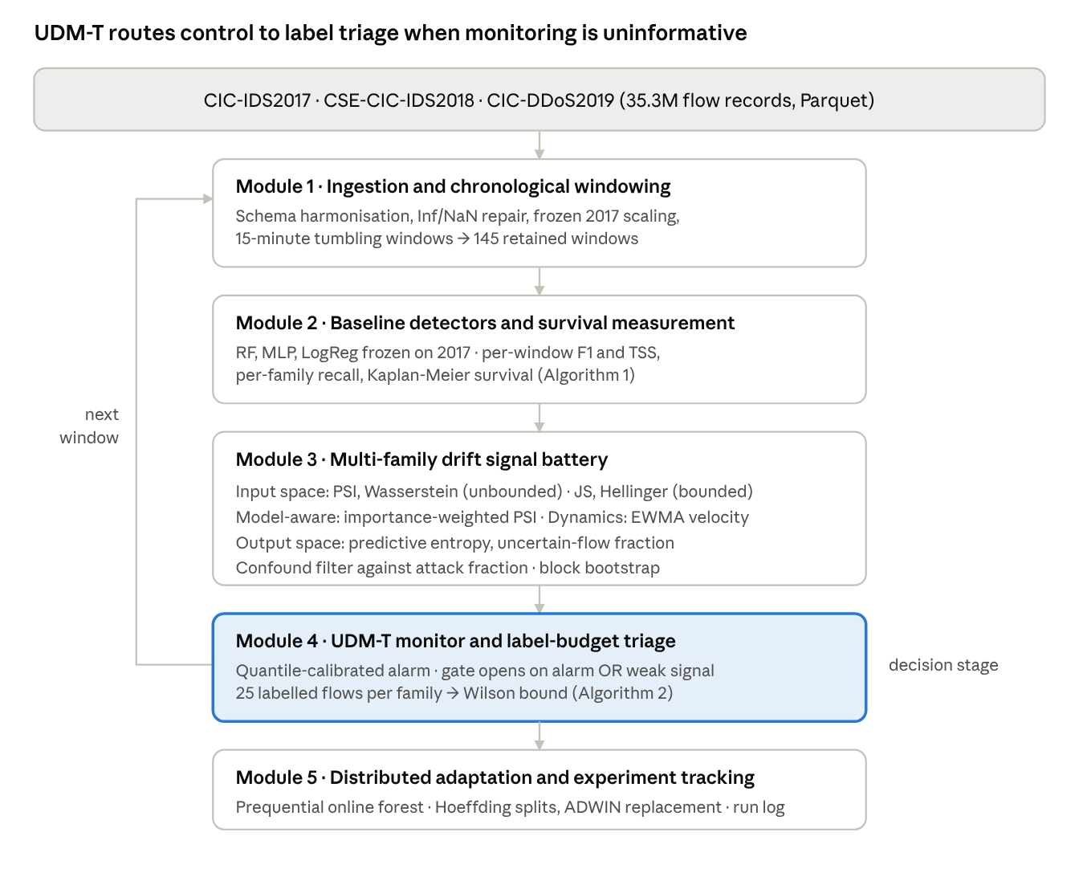
Fig. 1. UDM-T system architecture. Data flows downward from the harmonised sources through ingestion, baseline measurement and the drift battery; Module 3 evaluates both signal spaces on identical windows, Module 4 is the decision stage, and control returns to Module 1 for the next window.

A. Module 1: Streaming Ingestion and Chronological Windowing
Module 1 converts three heterogeneous benchmark captures into a single chronologically ordered stream with a common schema. Each flow record is a vector of descriptive statistics over one connection,
$$x_{i}={\left[x_{i,1},x_{i,2},…,x_{i,d}\right]}^{⊤}∈R^{d}, d=76$$ | (1)
carrying a binary label and an attack family,
$$y_{i}=1\left[ℓ_{i}≠BENIGN\right], ϕ_{i}=Φ\left(ℓ_{i}\right)$$ | (2)
where ℓ_{i} is the raw dataset label and Φ the harmonisation map onto six shared families. Harmonisation is non-trivial: the captures differ in label casing, carry nine divergent column names for identical quantities—four of which rank among the detector’s ten most important features—and include a dataset-internal spelling inconsistency. All are resolved before windowing, since an unresolved rename would present as drift rather than as an artefact.
Identifier-bearing columns are excluded so that no model can key on capture topology. Flow-rate features carry non-finite values arising from division by near-zero durations and are repaired by
$${\tilde{x}}_{i,j}=\left\{\begin{matrix}0 & x_{i,j}∈\{±∞\} \text{or} x_{i,j}=NaN \\ x_{i,j} & \text{otherwise}\end{matrix}\right.$$ | (3)
Each record is assigned to a tumbling window of width Δ = 15 minutes,
$$w\left(t_{i}\right)=\left\lfloor \frac{t_{i}−t_{0}}{Δ}\right\rfloor Δ+t_{0}$$ | (4)
and windows are retained when they satisfy a minimum population and contain at least one attack flow,
W=Wk: Wk≥nmin ∧ i∈Wk​yi≥1 | (5)
with n_{min} = 500. Windows containing no attack flows are excluded because window-level F₁ is undefined there and would otherwise contribute spurious maximal-decay observations. Features are standardised using statistics estimated exclusively on the 2017 training split,
$$z_{i,j}=\frac{{\tilde{x}}_{i,j}−μ_{j}^{\left(2017\right)}}{σ_{j}^{\left(2017\right)}}$$ | (6)
Freezing the transformation reproduces the deployment condition. It is monotonic in each coordinate and therefore cannot alter the split decisions of a tree ensemble; it is retained because it materially affects the linear and neural baselines of Module 2 and renders the divergences of Module 3 comparable across features of differing scale.

B. Module 2: Baseline Detectors and Survival Measurement
Three architectures with distinct inductive biases are trained so that observed failure can be attributed to the data rather than to one model class. The ensemble predictor aggregates B = 200 trees,
$${\hat{y}}_{i}^{RF}=1\left[\frac{1}{B}\sum_{b=1}^{B}{h_{b}}\left(z_{i}\right)>τ\right], τ=0.5$$ | (7)
and the predictive distribution used by Module 4 is the ensemble vote share,
$$p_{i}=\hat{P}\left(y_{i}=1∣z_{i}\right)=\frac{1}{B}\sum_{b=1}^{B}{h_{b}}\left(z_{i}\right)$$ | (8)
For each retained window the confusion counts are accumulated,
TPk=i∈Wk​yiyi,FNk=i∈Wk​yi1−yiFPk=i∈Wk​1−yiyi,TNk=i∈Wk​1−yi1−yi | (9)
from which the operating metrics follow,
$$F_{1,k}=\frac{2 TP_{k}}{2 TP_{k}+FP_{k}+FN_{k}}$$ | (10)
$$TSS_{k}=\frac{TP_{k}}{TP_{k}+FN_{k}}+\frac{TN_{k}}{TN_{k}+FP_{k}}−1$$ | (11)
The decay target against the in-distribution baseline is
$$ΔF_{1,k}=F_{1,base}−F_{1,k}, F_{1,base}=0.9966$$ | (12)
Because recall is invariant to subsampling of the negative class whereas F₁ is not, cross-configuration comparisons use family recall,
Rϕ=i:ϕi=ϕ​yiyii:ϕi=ϕ​yi | (13)
Survival is treated as a time-to-event quantity. Defining failure as the first window in which performance falls below an operational floor θ, the Kaplan–Meier product-limit estimator [29] is
Sk=j: kj≤k​1−djnj | (14)
with d_{j} detectors failing at window k_{j} and n_{j} operational immediately before it. We report this as a measurement instrument rather than a fitted hazard model: when failure occurs at the first observable window for most subjects, the curve is a step and its median is bounded below by the window width.

C. Module 3: Multi-Family Drift Signal Battery
All input-space statistics compare a window’s empirical feature distribution against a fixed 2017 reference discretised into M = 10 quantile bins, so that the only quantity varying across families is the divergence. Writing reference bin proportions as P_{j} and window proportions as Q_{j,k}, the unbounded family comprises
$${PSI}_{j,k}=\sum_{m=1}^{M}{\left(q_{j,k,m}−p_{j,m}\right)}ln\frac{q_{j,k,m}}{p_{j,m}}$$ | (15)
$$W_{1}\left(P_{j},Q_{j,k}\right)=\int_{−∞}^{∞}{|}F_{P_{j}}\left(u\right)−F_{Q_{j,k}}\left(u\right)| du$$ | (16)
Neither is bounded above, which is the property we hypothesise responsible for saturation. The bounded family tests that hypothesis directly, with M_{jk} = ½(P_{j} + Q_{j,k}),
$$JS\left(P_{j}∥Q_{j,k}\right)=1/2D_{KL}\left(P_{j}∥M_{jk}\right)+1/2D_{KL}\left(Q_{j,k}∥M_{jk}\right)$$ | (17)
$$H\left(P_{j},Q_{j,k}\right)=\sqrt{1−\sum_{m=1}^{M}{\sqrt{p_{j,m} q_{j,k,m}}}} ∈\left[0,1\right]$$ | (18)
The model-aware family weights each feature’s divergence by the detector’s reliance on it, with normalised Gini importances ω_{j},
$${PSI}_{k}^{ω}=\sum_{j=1}^{d}{ω_{j}} {PSI}_{j,k}, \sum_{j=1}^{d}{ω_{j}}=1$$ | (19)
The dynamics family tests whether the derivative of a saturated signal carries information its level does not,
$$S_{k}=α {PSI}_{k}+\left(1−α\right)S_{k−1}, α=0.3$$ | (20)
$$V_{k}=S_{k}−S_{k−1}, A_{k}=V_{k}−V_{k−1}$$ | (21)
The output-space family is computed from the predictive distribution,
$$H_{i}=−p_{i}\log_{2}p_{i}−\left(1−p_{i}\right)\log_{2}\left(1−p_{i}\right)$$ | (22)
Uk=1Wki∈Wk​1Hi>η, η=0.5 | (23)
Every candidate is ablated against workload composition. With a_{k} the attack fraction, a statistic is admitted only if
$$\left|ρ_{s}\left(g_{k},F_{1,k}\right)\right|>\left|ρ_{s}\left(g_{k},a_{k}\right)\right|$$ | (24)
and its predictive claim is assessed by partial Spearman correlation on rank residuals,
$$ρ_{p}=ρ_{s}\left(r\left(g_{k}\right)−\hat{r}\left(g_{k}∣a_{k},F_{1,k}\right), r\left(F_{1,k+1}\right)−\hat{r}\left(F_{1,k+1}∣a_{k},F_{1,k}\right)\right)$$ | (25)
Because adjacent windows are autocorrelated, significance is established by a moving-block bootstrap with block length 10 over 2000 resamples.

D. Module 4: UDM-T Monitor and Label-Budget Triage
The monitor raises a provisional alarm when the uncertainty statistic exceeds a quantile-calibrated threshold rather than a fixed constant,
$$A_{k}=1\left[U_{k}>u_{\left(1−β\right)}\right], u_{\left(1−β\right)}=Q_{1−β}\left(\{U_{j}\}_{j∈ref}\right)$$ | (26)
A provisional alarm is not by itself an adaptation trigger. Triage resolves the ambiguity: the gate draws n labelled attack flows of a family and observes s detections, giving the Wilson score upper bound [28]
$$R_{ϕ}^{+}=\frac{\hat{R}+\frac{z^{2}}{2n}+z\sqrt{\frac{\hat{R}\left(1−\hat{R}\right)}{n}+\frac{z^{2}}{4n^{2}}}}{1+\frac{z^{2}}{n}}, \hat{R}=\frac{s}{n}$$ | (27)
with failure declared when
$$F_{ϕ}=1\left[R_{ϕ}^{+}<θ\right], θ=0.5$$ | (28)
In the limiting case s = 0 the bound admits the rule of three [30],
$$R_{ϕ}^{+}≈\frac{3}{n} \text{at 95\%confidence}$$ | (29)
fixing the exchange rate between analyst effort and evidential strength: 30 adjudications bound recall below 0.10, and 60 below 0.05.

E. Module 5: Distributed Adaptation and Experiment Tracking
The adaptive learner is an online forest [25] trained prequentially: each arriving flow is predicted before it is learned from. For T incremental trees,
$${\hat{y}}_{i}^{ARF}=arg\max_{c∈\{0,1\}}\sum_{t=1}^{T}{λ_{t}} 1\left[h_{t}^{\left(i\right)}\left(x_{i}\right)=c\right]$$ | (30)
Each tree is grown under the Hoeffding bound [26], which specifies the observations required before a split is committed with confidence 1 − δ,
$$ϵ=\sqrt{\frac{R^{2}ln\left(1/δ\right)}{2n}}$$ | (31)
Structural adaptation is governed separately by an adaptive-windowing change detector [27] maintained per tree, signalling when
$$\left|{\hat{μ}}_{W_{0}}−{\hat{μ}}_{W_{1}}\right|>ϵ_{cut}$$ | (32)
We distinguish these mechanisms explicitly because they are frequently conflated: (31) governs split confidence within a tree, whereas (32) drives drift-triggered tree replacement.

F. Algorithms
Algorithm 1 establishes the shape of the failure. Lines 5–10 evaluate the frozen detectors strictly in chronological order, so no information from later windows influences an earlier measurement. Line 11 records the first window at which each detector crosses the operational floor; because this occurs at the first observable window for most subjects, the survival estimate at line 18 is a step function rather than a decay curve, and its median is bounded below by the window width. Lines 15–17 decompose failure by attack family, revealing collapse to be subtype-structured rather than uniform. The dominant cost is ensemble inference over the full flow population.
Algorithm 1 Chronological Collapse Measurement (CCM)
Require: stream S; frozen detectors M; scaler σ₂₀₁₇; window width Δ; floor θ
Ensure: {F_{1,k}}, {TSS_{k}}, {R_{φ}}, Ŝ(k)
1: W ← partition S into windows of width Δ ▷ (4)
2: W ← {W_{k} : |W_{k}| ≥ n_{min} ∧ Σy_{i} ≥ 1} ▷ (5)
3: for all m ∈ M do
4: failed[m] ← false
5: for all W_{k} ∈ W in chronological order do
6: Z_{k} ← standardise(W_{k}, σ₂₀₁₇) ▷ (6)
7: ŷ ← m.predict(Z_{k}) ▷ (7)
8: (TP, FN, FP, TN) ← confusion(y_{k}, ŷ) ▷ (9)
9: F_{1,k}, TSS_{k} ← metrics(·) ▷ (10), (11)
10: ΔF_{1,k} ← F_{1,base} − F_{1,k} ▷ (12)
11: if F_{1,k} < θ and ¬failed[m] then
12: failed[m] ← true; t_{fail}[m] ← k
13: end if
14: end for
15: for all families φ do
16: R_{φ}[m] ← TP(φ) / attacks(φ) ▷ (13)
17: end for
18: end for
19: Ŝ ← KaplanMeier({t_{fail}[m]}) ▷ (14)
Algorithm 2 implements the paper’s central operational argument. Lines 2–4 compute the output-space statistic from the detector’s own predictive distribution, requiring neither a reference window nor labels. Lines 5–8 apply the confound filter of (24), excluding any candidate whose association with workload composition exceeds its association with performance; this rejects the bounded divergences despite their favourable range. Lines 9–10 establish whether the admitted statistic supports a predictive claim once autocorrelation is accounted for. The disjunction at line 12 is deliberate: triage is invoked both when the monitor fires and when it is too weak to be trusted—the regime our measurements identify. A conventional pipeline would do nothing in the second case and remain silent through exactly the failures documented in Section IV. Monitoring is O(|W_{k}|) per window; triage costs n analyst actions per family, independent of traffic volume.
Algorithm 2 Uncertainty-Driven Monitoring and Triage (UDM-T)
Require: windows {W_{k}}; detector M; candidate set G; quantile β; threshold η; budget n; floor θ
Ensure: {U_{k}}, {F_{φ}}, adaptation signal
1: for all W_{k} in chronological order do
2: p_{i} ← M.predictProba(W_{k}) ▷ (8)
3: H_{i} ← binary entropy of p_{i} ▷ (22)
4: U_{k} ← mean(1[H_{i} > η]) ▷ (23)
5: for all g ∈ G do
6: if |ρ_{s}(g, F₁)| ≤ |ρ_{s}(g, a_{k})| then
7: mark g CONFOUNDED; exclude ▷ (24)
8: end if
9: end for
10: ρ_{p} ← partialSpearman(U, F_{1,k+1} | a_{k}, F_{1,k}) ▷ (25)
11: CI ← blockBootstrap(ρ_{p}, L = 10, B = 2000)
12: 𝒜_{k} ← 1[U_{k} > Q_{1−β}(U_{ref})] ▷ (26)
13: if 𝒜_{k} = 1 or 0 ∈ CI then
14: for all families φ in W_{k} do
15: draw n labelled attack flows of family φ
16: s ← number detected by M
17: R⁺_{φ} ← WilsonUpper(s, n) ▷ (27)
18: F_{φ} ← 1[R⁺_{φ} < θ] ▷ (28)
19: if F_{φ} = 1 then
20: logFailure(φ, R⁺_{φ}, k); triggerAdaptation(φ, W_{k})
21: end if
22: end for
23: end if
24: end for

IV. RESULTS AND DISCUSSION

A. Experimental Setup
All experiments run on a single commodity node under a managed notebook environment, with Apache Spark 4.0 in local mode across all available cores and a 20 GB JVM driver heap within a 30 GB envelope. Out-of-core execution with disk spill is relied on throughout: the harmonised corpus of 35.3 million flow records cannot be held in memory as dense frames.
The pipeline is checkpointed at every stage, so re-execution skips completed work and the long-running passes—the 200-tree ensemble fit, the full-population scoring pass, and the prequential online evaluation—are resumable across sessions. The online learner checkpoints model state every five windows. Static models use Spark MLlib; the online learner uses the river library [32], which is single-threaded and pure Python, constraining throughput and motivating the class-capped sample discussed in Section IV-D. Randomness is seeded at 42 throughout.

B. Dataset Description
Three CIC flow corpora are used [23], [24] (Table II), each captured on a distinct testbed with its own topology, benign traffic generator and capture period—the property this paper argues is material.
TABLE II
CORPUS COMPOSITION AFTER HARMONISATION
Corpus | Flows | Attack flows | Attack share
CIC-IDS2017 | 2,827,677 | 556,555 | 19.68%
CSE-CIC-IDS2018 | 15,727,888 | 2,352,967 | 14.96%
CIC-DDoS2019 (03-11) | 19,557,011 | 19,500,705 | 99.71%
Harmonisation required three corrections, each of which silently invalidates results if missed. CIC-DDoS2019 labels benign traffic in upper case where the others use title case; a case-sensitive comparison classifies the entire 2019 corpus as attack traffic. CIC-DDoS2019 retains original extractor column names for nine features the others rename, four of which rank among the detector’s ten most important; unmatched, their absence presents as drift. CSE-CIC-IDS2018 carries a dataset-internal misspelling of one family. Timestamps are 64-bit nanosecond integers requiring explicit conversion.
Seventy-six features survive the schema intersection after identifier-bearing columns are excluded. Windowing at 15 minutes yields 145 retained windows, 112 in 2018 and 33 in 2019. Width was selected from Table III.
TABLE III
WINDOW-WIDTH SELECTION. “GRADED” COUNTS WINDOWS WHOSE DECAY TARGET IS NEITHER ZERO NOR MAXIMAL.
Width | Windows | 2018/2019 | Target SD | Ceiling | Graded
15 min | 145 | 112/33 | 0.172 | 74% | 11
30 min | 82 | 65/17 | 0.179 | 71% | 7
1 h | 50 | 41/9 | 0.171 | 70% | 5
2 h | 35 | 30/5 | 0.201 | 66% | 4
4 h | 26 | 23/3 | 0.134 | 73% | 3
The table is itself a result. Refining the window does not resolve a gradient: the ceiling proportion remains between 66% and 74% at every width, and graded windows never exceed 11 of 145. A quantity that subdivides without revealing structure is a step, not a slope.

C. Proposed Model Results
The detector’s held-out 2017 performance is F₁ = 0.9966 with TSS = 0.9954 (TP 66,357; TN 357,747; FP 185; FN 272). Against that baseline, 108 of 112 windows in 2018 fall below F₁ = 0.5, and all 33 windows in 2019 do (Fig. 2). Median survival is one window—15 minutes, the shortest interval the instrument resolves—so the survival curve of Fig. 3 is a step at the first observation rather than a decaying hazard.

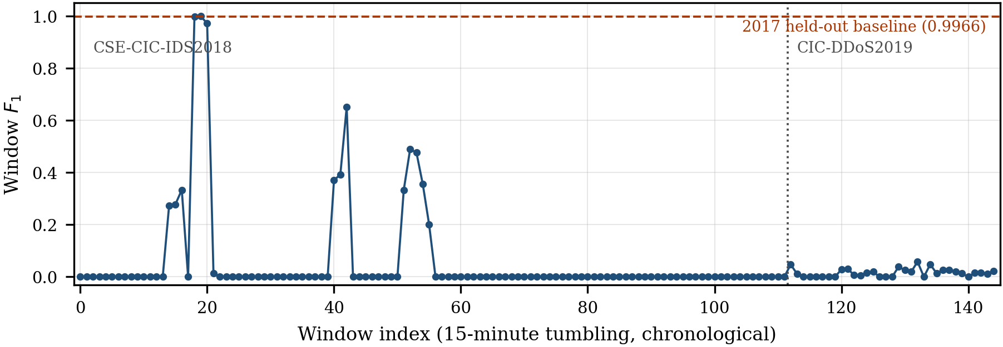
Fig. 2. Per-window F₁ of the static detector in chronological order.

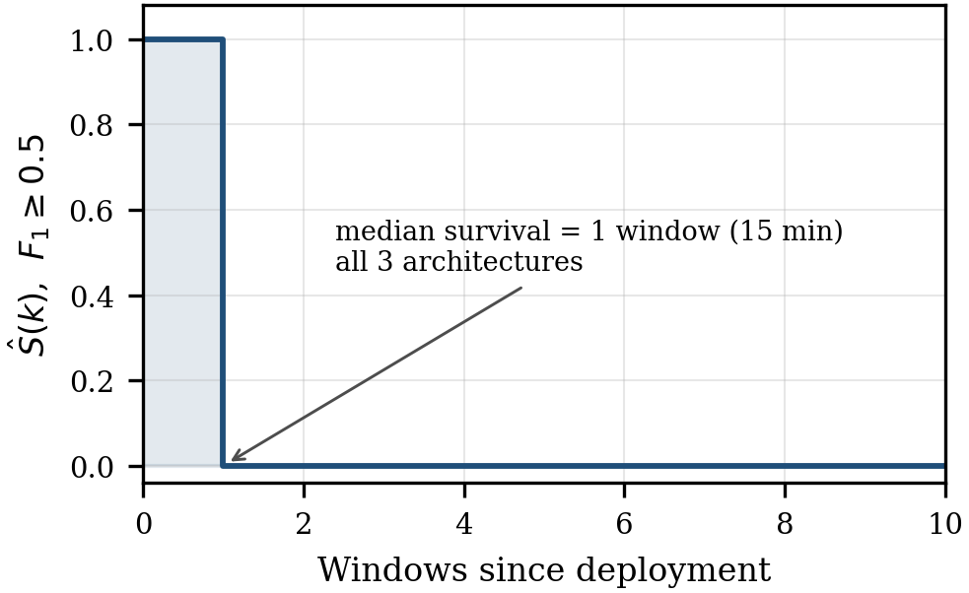
Fig. 3. Kaplan–Meier survival for the three static architectures under an operational floor of F₁ = 0.5.
Every family in Table IV was represented in the 2017 training labels, and none exceeds 8.1% recall. The distribution is bimodal rather than graded: no 2018 family lies between 0.05 and 0.5 (Fig. 4).
TABLE IV
PER-FAMILY RECALL OF THE STATIC 2017 DETECTOR
Year | Family | Attack flows | Detected | Recall
2018 | Web | 928 | 75 | 0.0808
2018 | DoS | 506,075 | 20,501 | 0.0405
2018 | BruteForce | 156,668 | 7 | 0.000045
2018 | Infiltration | 160,604 | 4 | 0.000025
2018 | Bot | 282,310 | 0 | 0.0000
2018 | DDoS | 1,246,382 | 0 | 0.0000
2019 | DDoS | 19,500,705 | 70,296 | 0.0036
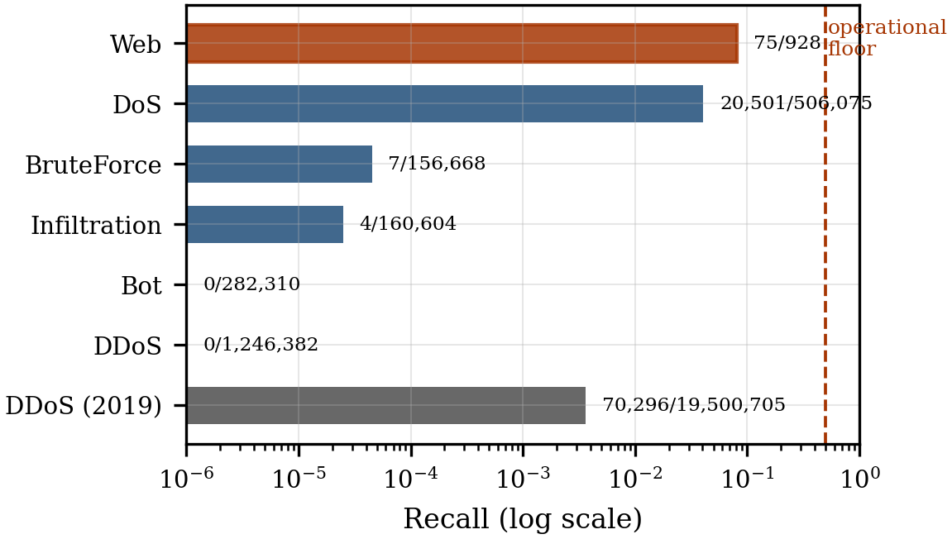
Fig. 4. Per-family recall, logarithmic ordinate. Bot and DDoS (2018) have exactly zero recall and therefore no bar; their counts are annotated.
Fig. 5 isolates the mechanism. Both 02-15 and 02-16 are denial-of-service days and all four tools involved have counterparts in the 2017 training labels, yet recall differs by a factor of 55 (0.3416 against 0.0062). Shared taxonomy does not imply compatible traffic behaviour. The agreement between the recall pattern and the independently published capture schedule also validates the pipeline end to end.

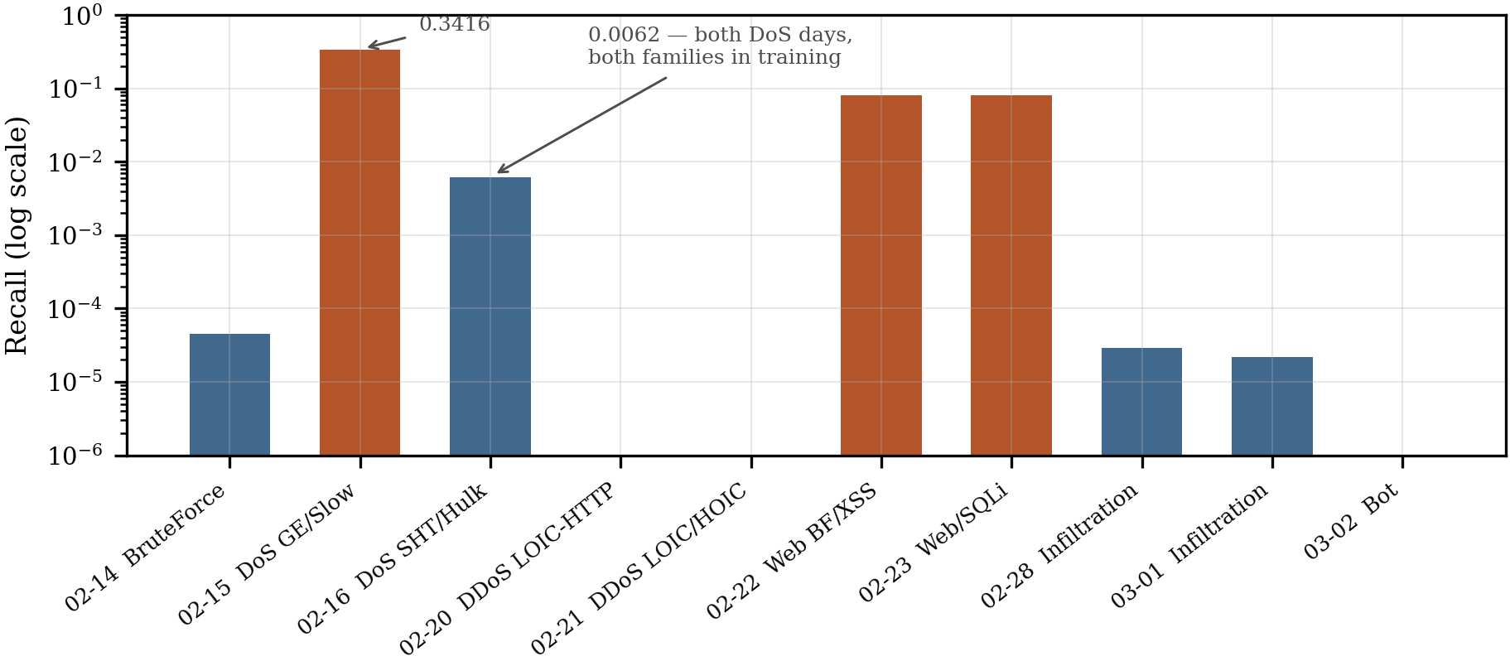
Fig. 5. Per-day recall across the CSE-CIC-IDS2018 schedule.

PSI exceeds the conventional alarm threshold in 100% of the 145 windows (Fig. 6). The count of individual features above threshold has median 44 of 56, minimum 35. The lowest window mean anywhere in 2018 is 0.519, twice the threshold. Mean PSI has sample mean 1.256 and standard deviation 1.455 in 2018 (range 0.519–6.671) and mean 0.912 with standard deviation 0.639 in 2019. Spearman correlation between window index and mean PSI across 2018 is 0.028. The statistic therefore has ample variance, but that variance is not organised in time (Fig. 7): drift varies by an order of magnitude across windows yet neither accumulates monotonically nor aligns with detection failure. Comparing Fig. 7 against Fig. 2, the windows in which detection survives carry ordinary drift, while the high-drift excursion falls in a period where F₁ has already reached zero. We distinguish this saturation regime from degeneracy: the predictor is not flat, its relationship to performance is.
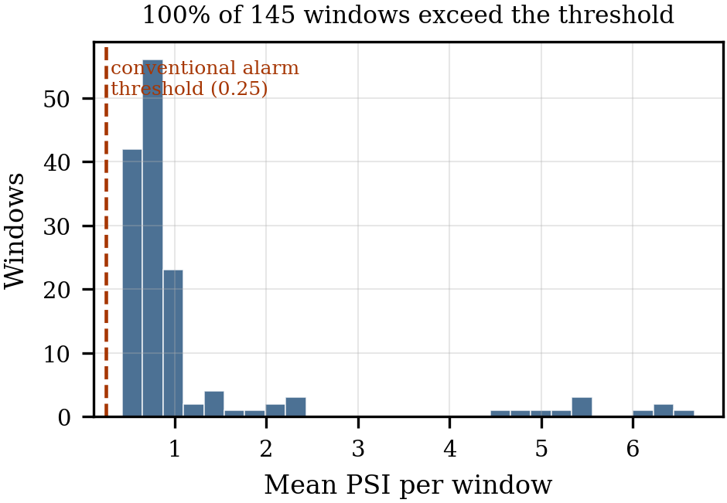
Fig. 6. Distribution of mean PSI across all 145 windows.
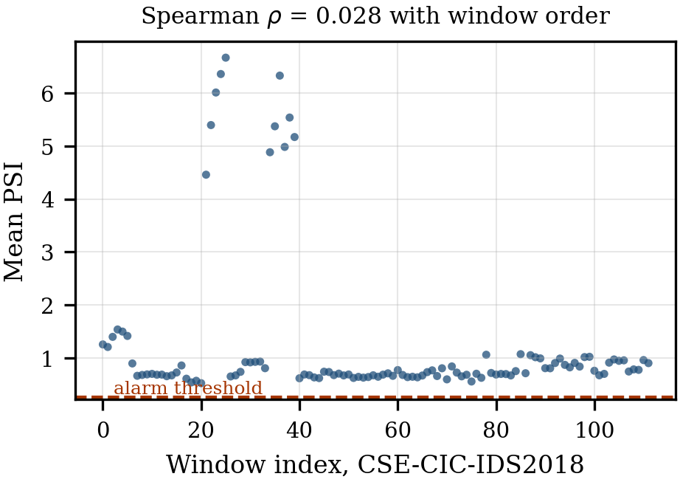
Fig. 7. Mean PSI against window index for CSE-CIC-IDS2018.
Table V supplies the mechanism behind the monitoring failure. On flows that are genuinely attacks, the detector’s mean predicted attack probability ranges from 0.017 to 0.143—uniformly far below the 0.5 decision threshold. The detector is not uncertain about these flows; it is confident and wrong. Infiltration and Bot are the extreme cases, with the lowest entropies in the table, uncertain fractions of 0.025 and 0.003, and recalls of 0.000025 and 0.000000. Infiltration also carries the lowest input-space drift of any family. A family whose traffic most closely resembles the training distribution, on which the detector is maximally confident, is nonetheless undetected—the signature of a conditional shift with the marginal preserved, which no input-space statistic can observe by construction (Fig. 8).
TABLE V
OUTPUT-SPACE BEHAVIOUR ON 2018 ATTACK FLOWS
Family | Entropy | P(attack) | Uncertain | Recall
Web | 0.4049 | 0.1425 | 0.2963 | 0.0808
DoS | 0.3049 | 0.0958 | 0.1485 | 0.0405
BruteForce | 0.4919 | 0.1089 | 0.3837 | 0.000045
DDoS | 0.3549 | 0.0851 | 0.4332 | 0.0000
Bot | 0.1184 | 0.0168 | 0.0026 | 0.0000
Infiltration | 0.1059 | 0.0197 | 0.0251 | 0.000025

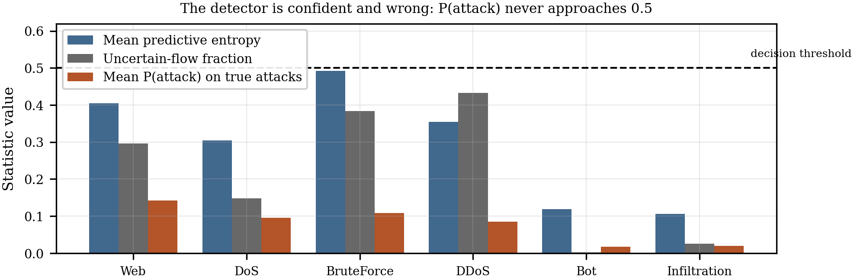
Fig. 8. Output-space behaviour on 2018 attack flows, by family.

Twenty-five labelled attack flows per family suffice for certain detection across all six families (Table VI, Fig. 9). The two families retaining residual capability are the harder calls at the smallest budget. In the limiting case of zero detections, (29) gives 30 adjudications to bound recall below 0.10 and 60 below 0.05.
TABLE VI
LABEL-BUDGET TRIAGE: PROPORTION OF 2000 TRIALS IN WHICH THE WILSON BOUND CORRECTLY ESTABLISHES FAILURE
Family | True recall | n=10 | n=25 | n=50
Bot | 0.0000 | 1.000 | 1.000 | 1.000
DDoS | 0.0000 | 1.000 | 1.000 | 1.000
Infiltration | 0.000025 | 1.000 | 1.000 | 1.000
BruteForce | 0.000045 | 1.000 | 1.000 | 1.000
DoS | 0.0405 | 0.940 | 1.000 | 1.000
Web | 0.0808 | 0.814 | 1.000 | 1.000
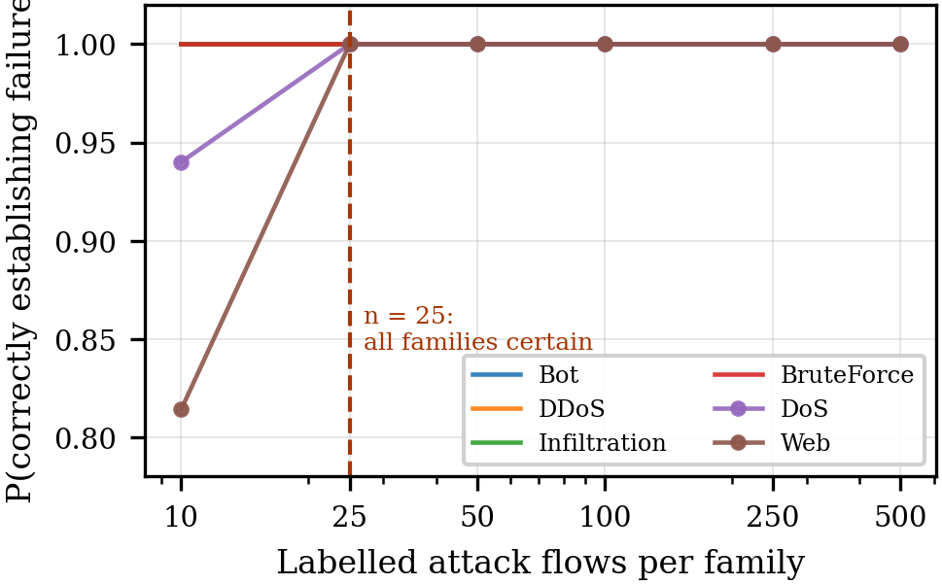
Fig. 9. Probability of correctly establishing detector failure as a function of label budget, by family.

D. Baseline Comparison
A multilayer perceptron and a logistic regression were trained on the identical 2017 split with the identical frozen scaler. These architectures were chosen deliberately: standardisation is monotonic per feature and cannot move a tree’s split points, but it directly shapes a linear boundary and a network’s input layer. Had the frozen scaling caused the collapse, these two would exhibit it most strongly.
All three architectures collapse. Table VII appears to favour the weaker models on several families, and the false-positive rate explains why. The perceptron fires on 1.76% of benign 2018 traffic and the logistic regression on 3.92%, against 0.042% for the forest—factors of 42 and 93. On the 13,374,907 benign flows in the 2018 corpus, the logistic regression would raise on the order of 523,000 false alarms to obtain its 0.109 recall on DDoS. Its apparent advantage is a lower effective decision threshold rather than retained capability, and recalls obtained at such disparate operating points are not comparable. We therefore do not report the per-family ordering as a model-dependent finding; what is stable is that none transfers. The best recall by any model on any 2018 family is 0.252, at 42 times the forest’s false-alarm rate, from models scoring 0.823–0.997 in distribution.
TABLE VII
CROSS-ARCHITECTURE COMPARISON ON CSE-CIC-IDS2018
Family | Attack flows | RF | MLP | LogReg
DDoS | 1,246,382 | 0.0000 | 0.1306 | 0.1086
DoS | 506,075 | 0.0405 | 0.0633 | 0.0295
Bot | 282,310 | 0.0000 | 0.0000 | 0.0006
Infiltration | 160,604 | 0.000025 | 0.1844 | 0.1944
BruteForce | 156,668 | 0.000045 | 0.2520 | 0.1375
Web | 928 | 0.0808 | 0.0011 | 0.0000
2017 held-out F₁ | — | 0.9966 | 0.9341 | 0.8226
2018 benign FPR | — | 0.00042 | 0.01757 | 0.03915
The adaptive learner recovers the task that defeated the static detector (Table VIII). The comparison is sound in recall and not in F₁: recall is invariant to negative-class subsampling, whereas the static detector was scored on the full population at 99.7% attack share and the online learner on a class-capped sample at approximately 17%. A matched-sample rescoring remains outstanding. Adaptation is not free: in 7 of 112 windows in 2018 the online learner itself falls below F₁ = 0.5, five to zero, and 45 windows exhibit a local minimum followed by recovery—windows in which a reactive learner has absorbed damage before its change detection responds.
TABLE VIII
STATIC VERSUS ADAPTIVE DETECTION ON IDENTICAL WINDOWS
Measure | Static RF | Adaptive forest
2018 windows below F₁ = 0.5 | 108/112 | 7/112
2018 mean per-window recall | < 0.05 (108/112) | 0.887
2019 per-window recall (median) | 0.0036 | 0.971
2019 per-window recall (min) | — | 0.904
Local minima with recovery | — | 45/145
The diagnostic value is that it bounds every other result. Because an online learner recovers these attacks from the same features in the same windows, the information required to detect them is present. The static detector’s failure is a transfer failure, and the monitoring failure is a property of the signal rather than of the task.

E. Ablation Studies
1) Drift-metric family ablation: All sixteen candidate statistics were computed on identical windows against identical targets (Table IX, Fig. 10).
TABLE IX
DRIFT-SIGNAL BATTERY, 145 WINDOWS. ρ VALUES ARE SPEARMAN; “CONF.” MARKS STATISTICS REJECTED BY THE CONFOUND FILTER OF (24).
Family | Statistic | F₁ | F₁ nxt | a_{k} | Conf.
Unb. | PSI mean | 0.670 | 0.486 | 0.712 | Y
Unb. | PSI max | −0.110 | −0.138 | −0.049 | N
Unb. | Wass. mean | 0.227 | 0.138 | 0.213 | N
Unb. | Wass. max | 0.025 | −0.019 | 0.031 | Y
Bnd. | JS mean | 0.687 | 0.495 | 0.743 | Y
Bnd. | JS max | −0.021 | −0.045 | 0.121 | Y
Bnd. | Hellinger mean | 0.694 | 0.504 | 0.723 | Y
Bnd. | Hellinger max | −0.020 | −0.057 | 0.073 | Y
Model | Imp.-wtd PSI | 0.691 | 0.515 | 0.659 | N
Model | Top-10 PSI | 0.687 | 0.510 | 0.629 | N
Dyn. | EWMA vel. (PSI) | 0.349 | 0.212 | 0.530 | Y
Dyn. | EWMA acc. (PSI) | −0.042 | −0.081 | −0.087 | Y
Dyn. | EWMA vel. (Wass.) | 0.404 | 0.372 | 0.404 | Y
Out. | Mean entropy | 0.278 | 0.125 | 0.330 | Y
Out. | Mean confidence | −0.100 | 0.036 | −0.166 | Y
Out. | Uncertain frac. | −0.425 | −0.465 | −0.326 | N

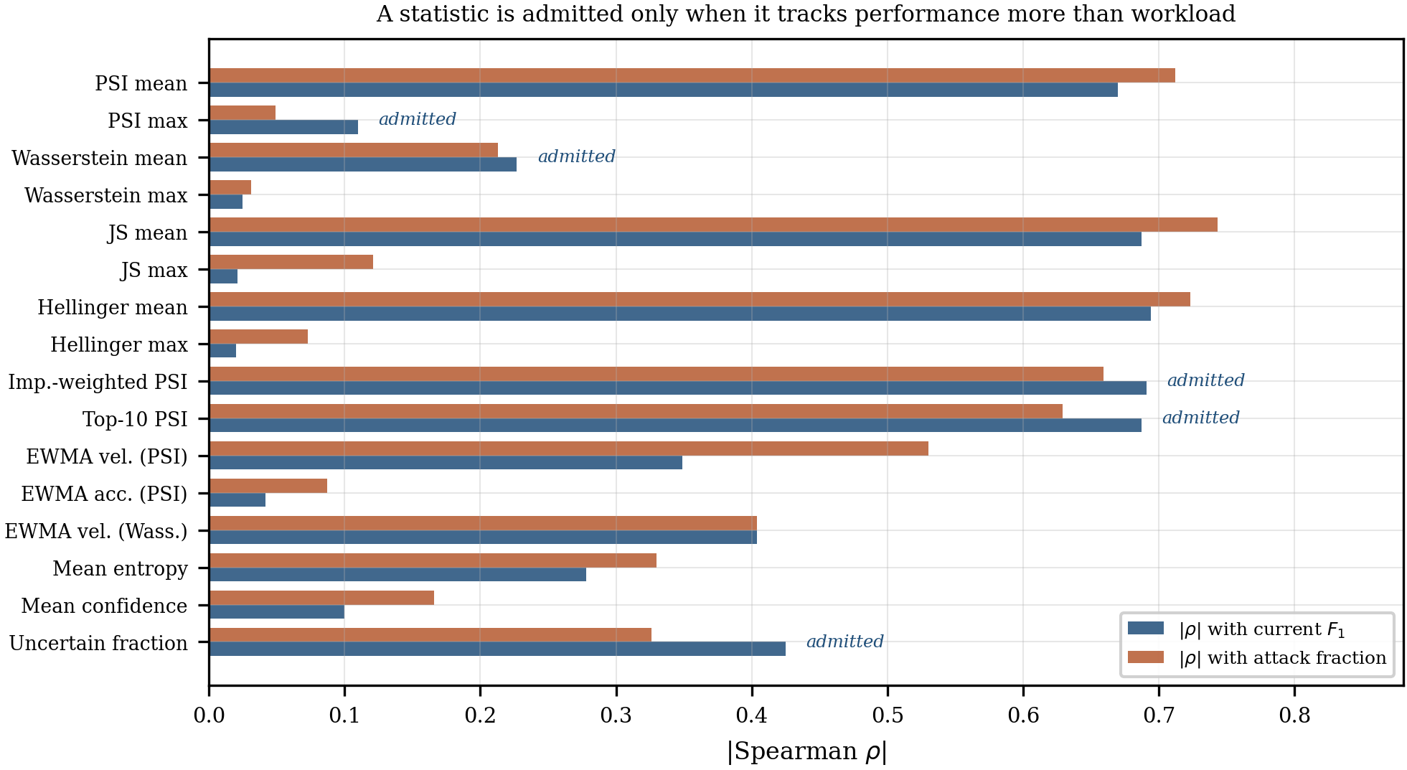
Fig. 10. Drift battery. A statistic is admitted only when it tracks performance more closely than workload composition.

Four findings follow. First, bounded divergences do not saturate: Jensen–Shannon has mean 0.131 with maximum 0.461 against a unit ceiling, so confinement to the unit interval restores usable range where PSI runs to 6.671. Second, range does not confer validity—both bounded statistics correlate more strongly with attack fraction (0.743, 0.723) than with performance (0.687, 0.694) and are rejected by (24). Third, importance weighting raises measured drift rather than lowering it (weighted mean 1.422, top-10 mean 1.569, against an unweighted 1.177), indicating the features the detector most relies on are the most displaced; its margin over the filter is 0.691 against 0.659, which on 145 autocorrelated windows is a statistical tie and we report it as inconclusive. Fourth, the dynamics family does not rescue the saturated level. Only the uncertain-flow fraction clears the filter with a material margin, carries the expected sign, and—uniquely—strengthens when shifted forward one window, from −0.425 to −0.465, the signature of a leading rather than a coincident indicator.
2) Reference-construction ablation: A natural objection is that drift measured against a predominantly benign 2017 reference partly reflects the benign–attack contrast. We therefore rebuilt the reference per family (Table X).
TABLE X
GLOBAL VERSUS FAMILY-MATCHED REFERENCE, 2018
Family | PSI, global | PSI, family-matched | Recall
Web | 3.355 | 5.166 | 0.0808
DoS | 3.566 | 4.585 | 0.0405
BruteForce | 6.122 | 5.669 | 0.000045
Bot | 5.164 | 4.892 | 0.0000
DDoS | 2.471 | 5.386 | 0.0000
Matching by family increases measured drift for Web, DoS and DDoS. Comparing 2018 denial-of-service flows against 2017 denial-of-service flows yields greater divergence than comparing them against a predominantly benign 2017 sample. This disposes of the contrast objection and quantifies the behavioural divergence behind Fig. 5. Rank correlation between family-matched drift and recall across five admissible families is −0.205 for mean PSI and +0.462 for mean Wasserstein distance—inconsistent in sign and, on five points, uninformative. Two families were excluded because CIC-IDS2017 contains only 36 infiltration flows and 11 in the residual category.
3) Confound ablation: A gradient-boosted regressor predicting same-window adaptive-detector F₁ from the seven drift aggregates attains cross-validated R² = 0.609 under blocked validation—a figure that would ordinarily be reported as a working monitor. Feature-importance attribution assigns 0.957 to the window’s attack fraction and approximately 0.04 to all seven drift statistics combined. Trained on 2018 and evaluated on 2019, the same model attains R² = −12.2.
The association survives both controls and replicates independently across two corpora captured in different years on different testbeds (Table XI, Fig. 11). Because adjacent windows are autocorrelated and the nominal Spearman p-value assumes independence, significance was re-established by a moving-block bootstrap with block length 10 over 2000 resamples, giving a 95% confidence interval of [−0.445, −0.118], which excludes zero.
TABLE XI
PARTIAL CORRELATION OF UNCERTAIN-FLOW FRACTION WITH NEXT-WINDOW F₁, n = 143
Controls | ρ | p
None | −0.465 | < 0.0001
Attack fraction | −0.373 | < 0.0001
Current F₁ | −0.290 | 0.0004
Attack fraction and current F₁ | −0.296 | 0.0003
2018 only (n = 111) | −0.414 | < 0.0001
2019 only (n = 32) | −0.442 | 0.0113
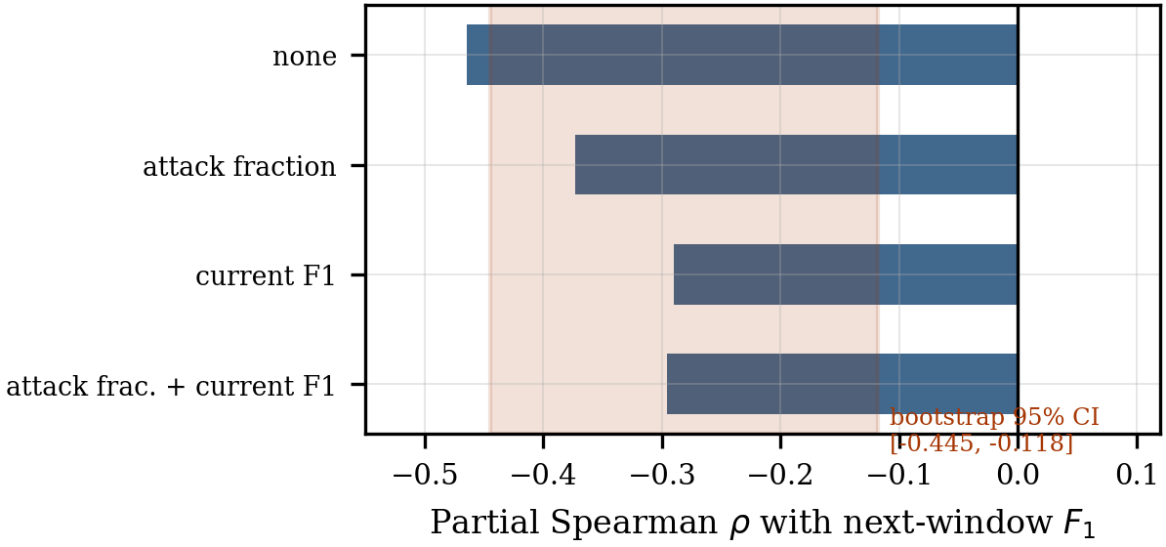
Fig. 11. Partial correlation ladder with the moving-block bootstrap interval.
The effect is nonetheless modest and we report its operational limits explicitly. Treated as a classifier for next-window performance dips, the statistic attains AUC 0.462 against a positive rate of 0.308—indistinguishable from chance, and no better than the input-space statistics it outperforms on the continuous target (PSI mean 0.561, JS mean 0.572). A threshold calibrated on the 2018 upper quartile and applied to 2019 yields precision 0.750 against a base rate of 0.500 at recall 0.188, but on 32 windows this corresponds to three true positives from four alarms and is not statistically distinguishable from chance. A weak but genuine leading signal exists in output space where input space provides none, and it is not yet strong enough to drive an unsupervised alarm—which is precisely why Algorithm 2 routes control to label triage when the signal is weak rather than acting on it.
4) Computational strategy ablation: Bounded divergences were computed by two paths over identical inputs: Spark’s Arrow-backed grouped-map interface distributed across all cores, and a single-threaded loop. The distributed path required 26.7 s for 145 windows; the loop required 1.3 s for 20 windows, projecting to 9.6 s. The distributed implementation is therefore 0.36× the speed of the sequential one at this problem size. We report this because it is instructive: at 145 windows of approximately 20,000 rows, JVM round-trip latency, task scheduling and Arrow serialisation dominate the arithmetic being distributed. Distributed execution is indispensable at the scale of Modules 1–2, where the 35.3-million-row scoring pass cannot be held in memory, and counterproductive at the scale of Module 3. The operative question is not whether to distribute but where the crossover lies.

F. Hyperparameter Tuning
Hyperparameter selection is deliberately conservative, because the object under investigation is a monitoring signal rather than a detector, and an over-tuned baseline would weaken the argument. Detector parameters follow prior work on these corpora so the baseline is comparable to published results. We observed during training that the per-level broadcast payload grew by shrinking increments beyond approximately depth 12, indicating the forest had saturated well before the configured depth; this is reported as a sensitivity observation rather than acted upon, since altering the baseline would break comparability.
The benign-count floor warrants comment. An earlier configuration imposed a minimum of 50 benign flows per window, standard practice for stabilising specificity. In CIC-DDoS2019 benign and attack traffic are separated in time, so that filter removed precisely the flood windows the study exists to measure. It was set to zero and TSS masked at reporting time instead.
Two settings in Table XII are load-bearing. Blocked cross-validation is used throughout in place of random folds, because adjacent windows are autocorrelated and random partitioning leaks future information; with 152 drift features against 112 training windows, feature selection is performed inside each fold rather than once globally, since selecting globally inflates validation scores through the same leakage. The bootstrap block length of 10 exceeds the autocorrelation scale of the performance series; shorter blocks would understate interval width and overstate significance.
TABLE XII
PARAMETER SETTINGS
Parameter | Value | Basis
RF trees | 200 | Prior work
RF max depth | 20 | Prior work; saturation near 12
RF max bins | 64 | MLlib default range
RF subsampling | 0.8 | Standard
RF feature subset | √d | Standard
MLP hidden layers | 32, 16 | Matched to 76 inputs
MLP max iterations | 60 | Convergence on train
LR regularisation | 0.01, L2 | Standard
Window width | 15 min | Table III
Min flows per window | 500 | F₁ stability
Min benign per window | 0 | See discussion
Per-class cap (drift) | 20,000 | Memory envelope
Per-class cap (online) | 3,000 | Throughput
Quantile bins | 10 | Conventional
PSI alarm threshold | 0.25 | Conventional
Reference sample | 200,000 | Bin stability
EWMA smoothing α | 0.3 | Conventional
Entropy threshold η | 0.5 | Midpoint of range
Alarm quantile β | 0.75 | Calibrated on 2018
Operational floor θ | 0.5 | Half of baseline
Label budget n | 25–60 | Table VI
Bootstrap block length | 10 | Autocorrelation scale
Bootstrap resamples | 2000 | Interval stability
CV scheme | Blocked, 5 folds | Prevents leakage
Online trees T | 10 | Throughput
Random seed | 42 | All components

V. CONCLUSION AND FUTURE WORK
This study set out to build a proactive decay forecaster for flow-based intrusion detection and instead established why one cannot be built from input-space drift statistics on chained benchmark corpora. Transition between CIC-IDS2017, CSE-CIC-IDS2018 and CIC-DDoS2019 is a discrete regime change rather than a temporal process: a detector scoring F₁ = 0.9966 in distribution falls below F₁ = 0.5 in 108 of 112 windows of the following corpus and recovers 0.0036 of attacks on the 2019 evaluation day, with median survival of one 15-minute window. Failure is organised by attack family rather than by time, and label parity does not imply behavioural parity—two consecutive denial-of-service days drawn from trained families differ in recall by a factor of 55. Across five families of drift statistic, two reference constructions and both signal spaces, no input-space measure anticipates this failure: PSI exceeds its conventional threshold in every window on a median of 44 of 56 features with no monotonic temporal trend, bounded divergences retain range but track workload composition, and the single configuration that appeared successful proved on ablation to be 95.7% attributable to attack fraction. UDM-T establishes that a weak but statistically robust leading signal exists in model-output uncertainty (partial ρ = −0.296, bootstrap 95% CI [−0.445, −0.118], replicating across both corpora), that detector failure is silent rather than uncertain, and that 25 labelled flows per family resolve in minutes what unlimited unlabelled traffic does not.
Three directions follow. The most consequential is replication on a second corpus chain with independent capture lineage, since all results here concern datasets sharing a common extractor and institutional provenance; whether the step-change character generalises is the principal open question. Second, the output-space signal should be strengthened before it can drive an unsupervised alarm: candidate extensions include disagreement between a frozen and a continuously adapting model, calibrated ensemble variance, and conformal non-conformity scores, all of which remain sensitive to conditional shift while avoiding the saturation that defeats marginal statistics. Third, the triage stage invites an active-learning treatment in which the per-family budget is allocated adaptively according to posterior uncertainty rather than uniformly. Two measurement gaps also remain: a matched-sample rescoring to make static and adaptive F₁ directly comparable, and a recall comparison at equalised false-positive rate across architectures. # REFERENCES
[1] Z. Xu et al., “Deep learning-based intrusion detection systems: A survey,” arXiv:2504.07839, 2025.
[2] M. A. Shyaa, N. F. Ibrahim, Z. Zainol, R. Abdullah, M. Anbar, and L. Alzubaidi, “Evolving cybersecurity frontiers: A comprehensive survey on concept drift and feature dynamics aware machine and deep learning in intrusion detection systems,” Eng. Appl. Artif. Intell., vol. 137, Art. no. 109143, 2024, doi: 10.1016/j.engappai.2024.109143.
[3] M. Ghayoumi et al., “Trustworthy deep learning for cybersecurity: A structured review across detection, robustness, privacy, explainability, and deployment,” Electronics, vol. 15, no. 11, Art. no. 2421, 2026, doi: 10.3390/electronics15112421.
[4] J. Talpini, F. Sartori, and M. Savi, “Enhancing trustworthiness in ML-based network intrusion detection with uncertainty quantification,” J. Reliable Intell. Environ., 2024, doi: 10.1007/s40860-024-00238-8.
[5] J. Gawlikowski et al., “A survey of uncertainty in deep neural networks,” Artif. Intell. Rev., vol. 56, no. S1, pp. 1513–1589, 2023, doi: 10.1007/s10462-023-10562-9.
[6] T. Yang, Y. Qiao, and B. Lee, “Towards trustworthy cybersecurity operations using Bayesian deep learning to improve uncertainty quantification of anomaly detection,” Comput. Secur., vol. 144, Art. no. 103909, 2024, doi: 10.1016/j.cose.2024.103909.
[7] J. Ren, J. Wen, Z. Zhao, R. Yan, X. Chen, and A. K. Nandi, “Uncertainty-aware deep learning: A promising tool for trustworthy fault diagnosis,” IEEE/CAA J. Autom. Sinica, vol. 11, no. 6, pp. 1317–1330, 2024, doi: 10.1109/JAS.2024.124290.
[8] A. Tziouvaras et al., “Label-free concept drift assessment for reliable AI in emerging wireless applications,” arXiv:2508.00042, 2026.
[9] S. Barrett, G. Dorai, L. Li, and S. Rajaganapathy, “FADES: Adaptive drift estimation via conformal signals for streaming intrusion detection,” Electronics, vol. 15, no. 10, Art. no. 2114, 2026, doi: 10.3390/electronics15102114.
[10] S. Barrett, L. Li, G. Dorai, and S. Rajaganapathy, “FIRCE: A framework for intrusion response and conformal evaluation,” arXiv:2605.01962, 2026.
[11] R. Gupta et al., “Generative active adaptation for drifting and imbalanced network intrusion detection,” arXiv:2503.03022, 2025, doi: 10.1145/3830389.
[12] S. Jeon and A. Kim, “A label-efficient adaptive retraining framework for network intrusion detection under streaming arrival bias,” Electronics, vol. 15, no. 17, Art. no. 3812, 2026, doi: 10.3390/electronics15173812.
[13] A. Lara-Gutiérrez, C. Fernandez-Gago, and J. A. Onieva, “A framework for drift detection and adaptation in AI-driven anomaly and threat detection systems,” Int. J. Inf. Secur., vol. 24, 2025, doi: 10.1007/s10207-025-01118-9.
[14] X. Hu, D. Ma, W. Wang, and F. Liu, “Dual adaptive windows toward concept-drift in online network intrusion detection,” in Computational Science—ICCS 2025. Springer, 2025, doi: 10.1007/978-3-031-97626-1_15.
[15] C. Zha et al., “A-NIDS: Adaptive network intrusion detection system based on clustering and stacked CTGAN,” IEEE Trans. Inf. Forensics Security, vol. 20, pp. 3204–3219, 2025, doi: 10.1109/TIFS.2025.3551643.
[16] B. M. Xavier, M. Martinello, C. Trois, B. Mello, and R. Rios, “Fast learning enabled by in-network drift detection,” in Proc. 8th Asia-Pacific Workshop Netw. (APNet ’24). ACM, 2024, doi: 10.1145/3663408.3663427.
[17] S. Drago, M. Lorusso, P. Ferraro, A. De Paola, and G. Lo Re, “Online framework for intrusion detection systems with explainable concept drift detection and adaptation phases,” in Proc. Joint Nat. Conf. Cybersecurity (ITASEC & SERICS 2026), CEUR Workshop Proc., 2026.
[18] M. A. Shyaa, N. F. Ibrahim, Z. Zainol, R. Abdullah, and M. Anbar, “Reinforcement learning-based voting for feature drift-aware intrusion detection: An incremental learning framework,” IEEE Access, vol. 13, pp. 37872–37903, 2025, doi: 10.1109/ACCESS.2025.3544221.
[19] E. Rivas, S. Saika, A. Bakht, A. Piplai, N. D. Bastian, and A. Shah, “Adapting under fire: Multi-agent reinforcement learning for adversarial drift in network security,” arXiv:2506.06565, 2025.
[20] J. Yuan, Y. Yang, and M. Wang, “ADAWU-IDS: A dynamic adaptive weight update mechanism for concept drift-aware network intrusion detection systems,” J. King Saud Univ.—Comput. Inf. Sci., vol. 38, no. 6, 2026, doi: 10.1007/s44443-026-00964-4.
[21] B. Yurdakul and J. Naranjo, “Statistical properties of the population stability index,” J. Risk Model Validation, vol. 14, no. 4, pp. 89–100, 2020, doi: 10.21314/JRMV.2020.227.
[22] A. Ramdas, N. García Trillos, and M. Cuturi, “On Wasserstein two-sample testing and related families of nonparametric tests,” Entropy, vol. 19, no. 2, Art. no. 47, 2017, doi: 10.3390/e19020047.
[23] I. Sharafaldin, A. H. Lashkari, and A. A. Ghorbani, “Toward generating a new intrusion detection dataset and intrusion traffic characterization,” in Proc. 4th Int. Conf. Inf. Syst. Secur. Privacy (ICISSP), 2018, pp. 108–116, doi: 10.5220/0006639801080116.
[24] I. Sharafaldin, A. H. Lashkari, S. Hakak, and A. A. Ghorbani, “Developing realistic distributed denial of service (DDoS) attack dataset and taxonomy,” in Proc. Int. Carnahan Conf. Secur. Technol. (ICCST), 2019, pp. 1–8, doi: 10.1109/CCST.2019.8888419.
[25] H. M. Gomes et al., “Adaptive random forests for evolving data stream classification,” Mach. Learn., vol. 106, nos. 9–10, pp. 1469–1495, 2017, doi: 10.1007/s10994-017-5642-8.
[26] P. Domingos and G. Hulten, “Mining high-speed data streams,” in Proc. 6th ACM SIGKDD Int. Conf. Knowl. Discovery Data Mining, 2000, pp. 71–80, doi: 10.1145/347090.347107.
[27] A. Bifet and R. Gavaldà, “Learning from time-changing data with adaptive windowing,” in Proc. SIAM Int. Conf. Data Mining, 2007, pp. 443–448, doi: 10.1137/1.9781611972771.42.
[28] E. B. Wilson, “Probable inference, the law of succession, and statistical inference,” J. Amer. Statist. Assoc., vol. 22, no. 158, pp. 209–212, 1927, doi: 10.1080/01621459.1927.10502953.
[29] E. L. Kaplan and P. Meier, “Nonparametric estimation from incomplete observations,” J. Amer. Statist. Assoc., vol. 53, no. 282, pp. 457–481, 1958, doi: 10.1080/01621459.1958.10501452.
[30] J. A. Hanley and A. Lippman-Hand, “If nothing goes wrong, is everything all right? Interpreting zero numerators,” JAMA, vol. 249, no. 13, pp. 1743–1745, 1983, doi: 10.1001/jama.1983.03330370053031.
[31] M. Zaharia et al., “Apache Spark: A unified engine for big data processing,” Commun. ACM, vol. 59, no. 11, pp. 56–65, 2016, doi: 10.1145/2934664.
[32] J. Montiel et al., “River: Machine learning for streaming data in Python,” J. Mach. Learn. Res., vol. 22, no. 110, pp. 1–8, 2021.

