Polar Measurements on a Small Turntable
  - When the cabinet cannot turn about its baffle, the off-axis measurements are taken too far away and from the wrong direction. Geometry can remove most of the error. A boundary-element simulation shows how close the corrected data come to the real thing, and where the cabinet sets the limit.
By Arnaud Demion
A loudspeaker’s off-axis behavior is measured by turning it in front of a fixed microphone. For the data to mean what they should, the loudspeaker has to turn about a point on its baffle, the reference point, usually on the tweeter axis. The microphone then stays at the same distance from that point at every angle, as a distant listener would. CTA-2034-A, the standard behind the “spinorama” curves, defines its measurements that way, on a horizontal and a vertical orbit (a full circle of measurement positions) around the reference point, at 2 m [3].
With a large turntable, or a rig that holds the cabinet with its baffle over the axis, this is easy. The turntables most small manufacturers and hobbyists use are 30 to 40 cm across. A large loudspeaker, a three-way tower for instance, cannot stand on such a table with its baffle over the axis, because most of the cabinet would hang off the edge. So it goes in the middle of the table, and the rotation axis runs through the middle of the box (Figure 1).
Everything in this article comes from simulations, computed with the boundary element method (BEM). A simulation can measure the same loudspeaker both ways, with the axis on the baffle and with the cabinet centered, and compare them exactly. It also leaves out what would blur that comparison in a real measurement: the room and its reflections, the gating window, noise, positioning errors, and the drivers’ own behavior, such as cone breakup, since the diaphragms are rigid. What remains is the problem itself, moving the measurements from where they were taken to where they should have been, and the cabinet’s part in it.
The loudspeaker studied is an ordinary two-way: a 24-liter closed box, 290 mm wide, 440 mm high and 290 mm deep, with a Dayton Audio SIG225-4 8-inch woofer and a SICA LP 90.28/N92 1.1-inch dome tweeter 205 mm above it. Their responses follow the manufacturers’ datasheets, and a crossover sums them: each driver is equalized on axis to a fourth-order Linkwitz-Riley target at 2 kHz. In the simulation the woofer is a rigid recessed cone and the tweeter a rigid dome. A two-way of this size keeps the drawings and the computations simple, and it would fit on a small turntable more easily than a large three-way tower. The geometry is the same, though, and the errors to correct grow with the depth of the cabinet.
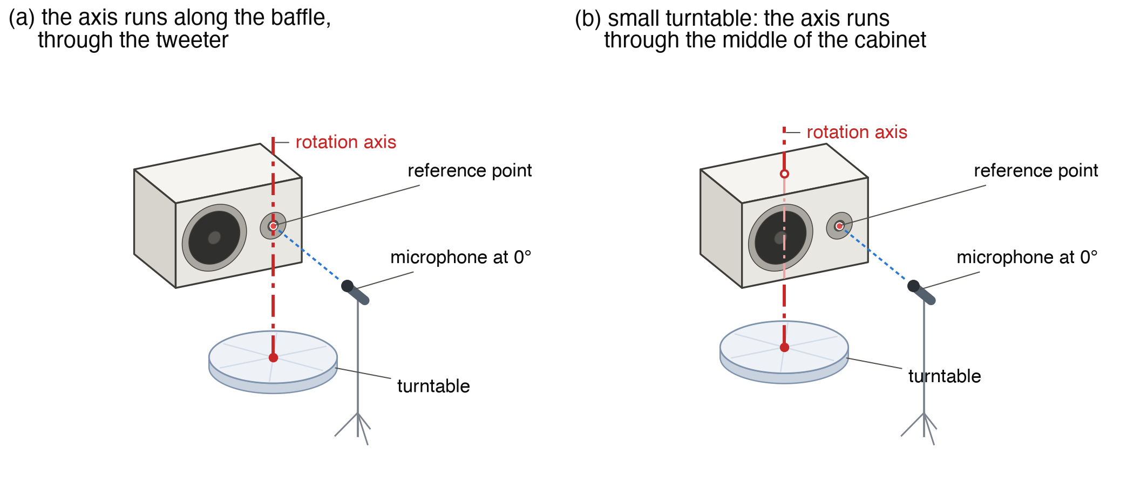
Figure 1: The two-way lying on its side, as it is for measuring its vertical directivity. In (a), the rotation axis runs along the baffle, through the tweeter. In (b), the cabinet is centered on the turntable and the axis runs through the middle of the box.

What Goes Wrong
Standing on the turntable for its horizontal directivity, the two-way turns about an axis 145 mm behind the baffle, and the microphone faces the tweeter at 0°. For its vertical directivity it lies on its side (Figures 1 and 2). The axis is still 145 mm behind the baffle, but the tweeter is now 120 mm to the side of it, so the microphone has to be moved 120 mm sideways to face it at 0°.
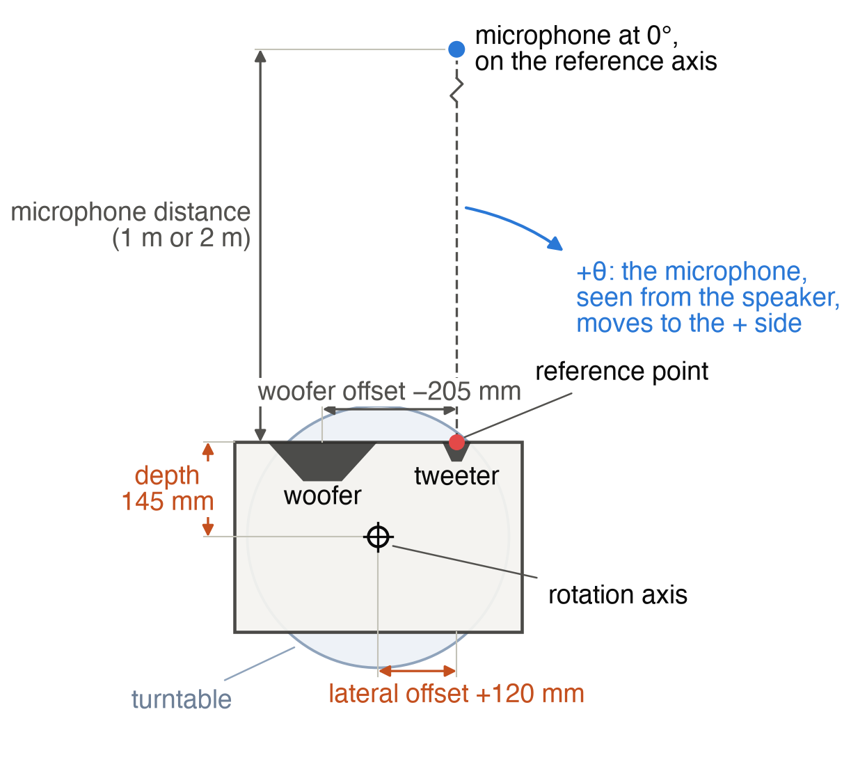
Figure 2: The two-way lying on its side, seen from above, with the four distances the correction needs. The lateral offset is positive here, because the reference axis lies on the side the microphone moves toward at positive angles.
Off axis, the microphone is then farther from the drivers than intended. In the vertical orbit, behind the cabinet, at a nominal 1 m, it is up to a third farther away, so the response reads 2.5 to 2.8 dB low, and the sound arrives up to 1 ms late. Each driver is also heard from another direction than the nominal angle, by as much as 15°. Since the microphone was moved sideways, the errors are not the same on the woofer’s side and on the other. At 2 m the level and direction errors are about halved, while the delay stays the same, because it depends on where the axis is, whatever the distance.
Figure 3 shows what this does to the summed loudspeaker in the vertical orbit. At 60° above the axis, the uncorrected response is 1 to 2 dB low. At 150°, it also has notches around the 2 kHz crossover that the real response does not have. Heard from the wrong place, the woofer and the tweeter reach the microphone with another relative delay, and they no longer add up the same way.
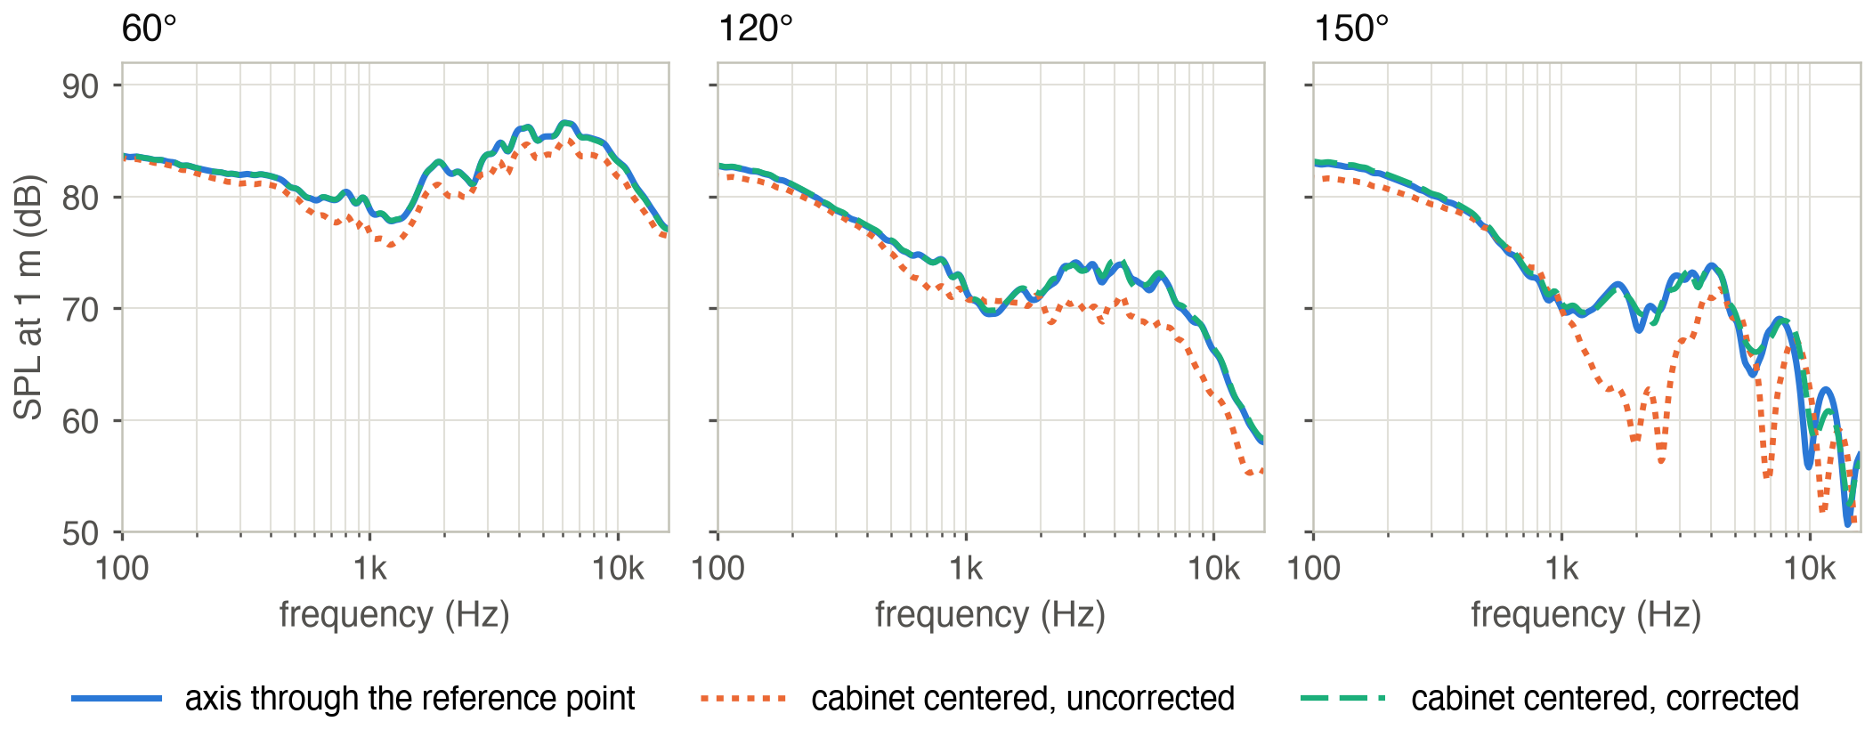
Figure 3: The summed two-way at 60°, 120° and 150° above the axis (vertical orbit), microphone at 1 m, measured in 10° steps, 1/12-octave smoothing. Blue: the reference, with the axis through the tweeter. Orange: the centered cabinet, uncorrected. Green: the same data corrected.

Putting the Measurements Back
The correction works one driver at a time, each measured on its own. For each nominal angle, it asks where the microphone should have been, and which measurements were taken closest to that direction, as seen from the driver. Both questions have exact answers, because the geometry of the setup is known. The correction takes the two measurements whose directions bracket the ideal one, moves each to the ideal distance, and averages them, each with a weight that depends on how close its direction is to the ideal one.
Moving a measurement to another distance assumes that, around each driver, the sound behaves like that of a point source with some directivity. Farther away, the sound arrives later and its pressure falls in inverse proportion to the distance (6 dB per doubling), while its directivity stays the same. Each move is then a delay and a gain. The directivity itself can be anything, since the measurements describe it.
All of this needs four distances in each plane of rotation, which a tape measure provides (Figure 2):
- the depth, from the rotation axis to the baffle;
- the lateral offset, from the rotation axis to the reference axis (the line the microphone is on at 0°), with its sign;
- each driver’s offset from the reference axis;
- the microphone distance at 0°.
A driver out of the plane the microphone turns in also has its distances counted in 3D. Standing for its horizontal orbit, the two-way has its woofer 205 mm below that plane; taking it as in the plane would cost only a few hundredths of a dB here.
The two measurements can be averaged as complex responses, magnitude and phase together, or as powers, the squared magnitudes, which ignore the phase. When the two measurements are in phase, both give almost the same result. When they are not, the complex average partly cancels and digs notches that neither measurement has. This happens behind the cabinet at high frequency, where the response changes faster with angle than a 10° step can follow. Averaging the powers avoids it. The cost is small: on the steep edge of a driver’s main lobe, where the level changes quickly with angle, the power average reads slightly high. The correction here averages the powers and keeps the phase of the complex average (see “The Arithmetic” sidebar).

The Simulation
The BEM computes the sound field around the cabinet from what happens on its surface, every face and edge of the box included. It was solved from 20 Hz to 16 kHz in 1/48-octave steps, at 1,728 microphone positions: the horizontal and vertical orbits of both setups, at 1, 2 and 4 m, every 2.5°. It took 3.8 hours on a Mac mini with the BEM solver I am developing.
To compare a corrected measurement with the reference, I take their level difference at every angle and frequency, after 1/24-octave smoothing, and compute its RMS value. The points more than 20 dB below the on-axis response are left out: in a deep null, a fraction of a degree changes the level by tens of dB.

How Close It Gets
In the vertical orbit, at 1 m with 10° steps, the summed two-way is 2.56 dB RMS off before correction and 0.62 dB after. The corrected curves of Figure 3 follow the reference closely at 60° and 120°. At 150° they match up to a few kHz and keep some error above. The horizontal orbit, where only the depth is offset, goes from 1.86 to 0.38 dB RMS.
That remaining error comes from the cabinet. With the same drivers as point sources in an infinite baffle, the correction leaves 0.09 dB RMS. A cabinet adds diffraction: when the sound running along the baffle reaches an edge, the edge radiates a secondary wave, as if a weaker source sat there. The microphone hears the sum of the direct sound and these edge waves, each with its own delay. The correction cannot move the edge waves properly, because it moves everything as if it came from the driver. And behind the cabinet, where the edge waves are most of what the microphone hears, their interference pattern changes faster with angle than 10° steps can follow.
Figure 4 shows where the error sits in the vertical orbit: behind the cabinet, and below the axis, on the woofer’s side, where the bottom edge of the baffle, 340 mm below the tweeter, adds ripples with a period of only 10° around 6 kHz.
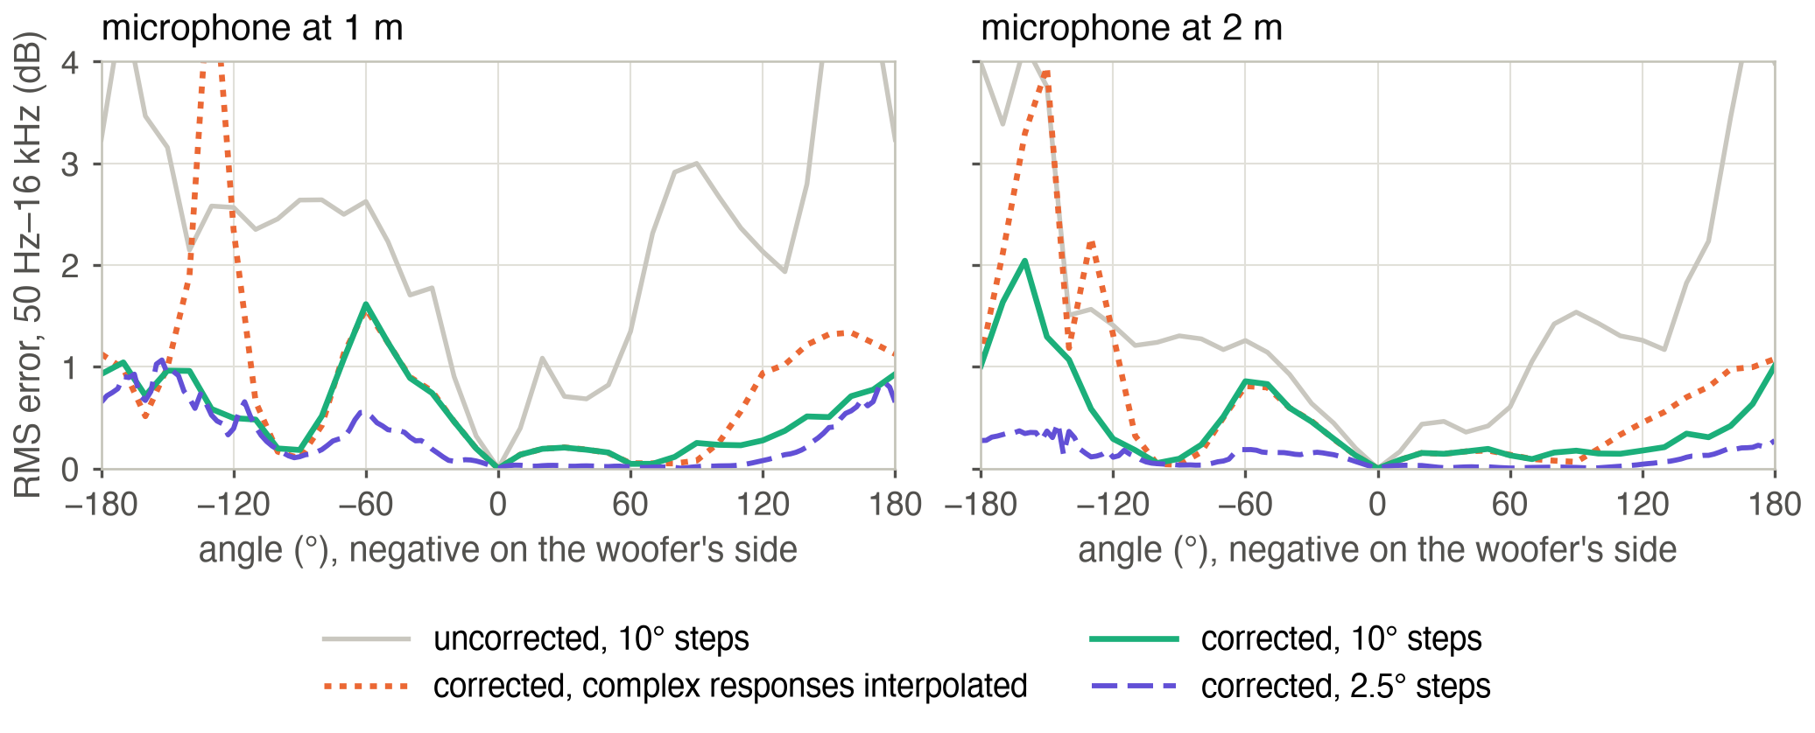
Figure 4: RMS level error of the summed two-way at each angle (50 Hz to 16 kHz), vertical orbit. Negative angles are below the axis, on the woofer’s side. Corrected with 10° steps, averaging powers (green) or complex responses (orange), and with 2.5° steps (purple). Gray: uncorrected.
A finer angular step removes most of it (Table 1). With 10° steps the residual is about the same at every distance, because the interference patterns keep their angular period. With 2.5° steps it falls to 0.14 dB at 2 m and 0.09 dB at 4 m. At 1 m about 0.4 dB remains even with 2.5° steps, because that close to the cabinet the correction gets the timing of the edge waves slightly wrong, which no step can fix.
Summed two-way | 1 m | 2 m | 4 m
Uncorrected | 2.56 | 1.79 | 1.20
Corrected, 10° steps | 0.62 | 0.60 | 0.58
Corrected, 5° steps | 0.41 | 0.28 | 0.27
Corrected, 2.5° steps | 0.38 | 0.14 | 0.09
Table 1: RMS level error of the summed two-way on the vertical orbit (dB), against the angular step.
Averaging powers matters most with coarse steps. With 10° steps, the complex average leaves 1.21 dB RMS at 1 m, twice as much, with notches down to −20 dB behind the cabinet, where the orange curve of Figure 4 peaks. With 2.5° steps, neighboring measurements are in phase again and both averages agree.

Drivers One by One, or the Whole Loudspeaker
So far each driver was measured on its own and moved from its own position, then the two were summed through the crossover. A finished loudspeaker, a passive one for instance, is often measured as a whole, and can then only be moved from one point, the reference point on the tweeter axis. Measured at once and corrected that way, the two-way keeps 0.68 dB RMS of error on its vertical orbit at 1 m with 10° steps, against 0.62 dB with the drivers taken one by one, and its PIR is the same. The difference sits around the crossover, 0.85 against 0.70 dB between 1 and 4 kHz, because the woofer and the tweeter keep the relative delay of the position the microphone was really at. That error should grow with the drivers’ distance from the reference point, relative to the measurement distance, as on a tall tower measured up close, which this study did not simulate. Measuring the drivers separately remains the cleaner way, and it is the one a crossover is designed from.

The Spatial Averages
CTA-2034-A condenses the polar data into a few curves: the listening window (the average of the directions within ±30° horizontally and ±10° vertically), the early reflections (the directions that reach a listener after one reflection off the walls, floor and ceiling), the sound power (all directions), and the Predicted In-Room Response, or PIR, a weighted blend of the three that predicts the response in a typical room. All of them are power averages over many directions.
The centered setup lowers them all, because every off-axis position is too far away. Computed from both orbits, the PIR is up to 1.0 dB low at 1 m. After correction with 10° steps it is within 0.35 dB of the reference, and within 0.10 dB with 2.5° steps (Figure 5). Up to about 3 kHz the corrected PIR is within 0.05 dB at any step. Above, the deviations come in narrow bands, where the residual errors of individual directions do not cancel in the average.
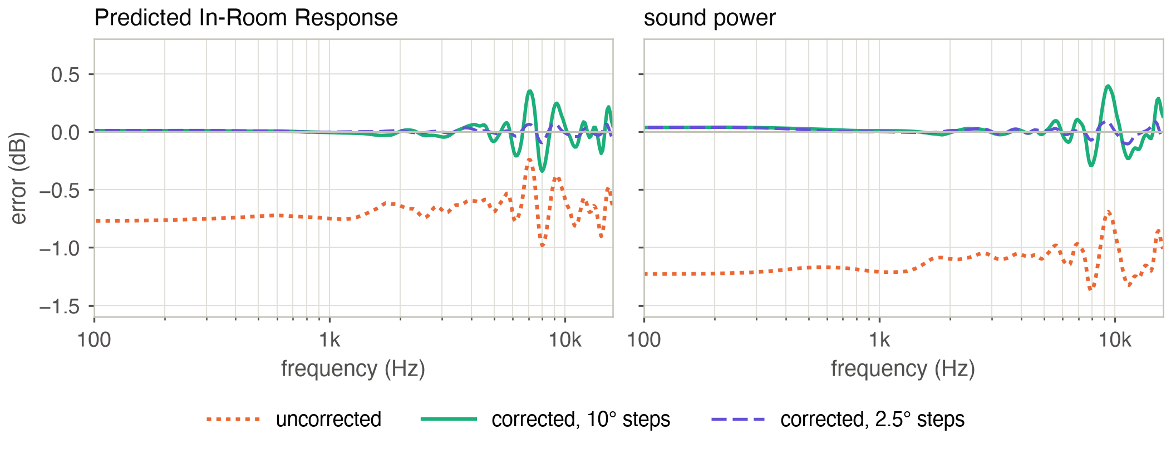
Figure 5: The PIR and the sound power of the two-way at 1 m, computed from both orbits, against the reference: uncorrected, and corrected with 10° and 2.5° steps.
Part of what remains with 10° steps belongs to the standard’s own sampling. The reference listening window, computed from directions 10° apart, already differs by up to 0.3 dB around 13 kHz from the same window averaged every 2.5°. With 10° steps, a few tenths of a dB in narrow bands is the resolution of the measurement, corrected or not.

The Lateral Offset
An error of 10 mm on the depth or on the lateral offset, or of 20 mm on the microphone distance, changes the PIR by less than 0.1 dB, so a tape measure is accurate enough.
Lying on its side, the two-way also needs its lateral offset: the tweeter is 120 mm from the rotation axis, and the correction must know on which side. With the offset left at zero, as for a symmetric loudspeaker, it places the measurements up to 11° away from where they were taken at 1 m, and up to 21° with the wrong sign. The individual curves of the vertical orbit then keep 1.4 and 2.0 dB RMS of error, two to three times the residual with the right offset.
With complex averaging, either mistake is worse than no correction at all. The two measurements around each direction, moved with the wrong delays, no longer line up in time and cancel each other. Computed from both orbits, the PIR ends up 1.7 to 1.8 dB off at 1 m, against 1.0 dB for the raw data. With the powers averaged, it stays within 0.4 dB, as with the right offset, while the individual curves keep the errors above.
To check the sign, turn the table to +90° and look at which side of the cabinet faces the microphone. The lateral offset is positive if the reference axis lies on that side.

Measuring at 1 m for Results at 2 m
Measuring at 1 m and rebuilding the data as seen from 2 m is tempting. At 1 m the room’s reflections arrive later relative to the direct sound, which leaves a longer usable window, and CTA-2034-A works at 2 m. The same correction can do it, with the ideal positions on a 2 m circle. The drivers beside the reference axis are then heard from the right angles. The woofer, 205 mm from the tweeter, is 11.6° off its own axis at 0° from 1 m, and 5.9° from 2 m.
The correction cannot account for the cabinet’s sound field changing shape between 1 and 2 m. At low frequency, the cabinet’s acoustic center, the point the low-frequency sound appears to come from, sits about 130 mm in front of the baffle, as Vanderkooy showed [2]. From 1 to 2 m the level then falls by 6.6 dB in front of the cabinet and 5.5 dB behind it, where the point-source model assumes 6 dB everywhere.
At high frequency, the diffraction pattern itself changes with distance. Rebuilt from 1 m, the 2 m data of the vertical orbit keep 0.67 dB RMS of error on the summed loudspeaker, even with 2.5° steps, where measurements taken at 2 m keep 0.14 dB. When the room allows it, measure at the distance you want the results at.

Limits
This is a free-field study. In a real room the measurements are gated to remove the reflections, and the delays the correction applies, up to 1 ms behind the cabinet, move the sound relative to the gate. That interaction is not simulated. The drivers are rigid, and the cabinet’s edges are sharp. Rounded edges diffract less, which should help the correction. Only one cabinet was tested, and a tower or a tweeter in a waveguide will behave differently.
The full study also covers a three-way monitor in the same cabinet, with an analytical model of edge diffraction instead of the BEM [1]. That model reaches the same conclusions below 3 kHz but underestimates the diffraction above, mainly because a rigid dome radiates wider than it assumes, so more of its sound reaches the edges.
The study’s code and data, and a technical report with every formula, are on GitHub (github.com/Arnwald/turntable-rotation-center-study).

Sidebar: The Arithmetic
A measurement taken at a distance $ρ$ from a driver is moved to the ideal distance $ρ^{′}$ by a delay and a gain:
$$Δt=\frac{ρ^{′}−ρ}{c}, G=20\log_{10}\frac{ρ}{ρ^{′}} dB$$
Two measurements $a$ and $b$, moved to the same distance, are averaged with a weight $u$ that goes from 0 at the direction of $a$ to 1 at the direction of $b$. Their powers are averaged, and the phase is that of the complex average:
$$|H|^{2}=(1−u) |H_{a}|^{2}+u |H_{b}|^{2}$$
An example, for the two-way lying on its side at 1 m (Figure 2): the measurement at a nominal 90° was taken 1.059 m from the tweeter, which heard it at 104.5°. The tweeter’s response at a true 90° is rebuilt from the measurements taken at nominal 70° and 80°, which the tweeter heard at 82.4° and 93.6°. The 80° one gets a weight of 0.68, the 70° one 0.32. Both are brought to 1 m: the 80° one is advanced by 0.089 ms and raised by 0.26 dB, the 70° one advanced by 0.017 ms and raised by 0.05 dB.
Sidebar: Checklist for a Small Turntable
- Center the cabinet on the turntable. Put the microphone on the reference axis at 0°, at the height of the reference point.
- Measure the depth and the lateral offset to within a centimeter. Give the lateral offset its sign: positive if the reference axis lies on the side the microphone faces at +90°.
- Give each driver its offset from the reference axis in the plane of rotation. A woofer beside the tweeter, as in a two-way lying on its side, is not at zero.
- Measure the drivers on their own when you can. A whole loudspeaker can be corrected as one source at the reference point, a little less well around the crossover.
- Average the powers between measured directions.
- Use 5° steps or finer if the response above a few kHz matters, 2.5° to get closest.
- Measure at the distance you want the results at, when the room allows it.
- Treat rear responses at mid and high frequencies as approximate. Below 3 kHz, the spatial averages are good to about 0.1 dB.

References
[1] M. Urban, C. Heil, C. Pignon, C. Combet and P. Bauman, “The Distributed Edge Dipole (DED) Model for Cabinet Diffraction Effects,” Journal of the Audio Engineering Society, Vol. 52, No. 10, 2004, pp. 1043–1059.
[2] J. Vanderkooy, “The Low-Frequency Acoustic Center: Measurement, Theory, and Application,” 128th Convention of the Audio Engineering Society, London, 2010.
[3] ANSI/CTA-2034-A, Standard Method of Measurement for In-Home Loudspeakers, Consumer Technology Association, 2015.
About the Author
Arnaud Demion is an engineer trained as a physicist, with a PhD from Aix-Marseille University. He runs DEM Audio in Valais, Switzerland, where he designs loudspeakers and works as an acoustics and DSP consultant for manufacturers (demaudio.com).

