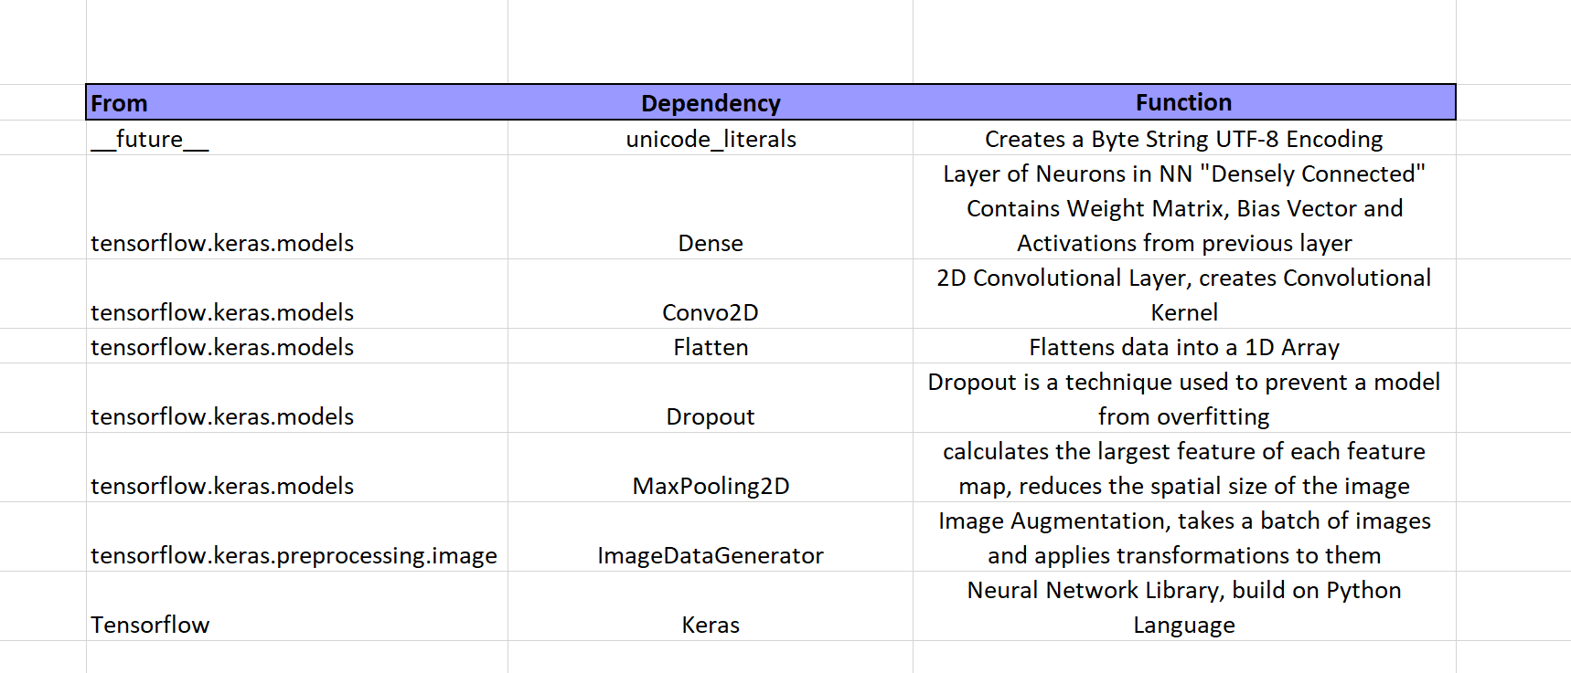

Summary:

This Keras Image Classification tutorial is from this documentation: <https://colab.research.google.com/github/tensorflow/docs/blob/master/site/en/tutorials/images/classification.ipynb#scrollTo=E82grprdYPI0>

I used images from <https://github.com/Horea94/Fruit-Images-Dataset> to train my CNN. I was able to upload the 10 chosen fruit types for Testing and Training to Google Drive. I then connect that to the Google Colab Tutorial. We first set up our Batch Size, Image dimensions and Epoch number. The ImageDataGenerator( ) rescaled the images for both testing and training sets. The sequential model had three convolutional layers, each layer having a MaxPool layer as well. Finally, we add a Dense or “fully connected” layer with 512 units to the model. The model was trained on 11 steps as was set by dividing the training data by the batch size. The model was only able to achieve 10.8% accuracy, sometimes performing at 11% accuracy. I learned that the ‘rmsprop’ optimizer performed slightly better than the ‘adam’ optimizer in this classification exercise. I researched Optimizers and found that the ‘Adagrad’ optimizer would have been better for this classification problem.

