ECEN 5013- FINAL PROJECT MILESTONE

**Team Members:**

**Gaurav Gandhi**

**Sanjana Kalyanappagol**

Test/Verification Methodology:

|  |  |  |  |
| --- | --- | --- | --- |
| Function | Feature to be tested | Plan test | Definition of pass or fail |
| Accelerometer | RGB LED controlled by the accelerometer | Change the orientation of the FRDM board | Does it give 3 different colors in 3 different orientations? |
| ADC with Temperature sensor | Display the temperature | Initialise and configure ADC and temperature sensor | Does it display the present temperature? |
| DMA | Perform memory allocation without using the CPU | Initialise and configure the DMA. | Does the memory allocation happen without using DMA? |
| I2C | Communication with EEPROM | Sending data to the over I2C EEPROM and reading it back. |  |
| EEPROM | Storing Logged data or Error Logging data | Writing and reading single byte as well as block of data |  |
| RTC | Providing Time stamp for the Logged data | Checking for correct time stamp on the Logged Data |  |
| Capacitive Touch | Controlling the speed of Motor | Touch the capacitive touch pad in different patterns |  |
| Motor | Its speed is adjusted by inputs of various sensors mentioned above | Run motor at different possible speeds |  |
| Low Power Modes |  | Checking overall functionality of the mode with reduced power consumption |  |

DEMO:

We would be demonstrating the changing colors of RGB LED with respect to change in the orientation of the board measured by the accelerometer which can be used for light control.

Using temperature sensor with ADC and DMA, we would be displaying the temperature which can later on be used to control the speed of the motor.

Using Capacitive touch speed of motor will be controlled through DAC

EEPROM will be used for data logging through I2C. After certain time data will be read by controller including time stamp using RTC and sent to terminal through UART for demo purpose .

System Diagram:

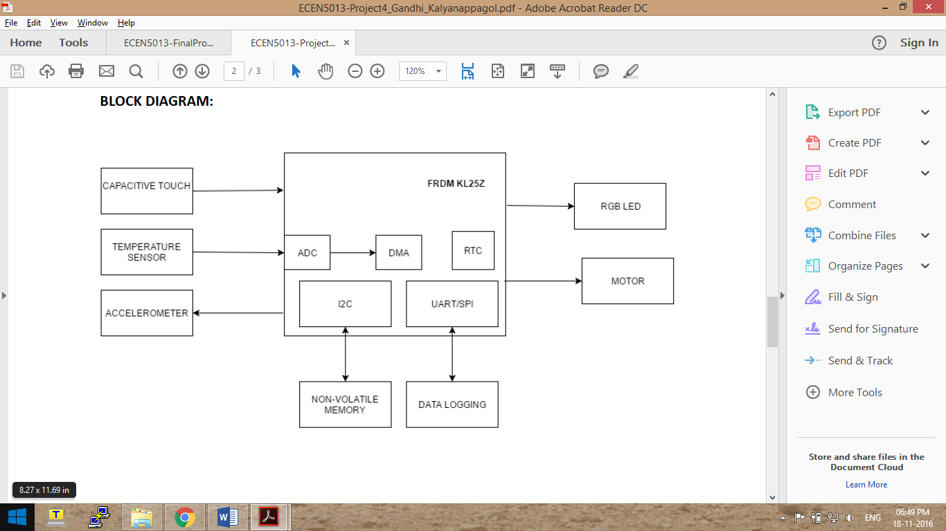

Stretch Goals:

1. Implementing Binary Data Logging and Python script for the user interface
2. Implementing NRF communication between frdm and Beaglebone Black using either NRF module or Zigbee