Project
- Create the Remote Repository: Go to GitHub or GitLab and create a new repository. During the setup screen, be sure to check the boxes to automatically initialize the repository with a README.md file and a .gitignore file (choose the Python template if asked). (done)
- Clone it to Your Computer: Copy the URL of your new repository and use git clone <URL> in your terminal to link the cloud repository to your local machine. This downloads the initialized folder to your computer. (done)
- Repository auf github: https://github.com/ArohaRussi/sds210project.git
- in Anaconda Prompt um repository local zu speichern
- (base) C:\Users\aruss>cd Documents\Universität\SDS210 Project (ordner wählen)
- (base) C:\Users\aruss\Documents\Universität\SDS210 Project>git clone https://github.com/ArohaRussi/sds210project.git (um zu speichern)
- (base) C:\Users\aruss\Documents\Universität\SDS210 Project>cd sds210project
- (base) C:\Users\aruss\Documents\Universität\SDS210 Project\sds210project>jupyter lab

- Build the File Structure: Open the newly cloned folder on your computer and create your empty subfolders (e.g., create a data/ folder and a notebooks/ folder). (done)
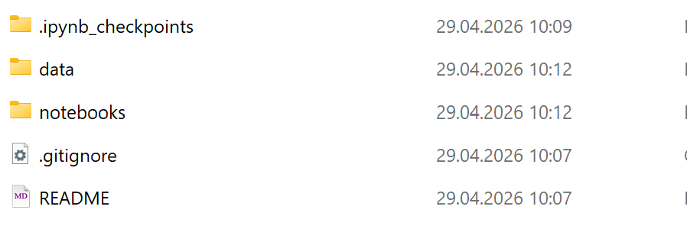
- Configure your .gitignore: Open the .gitignore file in a text editor and add the line data/ at the bottom. This explicitly tells Git to ignore any raw data or shapefiles you place in that folder, preventing massive files from being tracked and crashing your cloud upload. (done)
- Start Coding and Committing: Create your first Jupyter Notebook inside the notebooks/ folder. Now, you can safely experiment with your code, using git commit to save meaningful snapshots of your progress, and git push to back everything up online
  - Fehlermeldung:
  - (base) C:\Users\aruss\Documents\Universität\SDS210 Project\sds210project>git commit -m "this_is_a_test" Author identity unknown *** Please tell me who you are.
    - Run git config --global user.email "you@example.com"
    - git config --global user.name "Your Name"
      - to set your account's default identity. Omit --global to set the identity only in this repository. fatal: unable to auto-detect email address (got 'aruss@HPvonArohaRussi.(none)')
  - Lösung:
  - git config --global user.name "ArohaRussi"
git config --global user.email aroha.russi@uzh.ch
  - Checke: git config -- global – list
  - Hochladen in eigenen Ordner: git commit -m «filename»
  - Hochhladen in github: git push

What to Include in my README
A robust README should contain the following sections:
- Project Title & Description: A one or two-sentence summary of the spatial question you are answering.
- Data Sources: Explicit links to where the raw open data was obtained.
- Setup Instructions: Exactly what software and libraries are required to run the code (e.g., pointing to an environment.yml or requirements.txt file).
- Execution Order: Clear instructions on how to run the project (e.g., “Run the data_cleaning.ipynb notebook first, followed by spatial_analysis.ipynb”).
If your project relies on special local settings or manual data downloads that you fail to explain in the README, your project is not reproducible.
!! Big mistake to avoid
- Never assume the reviewer knows where your data is stored, which specific packages you used, or the order in which to run your files. State everything explicitly in the README.

Reproducible Notebooks:
Wichtig ist dass es Relative paths sind:
- gdf = gpd.read_file(“data/Zurich.gpkg)

