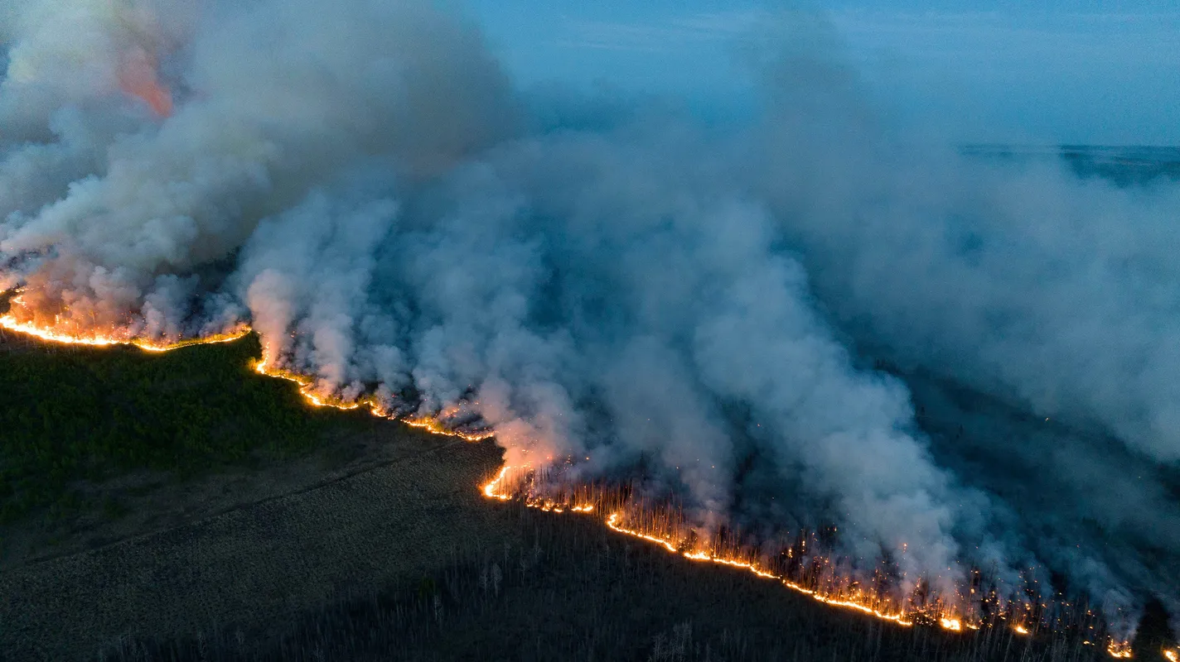
Figure 1: (Eyevine, 2023)

Canada Wildfire season 2023

An Interactive Fire Impact Map
University of Zurich || SDS210
Aroha Russi

Project Report
- Introduction
The year 2023 marks the most destructive wildfire season on record for Canada, with fires burning more than 15 million of hectares from British Columbia to Quebec (Government of Canada, 2023). Large wildfires alter the air and drive a positive climate-fire feedback loop since the fire emissions contribute to hotter and drier weather conditions which then increases the frequency and spatial extent of fires (Government of Canada, 2013). The project addresses the following research question: Which Canadian Cities were exposed to the most risk during wildfire season in 2023? The aim is to quantify fire proximity to major cities and visualize the historical fire data in an interactive map. Additionally, live satellite fire detections from NASA FIRMS are integrated into the map as an extra layer to provide a current state of wildfires in Canada. (FIRMS US/CANADA, n.d.) The map than can be used as a support for risk communication and awareness.
- Workflow and Implementation
The project is structured in three notebooks which should be executed in a specific order. The first notebook (fire2023_data_cleaning.ipynb) that has to be run loads in the first place the raw National Fire Database (NFDB) point dataset (Government of Canada, n.d.). Then in different steps it data cleaning steps were implemented like filtering for uncontrolled fires in 2023, decoding abbreviations for province and cause, removing spatial outliers with a longitude validity check. Then it classifies each fire record into five size classes (small, medium, big, very big and mega fire). This classification uses CIFFC Glossary of Terms classification system with changes to represent best the fire records and giving them a name not just numbers or letters (Grahame Gordon Wildfire, 2014). This classification is then used to assign for each class a weight. Since there are a lot of small fires, I decided to assign exponentially spaced weights (1,2,4,16,256) since with that the map looked also the best on every zoom level.
The second notebook (cities_canada.ipynb) aims to build a representative set of Canadian cities from the raw Simple Maps World Cities dataset (simplemaps, 2025). As seed locations al provincial and the federal capital are included. All other cities are candidates of being added if the requirements are met. Those requirements are that they have a high amount of population and additionally are at least 150km from every already selected city. This is to prevent overrepresentation of dense urban agglomerations such as in the Toronto area. The aim is to get a spatially balanced selection of the most populated cities of Canada.
The third notebook (visualization.ipynb) brings the first two notebooks together. Here a 200km buffer (Jordahl et al., 2020) is drawn around each selected city. Therefore the data needs to be in a metric projection EPSG: 3347 (Statistics Canada Lambert) (epsg.io, 2010). A spatial join (Jordahl et al., 2020) then aggregates the class weights of all fires within each buffer into a fire score. After merging to one layer (Jordahl et al., 2020) then the cities are classified into five impact levels, from no impact to very high impact and then visualized as Circle Markers on a leaflet map and costumed colored from light (no impact) to dark (very high impact) (w3schools, n.d.). A leafmap is necessary to add a legend to the map. (Jordahl et al., 2020) Secondly a layer was added using an inferno inspired gradient to show all NFDB fire records of 2023 (Stack Overflow, 2017). A third layer fetches live Near Real Time fire detections form the NASA FIRMS VIIRS NOAA-20 API (FIRMS US/CANADA, n.d.).
- Results
The interactive map reveals a clear northwest to southeast trend. There are two main clusters on the map: a large and intense zone from British Columbia, Alberta and Northwest Territories and the second cluster across Quebec and the Atlantic Canada in the south-east. What is clearly visible is, that the Central Canada, in particular Saskatchewan and Manitoba show a lower fire activity.
The impact scores and their colors reflect this patial pattern. Cities in western Canada display High and Very High Impact scores, since they are within or adjacent to the most active fire zones. In the centre of Canada along the southern Prairie cities show mostly low or no impact which is being reflected also in the low density in the heat map.
Overall, the map demonstrates that the 2023 wildfire season was disproportionately severe in eastern and western parts of Canadian cities. As a limitation I would say that the map doesn’t take into account the smoke dispersion or wind direction, which may make us underestimate the actual impact.
The live NASA FIRMS layer shows that at the moment there are not that many fires recorded for Canada and is therefore rather empty. But it also confirms that the 2023 season was extraordinary.
- Challenges and Reflection
It was a bit challenging to figure out which operation requires a metric projection and which geographic one. When computing the impact scores with buffers calculated in degrees an error occurred which had me change this with a short code. This reinforced the value of defensive coding, as a single mismatch in projection can silently corrupt all calculations below without raising an error.
Another mentionable challenge was for sure selecting the relevant cities with an algorithm. A first approach just showed the additional to the primary cities the most populated cities of Canada. In Canada a lot of agglomerations of big cities are as well more populated than most cities across the country. To have not just clusters of urban areas but rather a balanced spatial distribution I implemented a spacing-based algorithm to just visualize a city if the city lies at least 159km from every other already selected city. A problem arised now, that with such an algorithm some cities haven’t been selected, like Vancouver or Montréal which are high populated and standalone cities but an already selected city is nearer than 150 km.
- Repository
https://github.com/ArohaRussi/sds210project.git
- AI Use Disclosure
Most theoretical parts come from the course website (https://hendrikwulf.github.io/sds210-jb/ ). As an adding I used the following website (https://geopandas.org/ ). And finally, a large language model (Claude.ai) was used to check spelling, improve code structure and readability, and help debug operations. All decisions, the research questions, about the workflow design and the final implementation were developed and validated by me. Before including a code it was tested and understood.

Sources
epsg.io. (2010, March 30). NAD83 / Statistics Canada Lambert—EPSG:3347. https://epsg.io
Eyevine. (2023, June 15). Canada’s wildfires have burnt an area 16 times larger than normal. The Economist. https://www.economist.com/the-americas/2023/06/15/canadas-wildfires-have-burnt-an-area-16-times-larger-than-normal
FIRMS US/CANADA. (n.d.). NASA-FIRMS. Retrieved May 21, 2026, from https://firms.modaps.eosdis.nasa.gov/map/
Government of Canada. (n.d.). CWFIS Data & Service Catalogue [Dataset]. Retrieved May 22, 2026, from https://cwfis.cfs.nrcan.gc.ca/en/catalogue/results/7355c08f-1590-41cc-a751-8856afaa5959
Government of Canada. (2013, July 9). Climate change and wildland fire. https://natural-resources.canada.ca/forests-forestry/wildland-fires/climate-change-wildland-fire
Government of Canada. (2023, September 7). Canada’s record-breaking wildfires in 2023: A fiery wake-up call. https://natural-resources.canada.ca/stories/simply-science/canada-s-record-breaking-wildfires-2023-fiery-wake-call
Grahame Gordon Wildfire. (2014). Developing More Common Language, Terminology and Data Standards for Wildland Fire Management in Canada.
Jordahl, K., Bossche, J. V. den, Fleischmann, M., Wasserman, J., McBride, J., Gerard, J., Tratner, J., Perry, M., Badaracco, A. G., Farmer, C., Hjelle, G. A., Snow, A. D., Cochran, M., Gillies, S., Culbertson, L., Bartos, M., Eubank, N., maxalbert, Bilogur, A., … Leblanc, F. (2020). geopandas/geopandas: V0.8.1 [Computer software]. Zenodo. https://doi.org/10.5281/zenodo.3946761
simplemaps. (2025). World Cities Database [Dataset]. https://simplemaps.com/data/world-cities
Stack Overflow. (2017, April 10). Answer to “How to specify gradient parameter to folium heatmap?” [Online post]. Stack Overflow. https://stackoverflow.com/a/67838638
w3schools. (n.d.). HTML Color Picker. Retrieved May 21, 2026, from https://www.w3schools.com/colors/colors_picker.asp

