Profile of patients triaged green in the Emergency Department (ED) of a secondary care hospital in Mumbai

Anna

12/05/2020

# Abstract

## Introduction

Injuries are one of the leading causes of Emergency Department visits. Physicians use localized screening methods to triage patients into Red, Orange, Yellow and Green, from most to least urgent. Screening methods depend on various factors, such as, physiological parameters of the patient, injury severity, anticipated use and availability of resources (incase of mass casualty). The proportion of patients with life-threatning injuries or injuries that require urgent attention is far less in comparison to patients that are triaged green. While, retrospectively considering management of injuried patients, most attention is given to patients that have injuries which may require hospitalization. Thereby disregarding the pool of patients where most of the ED resorurces are spent. Understanding the characteristic of these patients might give us an insight in managing them, inadvertently making effective use of the resources without affecting the quality of care provided.

## Aim

The aim of this study is to describe the demographic, physiological and injury characteristics of trauma patients triaged green in the ED of a secondary healthcare hospital in Mumbai.

## Methods

Data of patients triaged green were extracted from the Trauma Triage Study in India dataset. A retrospective analysis of the data was performed using R.

## Results

In the TTRIS dataset, 4759 patients were triaged green. The mean age of these patients was 33.28 (+-13.39). 96.41% of the patients were below 65 years of age. 76.7% patients were male, while 23.24% patients were female. 98.49% patients had blunt injuries.Most common mode of arrival to the ED was through private vehicles (80.14%). 13.62% patients came to the ED on foot. Patients with history of assualt were the highest followed by transport accidents. Injury due to animal bites were significantly high.

Table 1. ISS Score of patients

|  |  |
| --- | --- |
| kbbh.isspv | Freq |
| Minor | 2193 |
| Moderate | 12 |
| No injuries defined | 2504 |

## < table of extent 0 >

Table 2. ISS and RTS of patients

|  |  |  |  |  |  |
| --- | --- | --- | --- | --- | --- |
|  | 4 | 5 | 6 | 7 | 8 |
| Minor | 1 | 0 | 7 | 20 | 2147 |
| Moderate | 0 | 0 | 0 | 0 | 11 |
| No injuries defined | 1 | 1 | 2 | 21 | 2460 |

## Conclusion

Among the patients triaged green, injury due to assualt and transport accidents were predominant.More than half of the patients had no injuries defined with an RTS score of 8.

## Analysis

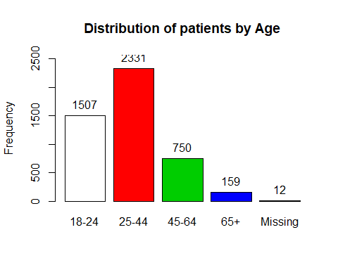

## kbbh$agegrp :   
## Frequency %(NA+) %(NA-)  
## 18-24 1507 31.7 31.7  
## 25-44 2331 49.0 49.1  
## 45-64 750 15.8 15.8  
## 65+ 159 3.3 3.3  
## NA's 12 0.3 0.0  
## Total 4759 100.0 100.0

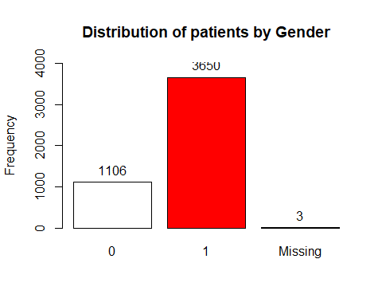

## kbbh$sex :   
## Frequency %(NA+) %(NA-)  
## 0 1106 23.2 23.3  
## 1 3650 76.7 76.7  
## <NA> 3 0.1 0.0  
## Total 4759 100.0 100.0

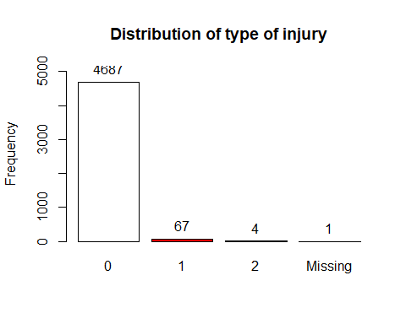

## kbbh$tyi :   
## Frequency %(NA+) %(NA-)  
## 0 4687 98.5 98.5  
## 1 67 1.4 1.4  
## 2 4 0.1 0.1  
## <NA> 1 0.0 0.0  
## Total 4759 100.0 100.0

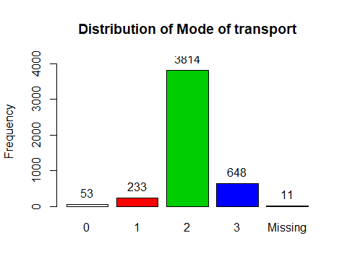

## kbbh$mot :   
## Frequency %(NA+) %(NA-)  
## 0 53 1.1 1.1  
## 1 233 4.9 4.9  
## 2 3814 80.1 80.3  
## 3 648 13.6 13.6  
## <NA> 11 0.2 0.0  
## Total 4759 100.0 100.0

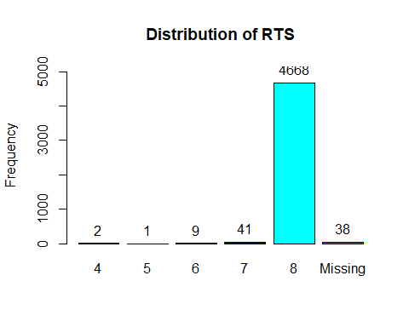

## kbbh$RTS :   
## Frequency %(NA+) %(NA-)  
## 4 2 0.0 0.0  
## 5 1 0.0 0.0  
## 6 9 0.2 0.2  
## 7 41 0.9 0.9  
## 8 4668 98.1 98.9  
## <NA> 38 0.8 0.0  
## Total 4759 100.0 100.0

## Categorizing moi

### 1

## [1] TRUE

#library(dplyr) #kbbh$moi2 <- mutate(kbbh, moi = case_when( moi %in% V010:V99 ~ “Transport Accidents”))

#table(kbbh$moi)

### 2

#library(tidyverse) #library(stringr) #library(forcats)

#assign_moi <- function(code){ # if(str_sub(code, 2) %in% as.factor(c( # “V1”,“V2”,“V3”,“V4”,“V5”,“V6”,“V7”,“V8”,“V9”)){ # “Transport Accidents” # } else { # code # } #}

#kbbh %>% mutate(moi = fct_relabel(moi, assign_moi))

#class(kbbh$moi)

### 3

#ifelse(kbbh$moi %in% c(“V01”,“V010”,“V011”,“V019”,“V02”, # “V020”,“V021”,“V029”,“V03”,“V030”,“V031”,“V039”, # “V099”), return(“Accidents”),return(“YTBD”))

### 4

#accidents <- c(“V01”,“V010”,“V011”,“V019”,“V02”, # “V020”,“V021”,“V029”,“V03”,“V030”,“V031”,“V039”, # “V099”)

#moi <- transform(kbbh$moi, newcat = # ifelse( # moi %in% accidents, # “yes!”, # “no” # ))