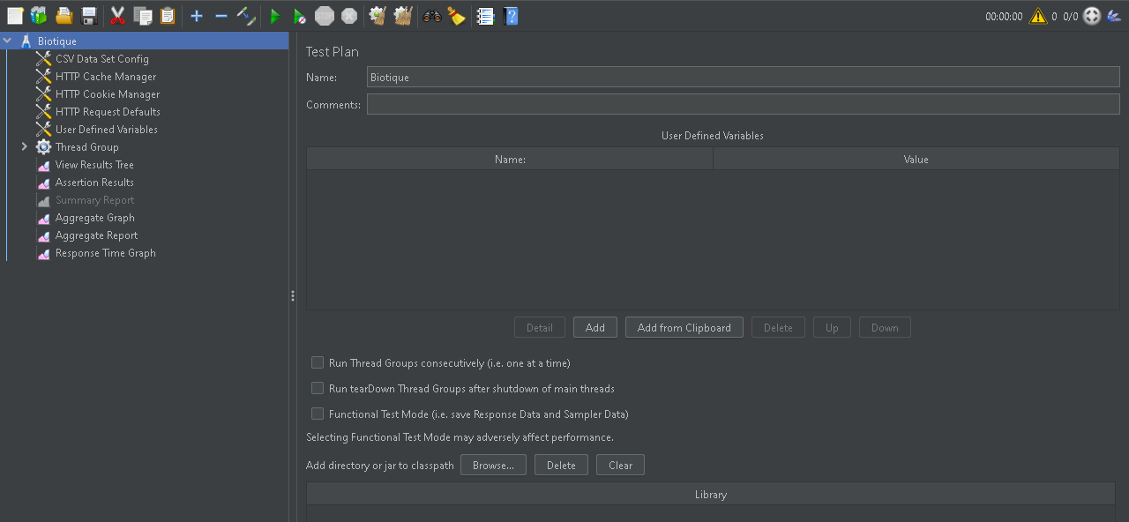Creating a Test Plan

Defining variables for Biotique

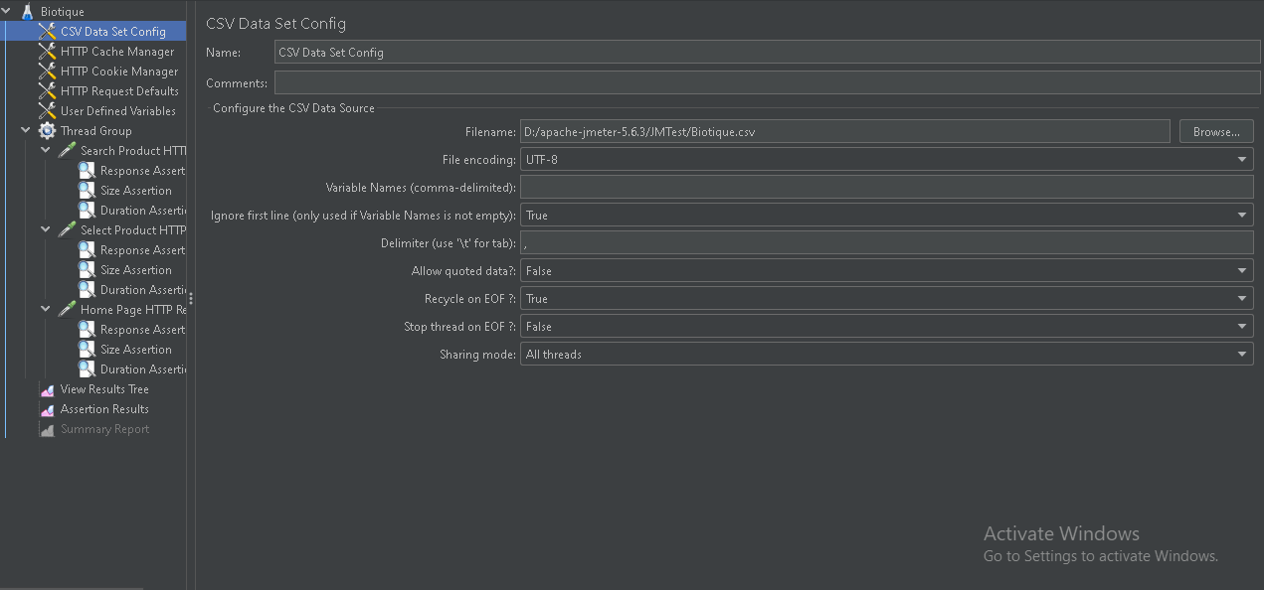

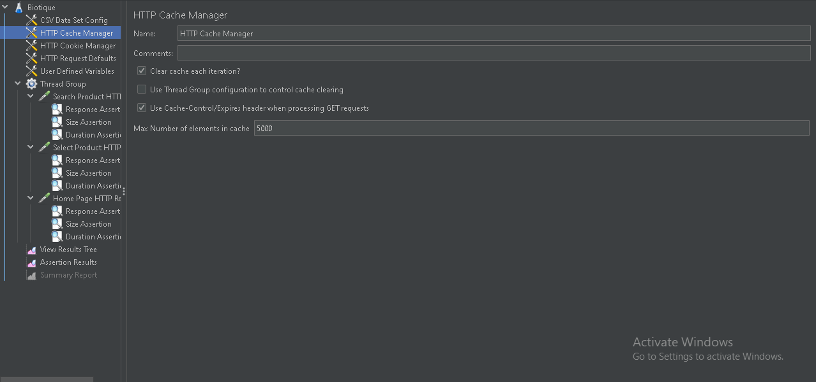Adding Cache Manager

Adding cookie Manager

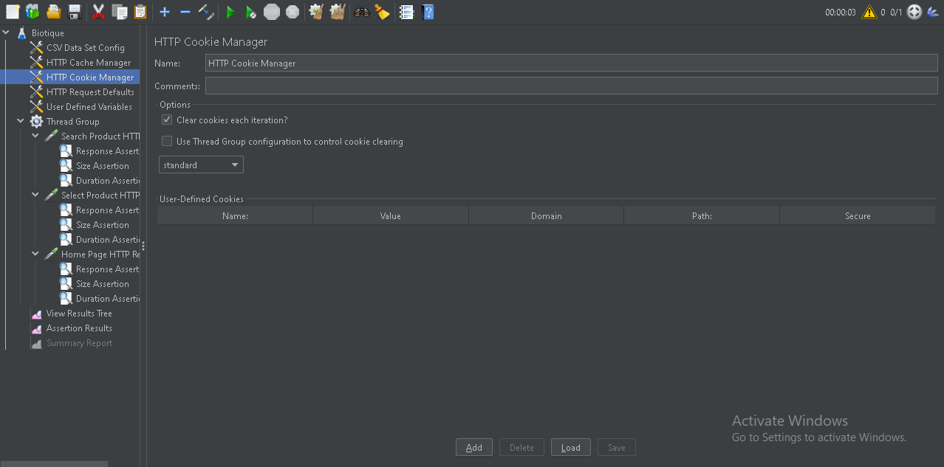

Adding Http Default Request

Biotique Home Page HTTP Request

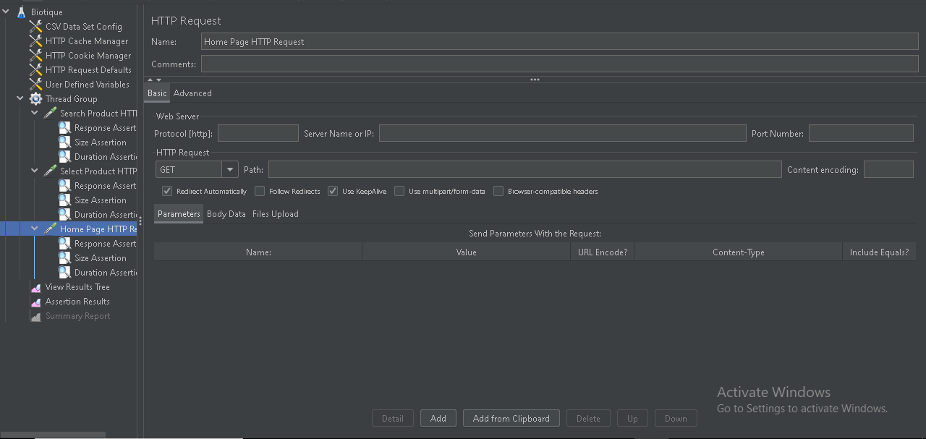

Home Page Response Assertion

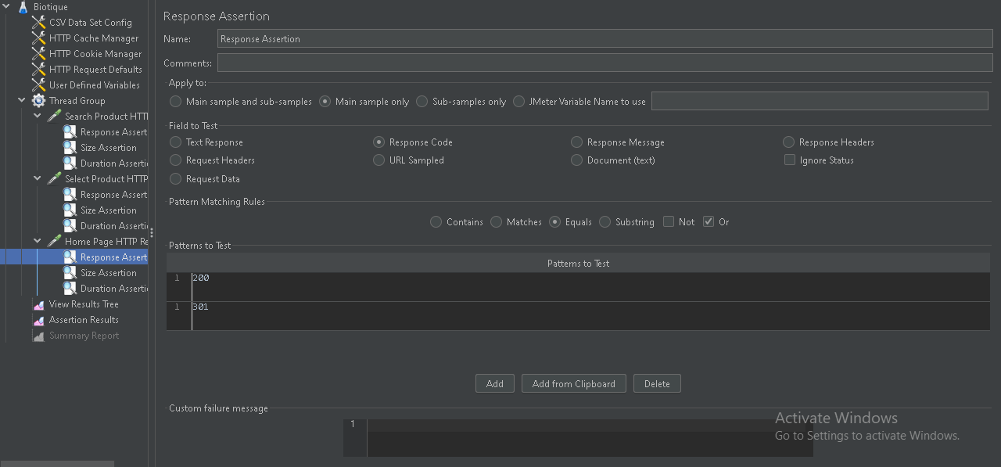

Home Page Size Assertion

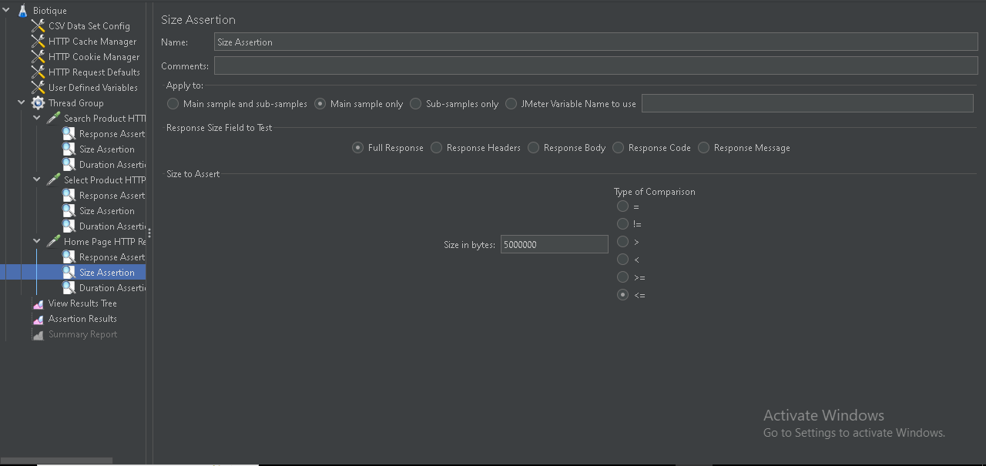

Home Page Duration Assertion

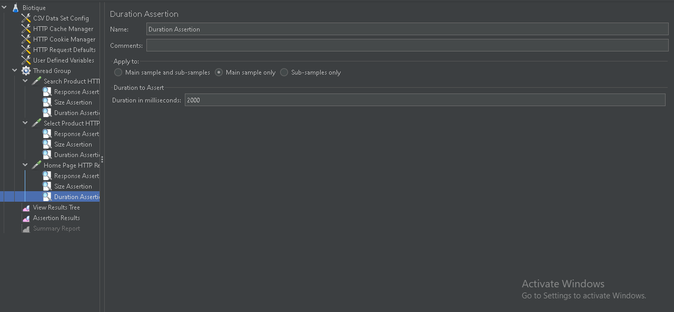

Search For Product Http request

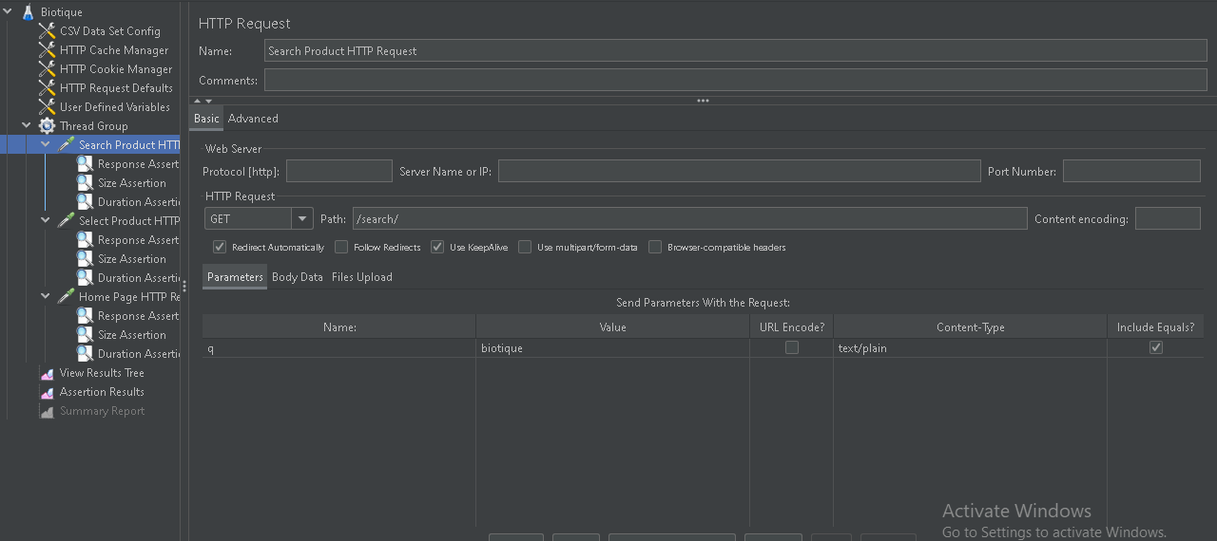

Search for Product Response Assertion

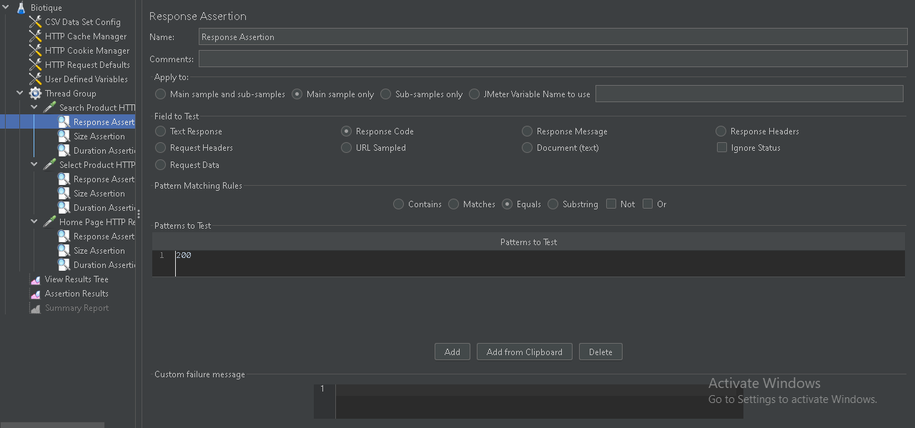

Search for Product Size Assertion

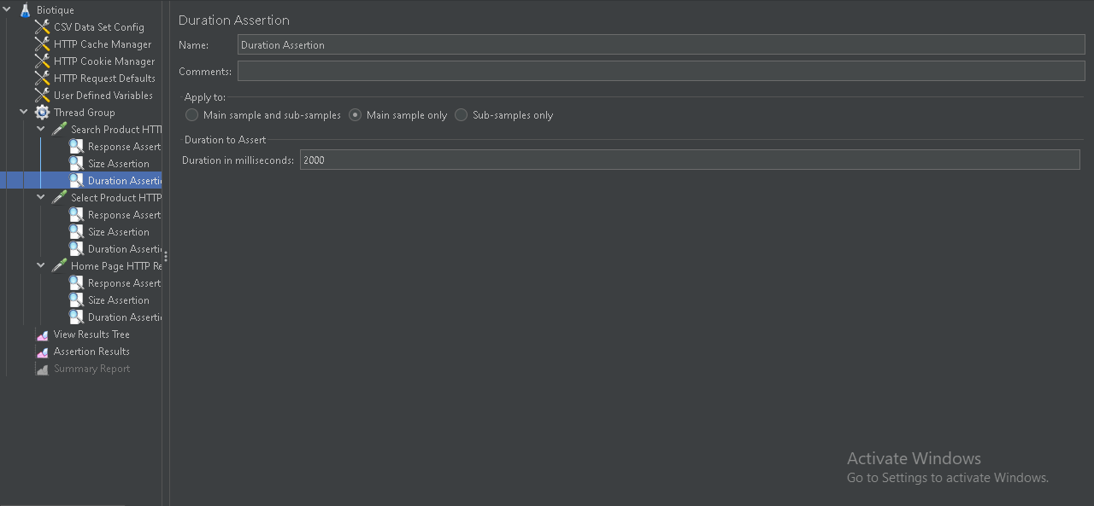 Search for Product Duration Assertion

Select Product Http Request

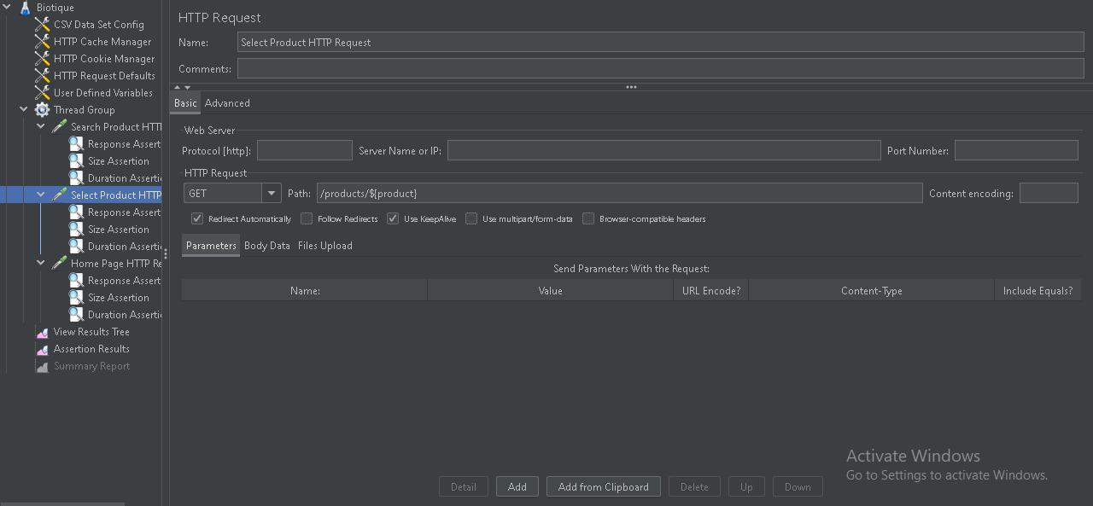

Select Product Response Assertion

Select Product Duration Assertion

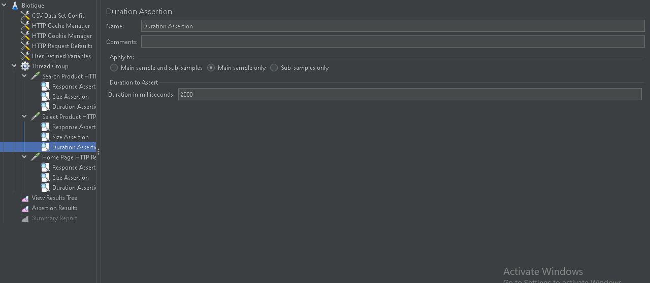

Select Product Size Assertion

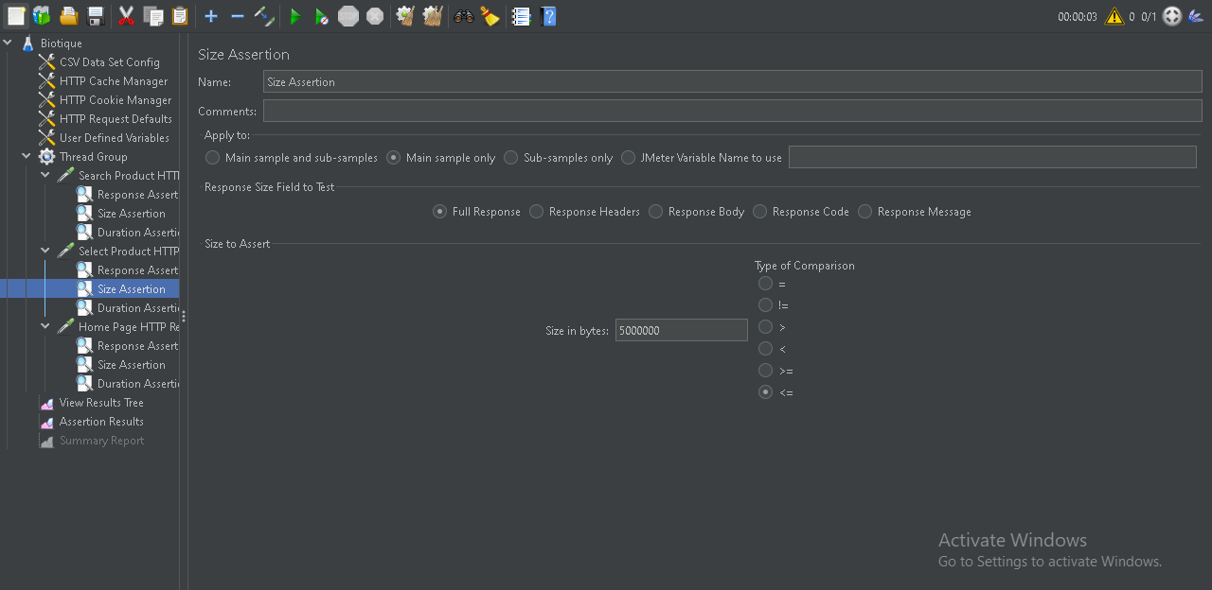

View Result Tree

Assertion Results

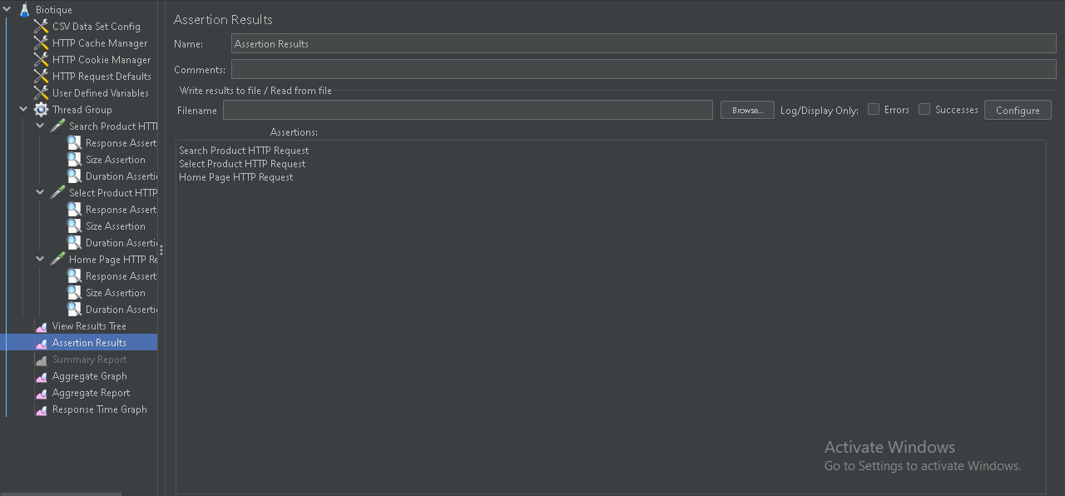

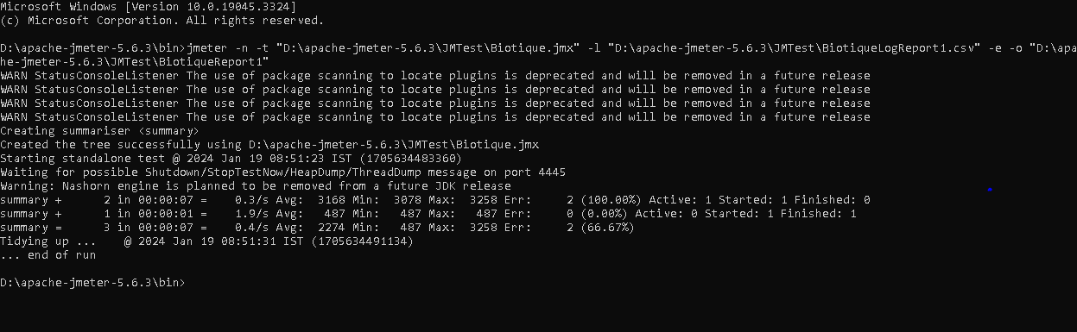 Report and Log Creation

Generated Report

