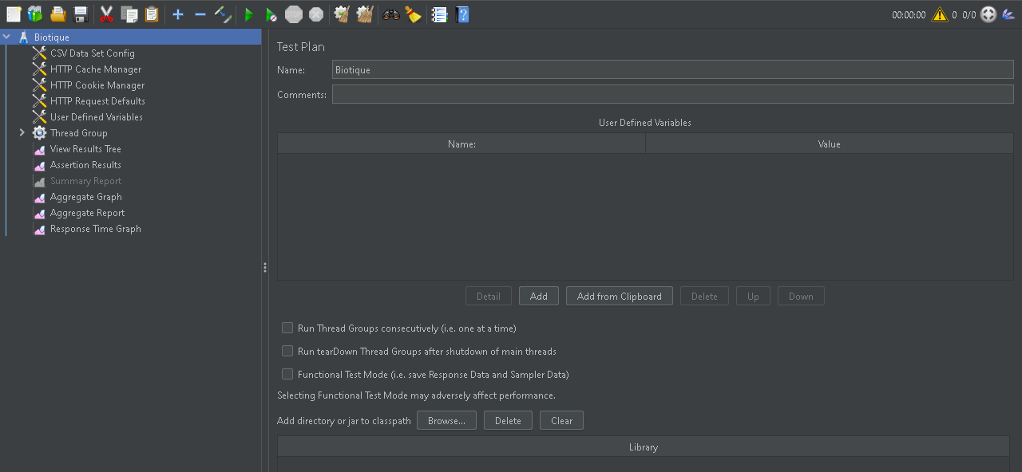Creating a Test Plan

Defining variables for Biotique

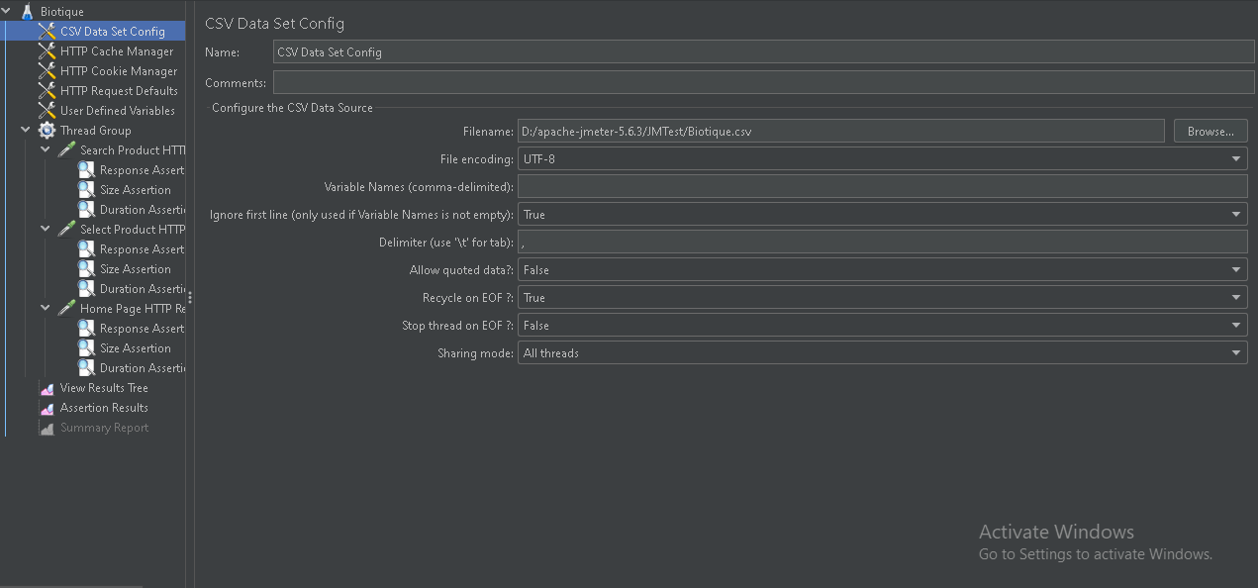

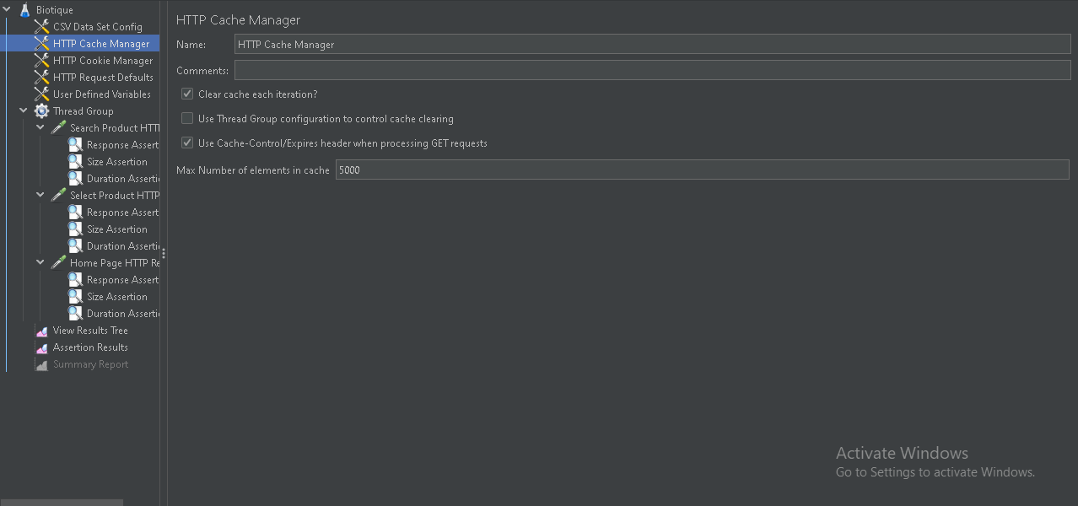Adding Cache Manager

Adding cookie Manager

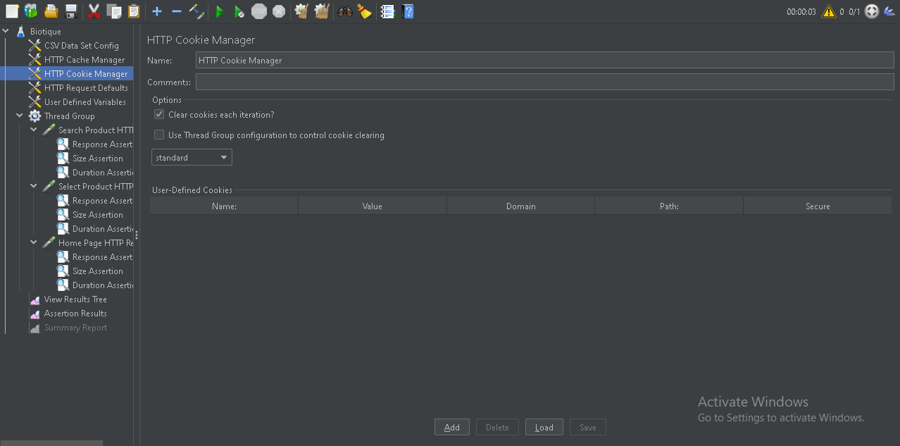

Adding Http Default Request

Biotique Home Page HTTP Request

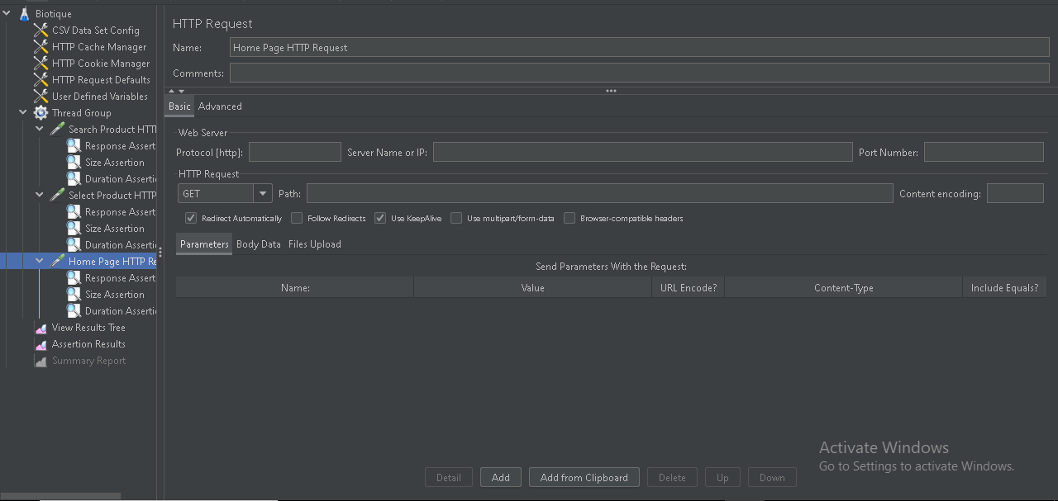

Home Page Response Assertion

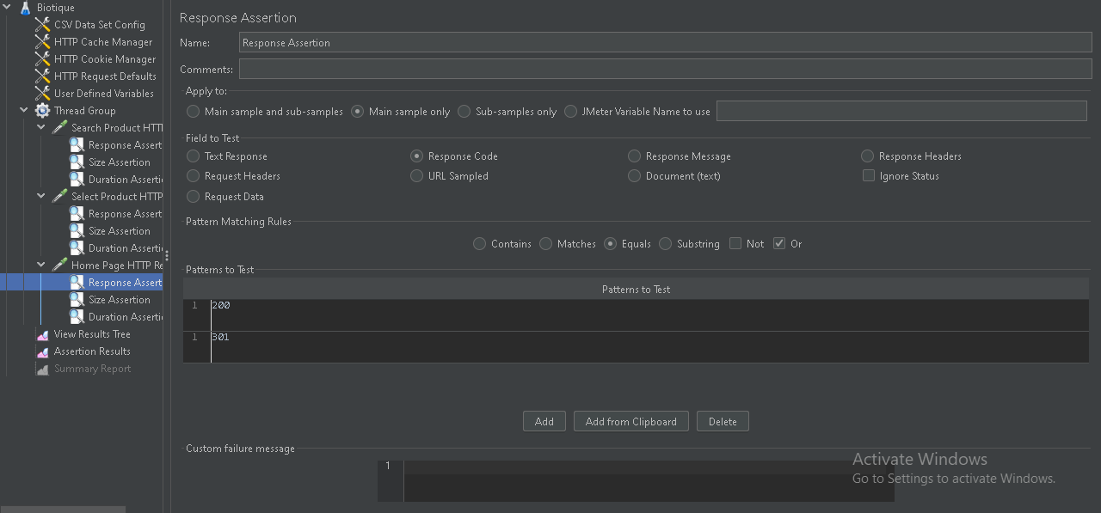

Home Page Size Assertion

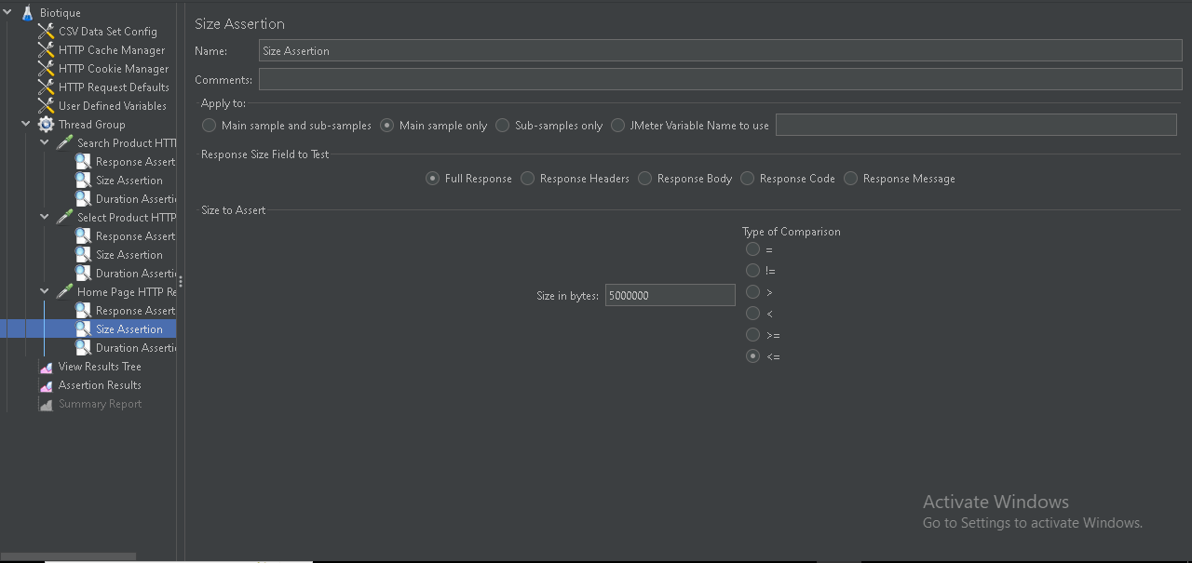

Home Page Duration Assertion

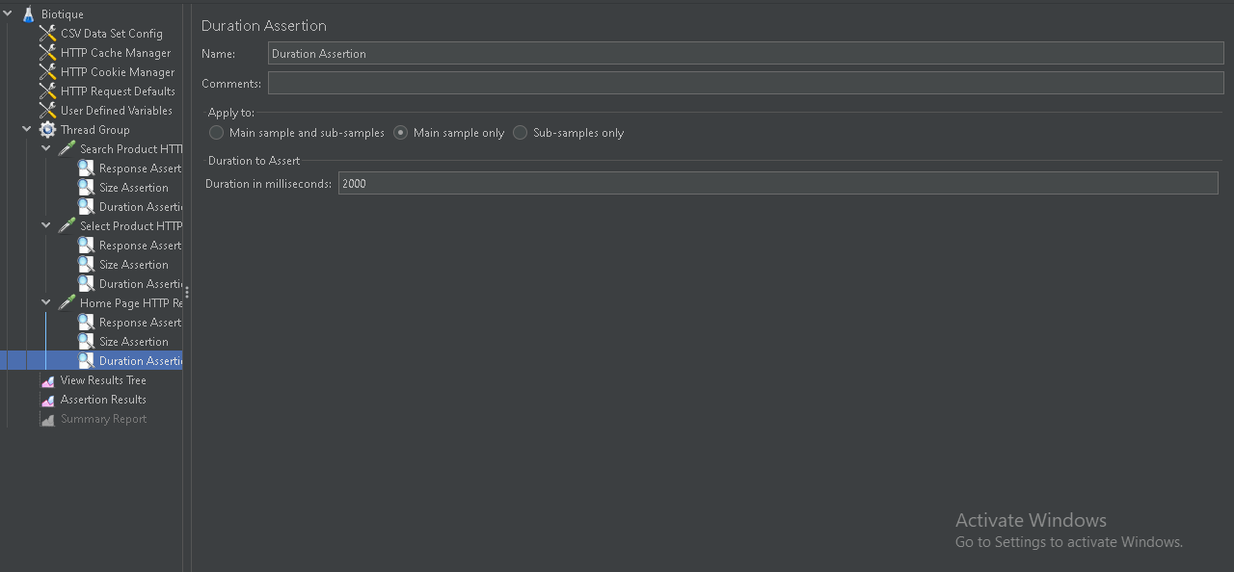

View Result Tree

Assertion Results

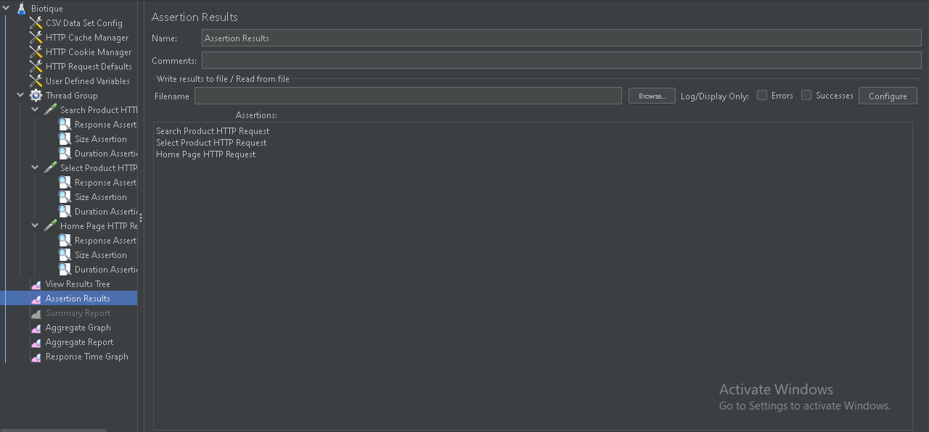

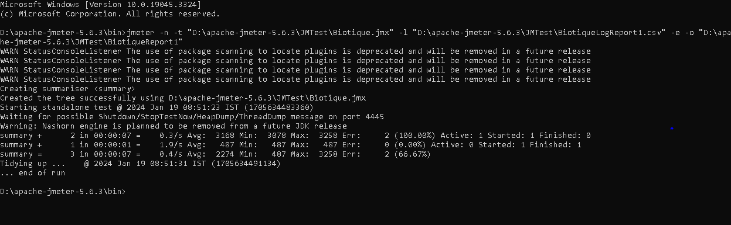 Report and Log Creation

Generated Report

Creating Backend Listener

Connecting With InfluxDB using the test created using JMeter

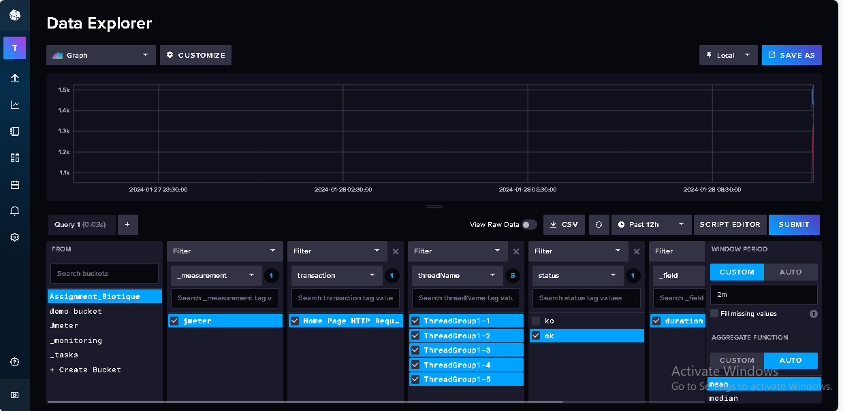

Creating a dataSource in Grafana Using influxDB

Creating Dashboard with Multiple panels

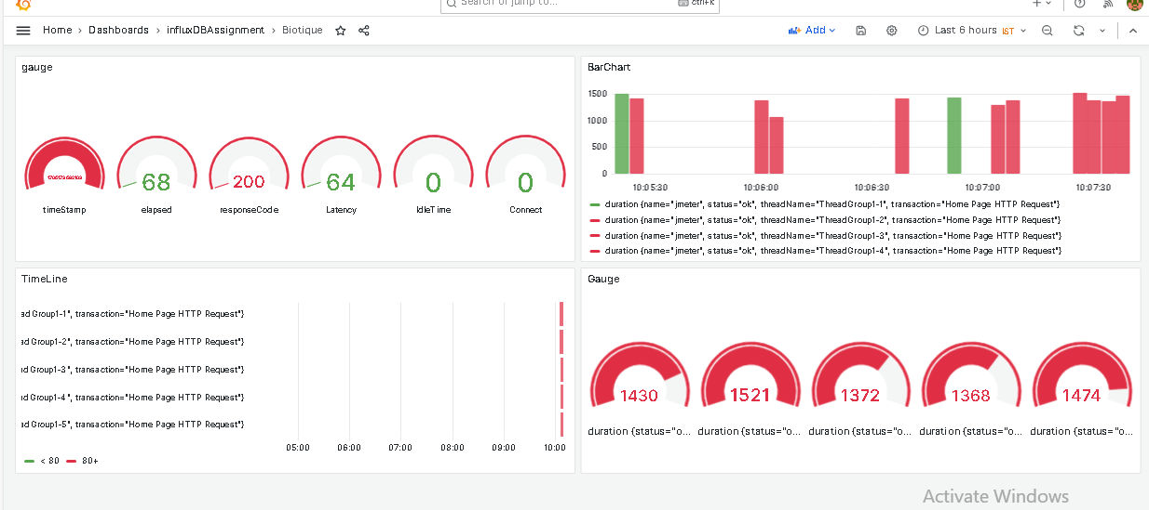

Creating An alert Using the Query From InfuxDB

Monitoring the Alert

