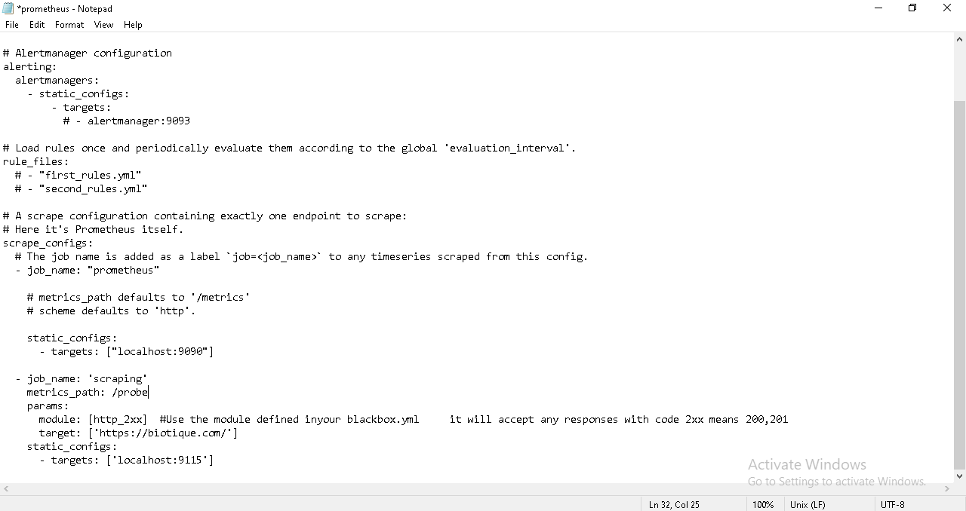Editing the Prometheus yml file

starting Prometheus using cmd

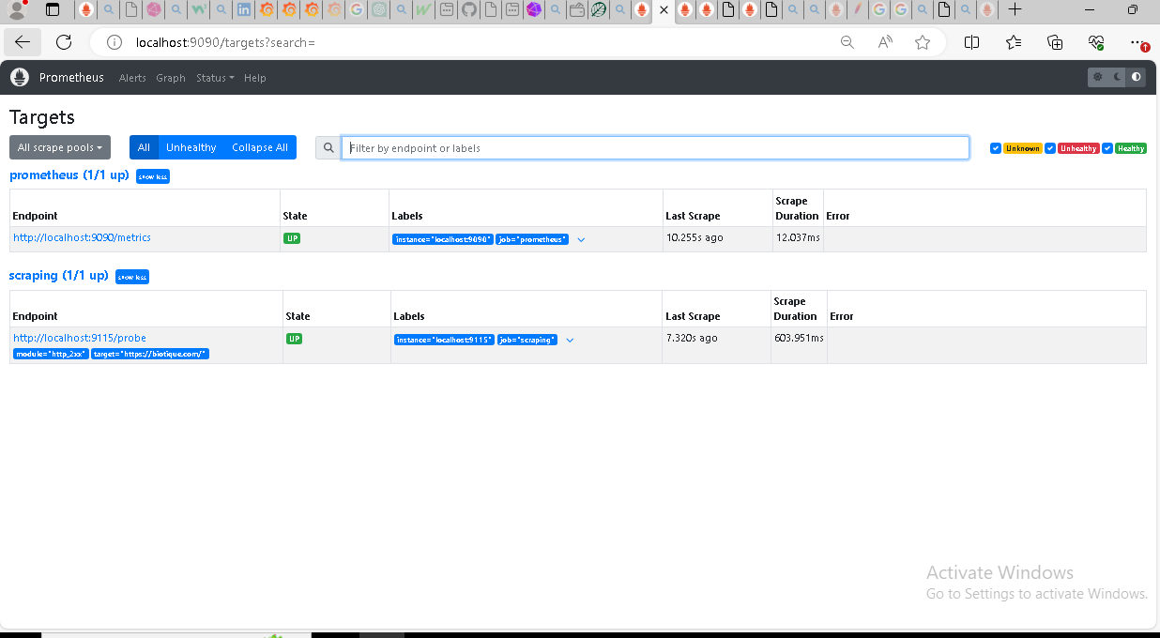

creating datasource

Dashboad created

Creating Alerts

