Creating Jmeter

Editing the rules file for Prometheus

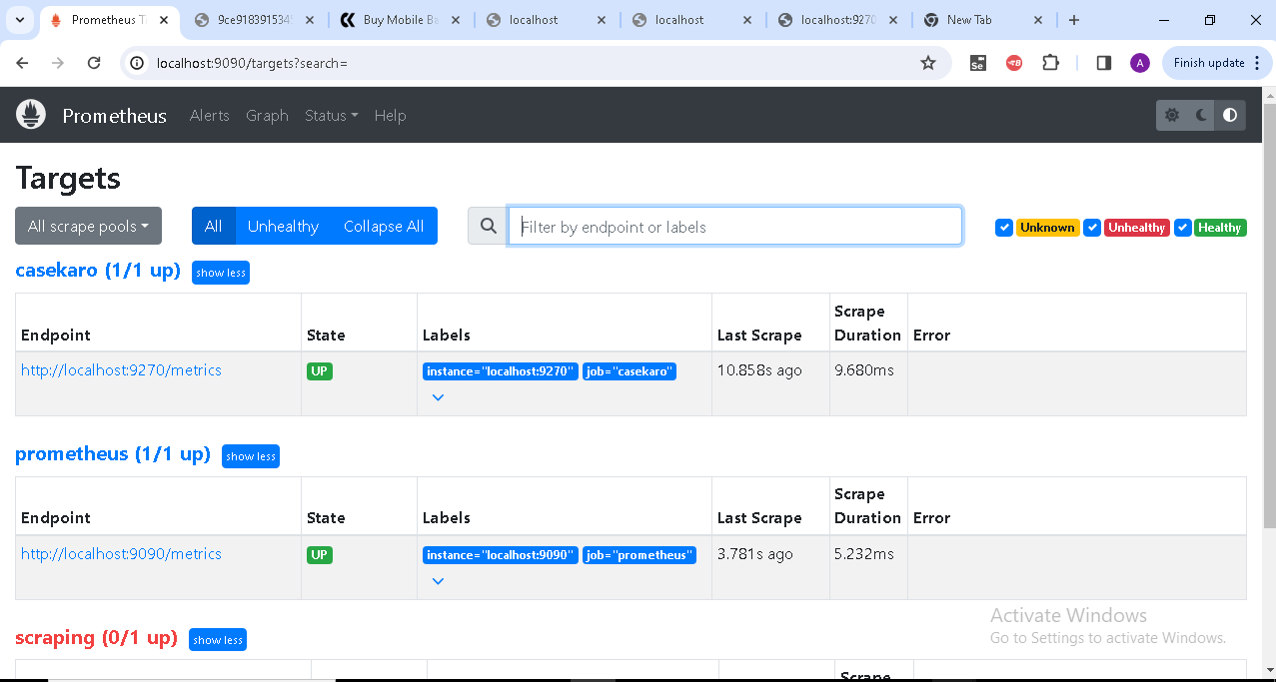

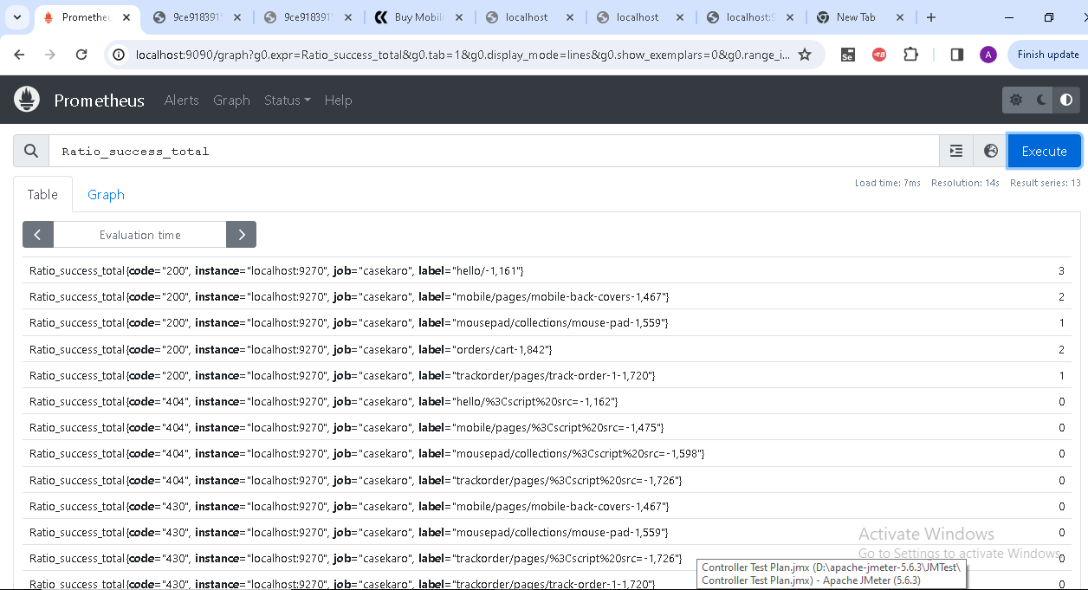

Creating Grafana Dashboads And Alerts

