Accessing the CSV Data Using The HTTP Link

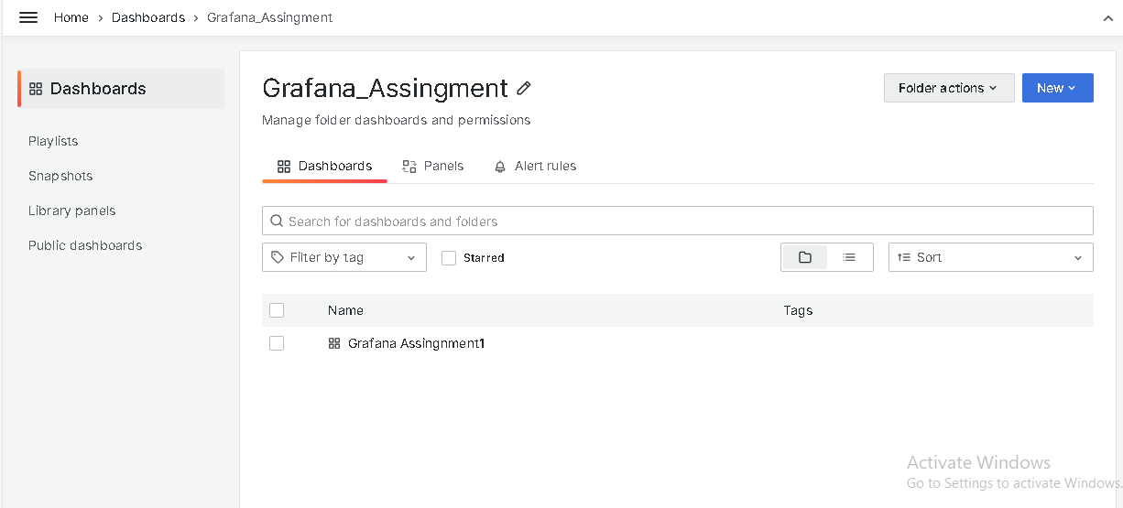Creating A Folder and a dashboard

Adding Graph

Adding BarGraph

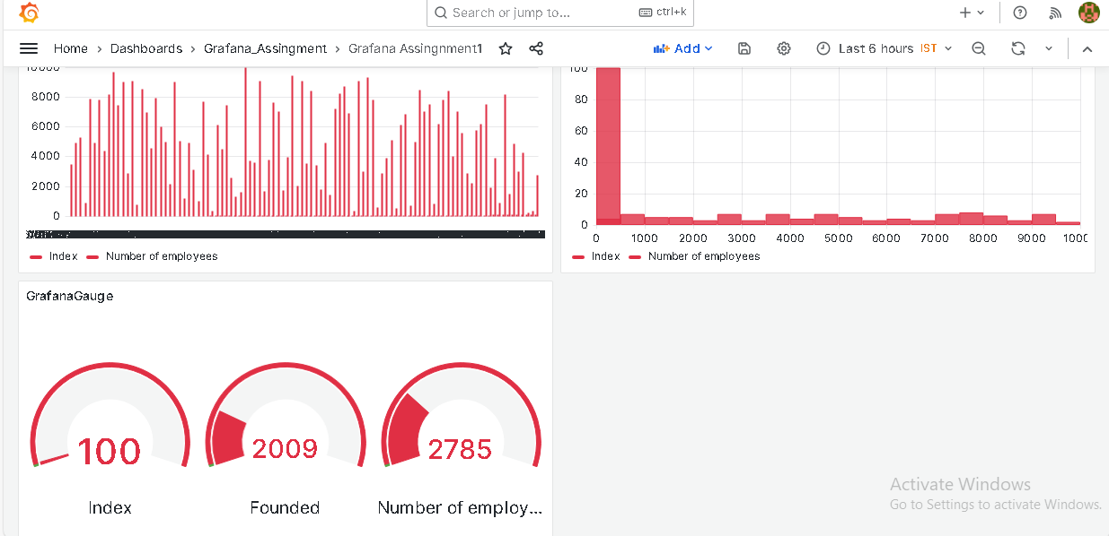Dashboard Created