Argenis Roman 00281079

Awk (use the file attached called lab3.data)

1. Print all the phone numbers.

awk -F: '{print $2}' lab3.data

1. Print Dan 's phone number.

awk -F: '/Dan/{print $2}' lab3.data

1. Print Susan 's name and phone number.

awk -F: '/Susan/{print $1,$2}' lab3.data

1. Print all last names beginning with D .

awk -F"[ :]" '$2~/^D/{print $2}' lab3.data

1. Print all first names beginning with either a C or E .

awk '$1~/^(C|E)/{print $1}' lab3.data

1. Print all first names containing only four characters .

awk '$1~/^[A-Za-z][A-Za-z][A-Za-z][A-Za-z]$/{print $1}' lab3.data

1. Print the first names of all those in the 916 area code.

awk '/(916)/{print $1}' lab3.data

1. Print Mike 's campaign contributions. Each value should be printed with a leading dollar sign; e.g., $250 $100 $175.

awk -F: '/Mike/{print "$"$3,"$"$4,"$"$5}' lab3.data

1. Print last names followed by a comma and the first name.

awk -F"[ :]" '{print $2 ", " $1}' lab3.data

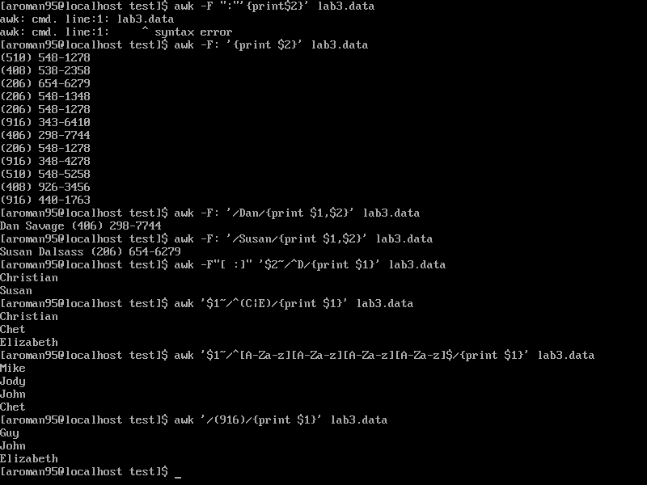

1. Write an awk script called facts that
   1. Prints full names and phone numbers for the Savages .
   2. Prints Chet 's contributions.
   3. Prints all those who contributed $250 the first month.