Argenis Roman

To check the repositories on the CentOS, I used the command **yum -v repolist**

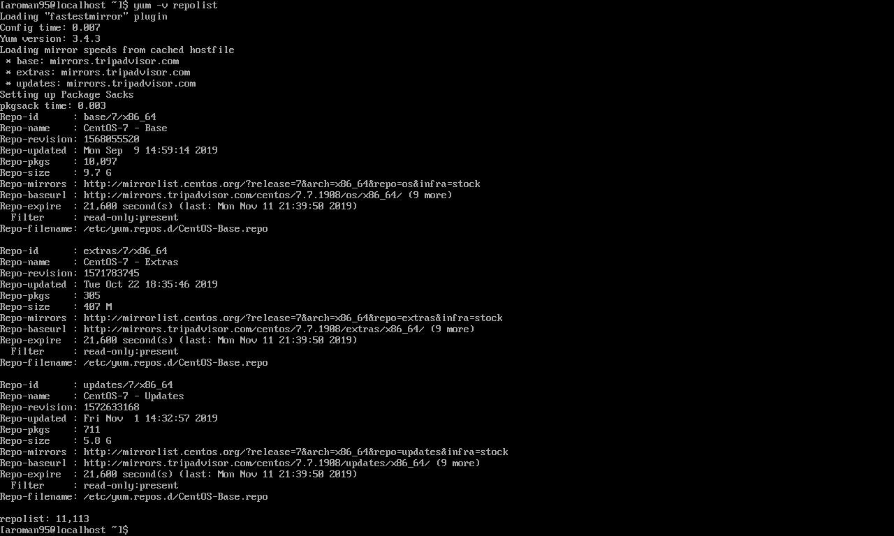

**TMUX**

To install **Tmux** into centos the command



To start tmux, on the command line run the tmux command



After installation is done this is how **tmux** looks

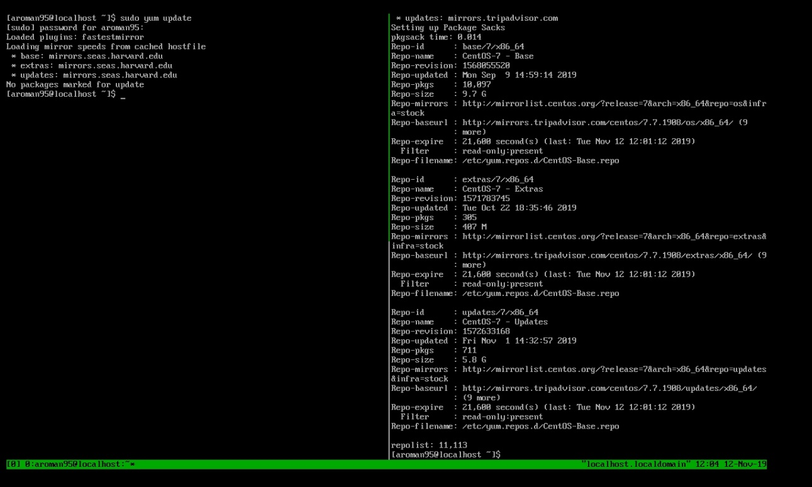

No difficulty downloading and running the program, had to research the commands needed to use tmux to its full potential.

Emacs

Emacs is a text editor



To start the text editor run the command “$ emacs”



This is what command gives you a menu

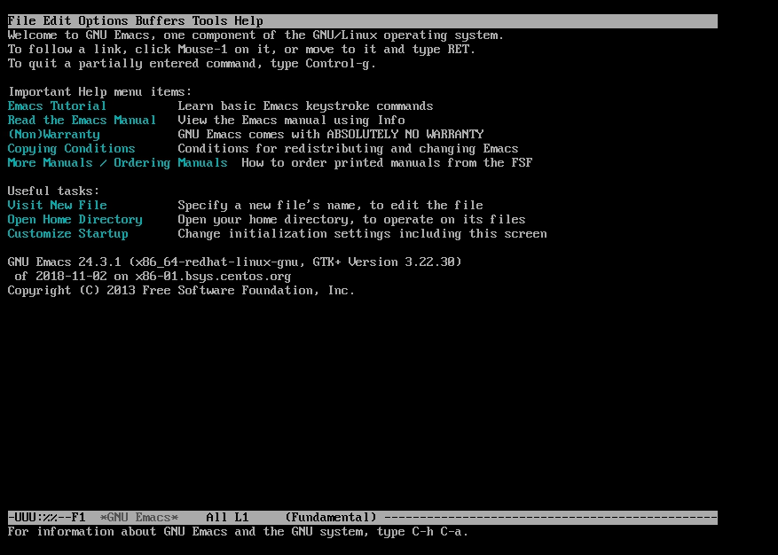

Fail2ban

Had to install the Epel(Extra Packages for Enterprise Linux) repository first to get Fail2ban



After repo was added, ran the install



After the install. I enabled the firewall and the fail2ban

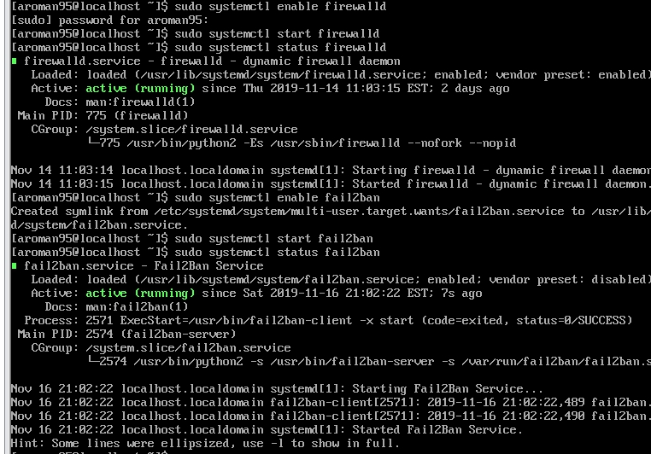

Cowsay and lolcat

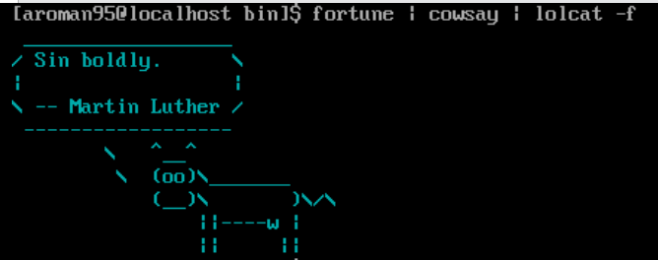

VIM

Installing VIM using this command



Demonstrating that VIM is installed

