Argenis Roman

Security, Hardening and Compliance

Lynis is an open source security auditing tool for UNIX systems. It provides guidance for system hardening and compliance testing. It performs a security scan on varies aspects. It will also scan for general system information, vulnerable software packages, and possible configuration issues. It’s very useful for System administrators or for anyone on the security field

Lynis performs hundreds of individual tests and could be an important asset to your server. Each test will help to determine the security state of the system. The program will make sure that if anything goes wrong on your server, it will inform the user as soon as it occurs

I couldn’t get containers to work on my server because of the lack of knowledge on how to properly do them, and any of the guides I found were complex and had to do more with the enterprise version of Lynis

Downloaded the tar file provided on the website and the decompressed it

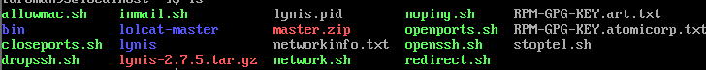

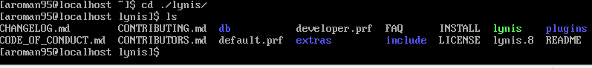

Starting the program

Using the command in the directory ./lynis audit system

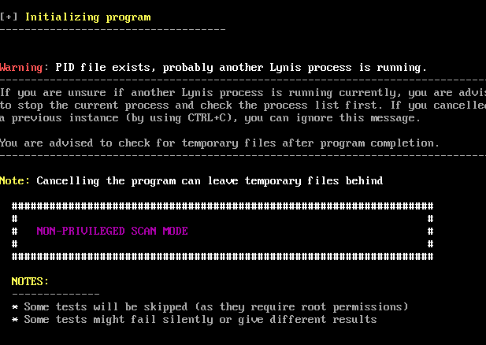

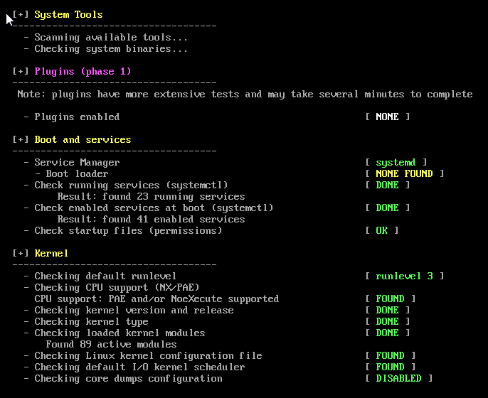

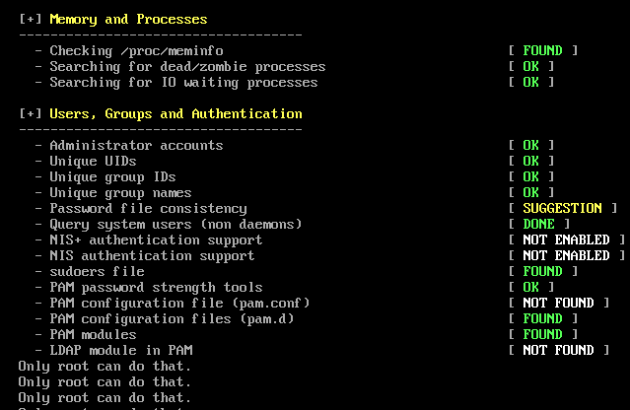

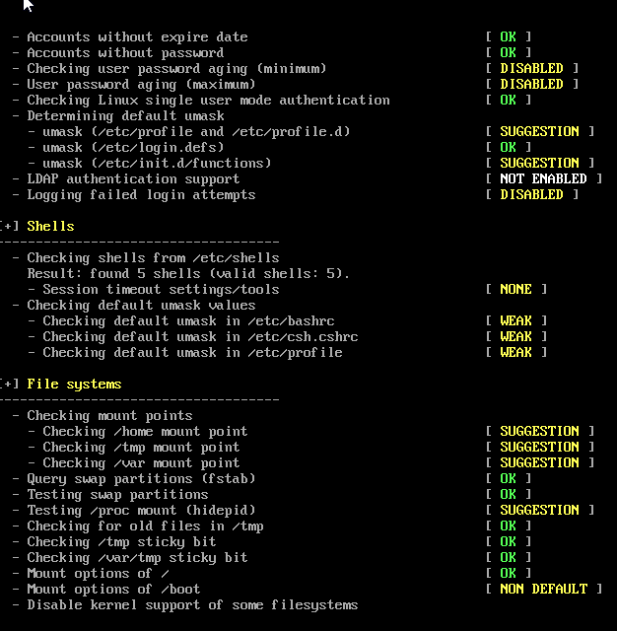

This is just a normal audit without any specific being requested. It shows file systems, memory, users and even the kernel. With more knowledge on how to navigate Lynis, the user can fully utilize all the security monitoring potential that is included in this program.