Argenis Roman

Ubuntu Install

Installed on Workstation, used ubuntu iso provided by the website.

Began the install by selecting preferred language and continue with the install wizard

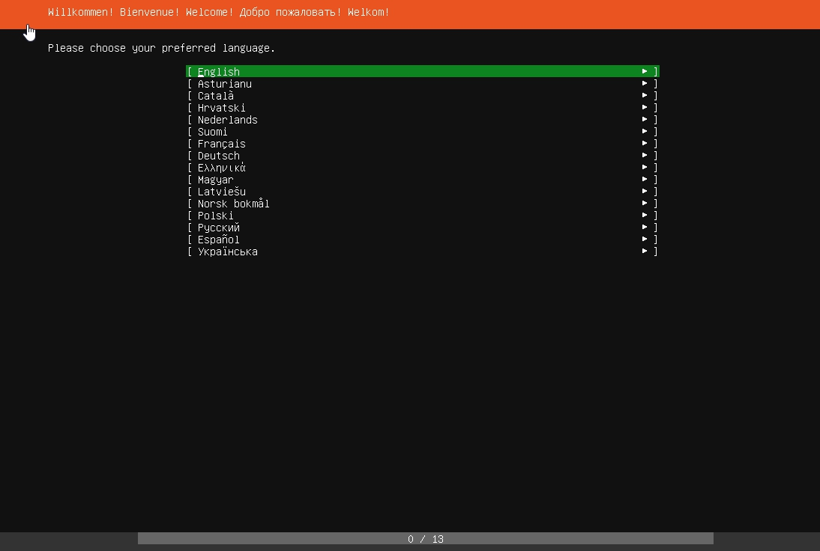

Next step in configuring the disk partitioning

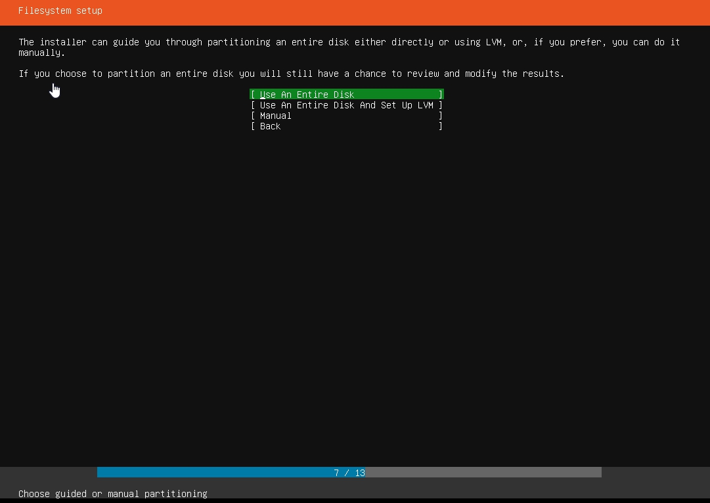

After configuring the partition, quickly review before continuing the install.

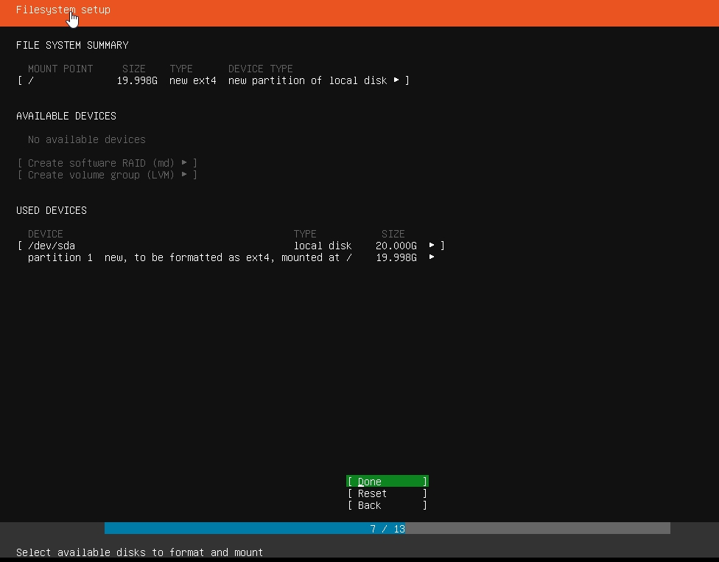

Next create the hostname, username and password

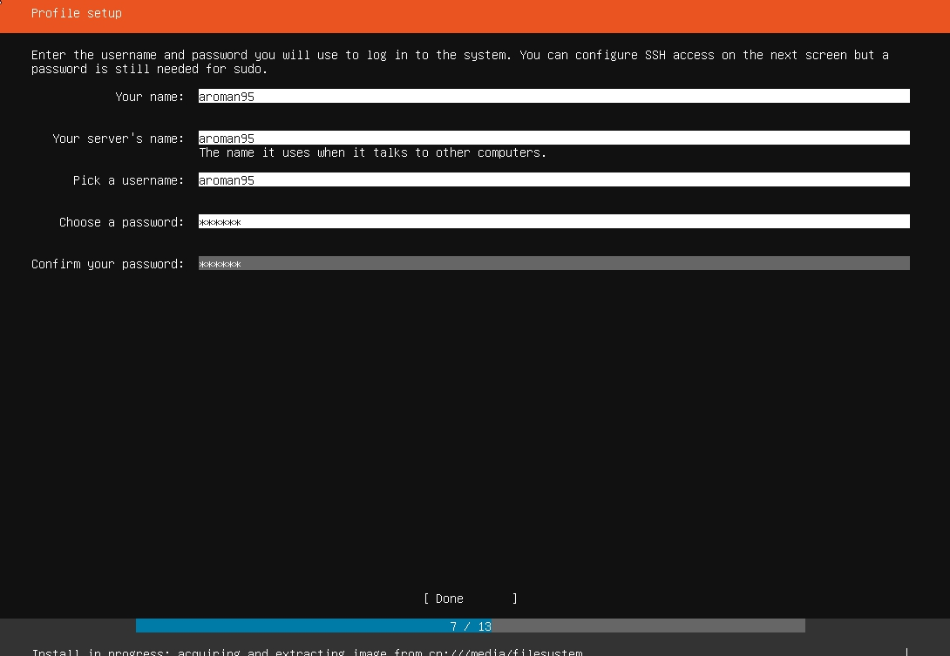

After creating the user, the install process will begin, and you will have to wait

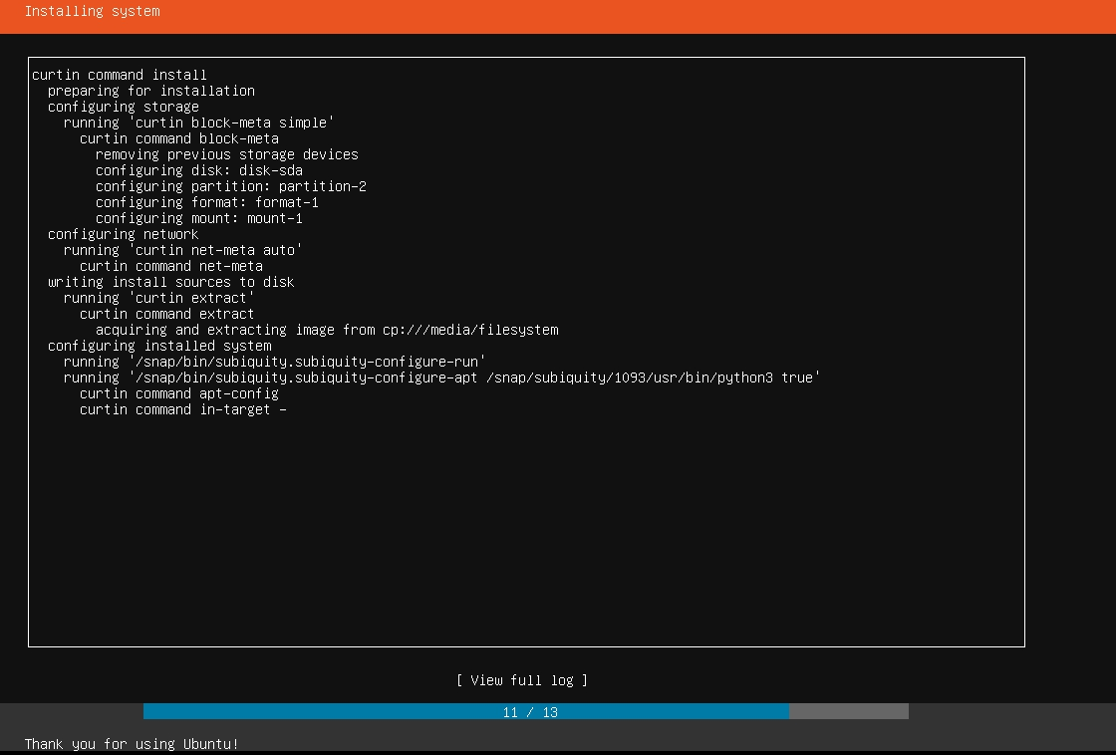

After the install is done reboot the system.

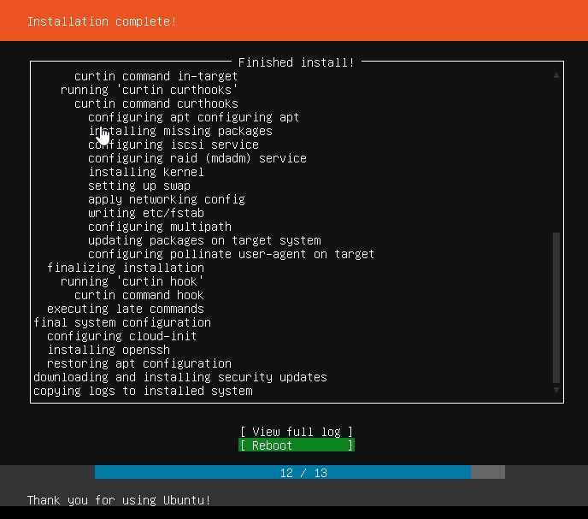

After the install sign in and you’re ready to begin.

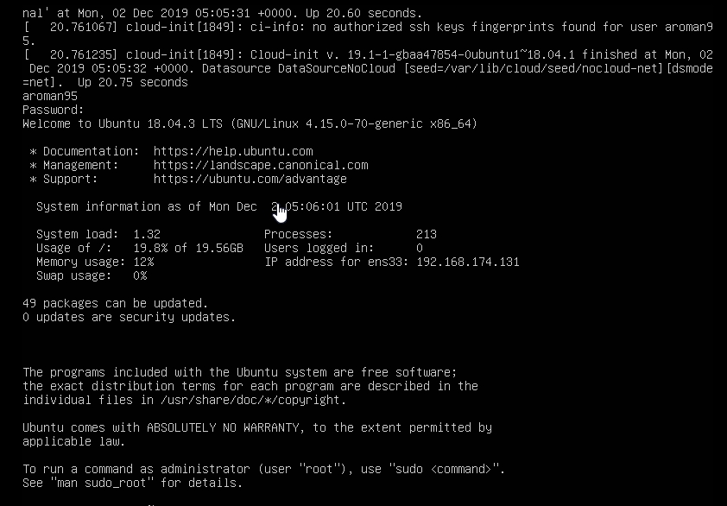

Soon after I logged in, I updated the apt-get service just to be safe.