Argenis Roman

Centos7 setup

Installed on Workstation, used the CentOS7 iso provided by the website

Start the setup by selecting **Install CentOS 7**

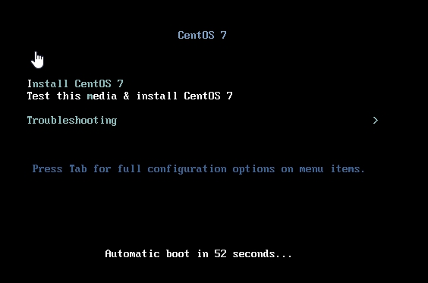

Choose preferred language for the install

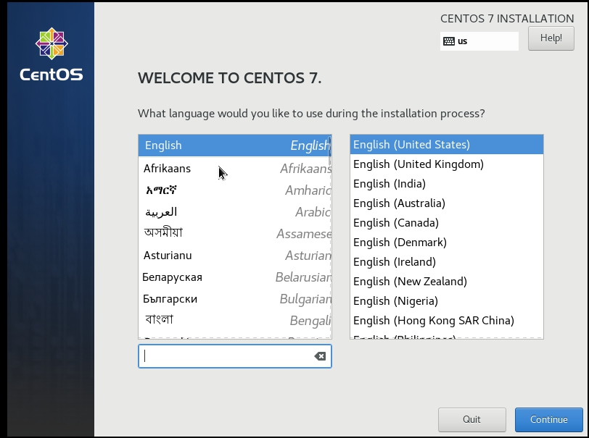

Setup wizard: This is the menu for the options you can select before beginning the installation

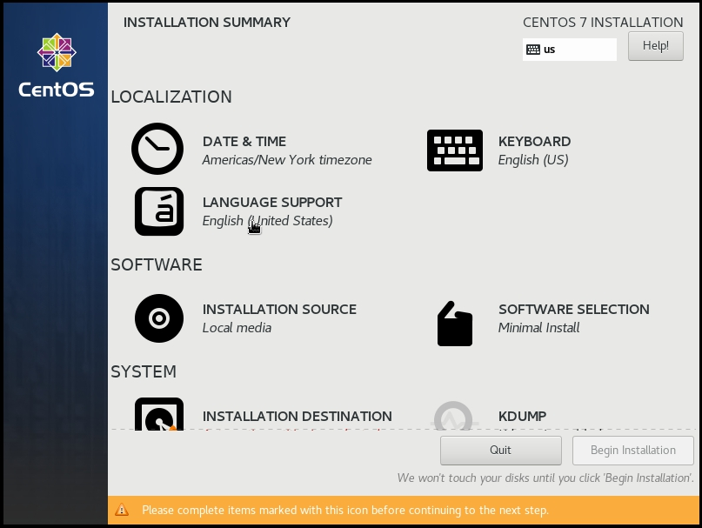

Select how the OS is going to be installed, I chose minimal for a fast install

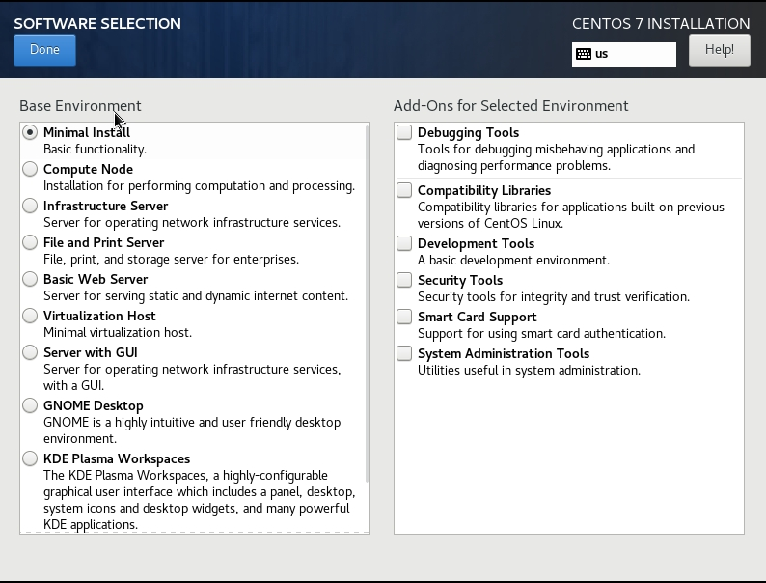

Select the storage device and the partitioning

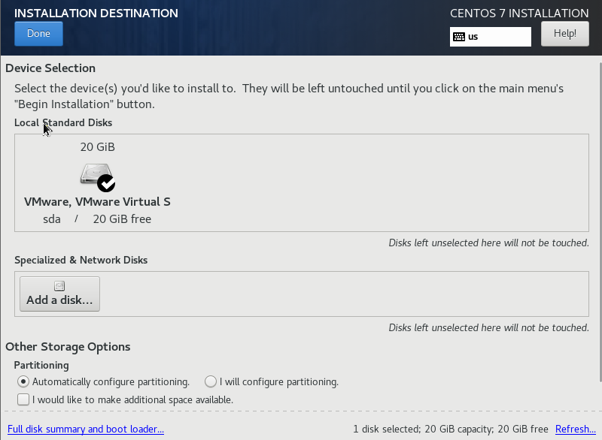

After selecting it start the installation, when it begins, you can create your user profile and assign the root password.

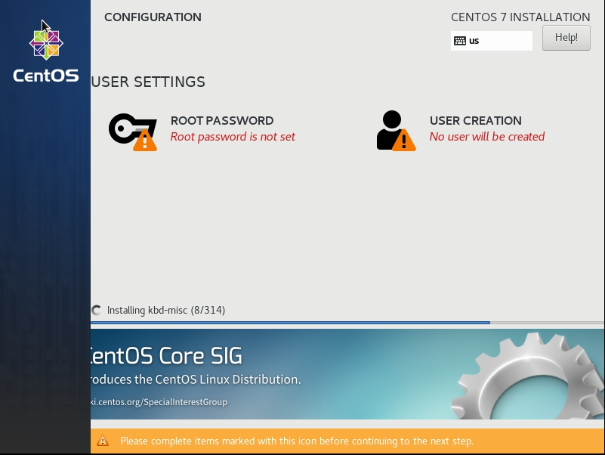

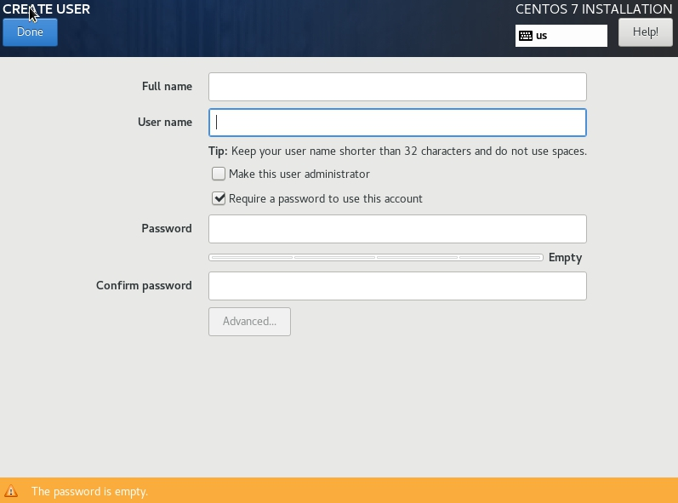

After it done installing you’ll be prompt to reboot. When the server starts up again you can sign in a began using it

