Write scripts to modifying firewall rules (iptables) for specific purposes:

1. Deal with web server (open needed ports, and forward port 80 traffic to 8080)

This is the code to open ports, to change the port, it has to changed manually by editing the script.

**-openports.sh**

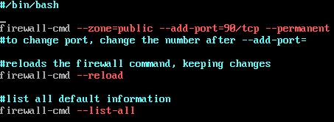

This is the output; it shows the ruleset information such as port 80 and 90 as active.

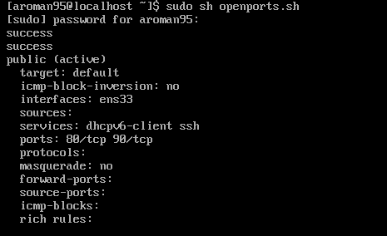

For forwarding port 80 traffic to 8080, I used the iptables command this time

**Redirect.sh**

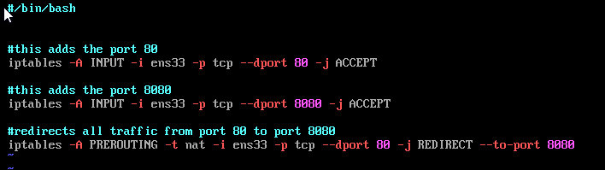

The results, so far there is no traffic being redirected



Also created a script to remove the active ports

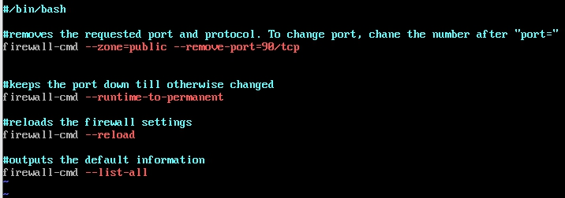

This is the output after the port has been removed

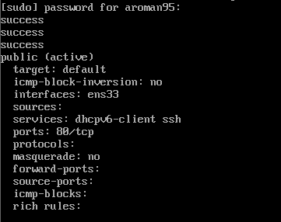

1. Deal with MySQL service (open needed ports)

The same script for shown at the first part can be applied to this part. After researching MySQL, a bit, I found that the default TCP/IP port is 3306, this time it was done on the ubuntu server.

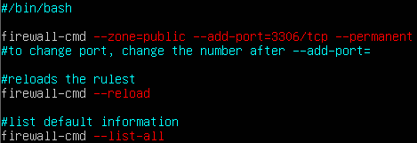

The results showing port 3306 open

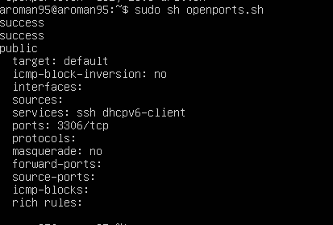

1. Deal with SSH service (allow incoming and outgoing SSH, second script to deny SSH)

The script showing the command to allow incoming and outgoing traffic

**-openssh.sh**

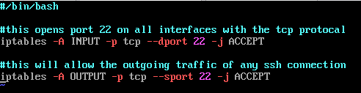

This is showing that port 22 is open and currently shows the packets and bytes



This is showing the ruleset allowing outgoing connections

This is the script to deny SSH and the ruleset showing that it is blocked

**-dropssh.sh**

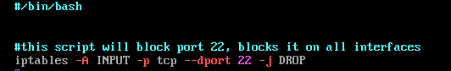

The DROP target simply drops the packet without sending any reply packets back.



1. Deal with Email service (Such as allow or block incoming SMTP, POP3...)

**Inmail.sh**

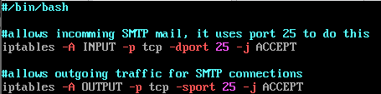

This is showing the ruleset allowing incoming connections on port 25



This is showing the ruleset allowing outgoing connections



To allow incoming POP3 connections, change the port # to 110

1. Script to allow/block specific hosts, MAC addresses, block telnet, block ping

This script allows will allow all ports access to system having physical address **1F:78:0D:6B:06:B5 -allowmac.sh**

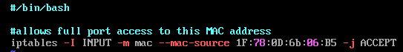

This show the made-up MAC address in the ruleset



Telnet **- Stoptel.sh**

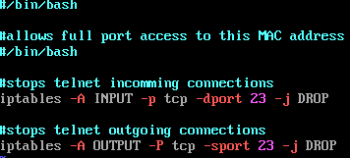

1. Write a script to back up your Firewall/iptables

The script to save the iptables is a simple line

**Ipsave.sh**

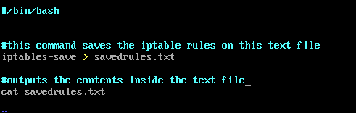

To restore the iprules, run the **iprestore**.sh script

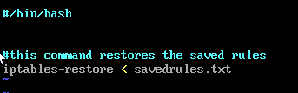

All the rules flushed

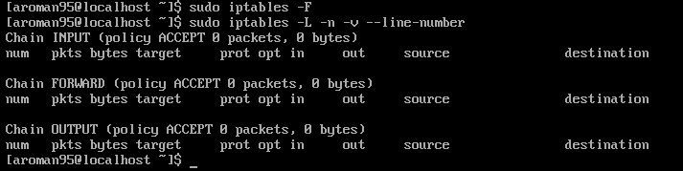

The script worked and restored all the rule

