Argenis Roman

Networking

Commands Used:

**nmcli**: a command-line tool for controlling Network Manager and reporting network status.

**ss**: a tool that is used for displaying network socket related information on a Linux system.

l – displays listening sockets

n- displays port number

t- displays Tcp connections

u-displays udp ports

CentOS

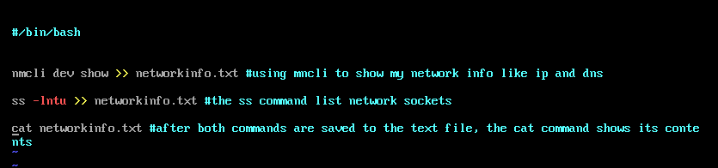

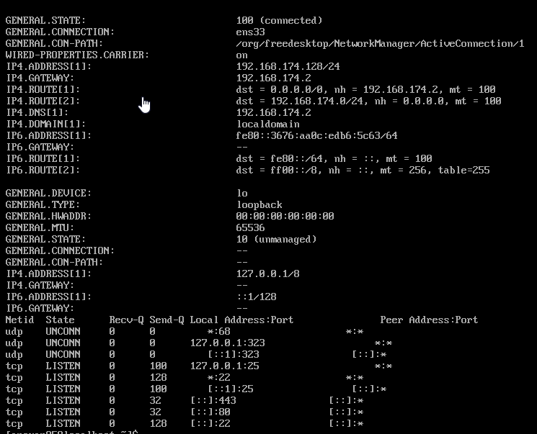

Ubuntu

Same script works on the ubuntu server but originally the nmcli command was found in the OS so had to install network



After the install was done the script ran well.

