Data Analysis Documentation
Crime in South East England

Contents
Project Purpose - Page 2

Project Scope – Page 2

Dataset Preprocessing Pandas - Page 3

PowerBI Table Description & Documentation – Page 8

Measure Creation – Page 10

Relationships and Datamodel – Page 12

Post Project Analysis – Page 13

Data Sources – Page 14

Project Purpose:
The following project aims to enrich multiple datasets to provide actionable insights in a power BI reporting dashboard. This dashboard is designed to assist Nadine - the Head of Sales at a real estate company called Best Nest, and her sales team in making data-driven recommendations. It supports identifying the best regions, counties and districts for clients based on critical factors such as safety, housing affordability, and transport links – based on their own preferences. With economic pressures growing, it is essential to provide a clear, data-driven guidance to help clients make smart decisions within this area.

My analysis focuses on 2 Police Forces: London and Thames valley. Thames Valley will be split into their respective counties of Oxfordshire, Buckinghamshire and Berkshire. These regions have been selected from the previous research and are also the most popular for migration in recent time. While many professionals continue to move to the capital, there's been a noticeable net migration away from London toward surrounding regions that offer greater tranquillity and quality of life. Our goal is to support those considering a move in or out of London by offering practical guidance, tailored recommendations, and examples of towns, cities, and properties that may align with their needs.

Project Scope:
Regions Covered: Surrey and Thames Valley.
Granularity: Includes lower super output area, and local authority districts within the outlined counties.
Time Period: Covers data trends from 2020 to 2024 for Census data. Additionally, Crime dataset covers the years 2023-2025.

Dataset Preprocessing: Pandas
Crime Dataset
I will now summarise the steps I took to clean and enrich this dataset. All the ipynb documents will be added to a separate folder.
Step 1 – Loaded raw Crime dataset with 4 Police Forces.
Step 2 – Filtered for Surrey and Thames Valley
Step 3 – Selected relevant column that I would need for my facts table
Step 4 – Merged with ONS Dictionary data to get Postcode Info for each row
Step 5 – Rename Columns and Date Formats for easier implementation.
Step 6 – Export final data to Crime.csv

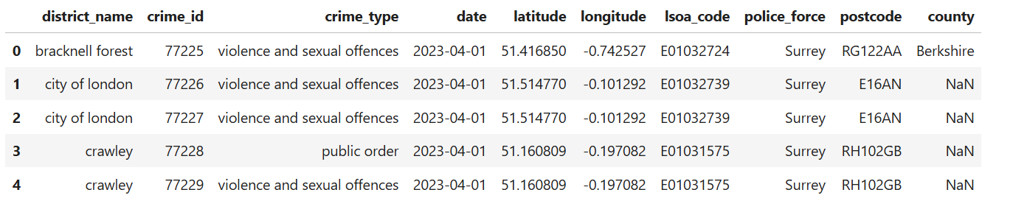
Final Table head

ONS Dictionary Dataset
This dataset was brought in for geographical merging and mapping of other datasets that did not have lsoa code or postcode. The dictionary allowed me to enrich my other datasets with necessary information to be used in the model.
Step 1 – Load full national postcode dataset from ONS
Step 2 – Extract LSOA codes and coordinates
Step 3 – Map each LSOA code to a district
Step 4 – Manually create a district to county mapping for higher granularity
Step 5 – Merge to assign each postcode to county
Step 6 – Export final lookup file ons_csv

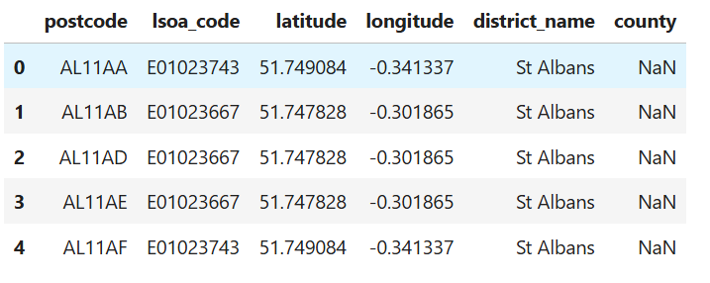
Final Table Head

Stations Dataset
For my station dataset I used a list of all stations in England along with their Latitude and Longitude. A good amount of preprocessing and enrichment will be needed to create a viable dataset for further use.
Step 1 – Load station data and ONS dictionary data for further merging.
Step 2 – Convert to Geodata Frames and reproject for spatial operations.
Step 3 - Use spatial join to map stations to LSOAs
Step 4 - Filter stations by target districts – A list of these Districts will be available in the Data Sources chapter.
Step 5 - Clean and rename only essential columns that will help with my further analysis or merging into my star schema model.
Step 6 – Enrichment of data including merging with property data to get property counts, merging with crime to get total crime count per lsoa and merge with price data to get average price of property in area.
Step 7 – Assign station Id’s for added granularity and export final file stations.csv

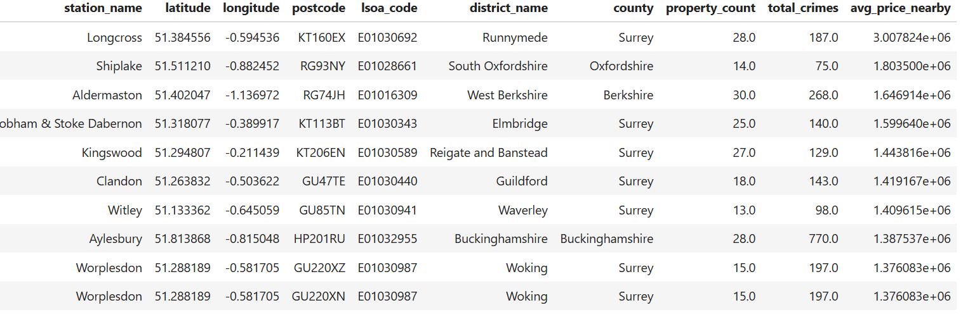
Final Table Head

Schools Dataset
For my school dataset I used a set of schools in the UK with their respective education phase and religion. Unfortunately, I did not use a dataset with school scores because at the time I did not manage to link the postcode to lsoa code. However, I now know how to do it and will use this in future projects.
Step 1 - Load and clean school data – cleaning column names by stripping whitespace and lowercasing. Converting county names to uppercase for consistency.
Step 2 – Filter for target counties
Step 3 - Standardize postcodes and rename columns for better view
Step 4 – Add school ids for better granularity
Step 5 - Map schools to LSOA codes and districts
Step 6 - Enrichment of data including merging with crime to get total crime count per lsoa and merge with price data to get average price of property in area.
Step 7 – Exported final file stations.csv

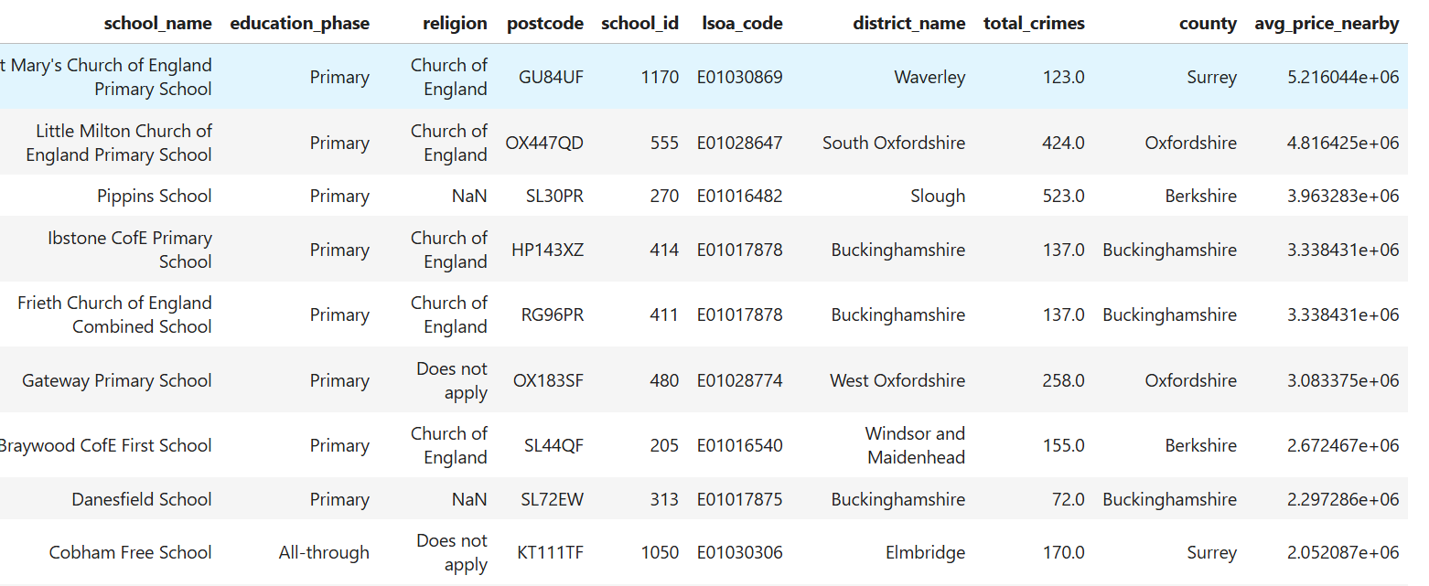
Final Table Head

Price Paid Dataset
For my price paid dataset, I used a set of properties sold in 2024, along with their price, house type and postcodes. Merging with ONS dictionary will be needed along with a creation of price band column that will split prices into bands for easier analysis.
Step 1 - Load and clean 2024 property transaction data – Normalised data though clearing of whitespace and lowercasing. Uppercasing the county field for filtering too.
Step 2 - Filter for key counties
Step 3 - Map property type codes to human-readable labels such as F – Flat and so on.
Step 4 - Clean postcodes for consistency
Step 5 - Categorize prices into bands for easier analysis e.g. £250,000 to £500,000
Step 6 – Enrich data with LSOA, district, and county from ONS datasets
Step 7 – Export enriched property dataset as price.csv

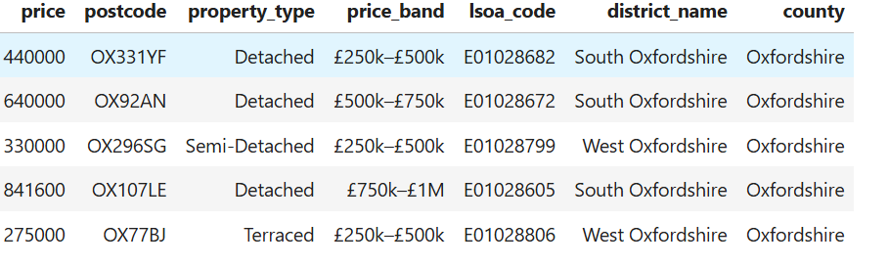
Final Table Head
Final Comments
I built a data integration and enrichment pipeline in Python that processes and links:
- Crime data (filtered, cleaned, LSOA-mapped)
- Train station data (spatially joined to LSOAs)
- School data (joined via postcode to LSOAs and districts)
- Property price data (banded and geolocated)
- ONS lookups (mapping postcode → LSOA → district → county)
Everything is joined using common geographic keys (postcode, lsoa_code, district_name, county) and exported into clean CSVs for Power BI.

PowerBI Table Description & Documentation
Fact Crime
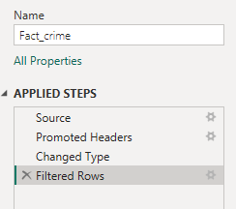
Minimal changes to fact table, as this was the main fact table of my Star schema, which allowed to have multiple rows with the same lsoa code.
Dim Price
This dataset was populated with many rows that had the same lsoa code. This meant that this table could not be joined to my fact table, so I had to duplicate it and create an aggregated dimension table for price.
Dim Agg Price
Duplicated version of Price was grouped by lsoa code to get an aggregated table that only holds one row per lsoa code and average price for the lsoa code.
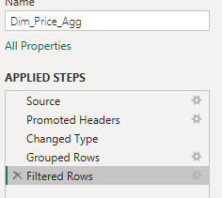
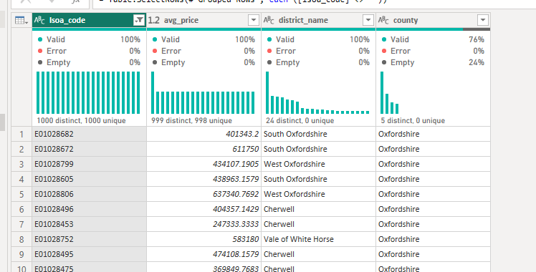

Dim Schools
Had to do a similar thing for schools, as a one-to-many relationship with the fact table was impossible due to schools being in the same lsoa code. Had to duplicate and create an aggregated table.
Dim Agg Schools
Duplicated version of Schools was grouped by lsoa code to get an aggregated table that only holds one row per lsoa code. Also included the school count, average crimes in vicinity and average crimes nearby as all of them were calculated by lsoa code.
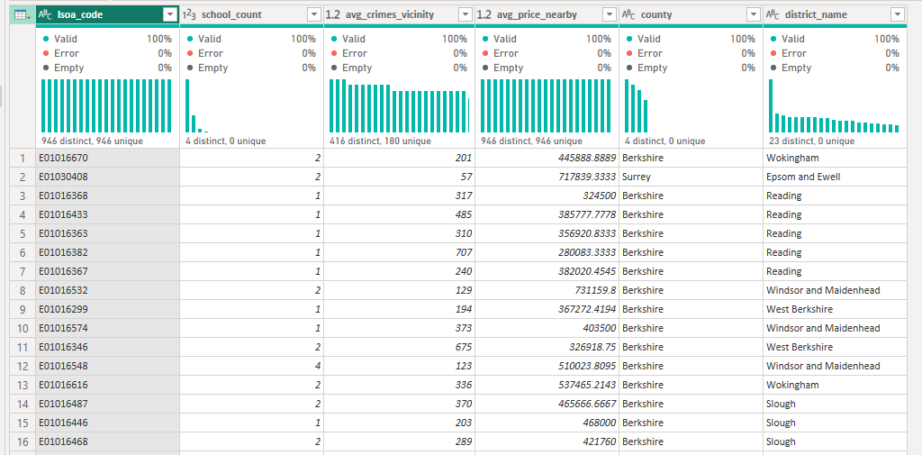
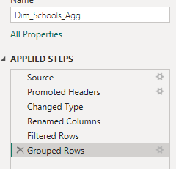

Dim Stations
Station data had some changes done to its column names for clarity. In addition, the duplicates for lsoa code were removed, to have one station per lsoa code so the dimension table could have a one-to-many relationship.
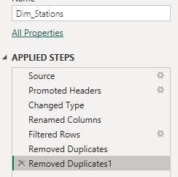

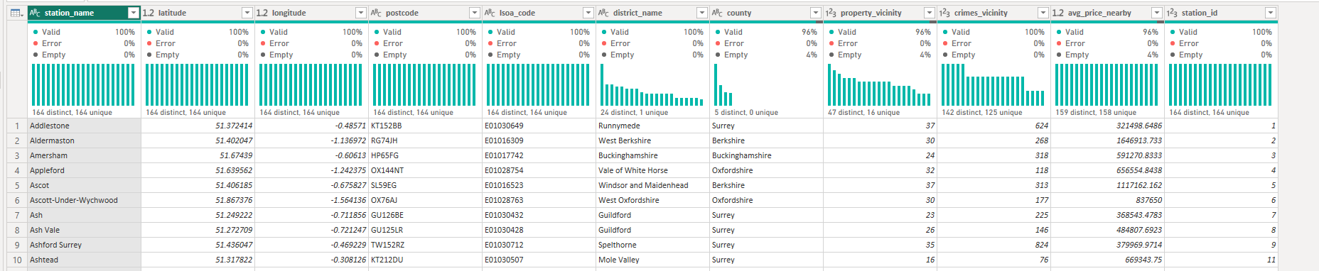
County Population
This was a quick custom table I added to get crimes per 1000 per county for my initial county dashboard. The measure creation will be explained in next part.
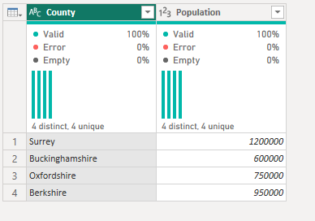

Measure Creation
This chapter will show and explain the calculated fields used in my analysis to present the data in a more comparable way.

Crime count – number of crimes reported within an area
Crimes Per 1000 people (County) – Crime pre capita for each distinct county 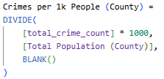
Total Stations per county – number of station in each county 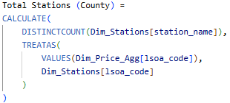

Station count per district – Number of stations within each district 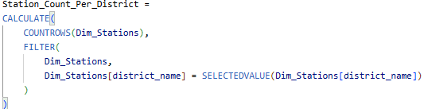
Properties Near Stations per county – Number of properties near stations in each couty 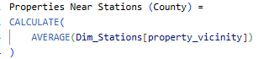
Total schools per county – Number of schools in each county 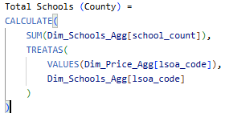
Average price per county – Average price of properties in each county 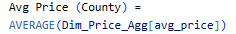
Total Population per county – Population count for each county 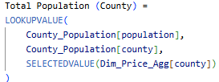

Data Model & Relationships
Relationships
Fact_Crimes connections:
- Many to One relationship with ‘Dim_Stations’ on ‘lsoa_code’.
- Many to One relationship with ‘Dim_Schools_Agg’ on ‘lsoa_code’.
- Many to One relationship with ‘Dim_Price_Agg’ on ‘lsoa_code’.
Dim_Stations connections:
- One to Many relationship with ‘Fact_Crimes’ on ‘lsoa_code’.
Dim_Schools_Agg connections:
- One to Many relationship with ‘Fact_Crimes’ on ‘lsoa_code’.
- One to Many relationship with ‘Dim_Schools’ on ‘lsoa_code’.
Dim_ Price_Agg connections:
- One to Many relationship with ‘Fact_Crimes’ on ‘lsoa_code’.
- One to Many relationship with ‘Dim_Price’ on ‘lsoa_code’.
- Many to One relationship with ‘County_Population’ on ‘county’.
Dim_Schools connections:
- Many to One relationship with ‘Dim_Schools_Agg’ on ‘lsoa_code’.
Dim_Price connections:
- Many to One relationship with ‘Dim_Price_Agg’ on ‘lsoa_code’.
County_Population connections:
- One to Many relationship with ‘Dim_Price_Agg’ on ‘county’.

Please see next page for data model and description.

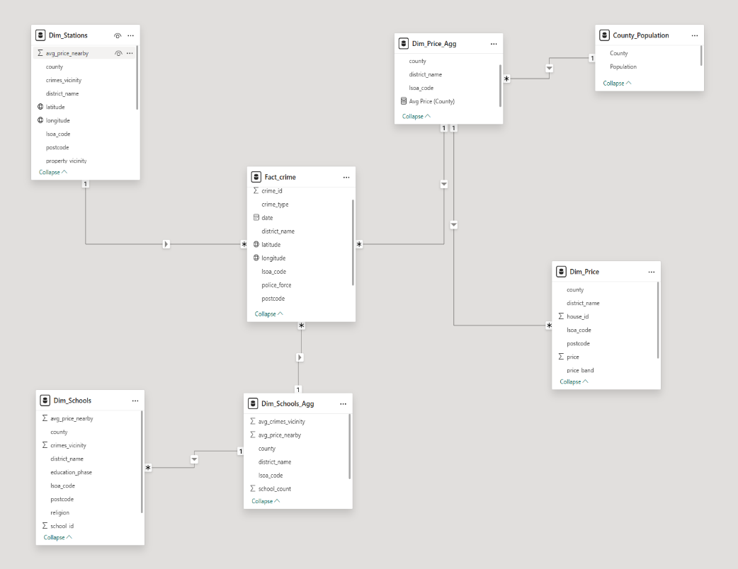
Data Model

This data model attempted to reflect a star schema. This schema was selected as the best practice for this kind of data which would help me connect all my tables and conduct analysis.
The fact table consists of crime data and is linked to all the other dimension tables via lsoa code. This allowed me to keep rows that had a repeated lsoa code due to it being the central table for relationships.
The dimension tables were all linked to the fact table via lsoa code. However, to avoid many to many relationships, certain dimensions tables were grouped by lsoa code to have a one-to-many relationship to the fact table and remove redundancy.
Post Project Analysis
In hindsight, I see that there a lot of problems with my project that could have been avoided. The most important is the granularity of my tables, as this would have allowed me to keep important integrity of my data and would have inhibited a much cleaner joining process. For example, for crime types I should have created a dimension table with crime type id and crime type. This is just one example of many that I should have thought about and included. In addition, I think that including data of school rating should have been the right idea, but I was too quick to make the decision not to use due to connection errors, but I now know that this could have been simply merged with lsoa dictionary. Overall, I feel like I missed the main point of the project, which was to create a star schema with maximum granularity, which would have allowed a smooth connection of all my datasets. Despite this, this project has showed me the reality of completing a professional project, and I will take away the outcomes I have learnt with great certainty.

Data Sources
Crime Data - https://data.police.uk/data/

Price Paid Data - https://www.gov.uk/government/statistical-data-sets/price-paid-data-downloads?utm_source=chatgpt.com#using-or-publishing-our-price-paid-data

Ons Postcode Directory -https://geoportal.statistics.gov.uk/datasets/e14b1475ecf74b58804cf667b6740706/about

Schools Data - https://get-information-schools.service.gov.uk/Downloads

Data For County Population
Surrey - 2021 Census: First results | Surrey-i
Buckinghamshire - Buckinghamshire Population (2025) - Total Population
Berkshire - Berkshire population stats in maps and graphs.
Oxfordshire - Oxfordshire Data Hub – Population – Current Population

