Diagram 1: System Context / Runtime Architecture
TokenStream CRA risk assessment artifact
This document provides the high-level system context and runtime architecture view used as an input to the TokenStream CRA risk assessment. It identifies the system boundary, expected actors, main runtime components, security-relevant stores, external providers and tools, and the principal high-level flows.
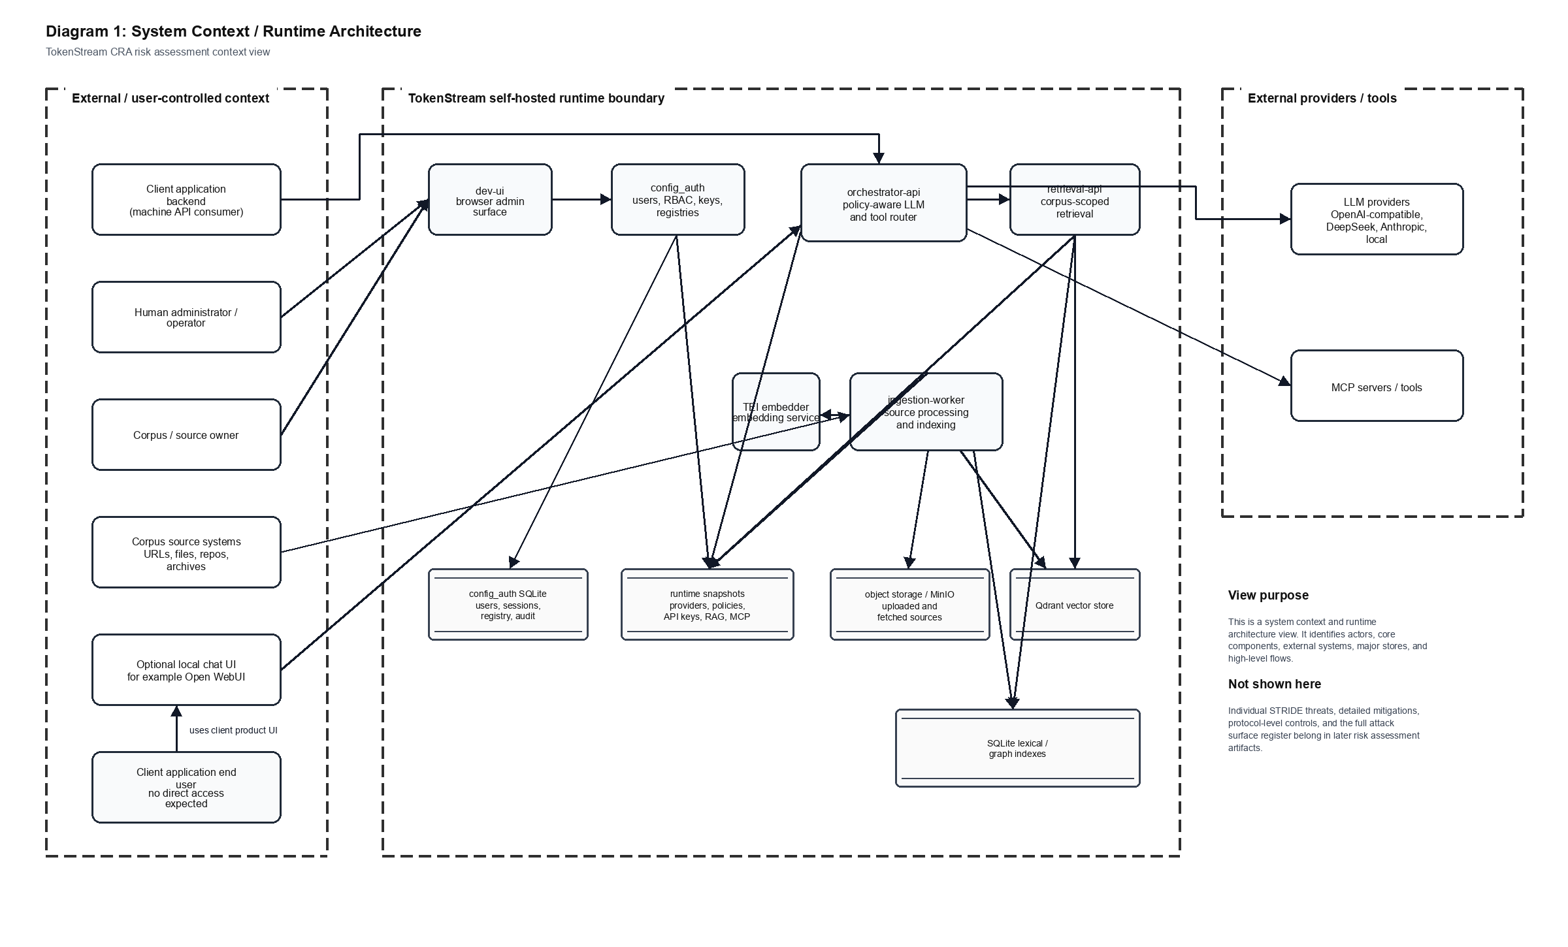

Interpretation
The diagram should be read as an architecture and context view rather than as the detailed STRIDE model. It establishes what is inside the self-hosted TokenStream runtime boundary and what remains external or user-controlled.
- External actors include client application backends, human administrators/operators, corpus/source owners, corpus source systems, optional local chat UI components, and indirect client application end users.
- TokenStream runtime components include dev-ui, config_auth, orchestrator-api, retrieval-api, ingestion-worker, TEI embedder, runtime snapshots, configuration/authentication storage, object storage, Qdrant vectors, and lexical/graph indexes.
- External systems include LLM providers and MCP servers/tools invoked through the orchestrator according to configured policy and available credentials.

Scope Notes
This artifact does not enumerate individual STRIDE threats, risk scores, mitigations, vulnerability handling controls, or every attack surface item. Those details should be maintained in the STRIDE Data Flow / Trust Boundary diagram, the Threat Dragon model, and the modelled attack surface register.
The optional local chat UI is shown as an external or adjacent client surface because it is not the administrative control plane. Direct user access to dev-ui remains outside the intended access model and should be treated as unintended except for trusted administration.

