

#### ClearPlan

IMS Export Utility

Version 3.1.0

February 26, 2019

# Version History

| Version | Date Published | Summary of Changes |
| --- | --- | --- |
| 2.0 | 7/30/2018 | Includes additional export configuration options, minor bug fixes, more flexible mapping of user input fields, and adds an IMS Data Check for verifying Cobra integration readiness. |
| 3.0 | 11/12/18 | Includes TimeScaleData Export option, which will export MSP Timephased Assignment data by week. This allows Cobra to integrate and aggregate by Accounting period without the need for consumption of accounting calendar by the Export utility. Cost and Material resource data are now also evaluated separately: material resources are exported using the assignment baseline/remaining work values. Cost resources are exported using the baseline/remaining cost values. |
| 3.1.0 | 2/26/19 | Includes WP Title export option, which will export the IMS WP Titles in the BCWS export by using the first row found for each unique WP ID (including Summary rows). Fixes bug in BCR optional ID Mapping (allows “<None>” for BCR field value). Fixes bug when using CAID 1 mapping only. Fixes header bug in Data Check report. Includes handling of punctuated CAM names or CAM names with comma delimited values. |

Contents

Version History 2

Overview 4

Prerequisites 4

Tools 4

Datasets 4

ClearPlan IMS Export Macro 5

Installing the ClearPlan IMS Export Macro 5

Copying the ClearPlan IMS Export Macro to the User Global Template 5

Running the ClearPlan IMS Export Macro from an MPP File 6

Configuring the IMS Export Macro 9

Running the IMS Data Check 11

Exporting CSV Files from MS Project 12

# Overview

This document is intended to serve as a step-by-step guide for installing and executing the ClearPlan IMS Export Utilty.

# Prerequisites

The following tools and datasets should be available prior to the start of this procedure. Their setup and configuration are not covered in this document.

### Tools

Microsoft Project (2013 or later)

### Datasets

IMS with metadata coded. Resource Loaded schedules must utilize the Cobra resource codes.

# ClearPlan IMS Export Macro

Though it is possible to import data to Cobra from an Excel workbook, it is recommended that CSV files are used to guarantee correct translation of data due to Excel’s auto-formatting capabilities (i.e. punctuated WBS elements, number formats, etc). There are two options for importing CSV files through the Integration Wizard:

* Two CSV files – one file containing structural Activity information, and a second file containing resource amounts and time-phasing
* A single CSV file with integrated Activity and Resource data

While the single file option may appear simpler, it can be more difficult to architect and debug due to the increased number of data points required to combine the Activity and Resource information, especially when importing tasks to be used as weighted milestones for earned value calculations.

While there are numerous methods for exporting data from MS Project, an easy to use export tool has been created.

## Installing the ClearPlan IMS Export Macro

The IMS Export Macro can be run directly from the container MPP file, or from the user/ Project Server Global template. For testing new releases, it is recommended that the user runs the macro directly from the MPP file to avoid risk of contaminating the Global template. Long term stable releases can be copied to the users Global for simpler execution.

### Copying the ClearPlan IMS Export Macro to the User Global Template

* Open the “ClearPlan_IMS Export Macro_rX.X.mpp” file
* From the “Info” section of the “File” menu, open the Organizer

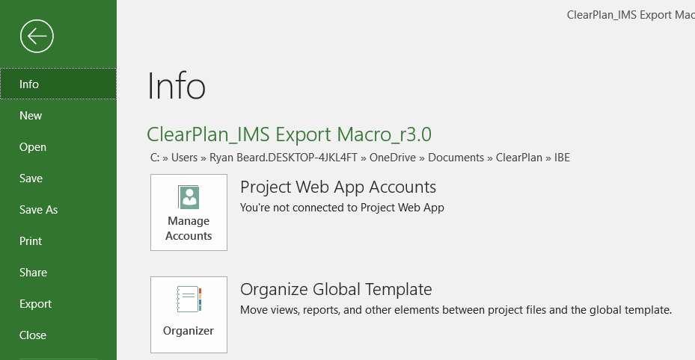

* On the “Modules” tab of the Organizer, select both the *IMSCobraExportFrm* and the *IMSCobraExportModule* from the “ClearPlan_IMS Export Macro_rX.X.mpp”, and click the “Copy” button to copy the modules to the user’s “Global.MPT”

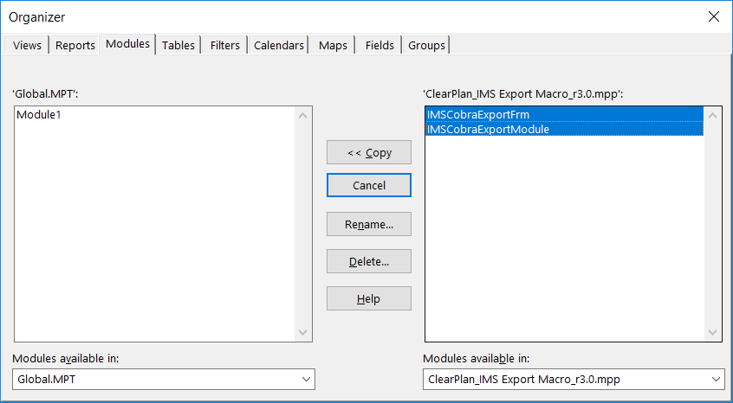

* Note that existing versions of the Export Macro should be deleted prior to installing any updates. To delete existing versions, select both the *IMSCobraExportFrm* and the *IMSCobraExportModule* from the “Global.MPT” and click the “Delete” button

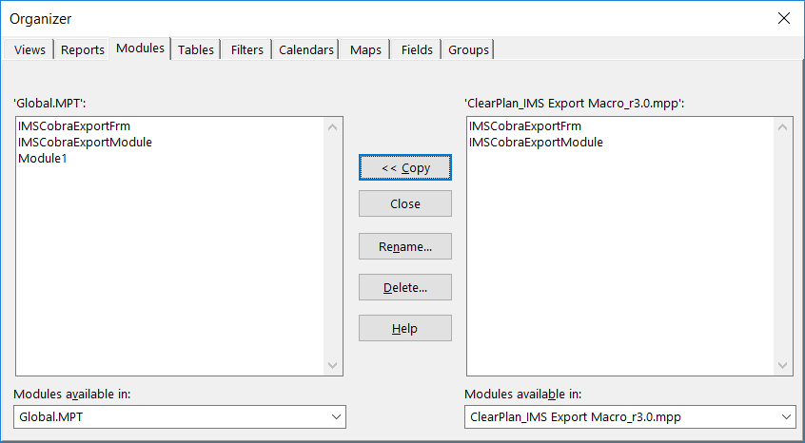

### Running the ClearPlan IMS Export Macro from an MPP File

* With the schedule to be exported already open, open the “ClearPlan_IMS Export Macro_rX.X.mpp” file
* Navigate back to the schedule to be exported using either the “Switch Windows” command on the View tab of the ribbon menu, or by selecting the appropriate icon from the Windows Taskbar

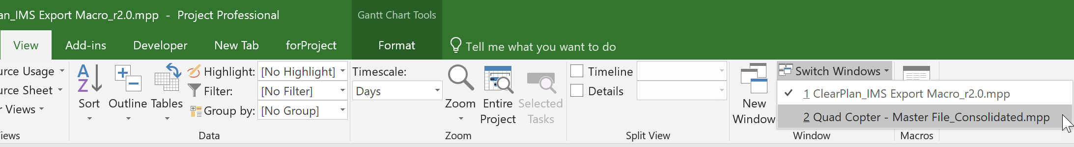

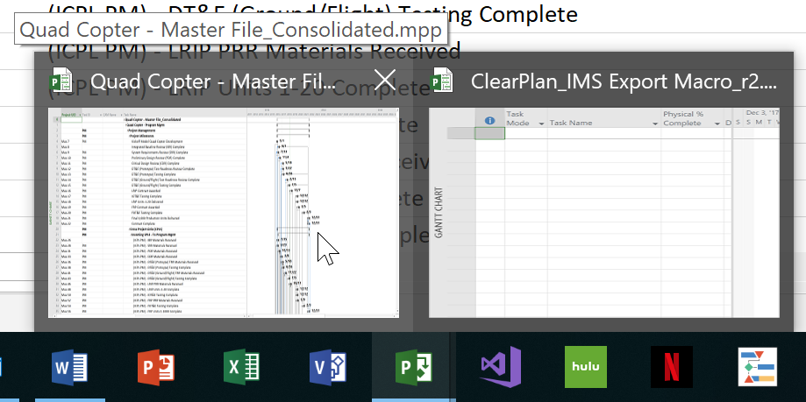

* From the View tab of the ribbon menu, select the “View Macros” command under the “Macros” drop-down menu

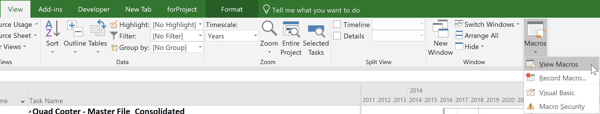

* Select the “ClearPlan_IMS Export Macro_rX.X.mpp” file from the “Macros in:” drop-down menu, then select the “Export_IMS” macro and click the “Run” button

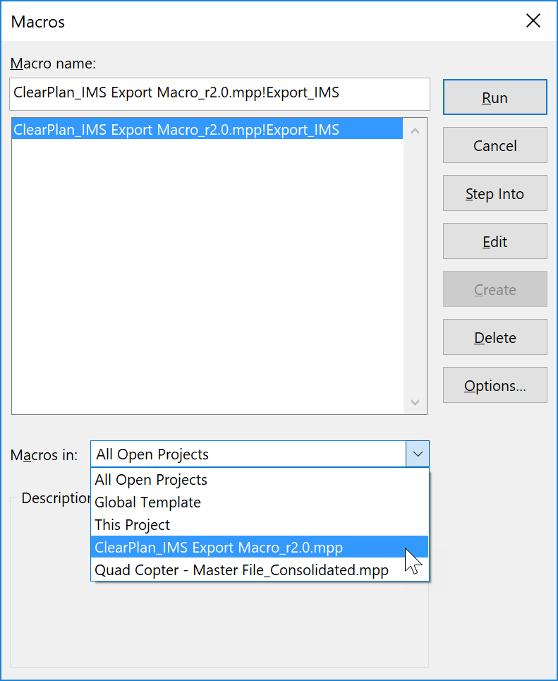

## Configuring the IMS Export Macro

Prior to running the IMS Export Macro on any schedule file (Master Project or individual Subproject), the tool must be configured to work with the MS Project custom fields. If the configuration is incomplete, or if previously mapped fields have been renamed, an error message will be displayed and the User will be prevented from producing the export until the configuration is complete.

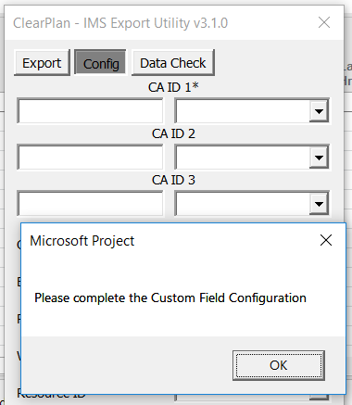

To complete the IMS Export Macro configuration:

* Click the dropdown arrow for each item and select the appropriate native or custom field

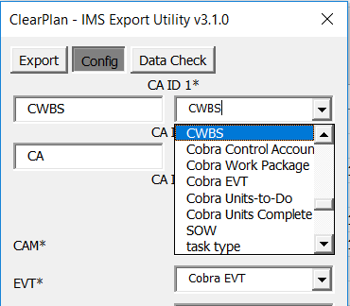

* CA ID 1 is a required element, and in addition to a custom field map, a title must also be provided in the Input Box. These elements should be coordinated with the designated Program Finance Analyst.

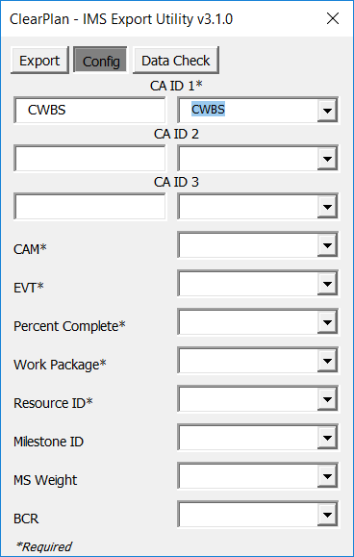

* If not using CA ID 2 or 3, select “<None>” from the drop down

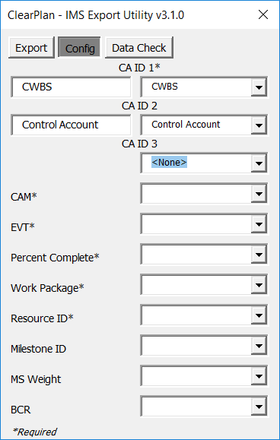

* Once the configuration is complete, click the “Data Check” tab to review IMS readiness to proceed with Cobra integration
* Note that required elements are marked with an * after the Field Map Title.

## Running the IMS Data Check

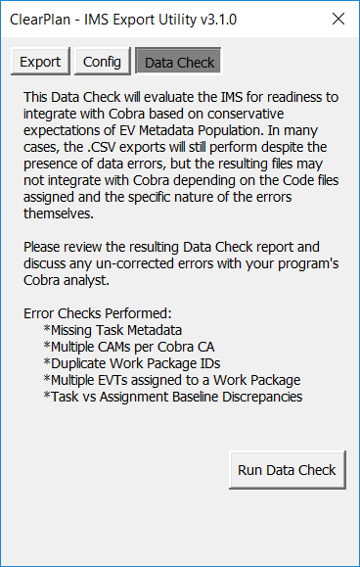

The IMS Data Check will review and report on preparedness of the IMS to provide Cobra export files capable of successful integration. The following evaluations are performed, and any data errors are enumerated in an output report.

* **Tasks Missing Data:** Reports tasks missing CA ID values, CAM, WP, EVT, Baseline Work/Cost, Baseline Start/Finish, Milestone ID or Weight (as required based on EVT). Only EV relevant tasks are evaluated, meaning tasks must have at least one of the following values populated: Work Package ID, EVT, Baseline Work, Baseline Cost.
* **CAM Errors:** Reports Control Accounts with multiple CAM assignments (only one CAM can be assigned to each Control Account). A Control Account, as interpreted by Cobra, is based on a Unique Record ID made of up the Concatenated CA ID values (e.g. CWBS, OBS & CA).
* **Work Package Errors:** Reports Work Package IDs that are children of multiple Control Accounts. Work Packages, can only have a single Control Account Parent (note that some programs without formal EV surveillance may still allow duplication of Work Package IDs). This evaluation also reports Work Packages with Multiple assigned EVTs. Only a single EVT can be assigned to any Work Package.
* **Task Assignment Discrepancies:** Reports task assignments with vertical traceability errors. Task Assignment Baseline Work/Cost and Baseline Start/Finish values should sum correctly to the task level. This evaluation also reports Task Assignments that are missing any of the required baseline values (Work/Cost, Start, Finish).

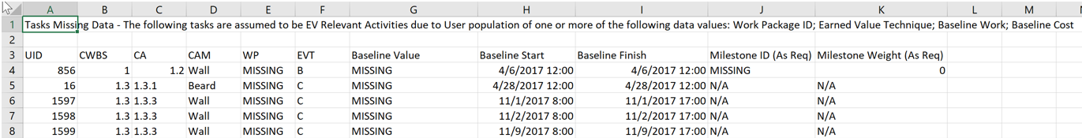

## Exporting CSV Files from MS Project

To export the IMS data:

* Open the MS Project schedule to be exported (can be a single file, or master with multiple subprojects)
* From the View menu, click the Macros and choose the “Export_IMS” macro from the Global Template, then click Run to execute

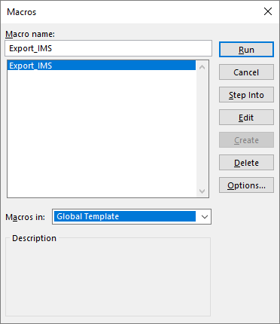

* 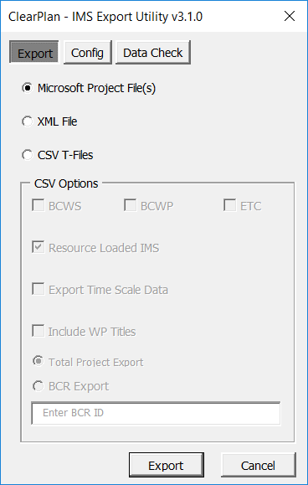Choose the “CSV T-Files” option and mark the check-box for any combination of “BCWS”, “BCWP” and “ETC” exports
  + Any combination or all the CSV files can be exported at once
  + The “BCWS” export will create both the “ACT” and “RES” files using the schedule Baseline Dates and Baseline Work / Cost values for loading new / revised baseline information into Cobra
    - The “BCWS” export function will enable the radio buttons for “Total Project Export” and “BCR Export”.
    - If exporting all project baseline information, use the “Total Project Export” option
    - If exporting only specific BCR changes, use the “BCR Export” option and enter the BCR ID in the provided text box.
    - To include WP Titles, select the “Include WP Titles” option. Note that this will pull the WP Title from the first activity row with a unique WP ID (concatenation of CAID and WP values).
  + The “BCWP” export will create the “ACT” file using the Actual Dates and Physical % Complete values for loading monthly progress into Cobra. Note that this applies to C – Percent Complete and B – Milestone Earned Value Techniques only; all other Earned Value Techniques are calculated by Cobra.
  + The “ETC” export will create both the “ACT” and “RES” files using the Forecast Dates and Forecast / Remaining Work and Cost values for loading forecast information into Cobra. Only incomplete task assignments are included in the ETC export.
  + The “Export Time Scale Data” option will export the IMS time-phasing data by week for integration and aggregation by Cobra into the corresponding accounting periods. Use this option when managing manual assignment spreads or using non-linear work contours in the IMS (e.g. Material). Note that weeky data is exported based on the “Week starts on” setting in MSP Options > Schedule. This should be consistent with the Account period end (e.g. if the Accounting periods end on Friday, the week should start on Saturday).

* + For non-resource loaded schedules, uncheck the “Resource Loaded IMS” option. This will allow tasks without Baseline Work or Baseline Cost to be exported for successful Cobra Integration. For BWP purposes, each task is given a nominal weight of 1 unit.
* Once the export is complete, a new folder will be created on the active user’s desktop containing the user selected Activity and Resource CSV exports, and the folder will be opened automatically and presented to the user for subsequent action

