# General Description

This is original code for paper "Fall Detection using Biometric Information Based on Multi-Horizon Forecasting"(ICPR'22)

A fall detection method with multi-horizon forecasting usring Temporal Fusion Transformers and other deep learning methods.

For other deep learning methods, 1D CNN, single LSTM, stacked LSTM were used.

All models were configured to forecast falls through the window size of data from the perspective of regression instead of classification.

For the last predicted value, the class of the predicted values was classified on the basis of the threshold value.

To verify benchmark performance, we faithfully reproduced the 1D CNN and LSTM-basedmodels, although the model structures were modified to enable regression in both cases because they were tailored to the classification task.

1D CNN model architecture is based on the model structure proposed in 2020 by Kraft et al([paper](https://github.com/IKKIM00/Fall_Detection_using_multihorizon_forecasting/files/6866631/Deep.Learning.Based.Fall.Detection.Algorithms.for.Embedded.Systems.Smartwatches.and.IoT.Devices.Using.Accelerometers.pdf)).

Signle LSTM and stacked LSTM model is based on the model architecture proposed in 2019 by Luna et al ([paper](https://github.com/IKKIM00/Fall_Detection_using_multihorizon_forecasting/files/6866652/sensors-19-04885-v2.pdf)).

# Requirements

python==3.7.3

tensorflow-gpu==2.5.3 or tensorflow==2.5.3

sklearn==0.24.2

## Multi-horizon forecasting result

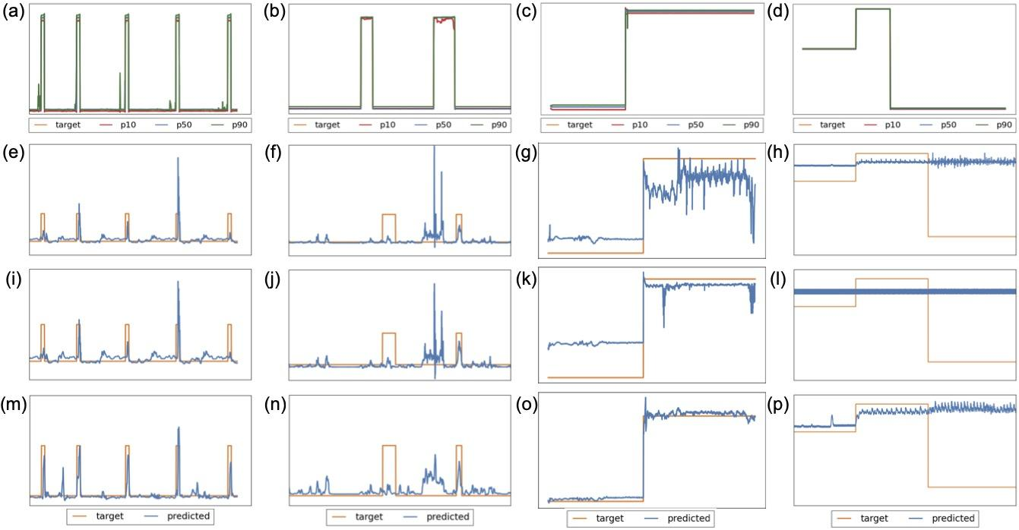 Prediction results for the SmartFall, Notch, DLR and MobiAct datasets in order using:

(a)-(d) TFT method, (e)-(h) Single LSTM, (i)-(l) Stacked LSTM, (m)-(p) 1D CNN

# Download Dataset

For SmartFall and Notch dataset, I have uploaded zip files in dataset/. You can also download data through the link below.

### SmartFall and Notch dataset

dataset url - <https://userweb.cs.txstate.edu/~hn12/data/SmartFallDataSet/>

paper - <https://www.ncbi.nlm.nih.gov/pmc/articles/PMC6210545/>

### DLR dataset

dataset url - <https://www.dlr.de/kn/en/desktopdefault.aspx/tabid-12705/22182_read-50785/>

### MobiAct dataset

dataset url - <https://bmi.hmu.gr/the-mobifall-and-mobiact-datasets-2/>

# How to use

## Data Preprocess

Please download all datasets through the URL or zip files provided in dataset/.

### SmartFall Dataset

1. Put dataset into directory named dataset/SmartFall_Dataset/.
2. For SmartFall dataset, preprocessing codes are included in ipynb files.

### Notch Dataset

1. Put dataset into directory named dataset/Notch_Dataset/
2. For Notch dataset, preprocessing codes are included in ipynb files.

### DLR Dataset

1. Put dataset into directory named dataset/ARS DLR Data Set/.
2. Use dataset/DLR_preprocess.ipynb for preprocessing. Run all cells in the ipynb file.
3. Save all preprocessed files in dataset/dlr_preprocessed.

### MobiAct Dataset

1. Put dataset into directory named dataset/MobiAct_Dataset_v2.0.
2. Use dataset/MobiAct_preprocess.ipynb for preprocessing. Run all cells in the ipynb file.
3. Save all preprocessed files in dataset/mobiact_preprocessed.

## For DL Methods

run python dl_main.py <dataset_name> <model> <use_gpu>

* dataset_name: choose between <mobiact, dlr, notch, smartfall>
* model: choose between <singleLSTM, stackedLSTM, CNN>
* use_gpu: if like to use GPU set to yes or set to no
* You can find all previous ipynb files in prev_jupyter_files/ .

## For TFT Method

### All files included are modified version of [original github repo](https://github.com/google-research/google-research/tree/master/tft) with all version error fixed(with tensorflow v2).

run python tft_main.py <dataset_name> <save_dir_name> <use_gpu> <restart_opt>

* dataset_name: choose between <mobiact, dlr, notch, smartfall>
* save_dir_name: set save name
* use_gpu: if like to use GPU set to yes or set to no
* restart_opt: if like to restart set to yes or set to no
* You can find all previous ipynb files in prev_jupyter_files/ .
* For the cases of personal biometric information removed, use files: prev_jupyter_files/dlr_tft_wo_bioinfo.ipynb and prev_jupyter_files/mobi_tft_no_bioinfo.ipynb