ACCOMPLISHMENT AND CONSULTATION FORM

INSTRUCTION: List all the activities, improvements, or accomplishments in your Thesis/Capstone Project Documentation and System/Prototype. This form may be reproduced as you go along with your thesis/capstone project. This form should be submitted to your Thesis/Capstone Project Adviser every week.

Thesis/Capstone Project Title:
Week Number: 23
ACTIVITY/  ACCOMPLISHMENT | REMARKS/ COMMENTS/ SUGGESTIONS/  DELIVERABLES and DUE DATE
- Redesigned conductor large-screen UI (popovers, dock, Payment/End-of-Day/Metrics/Settings) and added a commuter floating dock/action bar.

- Required email verification for commuter password changes and fixed shift-state sync before dashboard redirect.

- Fixed GCash scan camera letterboxing and addressed mobile-isolation PR review findings.

- Tightened admin Safety & Notifications settings

- Matched web commuter functionality on mobile with paper receipt scanning, a full voucher rewards wallet, broadcast announcements, and QR-based fare settlement.
- Built isolated backend infrastructure for mobile commuters, introducing platform-specific authentication tokens to prevent session drops and structuring dedicated mobile commuter routes.
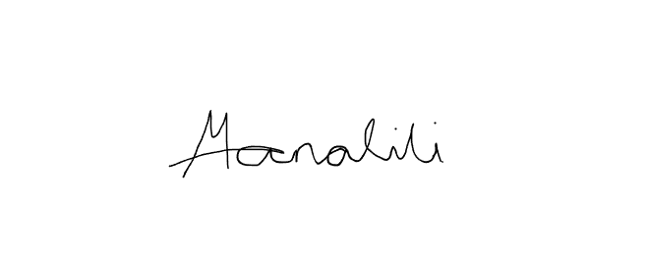    Prepared by:  Mark Arone M. Dela Cruz  Mhaku Jose M. Manalili | 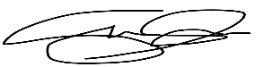  Marinel T. Carbonell  Rod Erick T. Dulalia
Checked by:  Jose Crisanto S. Austria  Thesis/Capstone Project Adviser  Date Signed: | Noted by:  Alejandro B. Burgos Jr.  Thesis/Capstone Project Coordinator  Date Signed:

