ACCOMPLISHMENT AND CONSULTATION FORM

INSTRUCTION: List all the activities, improvements, or accomplishments in your Thesis/Capstone Project Documentation and System/Prototype. This form may be reproduced as you go along with your thesis/capstone project. This form should be submitted to your Thesis/Capstone Project Adviser every week.

Thesis/Capstone Project Title: E-Chatco: An Integrated Smart-Hailing and Fleet Management Platform for the Modernized Philippine Jeepney
Week Number: 24
ACTIVITY/  ACCOMPLISHMENT | REMARKS/ COMMENTS/ SUGGESTIONS/  DELIVERABLES and DUE DATE
- Redesigned the landing page and the login page, with form accessibility fixes.
- Improved authentication performance by giving each user their own rate-limit bucket and cutting redundant auth writes and calls.

- Blocking password resets for commuters still pending approval.

- Implemented the Commuter mobile app, including account access, live tracking, fares, payments, rewards, Lost &
Found, feedback, SOS, and profile features.

- Strengthened operational workflows and resolved system-test issues across shift setup, route management, conductor
accounts, SOS, and commuter profiles.
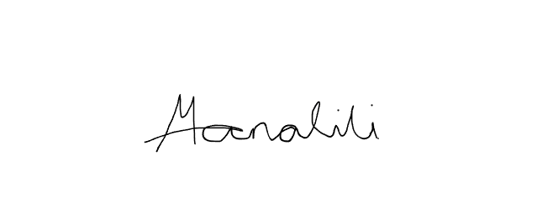    Prepared by:  Mark Arone M. Dela Cruz  Mhaku Jose M. Manalili |   Marinel T. Carbonell  Rod Erick T. Dulalia
Checked by:  Jose Crisanto S. Austria  Thesis/Capstone Project Adviser  Date Signed: | Noted by:  Alejandro B. Burgos Jr.  Thesis/Capstone Project Coordinator  Date Signed:

