ACCOMPLISHMENT AND CONSULTATION FORM

INSTRUCTION: List all the activities, improvements, or accomplishments in your Thesis/Capstone Project Documentation and System/Prototype. This form may be reproduced as you go along with your thesis/capstone project. This form should be submitted to your Thesis/Capstone Project Adviser every week.

Thesis/Capstone Project Title: E-Chatco: An Integrated Smart-Hailing and Fleet Management Platform for the Modernized Philippine Jeepney
Week Number: 27
ACTIVITY/  ACCOMPLISHMENT | REMARKS/ COMMENTS/ SUGGESTIONS/  DELIVERABLES and DUE DATE
- Added discount applications for commuters with admin review, plus an annual student discount renewal flow.

- Built voucher distribution with tracking and private update notices to commuters.

- Added a role-scoped maintenance mode that the backend enforces.

- Added verified email changes and shared profile photo uploads for commuters.

- Expanded the activity logs to record the actor's role and field-level changes, with an actor filter and export.
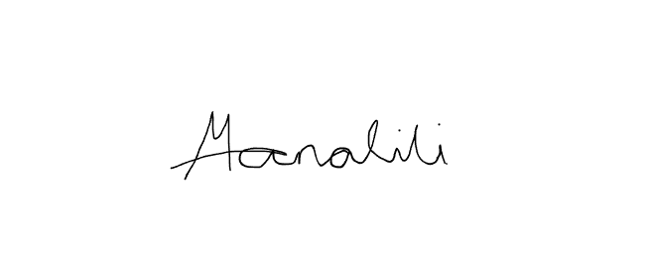    Prepared by:  Mark Arone M. Dela Cruz  Mhaku Jose M. Manalili |   Marinel T. Carbonell  Rod Erick T. Dulalia
Checked by:  Jose Crisanto S. Austria  Thesis/Capstone Project Adviser  Date Signed: | Noted by:  Alejandro B. Burgos Jr.  Thesis/Capstone Project Coordinator  Date Signed:

