ACCOMPLISHMENT AND CONSULTATION FORM

INSTRUCTION: List all the activities, improvements, or accomplishments in your Thesis/Capstone Project Documentation and System/Prototype. This form may be reproduced as you go along with your thesis/capstone project. This form should be submitted to your Thesis/Capstone Project Adviser every week.

Thesis/Capstone Project Title: E-Chatco: An Integrated Smart-Hailing and Fleet Management Platform for the Modernized Philippine Jeepney
Week Number: 28
ACTIVITY/  ACCOMPLISHMENT | REMARKS/ COMMENTS/ SUGGESTIONS/  DELIVERABLES and DUE DATE
- Added onsite commuter registration by admins with an emailed temporary password, and admin account registration. All new accounts must set a new password at first sign-in.

- Fixed the GCash payment flow regarding getting stuck on payments process and resume, voucher-covered group payments settle correctly, the QR time limit is now 2 minutes, and GCash is no longer double-counted in the conductor report.

- Grouped fare receipts into a day-by-day ledger, issued readable year-prefixed transaction IDs, and moved safety history filtering and paging to the server.

- Added profile photo cropping and in-browser image compression before upload.
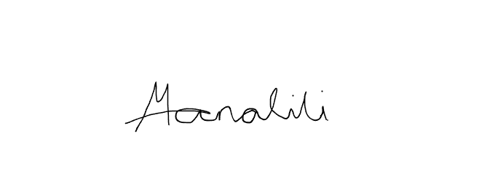    Prepared by:  Mark Arone M. Dela Cruz  Mhaku Jose M. Manalili |   Marinel T. Carbonell  Rod Erick T. Dulalia
Checked by:  Jose Crisanto S. Austria  Thesis/Capstone Project Adviser  Date Signed: | Noted by:  Alejandro B. Burgos Jr.  Thesis/Capstone Project Coordinator  Date Signed:

