ACCOMPLISHMENT AND CONSULTATION FORM

INSTRUCTION: List all the activities, improvements, or accomplishments in your Thesis/Capstone Project Documentation and System/Prototype. This form may be reproduced as you go along with your thesis/capstone project. This form should be submitted to your Thesis/Capstone Project Adviser every week.

Thesis/Capstone Project Title: E-Chatco: An Integrated Smart-Hailing and Fleet Management Platform for the Modernized Philippine Jeepney
Week Number: 30
ACTIVITY/  ACCOMPLISHMENT | REMARKS/ COMMENTS/ SUGGESTIONS/  DELIVERABLES and DUE DATE
- Adopted the cooperative fare matrix and the LTFRB fare rule, priced trips from the financial rules, and made fare changes sign conductors out and refresh commuter fare calculators.

- Added trip direction for conductors with direction-aware bus markers on the map, and hid offline units from commuters (their hails are refused).

- Made conductor sessions last-login-wins, and locked released and closed Lost & Found items from edits.

- Added a receipt QR promo toggle to the Voucher Generator, and added a sticky scroll story with real app screens to the landing page.
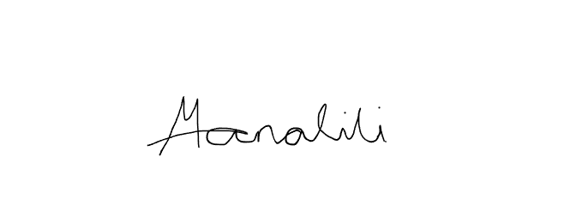    Prepared by:  Mark Arone M. Dela Cruz  Mhaku Jose M. Manalili |   Marinel T. Carbonell  Rod Erick T. Dulalia
Checked by:  Jose Crisanto S. Austria  Thesis/Capstone Project Adviser  Date Signed: | Noted by:  Alejandro B. Burgos Jr.  Thesis/Capstone Project Coordinator  Date Signed:

