ACCOMPLISHMENT AND CONSULTATION FORM

INSTRUCTION: List all the activities, improvements, or accomplishments in your Thesis/Capstone Project Documentation and System/Prototype. This form may be reproduced as you go along with your thesis/capstone project. This form should be submitted to your Thesis/Capstone Project Adviser every week.

Thesis/Capstone Project Title: E-Chatco: An Integrated Smart-Hailing and Fleet Management Platform for the Modernized Philippine Jeepney
Week Number: 25
ACTIVITY/  ACCOMPLISHMENT | REMARKS/ COMMENTS/ SUGGESTIONS/  DELIVERABLES and DUE DATE
- Added pickup schedules and no-show handling to Lost & Found, and redesigned the commuter Lost & Found screen.

- Refreshed the admin Settings layouts and loading skeletons, and added shared underline page tabs across admin pages.

- Changed conductor’s account suspension to disabling them due to overlapping of both feature and added a three-dot row actions menu in Fleet Management.
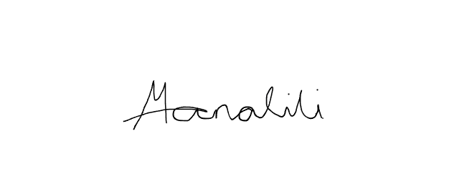    Prepared by:  Mark Arone M. Dela Cruz  Mhaku Jose M. Manalili |   Marinel T. Carbonell  Rod Erick T. Dulalia
Checked by:  Jose Crisanto S. Austria  Thesis/Capstone Project Adviser  Date Signed: | Noted by:  Alejandro B. Burgos Jr.  Thesis/Capstone Project Coordinator  Date Signed:

