

**Ahsanullah University of Science and Technology (AUST)**

**Department of Computer Science and Engineering**

**Thesis Report**

**Course No.: CSE4100**

**Course Title: Thesis**

**Submitted To- Dr. S.M.A. Al-Mamun**

**Submitted By-**

**Mahin Hossain (190204061)**

**MD Shihabul Islam Shovo (190204075)**

**MD Fardin Jaman Aranyak (190204093)**

**Md. Symum Hossain (190204105)**

**Year- 4th**

**Semester- 1st**

**Session: Fall’22**

**Subject: Gene-Disease Associations**

**Introduction:**

A gene is a specific sequence of DNA that encodes the instructions for producing a functional molecule, usually a protein. Genes are responsible for various biological functions and traits.

A disease refers to an abnormal condition or disorder that affects the normal functioning of an organism. Diseases can have genetic, environmental, or multifactorial causes.

An association indicates a relationship or connection between two or more entities. In the context of gene-disease associations, it refers to the relationship between a specific gene and a particular disease.

Gene-disease associations refer to the relationships between specific genes and human diseases. These associations provide insights into the genetic factors contributing to the development, progression, or susceptibility to various diseases. Understanding gene-disease associations is crucial for advancing biomedical research, clinical diagnostics, and personalised medicine.

**Important terms related to Gene-Disease Association:**

**Ontologies:**

->define the concepts and relationships within a specific domain.

An ontology is a technique or technology used to represent the knowledge about a domain, by modelling concepts and the relationships between them, being that these relationships describe the properties of those concepts.

Ontologies havetwo major components:

(i) a set of classes (concepts) that define the entities in a domain; and

(ii)a set of semantic links (relationships) between the classes that describe interactions between classes or properties of classes.

facilitating text mining, intelligent searching, and unambiguous identification.

**knowledge graph:**

->entities (such as genes and diseases) are represented as nodes, and the relationships between them are represented as edges.

**knowledge graph embeddings:**

->represent entities and relationships in a knowledge graph as numerical vectors in a high-dimensional space.

->enabling computational algorithms to perform various tasks, including prediction.

**Semantic Similarity:**

Semantic similarity measures quantify the degree of similarity or relatedness between two pieces of text based on their semantic content or meaning.

**One Ontology:**

Utilizing a single ontology can simplify the overall knowledge representation and management. It reduces the complexity of maintaining and aligning multiple ontologies.

**Two Ontologies:**

Domain Separation: When dealing with distinct domains or subject areas, it may be beneficial to have separate ontologies. This allows for focused representation and organization of knowledge specific to each domain.

**Disconnected Ontologies:**

Disconnected ontologies refer to separate ontologies that are developed and maintained independently, without explicit links or connections between them. Each ontology represents a specific domain or subject area, and the knowledge within each ontology is self-contained.

**Linked Ontologies:**

Linked ontologies, also known as ontology networks or ontology alignments, involve establishing explicit links or mappings between concepts and relationships across multiple ontologies.

**Genetic Variation:**

Genetic variation refers to the differences in DNA sequences among individuals or populations. Genetic variations can include single nucleotide polymorphisms (SNPs), insertions, deletions, and structural variations, which may influence susceptibility to diseases.

**Genome-Wide Association Study (GWAS):**

GWAS is a study design used to identify genetic variations associated with particular diseases or traits. It involves comparing the genomes of individuals with and without a specific condition to identify genetic markers associated with the disease.

**Disease Ontology:**

Disease ontology is a structured representation of various diseases and their relationships. It provides a standardized vocabulary and hierarchy to categorize and describe diseases, facilitating data integration and analysis.

**Genetic Database:**

Genetic databases store and organize genetic information, including gene sequences, genetic variations, and gene-disease associations. These databases serve as valuable resources for researchers and clinicians working in the field of genetics.

**Functional Annotation:**

Functional annotation involves assigning biological or functional information to genes or genetic variations. It helps in understanding the potential roles and functions of genes in different biological processes or disease mechanisms.

**Important Resources links:**

[**DisGeNET**](https://www.disgenet.org/)**: DisGeNET integrates data from expert curated repositories, GWAS catalogues, animal models and the scientific literature.**

[**BioPortal**](https://bioportal.bioontology.org/)**: the world's most comprehensive repository of biomedical ontologies.**

[**XGB**](https://xgboost.ai/)**:** is an open-source library that provides an efficient and effective implementation of the gradient boosting algorithm. Repository: [dmlc/xgboost: Scalable, Portable and Distributed Gradient Boosting (GBDT, GBRT or GBM) Library, for Python, R, Java, Scala, C++ and more. Runs on single machine, Hadoop, Spark, Dask, Flink and DataFlow (github.com)](https://github.com/dmlc/xgboost)

**Liu, W., Liu, J., and Rajapakse, J. (2018). Gene ontology enrichment improves performances of functional similarity of genes. Scientific Reports, 8. 13**

**OMIM knowledgebase**

**Uniprot**

**RDFlib library**. RDFLib contains parsers for most of the known RDF serializations, including RDF/XML (OWL)

**http://www.paccanarolab.org/cardigan.**

**https://github.com/RDFLib/rdflib;** [**https://rdflib.readthedocs.io/en/stable**](https://rdflib.readthedocs.io/en/stable)

**https://github.com/thunlp/OpenKE 5https://github.com/IBCNServices/pyRDF2Vec https://github.com/KRR-Oxford/OWL2Vec-Star https://github.com/bio-ontology-research-group/opa2vec**

**https://github.com/liseda-lab/SSMC**

**Our Readings:**

**Here is the title of some known thesis paper:**

**1)Thesis Paper Title: Predicting Gene-Disease Associations with knowledge graph embeddings over multiple ontologies.**

**2)Thesis Paper Title: Disease gene prediction for molecularly uncharacterized diseases.**

**3)Thesis Paper Title:Identifying disease genes by integrating multiple data sources.**

**4)Thesis Paper Title: Recent advances in predicting gene–disease associations.**

**5)Thesis Paper Title: Identifying Disease-Gene Associations With Graph-Regularized Manifold Learning.**

The above mentioned titles are some thesis papers published by scientists and researchers who are experienced in their field. We have read these papers and gathered some information which we think will be helpful in our research. We chose these papers as all these are about gene-disease associations which are very related to our thesis.

**Summary of the thesis papers:**

**1)Thesis Paper: Predicting Gene-Disease Associations with knowledge graph embeddings over multiple ontologies.**

**Abstract:**

Our approach integrates different methods for building the shared semantic space, as well as multiple knowledge graph embedding algorithms and machine learning methods.

The prediction performance was evaluated on curated gene-disease associations from DisGeNET and compared to classical semantic similarity measures.

**Objective:**

The main goal of this work is to investigate approaches to predict gene-disease associations that explore the semantic richness of knowledge graphs.The work tackles semantic richness from different perspectives: semantic similarity vs. knowledge graph embeddings; one ontology vs. two ontologies; disconnected ontologies vs. linked ontologies.

**The work aims to answer three research questions:**

1. **RQ1**: What are the advantages of knowledge graph embedding over semantic similarity measures as a representation strategy?

2. **RQ2**: How can different knowledge graph embedding approaches be computed over multiple biomedical ontologies to represent both genes and diseases as vectors?

3. **RQ3**: What is the impact of employing multiple ontologies and having logical links between them?

**Machine Learning:**

The main learning task is to learn a mapping from this feature vector to an output prediction of some form (Nickel et al., 2016a). The algorithms can be divided into supervised and unsupervised learning algorithms.

**Supervised Learning:**

Supervised learning can be divided further into two categories of problem:

1. **Classification**: Common classification algorithms are linear classifiers, support vector machines, decision trees, k-nearest neighbour, and random forest, etc.
2. **Regression**: It is used for the prediction of continuous variables. Linear regression, logistical regression, and polynomial regression are popular regression algorithms.

In this work, we focused on four different supervised learning algorithms:

* Random Forest (RF) (Breiman, 2001),
* Gradient Boosting (Chen and Guestrin, 2016),
* Na¨ıve Bayes (NB) (Friedman et al., 1997), and
* Multi-Layer Perceptron (MLP) (Rumelhart et al., 1986).

**Gene-Disease Prediction:**

We categorize them into two types of approaches: those that do not employ ontologies, and those that do.

1. Non Ontology-Based approaches

2.Ontology-Based approaches

**Methodology:**

The methodology proposed in this work can be divided into four main steps as depicted in Figure 4.1. The first step in the approach is to integrate the different ontologies and annotation data to build the knowledge graph. In a second step, the embeddings that represent the gene and the disease according to their annotations in different knowledge graphs are created. In a third step, these embeddings are combined using different vector operators producing a representation of genes and diseases in what is effectively a shared semantic space. Finally, in a fourth step, supervised learning algorithms are trained over the combined embeddings to predict gene-disease associations. This approach is evaluated against non-machine learning approaches based on classical semantic similarity measures (baseline) and knowledge graph embedding similarity.

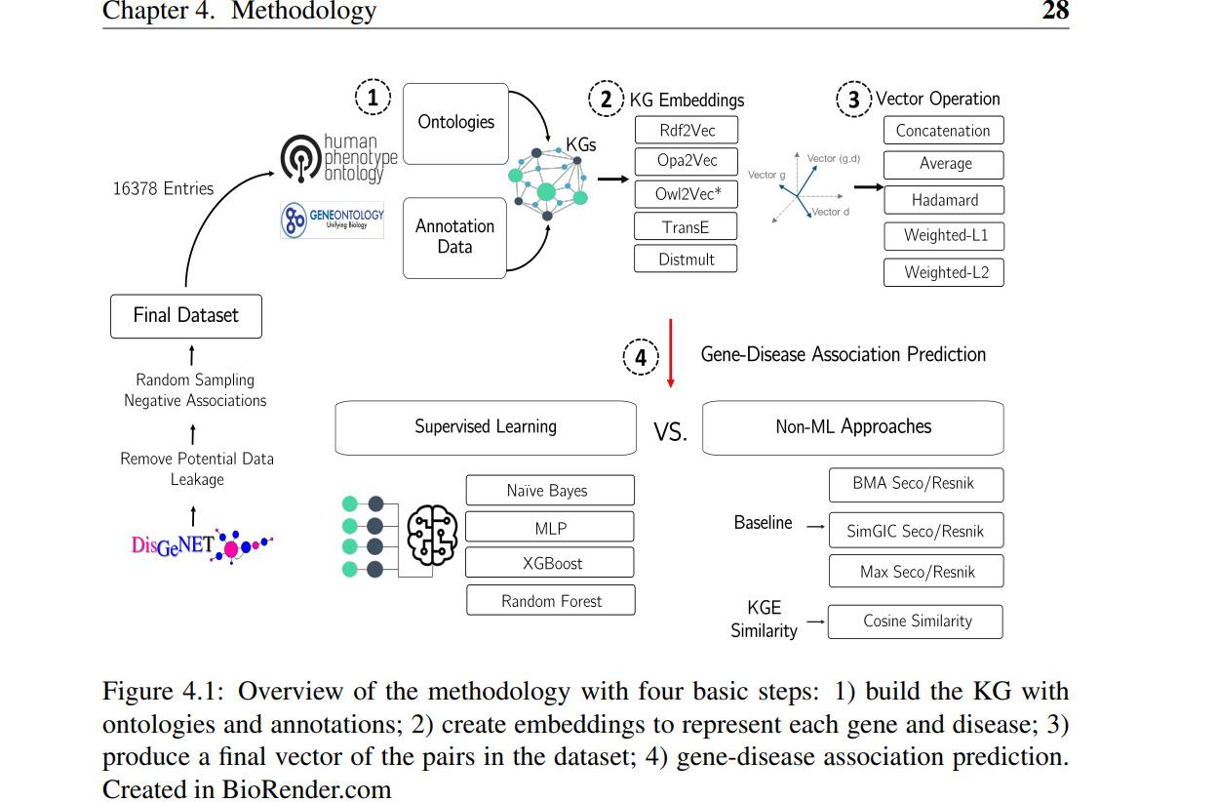

**Ontologies and Knowledge Graphs:**

Two of the most popular biomedical ontologies were chosen: Human Phenotype Ontology and Gene Ontology.

1 https://hpo.jax.org/app/

2 http://geneontology.org/

**Knowledge Graph Integration:**

A first step was to merge the Human Phenotype Ontology and Gene Ontology through a common virtual root and save into an **OWL file.**This was achieved by using the **RDFlib library.**

**Knowledge Graph Embeddings and Representation:**

Three types of popular knowledge graph embedding approaches (AppendixA for default parameters):

• Translational Distance: TransE4 (Bordes et al., 2013) with default parameters;

• Semantic Matching: DistMult4 (Yang et al., 2015) with default parameters;

• Path-based: (i)Random Walk , (ii) Non-Random Walk

**Gene-Disease Prediction:**

We used **four** different machine learning algorithms: **RF** (Breiman, 2001), **XGB** (Chen and Guestrin, 2016), **NB** (Friedman et al., 1997) and **MLP** (Rumelhart et al., 1986).

**Baseline and Experiments:**

The **six state-of-the-art** semantic similarity measures used: BMAResnik, BMASeco, MaxResnik, MaxSeco, simGICResnik, and simGICSeco. These six measures are representative of the most successful approaches for the baseline calculation using a single ontology.

**Results and Discussion:**

There are three important aspects that need to be considered when elucidating the performance impact:

1. How can we combine the gene and disease vector?

2. Which knowledge graph embedding methods are more suitable for this task?

3. What is the impact of considering more than one ontology?

First, the results for the gene-disease prediction baseline established using semantic similarity measures are described. Then, the results obtained using a rich semantic representation with different embeddings methods, knowledge graphs, and machine learning techniques are presented and compared to the best semantic similarity measure that the baseline achieved as well as the calculated cosine similarity for each knowledge graph embedding.

**Baseline Performance :**

Concerning the performance of the six semantic similarity measures in terms of information content for WAF score with a single ontology, we observe that the Max approach is more sensitive to the IC measure employed.

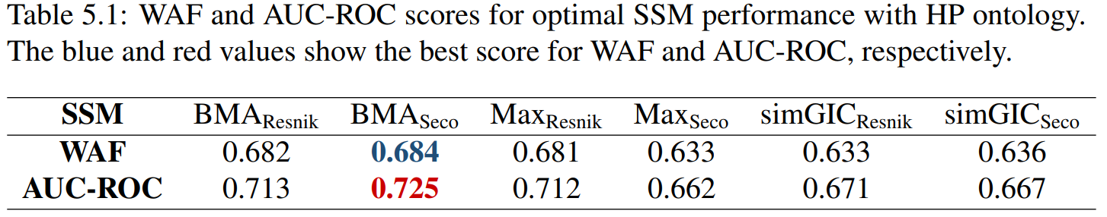

The pairwise approach followed by BMA achieves the best results with a top WAF of 0.684 and AUC-ROC of 0.725 when combined with ICSeco.

**Comparison:**

**Rich Semantic Representations Performance**

**Comparison of Vector Combination Approaches**

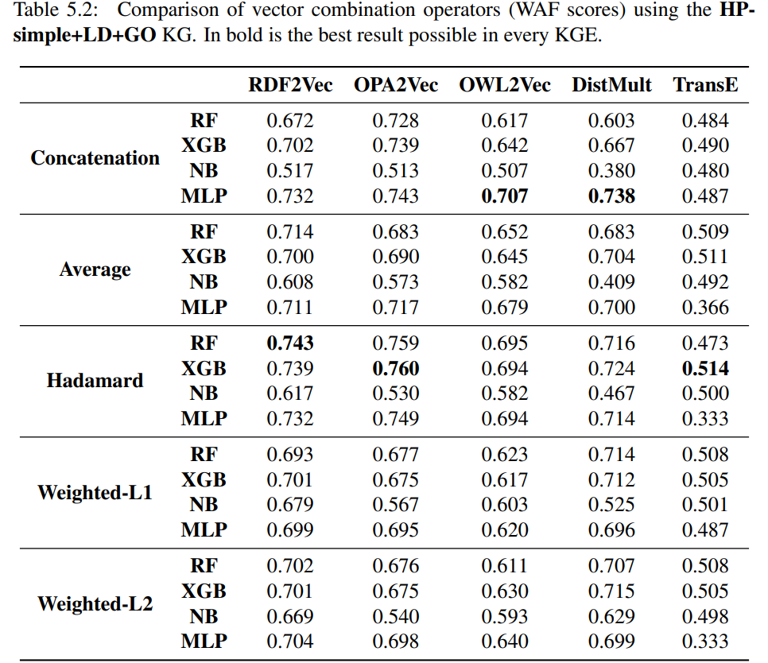

**Comparison of Knowledge Graph Embedding Methods:**

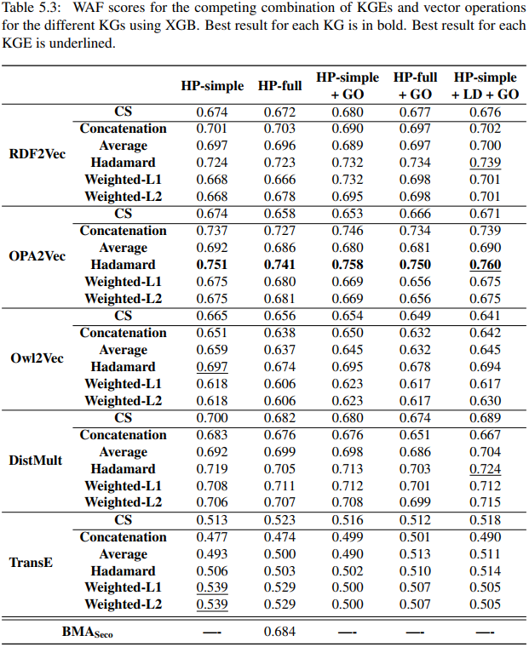

**Comparison of different Knowledge Graphs**

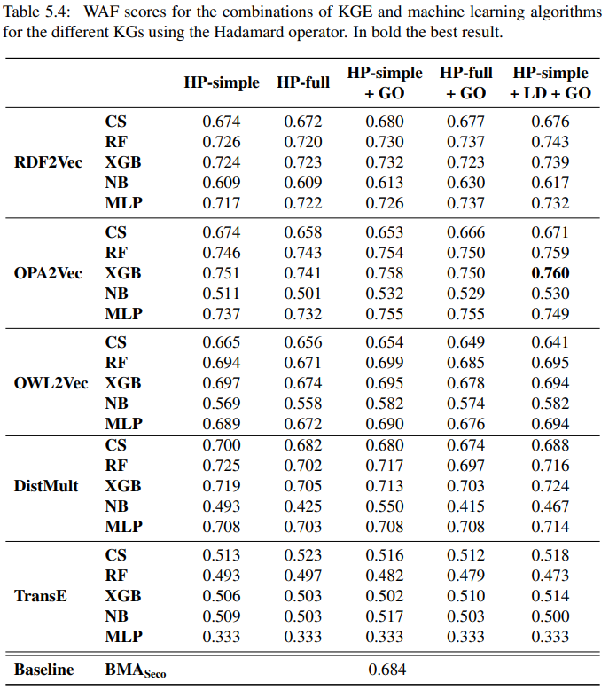

**A case study on gene BACH2 and KPD disease:**

This example illustrates the limitations of semantic similarity-based approaches in handling complex diseases which are related to more than one gene, and genes related to more than one disease. On one hand, a single score view coupled with a simple prediction approach based on a similarity threshold can fail to identify the association between a gene and a disease with few closely related annotations when using a measure such as BMA that considers all annotations. On the other, the Max approach is less suitable when several annotations support a prediction. Moreover, machine learning models coupled with embeddings afford the formulation of a more complex solution.

**Conclusions:**

The impact of different approaches to build a shared rich semantic representation for genes and diseases was investigated, as well as multiple knowledge graph embedding methods such as RDF2Vec and OPA2Vec. An unbiased benchmark dataset was created to support evaluation, ensuring its appropriateness for gene-disease prediction.

The experiments provided answers to the research questions. Namely, they showed that knowledge graph embeddings when coupled with machine learning algorithms achieve a better performance than semantic similarity measures, answering RQ. They also illustrated that some vector combination approaches support gene disease association prediction better, but that a simple cosine similarity between vectors can support predictions as well as semantic similarity, answering RQ2. Finally, the experiments also revealed that differences between using a single ontology or combining two ontologies are comparatively small regardless of a richer integration using the logical definitions, answering RQ3.

However, there is a clear advantage for most knowledge graph embeddings methods to employ graph versions where logical definitions are encoded as direct links between classes. We hypothesize that the information provided by the Gene Ontology and links to it does not provide substantial additional information comparing with what is already present in the Human Phenotype Ontology.

**2)Thesis Paper: Disease gene prediction for molecularly uncharacterized diseases.**

**Abstract:**

a novel network approach to prioritize gene-disease associations that is able to also predict genes for diseases with no known molecular basis. Our method, which we have called **Cardigan** (ChARting DIsease Gene AssociatioNs).

We evaluated its performance at predicting genes for both **molecularly characterized** and **uncharacterized diseases** in **OMIM**, using both weighted and binary interactomes, and compared it with state-of-the-art methods. Our tests, which use datasets collected at different points in time to replicate the dynamics of the disease gene discovery process, prove that **Cardigan** is able to **accurately predict** disease genes for molecularly uncharacterized diseases.

**Introduction:**

In this paper, we present a **disease gene prediction** method that predicts disease genes for both **charted and uncharted diseases** in **OMIM**, and can also predict disease modules. Our approach, which we have called **Cardigan** (ChARting DIsease Gene AssociatioNs), is based on a semi-supervised algorithm that propagates labels on the interactome. These labels integrate disease phenotypic information expressed as a similarity measure between diseases, which is obtained by **mining and comparing** **sets of MeSH terms** relevant for the diseases.

**The Cardigan algorithm:**

To predict disease genes for a given disease **(query disease)**, Cardigan begins by calculating its **phenotypic similarity** to **every other disease** in **OMIM.**

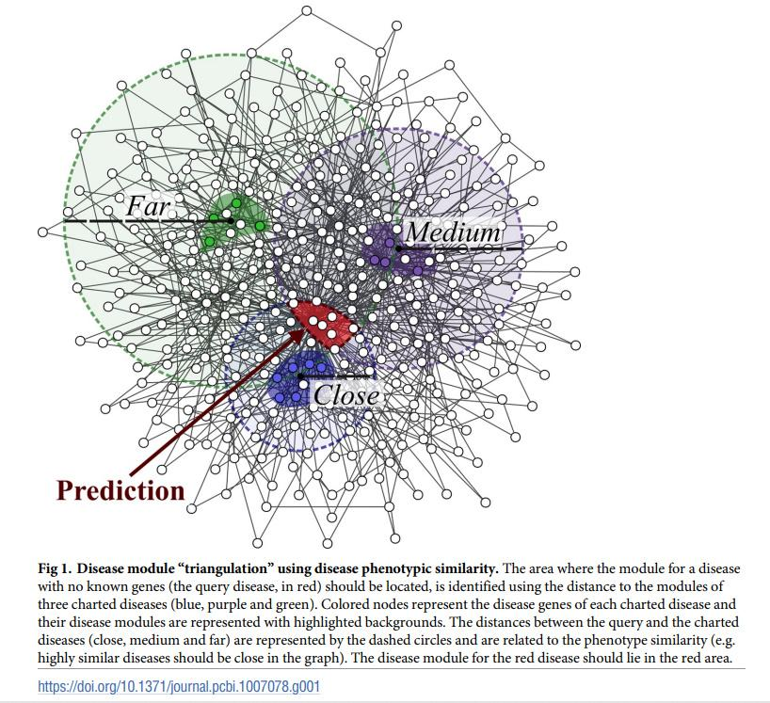

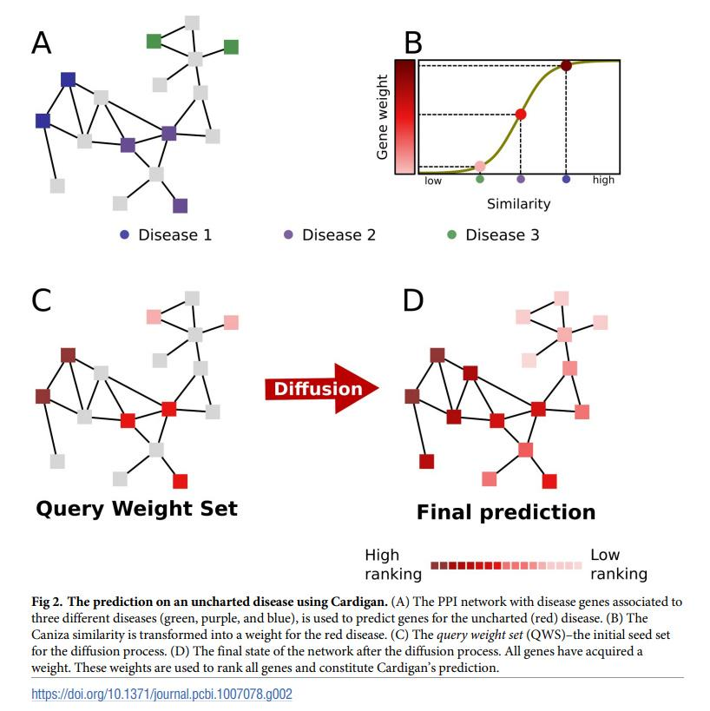

**Performance evaluation:**

We compared the performance of **Cardigan** against **PRINCE, ProDiGe1, ProDiGe4 and DIAMOnD** at predicting disease genes for OMIM diseases (these algorithms are described in the Methods section). PRINCE and Cardigan were run using both binary protein-protein interaction networks (HPRD [38], BioGRID [39], DiamondNet [34]) as well as weighted networks (HIPPIE [40] and FUNCOUP [41]), while ProDiGe1, ProDiGe4 and DIAMOnD can run only on binary networks (see Methods for details).

**Performance on uncharted diseases:**

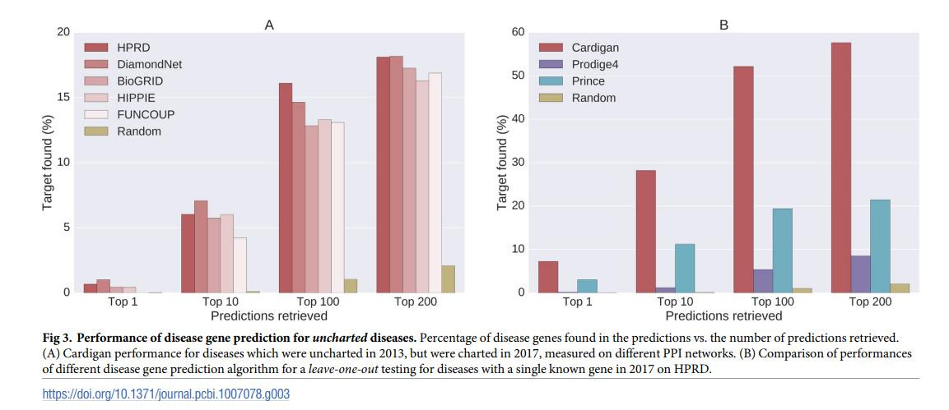

**Performance on charted diseases:**

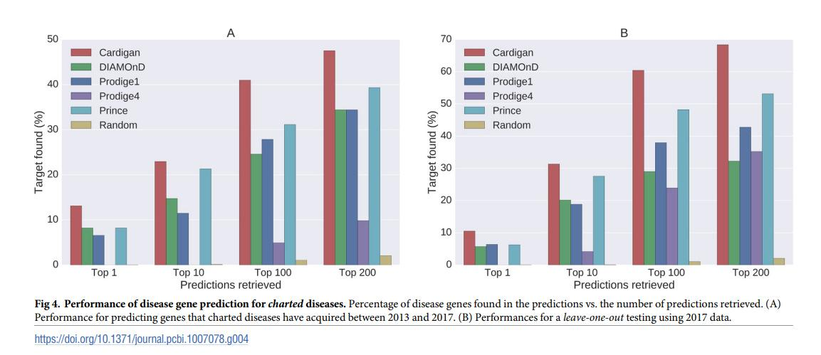

**Discussion:**

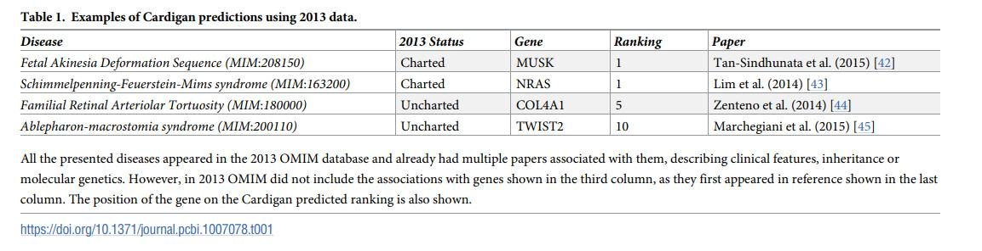

**Methods:**

**1.Disease data:**

Our experiments were carried out using disease data from the **OMIM database**.We also used **the Ghiassian et al. diseases** module dataset.

**2.Protein-protein interaction networks:**

we performed our tests using different types of protein interaction networks including **weighted and binary networks** with both experimental and predicted data: HPRD [48], DiamondNet [34] and BioGRID [39] are binary experimental networks; HIPPIE [49] is a weighted experimental network; **FUNCOUP** is a large weighted network including both experimental and predicted data.

**3.Other prediction methods;**

We compared **Cardigan** to four methods: **ProDiGe1, ProDiGe4[20], PRINCE** [19] and **DIAMOnD** [34]. These were chosen because they are state-of-the-art representatives of the disease gene prediction methods and of the disease module prediction methods described earlier.

**4.The Caniza similarity:**

**Caniza** et al. [36] recently proposed a measure to quantify the phenotypical similarity between hereditary diseases. Their method begins by collecting, for each disease, the **set of MeSH terms** assigned to the scientific publications relevant for that disease.

**Implementation;**

Our method is available as a fast, industrial strength library for **Python 2.7** which implements sparse matrices and lazy loading for disease similarities to reduce the memory footprint. The code is publicly available from the paper website at **http://www.paccanarolab.org/cardigan.**

**3)Thesis Paper:Identifying disease genes by integrating multiple data sources.**

**Abstract:**

Results: In this paper, we propose a multiple data integration method based on the theory of Markov random field (MRF) and the method of Bayesian analysis for identifying human disease genes.

**Background:**

Here the author mentioned some techniques that were proposed or developed by many scientists to predict gene-disease associations. E.g. Wu et al. [5] develop a tool called **CIPHER** to predict disease genes based on a global concordance between a PPI network and a phenotype network.

In this paper, we introduce a multiple data integration method for disease gene identifications, which considers comprehensive characters of a set of heterogeneous datasets to capture the complex relationship between genotypes and phenotypes. The method is based on the theory of MRF and the method of Bayesian analysis. Two previous algorithms of Deng et al. [30] and Ma et al. Their method cannot be directly employed to identify human disease genes. It is not clear how to integrate more kinds of biological data by using their method. In paper [32], we have developed a basic modified MRF model for human disease gene prioritization. In this study, we will further improve it by introducing a new parameter estimation strategy and a new Gibbs sampling strategy. The improved MRF algorithm is not only stable in terms of parameter estimation, but also reliable in terms of its prediction accuracy.

**Methods:**

In this paper, we first briefly describe how the problem is formulated as a Bayesian labelling problem. The labelling configuration assumes to follow a Gibbs distribution. After that, a MRF model is introduced to solve this problem by integrating multiple kinds of biological data, including known gene-disease associations, protein complexes, PPIs, pathways and gene expression profiles.

In this section the authors described **The Bayesian labelling problem** and **Gibbs distribution in MRF.**

**The MRF model for identifying human disease genes**

Suppose human genome consists of a set of N genes G = {g1, g2, ..., gN}. Some of them are already known to be associated with genetic diseases, while associations of most other genes are still not known.

**The Gibbs sampling**

The Gibbs distribution (14) gives a prior probability distribution of the configuration for all genes. In the study of identifying human disease genes, the objective is to find the posterior probability of X1, X2, · · ·, Xn conditional on known disease genes.

**Parameter estimation**

In practice, we do not know parameters of the model and they need to be estimated according to those known informations.The step-by-step description of this procedure is given in this section.

**Estimating a prior probability**

Now, the only problem left is to estimate the prior probability of πi. Similarly as the method used in Deng et al. [30], we also estimate them according to known protein complexes. Since genes that encode proteins in a same complex tend to associated with similar diseases.

**Data sources:**

The gene-disease association data are obtained from Goh et al. These data are originally collected from the Morbid Map list of the Online Mendelian Inheritance in Man (OMIM) [38]. In this study, we consider only those disease classes that consist of at least 30 genes.

The protein complex data are collected from the database of CORUM [39] and PCDq.

The PPI datasets are derived from the database of HPRD (Release 9) [9], BioGrid (Release 3.2.108) [10] and IntAct (downloaded on Jan 26, 2014) [11], respectively. Duplicated edges between the same pair of vertices and edges connecting to itself are deleted.

The pathway datasets are obtained from the database of KEGG [12], Reactome [13], PharmGKB.

The human gene expression profiles are obtained from BioGPS (GSE1133) [16,17], which contain 79 human tissues in duplicates, measured using the Affymetrix U133A array.

Hence, five biological networks are constructed by collecting data from various databases.

**Validation method and evaluation criteria:**

The accuracy of predictions is validated by the leaveoneout method. For each known disease gene with at least one annotated interaction partner in a biological network, we assume it is an unknown gene and predict its posterior probability by our proposed methods.

**Decision score and declaration of positives:**

One can directly use the posterior probabilities obtained by the Gibbs sampling to select candidate disease genes. The greater the probability is for a gene, the more likely it is to associated with specific disease. We propose to use a percentage as a decision score to generate the finial predictions. All the ROC curves and the AUC scores of our “IMRF1“ and “IMRF2“ method are calculated according to the decision score hereafter.

**Results and discussion:**

Firstly, since ideas of our improved methods (IMRF1 and IMRF2) are initially inspired by the MRF-Deng method, the direct comparison illustrates how much improvement can be made results from our methods.

Secondly, we compare our methods with the RWR algorithm to show which manner of multiple data integration is better. The RWR algorithm is a typical data integration method that uses a mixed network, where vertices and edges of several biological networks are simply merged together, while our methods integrate different networks separately.

Finally, the DIR algorithm has a very good performance among multiple data integration methods, which also integrates different networks separately. It is the same with our methods in terms of the data integration method.

**Stability and reliability of MRF methods:**

We first investigate the stability and reliability MRF methods, by analyzing Markov processes of the IMRF1 method and the MRF-Deng method.

However, for disease gene identifications, only dozens of disease genes are available for individual disease classes. The estimated parameters of the MRF-Deng method becomes unreliable. stabilized Markov processes and parameters do not indicate they converge to expected results. It seems the performance of the MRF-Deng method is better.

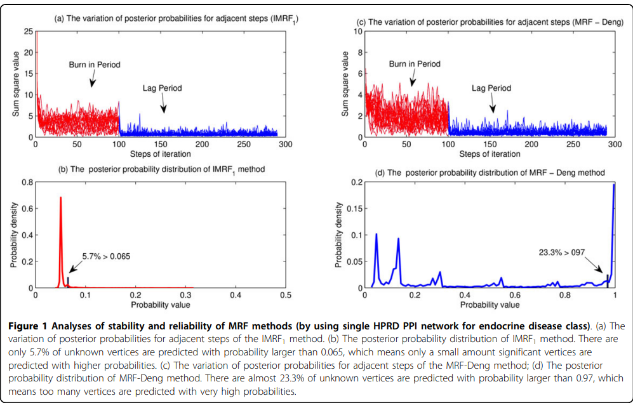

**Comparisons with the MRF-Deng method:**

Our improved methods are significantly better than the MRF-Deng method in terms of identifying disease genes. Predictions of the IMRF1 method is significantly better than that by using the MRF-Deng method, but is a little worse than the IMRF2 method.

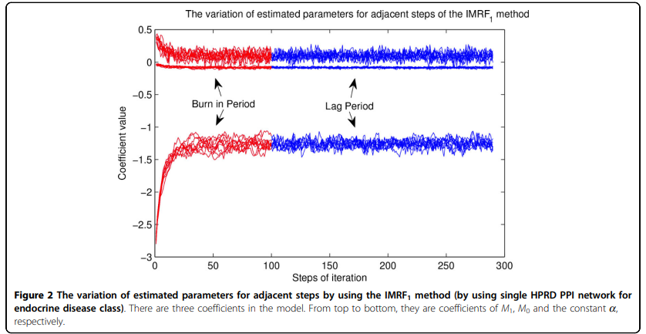

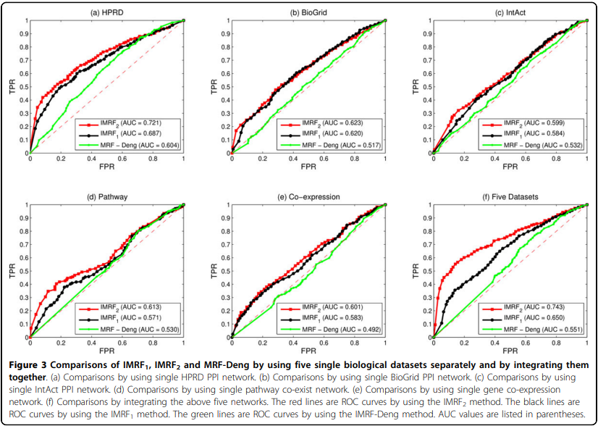

**Integration of heterogeneous data sources:**

An inappropriate method may result in a set of worse predictions than using only single dataset. Generally, various data integration methods can be divided into two categories: (1) by using a mixed network and (2) by using several separated networks. One advantage of the MRF model is that it takes the whole network into consideration, which potentially yields better performance than those using mixed network ones.

The separated network method achieves the best performance among all predictions, while the mixed network method achieves only modest performance.

**Comparisons by using multiple data sources:**

The IMRF2 method is compared with the RWR algorithm, the DIR algorithm and the MRF-Deng algorithm respectively.

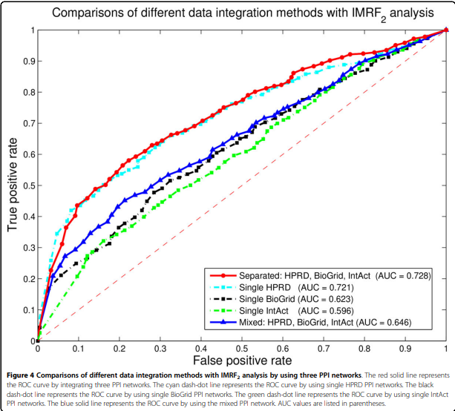

The IMRF2 method achieves the highest AUC score at 0.743, followed by the DIR algorithm (AUC = 0.691) and the RWR algorithm (AUC = 0.676). The MRF-Deng method achieves the AUC score only at 0.551. It also shows that the separated network interaction method performs better than the mixed

network RWR method.

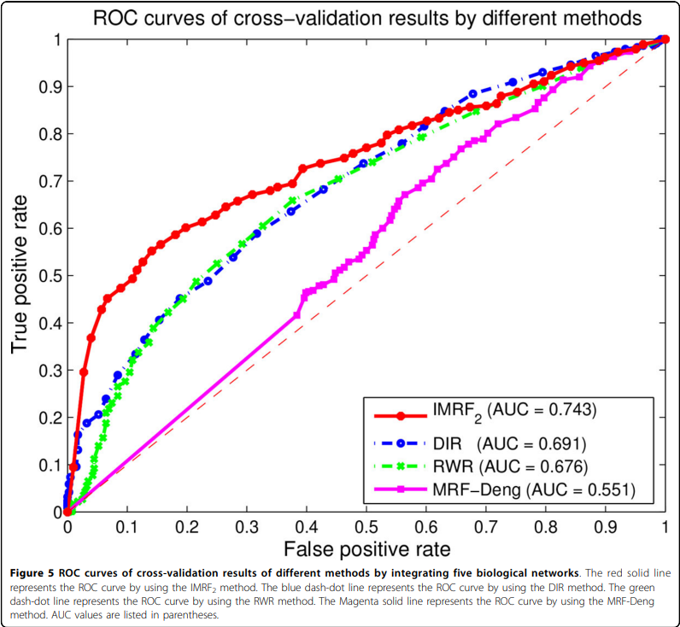

**Conclusions:**

In this paper, we have presented an improved multiple data integration method for prioritizing human disease genes, which is based on the theory of MRF and the method of Bayesian analysis. Compared to the MRF-Deng method [30], two strategies have been developed to significantly improve the performance of the MRF method for disease gene identifications.

Predictions when integrating known gene-disease associations, protein complexes, PPIs, pathways and gene expression profiles achieve the AUC score of 0.743, which is better than the RWR method and the DIR method by using the same datasets.

**4)Thesis Paper: Recent advances in predicting gene–disease associations.**

**Abstract:**

Deciphering gene–disease association is a crucial step in designing therapeutic strategies against diseases.There are experimental methods for identifying gene–disease associations, such as genome-wide association studies and linkage analysis, but these can be expensive and time consuming.As a result, various in silico methods for predicting associations from these and other data have been developed using different approaches.

**Introduction:**

Aberrations in certain genes have been observed to either predispose individuals to disease or be directly responsible for the development of a disease phenotype, as in the case of Huntington’s disease1 and sickle cell disease2 . Deciphering the link.

between genes and diseases is an open problem in biomedical sciences, here we are describing only the links or associations between genes and disease rather than suggesting causality, as the issue of causality is still under debate

Experimental methods for gene–disease association, such as linkage studies3 , genome-wide association studies (GWAS)4 , and RNA interference screens5 , are expensive and time consuming to run

**Genome variation**

GWAS and genetic linkage studies3 are the main methods used for identifying variations across the genomes of individuals and associating these with diseases or phenotypes. The idea behind GWAS is to establish whether there is a significant genetic variation between case and control populations for a given phenotype under investigation. The most common type of variation studied for diseases is the variation at a single nucleotide position, otherwise known as the single nucleotide polymorphism (SNP), although other types of variation such as copy number or chromosomal rearrangements have also been linked to many diseases. GWAS identify marker SNPs that are associated with the phenotype/trait under investigation. Once the marker SNPs have been identified, the next challenge is to determine how the variants are responsible for the phenotypes. This entails finding the location of the SNPs in relation to genes and, if associated with a gene, then identifying the pathways the gene is involved in. Genetic linkage studies, on the other hand, identify linked regions on the genomes of related

**Crowdsourcing**

Crowdsourcing refers to the act of delegating a job traditionally assigned to a dedicated agent (usually an employee) to a large group of people in the form of an open call32. The immense quantity of data that biomedical scientists need to deal with today has prompted the search for innovative ways of solving scientific problems. The following qualities identify suitable candidates for crowdsourcing solutions: 1) Few individuals with rare abilities could solve the problem. It is sometimes difficult to harness all the necessary skills for a particular task in one organization or through traditional ways of collaboration. 2) The problems are simple tasks that require human intelligence, e.g. annotating images. 3) The problems can be broken into tasks with definite endpoints. The possibility of breaking jobs into smaller tasks translates to the possibility of sharing the incentives with a larger group of people and, in essence, simplifying the problem

**Text mining**

The bulk of scientific knowledge is still kept in textual format, although the availability of these data in scientific databases is also growing exponentially. For instance, Burger et al. 22 estimate that articles about gene–disease associations that are deposited in public databases grow at the rate of about 10,000 papers per year (approximately one paper every hour of every day). As a result, there is an increasing need to find better and faster ways of retrieving and processing knowledge from scientific databases. Databases that are manually curated by experts provide highquality data, albeit at a very slow pace, so text mining algorithms are now being used to automate some manual processes.

**Networks and semantic similarity-based algorithms**

Network algorithms rely on the premise that phenotypically similar diseases are caused by genes that are functionally related40. The idea is to find a set of genes that are already linked to the disease or phenotype in question and then find genes that are functionally related to that set. Many examples of network-based methods have been reviewed in Piro & Cunto6 and two are mentioned below. HeteSim41 integrates heterogeneous networks of protein–protein interaction (PPI), gene–phenotype association, and phenotype–phenotype similarity to prioritise novel gene– phenotype associations. Natarajan & Dhillon42 formulate the gene–disease association problem in a similar way to a recommendation problem in which the players are genes as the “recommenders”, and diseases are the “items” that they recommend or “prefer”. The goal is to identify which diseases a given set of genes would prefer given a set of observed preferences provided as biological entities

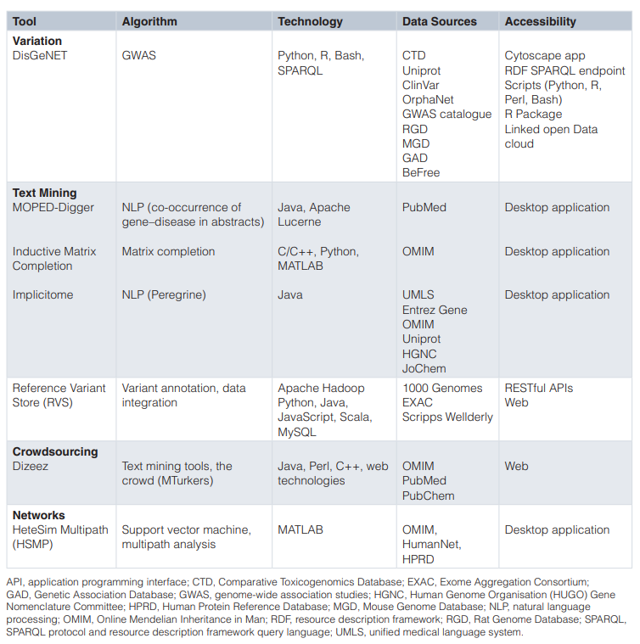

**5)Thesis Paper: Identifying Disease-Gene Associations With Graph- Regularized Manifold Learning.**

Complex diseases are known to be associated with disease genes.

A manifold learning-based method is proposed for predicting disease-gene associations by assuming that the geodesic distance between any disease and its associated genes should be shorter than that of other non-associated disease-gene pairs.

In the 3-fold cross-validation experiments, our method achieves scores of 0.882 and 0.854 in terms of the area under of the receiver operating characteristic (ROC) curve (AUC) for diseases with more than one known associated genes and diseases with only one known associated gene, respectively. Further de novo studies on Lung Cancer and Bladder Cancer also show that our model is capable of identifying new disease-gene associations.

**Introduction:**

Identifying disease-gene associations is of critical importance since it helps us unravel the mechanisms of diseases, which has many applications such as diagnosis, treatment and prevention of disease.

Computational methods that translate the experimental data into legible disease-gene associations are necessary for in-depth experimental validation.

Currently, many algorithms have been developed to predict disease-gene associations, and they can be briefly divided into two categories: **the machine learning-based methods** and **the network-based methods**

**The typical machine learning-based methods**

Extract gene-related features and train models that can discriminate disease genes and passenger genes. these algorithms are usually single-task algorithms which once can only predict disease genes for a specific disease.

**Matrix completion methods**, as a type of machine learning methods, can solve the above two issues by jointly predicting **diseasegene** associations and leveraging the similarities among diseases during the calculation (Natarajan and Dhillon, 2014; Zeng et al., 2017)

**Networkbased methods** are based on the assumption that genes close related in the network are associated with the same diseases. Centrality indices, random walk and network energy are used in many methods to predict disease-gene associationss (Köhler et al., 2008; Vanunu et al., 2010; Chen et al., 2014a,b)

y, we propose a manifold learning-based method (**dgManifold**) to predict disease-gene associations.

In our dgManifold, genes and diseases are regarded as points in the same high-dimensional Euclidean space

In this study, we propose a manifold learning-based method (**dgManifold**) to predict disease-gene associations.

**MATERIALS AND METHODS**

1. General Model
2. Similarity Network
3. Gene Similarity
4. Disease Similarity

**RESULTS:**

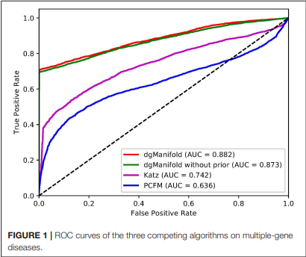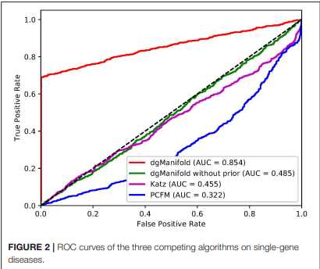

**Conclusion:**

In this study, we have proposed dgManifold to predict diseasegene associations with manifold learning. Our dgManifold assumes that the distance between diseases and their associated genes should be shorter than that of other non-associated diseasegene pairs and maps the diseases and genes into a lower dimensional manifold based on known disease-gene associations, disease similarity and gene similarity.