National Textile University, Faisalabad


Department of Computer Science
Name: | Arooj Fatima
Class: | BSCS-5th (A)
Registration No: | 24-NTU-CS-FL-1018
Lab: | 06 and 07
Course Name: | WAD
Submitted To: | Sir Zahid Javed / Sir Abdul Basit
Submission Date: | 25-10-2026

CSS Forms:-
Question no. 01:-
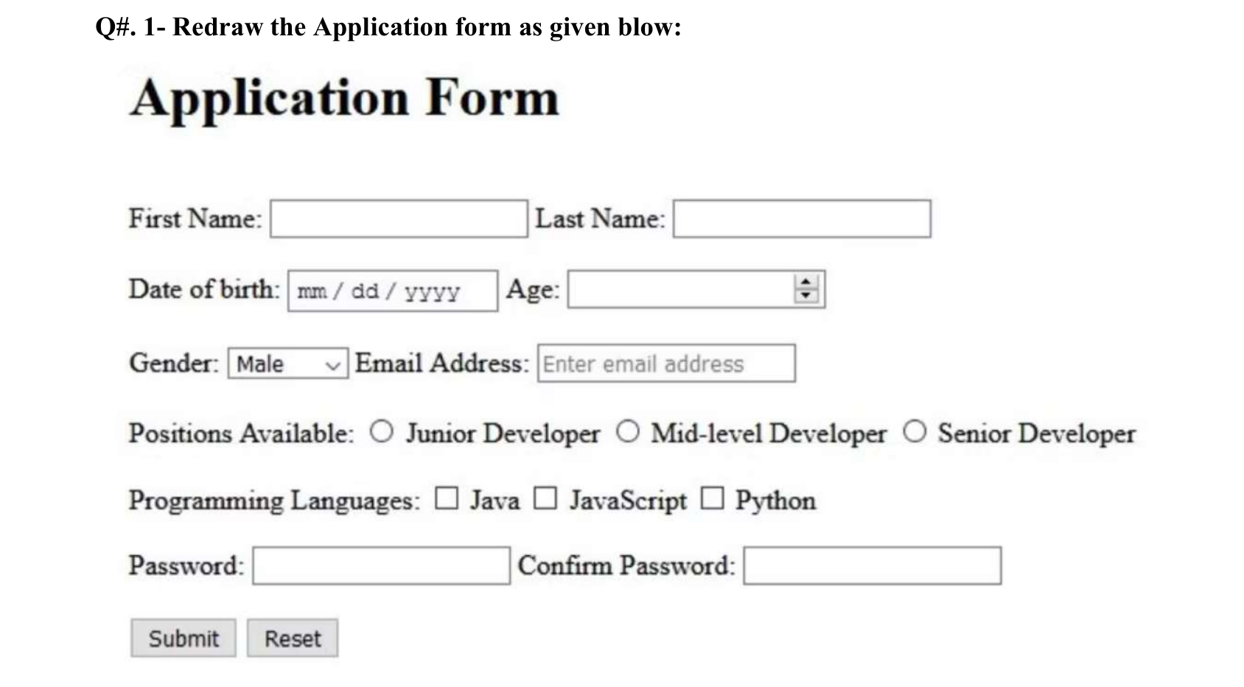
Code:-
<!DOCTYPE html>
<html><head><meta charset="UTF-8"><title>Q1 Application Form</title>
<style>body{font-family:"Times New Roman",serif;margin:30px}h1{font-size:40px}p{margin:22px 0}</style></head>
<body>
<h1>Application Form</h1>
<form>
<p>First Name: <input type="text" name="fname" size="20"> Last Name: <input type="text" name="lname" size="20"></p>
<p>Date of birth: <input type="date" name="dob"> Age: <input type="number" name="age"></p>
<p>Gender: <select name="gender"><option>Male</option><option>Female</option></select>
Email Address: <input type="email" name="email" placeholder="Enter email address"></p>
<p>Positions Available:
<input type="radio" name="pos" value="junior"> Junior Developer
<input type="radio" name="pos" value="mid"> Mid-level Developer
<input type="radio" name="pos" value="senior"> Senior Developer</p>
<p>Programming Languages:
<input type="checkbox" name="lang" value="java"> Java
<input type="checkbox" name="lang" value="js"> JavaScript
<input type="checkbox" name="lang" value="py"> Python</p>
<p>Password: <input type="password" name="pass"> Confirm Password: <input type="password" name="cpass"></p>
<p><input type="submit" value="Submit"> <input type="reset" value="Reset"></p>
</form></body></html>

Output:-

Question no. 02:-
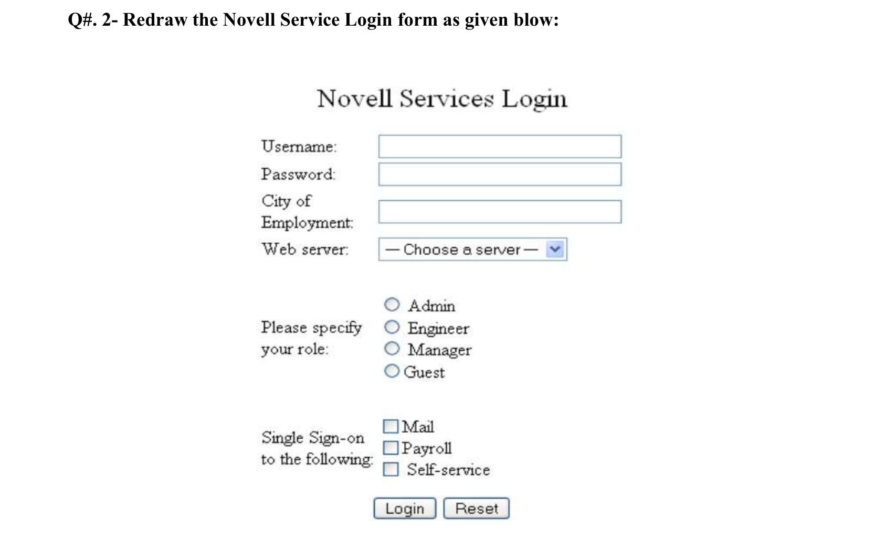
Code:-
<!DOCTYPE html>
<html><head><meta charset="UTF-8"><title>Q2 Novell Services Login</title>
<style>body{font-family:Georgia,serif;font-size:14px;color:#333}h2{text-align:center;font-weight:normal}
table{margin:auto}td{padding:2px 4px;vertical-align:middle}input[type=text],input[type=password]{width:230px}</style></head>
<body>
<h2>Novell Services Login</h2>
<form><table>
<tr><td>Username:</td><td><input type="text" name="user"></td></tr>
<tr><td>Password:</td><td><input type="password" name="pass"></td></tr>
<tr><td>City of Employment:</td><td><input type="text" name="city"></td></tr>
<tr><td>Web server:</td><td><select name="server"><option>--- Choose a server ---</option><option>Apache</option><option>IIS</option></select></td></tr>
<tr><td>Please specify your role:</td><td>
<input type="radio" name="role" value="admin"> Admin<br><input type="radio" name="role" value="eng"> Engineer<br>
<input type="radio" name="role" value="mgr"> Manager<br><input type="radio" name="role" value="guest"> Guest</td></tr>
<tr><td>Single Sign-on to the following:</td><td>
<input type="checkbox" name="sso" value="mail"> Mail<br><input type="checkbox" name="sso" value="pay"> Payroll<br>
<input type="checkbox" name="sso" value="self"> Self-service</td></tr>
<tr><td></td><td><input type="submit" value="Login"> <input type="reset" value="Reset"></td></tr>
</table></form></body></html>

Output:-

Question no. 03:-
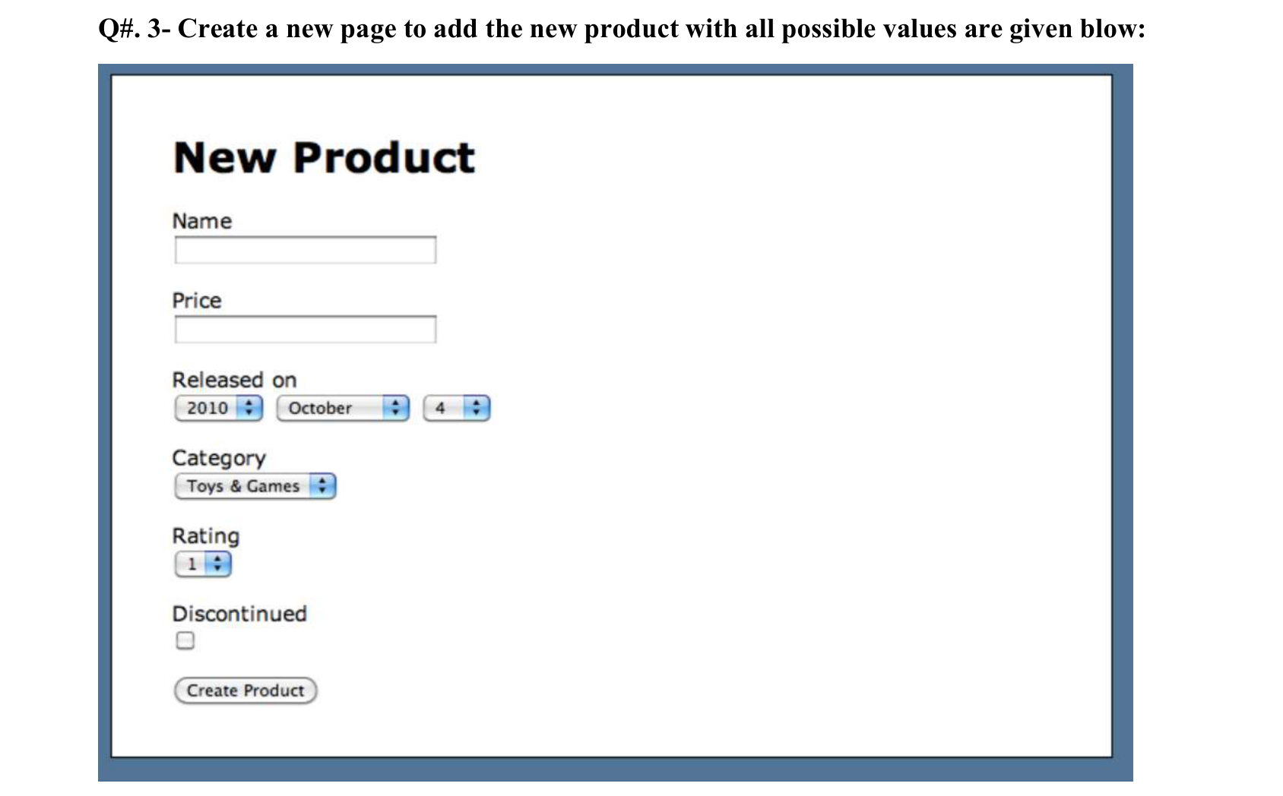
Code:-
<!DOCTYPE html>
<html><head><meta charset="UTF-8"><title>Q3 New Product</title>
<style>body{background:#5878a0;font-family:Verdana,sans-serif;margin:0;padding:10px}
.box{background:white;border:2px solid #333;padding:30px 40px;height:420px}
h1{font-size:30px;margin:10px 0 15px}label{display:block;font-size:15px;margin-top:14px}
input[type=text]{width:170px}</style></head>
<body><div class="box">
<h1>New Product</h1>
<form>
<label>Name</label><input type="text" name="name">
<label>Price</label><input type="text" name="price">
<label>Released on</label>
<select name="year"><option>2010</option><option>2011</option><option>2012</option></select>
<select name="month"><option>October</option><option>November</option><option>December</option></select>
<select name="day"><option>4</option><option>5</option><option>6</option></select>
<label>Category</label><select name="cat"><option>Toys &amp; Games</option><option>Books</option><option>Electronics</option></select>
<label>Rating</label><select name="rating"><option>1</option><option>2</option><option>3</option><option>4</option><option>5</option></select>
<label>Discontinued</label><input type="checkbox" name="disc"><br><br>
<input type="submit" value="Create Product">
</form></div></body></html>

Output:-

Question no. 04:-
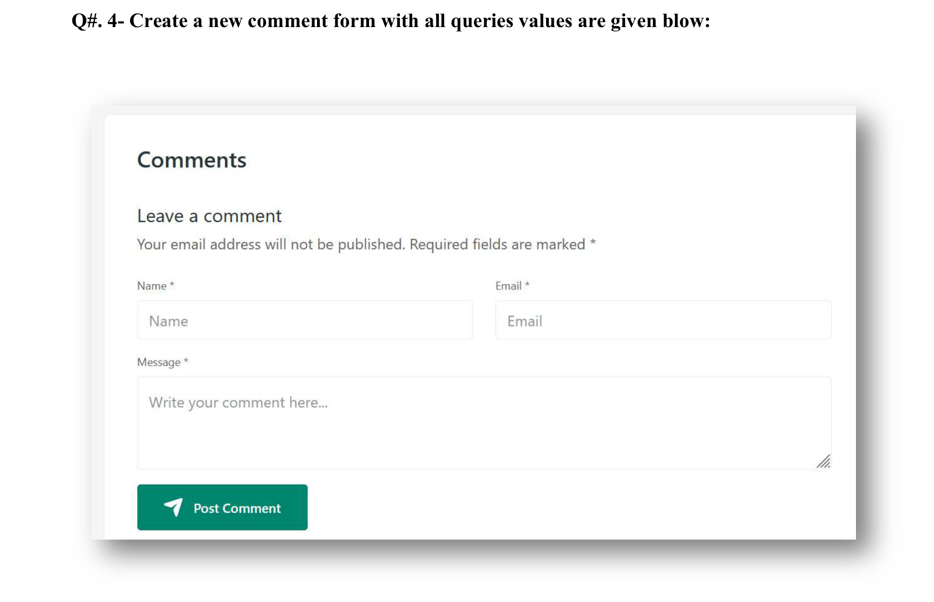
Code:-
<!DOCTYPE html>
<html><head><meta charset="UTF-8"><title>Q4 Comments</title>
<style>body{background:#f4f4f4;font-family:Segoe UI,Arial,sans-serif;padding:30px}
.card{background:white;width:700px;margin:auto;padding:30px;box-shadow:0 8px 25px rgba(0,0,0,.45)}
.row{display:flex;gap:20px}.row div{flex:1}label{font-size:12px;display:block;margin:12px 0 6px}
input,textarea{width:100%;box-sizing:border-box;padding:12px;border:1px solid #e5e5e5;border-radius:4px}
textarea{height:90px}button{background:#00896b;color:white;border:0;padding:14px 28px;margin-top:15px;border-radius:4px}
p{color:#555}</style></head>
<body><div class="card">
<h2>Comments</h2><h3 style="font-weight:normal">Leave a comment</h3>
<p>Your email address will not be published. Required fields are marked *</p>
<form><div class="row">
<div><label>Name *</label><input type="text" placeholder="Name" required></div>
<div><label>Email *</label><input type="email" placeholder="Email" required></div></div>
<label>Message *</label><textarea placeholder="Write your comment here..." required></textarea>
<button type="submit">&#10148; Post Comment</button>
</form></div></body></html>

Output:-

Question no. 05:-
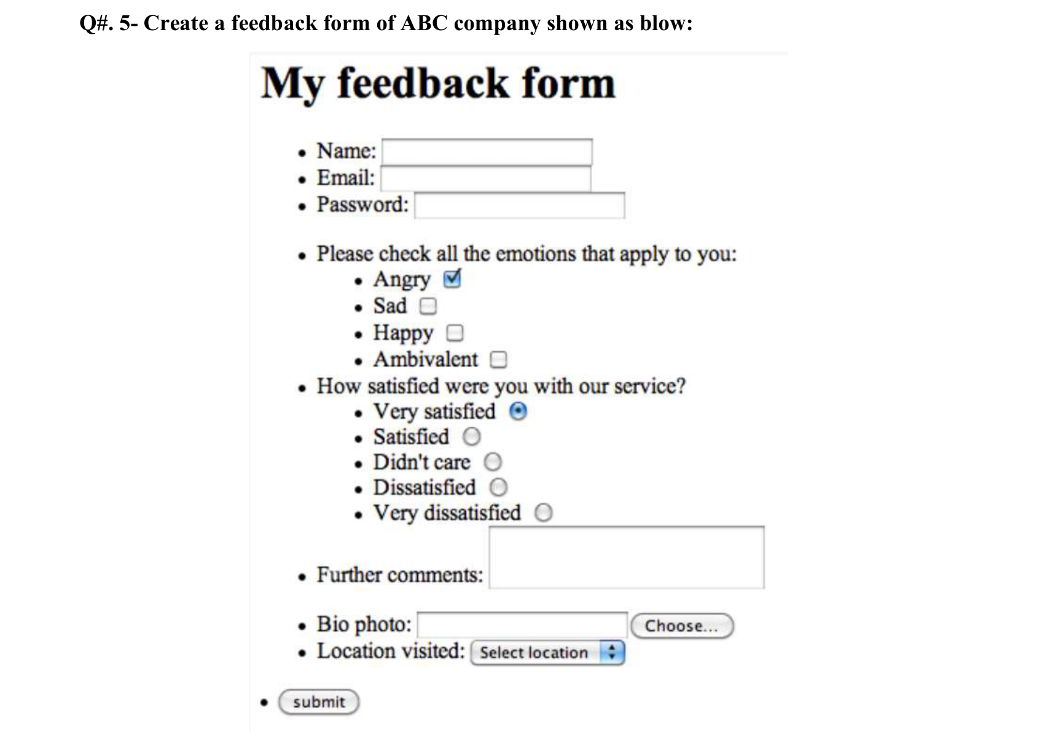
Code:-
<!DOCTYPE html>
<html><head><meta charset="UTF-8"><title>Q5 Feedback Form</title>
<style>body{font-family:"Times New Roman",serif;font-size:18px;margin:30px 150px}h1{font-size:40px}
ul{margin:0}ul ul{list-style:disc}</style></head>
<body>
<h1>My feedback form</h1>
<form>
<ul>
<li>Name: <input type="text" name="name"></li>
<li>Email: <input type="email" name="email"></li>
<li>Password: <input type="password" name="pass"></li>
<li style="margin-top:20px">Please check all the emotions that apply to you:
<ul><li>Angry <input type="checkbox" name="e" checked></li><li>Sad <input type="checkbox" name="e"></li>
<li>Happy <input type="checkbox" name="e"></li><li>Ambivalent <input type="checkbox" name="e"></li></ul></li>
<li>How satisfied were you with our service?
<ul><li>Very satisfied <input type="radio" name="s" checked></li><li>Satisfied <input type="radio" name="s"></li>
<li>Didn't care <input type="radio" name="s"></li><li>Dissatisfied <input type="radio" name="s"></li>
<li>Very dissatisfied <input type="radio" name="s"></li></ul></li>
<li style="margin-top:10px">Further comments: <textarea name="comments" rows="3" cols="25"></textarea></li>
<li style="margin-top:10px">Bio photo: <input type="file" name="photo"></li>
<li>Location visited: <select name="loc"><option>Select location</option><option>Lahore</option><option>Karachi</option></select></li>
</ul>
<ul><li><input type="submit" value="submit"></li></ul>
</form></body></html>

Output:-

Question no. 06:-
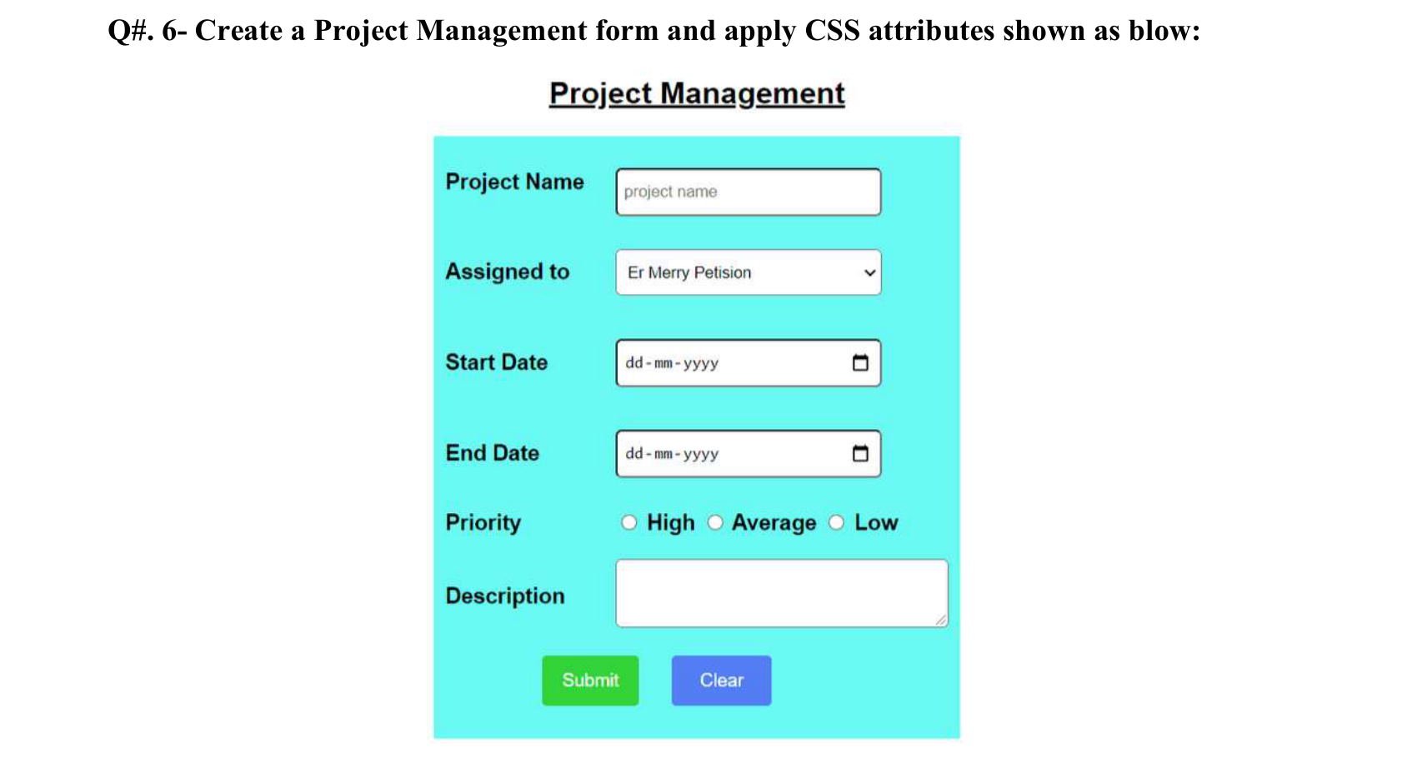
Code:-
<!DOCTYPE html>
<html><head><meta charset="UTF-8"><title>Q6 Project Management</title>
<style>body{font-family:Arial,sans-serif}h2{text-align:center;text-decoration:underline;font-size:20px}
form{background:#66f9f0;width:320px;margin:auto;padding:20px 15px}table{width:100%}td{padding:10px 4px;font-weight:bold;font-size:14px}
input[type=text],input[type=date],select{width:160px;padding:8px;border:1px solid #333;border-radius:4px}
textarea{width:160px;height:40px}.s{background:#22cc44;color:white;border:0;padding:10px 16px}
.c{background:#4f7cf2;color:white;border:0;padding:10px 20px}.b{text-align:center}</style></head>
<body><h2>Project Management</h2>
<form><table>
<tr><td>Project Name</td><td><input type="text" placeholder="project name"></td></tr>
<tr><td>Assigned to</td><td><select><option>Er Merry Petision</option><option>Ali Khan</option></select></td></tr>
<tr><td>Start Date</td><td><input type="date"></td></tr>
<tr><td>End Date</td><td><input type="date"></td></tr>
<tr><td>Priority</td><td><input type="radio" name="p"> High <input type="radio" name="p"> Average <input type="radio" name="p"> Low</td></tr>
<tr><td>Description</td><td><textarea></textarea></td></tr>
<tr><td colspan="2" class="b"><input type="submit" value="Submit" class="s"> &nbsp; &nbsp; <input type="reset" value="Clear" class="c"></td></tr>
</table></form></body></html>

Output:-

Question no. 07:-
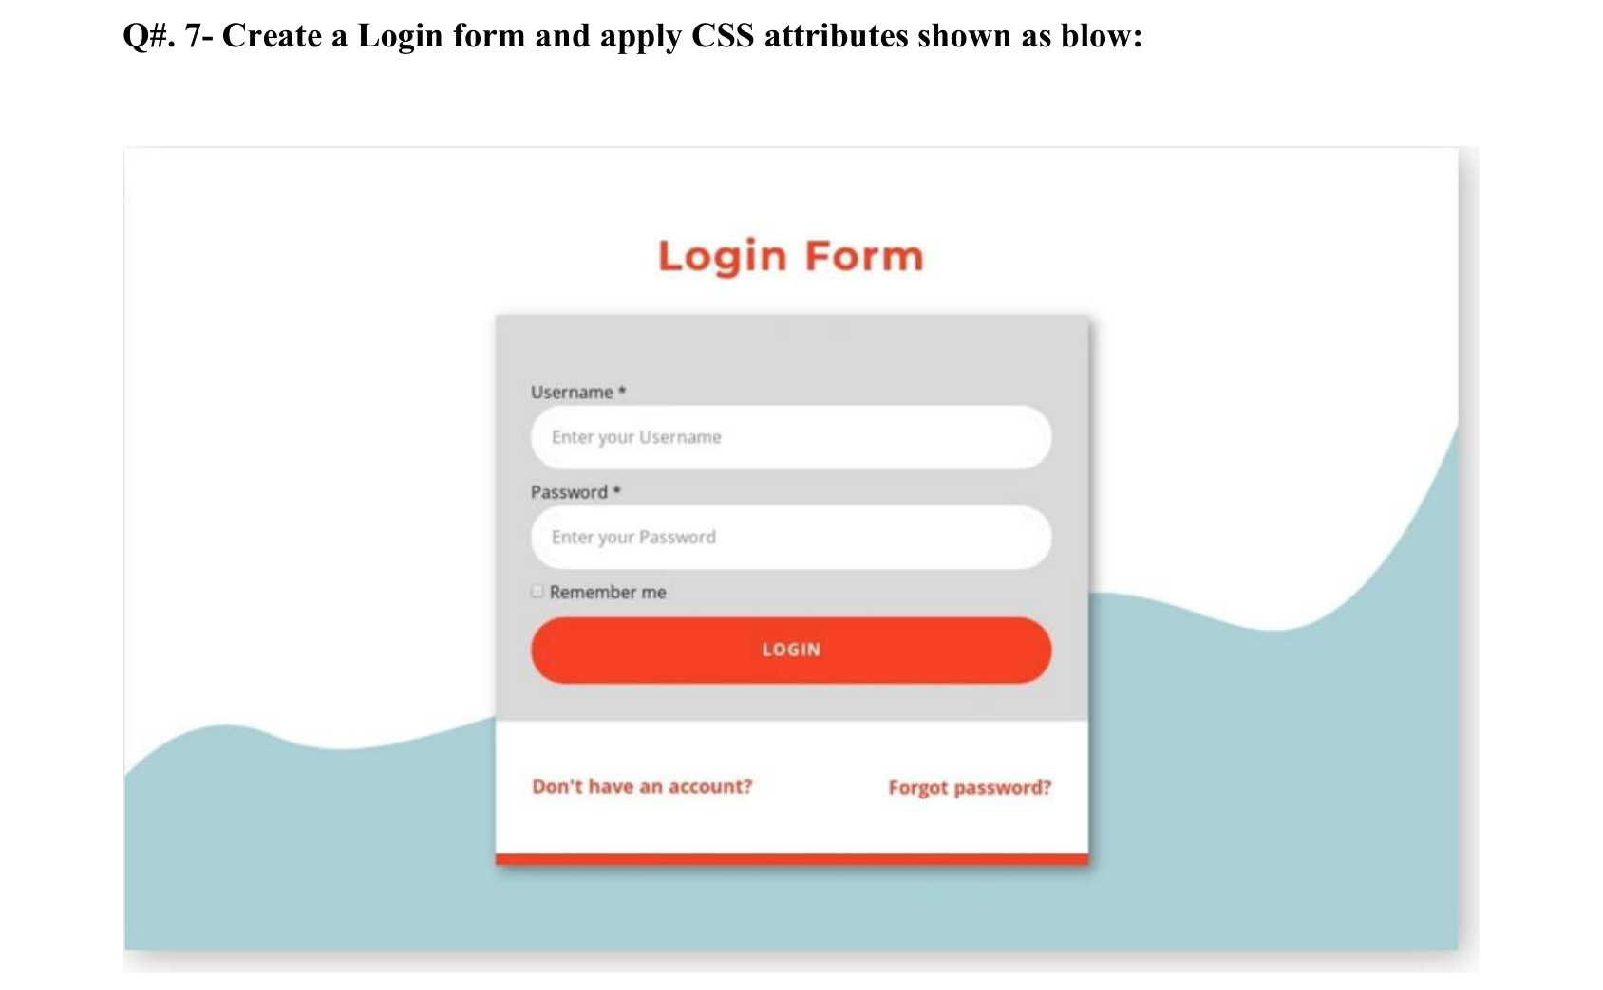
Code:-
<!DOCTYPE html>
<html><head><meta charset="UTF-8"><title>Q7 Login Form</title>
<style>body{margin:0;background:#aacfd6;font-family:Arial,sans-serif;font-size:12px}
h1{text-align:center;color:#f94327;font-size:28px;margin:0;padding:40px 0 20px;background:white}
.wrap{background:white;padding-bottom:60px}.box{width:300px;margin:auto;box-shadow:0 4px 12px #666}
.top{background:#d8d8d8;padding:20px}input[type=text],input[type=password]{width:100%;box-sizing:border-box;padding:12px 10px;border:0;border-radius:20px;margin:4px 0 8px}
button{width:100%;padding:12px;background:#f94327;color:white;border:0;border-radius:20px;font-weight:bold;margin-top:6px}
.bot{background:white;padding:25px 20px;display:flex;justify-content:space-between;border-bottom:6px solid #f94327}
.bot a{color:#f94327;font-weight:bold;text-decoration:none}</style></head>
<body><div class="wrap"><h1>Login Form</h1>
<div class="box"><form><div class="top">
<label>Username *</label><input type="text" placeholder="Enter your Username">
<label>Password *</label><input type="password" placeholder="Enter your Password">
<input type="checkbox"> Remember me<br><button type="submit">LOGIN</button></div></form>
<div class="bot"><a href="Q8.html">Don't have an account?</a><a href="#">Forgot password?</a></div></div></div></body></html>

Output:-

Question no. 08:-
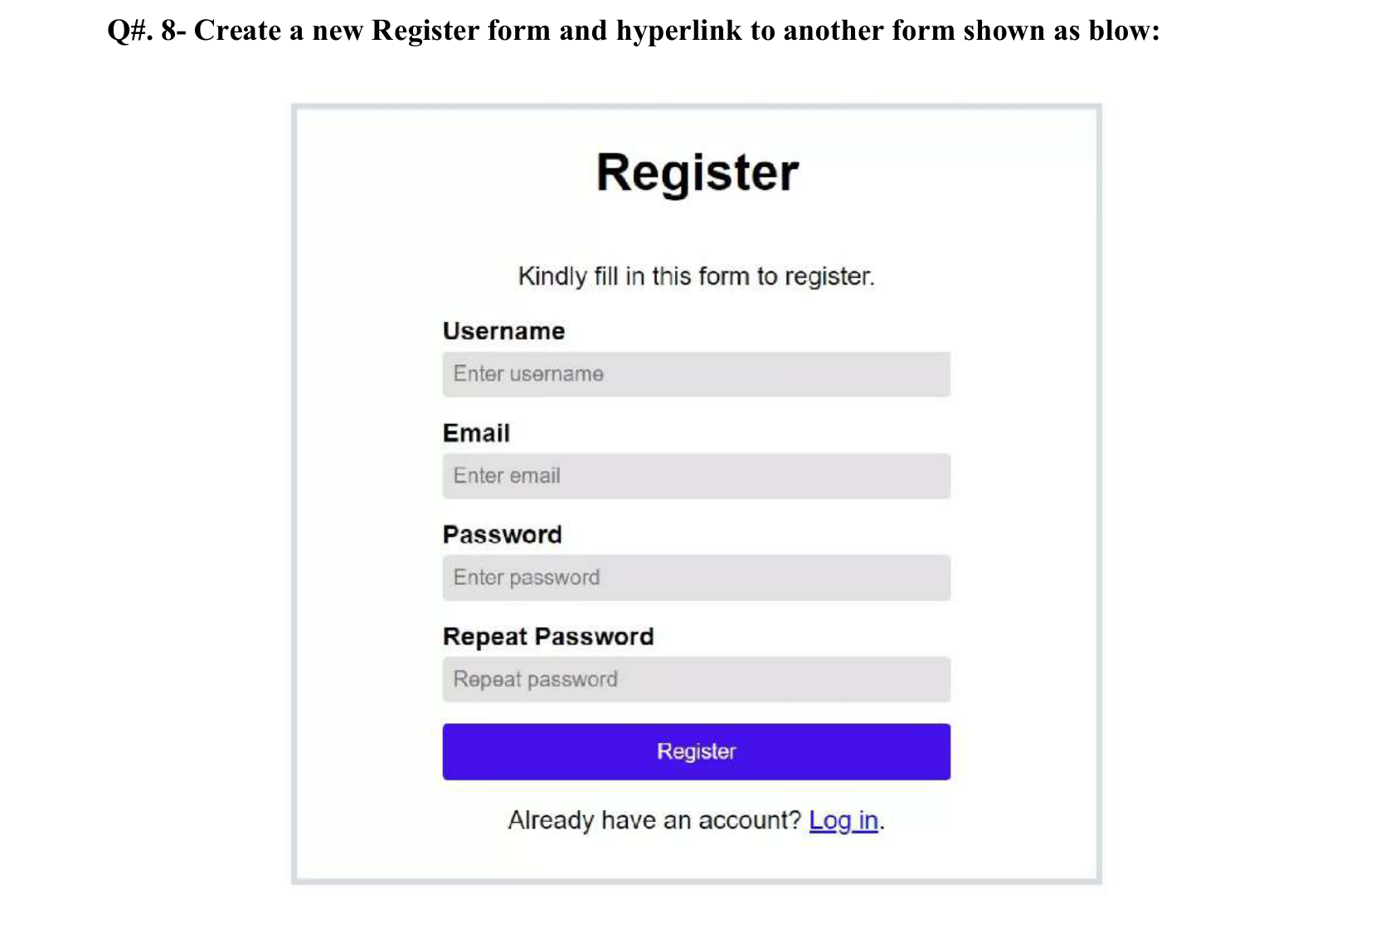
Code:-
<!DOCTYPE html>
<html><head><meta charset="UTF-8"><title>Q8 Register</title>
<style>body{font-family:Arial,sans-serif}.box{width:400px;margin:20px auto;border:5px solid #dde1ee;padding:20px 80px 20px 90px}
.box{width:500px;box-sizing:content-box;padding:10px 30px}h1{text-align:center}p{text-align:center}
.f{width:310px;margin:auto}label{font-weight:bold;display:block;margin-top:10px}
input{width:100%;box-sizing:border-box;padding:8px;border:0;background:#e1e0e3;margin:4px 0}
button{width:100%;padding:10px;background:#4510e8;color:white;border:0;margin-top:10px}</style></head>
<body><div class="box"><h1>Register</h1><p>Kindly fill in this form to register.</p>
<form class="f"><label>Username</label><input type="text" placeholder="Enter username">
<label>Email</label><input type="email" placeholder="Enter email">
<label>Password</label><input type="password" placeholder="Enter password">
<label>Repeat Password</label><input type="password" placeholder="Repeat password">
<button type="submit">Register</button></form>
<p>Already have an account? <a href="Q7.html">Log in</a>.</p></div></body></html>

Output:-

Question no. 09:-
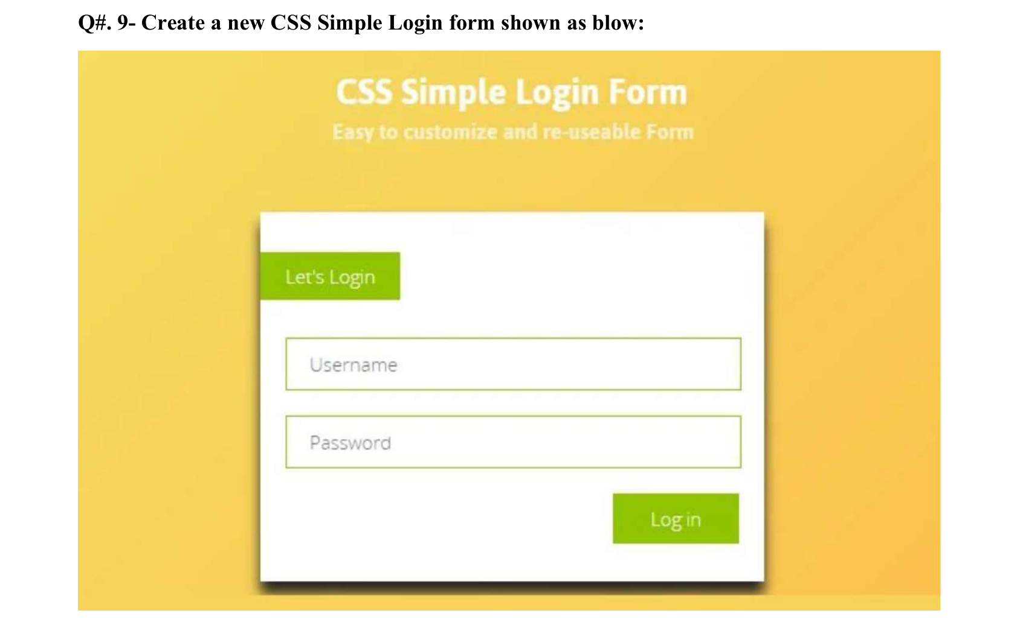
Code:-
<!DOCTYPE html>
<html><head><meta charset="UTF-8"><title>Q9 CSS Simple Login Form</title>
<style>body{margin:0;background:linear-gradient(135deg,#f7dc62,#fbc54a);font-family:"Open Sans",Arial,sans-serif;text-align:center;padding:20px}
h1{color:white;margin:10px 0 0}h4{color:#fbeaa0;margin:5px 0 60px}
.box{background:white;width:430px;margin:auto;padding:30px 20px;text-align:left;box-shadow:0 8px 6px #555}
.tag{background:#96c800;color:white;display:inline-block;padding:14px 20px;margin-left:-20px;margin-bottom:25px}
input{display:block;width:100%;box-sizing:border-box;padding:14px;border:1px solid #96c800;margin-bottom:20px;font-size:16px}
button{background:#96c800;color:white;border:0;padding:14px 30px;font-size:16px;float:right}.box:after{content:"";display:block;clear:both}</style></head>
<body><h1>CSS Simple Login Form</h1><h4>Easy to customize and re-useable Form</h4>
<div class="box"><div class="tag">Let's Login</div>
<form><input type="text" placeholder="Username"><input type="password" placeholder="Password">
<button type="submit">Log in</button></form></div></body></html>

Output:-

Question no. 10:-
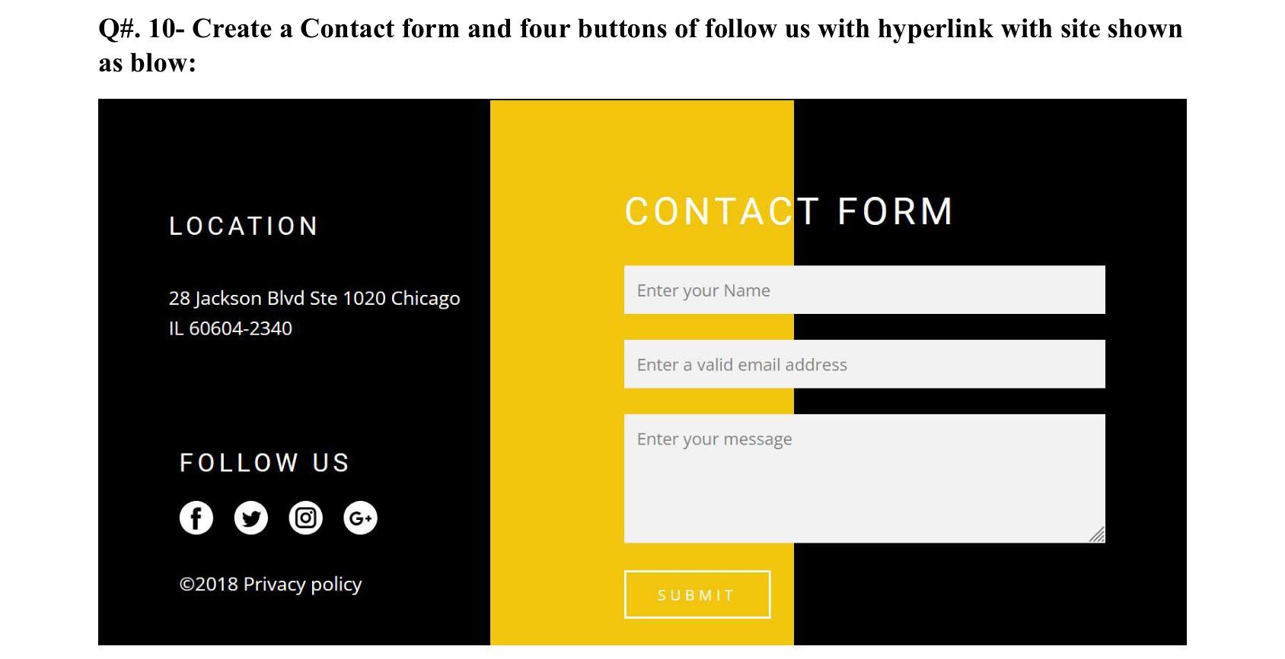
Code:-
<!DOCTYPE html>
<html><head><meta charset="UTF-8"><title>Q10 Contact Form</title>
<style>body{margin:0;background:black;color:white;font-family:Roboto,Arial,sans-serif}
h2{font-weight:normal;letter-spacing:3px;font-size:16px}h1{font-weight:normal;letter-spacing:3px;font-size:28px;margin:0 0 20px}
.left{width:260px;flex:none;padding:70px 20px 0 45px;font-size:13px;box-sizing:border-box}
.cf{display:flex;min-height:340px}.cf .form{flex:1;background:linear-gradient(90deg,#f1c40f 0,#f1c40f 205px,black 205px);padding:50px 55px 0 0}
input,textarea{display:block;width:100%;box-sizing:border-box;background:#f0f0f0;border:0;padding:10px;margin-bottom:15px}
textarea{height:85px}.btn{background:none;border:1px solid white;color:white;padding:12px 20px;letter-spacing:3px;font-size:10px}
.s{display:inline-block;width:20px;height:20px;border-radius:50%;background:white;color:black;text-align:center;font-weight:bold;font-size:12px;line-height:20px;margin-right:10px;text-decoration:none}</style></head>
<body><div class="cf">
<div class="left"><h2>LOCATION</h2><p>28 Jackson Blvd Ste 1020 Chicago IL 60604-2340</p><br><br>
<h2>FOLLOW US</h2>
<a class="s" href="https://www.facebook.com" target="_blank">f</a>
<a class="s" href="https://www.twitter.com" target="_blank">t</a>
<a class="s" href="https://www.instagram.com" target="_blank">in</a>
<a class="s" href="https://plus.google.com" target="_blank">G+</a>
<p>&copy;2018 Privacy policy</p></div>
<div class="form"><h1>CONTACT FORM</h1>
<form><input type="text" placeholder="Enter your Name"><input type="email" placeholder="Enter a valid email address">
<textarea placeholder="Enter your message"></textarea><button class="btn" type="submit">SUBMIT</button></form></div></div>
</body></html>

Output:-

Question no. 11:-
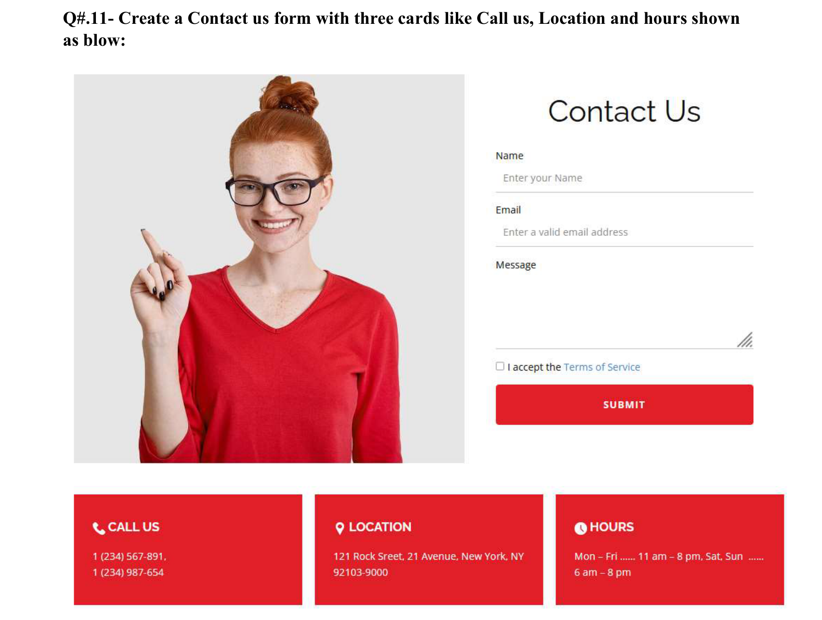
Code:-
<!DOCTYPE html>
<html><head><meta charset="UTF-8"><title>Q11 Contact Us</title>
<style>body{font-family:"Open Sans",Arial,sans-serif;font-size:13px;margin:20px 40px}
.top{display:flex;gap:30px;margin-bottom:30px}.pic{width:410px;height:410px;display:block;object-fit:cover;object-position:center top}
.form{width:270px}h1{font-weight:normal;font-size:34px;text-align:center;margin:10px 0}
label{display:block;margin-top:14px}input[type=text],input[type=email],textarea{width:100%;box-sizing:border-box;border:0;border-bottom:1px solid #999;padding:8px 4px}
textarea{height:90px}button{width:100%;background:#e01f26;color:white;border:0;padding:14px;margin-top:12px;font-weight:bold;border-radius:3px}
.cards{display:flex;gap:12px}.card{flex:1;background:#e01f26;color:white;padding:20px 20px 25px}.card h3{margin:0 0 15px;font-size:15px}.card p{margin:0}</style></head>
<body><div class="top"><img class="pic" src="images/q11_woman.jpg" alt="Contact Us">
<div class="form"><h1>Contact Us</h1>
<form><label>Name</label><input type="text" placeholder="Enter your Name">
<label>Email</label><input type="email" placeholder="Enter a valid email address">
<label>Message</label><textarea></textarea>
<p><input type="checkbox"> I accept the <a href="#">Terms of Service</a></p>
<button type="submit">SUBMIT</button></form></div></div>
<div class="cards">
<div class="card"><h3>CALL US</h3><p>1 (234) 567-891,<br>1 (234) 987-654</p></div>
<div class="card"><h3>LOCATION</h3><p>121 Rock Sreet, 21 Avenue, New York, NY 92103-9000</p></div>
<div class="card"><h3>HOURS</h3><p>Mon &ndash; Fri ...... 11 am &ndash; 8 pm, Sat, Sun ...... 6 am &ndash; 8 pm</p></div></div>
</body></html>

Output:-

Question no. 12:-
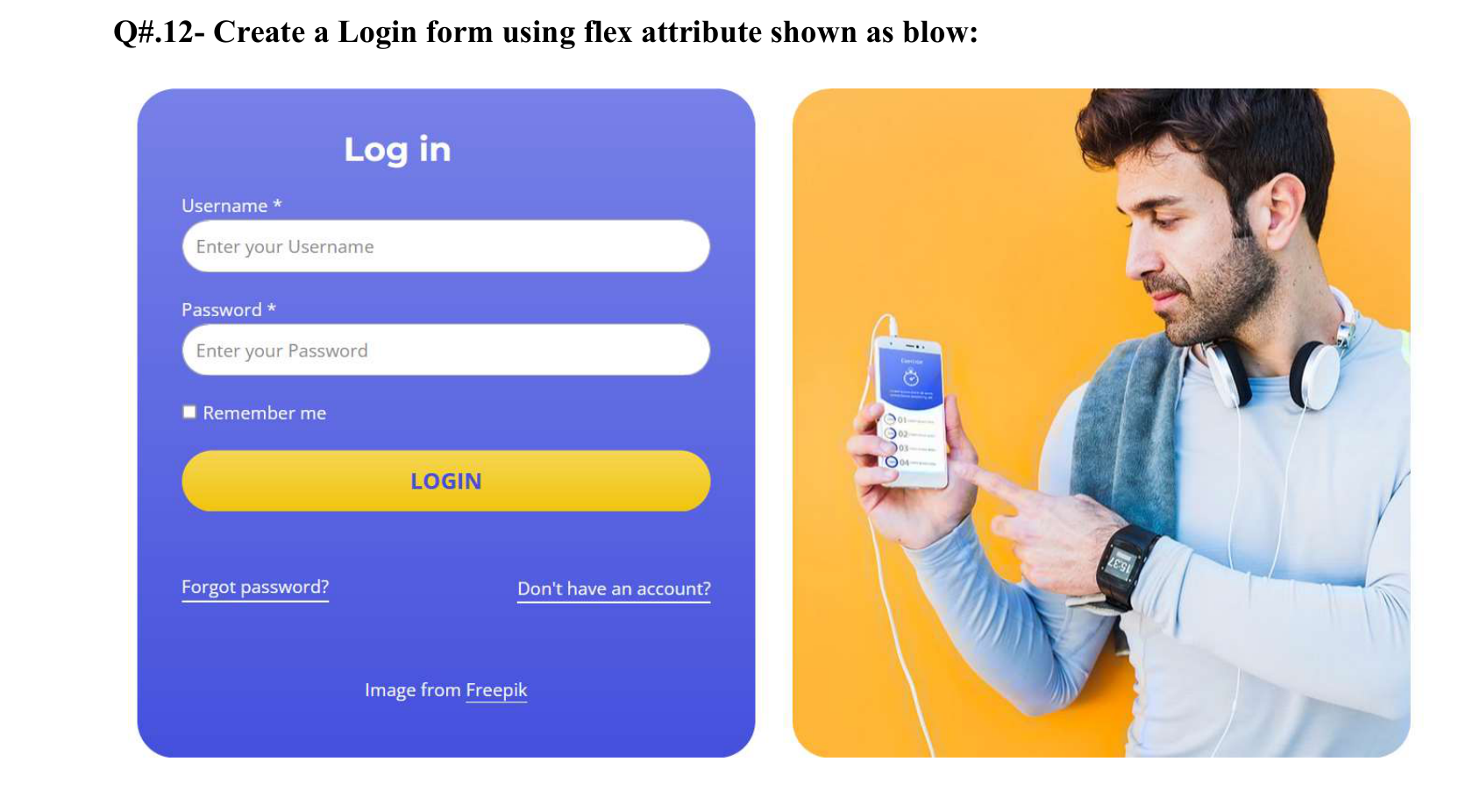
Code:-
<!DOCTYPE html>
<html><head><meta charset="UTF-8"><title>Q12 Login Flex</title>
<style>body{font-family:"Open Sans",Arial,sans-serif;margin:0;padding:30px}
.wrap{display:flex;gap:20px;width:740px;margin:auto}
.login{flex:1;background:linear-gradient(#7a80e8,#4352e0);border-radius:25px;color:white;padding:20px 25px;font-size:13px}
.img{flex:1;background:#fdb53a url(images/q12_man.jpg) center/cover no-repeat;border-radius:25px}
h2{text-align:center;margin:0 0 10px}input[type=text],input[type=password]{width:100%;box-sizing:border-box;padding:10px;border:0;border-radius:20px;margin:4px 0 10px}
button{width:100%;padding:12px;border:0;border-radius:20px;background:#f7cf2b;color:#3b3fb0;font-weight:bold;margin:10px 0 30px}
.links{display:flex;justify-content:space-between}.links a,.foot a{color:white}.foot{text-align:center;margin-top:30px}</style></head>
<body><div class="wrap"><div class="login"><h2>Log in</h2>
<form><label>Username *</label><input type="text" placeholder="Enter your Username">
<label>Password *</label><input type="password" placeholder="Enter your Password">
<input type="checkbox" checked> Remember me<button type="submit">LOGIN</button></form>
<div class="links"><a href="#">Forgot password?</a><a href="Q8.html">Don't have an account?</a></div>
<div class="foot">Image from <a href="https://www.freepik.com">Freepik</a></div></div>
<div class="img"></div></div></body></html>

Output:-

Question no. 13:-
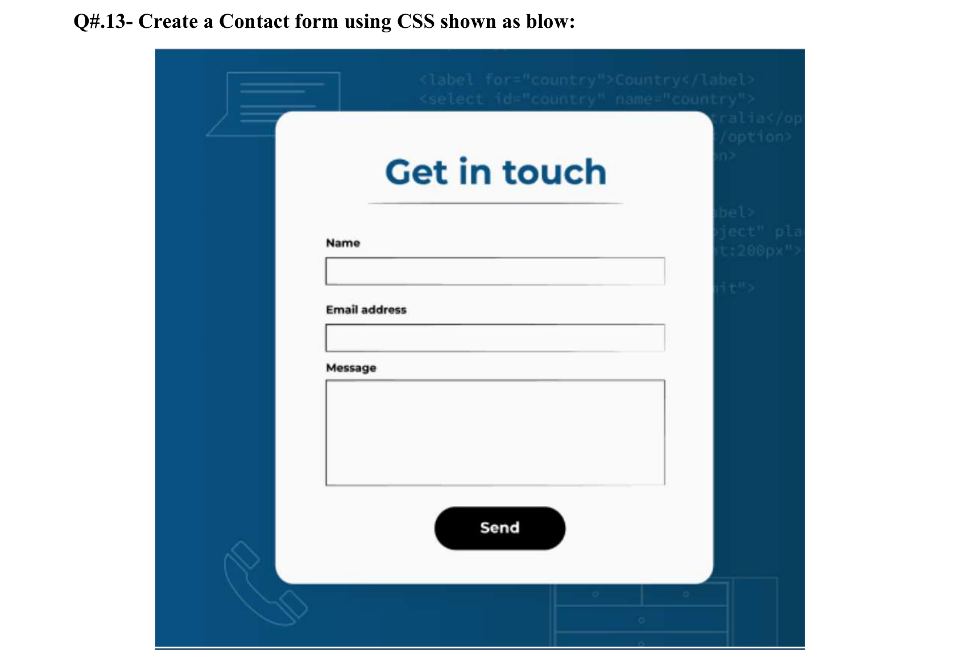
Code:-
<!DOCTYPE html>
<html><head><meta charset="UTF-8"><title>Q13 Get in touch</title>
<style>body{margin:0;background:#0a4f82;font-family:Montserrat,Arial,sans-serif;padding:50px 0}
.card{background:#fafafa;width:340px;margin:auto;border-radius:25px;padding:30px 45px}
h1{color:#0a4f82;text-align:center;font-size:30px;margin:10px 0;border-bottom:1px solid #999;padding-bottom:12px}
label{display:block;font-weight:bold;font-size:11px;margin-top:20px}input,textarea{width:100%;box-sizing:border-box;border:1px solid #333;padding:10px;margin-top:5px}
textarea{height:95px}.send{display:block;margin:25px auto 0;background:black;color:white;border:0;border-radius:25px;padding:14px 40px;font-weight:bold}</style></head>
<body><div class="card"><h1>Get in touch</h1>
<form><label>Name</label><input type="text"><label>Email address</label><input type="email">
<label>Message</label><textarea></textarea><button class="send" type="submit">Send</button></form></div></body></html>

Output:-

Question no. 14:-
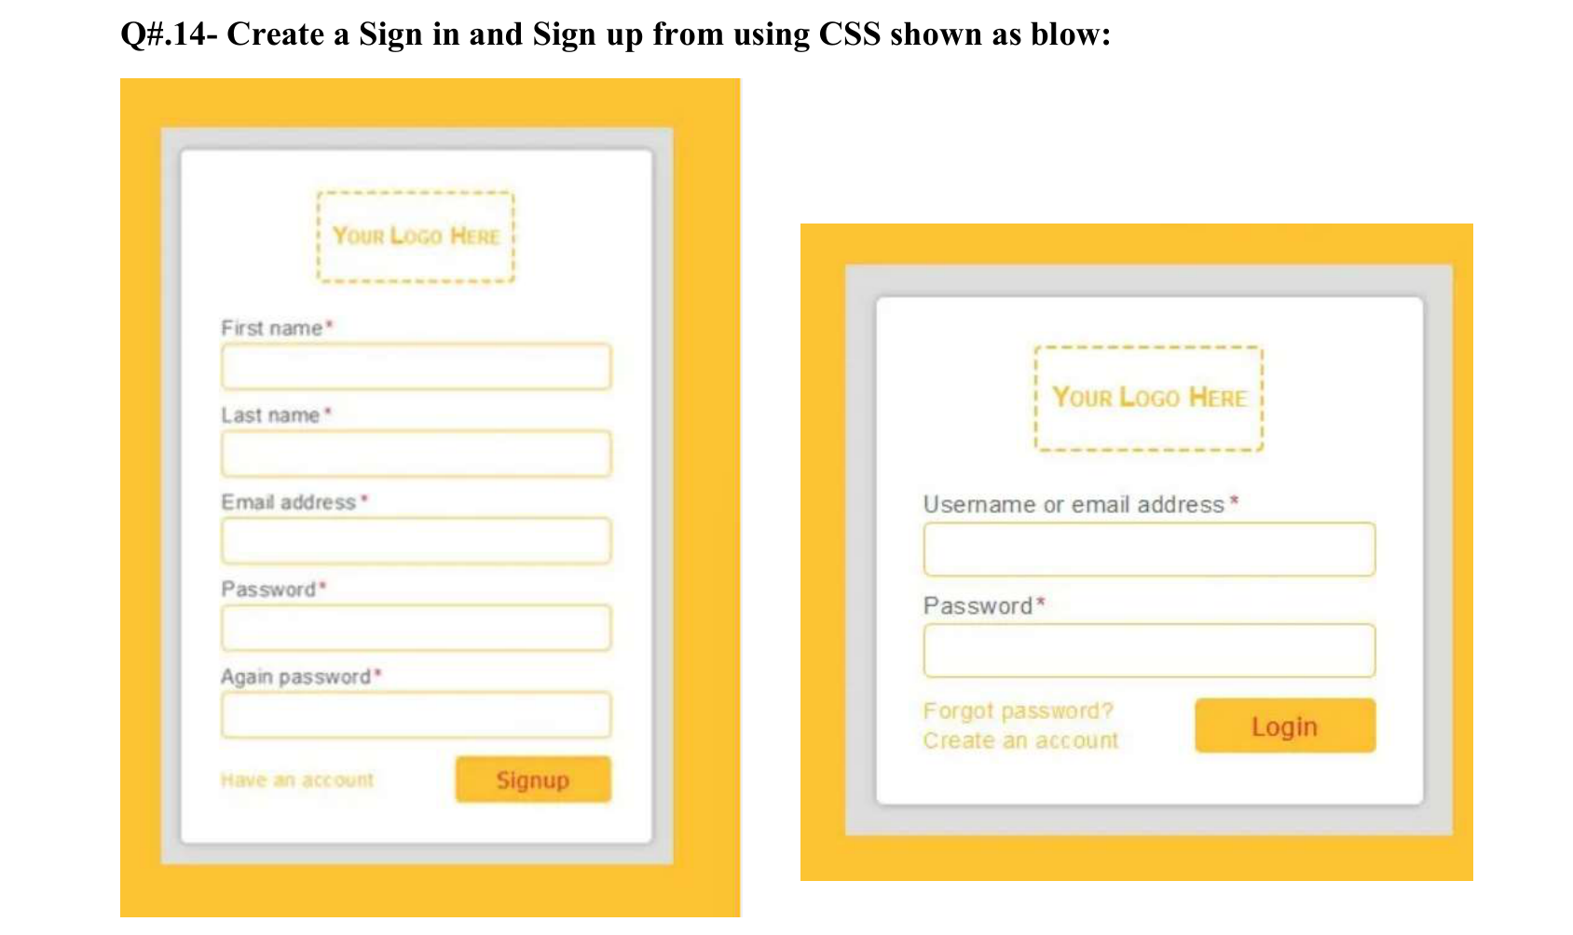
Code:-
<!DOCTYPE html>
<html><head><meta charset="UTF-8"><title>Q14 Sign in and Sign up</title>
<style>body{font-family:Arial,sans-serif;font-size:12px;display:flex;gap:30px;align-items:flex-start;padding:20px}
.out{background:#fcc230;padding:12px}.mid{background:#ddd;padding:10px}.in{background:white;border-radius:4px;padding:15px 20px;box-shadow:0 1px 3px #777;width:200px}
.logo{border:2px dashed #fcc230;color:#fcc230;font-weight:bold;text-align:center;padding:12px;width:80px;margin:0 auto 15px}
label{display:block;color:#888;margin-top:8px}b{color:red}input{width:100%;box-sizing:border-box;border:1px solid #fcc230;padding:7px;margin-top:3px}
.row{display:flex;justify-content:space-between;align-items:center;margin-top:10px}.row a{color:#fcc230;text-decoration:none}
button{background:#fcc230;color:white;border:0;padding:8px 22px}</style></head>
<body>
<div class="out"><div class="mid"><div class="in"><div class="logo">Your Logo Here</div>
<form><label>First name<b>*</b></label><input type="text"><label>Last name<b>*</b></label><input type="text">
<label>Email address<b>*</b></label><input type="email"><label>Password<b>*</b></label><input type="password">
<label>Again password<b>*</b></label><input type="password">
<div class="row"><a href="#">Have an account</a><button type="submit">Signup</button></div></form></div></div></div>
<div class="out" style="margin-top:80px"><div class="mid"><div class="in" style="width:230px"><div class="logo">Your Logo Here</div>
<form><label>Username or email address<b>*</b></label><input type="text"><label>Password<b>*</b></label><input type="password">
<div class="row"><span><a href="#">Forgot password?</a><br><a href="#">Create an account</a></span><button type="submit">Login</button></div></form></div></div></div>
</body></html>

Output:-

Question no. 15:-
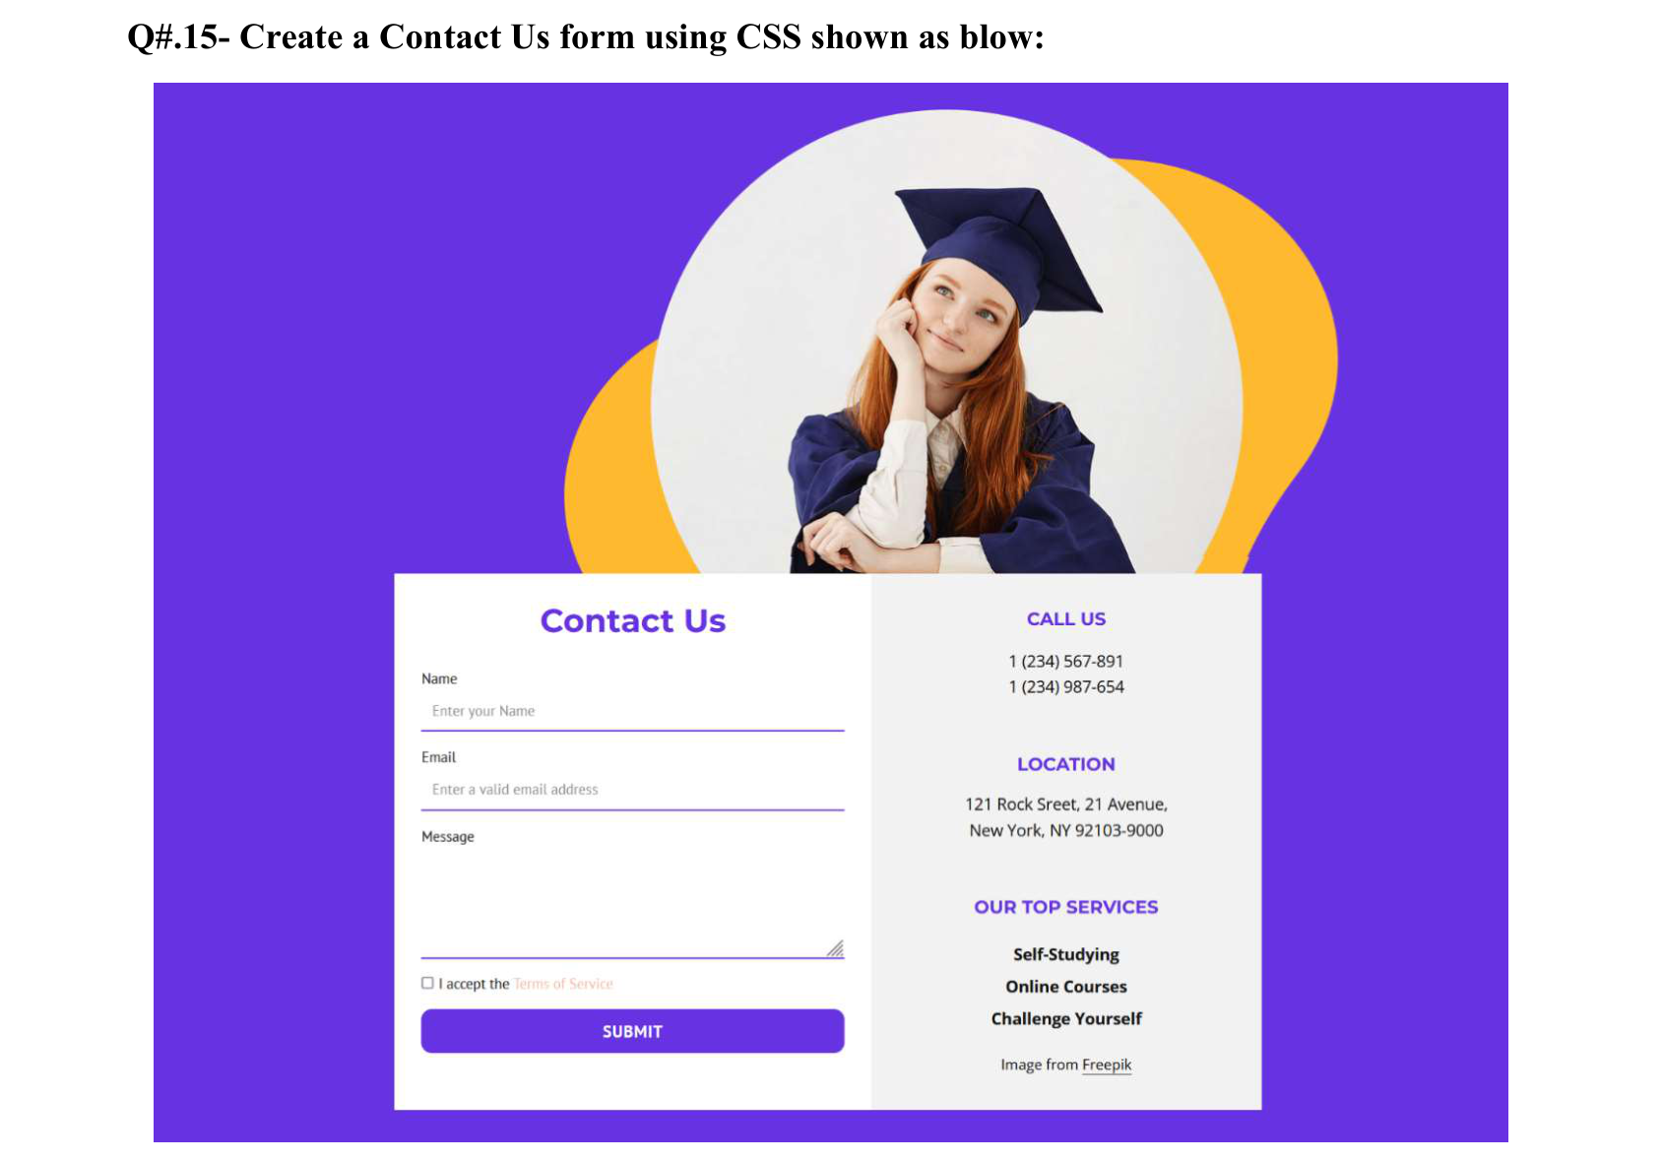
Code:-
<!DOCTYPE html>
<html><head><meta charset="UTF-8"><title>Q15 Contact Us</title>
<style>body{margin:0;background:#6732e2;font-family:Montserrat,Arial,sans-serif;font-size:11px;padding:20px 0}
.hero{display:block;width:420px;max-width:100%;height:auto;margin:0 auto -1px}
.card{display:flex;width:450px;margin:auto;background:white}.f{flex:1.2;padding:15px}.r{flex:1;background:#f2f2f2;text-align:center;padding:15px}
h1{color:#6633e3;text-align:center;font-size:18px;margin:0 0 10px}h3{color:#6633e3;font-size:11px;margin:15px 0 8px}
label{display:block;margin-top:10px}input[type=text],input[type=email],textarea{width:100%;box-sizing:border-box;border:0;border-bottom:1px solid #6633e3;padding:6px 2px}
textarea{height:60px}button{width:100%;background:#6732e2;color:white;border:0;padding:9px;margin-top:8px;font-weight:bold;border-radius:4px}
a{color:black}</style></head>
<body><img class="hero" src="images/q15_graduate.jpg" alt="Graduate">
<div class="card"><div class="f"><h1>Contact Us</h1>
<form><label>Name</label><input type="text" placeholder="Enter your Name"><label>Email</label><input type="email" placeholder="Enter a valid email address">
<label>Message</label><textarea></textarea><p><input type="checkbox"> I accept the <a href="#" style="color:#f5a">Terms of Service</a></p>
<button type="submit">SUBMIT</button></form></div>
<div class="r"><h3>CALL US</h3>1 (234) 567-891<br>1 (234) 987-654<h3>LOCATION</h3>121 Rock Sreet, 21 Avenue,<br>New York, NY 92103-9000
<h3>OUR TOP SERVICES</h3><b>Self-Studying<br><br>Online Courses<br><br>Challenge Yourself</b>
<p>Image from <a href="https://www.freepik.com">Freepik</a></p></div></div></body></html>

Output:-

Question no. 16:-
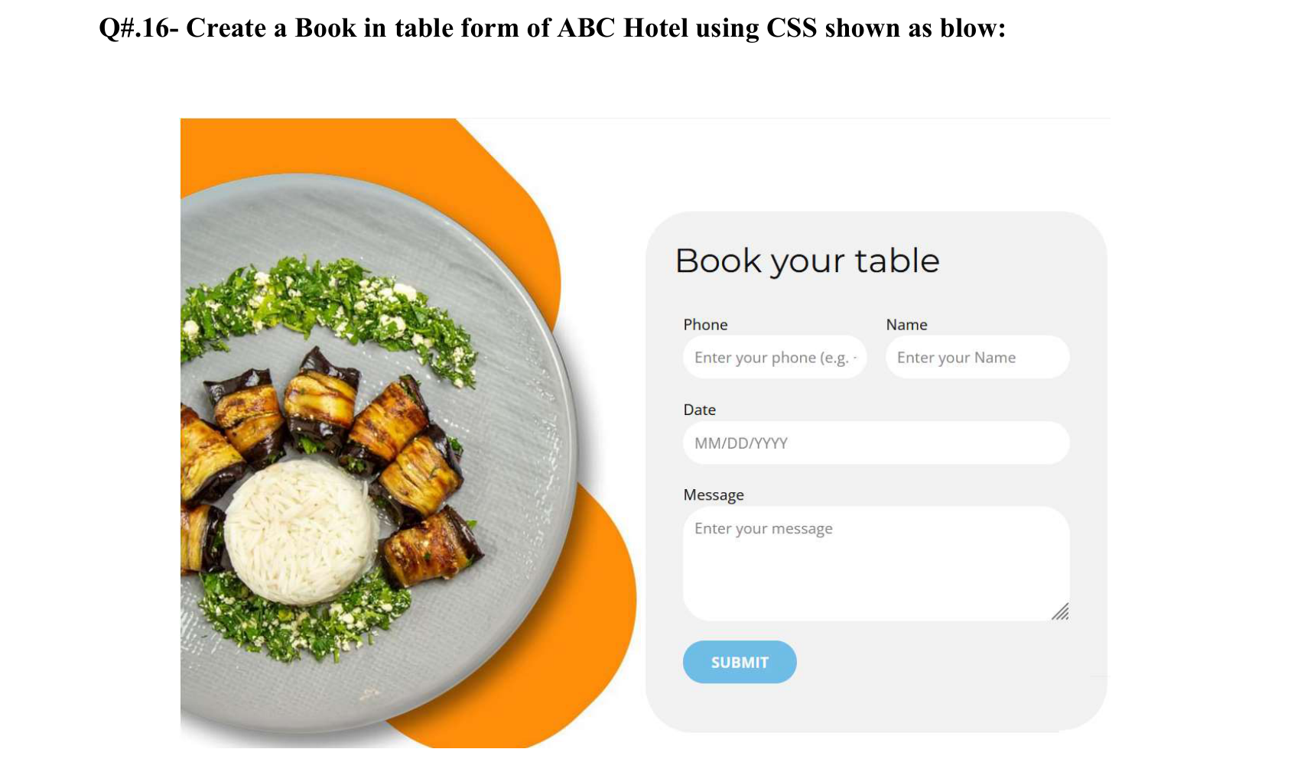
Code:-
<!DOCTYPE html>
<html><head><meta charset="UTF-8"><title>Q16 Book your table</title>
<style>body{font-family:"Open Sans",Arial,sans-serif;font-size:12px;margin:30px;display:flex;gap:30px;width:780px;margin:auto;padding-top:30px;align-items:center}
.pic{width:300px;height:auto;display:block}
.form{flex:1;background:#f1f1f1;border-radius:30px;padding:20px 25px}h1{font-weight:normal;font-size:24px;margin:0 0 15px}
.row{display:flex;gap:15px}.row div{flex:1}label{display:block;margin:12px 0 4px}
input,textarea{width:100%;box-sizing:border-box;border:0;border-radius:15px;padding:9px 10px}textarea{height:75px}
button{background:#74bde5;color:white;border:0;border-radius:20px;padding:10px 20px;font-weight:bold;margin-top:15px}</style></head>
<body><img class="pic" src="images/q16_food.jpg" alt="Book your table">
<div class="form"><h1>Book your table</h1>
<form><div class="row"><div><label>Phone</label><input type="text" placeholder="Enter your phone"></div>
<div><label>Name</label><input type="text" placeholder="Enter your Name"></div></div>
<label>Date</label><input type="text" placeholder="MM/DD/YYYY"><label>Message</label><textarea placeholder="Enter your message"></textarea>
<button type="submit">SUBMIT</button></form></div></body></html>

Output:-

Question no. 17:-
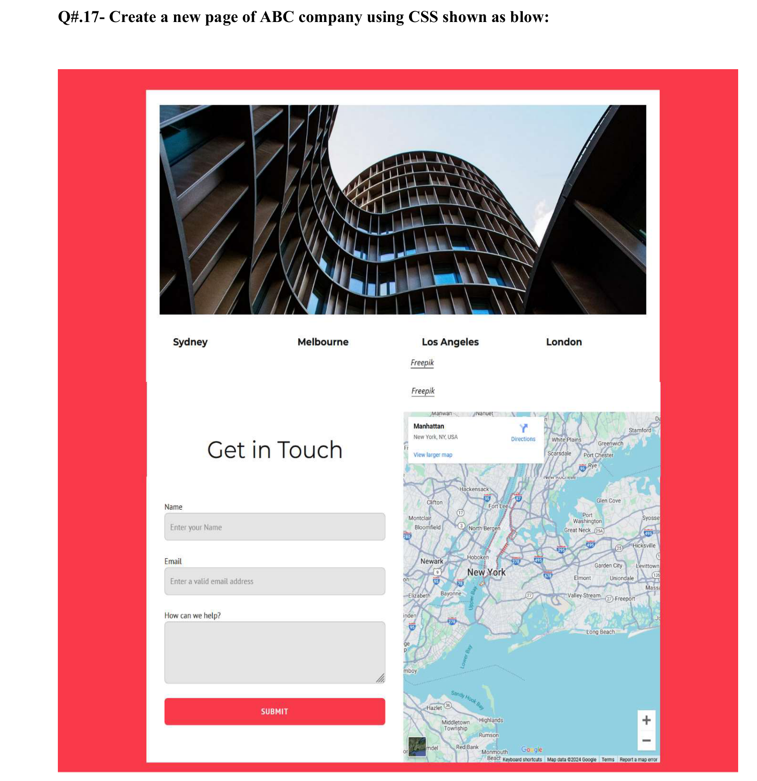
Code:-
<!DOCTYPE html>
<html><head><meta charset="UTF-8"><title>Q17 ABC Company</title>
<style>body{margin:0;background:#fc3a4a;font-family:Arial,sans-serif;font-size:12px;padding:20px 100px}
.page{background:white;width:580px;margin:auto}.hero{display:block;width:calc(100% - 30px);height:240px;object-fit:cover;margin:0 15px}
.cities{display:flex;justify-content:space-around;font-weight:bold;font-size:14px;padding:25px 0}
.bottom{display:flex}.form{flex:1;padding:30px 20px}.map{flex:1;min-width:0;display:flex}.map img{flex:1;min-width:0;width:100%;object-fit:cover;object-position:left top;display:block}
h1{font-weight:normal;font-size:30px;text-align:center;margin:30px 0 50px}label{display:block;margin-top:15px}
input,textarea{width:100%;box-sizing:border-box;background:#e5e5e5;border:1px solid #ccc;border-radius:4px;padding:10px;margin-top:4px}
textarea{height:70px}button{width:100%;background:#fc3a4a;color:white;border:0;padding:12px;margin-top:20px;border-radius:4px;font-weight:bold}</style></head>
<body><div class="page"><img class="hero" src="images/q17_building.jpg" alt="Building">
<div class="cities"><span>Sydney</span><span>Melbourne</span><span>Los Angeles</span><span>London</span></div>
<div class="bottom"><div class="form"><h1>Get in Touch</h1>
<form><label>Name</label><input type="text" placeholder="Enter your Name"><label>Email</label><input type="email" placeholder="Enter a valid email address">
<label>How can we help?</label><textarea></textarea><button type="submit">SUBMIT</button></form></div>
<div class="map"><img src="images/q17_map.jpg" alt="Map - Manhattan, New York"></div></div></div></body></html>

Output:-

Question no. 18:-
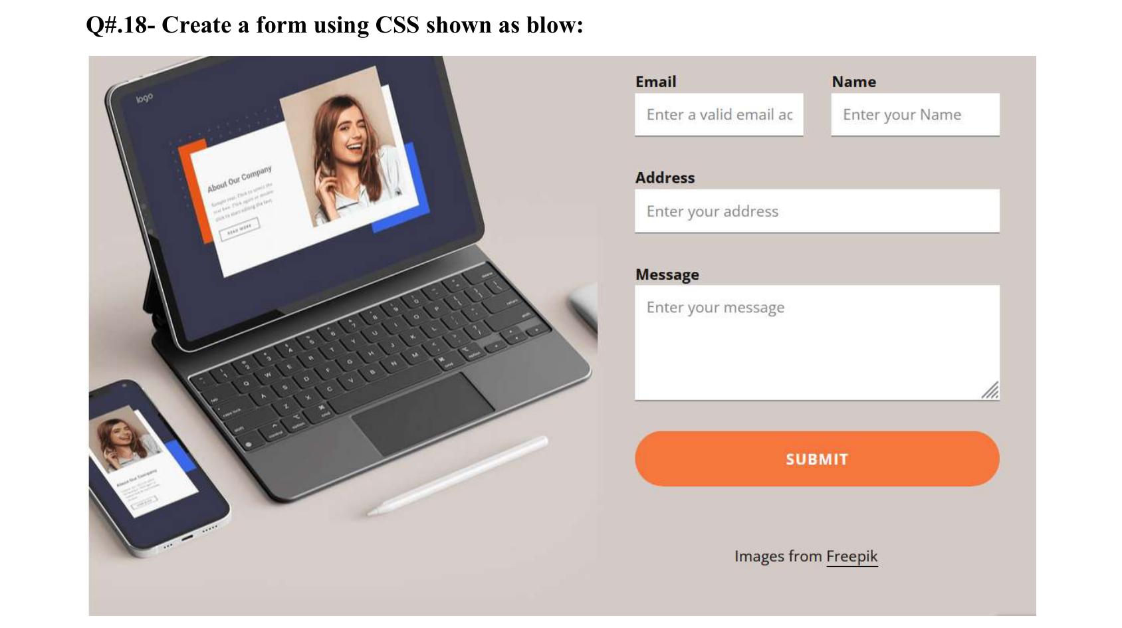
Code:-
<!DOCTYPE html>
<html><head><meta charset="UTF-8"><title>Q18 Form</title>
<style>body{margin:0;font-family:"Open Sans",Arial,sans-serif;font-size:13px}
.wrap{display:flex;background:#d1c7c5;width:730px;margin:20px auto}.pic{flex:1;background:url(images/q18_laptop.jpg) left center/cover no-repeat}
.f{width:280px;padding:15px 25px 20px 0}.row{display:flex;gap:20px}.row div{flex:1}label{display:block;font-weight:bold;margin-top:20px}
input,textarea{width:100%;box-sizing:border-box;border:0;border-bottom:1px solid #999;padding:10px;margin-top:3px}
textarea{height:85px}button{width:100%;background:#f7793b;color:white;border:0;border-radius:25px;padding:14px;font-weight:bold;margin-top:25px}
p{text-align:center;margin-top:35px}a{color:black}</style></head>
<body><div class="wrap"><div class="pic"></div>
<div class="f"><form><div class="row"><div><label style="margin-top:0">Email</label><input type="email" placeholder="Enter a valid email address"></div>
<div><label style="margin-top:0">Name</label><input type="text" placeholder="Enter your Name"></div></div>
<label>Address</label><input type="text" placeholder="Enter your address"><label>Message</label><textarea placeholder="Enter your message"></textarea>
<button type="submit">SUBMIT</button></form><p>Images from <a href="https://www.freepik.com">Freepik</a></p></div></div></body></html>

Output:-

Question no. 19:-
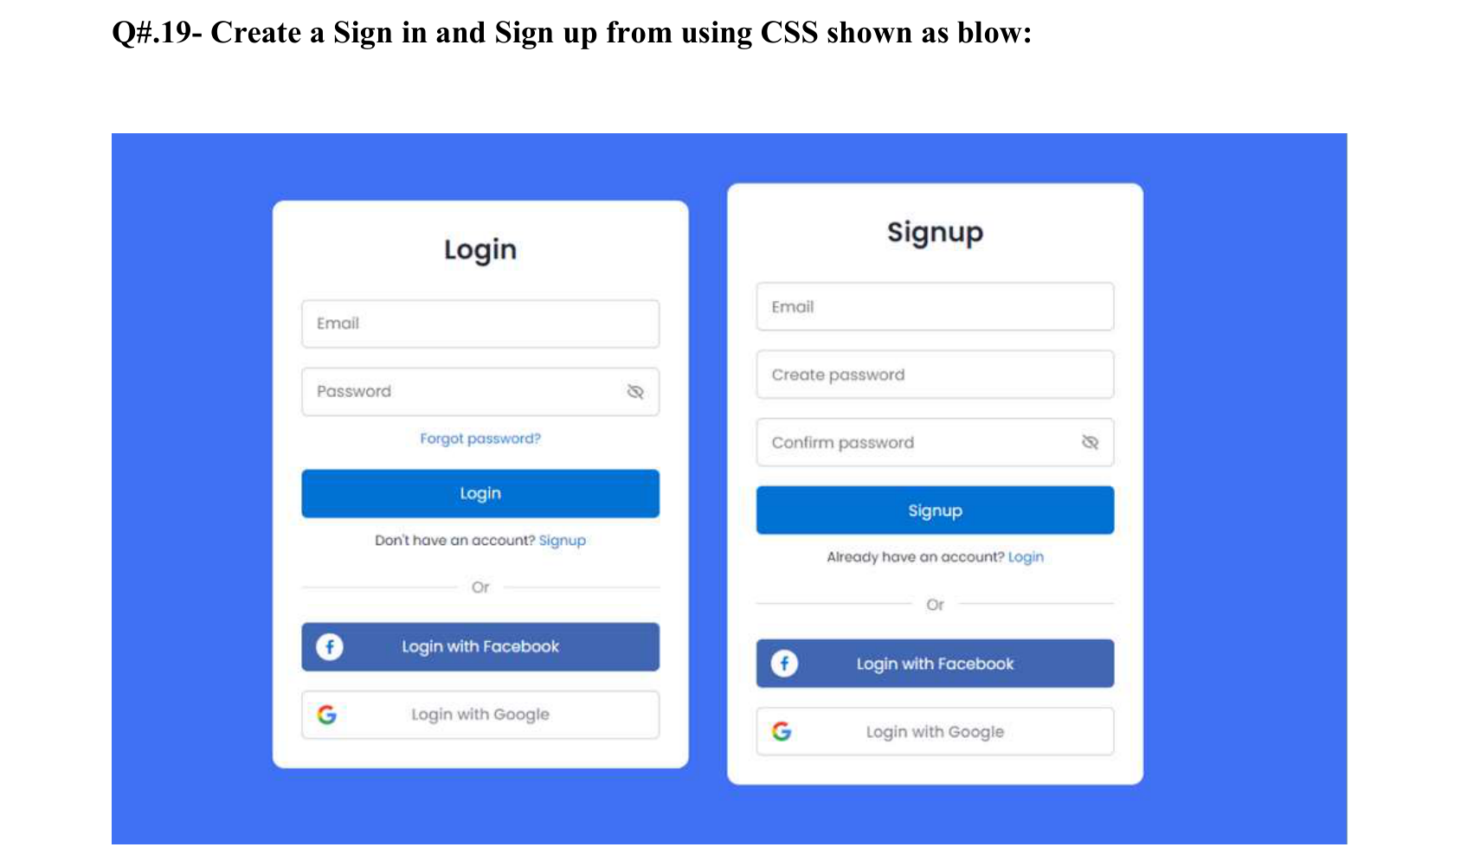
Code:-
<!DOCTYPE html>
<html><head><meta charset="UTF-8"><title>Q19 Login and Signup</title>
<style>body{margin:0;background:#4070f4;font-family:Poppins,Arial,sans-serif;font-size:11px;display:flex;gap:25px;justify-content:center;align-items:flex-start;padding:30px}
.card{background:white;width:240px;border-radius:6px;padding:15px 15px 20px;text-align:center}h2{font-size:18px;margin:10px 0 18px}
input{width:100%;box-sizing:border-box;border:1px solid #ddd;border-radius:4px;padding:10px;margin-bottom:12px}
.main{width:100%;background:#0071d9;color:white;border:0;padding:10px;border-radius:4px}a{color:#0071d9;text-decoration:none}
.or{margin:12px 0;color:#888}.fb{background:#4267b2;color:white;padding:10px;border-radius:4px;margin-bottom:10px}.g{border:1px solid #ddd;padding:10px;border-radius:4px;color:#666}</style></head>
<body>
<div class="card"><h2>Login</h2><form><input type="email" placeholder="Email"><input type="password" placeholder="Password">
<a href="#">Forgot password?</a><br><br><button class="main" type="submit">Login</button></form>
<p>Don't have an account? <a href="#">Signup</a></p><div class="or">&mdash;&mdash; Or &mdash;&mdash;</div>
<div class="fb">Login with Facebook</div><div class="g">Login with Google</div></div>
<div class="card"><h2>Signup</h2><form><input type="email" placeholder="Email"><input type="password" placeholder="Create password"><input type="password" placeholder="Confirm password">
<button class="main" type="submit">Signup</button></form>
<p>Already have an account? <a href="#">Login</a></p><div class="or">&mdash;&mdash; Or &mdash;&mdash;</div>
<div class="fb">Login with Facebook</div><div class="g">Login with Google</div></div>
</body></html>

Output:-

Question no. 20:-
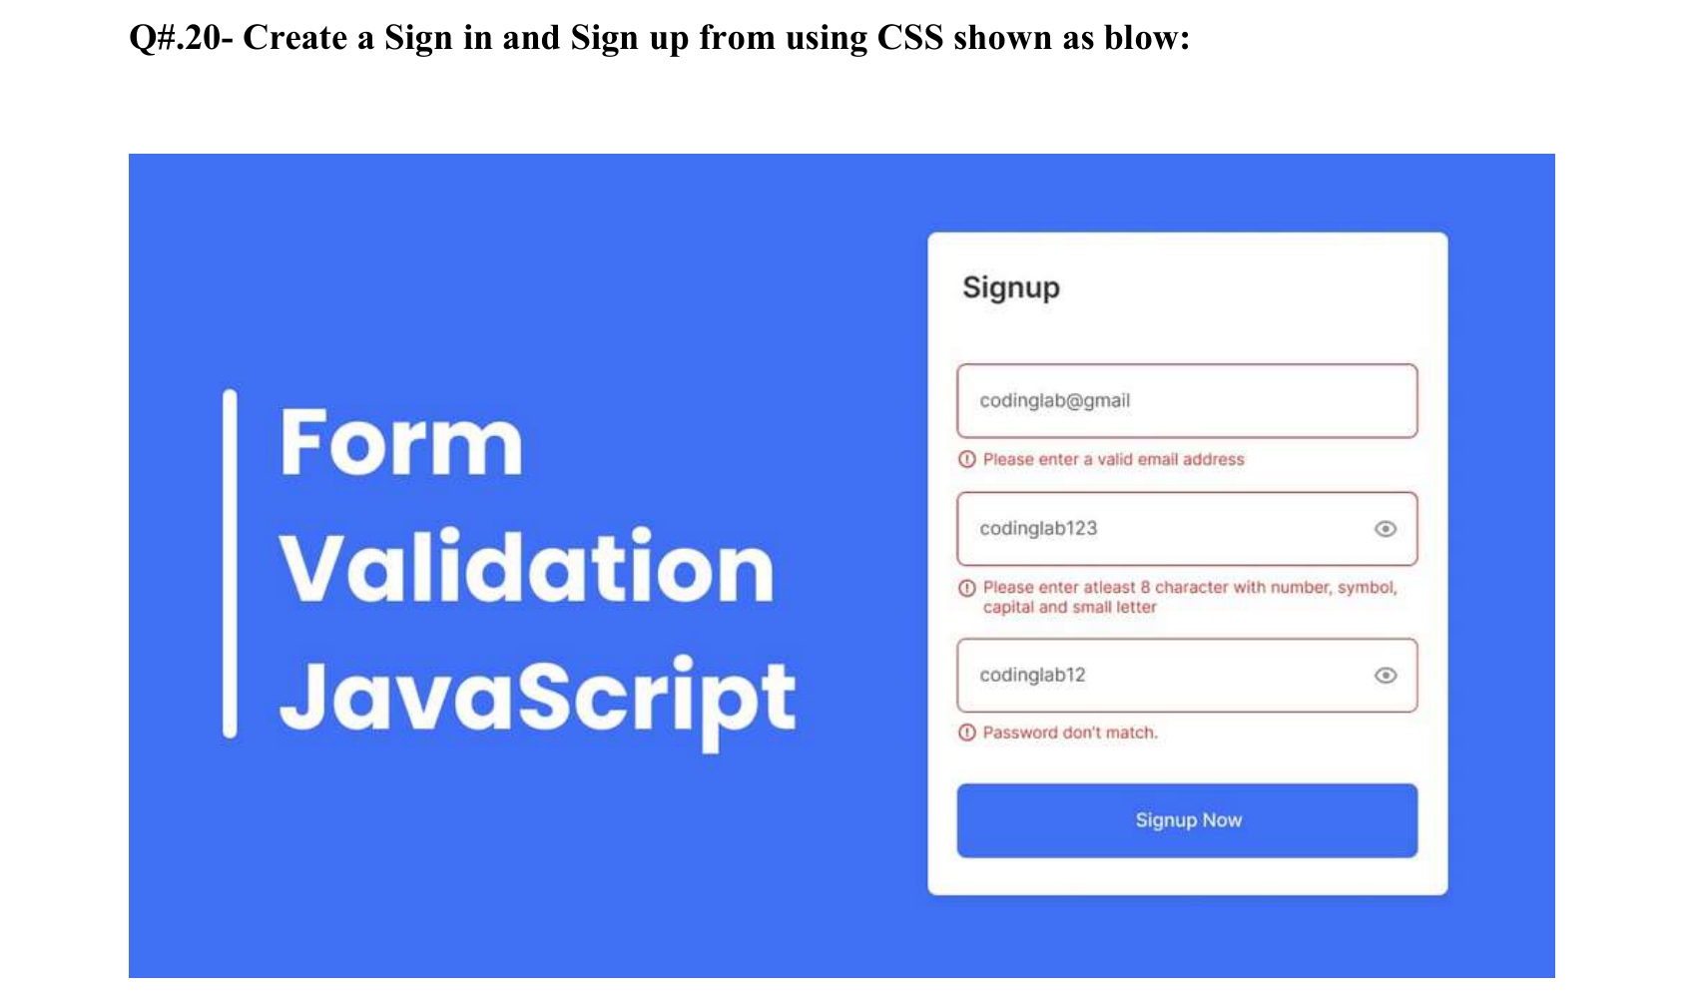
Code:-
<!DOCTYPE html>
<html><head><meta charset="UTF-8"><title>Q20 Signup Validation Design</title>
<style>body{margin:0;background:#4070f4;font-family:Poppins,Arial,sans-serif;display:flex;align-items:center;justify-content:space-around;min-height:100vh}
h1{color:white;font-size:44px;line-height:1.2;border-left:8px solid white;padding-left:25px;margin:0}
.card{background:white;width:300px;border-radius:6px;padding:25px}h2{font-size:16px;font-weight:500;margin:0 0 25px}
input{width:100%;box-sizing:border-box;padding:12px;border:1px solid #d93025;border-radius:5px;font-size:12px}
.err{color:#d93025;font-size:10px;margin:6px 0 14px}button{width:100%;background:#4070f4;color:white;border:0;padding:12px;border-radius:5px;margin-top:5px}</style></head>
<body><h1>Form<br>Validation<br>JavaScript</h1>
<div class="card"><h2>Signup</h2>
<form><input type="text" value="codinglab@gmail">
<div class="err">&#9432; Please enter a valid email address</div>
<input type="text" value="codinglab123">
<div class="err">&#9432; Please enter atleast 8 character with number, symbol, capital and small letter</div>
<input type="text" value="codinglab12">
<div class="err">&#9432; Password don't match.</div>
<button type="submit">Signup Now</button></form></div></body></html>

Output:-

