**Adaptive Heart Rate Alarm - Assessment of Seizure Detection Effectiveness and False Alarm Rate**

Graham Jones 25 Feb 2023

OpenSeizureDetector has included a simple heart rate threshold alarm for some time, but no data has been available for determining appropriate thresholds to give reliable seizure detection without introducing excessive false alarms.

The availability of the Open Seizure Database of contributed seizure detector data has allowed an assessment of the heart rate alarm to be made.

# Data

The database was reviewed to identify Tonic-Clonic seizure events that contain valid heart rate data. 26 events were identified, distributed between four different users:

| User ID | Number of Seizure Events |
| --- | --- |
| 8 | 3 |
| 39 | 7 |
| 45 | 13 |
| 83 | 3 |
| Total | 26 |

Furthermore, a set of 2680 ‘Normal Daily Activity’ (NDA) events were available in the database, covering approximately 3 days, which were used to assess the false alarm rate.

The time variation of heart rate was inspected from a summary report of each event, and the baseline heart rate, peak heart rate, and time to reach peak determined from the graph. This allowed the heart rate increase and rate of increase during the seizure to be determined.

The heart rate increase during the various seizures is shown below:

It can be seen that there are three distinct groups of seizures: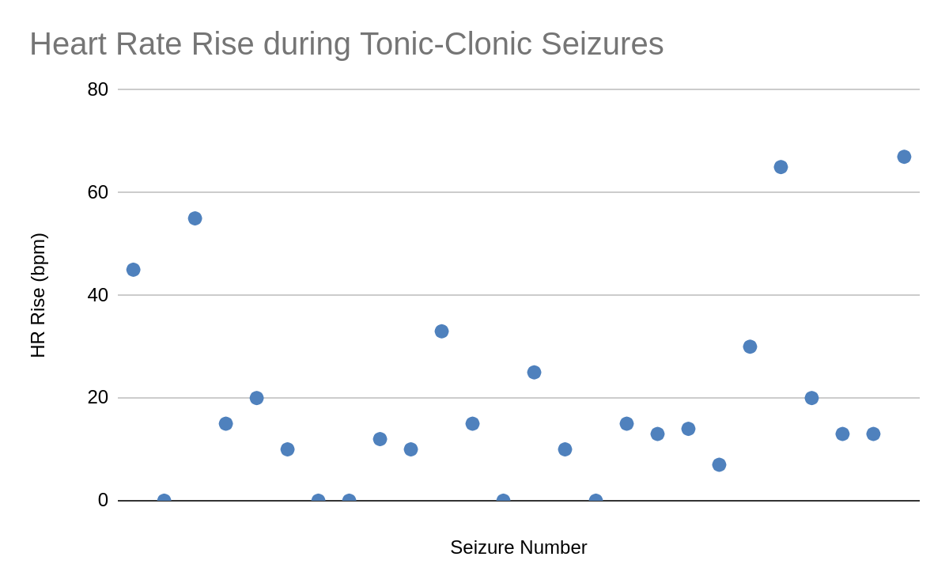

1. Large increase in heart rate during seizure (>40 bpm increase - 4 seizures)
2. Zero increase in heart rate during seizure (5 seizures)
3. Modest increase in heart rate during seizure (10-30 bpm increase) 17 seizures

Clearly seizures that show no increase in heart rate will not be detectable with a heart rate alarm so another measured parameter (such as acceleration) will need to be used instead. The seizures with a large increase in heart rate should be relatively straightforward to detect. The main difficulty will be in finding a set of parameters that can detect the modest increase seizures without giving a large number of false alarms during normal daily activities.

# Algorithm

The algorithm being assessed is an adaptive alarm threshold method. In this, the moving average heart rate over a given time period is calculated. The alarm threshold is determined by a fixed offset against this average. This means that if the heart rate increases gradually, the threshold will also increase, so the system should not alarm. However a rapid increase in heart rate should alarm because the heart rate can increase faster than the average.

The expected behaviour of the threshold in response to changes in heart rate is shown below where it can be seen that provided the heart rate increases sufficiently quickly, it will exceed the threshold, generating an alarm. If the heart rate were increasing more slowly, it would not exceed the threshold, so no alarm would be generated.

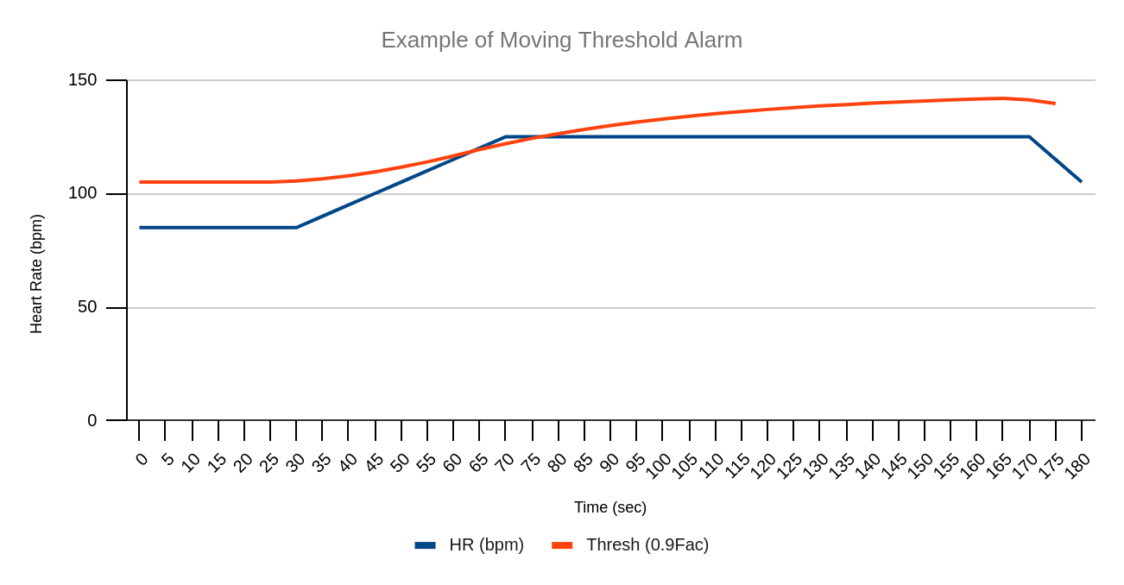

# Assessment

Using a moving average window of 60 seconds and a threshold offset of 10 bpm generated alarms for 37% of the tonic clonic seizures in the database. These settings did however produce an unacceptably high false alarm rate from the Normal Daily Activities data (113 alarms)

Reducing the moving average window from 60 seconds to 30 seconds (so the threshold can change faster), reduced the false alarms significantly (from 113 to 44 false alarms), but did reduce the seizure detection reliability from 37% to 24%

44 false alarms in a 3 day period is unacceptable, so the threshold offset was increased to 20 bpm. This reduced the false alarms significantly (from 44 to 8) which is approaching an acceptable level. The seizure detection reliability decreased slightly from 24% to 18%.

Examination of which seizures were detected correctly revealed that they are the seizures with a higher increase in heart rate, which are all associated with one user (User 39). This suggests that the adaptive heart rate alarm may be useful, but it will depend on the individual and the sort of seizures that they suffer.

# Conclusions

The adaptive heart rate alarm may be useful for some users, but only if they experience a significant increase in heart rate during a seizures (an increase of > 40bpm).

The appropriate settings would be a moving average window of 30 seconds, and a threshold offset of 20 bpm.

The false alarm rate is expected to be of the order 3 alarms per day.