Tab 12

Project 12 – X-ray Spectral Analysis of PSR J1826−1256

X-ray studies of the gamma-ray pulsar J1826−1256 and its pulsar wind nebula with Chandra and XMM–Newton

Objective
In this project, you will analyse Chandra X-ray data of the gamma-ray pulsar PSR J1826−1256. The reference paper studies both the pulsar and its pulsar wind nebula (PWN) using Chandra and XMM–Newton; however, for this project you are required to analyse only the pulsar using the Chandra data.
The main goal is to extract the X-ray spectrum of PSR J1826−1256, fit the spectrum using XSPEC, determine its best-fit parameters, and compare your results with the published analysis.

1. Required Software and Tutorials
Install the following software:
- CIAO Installation

https://drive.google.com/drive/folders/1pW5Kzo7mjTmFDh1HiNM63V4PiD7LLBXZ

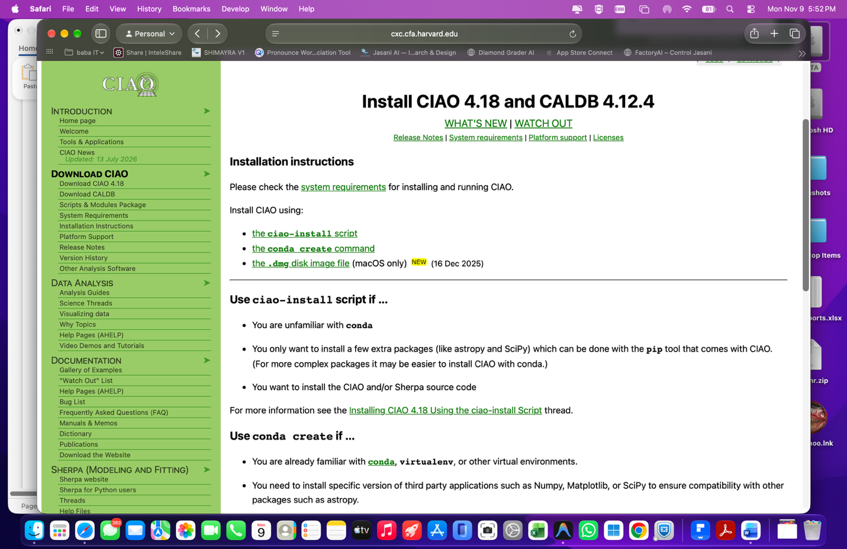
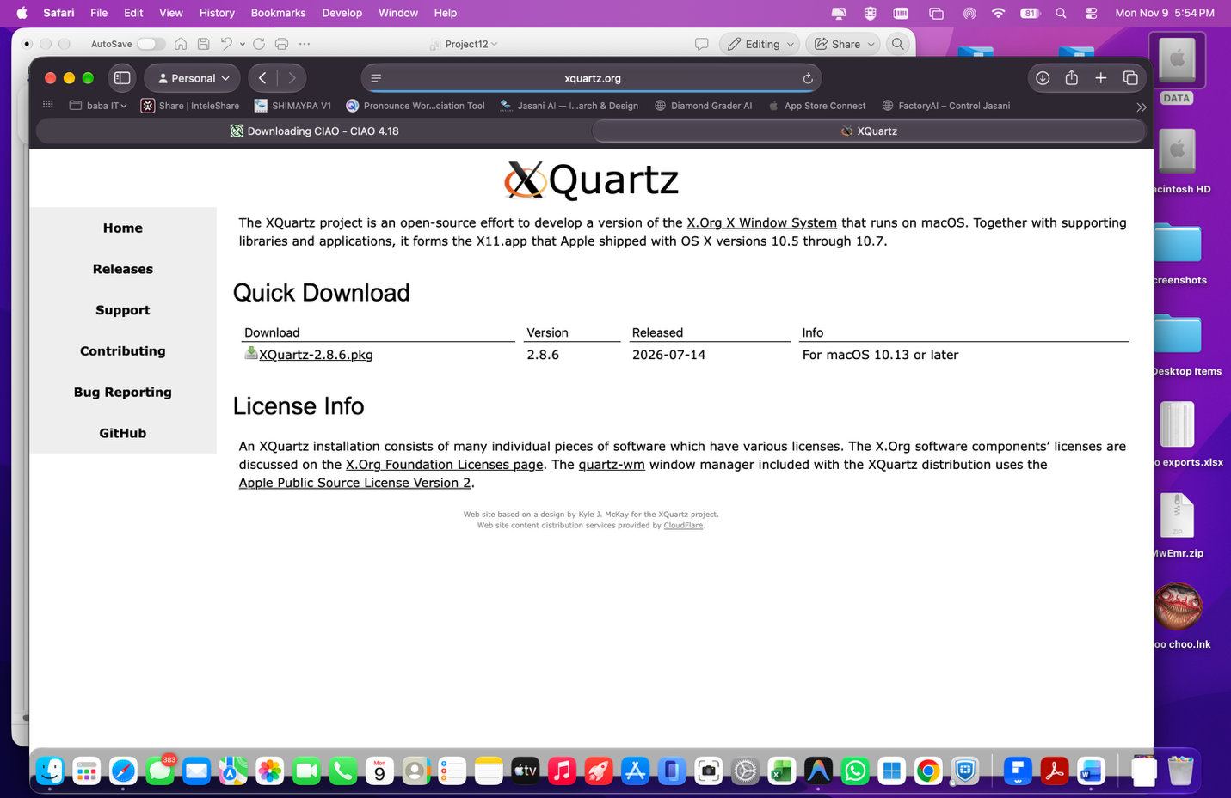

- DS9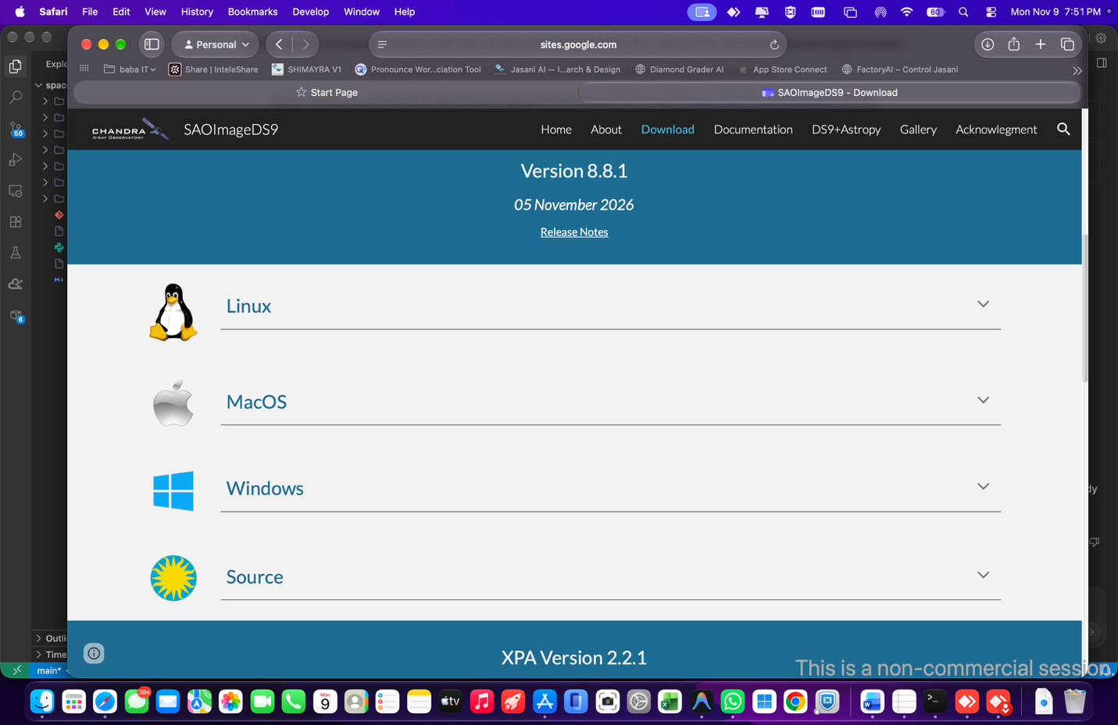

- HEASoft / XSPEC
Tutorials
- CIAO Tutorial
- DS9 Tutorial
- XSPEC Tutorial

2. Data and Reference Paper
Download the Chandra data for PSR J1826−1256 from the Chandra Data Archive.
For this project, use:
Chandra ObsID: 7641
This is the longest Chandra observation of the source, with an exposure of approximately 74.8 ks. The shorter ObsID 3851 was not used for the pulsar spectral analysis in the paper because of its much lower number of source counts.
Reference paper:
Karpova et al. (2019), X-ray studies of the gamma-ray pulsar J1826−1256 and its pulsar wind nebula with Chandra and XMM–Newton

3. Project Tasks

A. Chandra Data Reduction
- Download ObsID 7641.

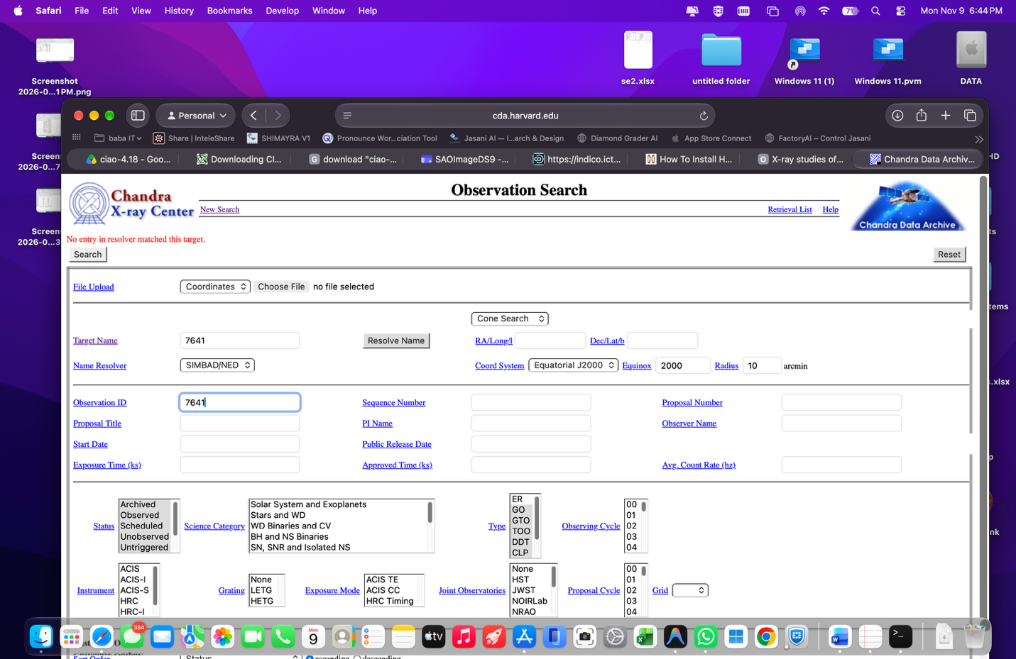

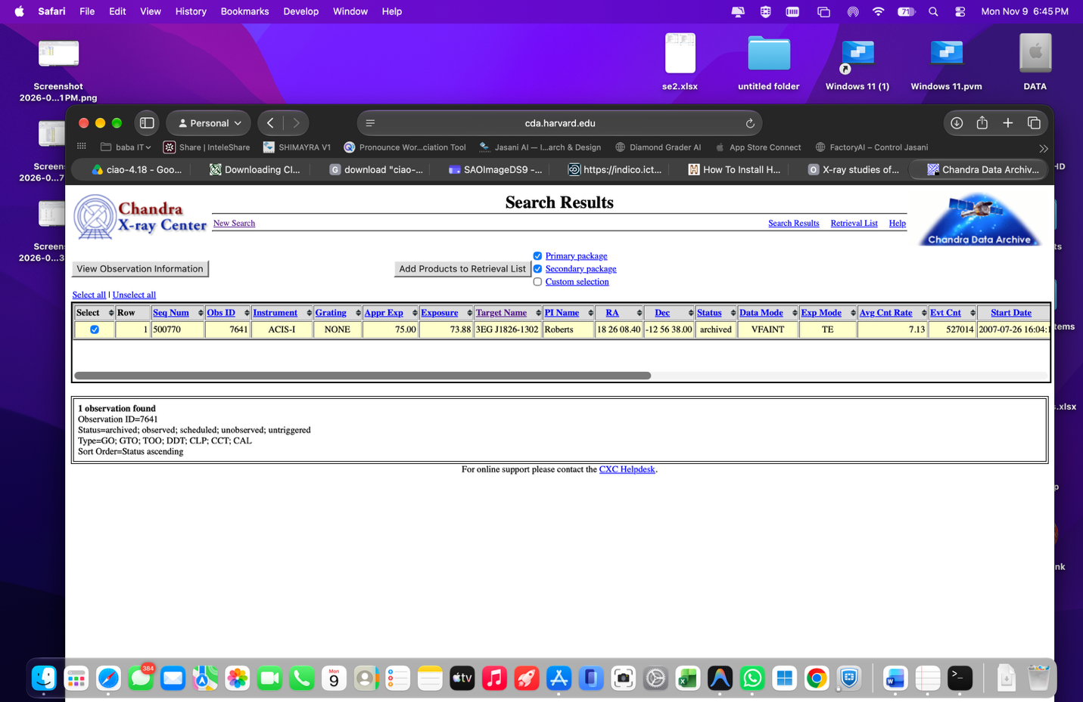

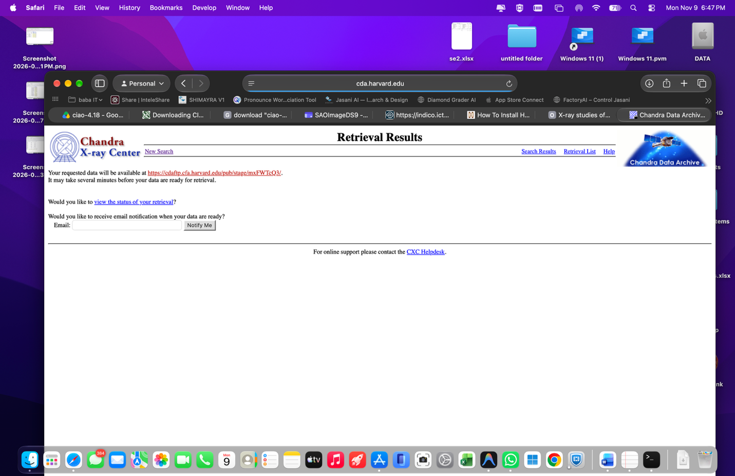

- Reprocess the observation using CIAO.- data reduction….
- Produce a clean X-ray image.
- Identify PSR J1826−1256.
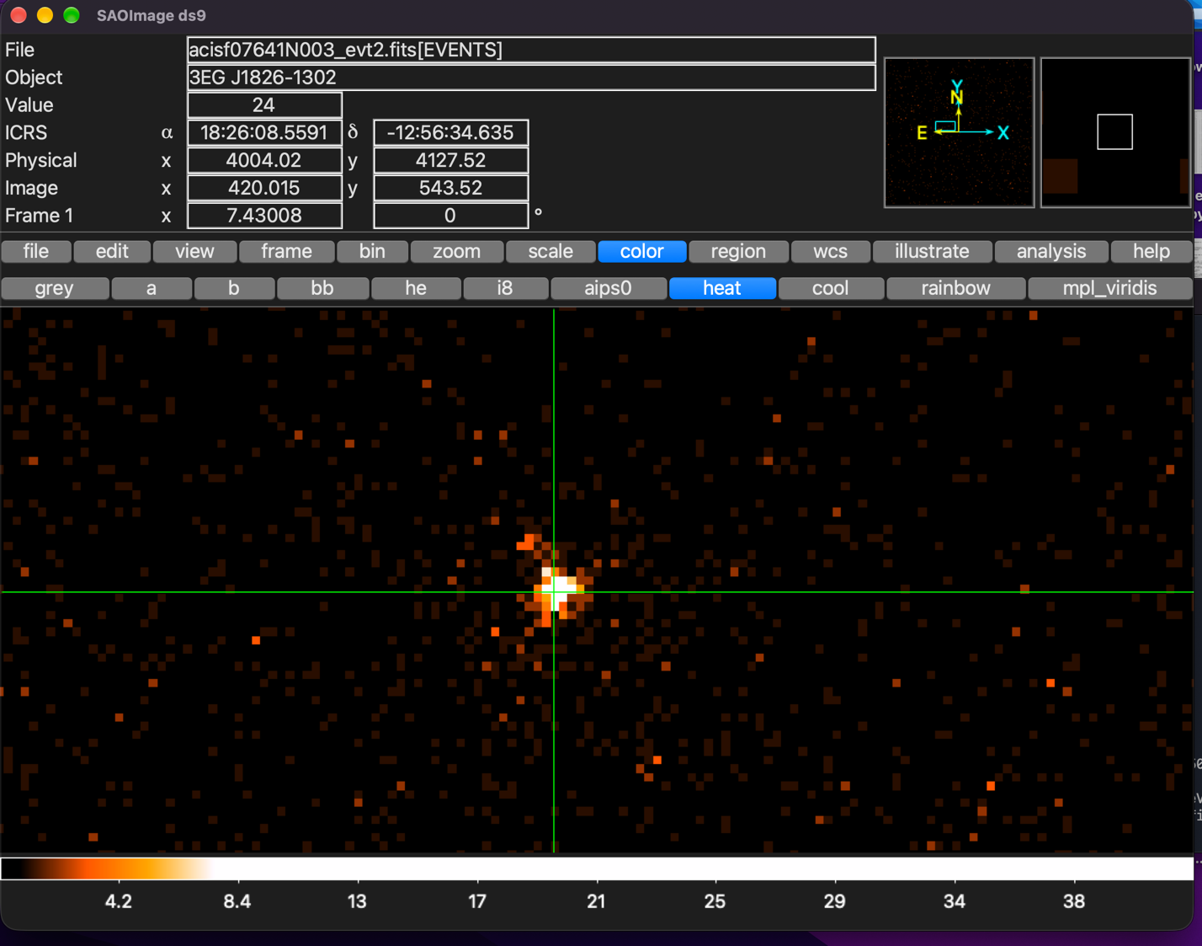

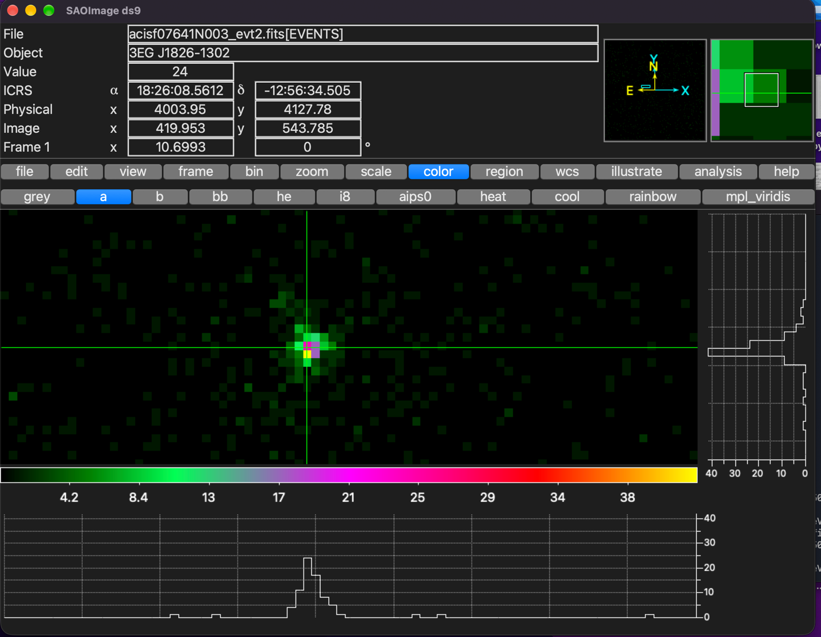

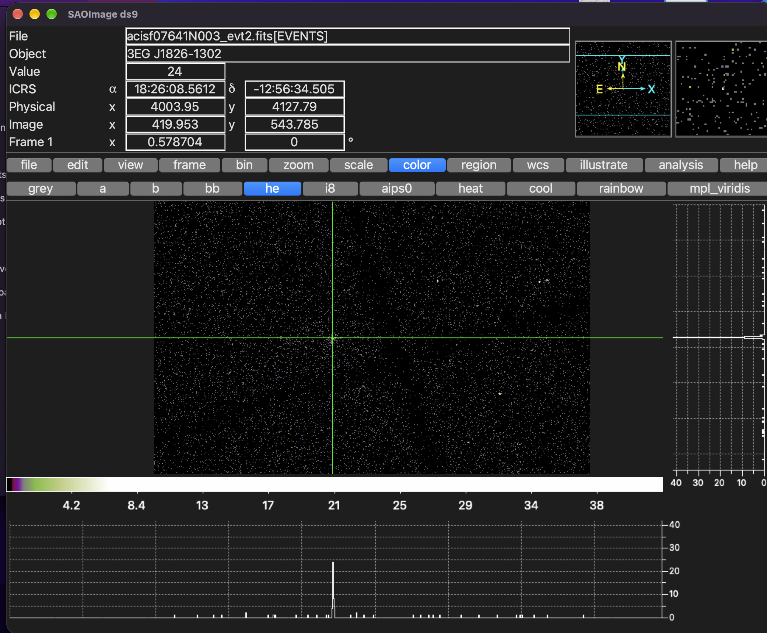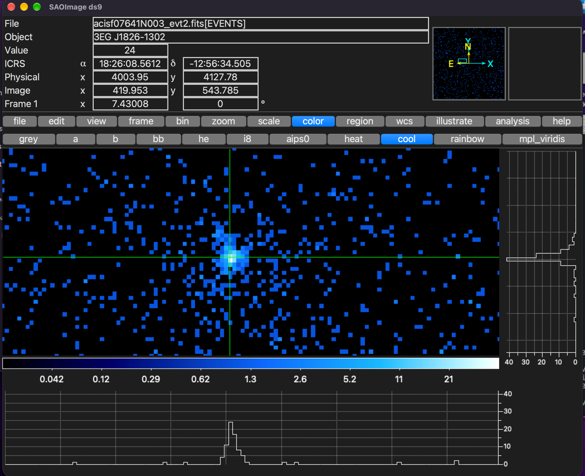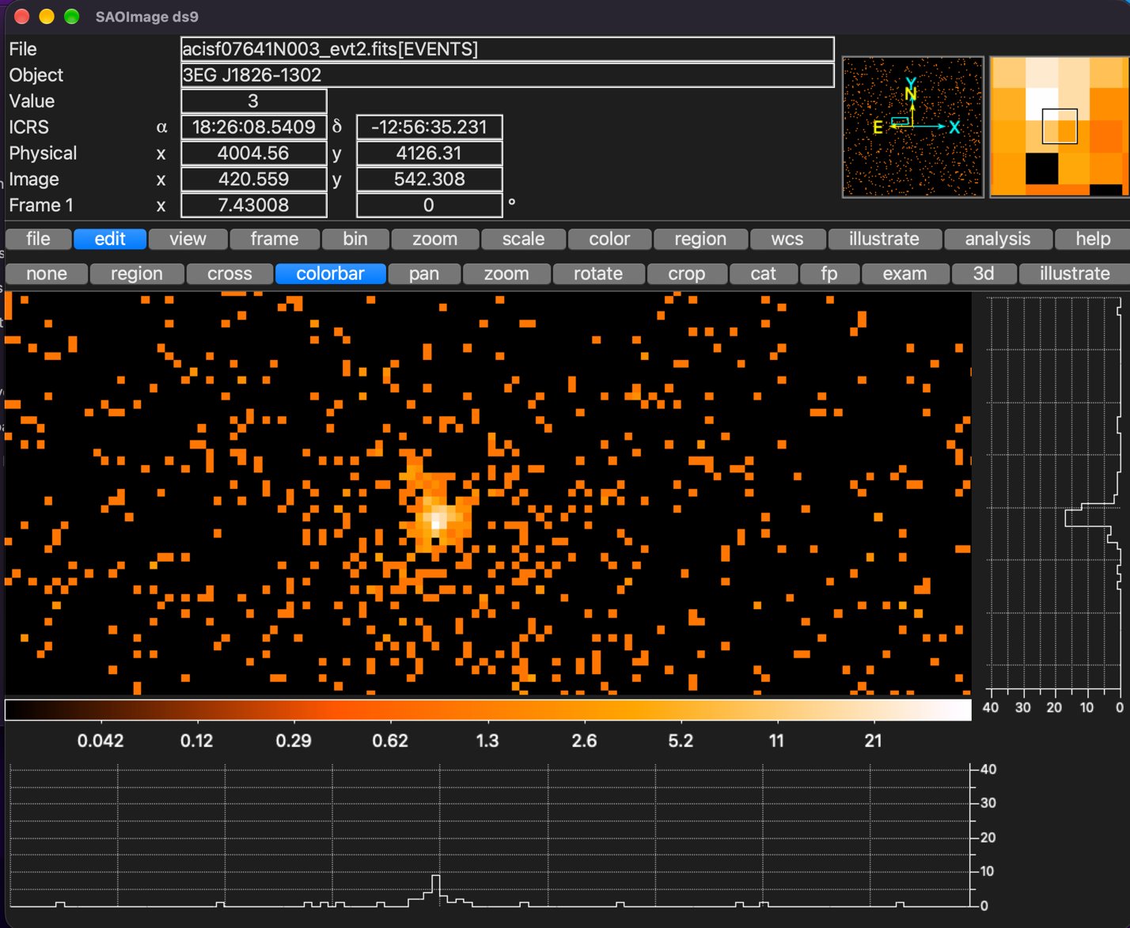
- Select an appropriate source region and background region.
- Extract the pulsar spectrum.
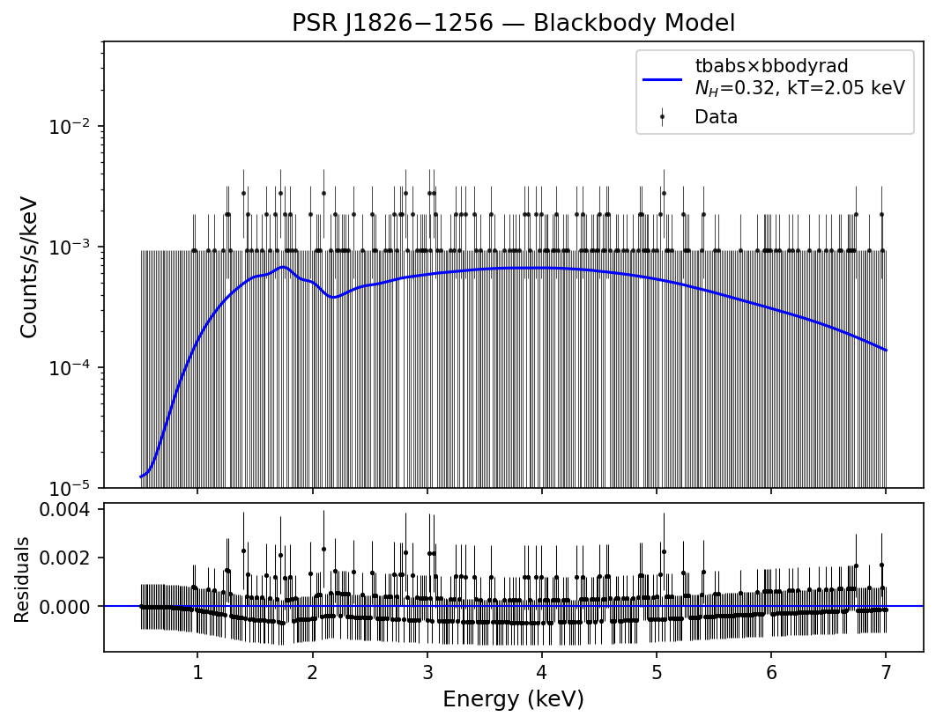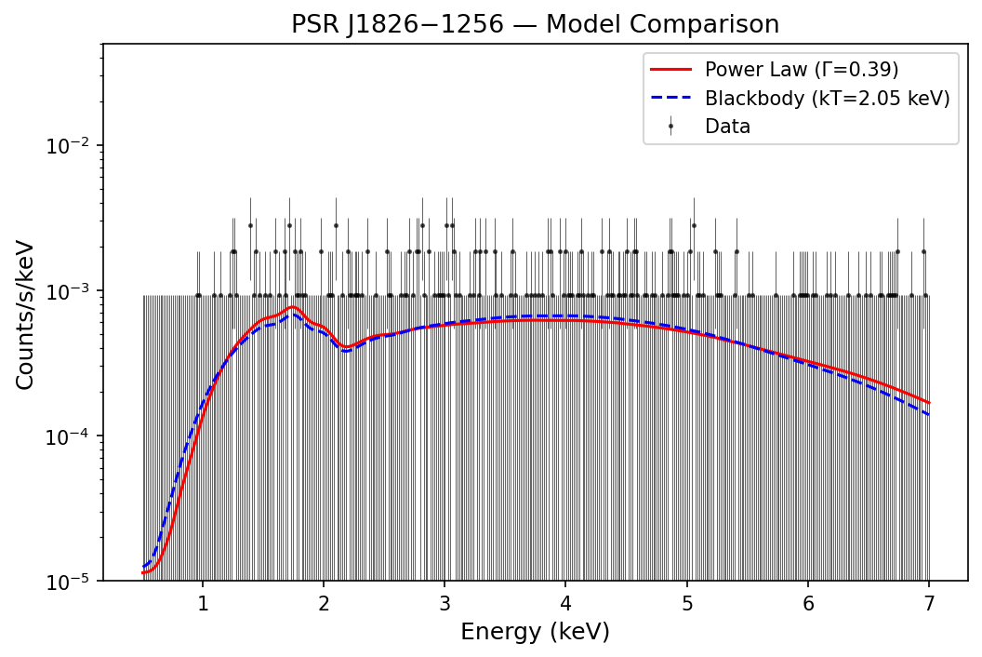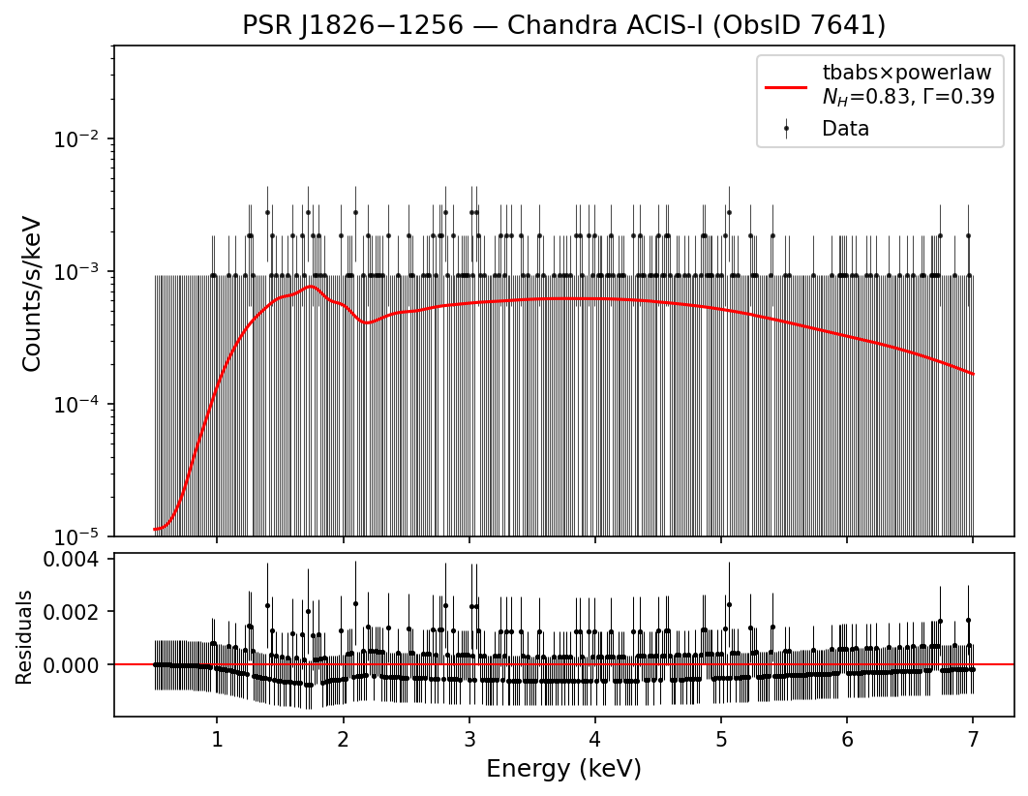

B. Spectral Analysis
Load the extracted spectrum into XSPEC and fit the spectrum with an absorbed power-law model:
tbabs*powerlaw
Determine the best-fit:
- Hydrogen column density, N_H
- Photon index, Γ
- Power-law normalization
- Absorbed flux
- Unabsorbed flux
- X-ray luminosity
- Flux density
- Energy
- Fit statistic
As an additional exercise, fit an absorbed blackbody model:
tbabs*bbodyrad
and compare the two models.

4. Comparison with the Published Results
Compare your best-fit parameters with those reported by Karpova et al. (2019).
Discuss possible differences between your results and the paper, considering:
- Source and background extraction regions
- Spectral grouping
- Energy range
- Data filtering
- Calibration/CIAO version
- XSPEC fitting procedure

5. Physical Interpretation
Explain what the fitted parameters tell you about PSR J1826−1256.
In particular, discuss:
- What does N_H tell us about the absorbing material along the line of sight?
- What does the photon index tell us about the nature of the X-ray emission?
- Why does a power-law spectrum suggest non-thermal emission?
- What does the measured X-ray luminosity tell us about the energetic nature of the pulsar?
- How does the X-ray emission of the pulsar differ from thermal emission from a neutron-star surface?
Important: Only Chandra ObsID 7641 and the PSR J1826−1256 point source are required for this project. The XMM–Newton data, ObsID 3851, and the spectral analysis of the PWN are not part of the project.
Main goal:
Reduce the Chandra ObsID 7641 data, extract and model the X-ray spectrum of PSR J1826−1256, determine its best-fit spectral parameters, and use these parameters to understand the physical nature of the pulsar's X-ray emission.

