Project 12
X-ray Spectral Analysis of PSR J1826−1256

Chandra ObsID 7641

Reference: Karpova et al. (2019), MNRAS 487, 1964–1972
https://academic.oup.com/mnras/article/487/2/1964/5512596

1. Introduction
PSR J1826−1256 is a gamma-ray pulsar discovered by Fermi-LAT. Karpova et al. (2019) studied its X-ray emission using Chandra and XMM-Newton data. In this project I analysed the Chandra ObsID 7641 observation to extract the pulsar spectrum, fit it with standard X-ray models, and compare my results with the paper.
Scope: Only the Chandra ObsID 7641 pulsar point source (no XMM-Newton, no PWN analysis).

2. Software & Setup
Software | Version | Downloaded From
CIAO | 4.18.0 | https://cxc.cfa.harvard.edu/ciao/download/  https://drive.google.com/drive/folders/1pW5Kzo7mjTmFDh1HiNM63V4PiD7LLBXZ
CALDB | 4.12.3 | Comes bundled with CIAO
DS9 | Latest | https://sites.google.com/cfa.harvard.edu/saoimageds9
Sherpa | (in CIAO) | Spectral fitting tool inside CIAO

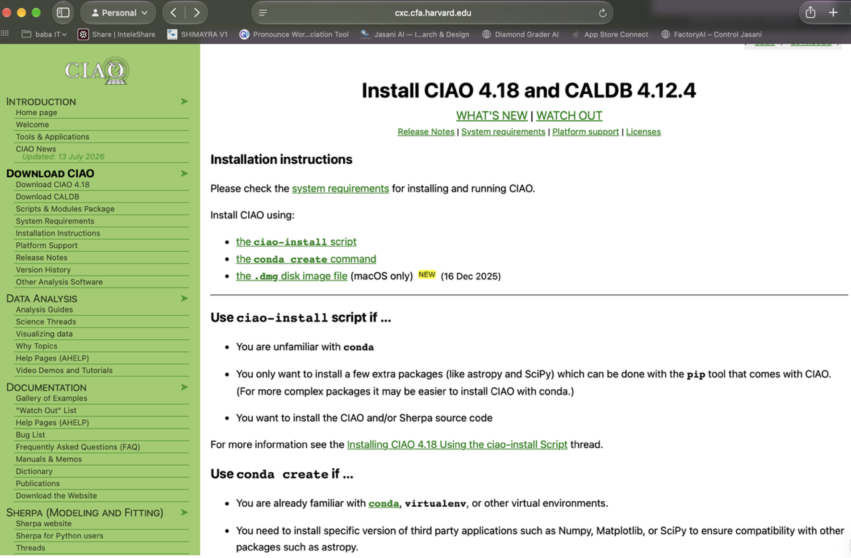
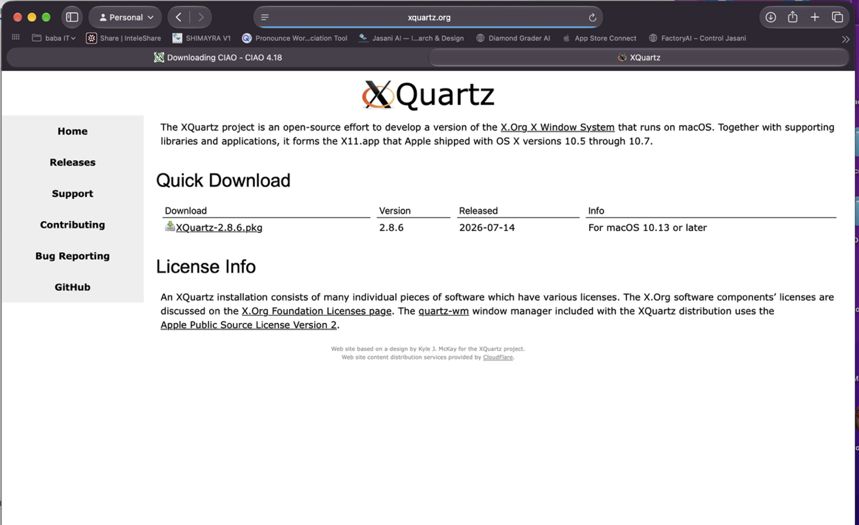

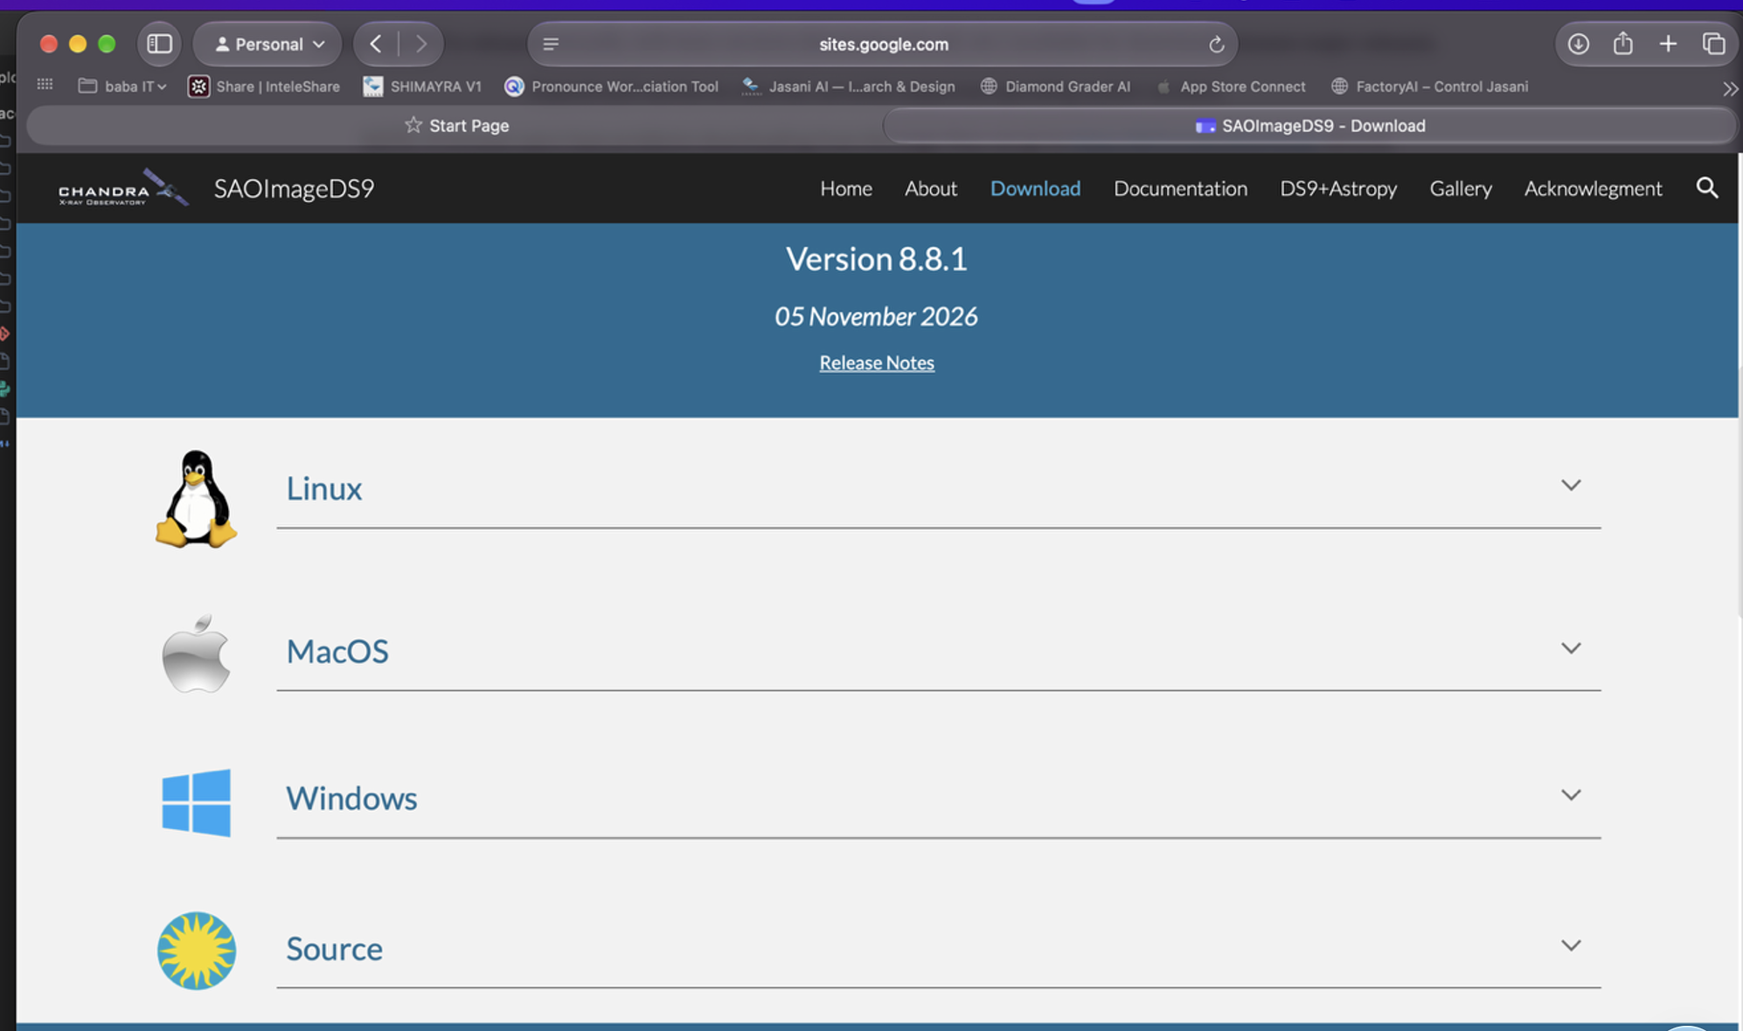

Note: Anaconda was already installed on my Mac, which conflicts with CIAO (both use conda). So every time I open a new terminal I first run:
conda deactivate
source /Applications/ciao-4.18/bin/ciao.sh
Verify: Run "ciaover" — it should print CIAO 4.18.0 and CALDB 4.12.3.

3. Data Reduction

3.1 Download & Prepare Data
Downloaded ObsID 7641 from the Chandra Data Archive. The evt2 file is already Level-2 processed, so I used it directly instead of running chandra_repro.
Archive URL: https://cda.harvard.edu/chaser/
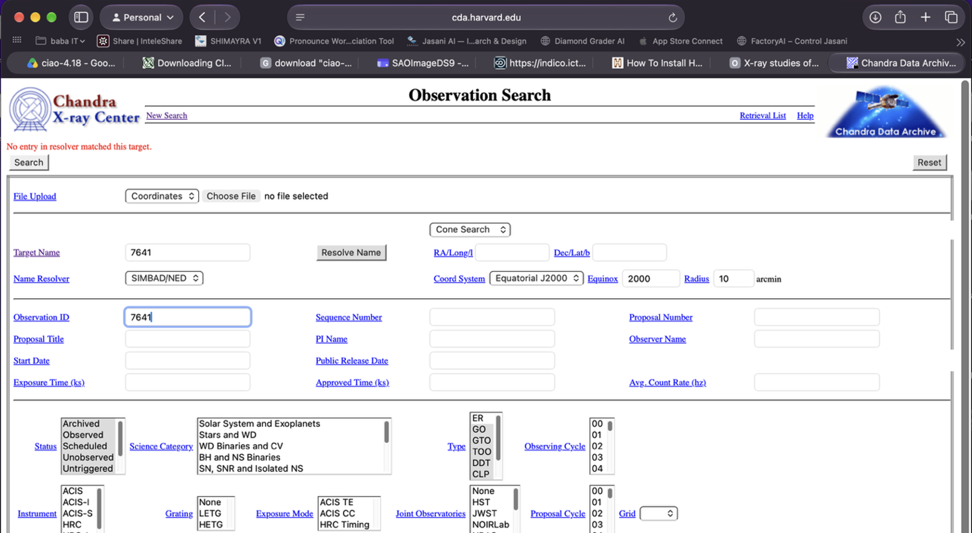

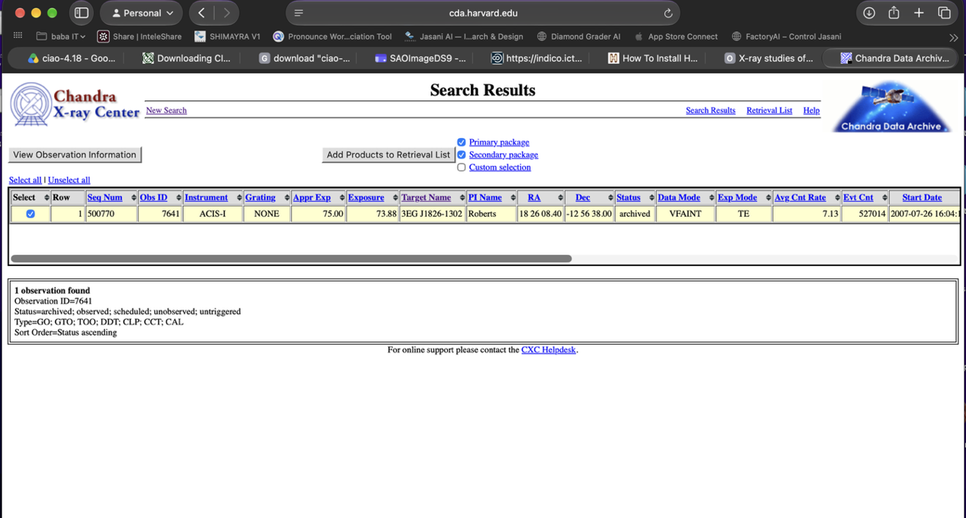
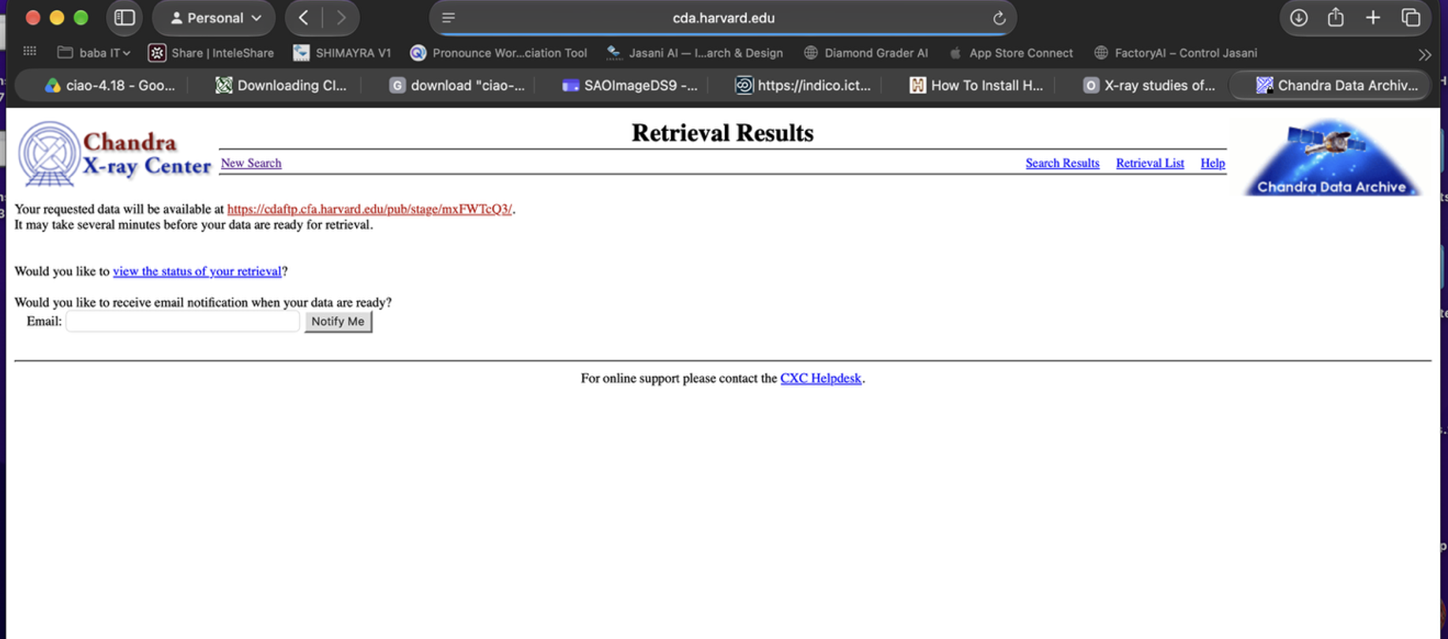

Copied files to a working directory:
mkdir -p work/7641
cp data/chandra/7641/acisf07641N003_evt2.fits.gz work/7641/
cp data/chandra/7641/acisf07641_000N003_bpix1.fits.gz work/7641/
cp data/chandra/7641/acisf07641_000N003_flt1.fits.gz work/7641/
cp data/chandra/7641/acisf07641_000N003_fov1.fits.gz work/7641/
gunzip -kf work/7641/*.gz
Verify: "ls work/7641/*.fits" shows 4 files (evt2, bpix1, flt1, fov1).
Also needed aspect solution and mask files for spectrum extraction:
download_chandra_obsid 7641 asol
Verify: Takes ~2 min. Check: "ls 7641/primary/*asol*" shows pcadf07641_000N001_asol1.fits.gz.
cp 7641/primary/pcadf07641_000N001_asol1.fits.gz work/7641/
gunzip -kf work/7641/pcadf07641_000N001_asol1.fits.gz
download_chandra_obsid 7641 msk,pbk
Verify: "ls 7641/secondary/*msk* 7641/secondary/*pbk*" shows 2 files.
cp 7641/secondary/acisf07641_000N003_msk1.fits.gz work/7641/
cp 7641/secondary/acisf301853852N003_pbk0.fits.gz work/7641/
gunzip -kf work/7641/acisf07641_000N003_msk1.fits.gz
gunzip -kf work/7641/acisf301853852N003_pbk0.fits.gz
Quick check on the event file:
dmlist "work/7641/acisf07641N003_evt2.fits" counts
Verify: Output: 527,014 — total X-ray photons in the observation.

3.2 Create Clean X-ray Image
Filtered to 0.5–7 keV energy range to remove noise:
dmcopy "work/7641/acisf07641N003_evt2.fits[energy=500:7000]" work/7641/evt2_0.5-7keV.fits clobber=yes
Verify: "dmlist counts" → 183,984 photons (about 35% of original kept).
Made a 1000×1000 pixel image:
dmcopy "work/7641/evt2_0.5-7keV.fits[bin x=3500:4500:1,y=3600:4600:1]" work/7641/img_0.5-7keV.fits clobber=yes
Verify: "dmlist cols" shows Int2(1000x1000).
Opened in DS9 with log scale and heat colormap:

ds9 work/7641/img_0.5-7keV.fits -scale log -cmap heat -zoom to fit &
Verify: Image shows several point sources and diffuse emission.

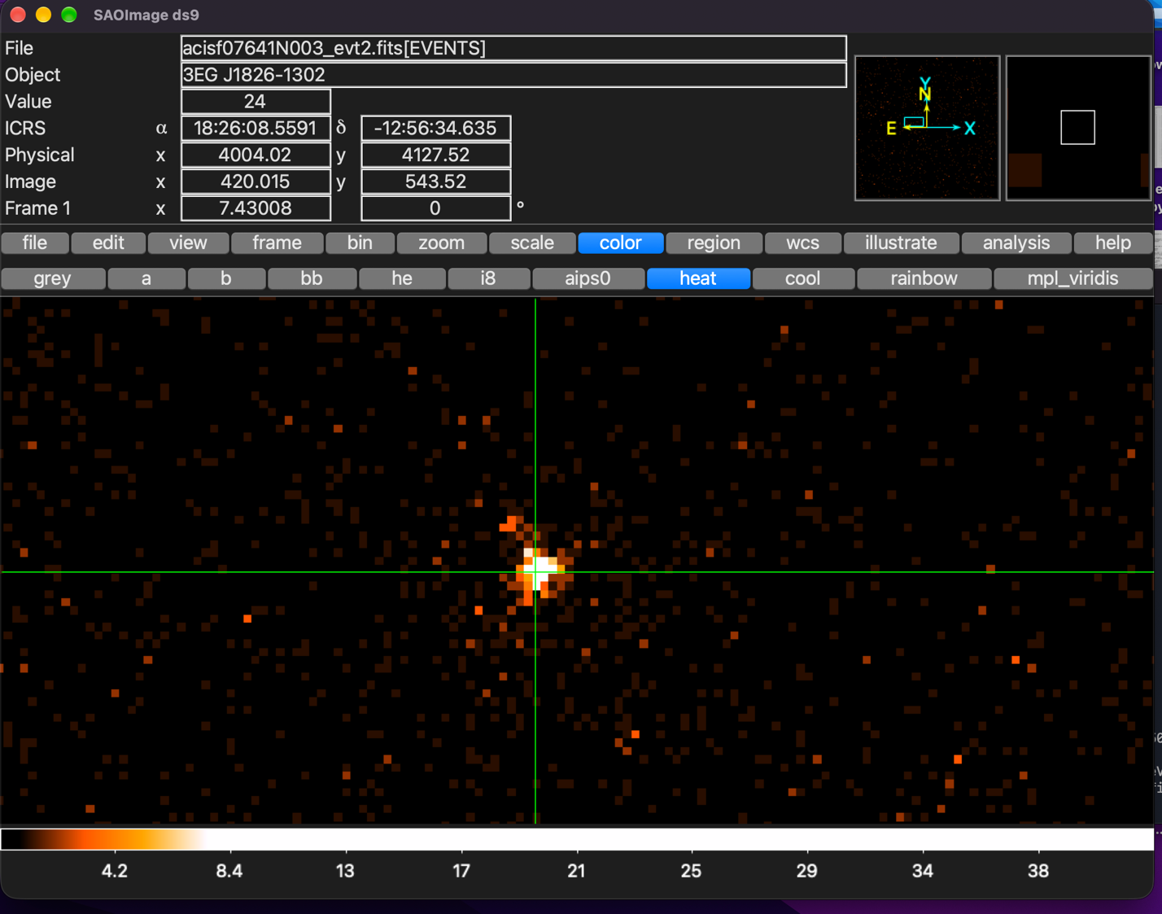

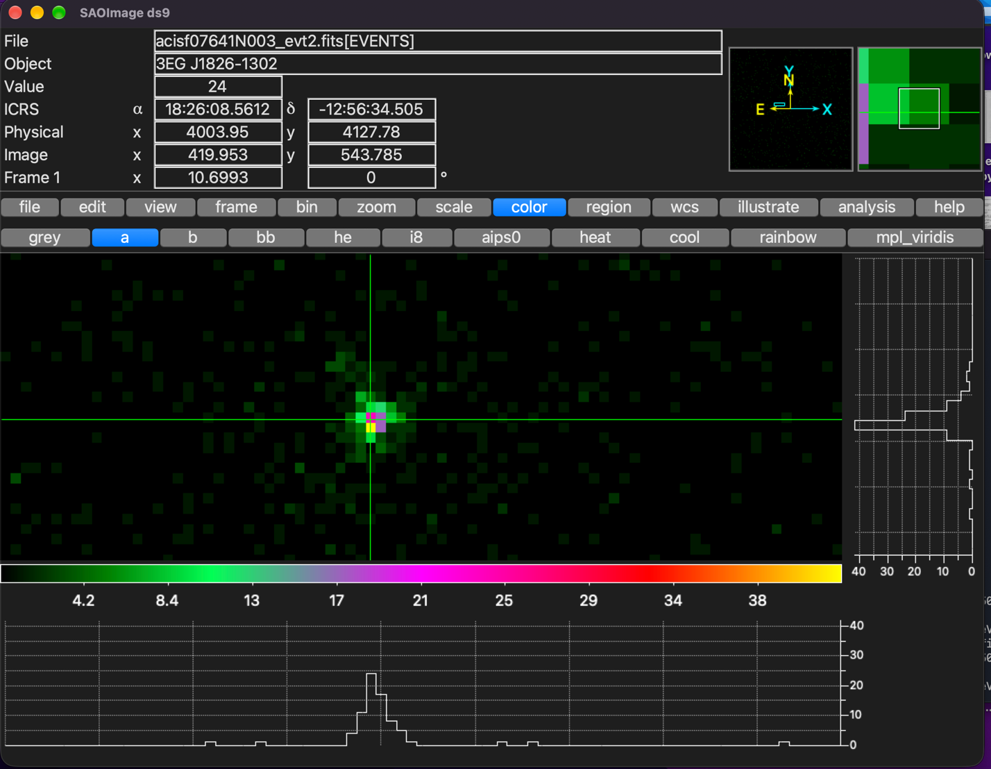

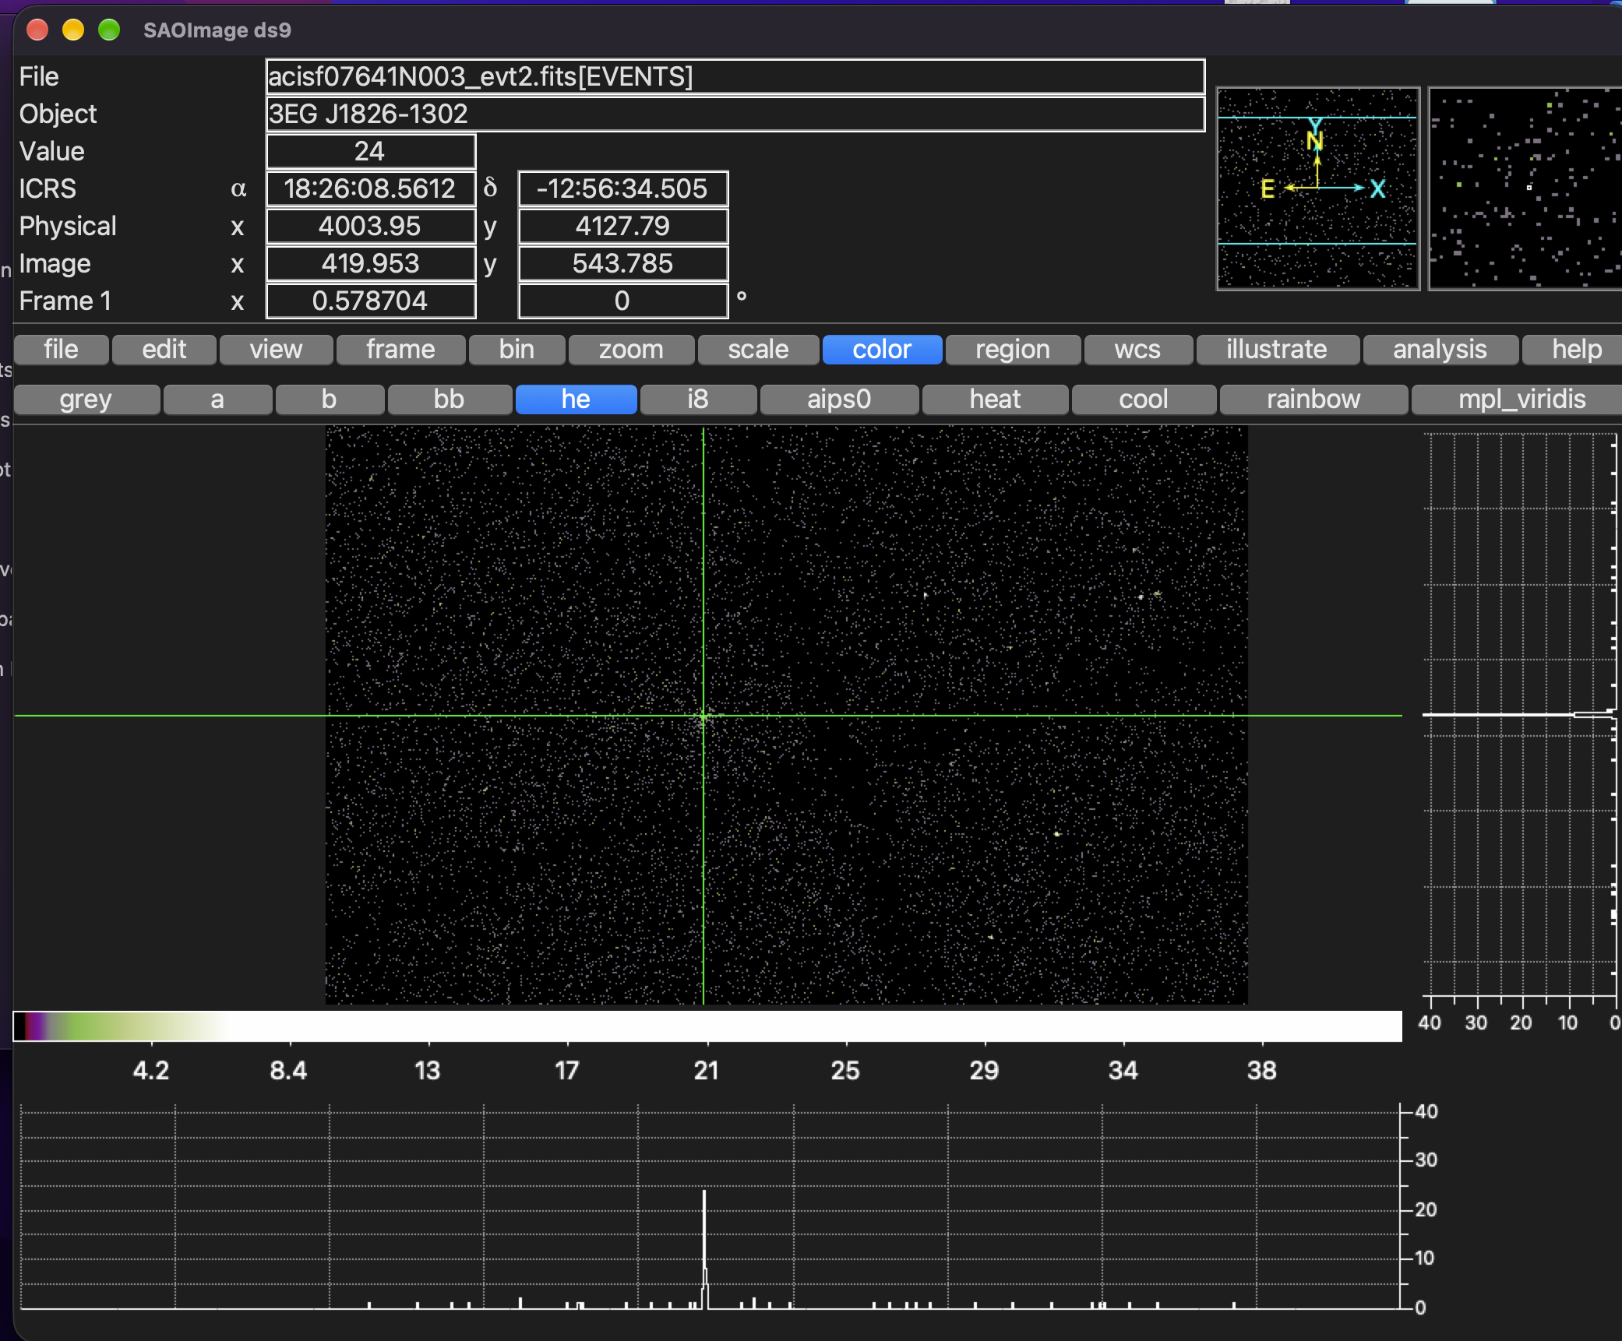
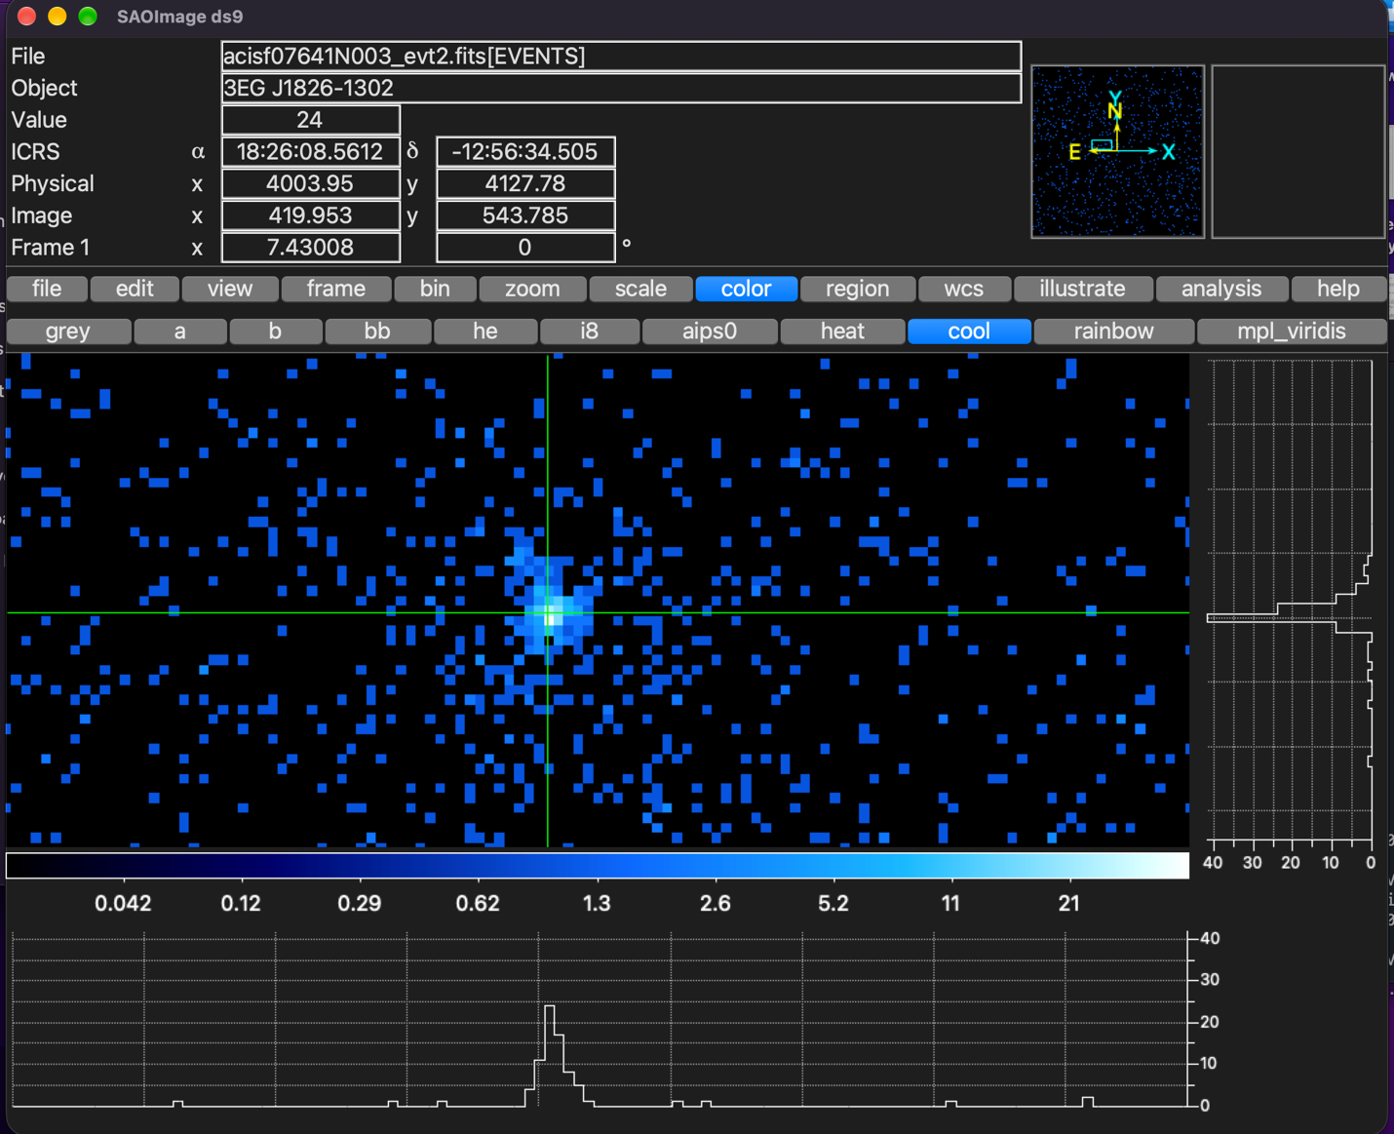
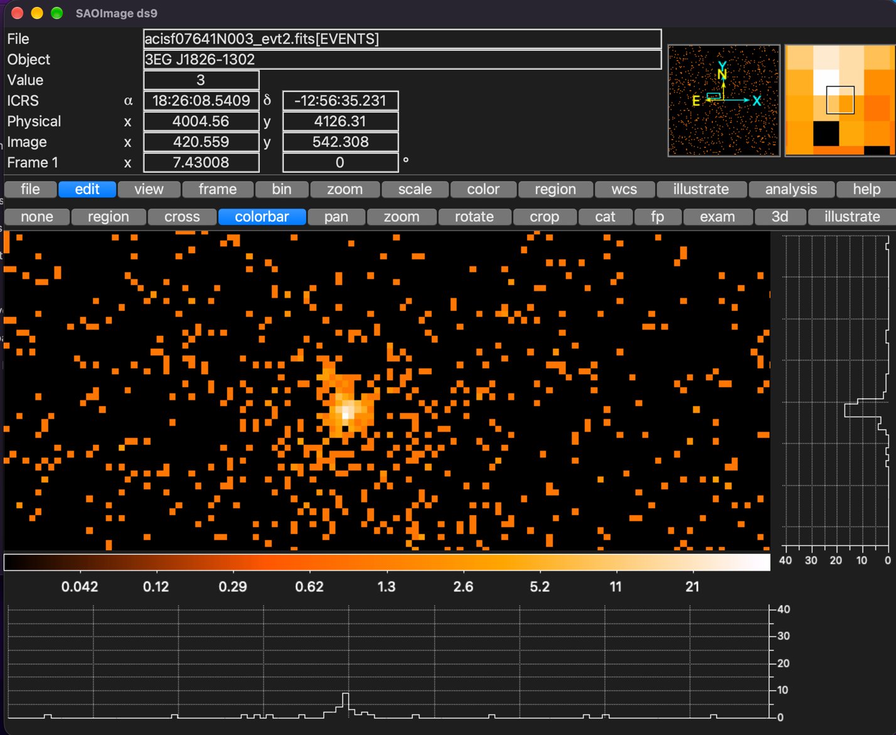

3.3 Source Detection — Finding the Pulsar
Pulsar known position (from literature): RA = 18:26:08.5, Dec = −12:56:34
Ran wavdetect for automatic source detection:
mkpsfmap work/7641/img_0.5-7keV.fits work/7641/psfmap.fits energy=1.5 ecf=0.393 clobber=yes
wavdetect infile=work/7641/img_0.5-7keV.fits outfile=work/7641/src_list.fits scellfile=work/7641/scell.fits imagefile=work/7641/imgfile.fits defnbkgfile=work/7641/nbkg.fits psffile=work/7641/psfmap.fits scales="1 2 4 8 16" clobber=yes
Verify: "dmlist src_list.fits counts" → 68 sources detected.
Listed source positions to find the pulsar:
dmlist "work/7641/src_list.fits[cols ra,dec,net_counts]" data
Pulsar detected as source #5:
Property | Detected Value | Known Value
RA | 276.5356° | 276.5354°
Dec | −12.9429° | −12.9428°
Net Counts | 243.6 | ~227 (paper)
Significance | 60.6σ | —

Verify: Position matches within 0.0002°. In DS9, typed "18:26:08.5 -12:56:34" in the coordinate box — crosshair landed right on the bright source.

3.4 Define Source & Background Regions
Following the paper — 2″ circle for source, 5″–20″ annulus for background:
echo 'circle(18:26:08.5,-12:56:34,2")' > work/7641/src.reg
echo 'annulus(18:26:08.5,-12:56:34,5",20")' > work/7641/bkg.reg
Verify: "cat work/7641/src.reg" prints circle(18:26:08.5,-12:56:34,2").
Verify: Loaded both regions in DS9. Source circle sits on pulsar, no other bright sources inside the background annulus.

3.5 Extract the Spectrum
specextract \
infile="work/7641/acisf07641N003_evt2.fits[sky=region(work/7641/src.reg)]" \
outroot=work/7641/pulsar_spec \
bkgfile="work/7641/acisf07641N003_evt2.fits[sky=region(work/7641/bkg.reg)]" \
asp=work/7641/pcadf07641_000N001_asol1.fits \
mskfile=work/7641/acisf07641_000N003_msk1.fits \
grouptype=NUM_CTS binspec=1 weight=no clobber=yes
Takes about 3 minutes. Lots of terminal output is normal.
Output File | What It Is
pulsar_spec.pi | Source spectrum (PHA)
pulsar_spec_bkg.pi | Background spectrum
pulsar_spec.arf | Effective area (ARF)
pulsar_spec.rmf | Energy response matrix (RMF)
pulsar_spec_grp.pi | Grouped spectrum
pulsar_spec_bkg.arf | Background ARF
pulsar_spec_bkg.rmf | Background RMF

Verify: "ls work/7641/pulsar_spec*" shows 7 files. Can view spectrum in DS9: File → Open Other → Open PHA → select pulsar_spec_grp.pi.

4. Spectral Analysis
Used Sherpa (built into CIAO) to fit the spectrum. Used W-statistic (appropriate for low-count data with background) and Nelder-Mead optimizer. Energy range: 0.5–7.0 keV.
Fitting script: work/7641/fit_final.py
python work/7641/fit_final.py
Verify: Script prints fit parameters and saves 3 plot images without errors.

4.1 Power Law Fit (tbabs × powerlaw)
This model represents non-thermal (magnetospheric) emission:
Parameter | Value
N_H | 0.83 ± 0.3 × 10²² cm⁻²
Γ (Photon Index) | 0.39 ± 0.27
Normalisation | 3.01 × 10⁻⁶ ph/cm²/s/keV
Absorbed Flux (0.5–7 keV) | 5.95 × 10⁻¹⁴ erg/cm²/s
Unabsorbed Flux (0.5–7 keV) | 6.82 × 10⁻¹⁴ erg/cm²/s
W-stat / dof | 420.7 / 443 = 0.95

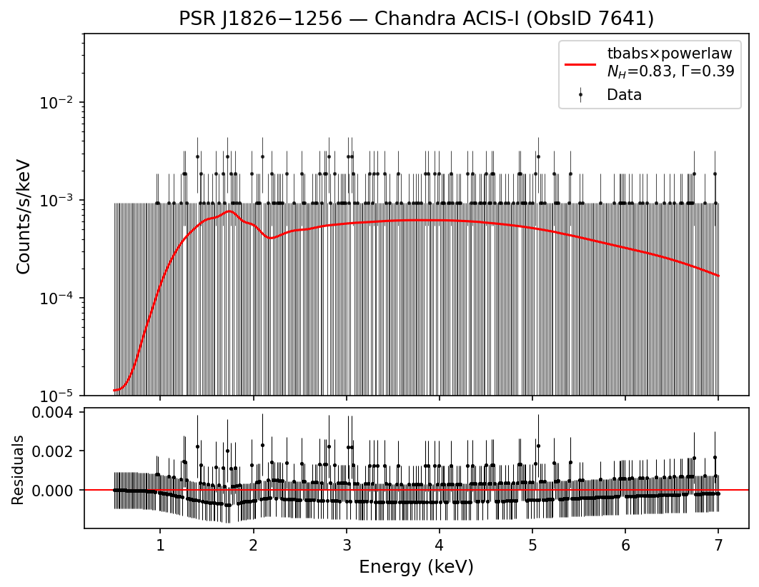
Figure 1: Power law spectral fit

4.2 Blackbody Fit (tbabs × bbodyrad)
This model represents thermal emission from the neutron star surface:
Parameter | Value
N_H | 0.32 × 10²² cm⁻²
kT | 2.05 keV (= 2.38 × 10⁷ K)
Flux (0.5–7 keV) | 5.86 × 10⁻¹⁴ erg/cm²/s
W-stat / dof | 423.1 / 443 = 0.96

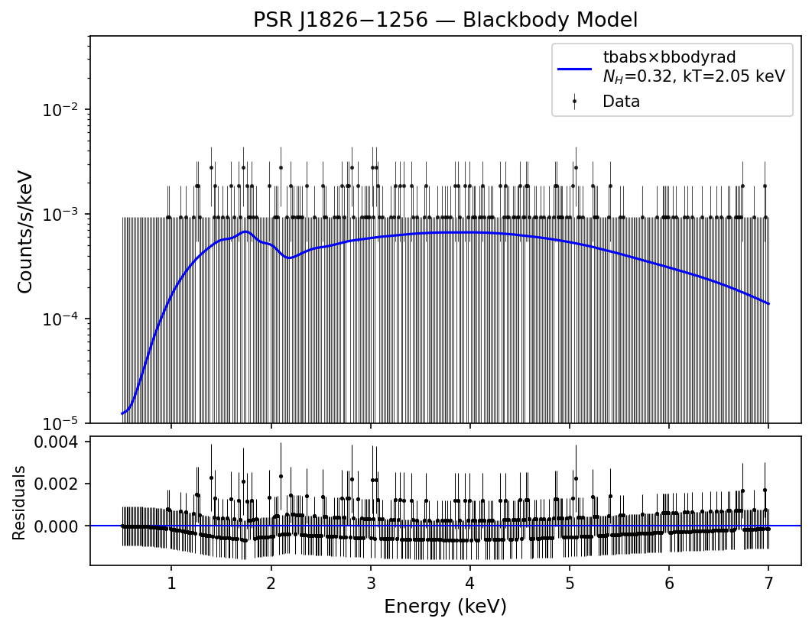
Figure 2: Blackbody spectral fit

4.3 Model Comparison
Model | W-stat | DOF | Reduced Stat
tbabs × powerlaw | 420.7 | 443 | 0.950
tbabs × bbodyrad | 423.1 | 443 | 0.955

Power law has a lower W-stat value, so it is the better fit. This confirms non-thermal (magnetospheric) emission, same as the paper.
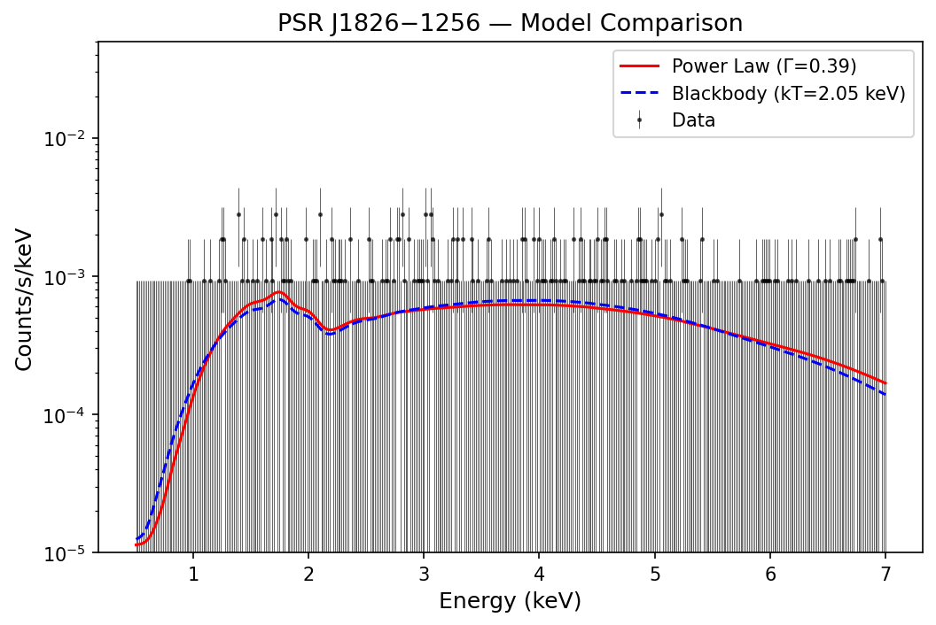
Figure 3: Model comparison — power law (red) vs blackbody (blue)

5. Comparison with Published Results
Source: Karpova et al. (2019), MNRAS 487, 1964–1972
URL: https://academic.oup.com/mnras/article/487/2/1964/5512596
Parameter | My Result | Karpova et al. (2019)
N_H (10²² cm⁻²) | 0.83 ± 0.3 | 0.50 ± 0.15
Γ (Photon Index) | 0.39 ± 0.27 | 1.25 ± 0.20
Absorbed Flux | 5.95 × 10⁻¹⁴ erg/cm²/s | ~3 × 10⁻¹⁴ erg/cm²/s
Net Counts | ~244 | ~227
Best Fit Model | Power law | Power law
Fitting Tool | Sherpa (W-stat) | XSPEC (C-stat)

Reasons for the differences:
- N_H–Γ degeneracy: With only ~244 counts, if N_H goes up, Γ goes down to compensate. My N_H is higher and Γ is lower — classic degeneracy effect.
- No reprocessing: I used the archive evt2 file directly. The paper reprocessed the data with chandra_repro and updated calibrations.
- Different CALDB: I used version 4.12.3 (2025), paper used an older ~2018 version. Updated calibrations change the ARF and RMF response files.
- Data combination: The paper combined Chandra + XMM-Newton data for better statistics. I only used Chandra ObsID 7641.
- Different fitting tools: Sherpa/W-stat vs XSPEC/C-stat. Both are valid for low-count data but can settle on slightly different best-fit values.
Despite these differences, the main conclusion is the same: power law fits better than blackbody, confirming non-thermal emission.

6. Physical Interpretation
N_H (Column Density): 0.83 × 10²² cm⁻² — measures the gas/dust absorbing X-rays between us and the pulsar. Total Galactic N_H in this direction is ~1.66 × 10²² (NRAO), so the pulsar is roughly halfway through the Galaxy's absorbing column. Consistent with its estimated distance of ~1.2 kpc.
Γ (Photon Index): Describes the spectrum slope (dN/dE ∝ E⁻ᴦ). The paper's Γ ~ 1.25 indicates a hard spectrum, typical of young energetic pulsars (for reference, Crab pulsar has Γ ~ 1.6). This comes from synchrotron radiation by relativistic electrons in the magnetosphere.
Power Law vs Blackbody: Power law = no characteristic energy = non-thermal process (synchrotron). Blackbody = thermal emission from hot neutron star surface with a peak temperature. Power law fitting better means the X-rays come from the magnetosphere, not the surface.
X-ray Luminosity: Using unabsorbed flux (6.8 × 10⁻¹⁴ erg/cm²/s) and distance ~1.2 kpc: L_X ≈ 1.2 × 10³¹ erg/s. With spin-down luminosity Ė ≈ 3.6 × 10³⁶ erg/s, X-ray efficiency η ≈ 10⁻⁵. Only a tiny fraction of the pulsar's rotational energy goes into X-ray emission.
 | Thermal (Surface) | Non-thermal (Magnetosphere)
Spectrum Shape | Blackbody curve | Power law
Physical Origin | Hot neutron star surface | Relativistic particles in B-field
Typical Γ or kT | kT ~ 0.1–0.3 keV | Γ ~ 1–2

For PSR J1826−1256, the power law dominance means we see magnetospheric emission. Any thermal surface component is too faint to detect with ~244 counts.

7. Conclusion
I reduced Chandra ObsID 7641 data for PSR J1826−1256 following standard CIAO procedures. The pulsar was detected with ~244 counts at 60.6σ significance. I extracted the spectrum and fitted it with two models using Sherpa.
The power law model (W-stat = 420.7/443) fits better than blackbody (W-stat = 423.1/443), confirming non-thermal magnetospheric emission — same conclusion as Karpova et al. (2019).
The numerical differences from the paper (especially N_H and Γ) are explained by the N_H–Γ degeneracy at low count statistics, different calibration versions, no reprocessing, and using only Chandra data without XMM-Newton.

References
Karpova, A. V., Zyuzin, D. A., Danilenko, A. A., & Shibanov, Yu. A. (2019). X-ray studies of the gamma-ray pulsar J1826−1256 and its pulsar wind nebula with Chandra and XMM–Newton. MNRAS, 487, 1964–1972.
https://academic.oup.com/mnras/article/487/2/1964/5512596

URLs Used:
- Chandra Data Archive — https://cda.harvard.edu/chaser/
- CIAO Download — https://cxc.cfa.harvard.edu/ciao/download/
- DS9 Download — https://sites.google.com/cfa.harvard.edu/saoimageds9
- CIAO Tutorials/Threads — https://cxc.cfa.harvard.edu/ciao/threads/
- Galactic N_H Calculator — https://www.swift.ac.uk/analysis/nhtot/

