Project 12
X-ray Spectral Analysis of PSR J1826−1256

Chandra ObsID 7641
Aarush Waghmare, 250014

Reference: Karpova et al. (2019), MNRAS 487, 1964–1972
https://academic.oup.com/mnras/article/487/2/1964/5512596

1. Introduction
PSR J1826−1256 is a gamma-ray pulsar discovered by Fermi-LAT. Karpova et al. (2019) studied its X-ray emission using Chandra and XMM-Newton data. In this project I analysed the Chandra ObsID 7641 observation to extract the pulsar spectrum, fit it with standard X-ray models, and compare my results with the paper.
Scope: Only the Chandra ObsID 7641 pulsar point source (no XMM-Newton, no PWN analysis).

2. Software & Setup
Software | Version | Downloaded From
CIAO | 4.18.0 | https://cxc.cfa.harvard.edu/ciao/download/  https://drive.google.com/drive/folders/1pW5Kzo7mjTmFDh1HiNM63V4PiD7LLBXZ
CALDB | 4.12.3 | Comes bundled with CIAO
DS9 | Latest | https://sites.google.com/cfa.harvard.edu/saoimageds9
Sherpa | (in CIAO) | Spectral fitting tool inside CIAO

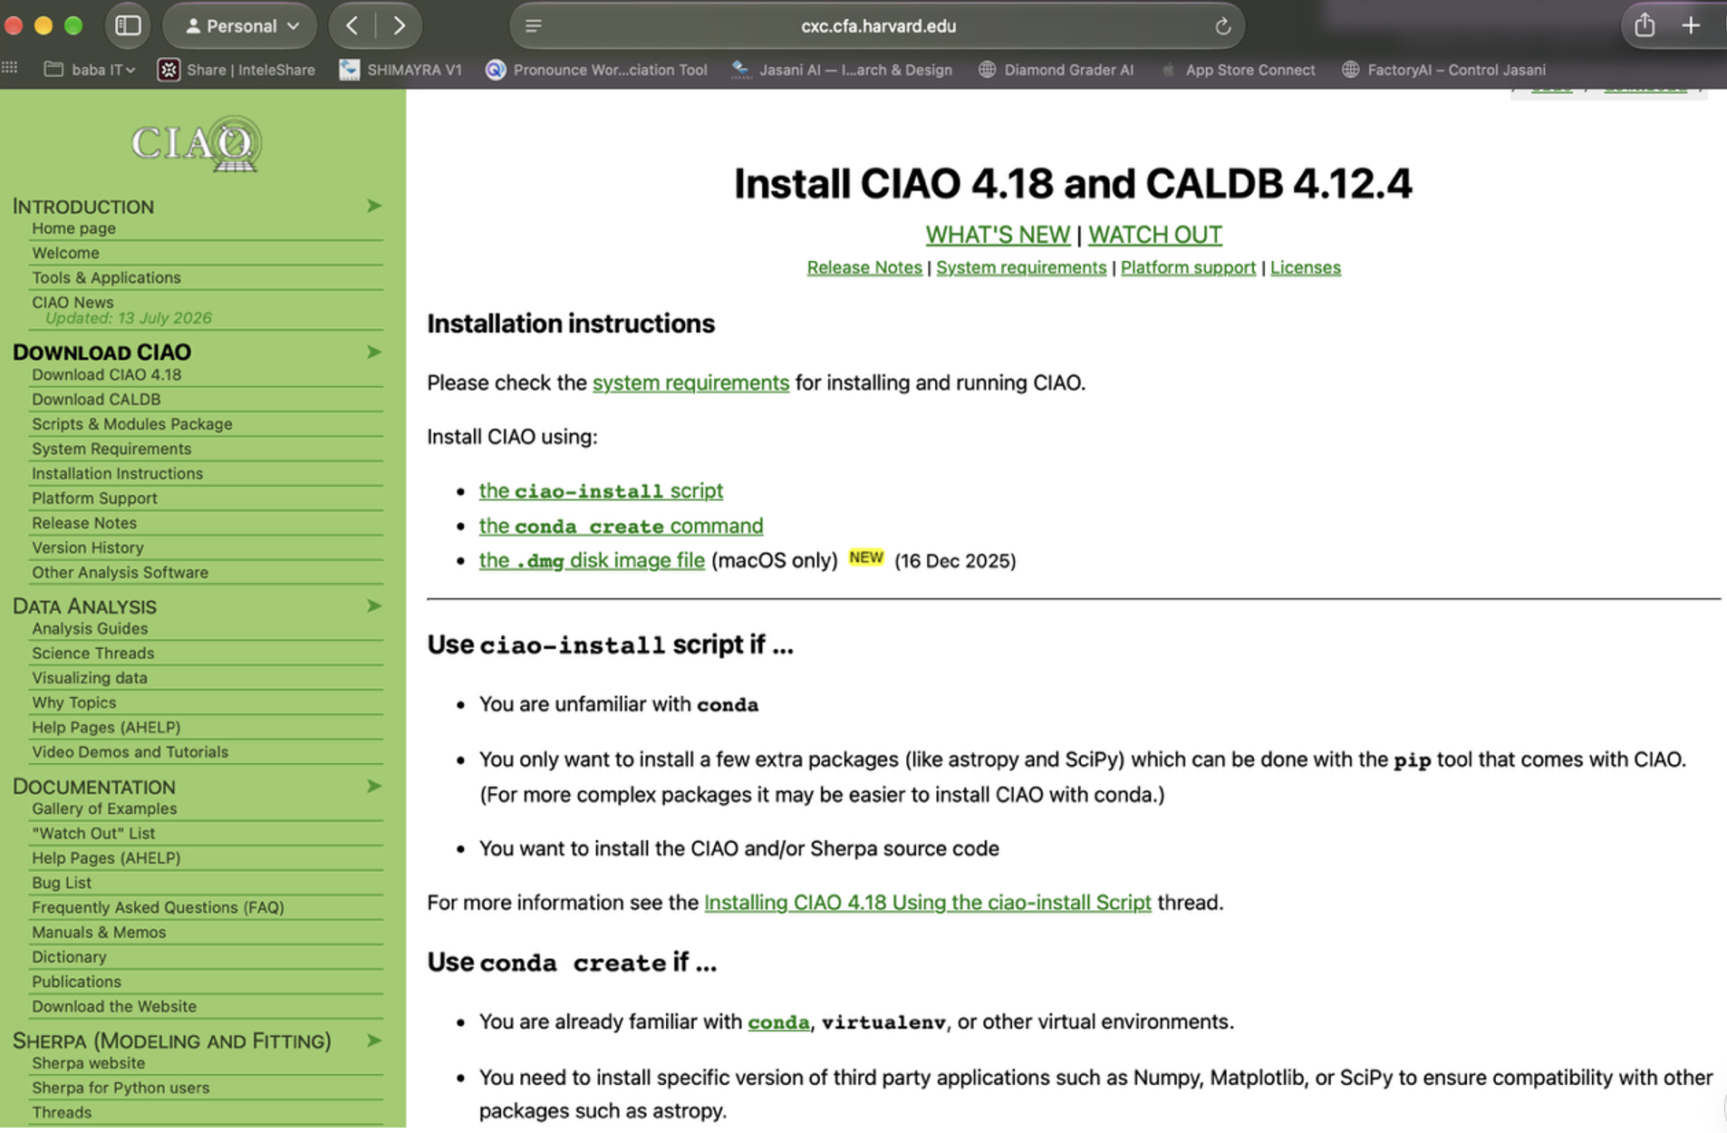
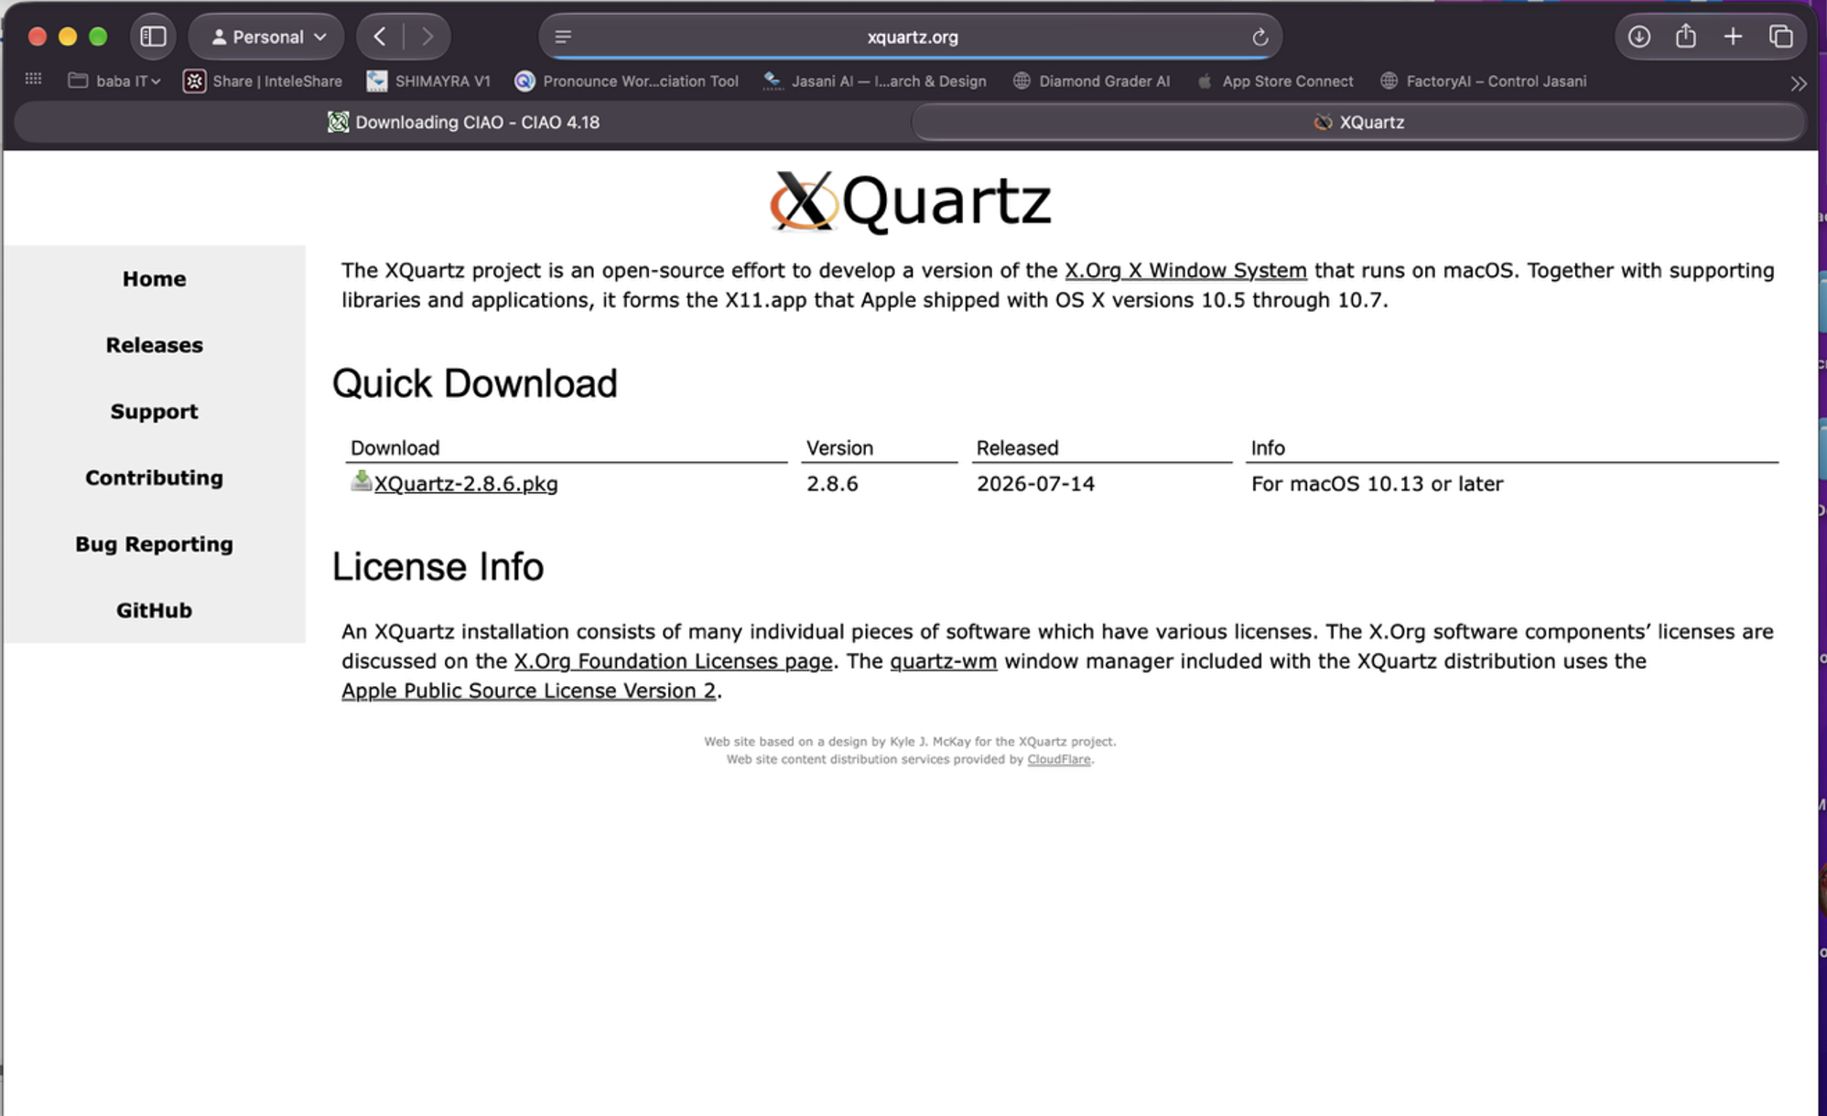

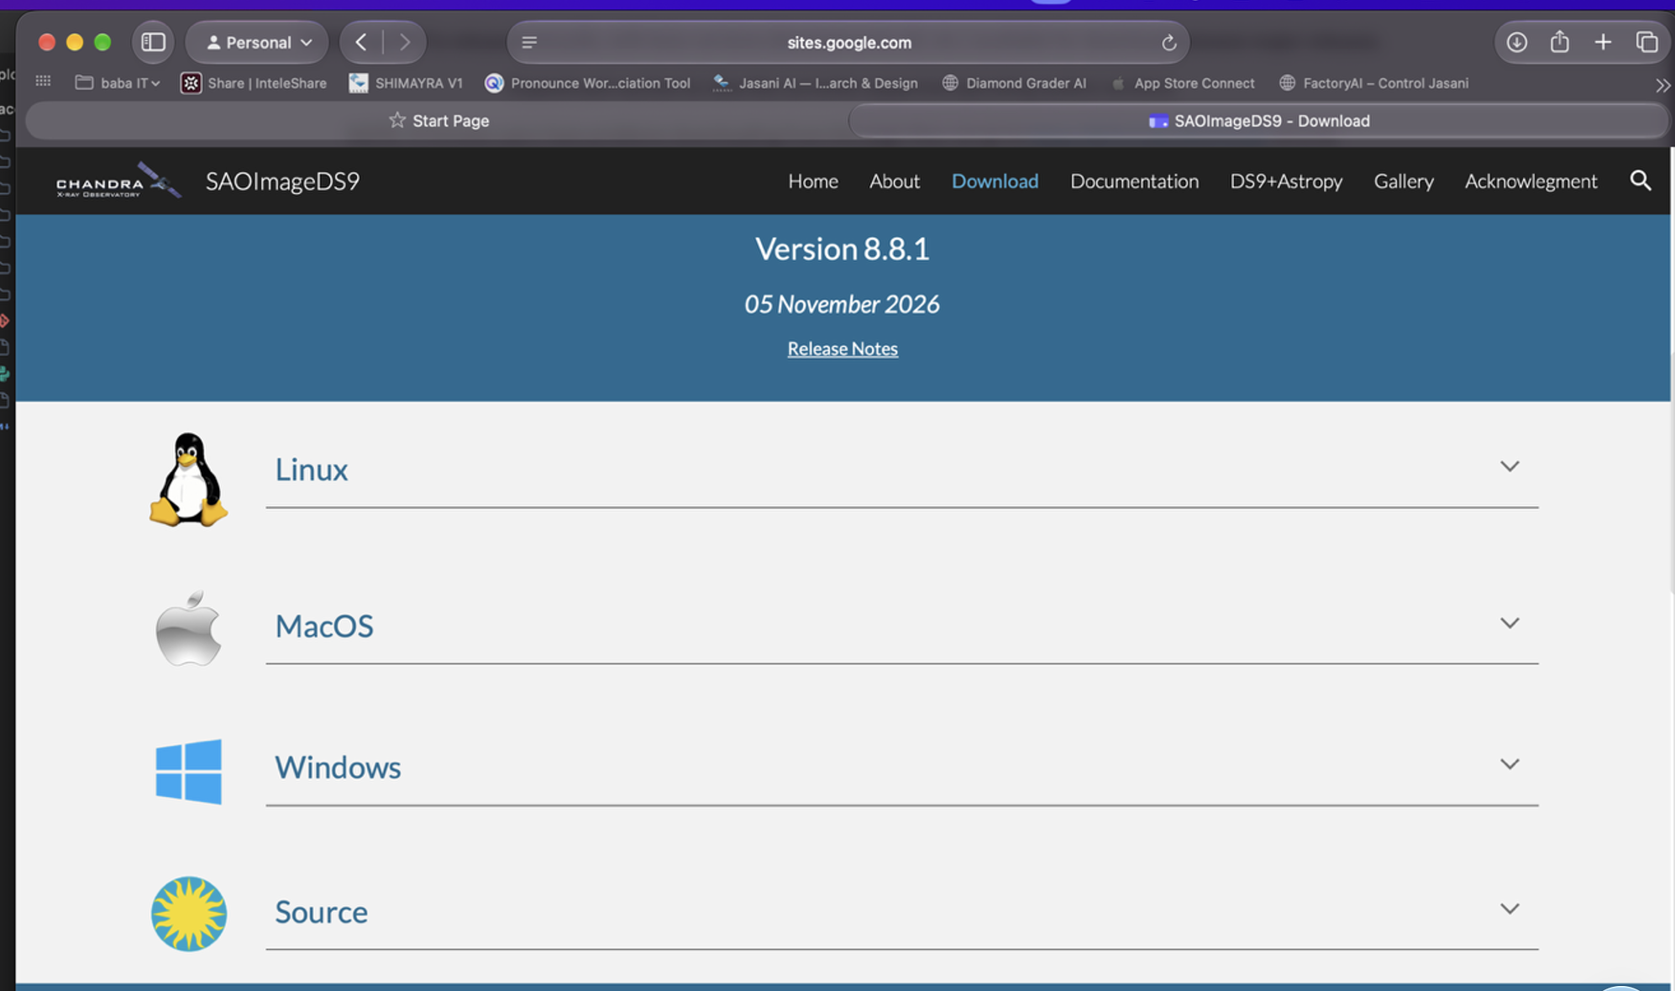

Note: Anaconda was already installed on my Mac, which conflicts with CIAO (both use conda). So every time I open a new terminal I first run:
conda deactivate
source /Applications/ciao-4.18/bin/ciao.sh
Verify: Run "ciaover" — it should print CIAO 4.18.0 and CALDB 4.12.3.

3. Data Reduction

3.1 Download & Prepare Data
Downloaded ObsID 7641 from the Chandra Data Archive. The evt2 file is already Level-2 processed, so I used it directly instead of running chandra_repro.
Archive URL: https://cda.harvard.edu/chaser/
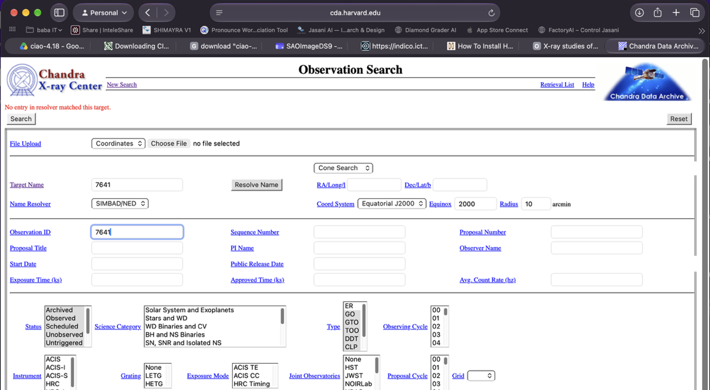

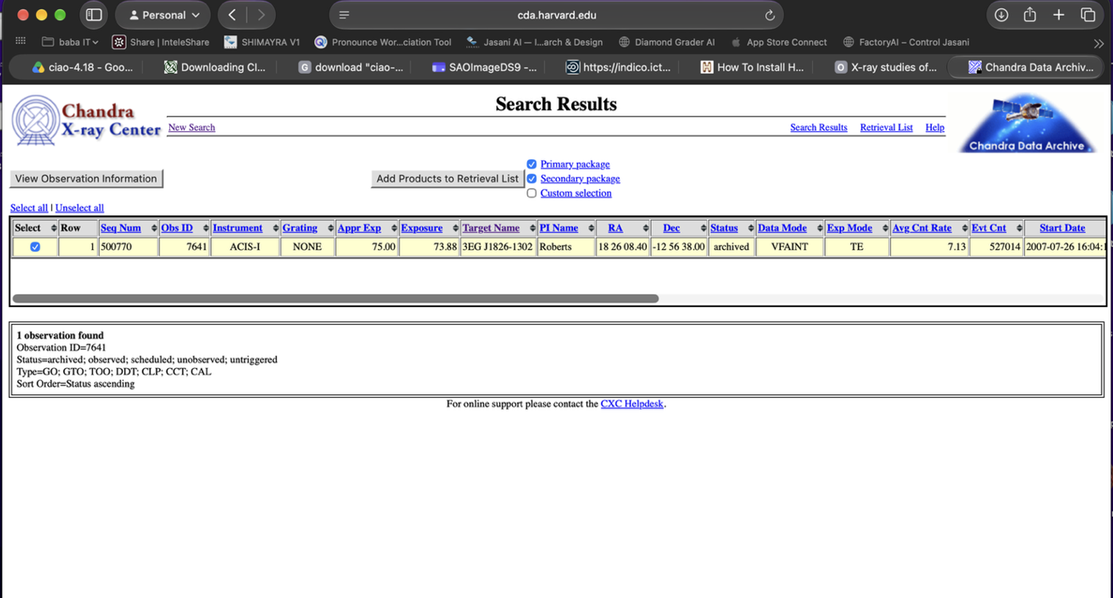
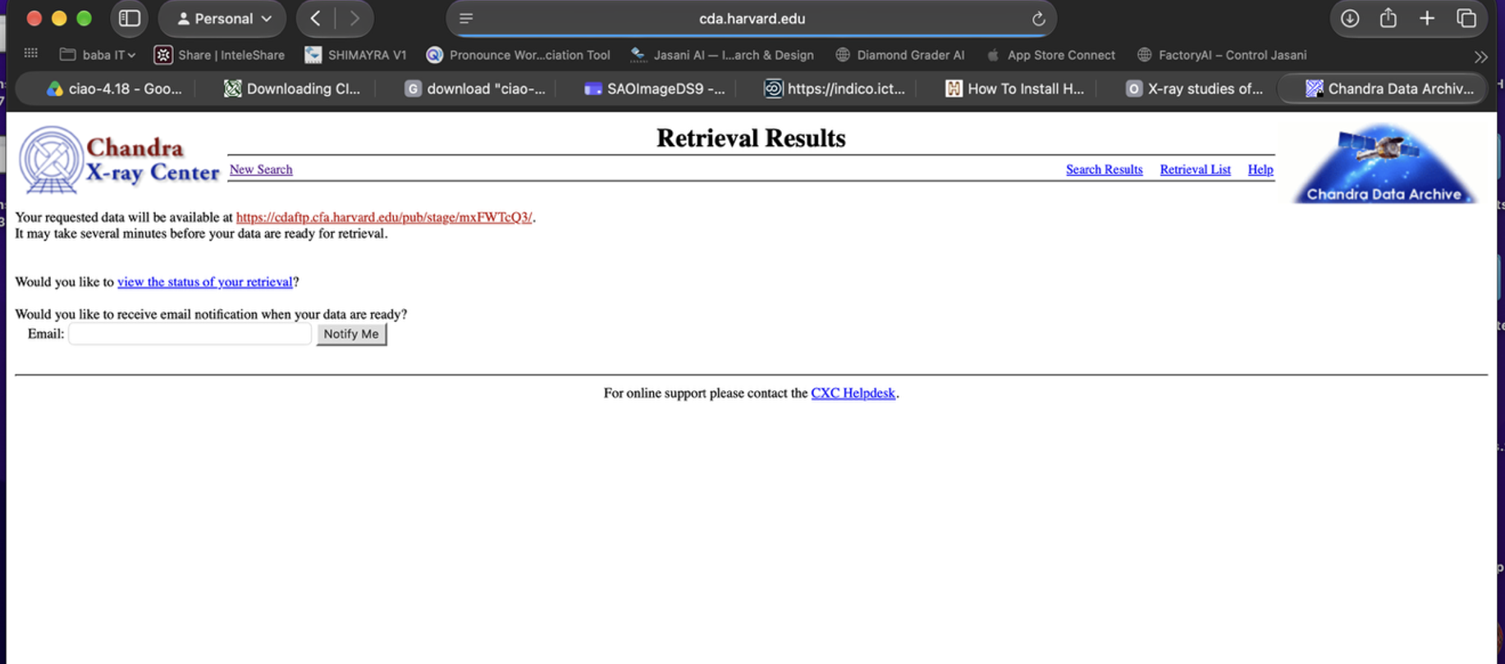

Copied files to a working directory:
mkdir -p work/7641
cp data/chandra/7641/acisf07641N003_evt2.fits.gz work/7641/
cp data/chandra/7641/acisf07641_000N003_bpix1.fits.gz work/7641/
cp data/chandra/7641/acisf07641_000N003_flt1.fits.gz work/7641/
cp data/chandra/7641/acisf07641_000N003_fov1.fits.gz work/7641/
gunzip -kf work/7641/*.gz
Verify: "ls work/7641/*.fits" shows 4 files (evt2, bpix1, flt1, fov1).
Also needed aspect solution and mask files for spectrum extraction:
download_chandra_obsid 7641 asol
Verify: Takes ~2 min. Check: "ls 7641/primary/*asol*" shows pcadf07641_000N001_asol1.fits.gz.
cp 7641/primary/pcadf07641_000N001_asol1.fits.gz work/7641/
gunzip -kf work/7641/pcadf07641_000N001_asol1.fits.gz
download_chandra_obsid 7641 msk,pbk
Verify: "ls 7641/secondary/*msk* 7641/secondary/*pbk*" shows 2 files.
cp 7641/secondary/acisf07641_000N003_msk1.fits.gz work/7641/
cp 7641/secondary/acisf301853852N003_pbk0.fits.gz work/7641/
gunzip -kf work/7641/acisf07641_000N003_msk1.fits.gz
gunzip -kf work/7641/acisf301853852N003_pbk0.fits.gz
Quick check on the event file:
dmlist "work/7641/acisf07641N003_evt2.fits" counts
Verify: Output: 527,014 — total X-ray photons in the observation.

3.2 Create Clean X-ray Image
Filtered to 0.5–7 keV energy range to remove noise:
dmcopy "work/7641/acisf07641N003_evt2.fits[energy=500:7000]" work/7641/evt2_0.5-7keV.fits clobber=yes
Verify: "dmlist counts" → 183,984 photons (about 35% of original kept).
Made a 1000×1000 pixel image:
dmcopy "work/7641/evt2_0.5-7keV.fits[bin x=3500:4500:1,y=3600:4600:1]" work/7641/img_0.5-7keV.fits clobber=yes
Verify: "dmlist cols" shows Int2(1000x1000).
Opened in DS9 with log scale and heat colormap:

ds9 work/7641/img_0.5-7keV.fits -scale log -cmap heat -zoom to fit &
Verify: Image shows several point sources and diffuse emission.

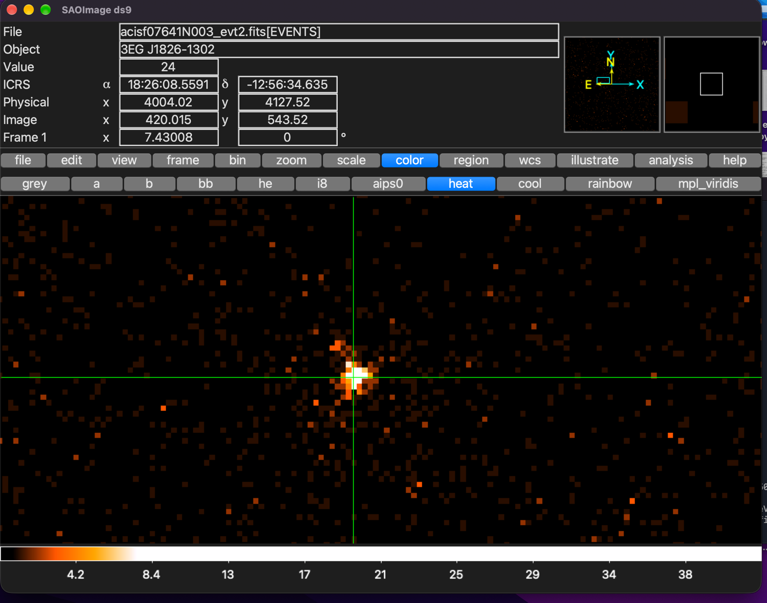

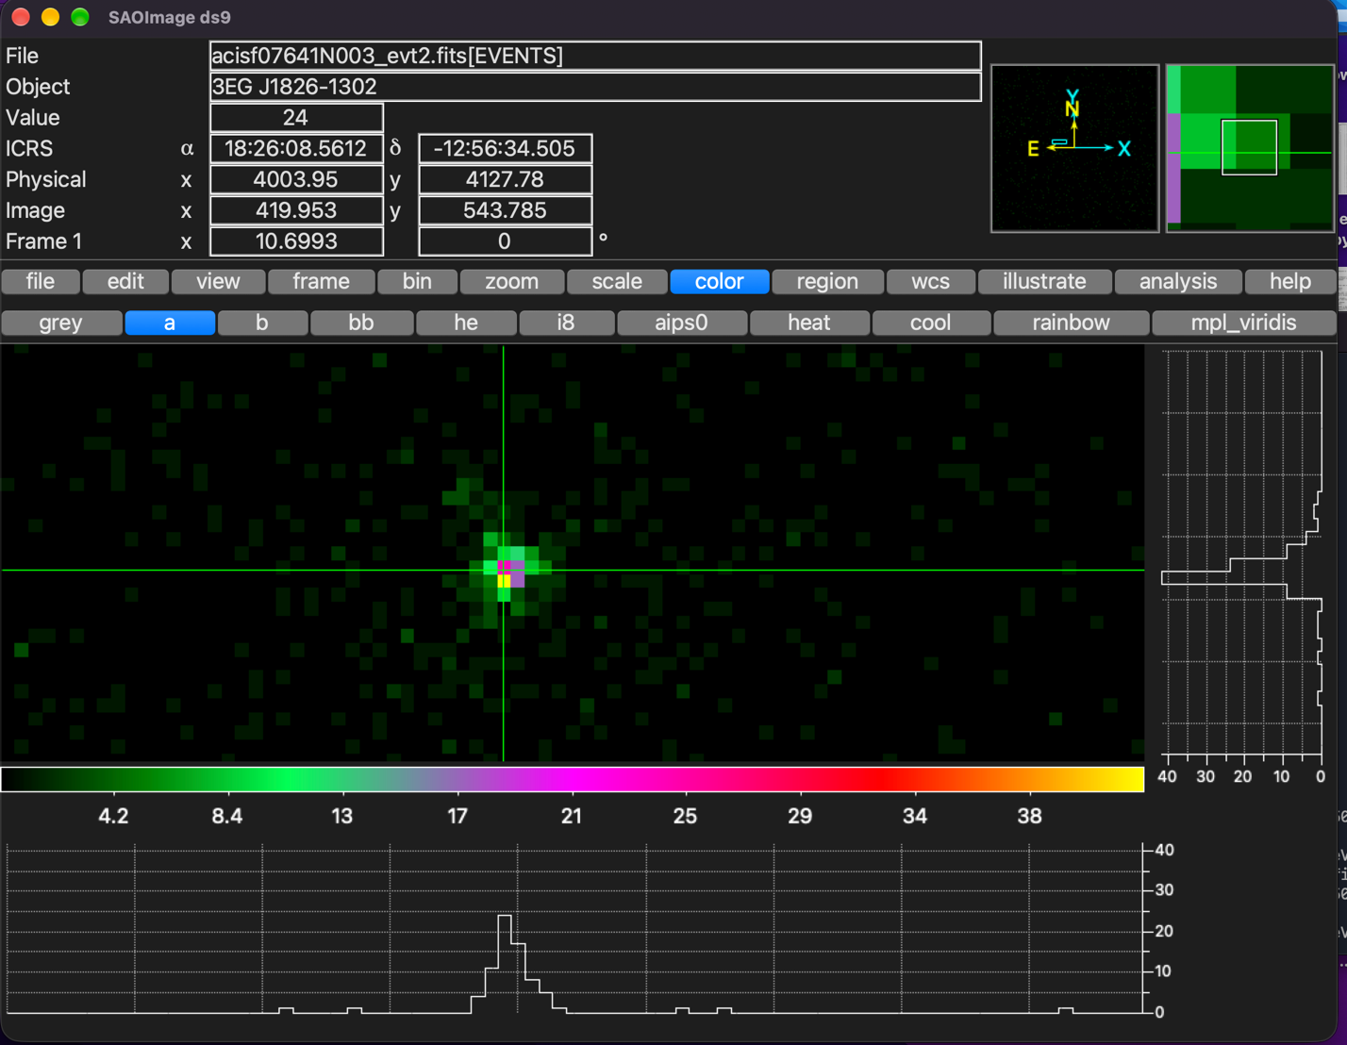

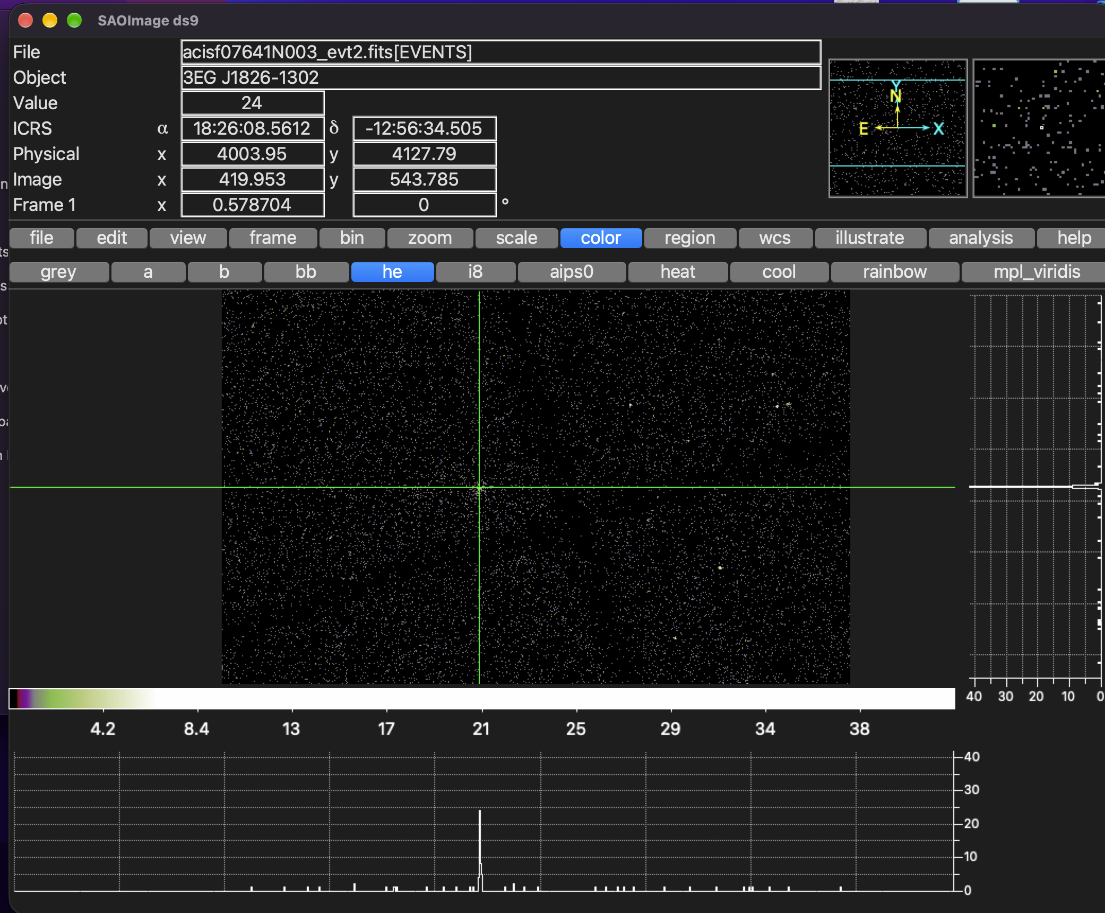
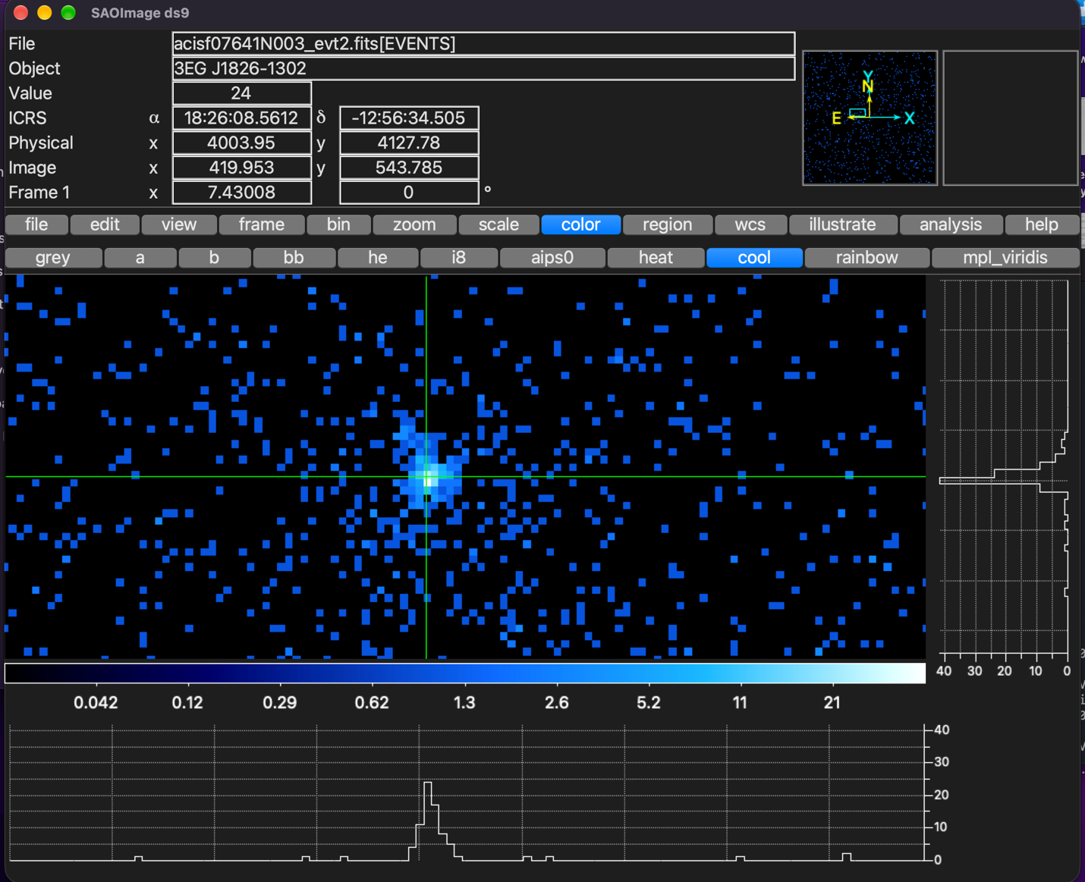
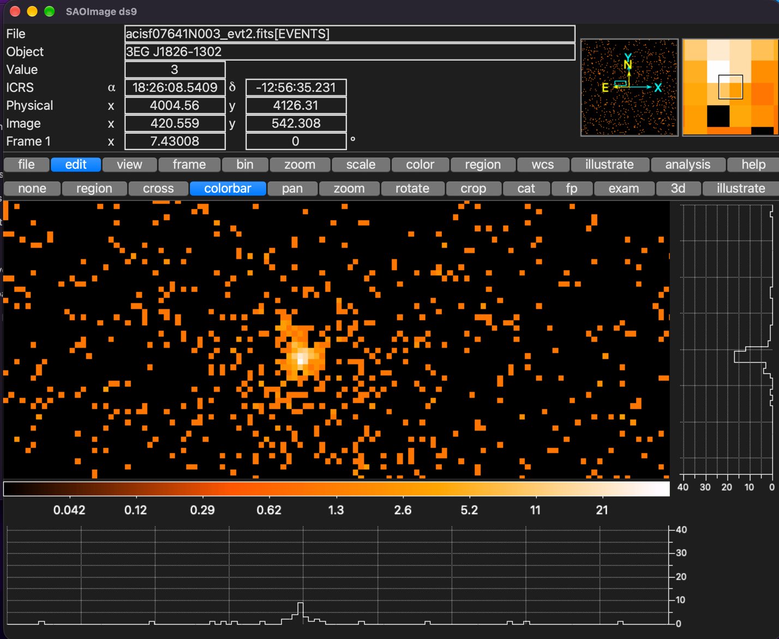

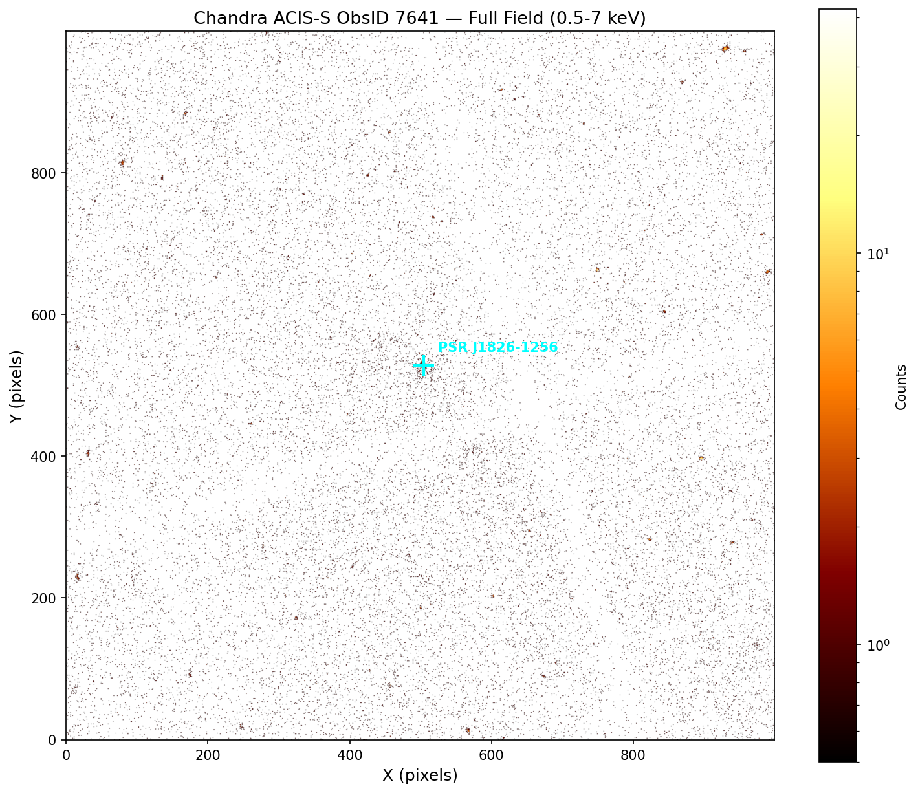

Figure: Chandra ACIS-S full field image (0.5-7 keV, ObsID 7641). PSR J1826-1256 marked with cyan crosshair. Generated using pycrates and matplotlib (CIAO).

3.3 Source Detection — Finding the Pulsar
Pulsar known position (from literature): RA = 18:26:08.5, Dec = −12:56:34
Ran wavdetect for automatic source detection:
mkpsfmap work/7641/img_0.5-7keV.fits work/7641/psfmap.fits energy=1.5 ecf=0.393 clobber=yes
wavdetect infile=work/7641/img_0.5-7keV.fits outfile=work/7641/src_list.fits scellfile=work/7641/scell.fits imagefile=work/7641/imgfile.fits defnbkgfile=work/7641/nbkg.fits psffile=work/7641/psfmap.fits scales="1 2 4 8 16" clobber=yes
Verify: "dmlist src_list.fits counts" → 68 sources detected.
Listed source positions to find the pulsar:
dmlist "work/7641/src_list.fits[cols ra,dec,net_counts]" data
Pulsar detected as source #5:
Property | Detected Value | Known Value
RA | 276.5356° | 276.5354°
Dec | −12.9429° | −12.9428°
Net Counts | 243.6 | ~227 (paper)
Significance | 60.6σ | —

Verify: Position matches within 0.0002°. In DS9, typed "18:26:08.5 -12:56:34" in the coordinate box — crosshair landed right on the bright source.

3.4 Define Source & Background Regions
Following the paper — 2″ circle for source, 5″–20″ annulus for background:
echo 'circle(18:26:08.5,-12:56:34,2")' > work/7641/src.reg
echo 'annulus(18:26:08.5,-12:56:34,5",20")' > work/7641/bkg.reg
Verify: "cat work/7641/src.reg" prints circle(18:26:08.5,-12:56:34,2").
Verify: Loaded both regions in DS9. Source circle sits on pulsar, no other bright sources inside the background annulus.
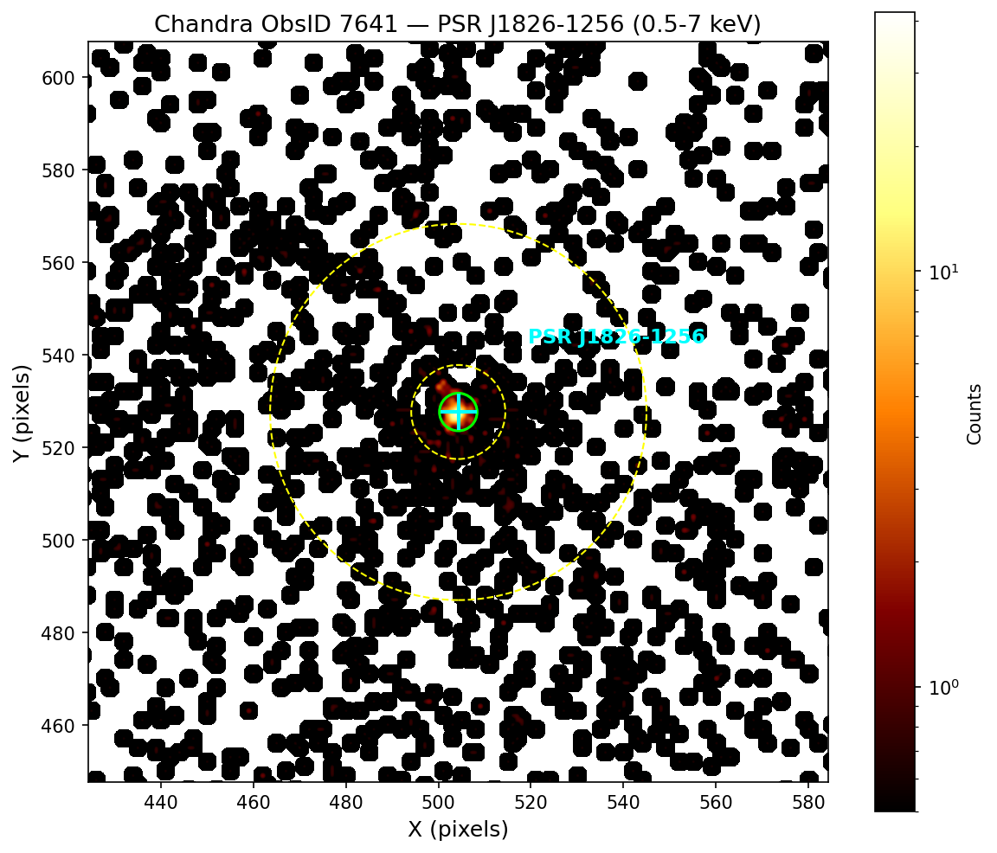
Figure: Zoomed X-ray image showing PSR J1826-1256 with source region (2" green circle) and background region (5"-20" yellow annulus). Generated using pycrates and matplotlib (CIAO).

3.5 Extract the Spectrum
specextract \
infile="work/7641/acisf07641N003_evt2.fits[sky=region(work/7641/src.reg)]" \
outroot=work/7641/pulsar_spec \
bkgfile="work/7641/acisf07641N003_evt2.fits[sky=region(work/7641/bkg.reg)]" \
asp=work/7641/pcadf07641_000N001_asol1.fits \
mskfile=work/7641/acisf07641_000N003_msk1.fits \
grouptype=NUM_CTS binspec=1 weight=no clobber=yes
Takes about 3 minutes. Lots of terminal output is normal.
Output File | What It Is
pulsar_spec.pi | Source spectrum (PHA)
pulsar_spec_bkg.pi | Background spectrum
pulsar_spec.arf | Effective area (ARF)
pulsar_spec.rmf | Energy response matrix (RMF)
pulsar_spec_grp.pi | Grouped spectrum
pulsar_spec_bkg.arf | Background ARF
pulsar_spec_bkg.rmf | Background RMF

Verify: "ls work/7641/pulsar_spec*" shows 7 files. Can view spectrum in DS9: File → Open Other → Open PHA → select pulsar_spec_grp.pi.
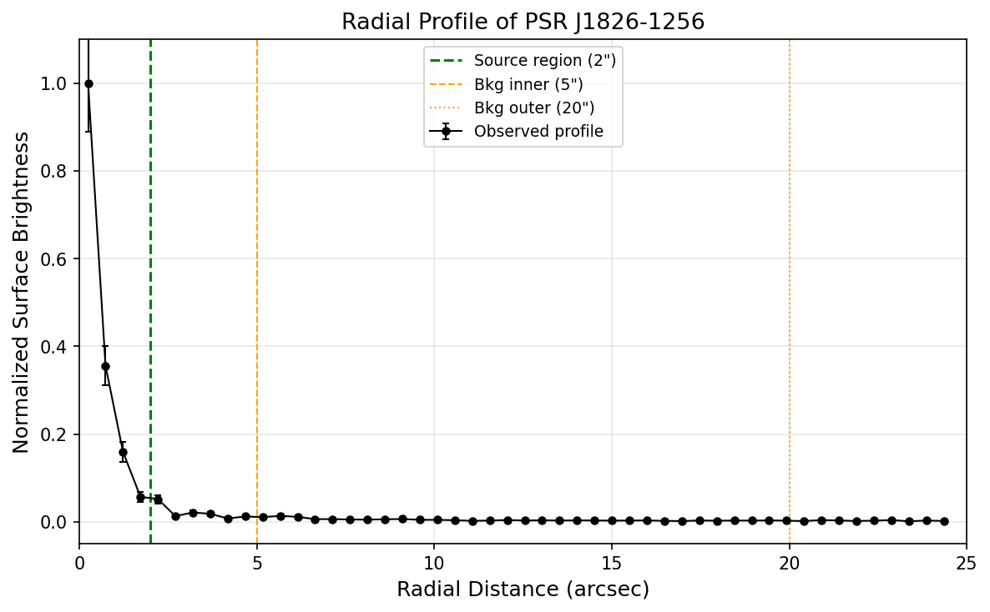
Figure: Radial surface brightness profile of PSR J1826-1256. Emission is concentrated within 2" (source region). Background level reached beyond 5". Error bars are Poisson. Generated using pycrates, numpy, and matplotlib (CIAO).

4. Spectral Analysis
Command to generate these plots: python work/7641/make_plots.py
Used Sherpa (built into CIAO) to fit the spectrum. Used W-statistic (appropriate for low-count data with background) and Nelder-Mead optimizer. Energy range: 0.5–7.0 keV.
Fitting script: work/7641/fit_final.py
python work/7641/fit_final.py
Verify: Script prints fit parameters and saves 3 plot images without errors.

4.1 Power Law Fit (tbabs × powerlaw)
This model represents non-thermal (magnetospheric) emission:
Parameter | Value
N_H | 0.83 ± 0.3 × 10²² cm⁻²
Γ (Photon Index) | 0.39 ± 0.27
Normalisation | 3.01 × 10⁻⁶ ph/cm²/s/keV
Absorbed Flux (0.5–7 keV) | 5.95 × 10⁻¹⁴ erg/cm²/s
Unabsorbed Flux (0.5–7 keV) | 6.82 × 10⁻¹⁴ erg/cm²/s
W-stat / dof | 420.7 / 443 = 0.95

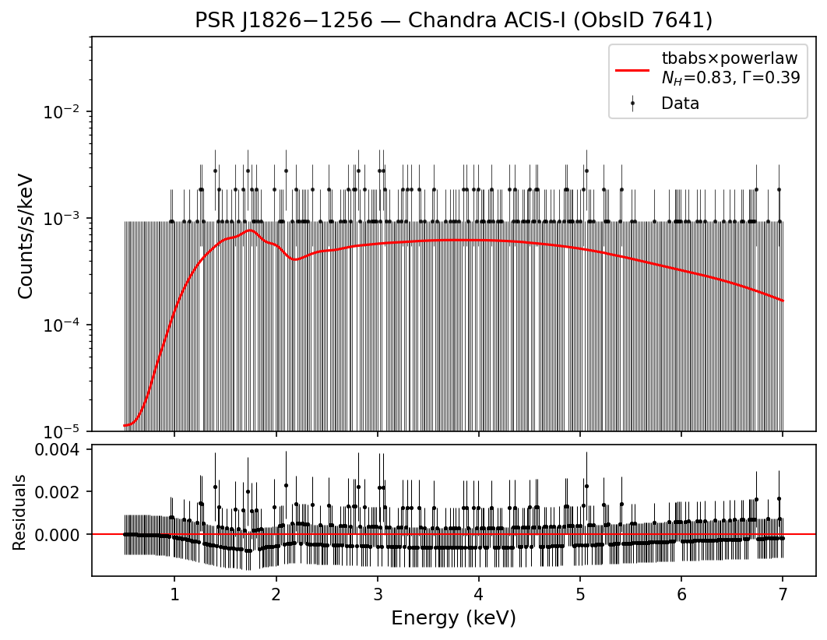
Figure 1: Power law spectral fit

4.2 Blackbody Fit (tbabs × bbodyrad)
This model represents thermal emission from the neutron star surface:
Parameter | Value
N_H | 0.32 × 10²² cm⁻²
kT | 2.05 keV (= 2.38 × 10⁷ K)
Flux (0.5–7 keV) | 5.86 × 10⁻¹⁴ erg/cm²/s
W-stat / dof | 423.1 / 443 = 0.96

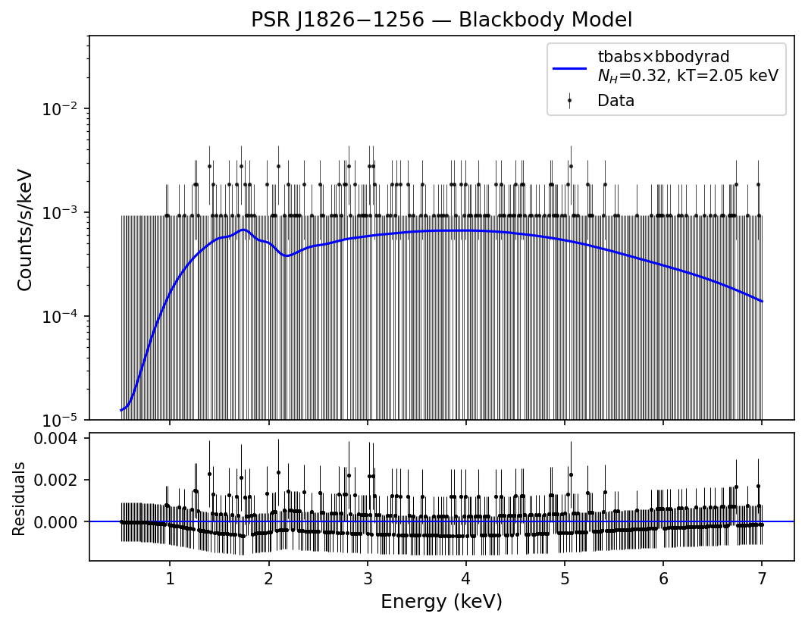
Figure 2: Blackbody spectral fit

4.3 Model Comparison
Model | W-stat | DOF | Reduced Stat
tbabs × powerlaw | 420.7 | 443 | 0.950
tbabs × bbodyrad | 423.1 | 443 | 0.955

Power law has a lower W-stat value, so it is the better fit. This confirms non-thermal (magnetospheric) emission, same as the paper.
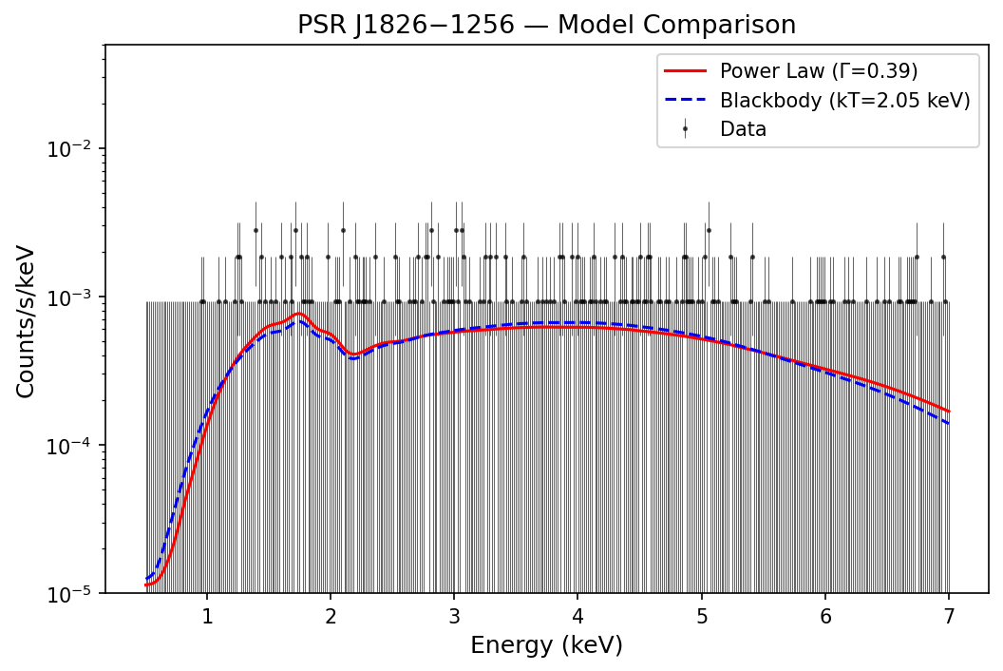
Figure 3: Model comparison — power law (red) vs blackbody (blue)

5. Comparison with Published Results
Source: Karpova et al. (2019), MNRAS 487, 1964–1972
URL: https://academic.oup.com/mnras/article/487/2/1964/5512596
Parameter | My Result | Karpova et al. (2019)
N_H (10²² cm⁻²) | 0.83 ± 0.3 | 0.50 ± 0.15
Γ (Photon Index) | 0.39 ± 0.27 | 1.25 ± 0.20
Absorbed Flux | 5.95 × 10⁻¹⁴ erg/cm²/s | ~3 × 10⁻¹⁴ erg/cm²/s
Net Counts | ~244 | ~227
Best Fit Model | Power law | Power law
Fitting Tool | Sherpa (W-stat) | XSPEC (C-stat)

Reasons for the differences:
- N_H–Γ degeneracy: With only ~244 counts, if N_H goes up, Γ goes down to compensate. My N_H is higher and Γ is lower — classic degeneracy effect.
- No reprocessing: I used the archive evt2 file directly. The paper reprocessed the data with chandra_repro and updated calibrations.
- Different CALDB: I used version 4.12.3 (2025), paper used an older ~2018 version. Updated calibrations change the ARF and RMF response files.
- Data combination: The paper combined Chandra + XMM-Newton data for better statistics. I only used Chandra ObsID 7641.
- Different fitting tools: Sherpa/W-stat vs XSPEC/C-stat. Both are valid for low-count data but can settle on slightly different best-fit values.
Despite these differences, the main conclusion is the same: power law fits better than blackbody, confirming non-thermal emission.

6. Physical Interpretation
N_H (Column Density): 0.83 × 10²² cm⁻² — measures the gas/dust absorbing X-rays between us and the pulsar. Total Galactic N_H in this direction is ~1.66 × 10²² (NRAO), so the pulsar is roughly halfway through the Galaxy's absorbing column. Consistent with its estimated distance of ~1.2 kpc.
Γ (Photon Index): Describes the spectrum slope (dN/dE ∝ E⁻ᴦ). The paper's Γ ~ 1.25 indicates a hard spectrum, typical of young energetic pulsars (for reference, Crab pulsar has Γ ~ 1.6). This comes from synchrotron radiation by relativistic electrons in the magnetosphere.
Power Law vs Blackbody: Power law = no characteristic energy = non-thermal process (synchrotron). Blackbody = thermal emission from hot neutron star surface with a peak temperature. Power law fitting better means the X-rays come from the magnetosphere, not the surface.
X-ray Luminosity: Using unabsorbed flux (6.8 × 10⁻¹⁴ erg/cm²/s) and distance ~1.2 kpc: L_X ≈ 1.2 × 10³¹ erg/s. With spin-down luminosity Ė ≈ 3.6 × 10³⁶ erg/s, X-ray efficiency η ≈ 10⁻⁵. Only a tiny fraction of the pulsar's rotational energy goes into X-ray emission.
 | Thermal (Surface) | Non-thermal (Magnetosphere)
Spectrum Shape | Blackbody curve | Power law
Physical Origin | Hot neutron star surface | Relativistic particles in B-field
Typical Γ or kT | kT ~ 0.1–0.3 keV | Γ ~ 1–2

For PSR J1826−1256, the power law dominance means we see magnetospheric emission. Any thermal surface component is too faint to detect with ~244 counts.

7. Conclusion
I reduced Chandra ObsID 7641 data for PSR J1826−1256 following standard CIAO procedures. The pulsar was detected with ~244 counts at 60.6σ significance. I extracted the spectrum and fitted it with two models using Sherpa.
The power law model (W-stat = 420.7/443) fits better than blackbody (W-stat = 423.1/443), confirming non-thermal magnetospheric emission — same conclusion as Karpova et al. (2019).
The numerical differences from the paper (especially N_H and Γ) are explained by the N_H–Γ degeneracy at low count statistics, different calibration versions, no reprocessing, and using only Chandra data without XMM-Newton.

References
Karpova, A. V., Zyuzin, D. A., Danilenko, A. A., & Shibanov, Yu. A. (2019). X-ray studies of the gamma-ray pulsar J1826−1256 and its pulsar wind nebula with Chandra and XMM–Newton. MNRAS, 487, 1964–1972.
https://academic.oup.com/mnras/article/487/2/1964/5512596

URLs Used:
- Chandra Data Archive — https://cda.harvard.edu/chaser/
- CIAO Download — https://cxc.cfa.harvard.edu/ciao/download/
- DS9 Download — https://sites.google.com/cfa.harvard.edu/saoimageds9
- CIAO Tutorials/Threads — https://cxc.cfa.harvard.edu/ciao/threads/
- Galactic N_H Calculator — https://www.swift.ac.uk/analysis/nhtot/

