**Main Features and App Flow Summary:**

*Note: Solution of each problem is under the problem in bold.   
Some hyperlinks in document would only work if the user is logged in.*

**For User:**

* User can Sign up / Log in and browse a list of common issues they need help with  
  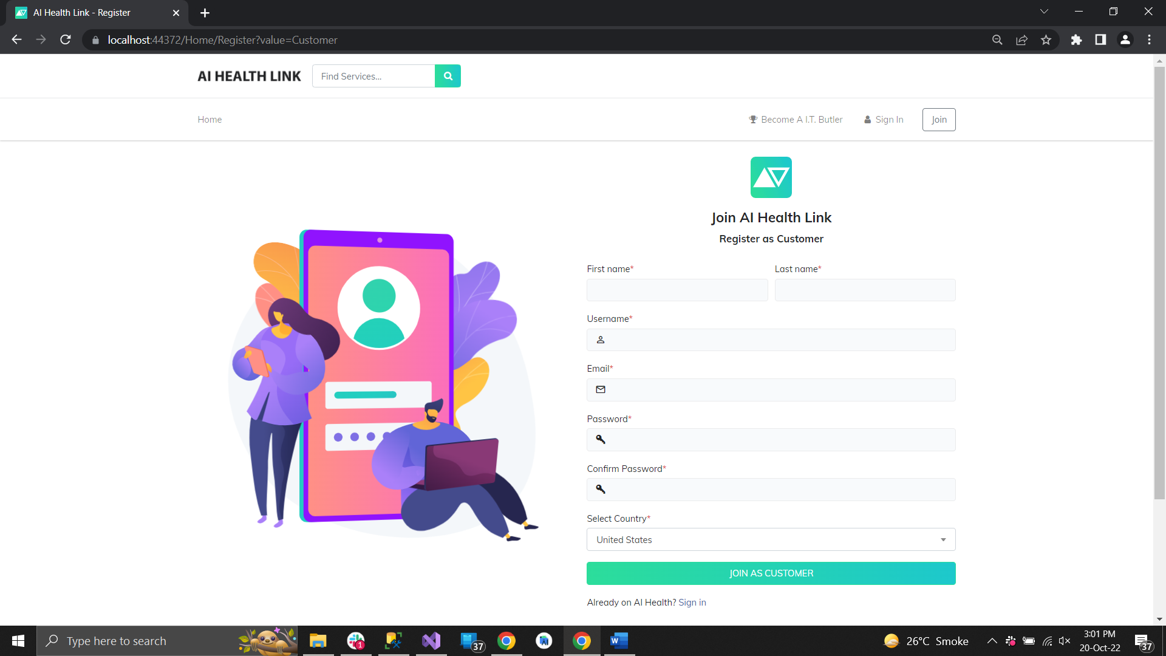  
  [https://usman78056-001-site2.gtempurl.com/Home/Register?value=Customer](https://usman78056-001-site2.gtempurl.com/Home/Register?value=Customer%20) **(Customer Sign Up)**

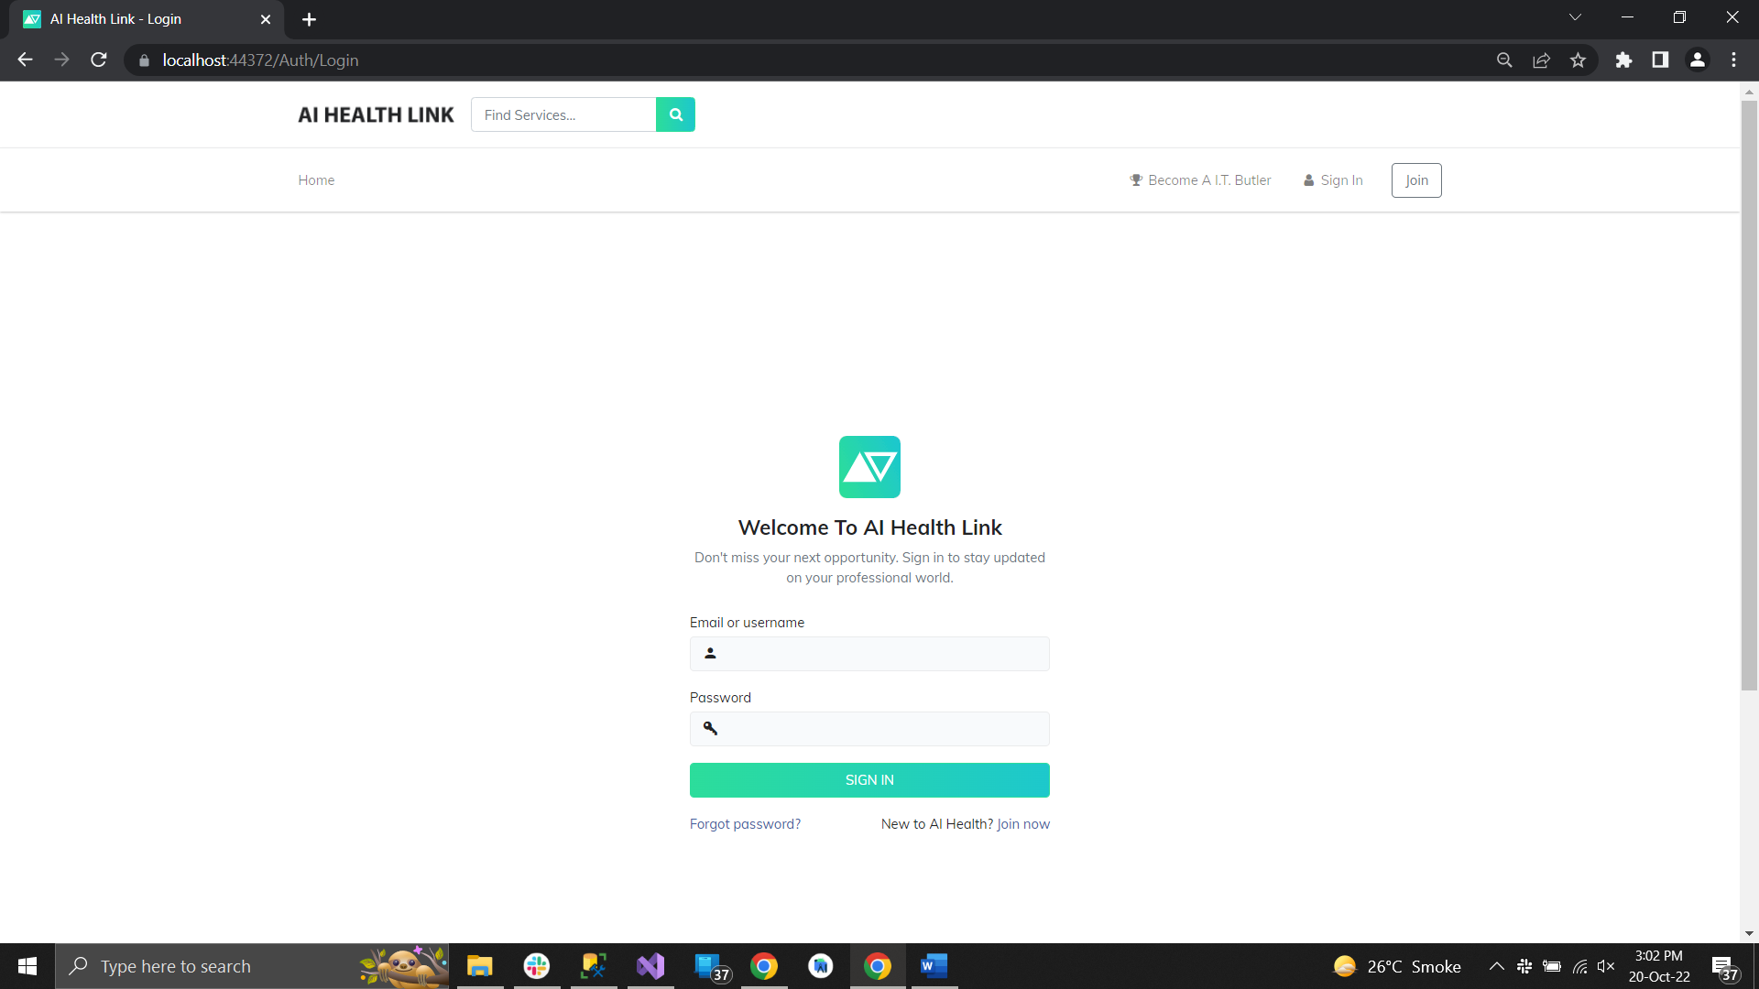

[https://usman78056-001-site2.gtempurl.com/Auth/Login](https://usman78056-001-site2.gtempurl.com/Auth/Login%20) **(Login)**

* User is able to type in the question in normal language and the system suggests the best match for the issue using tags and other factors below and display the list of suitable Service providers.

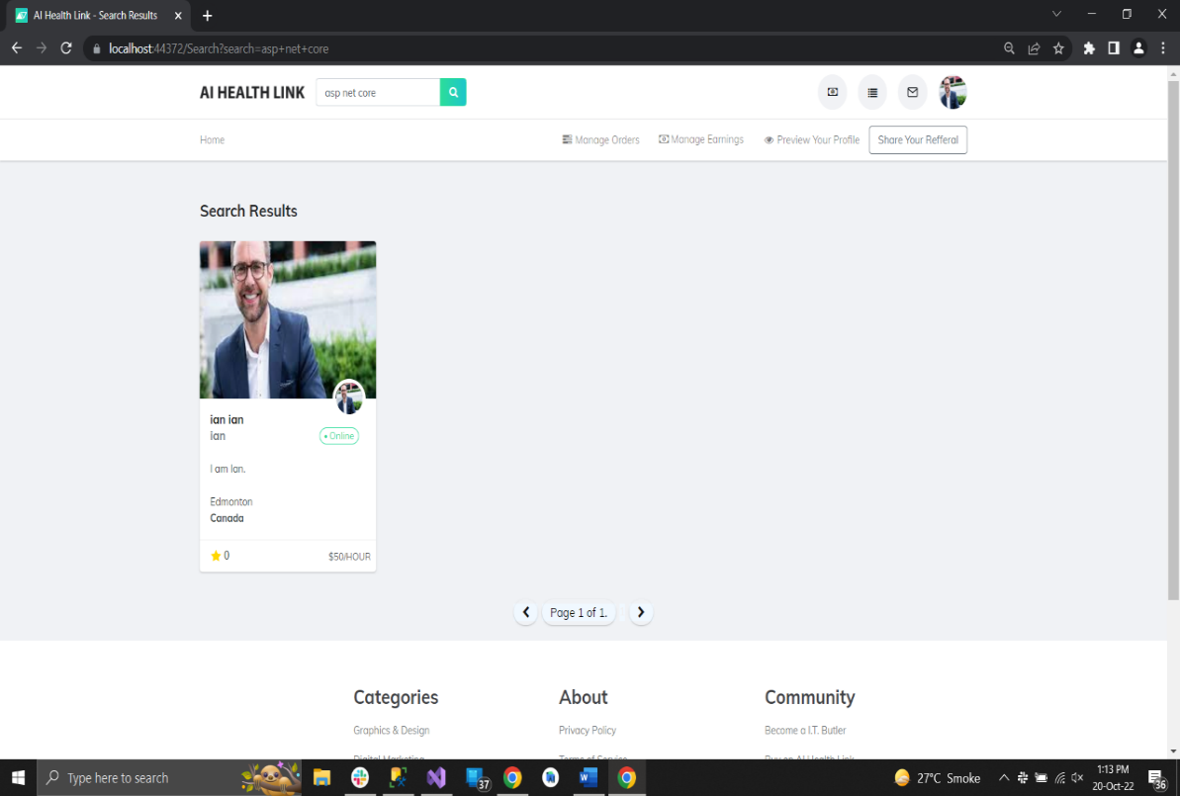  
  
[https://usman78056-001-site2.gtempurl.com/Home/Index](https://usman78056-001-site2.gtempurl.com/Home/Index%20) **(Search on the basis of Skills and Tags on Landing Page matching each keyword).**

* User is able to message a Service Provider and place an order.

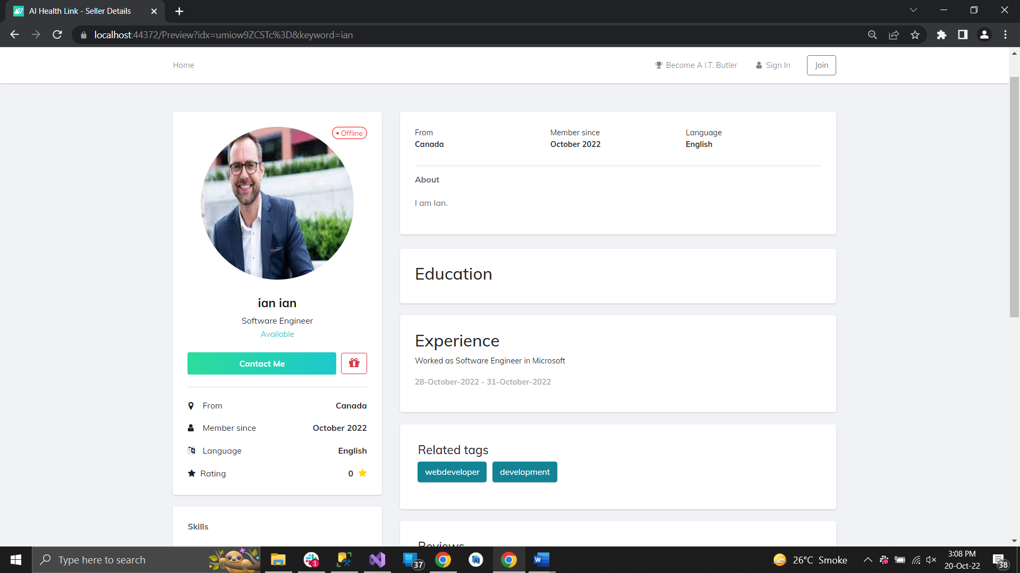

**(After searching Seller, Buyer clicks Contact Me button on the profile of Service Provider to msg him).**

* For Placing an order, they will be redirected to a secure Payment Integration service (Stripe).

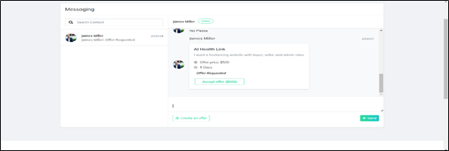  
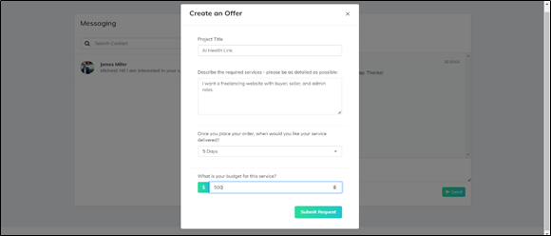

**(Within Messages, Seller Creates an offer for Buyer and Buyer can accept the order by clicking on accept order which will open Stripe Payment Integration Modal for doing payment for the order.)**

<https://usman78056-001-site2.gtempurl.com/Home/Messages>

* Once an order is placed, User is able to communicate through zoom which will be integrated in the App. User will also be able to give their system access through zoom to the Service provider.

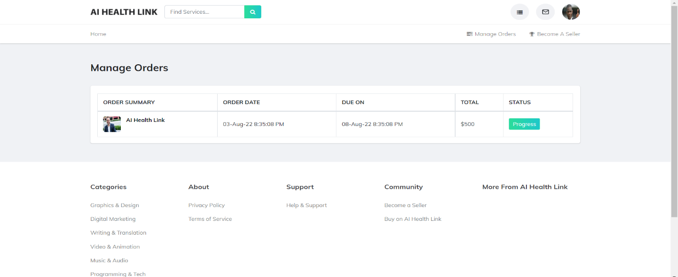

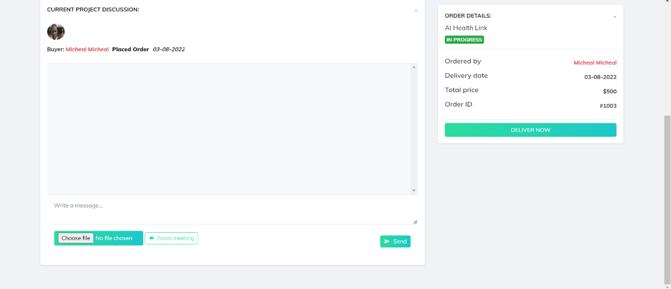  
<https://usman78056-001-site2.gtempurl.com/Orders> **(Manage Orders)**

**Post Order:**

**(**After order is placed, the user can go to order details page from the orders section where he can discuss about the order as well as can place a zoom meeting which would send a link to the other corresponding user in order to join meeting.   
  
The user who placed a request for zoom meeting would be the host so he can control other’s user system or allow him to control his system over zoom**).**

* User is able to search by the name of the Service Provider.

**(Filter by name, Implemented on Search bar).**

* USER CAN RATE THEIR SERVICE PROVIDER (STAR SYSTEM) AND MAKE COMMENTS ABOUT THEIR SERVICE PROVIDER.

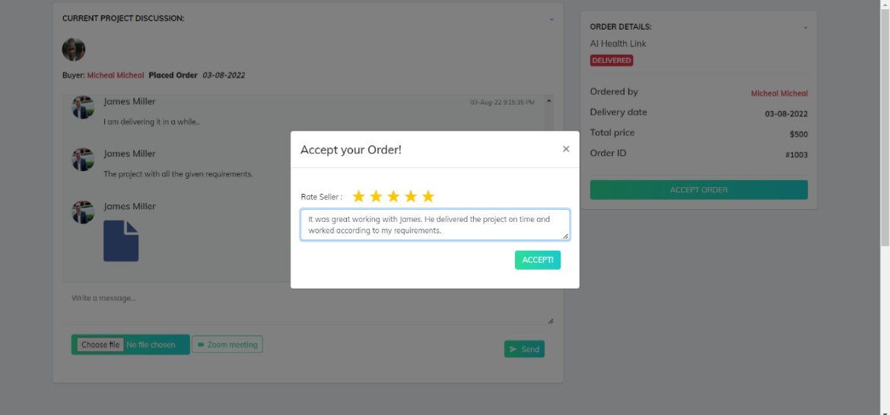

**(After delivery of the order while accepting the order, buyer gives rating and comments about the seller).**

**Logging User Data**

Search done by users gets logged as well as profile associated with the search and geodata associated with the search.

This will facilitate 2 things:

1. Understanding what the universe of clients need help with (note, the service providers can see what is needed help with, and this will drive service providers to tag/update their competencies if their competency meets a market need (they may have competencies they did not even know were needed, which they did not tag or list). Also it means service providers can train themselves in required competencies.
2. We can understand what types of profiles and geographic locations, require what types of competencies.

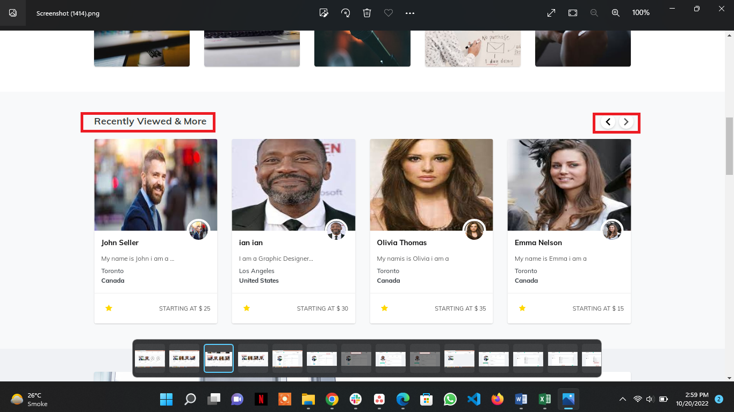

**(Data is being logged at backend of every user while he searches something from the search bar for later providing recommendations and recent searches paginations on landing page).**

**Post Order by User module:**

* Title of the problem is given, tags are added, the title of the problem, the tags for the problem, are searchable, such that other providers can refer to the documentation [like stack exchange].

**(Search keywords being logged are being used to match with skills and tags of the users in order to find the specified users).**

* Robust tag system will need to be developed, for the name of the piece of technology, the platform of a piece of technology (e.g., its operating system), the company of the piece of technology, etc.

**(Search keywords may contain combination of words, so every specific word of the whole sentence is being matched with the skills and tags that are saved within the database).**

* Ability of the user to review the summary content and give comments and star ratings (this may will help optimize machine learning for optimal customer satisfaction).

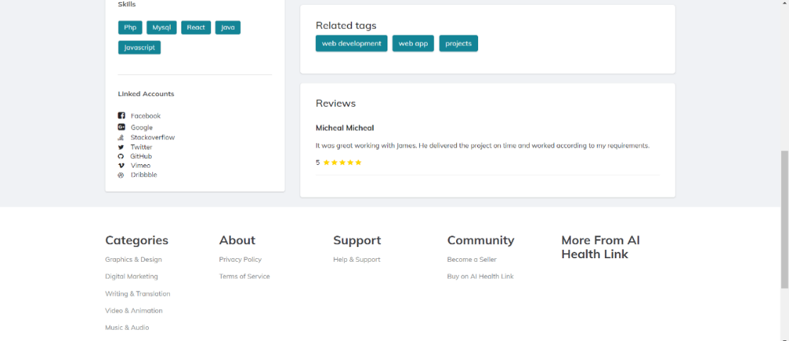  
<https://usman78056-001-site2.gtempurl.com/Preview?idx=umiow9ZCSTc%3D&keyword=ian>

**(Reviews being given within order completion would be shown in the profile of the seller who was rated).**

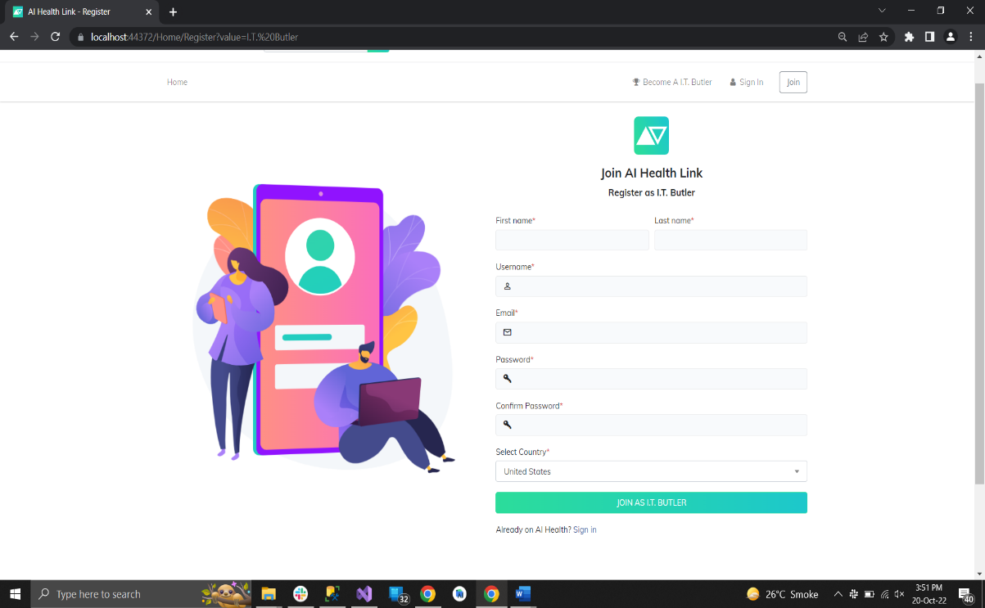**For Service Provider:**

* A Service provider is able to register by Signing Up / Applying **(Seller Signup)**

<https://usman78056-001-site2.gtempurl.com/Home/Register?value=I.T.%20Butler> **(Manage Orders)**

* Service provider’s information is then checked and their profile approved.

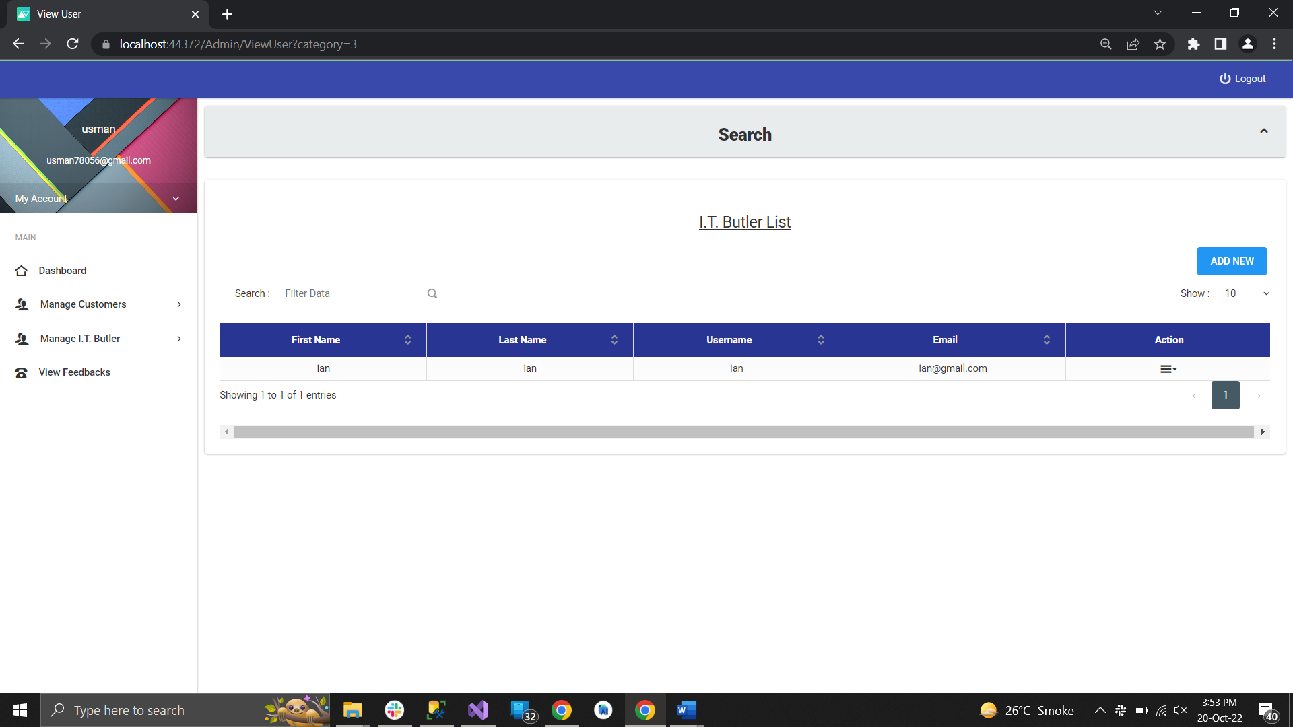

<https://usman78056-001-site2.gtempurl.com/Admin/ViewUser?category=3>  
**(Admin tracks the record of seller and approve its profile)**

* Once approved they will appear in User’s search results  
  **(The seller only appears in search results if he is approved by admin)**
* They are able to edit their profile for different skills, profile picture etc., but not the Name.

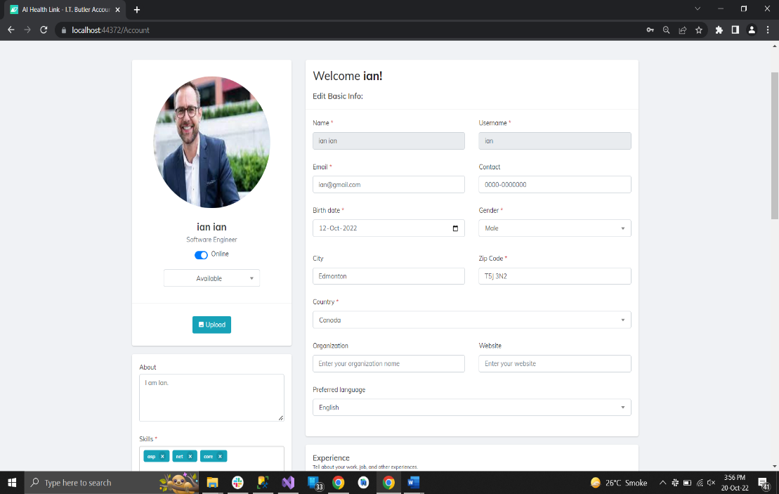

<https://usman78056-001-site2.gtempurl.com/Account> **(The user can edit his profile and edit all his information including skills, profile picture excluding Name and Username).**

* Service Provider is able to setup their banking information.

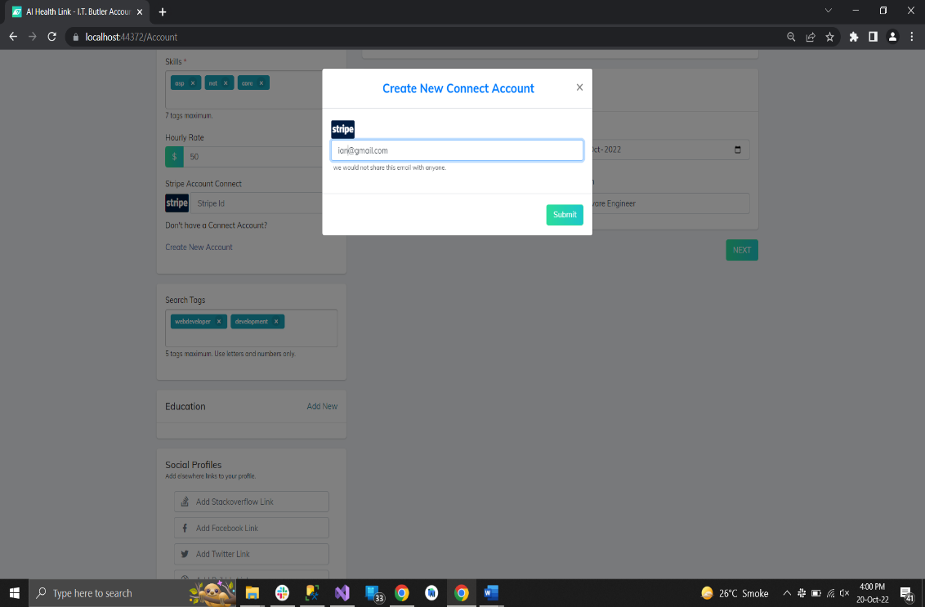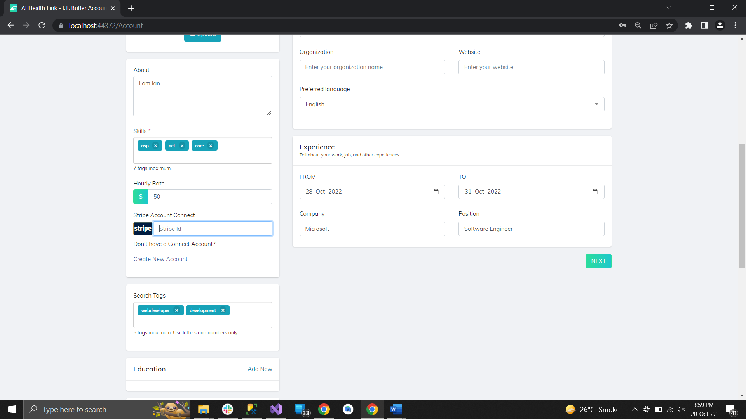

**Create New Connect Account Stripe**

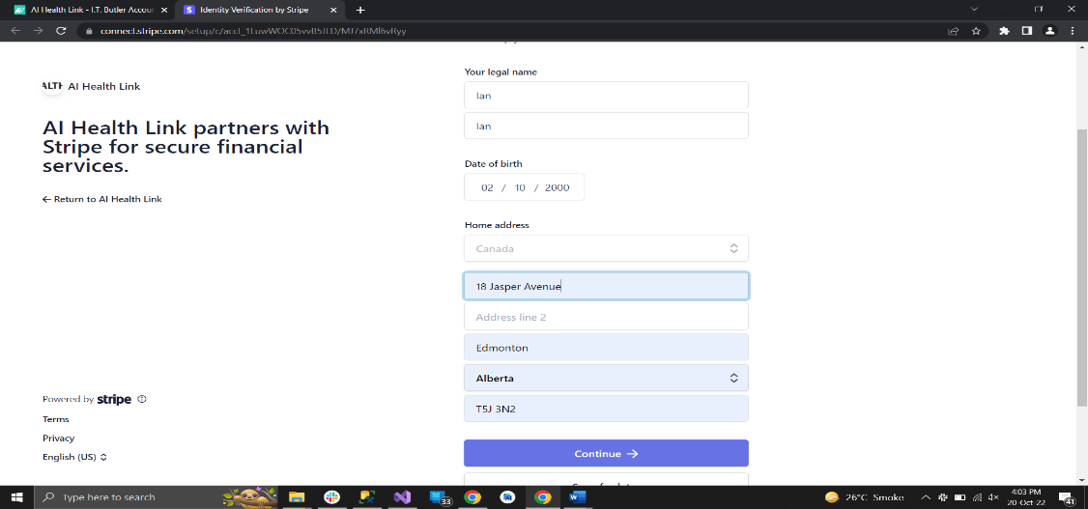

**Account Verification on Email Submission. +**

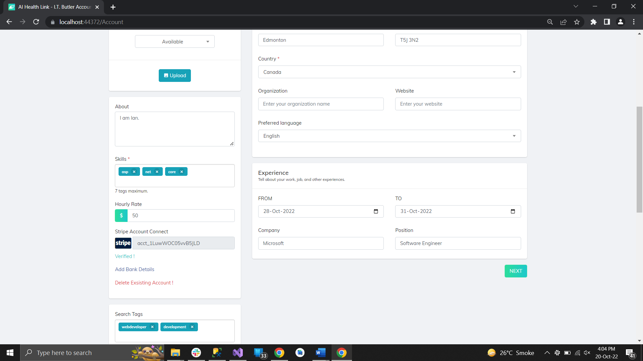

**Post Verification Interface**

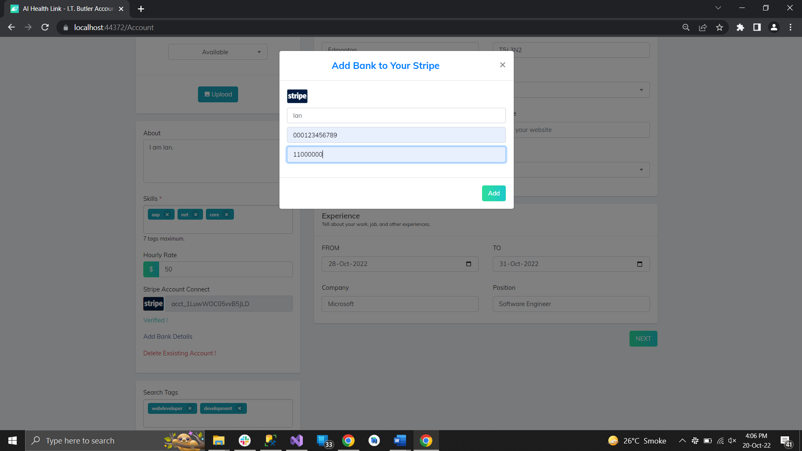

**Adding External Bank Account to Stripe**

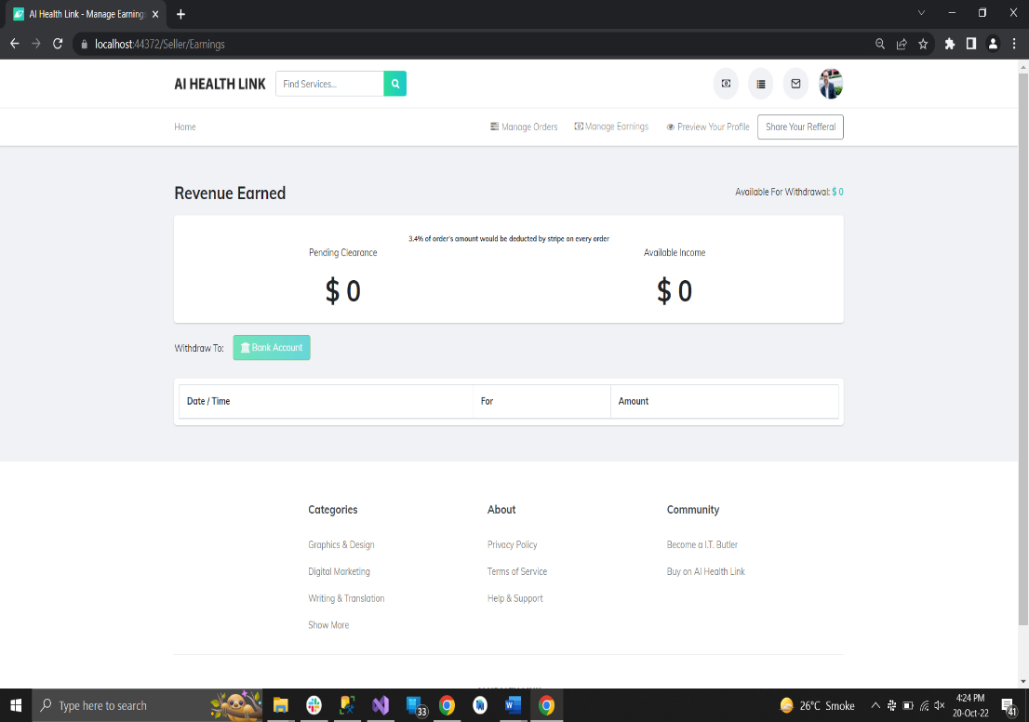

[https://usman78056-001-site2.gtempurl.com/Seller/Earnings](https://usman78056-001-site2.gtempurl.com/Seller/Earnings%20) **(Manage Earnings Section)**

**(User can create new Stripe Connect Account and after verification, he can add external bank account by providing account holder name, account number and transit number. User can also delete existing connect account if he wants).**

* Their Password and Security
* 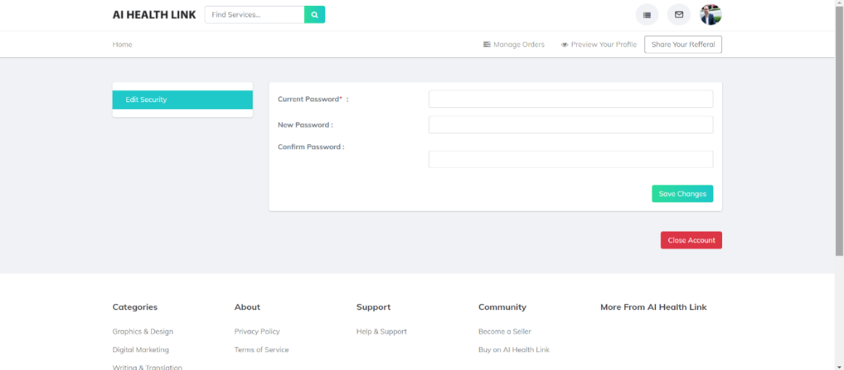Close account

[**https://usman78056-001-site2.gtempurl.com/Auth/UpdatePasswordUser**](https://usman78056-001-site2.gtempurl.com/Auth/UpdatePasswordUser) **(User can setup his password as well as Close Account, from Account Privacy Section from the profile dropdown).**

* ABILITY TO TAP A BUTTON AND INDICATE THEY ARE AVAILABLE NOW  
  **(User can click and check the button if it is disabled).**
* ABILITY TO INDICATE ON SCHEDULE WHEN THEY ARE AVAILABLE (I BELIEVE THERE ARE SEVERAL POSSIBLE INTEGRATIONS FOR THIS)  
  **(Available / Not Available Dropdown on profile)**

**For the Match Return:**

· Pagination based results

· Top three matches to be displayed on Page 1

· Rest of the results to be displayed on the following pages

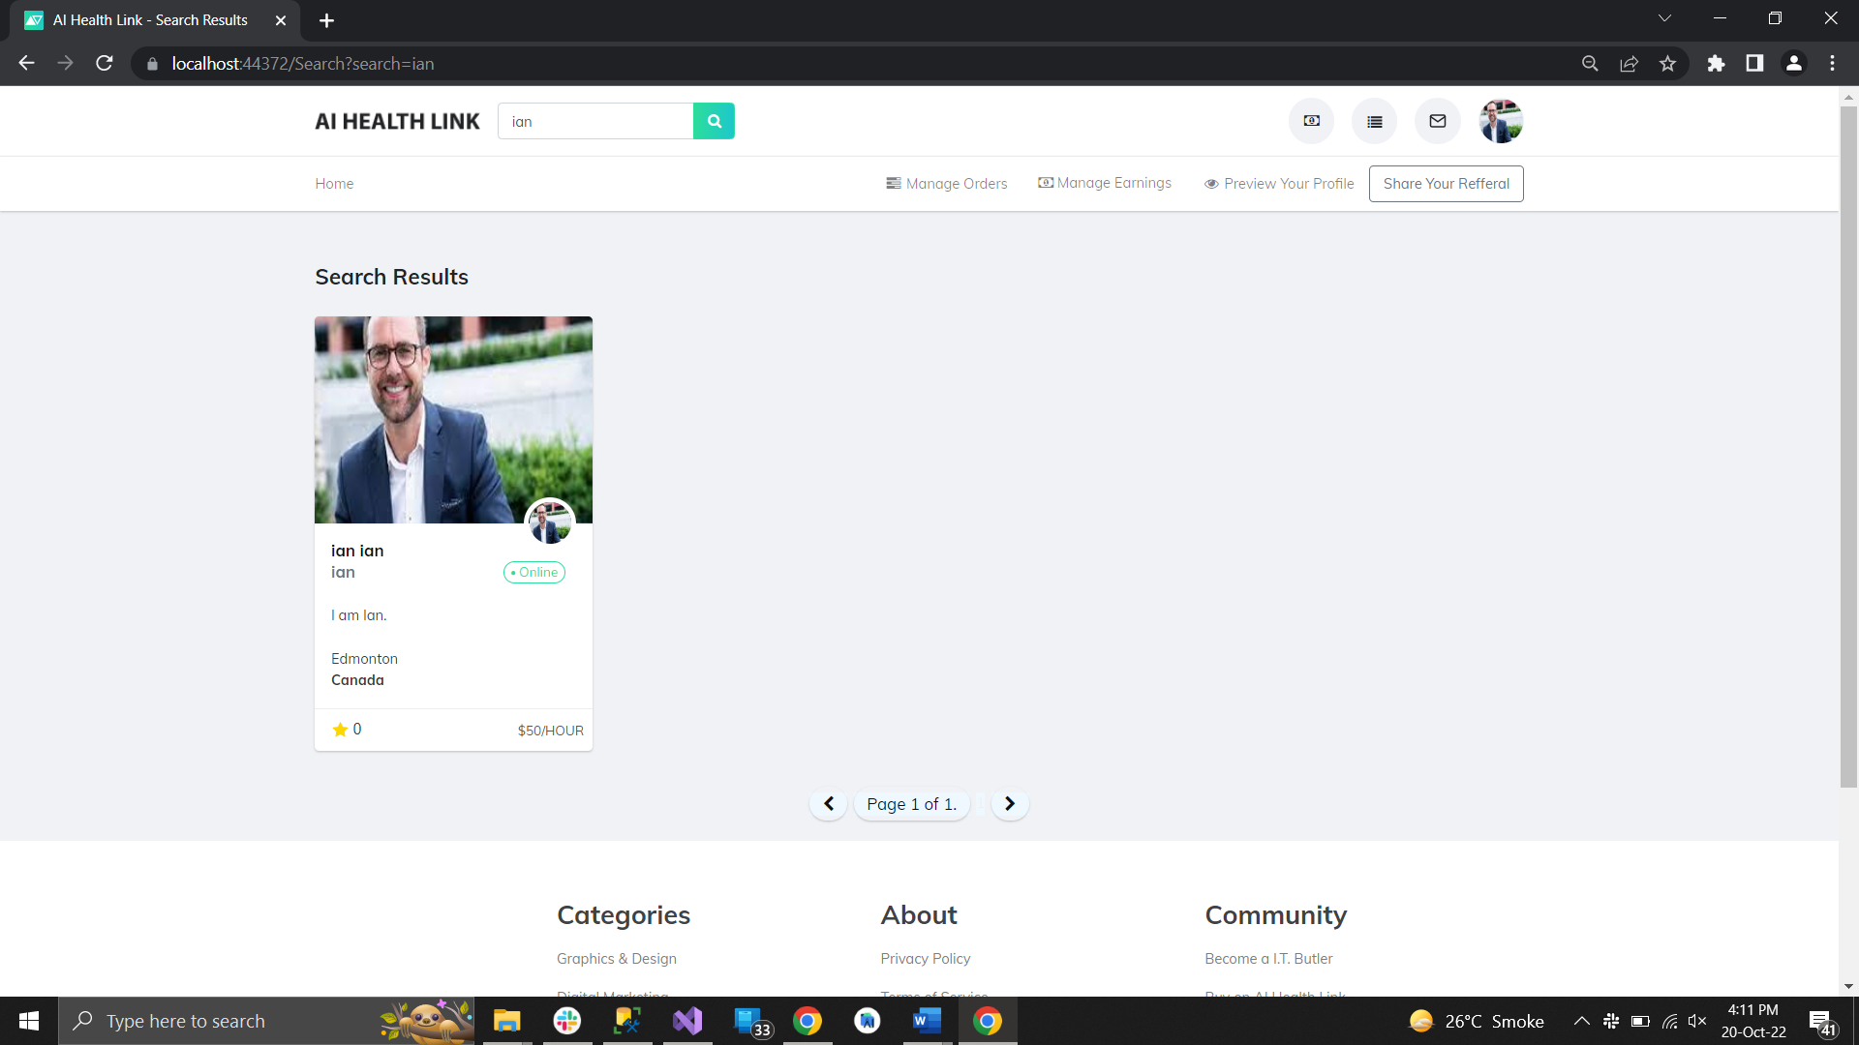  
  
[https://usman78056-001-site2.gtempurl.com/Search?search=ian](https://usman78056-001-site2.gtempurl.com/Search?search=ian%20) **(Pagination is implemented on search results)**

**Information about Matches (Service Providers):**

· Profile Image

· Name (Can be Full name or First name + Last name’s first Letter)

· Location (City, Country)

· Hourly rate  
**(Each profile card on pagination search results includes these details)**

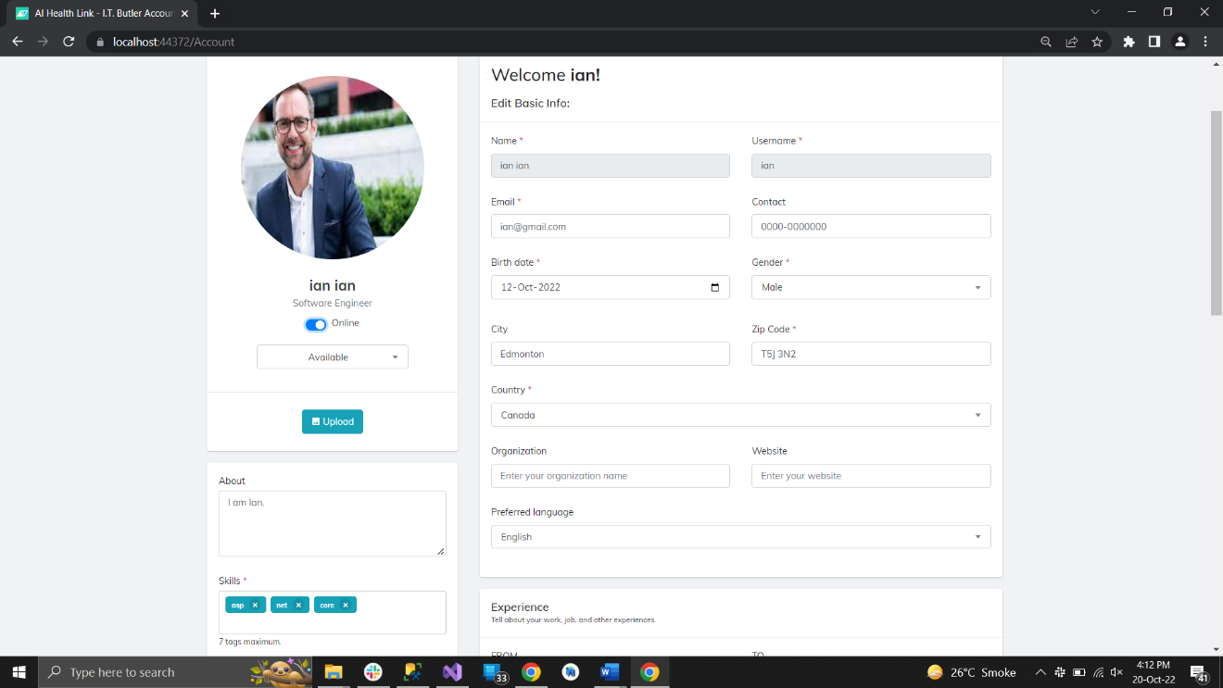· Short Description provided by the service provider when they setup their profile and is editable.

· Tags of their skills which have matched the users query  
**(Description Section under profile picture card is editable while user setups his profile and it also contains the skills and tags).**

ABILITY TO LIST THEIR TAGS/SKILLS EVEN IF THEY DO NOT EXIST YET THEY NEED TO BE ABLE TO LIST (FOR CUSTOMER SEARCH PURPOSES) **(User can list down their skills and tags according to their choice).**

**Matches to be Ranked by the following factors:**

· Best Rated (Out of 5 stars)

· Number of Skills matched to user’s query

· A combination of the above two factors  
 **(Records being matched by the searched keywords are being sorted on the basis of these factors).**

**AVAILABILITY NOW/LATER (Dropdown on Profile)**

**Referral and Rewards:**

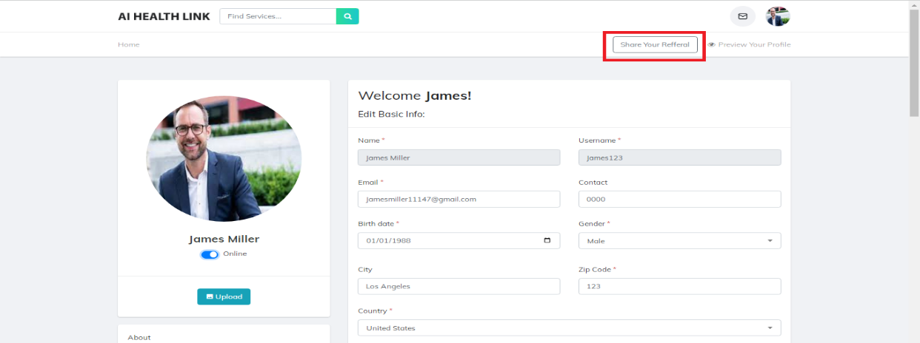Each User and Service Provider will be assigned and given a Referral code which will be displayed on their Profile.

**Signup Referral Link**

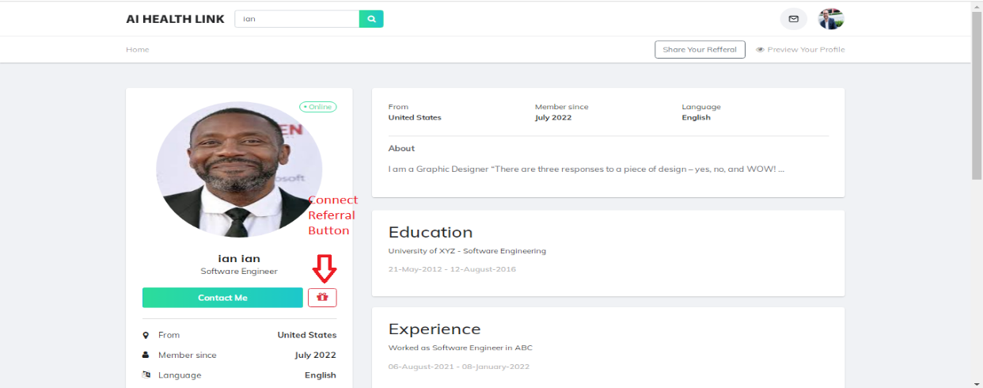 **Connect Referral Link**

(User is assigned the referral code when he signups.

User can share his own referral as signup Referral from the navbar, copies the link and share the link to the user. On opening that link the user can signup with the referral code of the user who shared his referral. **(Sign Up Referral).**

Link of the profile of other user is shared by the buyer or seller in order to refer that service provider to buyer **(Connect Referral)**)  
These submodules are present on the following page:  
<https://usman78056-001-site2.gtempurl.com/Account>