**PROJECT AI HEALTH LINK**

### Technical Specifications

### Systems will be developed using the following technologies:

* Microsoft ASP.NET Core for backend.
* MSSQL for the Central Database.
* Bootstrap HTML for Front-end.
* LOTTIEFILES for Animation.
* Signal R Broadcaster for Messaging Service.
* Zoom API using JWT Token App on Zoom Marketplace.

**Cloud Hosting:** Microsoft Azure.

**Module III**

In this Module we added following Features.

* **Data Logging and Popular Tags**
* **Referrals and Referred User Section**
* **Messaging and Zoom Meeting**
* **Create an Offer (Under Development)**
* **Starting service cost for seller in Seller’s Profile (Starting from)**

1. **Data Logging**

When a user searches any Seller using search bar. The keyword that he searched for, will be logged into the database for later using it for searching recommended and recently viewed profiles. These logs will be only logged for logged in user.

The recently viewed and recommended profiles will be shown within a carousal which could be slide left or right with the arrows placed in the top right corner of the carousal. Only four profiles will be shown on the first view of the carousal.

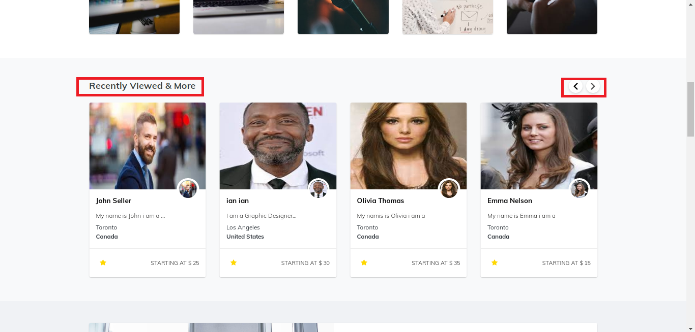

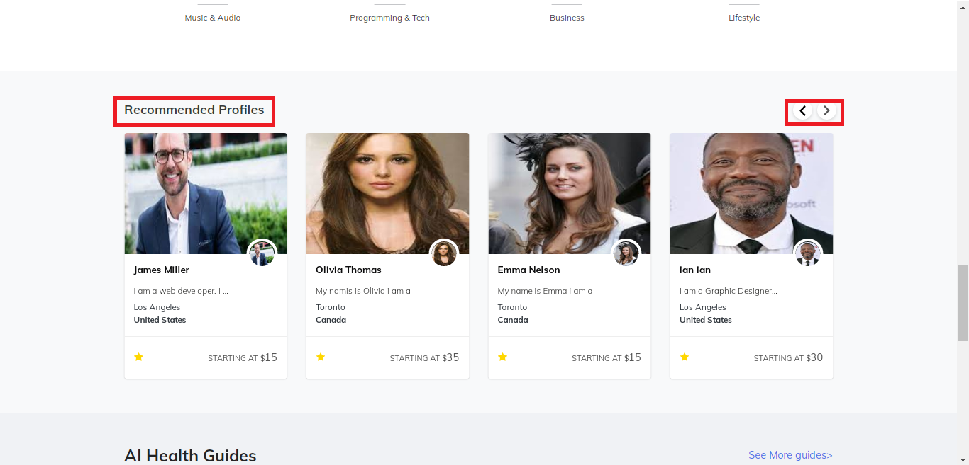

**Popular Tags**

Those Skill tags which are used by mostly Sellers in their profile are displayed here as Popular Tags. For Example

When first Seller adds Skills in his profile, five of them will be displayed here (in Popular tags)

As the number of Sellers increases it select five mostly added Skills and show them in popular tags section.

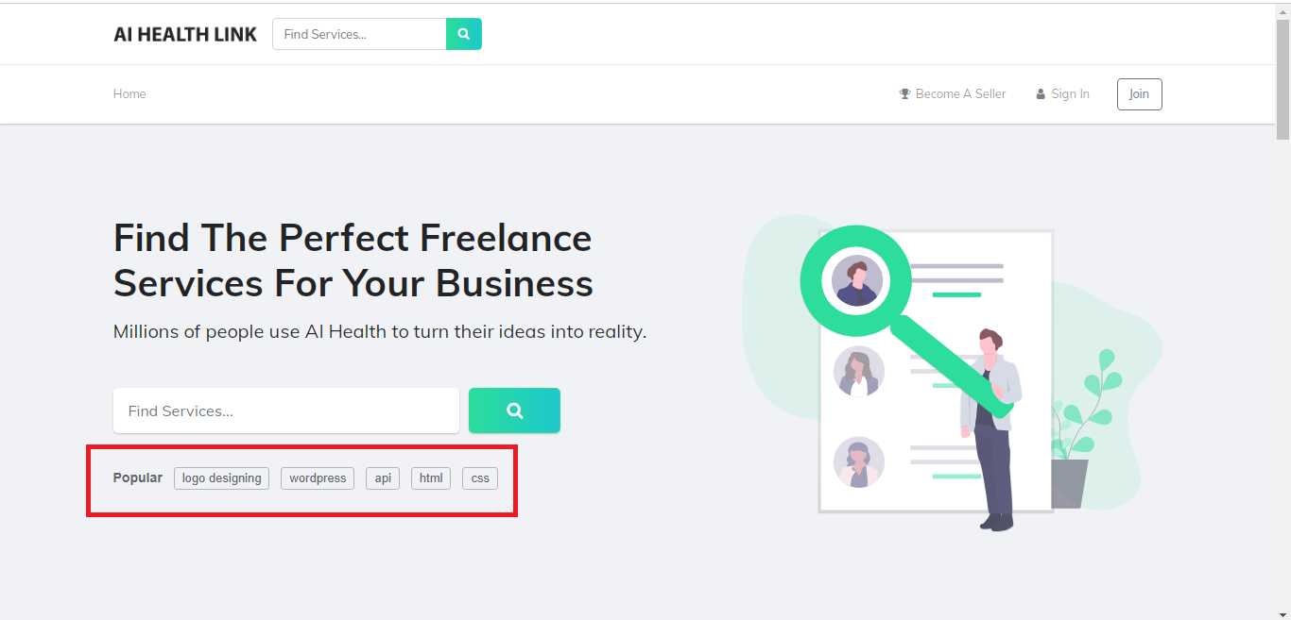

1. **Referrals**

There are two types of Referrals.

* Signup Referral
* Connect Referral

**Signup Referral**

In Seller’s Profile page, when a Seller clicks on Share Your Referral Button it copies a link to clipboard and a popup message will be displayed on the top of the screen. The link would be shared by that Seller on different platforms and that link would be used by a new upcoming user to register as a Buyer or Seller. In case that link is used to register by someone, the referral record will be added into the referrals section of the seller who shared the referral link with the details of registered user.

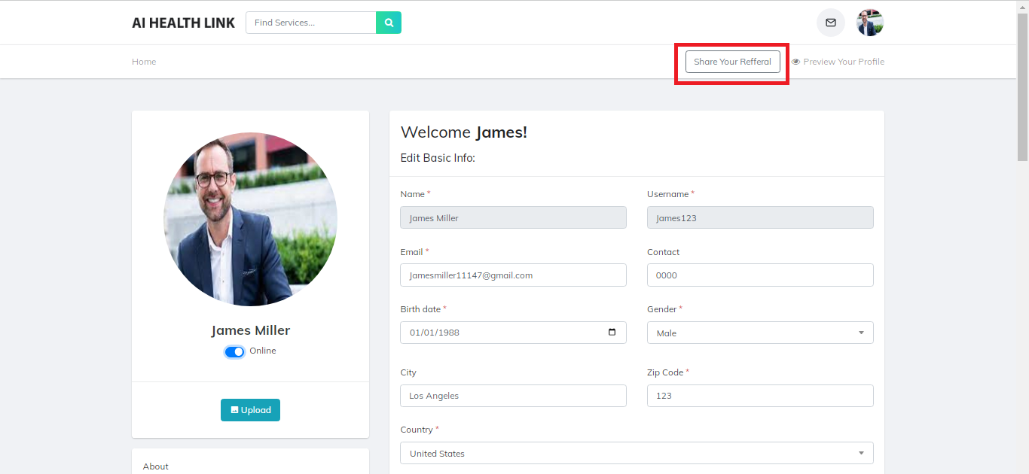

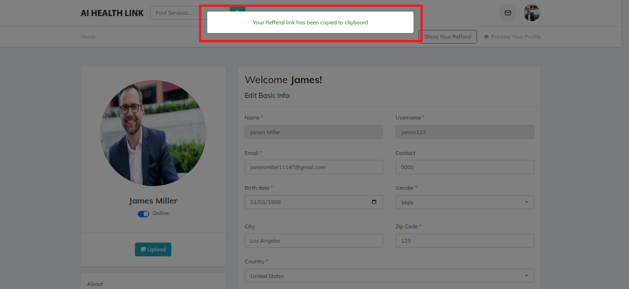

Any user who click on referral link goes to this page and here he chooses to Register as a seller or buyer.

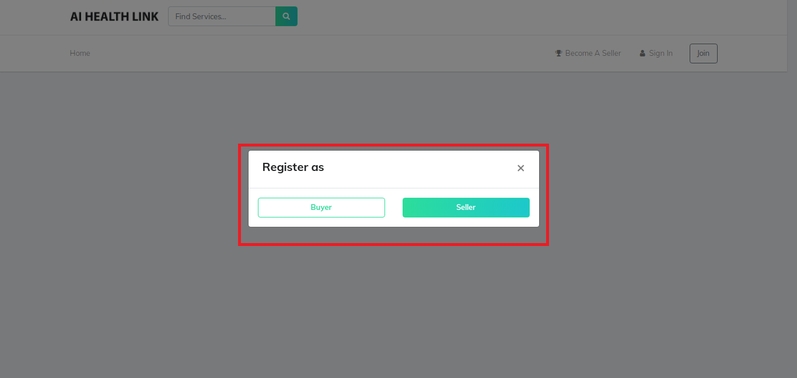

The user who get registered from that link will be shown in Seller’s profile page in **“Referred Users”** Section.

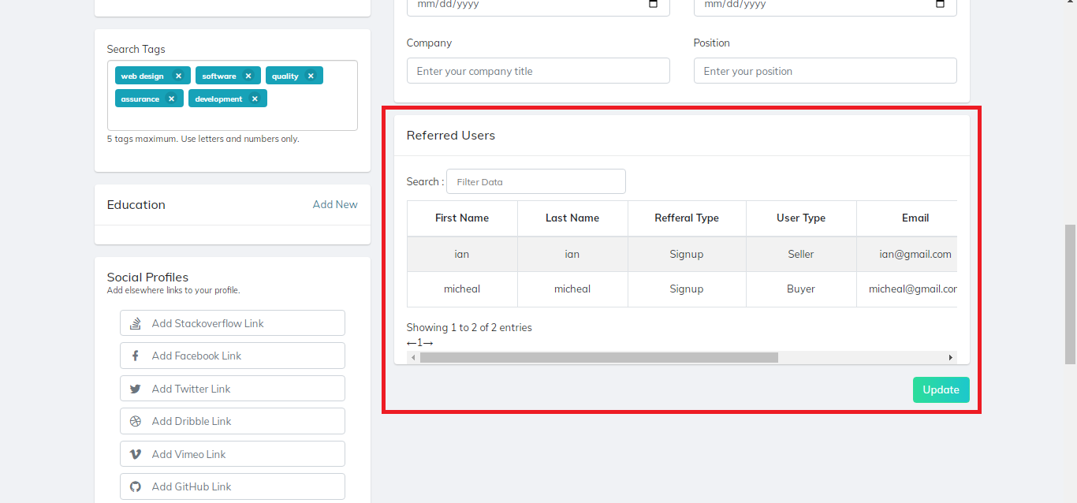

**Connect Referral**

If a buyer comes to a seller and the seller is unable to do buyer’s required job, He could recommend another seller by coping the referral link from that seller’s profile and provide it to the buyer so that he can contact with him.

If the buyer uses that referral link to contact that seller, a connect referral record will be added to the profile of Seller who shared the referral link.

A seller cannot share his own connect referral link or copy it from his own profile.

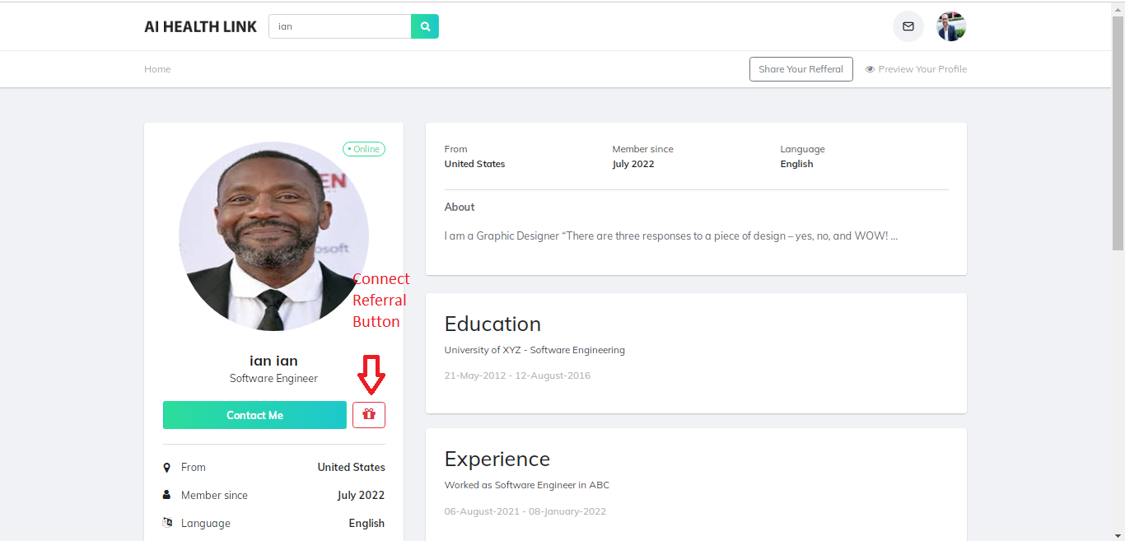

On clicking the Connect referral button, a copy message will appear as a pop up modal.

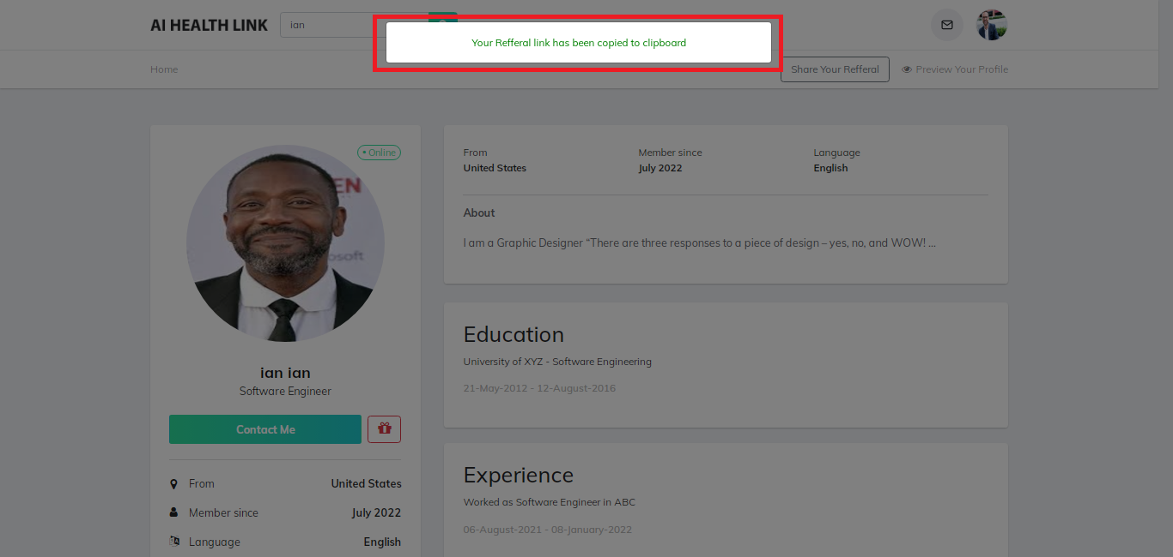

Connect Referral Record of That “User” is added in Seller’s Profile to whom the seller shared the connect referral link.

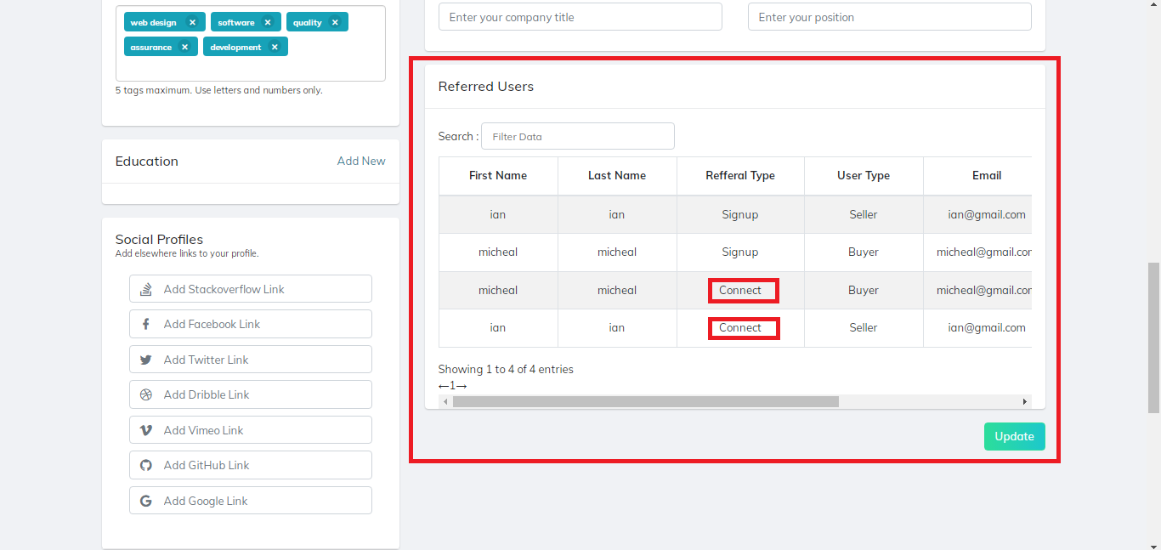

1. **Messaging**

Initially the message box will be empty with no user contacts. The user will contact the Seller by clicking the **“Contact Me”** button on the Seller’s Profile.

On clicking the “Contact Me” button, the user will be redirected to message page, an auto generated message will be sent to the seller and the chat will be started. User can send further messages after this message.

**Signal R Broadcaster** has been used for sending and receiving messages on sender and receiver side. Also, some of the code of SignalR is being used as a help for creating Zoom meetings.

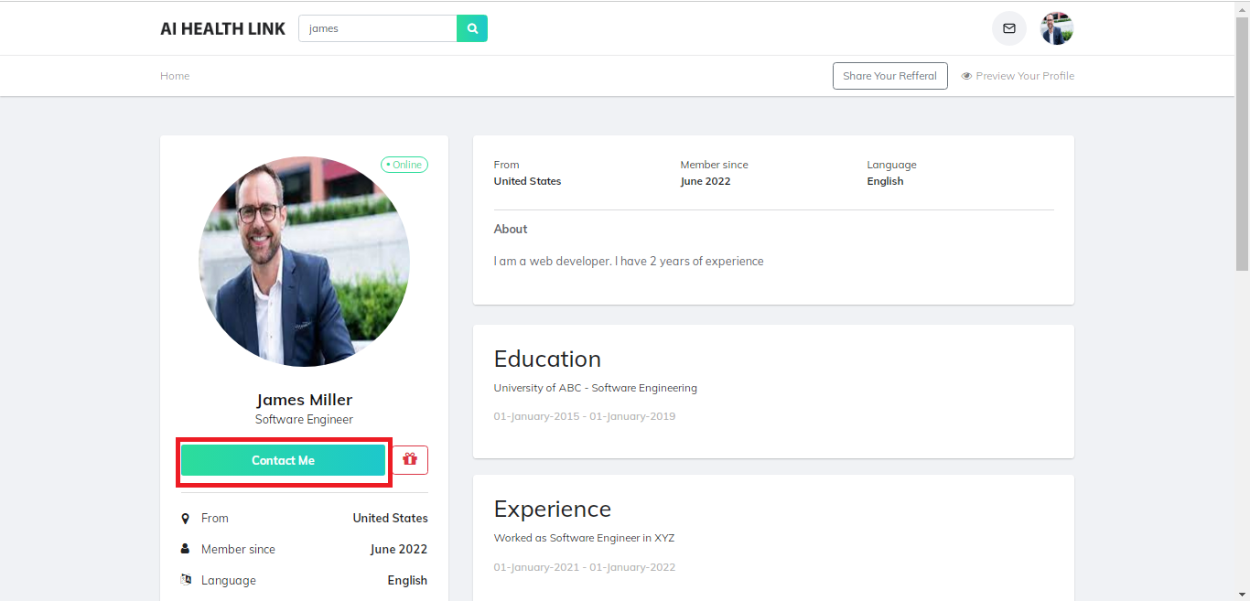

**Seller’s Profile Message View:**

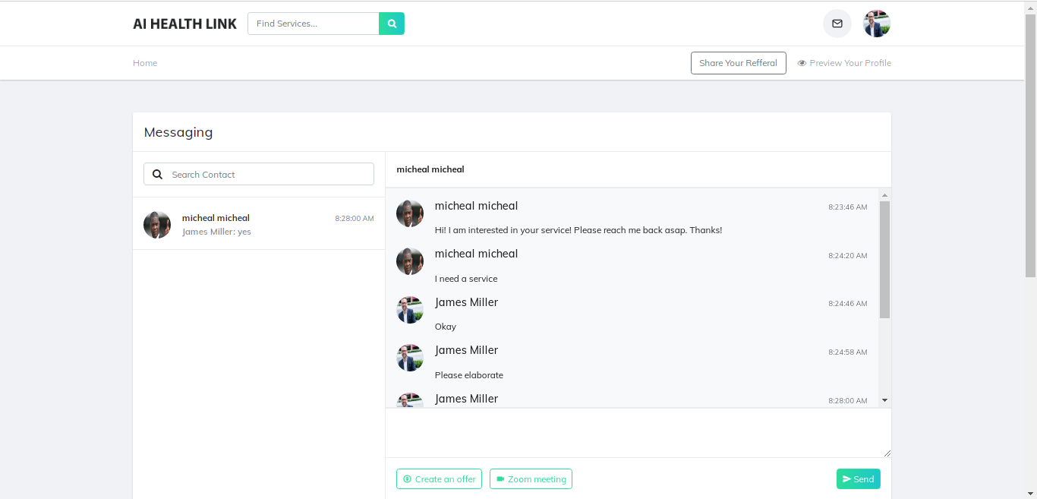

**Buyer’s Profile Message View:**

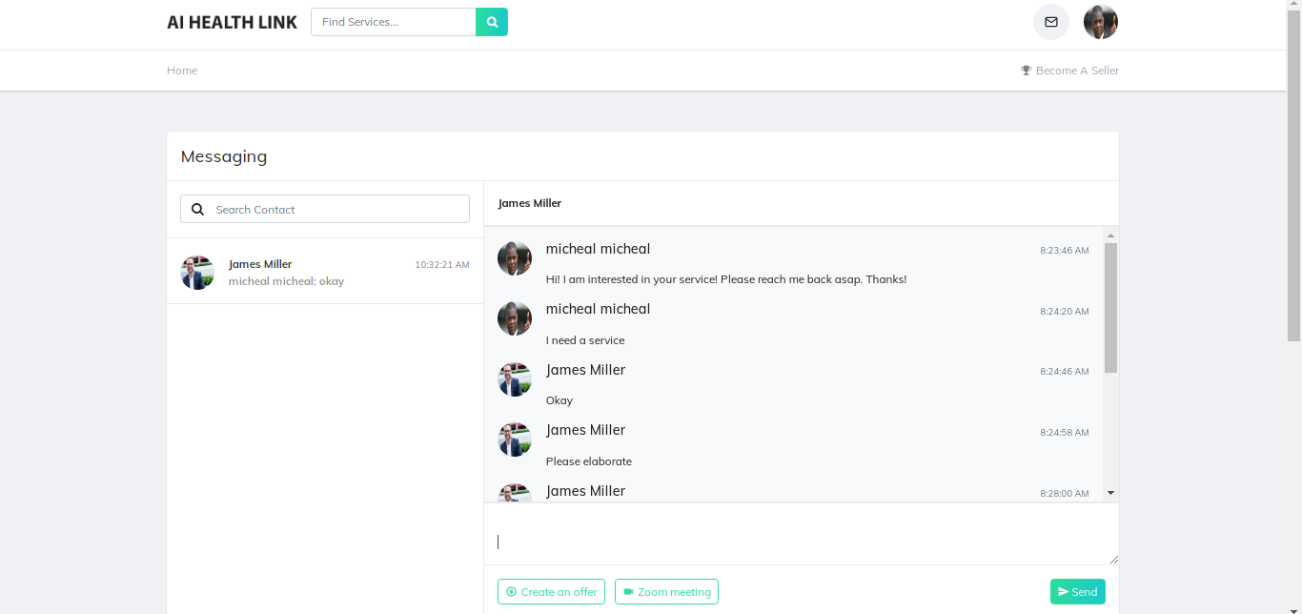

**Zoom Meeting**

Initially user can request for the zoom meeting to another user by clicking on “Zoom Meeting” button. The restriction for zoom meeting creation after successful placing of order will be added in the next module.

In this module, the user can request to other user for zoom meeting right after starting the chat.

Zoom API on Zoom Marketplace has been used for creating meetings for the users using unique JWT Tokens preventing conflicts between meetings of different users on runtime. So that the meeting could remain secure for the users from end to end. This is done by using Zoom API’s Secret Symmetric Key and JWT Identity Models.

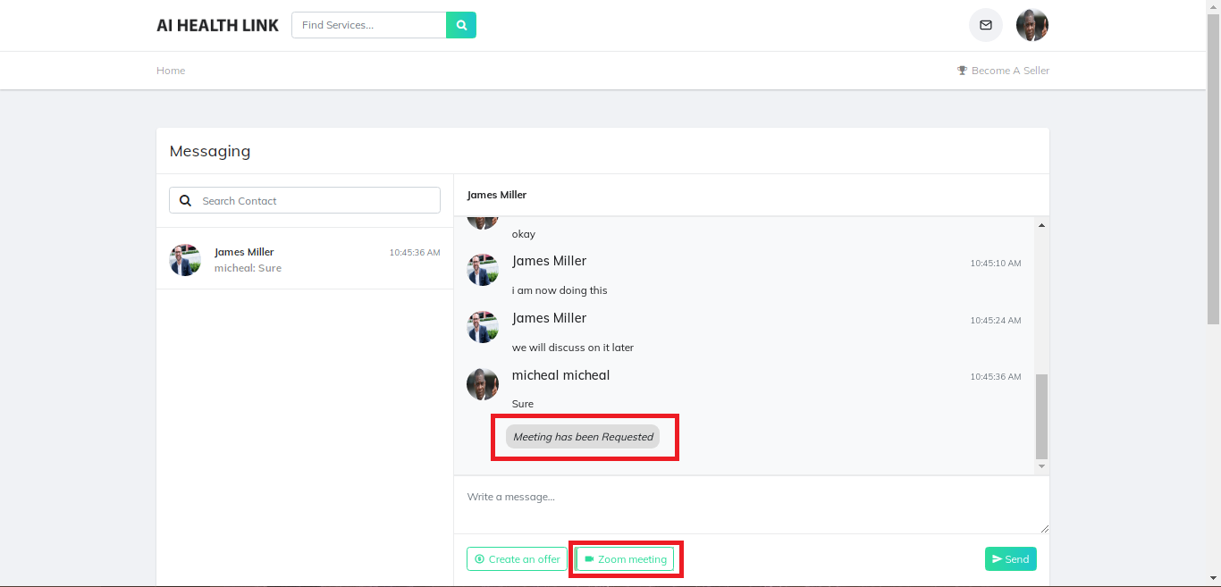

On sending request from one user, the other user will receive a consent modal for accepting/rejecting request of the meeting.

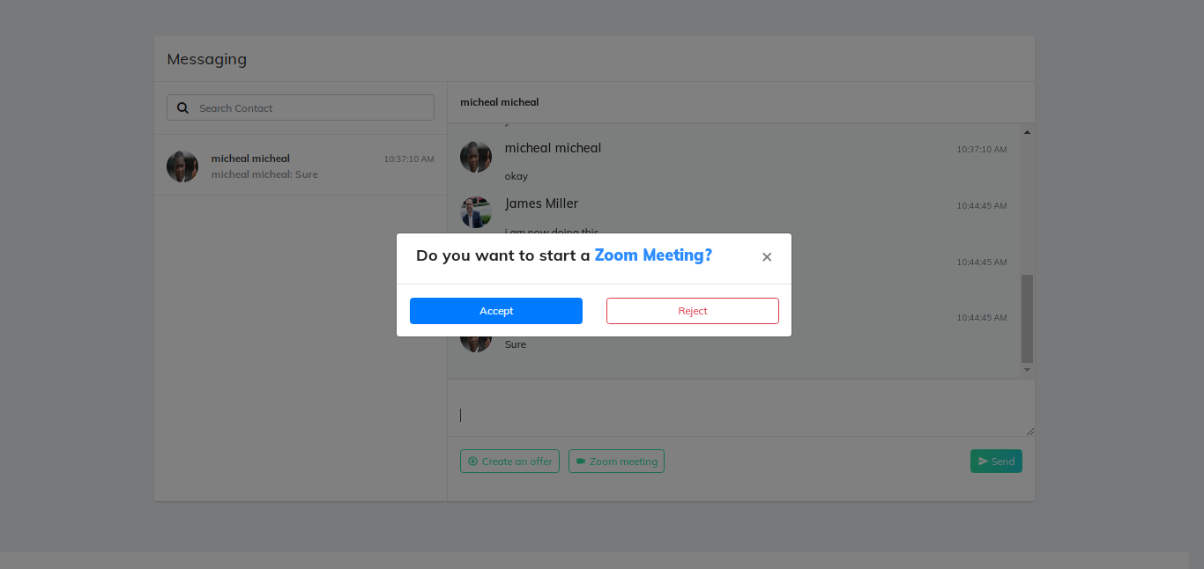

On accept, a meeting link will be sent to the requesting user for entering in the meeting and a window will open in new tab on the requested user side to join the created meeting.

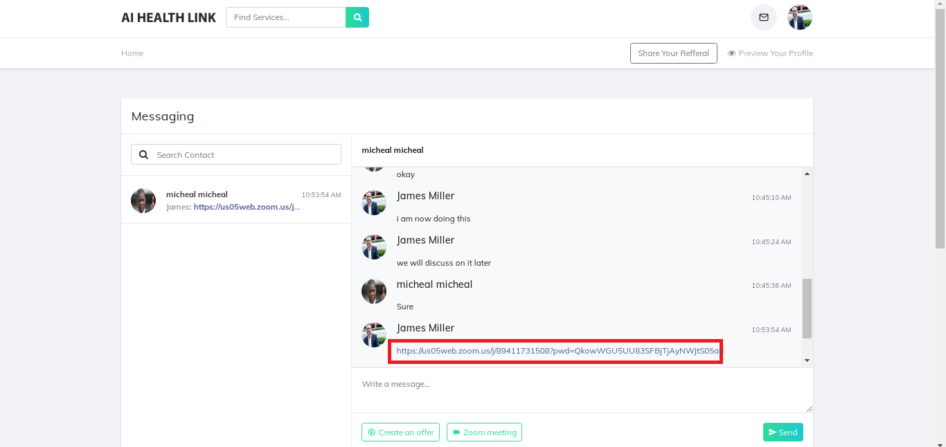

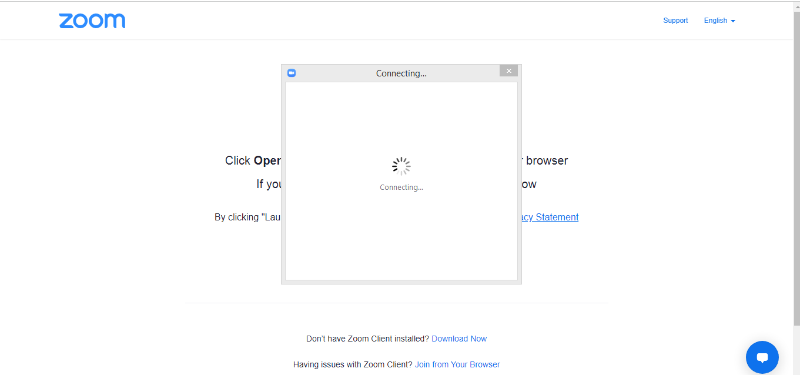

**Note:**

On rejecting, a message will appear on the requested user side as “request rejected by the user”.

1. **Create an Offer (Under Development)**

This modal is for creating a custom order within messages in which user will give details about the order and will submit request. This sub-module is under development. Only frontend has been implemented for this sub-module.

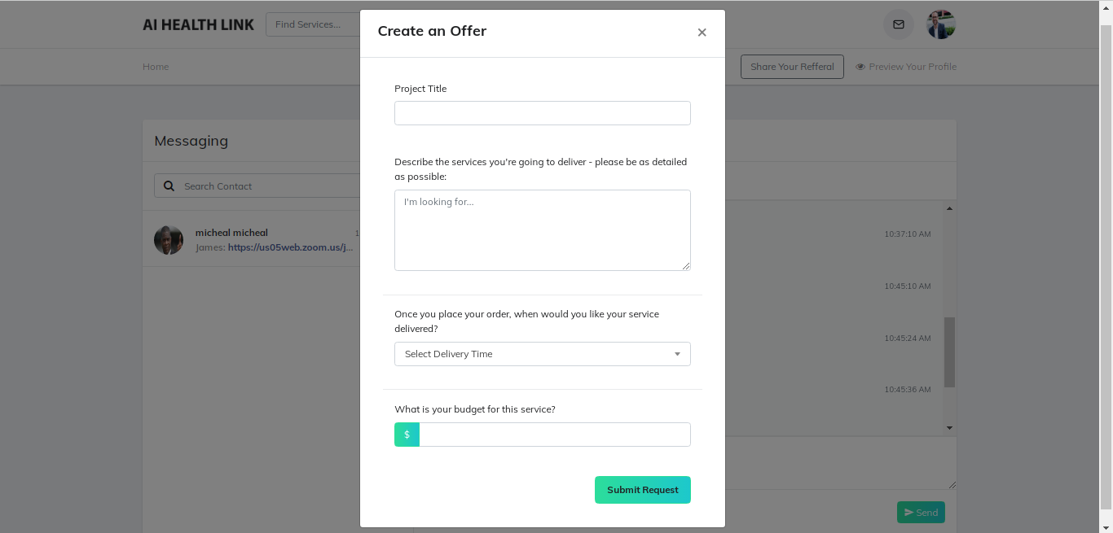

1. **Starting service cost for seller in Seller’s Profile (Starting from)**

The attribute **“Starting from”** is now available for the Seller to be added and will be shown in search results user’s card. So that the buyer can see the minimum service cost for the specific seller.

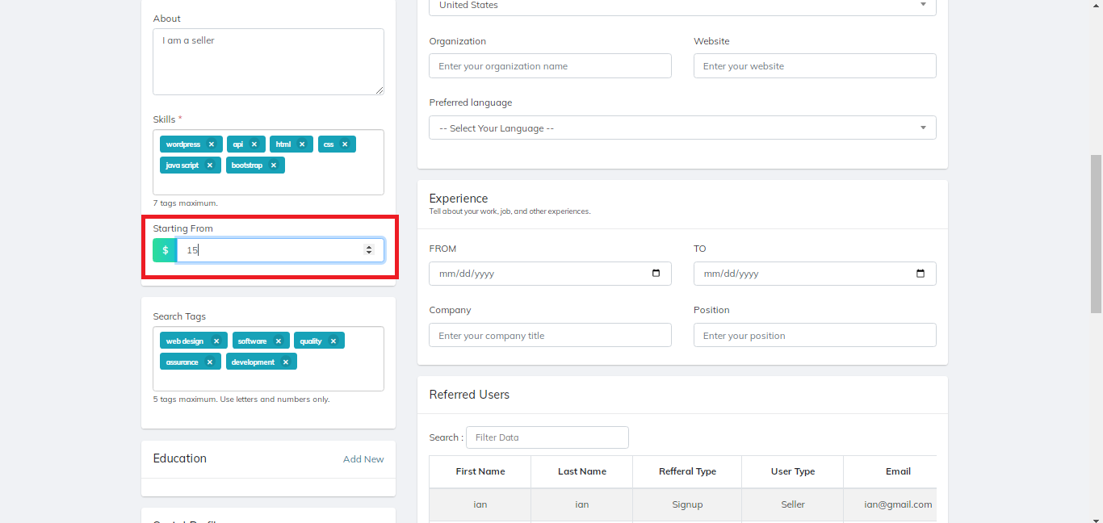

Starting from (Cost) Also shows on searched user Profile Card.

