COMPLETE METHODS & RESULTS REPORT
Controlled 0-D Golovin
Convergence in CLEO
What we prescribed, what CLEO produced, how we analysed it,
and why the formal fixed-50 rule selected 131,072 superdroplets
Primary formal result: The balanced experiment used 50 independent collision histories at every resolution. The first tested candidate satisfying the registered N/2N/4N accuracy, precision, equivalence, conservation, range and provenance requirements was N_SD = 131,072.
Prepared by Anirudh Arora
Bayley Group • Max Planck Institute for Meteorology, Hamburg
Supervisor briefing edition • 3 August 2026

How to use this report
This report is deliberately more detailed than a journal methods section. It is written so that the complete logic can be reconstructed before a discussion with Dr. Clara Bayley: the physical problem, the CLEO application, every controlled input, the raw output structure, the scripts, the statistical estimands, the selection rule, the compute workflow, the figures, the result and the limits of the claim.
Ten-minute meeting route: Read Sections 1, 3, 8, 10 and 14. The remaining sections answer likely technical follow-up questions about initialization, output fields, bootstrapping, Slurm execution, reproducibility and limitations.

Contents
- 1. The answer in one page
- 2. Scientific motivation and scope
- 3. What a superdroplet ensemble physically means
- 4. Exact conditions supplied to CLEO
- 5. Controlled and frozen initialization
- 6. What CLEO computes and writes
- 7. End-to-end execution workflow and scripts
- 8. Diagnostics and mathematical definitions
- 9. Statistical design and convergence criteria
- 10. Balanced fixed-50 experiment and formal result
- 11. Separate targeted precision follow-up
- 12. Figure-by-figure interpretation
- 13. Compute, failures, recovery and provenance
- 14. What the result means—and does not mean
- 15. How to explain the work to Clara
- Appendices: glossary, file map, command map, reproducibility ledger, references

1. The answer in one page
Meeting answer: For the controlled collision-only Golovin box, the original balanced fixed-50 protocol selected 131,072 SDs. The evidence is based on 50 independent collision members at every resolution and confirmation at N, 2N and 4N: 131,072, 262,144 and 524,288 SDs.
The word selected is more accurate than saying that the numerical error becomes zero. At 131,072 SDs, all registered ensemble-mean diagnostics are sufficiently accurate and precise, and further resolution doublings change them by less than the protocol allowed. Liquid mass remains conserved, the diagnostic radius range contains the represented liquid mass, and the provenance checks confirm that every member used the intended binary input, executable, configuration and random seed.
The headline contains two related but different quantities:
- 131,072 SDs is the minimum tested factor-of-two resolution selected by the original formal N/2N/4N rule at the fixed ensemble size.
- 50 members is the prospectively chosen number of independent collision histories per resolution that supports the formal result. The experiment did not test every possible ensemble size from 1 to 50, so 50 must not be described as a mathematically proven minimum ensemble size.
A later, separate targeted follow-up applied a stricter one-percentage-point diminishing-returns requirement to the high-resolution tail. It used 150 members at 262,144 SDs, 150 at 524,288 and 50 at 1,048,576, and supported 262,144 SDs under that targeted practical criterion. This is useful confirmation, but its metadata explicitly forbids presenting it as a retroactive replacement for the original balanced fixed-50 formal selection.
Evidence layer | Ensemble design | Selected resolution | Scientifically correct statement
Original formal fixed-50 | 50 members at each of 9 resolutions | 131,072 SDs | First tested N for which N, 2N and 4N pass the registered formal rule.
Targeted practical follow-up | 150 / 150 / 50 members at 262k / 524k / 1,049k | 262,144 SDs | Separate high-resolution precision result under a stricter 1-pp two-doubling rule.

Do not say: “131,072 SDs and 50 members are universal requirements for CLEO, Long, a cloud model or every diagnostic.” The result is conditional on this Golovin kernel, controlled initialization, box, timestep, time horizon, diagnostic grid, ensemble estimands and tolerances.

2. Scientific motivation and scope

2.1 The project-level question
The broader project asks how many superdroplets per gridbox and how many independent realizations are needed before cloud-microphysical quantities become numerically reliable. A superdroplet method replaces a vast population of physical droplets with a smaller weighted particle population. Increasing the SD number usually improves representation but increases cost. Increasing the number of ensemble members improves estimation of the stochastic mean and uncertainty but also increases cost. These two convergence dimensions must be investigated separately.

2.2 Why use Golovin before Long?
Golovin is an idealised collision kernel with an analytical mean-field solution for the evolving droplet population. That makes it a calibration case: if the numerical workflow cannot reproduce Golovin under controlled conditions, it is not ready for a physically more complicated kernel. The Long kernel is more realistic because it depends on gravitational collection, size-dependent collection efficiency and differential terminal velocity, but it lacks an equivalent closed-form population solution. Golovin therefore tests the machinery; Long addresses the later physical problem.

2.3 Scope deliberately excluded
- No condensation or evaporation.
- No droplet motion within or between gridboxes.
- No sedimentation, fallout or surface precipitation.
- No thermodynamic evolution, turbulent flow or dynamical feedback.
- No 1-D column, 2-D flow or ICON cloud simulation.
- No claim about convergence of realization-to-realization variance itself.
Physical interpretation: This is a closed, perfectly mixed collision volume. The model diagnoses how a population redistributes its liquid mass across sizes; it does not simulate rain reaching the ground.

3. What a superdroplet ensemble physically means

3.1 Real droplets, superdroplets and multiplicity
A real atmospheric volume can contain far too many droplets to track individually. CLEO therefore stores superdroplet records. Superdroplet i carries a radius rᵢ and a multiplicity ξᵢ. The multiplicity is the number of identical real droplets represented by that one computational record. The number of stored superdroplets is consequently not the same as the physical droplet number concentration.
M₀(t) = (1 / V) Σᵢ ξᵢ(t)
For example, the controlled box contains (8.388608×10^{18}) represented physical droplets initially, while a numerical member may use only 131,072 superdroplet records to represent them.

3.2 What happens during a collision
At every 0.1-s collision step, CLEO randomly samples possible collision pairs using the Golovin collision probability and the SDM all-or-nothing coalescence rule. A selected coalescence transfers represented droplet mass into a larger radius class and adjusts multiplicities according to the algorithm. In expectation, the stochastic algorithm reproduces the intended population collision rate. A finite member fluctuates around that expectation.

3.3 What an ensemble member is
One ensemble member is one complete 3600-s CLEO simulation with the same physical/numerical setup but a distinct collision random-number seed. It is not one MPI rank within a distributed simulation and it is not one output time. Fifty members mean fifty independent stochastic collision histories.

3.4 What is fixed and what varies
Component | Within one resolution | Between members | Between resolutions
Continuous target DSD | Fixed | Fixed | Fixed
CLEO-native initial binary | Same bytes | Same bytes | Different deterministic discretization of same target DSD
Collision seed | — | Different and recorded | Different and recorded
Collision timestep / duration | Fixed | Fixed | Fixed
Number of SD records | Fixed | Fixed | Changes with N_SD
Collision outcome | Stochastic | Different | Different independent ensemble

Independent-resolution warning: Member 17 at 131,072 SDs is not paired with member 17 at 262,144 SDs. Member numbers are labels. The confidence intervals for adjacent resolutions therefore use independent-ensemble statistics.

4. Exact conditions supplied to CLEO

4.1 Physical and geometric configuration
Input | Value | Meaning
Gridboxes | 1 | A single well-mixed collision volume.
Coordinate extent | 0–10,000 m in x, y and z | Inherited collisions0d geometry; gives V = 10¹² m³.
CLEO nspacedims | 3 | Coordinates are retained, but NullMotion and NullDynamics make the experiment physically 0-D.
Active microphysics | Golovin collision–coalescence | Only droplet merging changes the population.
Disabled physics | Condensation, motion, coupling, fallout | No competing growth or transport process.
Initial wet-radius support | 1–75 µm | Starting population only; evolved drops may become much larger.
Dry radius | 10⁻¹⁶ m | Effectively negligible dry-solute radius in this collision test.
Number concentration | 8,388,608 m⁻³ | Initial represented real-droplet concentration.
Represented physical total | 8.388608×10¹⁸ | Number concentration multiplied by box volume.

4.2 Time integration and output
Control | Value | Interpretation
Collision timestep | 0.1 s | Collision probabilities and coalescence are updated every 0.1 physical seconds.
End time | 3600 s | One-hour registered calibration horizon; not a universal physical stopping time.
Full-state output | Every 600 s | Raw states at 0, 600, 1200, 1800, 2400, 3000 and 3600 s.
Decision times | 600–3600 s | Six post-initial times; time zero is an initialization gate.
Rank/thread per member | 1 / 1 | Byte-replayable controlled stochastic member.
Diagnostic radius interval | 1–5000 µm | Analysis grid; wider than initial support to capture coalescence growth.
Primary/sensitivity bins | 500 / 250 and 1000 | Common logarithmic-radius edges; no N-dependent smoothing in formal L1.

4.3 Resolution and ensemble matrix
The balanced production matrix contained nine factor-of-two resolutions. Every resolution had 50 fresh collision seeds and one resolution-specific frozen initial binary.
N_SD | Members | Runs represented | Role
4,096 | 50 | 50 | Accuracy/equivalence ladder
8,192 | 50 | 50 | Accuracy/equivalence ladder
16,384 | 50 | 50 | Accuracy/equivalence ladder
32,768 | 50 | 50 | Accuracy/equivalence ladder
65,536 | 50 | 50 | Accuracy/equivalence ladder
131,072 | 50 | 50 | Accuracy/equivalence ladder
262,144 | 50 | 50 | Accuracy/equivalence ladder
524,288 | 50 | 50 | Accuracy/equivalence ladder
1,048,576 | 50 | 50 | Accuracy/equivalence ladder

Total: 9 resolutions × 50 members = 450 independent model members. The matrix checksum was cc838bc63f2d939f99f21013836d134195de6339658ba9555ca48d17d9a293ed.

5. Controlled and frozen initialization

5.1 Why random initialization was not used in the core ladder
If every member sampled a new initial superdroplet population, the observed spread would mix two stochastic sources: initial DSD sampling and subsequent collision sampling. The production ladder was designed to isolate collision-stream variability. Therefore one deterministic initialization was generated per resolution and reused by all 50 members at that resolution.

5.2 Construction of the deterministic population
- Condition the target exponential-in-volume distribution to wet radii between 1 and 75 µm.
- Partition the allowed range in logarithmic volume space.
- Integrate target droplet number and liquid volume within each source bin.
- Convert the continuous number allocation to integer multiplicities using a deterministic largest-remainder allocation.
- Choose representative volumes so the bin-integrated liquid volume is preserved.
- Write CLEO-compatible radius, multiplicity, coordinate and solute attributes to a native binary file.
- Read the binary back with CLEO's own reader and verify the physical totals and moments.
- Record sizes, hashes, source/config/CLEO commits and make the bundle read-only.

5.3 Initialization gates
Quantity | Gate | Reason
Relative M₀ error | ≤ 10⁻¹⁰ | Number concentration is explicitly controlled.
Relative M₃ error | ≤ 10⁻¹⁰ | Liquid volume/mass is explicitly controlled.
Relative M₆ error | ≤ 1% | Tail representation is checked rather than forced.
Representative radius | Inside its source bin | Prevents hidden DSD distortion.
Bundle bytes | Identical before/after each member | Proves the initial state was not mutated.
Permissions | Read-only | Prevents accidental modification.

5.4 Why M₆ was checked but not matched
Matching M₀ and M₃ ensures that physical number and liquid mass are controlled. Forcing M₆ as an additional exact constraint could distort the within-bin representative radii or hide the large-drop representation error that M₆ is supposed to diagnose. Therefore M₆ is a resolution-sensitive validation target.

5.5 Difference from the analytical initial state
The closed-form Golovin reference is untruncated, whereas the numerical population is conditioned to 1–75 µm. A direct audit found only a 0.00413% initial mass-distribution L1 mismatch and a 2.97×10⁻⁵ relative M₃ mismatch. These differences are two to three orders of magnitude smaller than the late-time distribution errors. The comparison is therefore practically equivalent for this calibration, but not mathematically identical.

6. What CLEO computes and writes

6.1 Code path
The project executable `collisions0d_golovin` is a small application around pinned CLEO. `main_golovin.cpp` constructs `GolovinProb`, passes it to the project-owned seeded collision adapter, and calls a shared `run_collisions0d` driver. The adapter changes only RNG seeding; it reuses CLEO's pair probability, coalescence update and timestep machinery.
CreateGolovinCollisions
→ GolovinProb()
→ SeededCollCoal(collision interval, Golovin probability, collision seed)
→ CLEO DoCollisions + DoCoalescence
→ RunCLEO with NullDynamics and NullMotion

6.2 The model evolution
At initialization, CLEO reads the grid and superdroplet binaries. During each 0.1-s interval, the stochastic collision process selects and updates pairs. Because motion and dynamics are null, no record crosses a boundary and no thermodynamic state feeds back on the droplets. Observers record the state at the 600-s cadence.

6.3 Raw output produced by one member
Raw product | Contents | How we use it
collisions0d_solution.zarr | Chunked, ragged superdroplet dataset | Primary numerical evidence.
time | Output times | Align states with registered decision times.
radius | Wet radius of each SD record | Distributions, moments, tail and range diagnostics.
xi | Multiplicity of each SD | Converts computational records into represented real droplets.
sdId | Stable SD identifier | Record bookkeeping and dataset reconstruction.
raggedcount | Records associated with each time | Reconstructs variable-length states.
msol | Solute-mass attribute | Retained by CLEO observer; not central to Golovin collision analysis.
collisions0d_setup.txt | Configuration and constants | Reproducibility and official CLEO plotting tools.
manifest.completed.txt | Seeds, commits, paths, resources and hashes | Admits or rejects member from the scientific matrix.

Important: CLEO does not write “converged = yes”. It writes radii and multiplicities. All physical moments, analytical errors, uncertainty intervals and convergence decisions are calculated afterward by project-owned analysis scripts.

7. End-to-end execution workflow and scripts

7.1 Stage A — pin and build the exact code
The researcher-owned repository consumes CLEO as a pinned external CMake dependency. The model result is tied to upstream CLEO commit 83318c23223546d10759d202d70f4fa2f7fe4688. Before running, the project worktree had to be clean and the build manifest had to match the exact project commit. This prevents an executable compiled from one revision being used with scripts from another.

7.2 Stage B — freeze the experiment definition
`config/golovin_fixed50_extended_resolution_convergence.yaml` declares the resolution ladder, 50-member design, timestep, outputs, diagnostics, bootstrap settings, tolerances and data-isolation rules. `prepare_golovin_matrix.py` validates this configuration and writes the immutable 450-row `cases.tsv`, assigning a unique deterministic collision seed and run label to each row.

7.3 Stage C — prepare and verify nine initial bundles
For each N_SD, the controlled initializer creates one native bundle. `controlled_bundle.py verify` checks the expected resolution, pinned CLEO commit, scientific-definition fingerprint, native readback, file permissions and SHA-256 hashes. The same verification runs before and after every consuming member.

7.4 Stage D — materialize one member configuration
For each matrix row, `materialize_collisions0d_config.py` converts the relative reference YAML into a run-local configuration with absolute paths to the selected read-only grid and superdroplet binaries, the exact output directory, one thread, the row's N_SD, 0.1-s collision timestep, 600-s observation cadence and 3600-s end time.

7.5 Stage E — run CLEO
`run_collisions0d.sbatch` validates all environment variables, refuses a pre-existing run directory, verifies the build and bundle, writes an in-progress manifest, and launches exactly one rank and one thread:
srun --exclusive --mem=0 --mpi=pmix_v3 \
--ntasks=1 --cpus-per-task=1 --hint=nomultithread \
collisions0d_golovin config.yaml COLLISION_SEED
After CLEO exits, the wrapper requires a Zarr dataset and setup file, computes a deterministic tree hash, re-verifies the frozen bundle, records modules/commits/resources/seeds/timings, and atomically replaces the in-progress manifest with a completed manifest. A failed member is never silently counted as complete.

7.6 Stage F — run many members efficiently
The matrix runner uses one Slurm allocation with several background worker loops. Each worker owns a disjoint subset of matrix rows, and each row launches one exclusive single-core CLEO step. This parallelizes independent ensemble members without attempting unsupported multi-rank decomposition of a 0-D member. OpenMPI is the launch/runtime layer; it does not divide one collision box among ranks.

7.7 Stage G — Stage-0 diagnostics
`analyze_collisions0d.py` reconstructs each ragged Zarr dataset, validates times, computes fixed-bin mass distributions and moments, compares with the analytical solution, checks mass/radius coverage, writes per-time and per-member CSV files, stores 250/500/1000-bin arrays in NPZ, creates diagnostic figures and publishes a checksum manifest.

7.8 Stage H — ensemble and resolution analysis
Script | Role
summarize_golovin_ensemble.py | Combines accepted member diagnostics into ensemble-level tables.
analyze_golovin_resolution_convergence.py | Computes analytical accuracy, precision, independent adjacent-resolution intervals and formal N/2N/4N selection.
analyze_golovin_practical_convergence.py | Computes one-sided 95% upper bounds on absolute changes, prefix stability and two-doubling practical selection.
analyze_golovin_convergence_law.py | Fits an optional error-floor-plus-power-law diagnostic; never selects a resolution.
audit_golovin_matrix.py | Confirms matrix completeness, manifests, paths and hashes.
analyze_golovin_targeted_precision_extension.py | Evaluates the prospectively conditioned 150/150/50 high-resolution follow-up.

7.9 Representative orchestration—not a copy-paste submission recipe
# 1. Freeze configuration and cases.tsv
python scripts/prepare_golovin_matrix.py ...
# 2. Build exact project/CLEO revisions
sbatch --account=mh0731 scripts/levante/build_cleo_app.sbatch
# 3. Prepare and verify controlled bundles
sbatch --account=mh0731 scripts/levante/prepare_controlled_bundle_ladder.sbatch
# 4. Run reviewed matrix inside one bounded allocation
sbatch --account=mh0731 --export=ALL,MATRIX_FILE=...,RESOLUTION_RECORD_ROOT=... ...
# 5. Run Stage-0 and aggregated analysis
sbatch --account=mh0731 scripts/levante/analyze_golovin_resolution_convergence.sbatch
The historical run used exact worktree-specific paths and resource overrides recorded in its manifests/runbook. The schematic above explains the command layers; it is intentionally not advertised as a current submission command.

8. Diagnostics and mathematical definitions

8.1 General radius moments
Mₙ(t) = (1 / V) Σᵢ ξᵢ(t) rᵢ(t)ⁿ
The multiplicity weighting is essential: the moments describe the represented physical droplet population, not the unweighted distribution of SD records.
Diagnostic | Physical meaning | Expected collision-only behaviour | Role
M₀ | Number concentration | Decreases as droplets merge | Bulk accuracy/convergence
M₃ | Proportional to liquid volume/mass | Conserved in a closed coalescence box | Hard integrity gate
M₆ | Strongly large-drop weighted; reflectivity-like | Grows and is noisy because rare large drops dominate | Tail accuracy/convergence

8.2 Relative liquid-mass drift
δ_L(t) = [L(t) − L(0)] / L(0)
Coalescence should only redistribute liquid mass. A drift above the tolerance would indicate a model/output/analysis integrity problem; it is not something additional SDs should be used to hide.

8.3 Fixed-bin mass distribution
All member radii are mapped to a common 1–5000-µm logarithmic grid. Each SD contributes its represented liquid mass to the appropriate bin. Formal diagnostics use exactly the same 500 edges for every member, time and resolution. Unlike the official Shima-style validation visual, no resolution-dependent Gaussian smoothing enters the formal convergence statistic.

8.4 Ensemble-mean relative L1 error
L1(t) = Σ_b |ḡ_b(t) − g_b^analytic(t)| / Σ_b |g_b^analytic(t)|
Here ḡ is formed by averaging the numerical bin masses over members before taking the absolute difference. That order matters because the research question concerns the mean numerical distribution. L1 = 0 is exact agreement on the chosen grid; L1 = 0.05 means the summed absolute binwise discrepancy equals 5% of the analytical mass represented on that grid.

8.5 Analytical moment bias
relative bias(Mₙ) = [Mₙ^numerical − Mₙ^analytical] / Mₙ^analytical
The sign is retained in the analytical-accuracy analysis: positive means overestimation and negative means underestimation. For practical adjacent-resolution changes, the absolute difference is used because the question is whether another doubling materially changes the result.

8.6 Other diagnostics
- Out-of-range liquid-mass fractions below 1 µm and above 5000 µm.
- Maximum represented radius.
- Mass-weighted radius quantiles, including q99.
- Mass fractions above configured thresholds, such as 1000 µm.
- Interval-censored threshold times for descriptive tail growth—not surface rain onset.

9. Statistical design and convergence criteria

9.1 Why visual flattening is insufficient
A curve can look flat because the estimator is noisy, and two estimates can be statistically non-significant while the confidence interval still allows scientifically large differences. Conversely, a tiny difference can be statistically significant with enough members. The protocol therefore combines analytical accuracy, uncertainty, practical effect size, two resolution doublings and hard integrity checks.

9.2 Confidence intervals
The analysis uses a 95% confidence level. L1 is nonlinear, so percentile bootstrap resampling is used for the ensemble-mean distribution statistic and its adjacent differences. Moment means and independent-resolution differences use corresponding mean/Student/Welch calculations in the formal analysis. The practical analysis uses 10,000 deterministic bootstrap resamples and a one-sided upper confidence bound on the absolute change.

9.3 Formal hard validity and precision gates
Requirement | Registered threshold
Primary 500-bin L1 analytical accuracy | Upper 95% bound ≤ 5%
M₀ analytical bias | Entire 95% interval inside ±5%
M₆ analytical bias | Entire 95% interval inside ±5%
L1 95% half-width | ≤ 1 percentage point
M₀ 95% half-width | ≤ 2.5% of analytical reference
M₆ 95% half-width | ≤ 5% of analytical reference
Relative liquid-mass drift | Every member ≤ 10⁻⁷
Mass outside 1–5000 µm | Every member ≤ 10⁻⁶
Provenance | All bundle, build, seed, config, path and output checks pass

9.4 Formal adjacent-resolution equivalence
Difference | Formal equivalence margin
Fixed-bin L1 between independent resolution ensembles | 95% interval entirely inside ±1 percentage point
Signed relative M₀ bias difference | 95% interval entirely inside ±5 percentage points
Signed relative M₆ bias difference | 95% interval entirely inside ±5 percentage points

9.5 N/2N/4N confirmation rule
A candidate N is selected only if N, 2N and 4N pass analytical/precision gates and both adjacent pairs N→2N and 2N→4N pass equivalence at every registered time. This prevents selecting a one-step accidental plateau.

9.6 Separate practical diminishing-returns rule
D_q(N,t) = 100 × |q̂(N,t) − q̂(2N,t)| percentage points
For q ∈ {L1, M₀ bias, M₆ bias}, the one-sided 95% bootstrap upper bound on D_q must be no larger than 1 percentage point for both successive doublings and every decision time. The 1-pp value is a project-defined minimum worthwhile improvement, equal to 20% of the 5% analytical-accuracy budget; it is not a universal threshold supplied by the literature.
Why two rules exist: The original formal rule uses metric-specific adjacent margins and produced the formal 131,072-SD selection. The later practical rule asks a stricter, more uniform diminishing-returns question. Its targeted follow-up supports 262,144 SDs but cannot rewrite the original formal design after the data are known.

10. Balanced fixed-50 experiment and formal result

10.1 What the complete decision file says
N_SD | Analytical + precision | Adjacent pair starting here | Pair equivalence
4,096 | fail | 4096 → 8192 | fail
8,192 | fail | 8192 → 16384 | fail
16,384 | fail | 16384 → 32768 | fail
32,768 | PASS | 32768 → 65536 | fail
65,536 | PASS | 65536 → 131072 | fail
131,072 | PASS | 131072 → 262144 | PASS
262,144 | PASS | 262144 → 524288 | PASS
524,288 | PASS | 524288 → 1048576 | PASS
1,048,576 | PASS | — | —

Resolutions from 32,768 upward pass their individual analytical and precision gates. However, all adjacent pairs up to and including 65,536→131,072 fail at least one formal equivalence row. The first adjacent pair that passes is 131,072→262,144, and the next pair 262,144→524,288 also passes.

10.2 Why the selected value is 131,072
Confirmation component | Required level | Outcome
Candidate validity | N = 131,072 | PASS
First confirmation validity | 2N = 262,144 | PASS
Second confirmation validity | 4N = 524,288 | PASS
First adjacent comparison | 131,072 → 262,144 | PASS
Second adjacent comparison | 262,144 → 524,288 | PASS

Formal conclusion: The first tested factor-of-two candidate satisfying the complete formal confirmation rule is 131,072 SDs. Lower candidates fail because at least one required adjacent comparison or individual validity/precision gate fails.

10.3 What the result does not prove about 50 members
The design fixed 50 members before inspecting the model output. It therefore demonstrates that 50 members per resolution are sufficient to support this formal selection. It does not establish 50 as the smallest possible ensemble size, because the study did not rerun the complete selection rule at every n = 1, 2, …, 50 with independent fresh ensembles. Prefix diagnostics provide useful stability evidence but are not a proof that 49 or 40 could never support the same formal result.

10.4 Fixed-50 practical result was more cautious
Under the later stricter one-percentage-point rule, the fixed-50 data selected no practical resolution. The 262,144→524,288 comparison was limited by the late-time M₆ upper bound: 1.174 percentage points, just above the 1-point threshold, even though the point change was only 0.536 points. This is an uncertainty limitation rather than evidence of a broken numerical solution.

11. Separate targeted precision follow-up

11.1 Why it was run
The fixed-50 practical analysis identified a single scientifically relevant uncertainty bottleneck: the 3600-s M₆ comparison between 262,144 and 524,288 SDs. Rather than rerunning the whole nine-level ladder, the follow-up prospectively added 100 fresh collision streams at each of those two resolutions. The initial binaries were reused byte-for-byte, while run labels, collision seeds and raw paths were new.
Resolution | Original members | Added | Combined targeted analysis
262,144 | 50 | 100 | 150
524,288 | 50 | 100 | 150
1,048,576 | 50 | 0 | 50

11.2 Exact limiting results
Pair | Metric | Worst time | Point change | 95% upper bound | Pass
262k → 524k | L1 | 3600 s | 0.180 pp | 0.299 pp | yes
262k → 524k | M₀ | 3600 s | 0.048 pp | 0.110 pp | yes
262k → 524k | M₆ | 3600 s | 0.570 pp | 0.923 pp | yes
524k → 1,049k | L1 | 3600 s | 0.043 pp | 0.140 pp | yes
524k → 1,049k | M₀ | 3000 s | 0.004 pp | 0.067 pp | yes
524k → 1,049k | M₆ | 3600 s | 0.177 pp | 0.490 pp | yes

The limiting result is the 262,144→524,288 M₆ upper bound, 0.923 pp. It remains below the predeclared 1.0-pp limit. All analytical/conservation/range gates pass, and the 250- and 1000-bin sensitivity analyses select the same candidate.
Targeted conclusion: Within this prospectively defined high-resolution follow-up, 262,144 SDs satisfy the stricter practical two-doubling criterion. The result metadata sets formal_convergence_claim_permitted = false, so this supports—but does not replace—the original 131,072-SD formal selection.

12. Figure-by-figure interpretation
The following figures are the exact high-resolution PNG products archived with the final report. Green shading denotes a registered acceptance region, not a confidence interval. Error bars or upper-bound symbols quantify uncertainty; lines connect related estimates for readability and are not additional model trajectories.
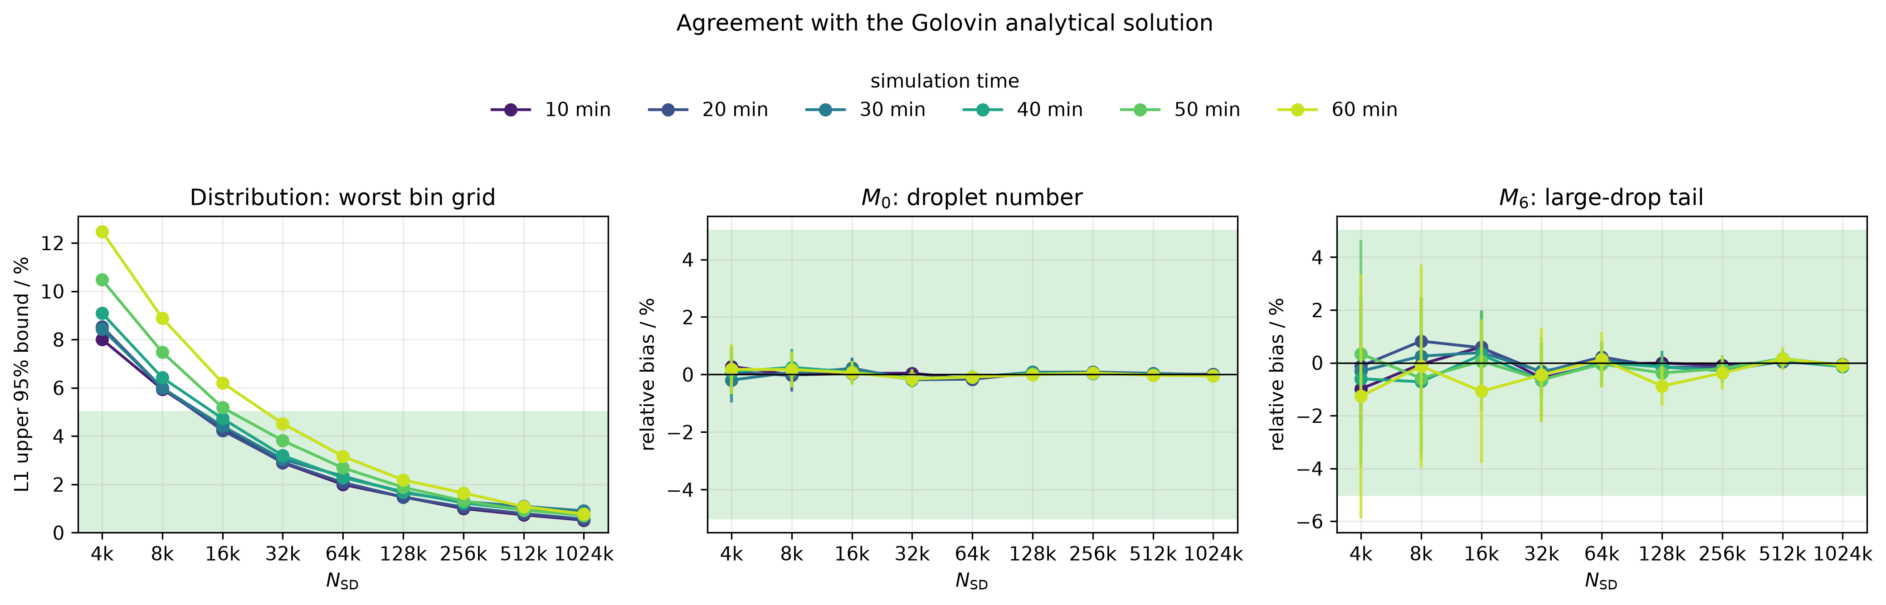
Figure 1. Original balanced fixed-50 analytical accuracy across resolution and decision time.
Source: Checksum-published fixed-50 analysis_v2, Levante job 26614553.
How to read it: Each panel asks whether the ensemble mean agrees with the analytical Golovin reference. The green region is the acceptable analytical-error range. Lower resolutions fail some distribution or moment rows; high resolutions lie well inside the tolerances. This prevents a numerically flat but analytically wrong sequence from being called converged.
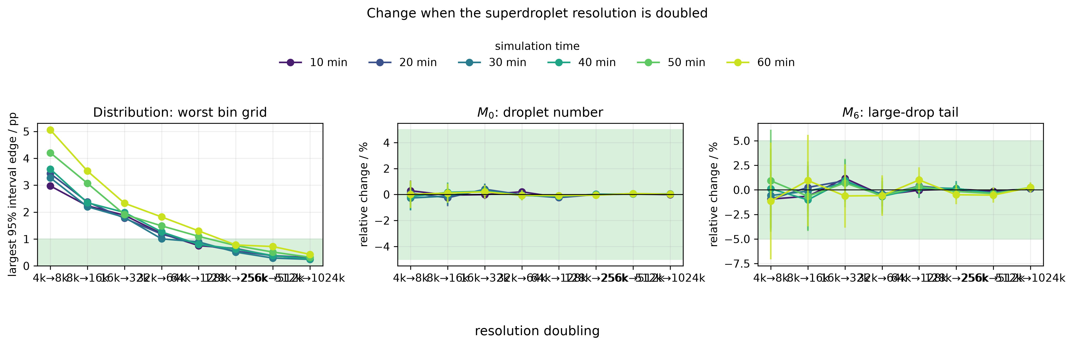
Figure 2. Original formal adjacent-resolution equivalence.
Source: Checksum-published fixed-50 analysis_v2, Levante job 26614553.
How to read it: The plotted intervals compare independent resolution ensembles. A pair passes only when the whole interval lies inside its green equivalence band at every time. The formal decision file shows that 131,072→262,144 and 262,144→524,288 are the first two consecutive passing pairs, which is why N = 131,072 is selected.
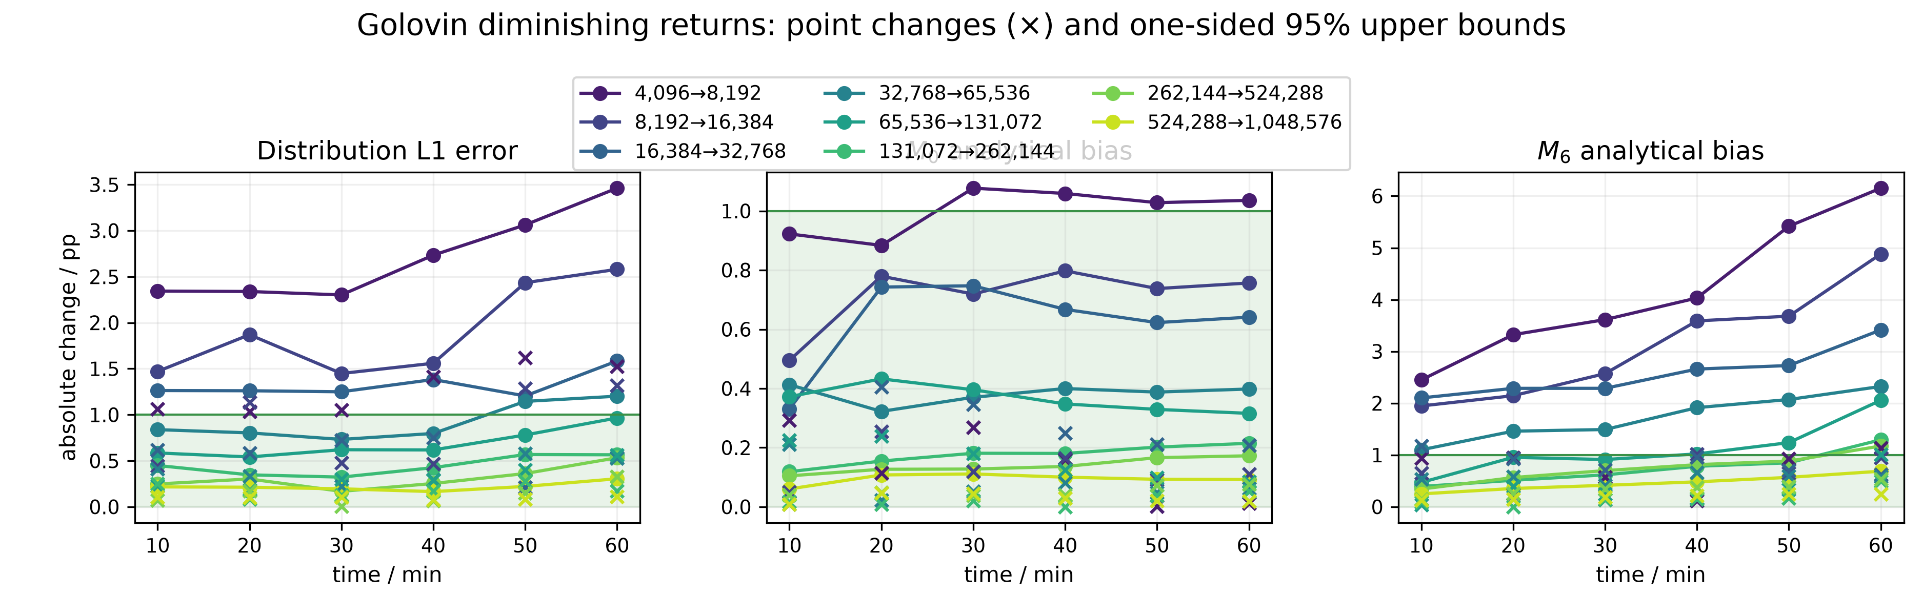
Figure 3. Original fixed-50 practical diminishing-returns diagnostic.
Source: Checksum-published fixed-50 analysis_v2, Levante job 26614553.
How to read it: Crosses show point changes and filled markers show one-sided 95% upper bounds. The green band is 0–1 percentage point. Most high-resolution point changes are small, but the uncertainty bound for late M₆ in 262,144→524,288 extends above 1 pp. Therefore the stricter practical rule selects no resolution at fixed 50, despite the formal selection.
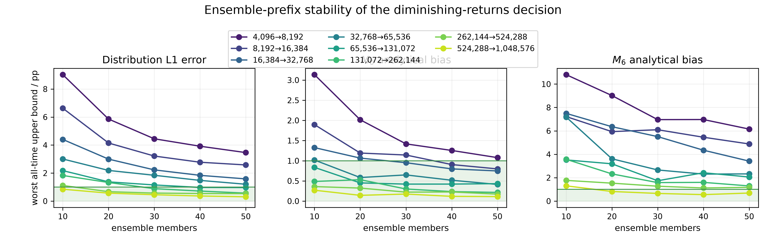
Figure 4. Original practical decision stability as the fixed ensemble grows from 10 to 50 members.
Source: Checksum-published fixed-50 analysis_v2, Levante job 26614553.
How to read it: This figure checks whether the decision is robust to using progressively larger prefixes of the same prospective 50-member pool. Prefix convergence is descriptive evidence about estimator stability. It is not a proof that a particular prefix is a universally sufficient ensemble size.
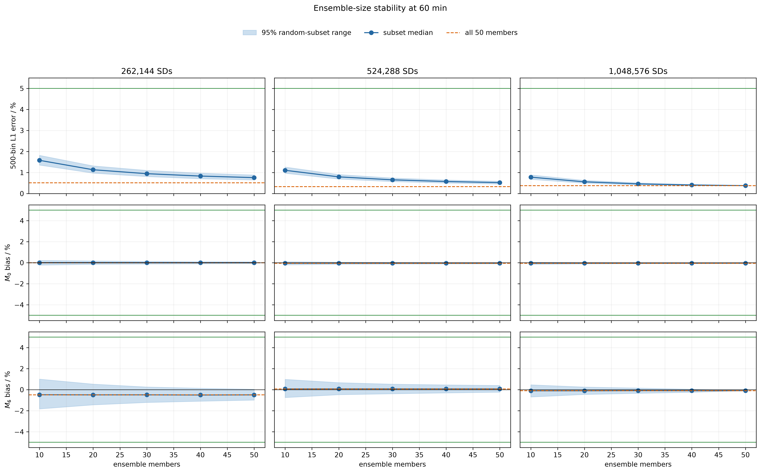
Figure 5. Random-subset ensemble-size stability at the registered late time.
Source: Checksum-published fixed-50 analysis_v2, Levante job 26614553.
How to read it: The spread of subset estimates narrows as more independent members are included. M₆ is the most ensemble-demanding quantity because it is controlled by rare large drops. The figure explains why ensemble size matters even when the mean error is already small.
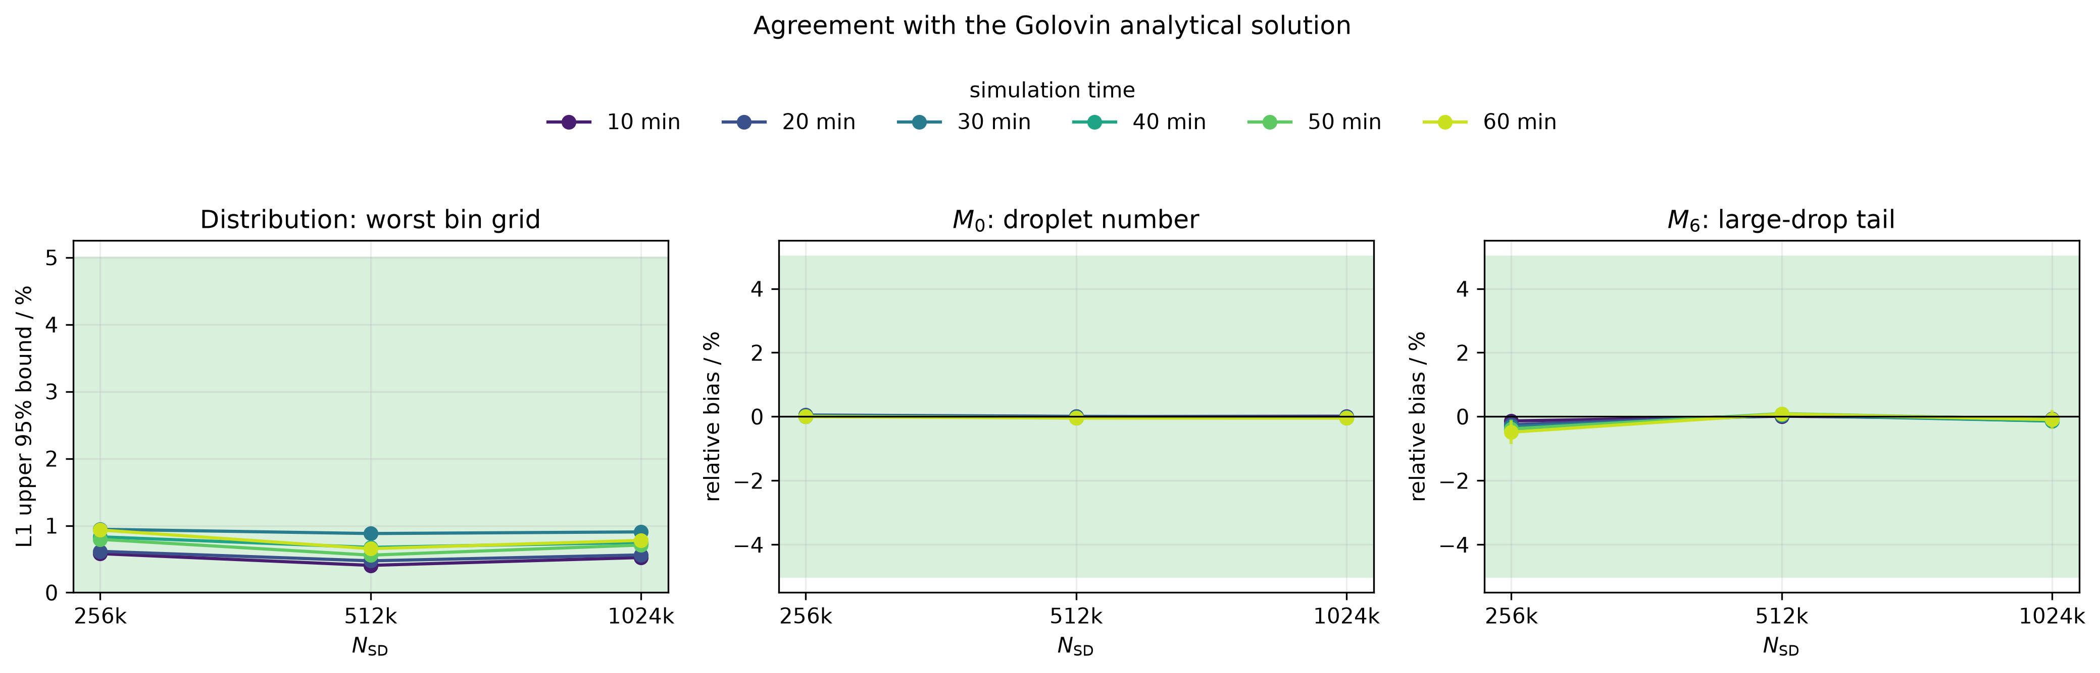
Figure 6. Analytical validity for the targeted 262,144/524,288/1,048,576-SD view.
Source: Checksum-published targeted analysis_v1, Levante job 26630002.
How to read it: All three targeted resolutions pass the analytical, conservation and range gates. At 262,144 SDs the worst primary 500-bin L1 estimate is 0.744%, with a 0.853% upper bound at 1800 s—comfortably inside the 5% budget.
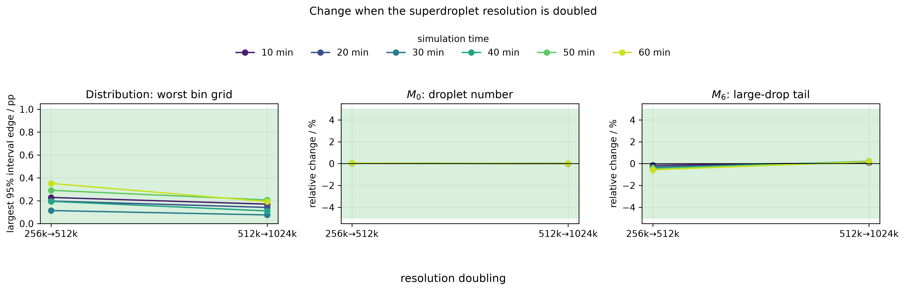
Figure 7. Targeted high-resolution adjacent comparisons after adding independent members.
Source: Checksum-published targeted analysis_v1, Levante job 26630002.
How to read it: The extra 100 members at 262,144 and 524,288 shrink the uncertainty relevant to the previously limiting comparison. Both high-resolution adjacent pairs now pass their registered primary checks; the 1,048,576-SD ensemble remains an independent second-doubling confirmation level.
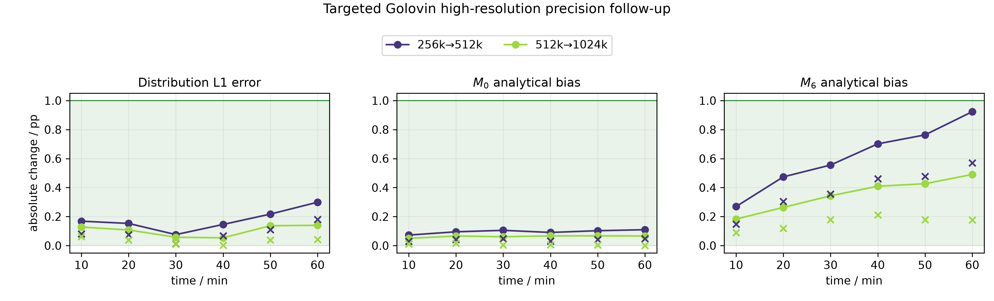
Figure 8. Final targeted practical diminishing-returns decision.
Source: Checksum-published targeted analysis_v1, Levante job 26630002.
How to read it: Every filled upper-bound marker lies within the green 0–1-pp region. The closest marker is late-time M₆ for 262,144→524,288 at 0.923 pp. Therefore 262,144 is selected within the targeted practical follow-up.

13. Compute, failures, recovery and provenance

13.1 Why operational failures are documented
A scientifically credible HPC result must distinguish failed wrappers or allocations from admitted model members. The workflow never silently reused an incomplete member. Failures were preserved under explicit failed paths, while completed members were admitted only after manifests and hashes passed.

13.2 Balanced fixed-50 execution record
Stage/job | Outcome | Scientific effect
Layout probe 26587104 | 16 exclusive one-rank/one-thread steps started within 0.291 s | Validated physical-core concurrency.
Build 26587225 | Completed in 2m11s | Exact project/CLEO executable built.
Bundle job 26587226 | Created 8 bundles, OOM at 1,048,576 | No model members; preserved failure.
Bundle retry 26587405 | Created missing ninth bundle | All nine bundles verified.
Primary/recovery allocations | Most of 450 members completed; shared-node walltime caused timeouts | Completed members preserved and checksum-audited.
Sequential recovery 26603806 | Completed final 14 members | Matrix reached 450/450.
Analysis 26614014 | Primary summaries completed; optional convergence-law bootstrap failed safely | No model data lost; staging preserved.
Corrected analysis 26614553 | Completed 0:0 in 6m07s | Published checksum-clean analysis_v2 and formal selection.

The complete fixed-50 archive contains 450 fresh members and 39,000,784,100 bytes (approximately 39.0 GB) of raw Zarr output. The corrected analysis verified all 450 cases at model commit 8e39a60.

13.3 Targeted follow-up execution record
Stage/job | Outcome | Scientific effect
Initial model 26615811 | Timed out; double nested exclusive srun prevented CLEO launch | Zero admitted completed members.
Scheduler probe 26625335 | Passed 20-worker layout | Validated corrected launch pattern.
Retry 26625391 | Workers launched but allocation OOM; cancelled | Zero complete manifests; preserved/excluded.
Exact build 26625503 | Passed | 8-GiB resource-only correction, unchanged science.
Clean model 26625529 | 200/200 members; 20 physical cores; 6h21m55s | 109.309 summed physical core-hours; 19.0 GB new Zarr.
Stage-0 26629617 | 200/200 diagnostics passed | All new members accepted.
Analysis attempts 26629828/26629925 | Safe configuration/view validation failures | No raw or Stage-0 data changed.
Final analysis 26630002 | Completed in 4m05s; 24 output checksums pass | Published 150/150/50 targeted decision.

13.4 What SHA-256 contributes
SHA-256 is a cryptographic digest of file bytes. Identical digests provide strong evidence that two files are byte-for-byte identical; a changed byte produces a different digest with overwhelming probability. Here hashes bind each initial bundle, matrix, executable provenance, Zarr tree and analysis product to the recorded run. A hash verifies identity and integrity, not physical correctness—that is why analytical, conservation and statistical checks are also required.

14. What the result means—and does not mean

14.1 Supported claims
- The controlled collision-only Golovin workflow is numerically healthy: analytical agreement, mass conservation, radius coverage and provenance pass.
- With 50 independent collision members at each tested resolution, the original formal N/2N/4N rule selects 131,072 SDs.
- The selection concerns ensemble-mean fixed-bin L1, M₀ and M₆ under the registered thresholds and times.
- The later targeted high-resolution follow-up supports 262,144 SDs under the stricter practical 1-pp criterion.
- M₆ is the limiting and most ensemble-demanding diagnostic because it strongly weights rare large drops.

14.2 Unsupported claims
- 131,072 SDs is universally sufficient for CLEO or every SDM.
- 50 is the mathematically smallest possible ensemble size.
- The variance of individual stochastic members has converged.
- The same SD count applies to Long, Hall, condensation, a column or an ICON cloud.
- The 0-D millimetre tail is surface precipitation or rain onset.
- The numerical initial state is exactly the untruncated analytical state.
- A green plot region alone proves convergence without the other gates.

14.3 The correct concise conclusion
Recommended wording: In a controlled one-box CLEO Golovin calibration with a 0.1-s collision timestep and frozen 1–75-µm initialization, the prospectively balanced 50-member resolution study selected 131,072 SDs using the registered N/2N/4N analytical-accuracy, precision, adjacent-equivalence, conservation, range and provenance rule. A separate targeted precision follow-up supported 262,144 SDs under a stricter one-percentage-point practical criterion.

15. How to explain the work to Clara

15.1 Thirty-second version
“I used CLEO's collision-only `collisions0d` application with the Golovin kernel because Golovin has an analytical solution. I froze one deterministic initial population at each SD resolution and ran 50 independent collision seeds at nine resolutions from 4,096 to 1,048,576 SDs. I compared the ensemble-mean size distribution, M₀ and M₆ with the analytical solution, checked M₃ conservation and radius coverage, and required two consecutive resolution doublings to pass. The original formal rule first passes at 131,072 SDs, confirmed at 262,144 and 524,288. A separate stricter high-resolution follow-up supports 262,144 SDs, but it does not replace the original formal result.”

15.2 Five-minute explanation
- Purpose: calibrate the entire stochastic collision workflow against a known analytical solution before Long.
- Controls: one box, collision only, 0.1-s timestep, 3600-s duration, common 1–5000-µm diagnostic grid.
- Initialization: deterministic 1–75-µm target population; M₀ and M₃ controlled; read-only binary reused across members.
- Ensemble: distinct collision seed per member; 50 members per resolution; different resolutions are independent.
- Outputs: CLEO writes time, radius, multiplicity and identifiers in Zarr; project scripts reconstruct distributions and moments.
- Metrics: L1 distribution error, M₀ number concentration, M₃ conservation, M₆ large-drop tail.
- Decision: accuracy + precision + adjacent equivalence + N/2N/4N confirmation + integrity/provenance.
- Result: formal 131,072 SDs at fixed 50; targeted stricter practical 262,144 with 150/150/50.
- Boundary: not a Long or cloud convergence result, and 50 is sufficient here rather than proven globally minimal.

15.3 Likely questions and answers
Question | Answer
Why not simply look for a flat curve? | Noise can create a false plateau; uncertainty bounds and two doublings make the claim testable.
Why 3600 s? | It is the registered one-hour calibration horizon, not a literature-mandated universal stop.
Why 500 bins? | It is the primary fixed common grid; 250 and 1000 bins check sensitivity.
Why freeze initialization? | To isolate collision-stream variability instead of mixing it with initial sampling variability.
Why is M₆ difficult? | Its r⁶ weighting makes rare large droplets dominate, so it has larger stochastic uncertainty.
Why 131,072 if targeted says 262,144? | They answer two protocols: original formal balanced selection versus separate stricter targeted practical follow-up.
Is 50 the minimum ensemble? | It is sufficient for the fixed-50 formal result; the study did not prove an absolute minimum member count.
Can we reuse the number for Long? | No. Long requires its own reference/comparator, metrics, initialization and convergence study.

Appendix A. Glossary
Term | Meaning in this project
AON | All-or-nothing stochastic coalescence update used by SDM.
Collision kernel | Physical rate law controlling how likely two droplets are to collide.
Collision seed | Recorded integer initializing the member's collision RNG stream.
Controlled bundle | Read-only CLEO-native grid/superdroplet input plus provenance manifest and hashes.
Ensemble member | One complete simulation with one collision seed.
Frozen initialization | One exact time-zero binary reused across all members at one resolution.
L1 error | Normalized summed absolute binwise difference between ensemble-mean numerical and analytical mass distributions.
M₀ | Multiplicity-weighted physical droplet number concentration.
M₃ | Radius-cubed moment proportional to liquid volume/mass.
M₆ | Large-drop-weighted sixth moment; reflectivity-like tail diagnostic.
Multiplicity ξ | Number of real droplets represented by one superdroplet record.
N_SD | Maximum number of superdroplet records used to represent the population.
One-sided upper bound | Confidence bound on the largest plausible absolute change relevant to the practical threshold.
Ragged Zarr | Dataset in which each output time can contain a different number of SD records.
Resolution convergence | Stability/accuracy of ensemble-mean diagnostics as N_SD increases.
Ensemble convergence | Precision/stability of an estimated mean as independent member count increases.

Appendix B. Project file and script map
Repository path | Purpose
config/collisions0d_reference.yaml | Inherited one-box geometry and baseline initialization/config paths.
config/golovin_fixed50_extended_resolution_convergence.yaml | Prospective balanced fixed-50 scientific/statistical definition.
src/collisions0d/main_golovin.cpp | Golovin executable entry point.
src/collisions0d/main_impl.hpp | Null motion/dynamics, binary initialization, observers and RunCLEO driver.
src/collisions0d/seeded_collisions.hpp | Explicit collision RNG seed adapter.
scripts/materialize_collisions0d_config.py | Writes absolute run-local YAML configuration.
scripts/prepare_collisions0d_inputs.py | Generates operational/controlled native input files.
scripts/controlled_bundle.py | Creates/verifies immutable controlled bundles.
scripts/prepare_golovin_matrix.py | Validates experiment and creates cases.tsv with unique seeds.
scripts/levante/run_collisions0d.sbatch | One-member Slurm wrapper, model launch, manifest and hashing.
scripts/levante/run_golovin_resolution_convergence_parallel.sbatch | Bounded multi-worker ensemble orchestration.
scripts/golovin_stage0.py | Fixed bins, Golovin analytical solution, moments, L1 and bootstrap primitives.
scripts/analyze_collisions0d.py | Per-member raw-output reconstruction and Stage-0 products.
scripts/analyze_golovin_resolution_convergence.py | Formal aggregate accuracy/precision/equivalence/selection.
scripts/analyze_golovin_practical_convergence.py | Practical 1-pp two-doubling analysis.
scripts/analyze_golovin_convergence_law.py | Supporting error-floor-plus-power-law diagnostic.
scripts/analyze_golovin_targeted_precision_extension.py | Separate targeted high-resolution follow-up analysis.

Appendix C. Reproducibility ledger
Primary Levante result locations:
/home/m/m301324/SDM/CLEO-SDM-Convergence-records/golovin_fixed50_extended_resolution_convergence_v1/analysis_v2/
/home/m/m301324/SDM/CLEO-SDM-Convergence-records/golovin_fixed50_highres_precision_extension_v1/analysis_v1/
/home/m/m301324/SDM/CLEO-SDM-Convergence-records/golovin_fixed50_highres_precision_extension_v1/combined_analysis_view_v1/
Provenance item | Value
Pinned CLEO commit | 83318c23223546d10759d202d70f4fa2f7fe4688
Fixed-50 matrix SHA-256 | cc838bc63f2d939f99f21013836d134195de6339658ba9555ca48d17d9a293ed
Fixed-50 combined diagnostics SHA-256 | 6350c8c457555d748607dd05adfd109a546f567dd994cdbd94f047c09cfa6551
Targeted matrix SHA-256 | 5898b6298882a89785ee7bb27b0c842654a31b82cf1d2095530fa87dee2b8f35
Targeted combined diagnostics SHA-256 | d87595b41c36bcd3e995ef5641258a8fb9419bd74d20b4277cbe763e759170c5
Targeted config SHA-256 | a3a4618cd4b5adddbdb63d3ccf1b8e5d0fd2ddbd94c9b5960e81d6c2d5246fab

These hashes are identity/integrity evidence. They do not replace physical or statistical validation.

References
- Shima, S., Kusano, K., Kawano, A., Sugiyama, T. and Kawahara, S. (2009). The super-droplet method for the numerical simulation of clouds and precipitation: a particle-based and probabilistic microphysics model coupled with a non-hydrostatic model. Quarterly Journal of the Royal Meteorological Society, 135, 1307–1320. DOI: 10.1002/qj.441.
- Unterstrasser, S., Hoffmann, F. and Lerch, M. (2017). Collection/aggregation algorithms in Lagrangian cloud microphysical models: rigorous evaluation in box model simulations. Geoscientific Model Development, 10, 1521–1548. DOI: 10.5194/gmd-10-1521-2017.
- Unterstrasser, S., Hoffmann, F. and Lerch, M. (2020). Collisional growth in a particle-based cloud microphysical model: insights from column model simulations using LCM1D. Geoscientific Model Development, 13, 5119–5145. DOI: 10.5194/gmd-13-5119-2020.
- Morrison, H. et al. (2024). Impacts of stochastic coalescence variability in a Lagrangian cloud microphysics model. Journal of the Atmospheric Sciences. DOI: 10.1175/JAS-D-23-0132.1.
- Zmijewski, P., Dziekan, P. and Pawlowska, H. (2024). Modeling collision–coalescence in particle microphysics: numerical convergence of mean and variance. Geoscientific Model Development, 17, 759–789. DOI: 10.5194/gmd-17-759-2024.
- Dziekan, P. and Pawlowska, H. (2017). Stochastic coalescence in Lagrangian cloud microphysics. Atmospheric Chemistry and Physics, 17, 13509–13520. DOI: 10.5194/acp-17-13509-2017.
- Schwenkel, J. et al. (2018). Comparison of initialization methods for Lagrangian cloud models. Geoscientific Model Development, 11, 3929–3948. DOI: 10.5194/gmd-11-3929-2018.
- Project source: Arora, A. CLEO-SDM-Convergence, pinned external CLEO commit 83318c23223546d10759d202d70f4fa2f7fe4688; fixed-50 and targeted result records audited 1–2 August 2026.

Final take-home message
Defensible conclusion for the meeting: The Golovin calibration is complete. Under the original balanced design, 50 independent collision members at every resolution support a formal minimum tested resolution of 131,072 SDs, confirmed at 262,144 and 524,288. The later targeted precision experiment shows that 262,144 SDs also satisfy a stricter practical 1-pp criterion. Neither number transfers automatically to Long or cloud-scale simulations, and 50 should be described as the sufficient fixed ensemble design—not a mathematically proven universal minimum.

