Contents

1 Installation - Power BI 1

1.1 Power BI Desktop 1

1.2 Power BI Gateway 2

2 Lab Files 4

3 Software 5

3.1 Excel 5

3.2 SQL Server 5

3.2.1 SQL Server and SQL Server Management Studio 5

3.2.2 Databases 5

# Installation - Power BI

## Power BI Desktop

1. Go to <https://powerbi.microsoft.com/en-us/desktop/>  
     
   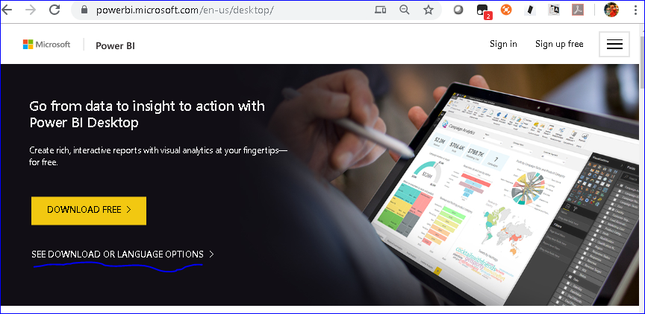
2. Click on SEE DOWNLOAD OR LANGUAGE OPTIONS, and it will show the screen as follows

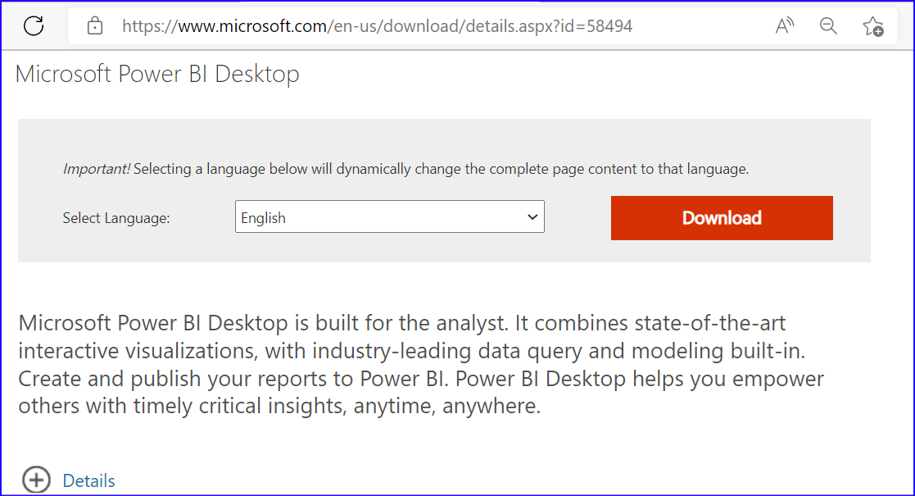

Click on Download button, and it will show the screen as follows

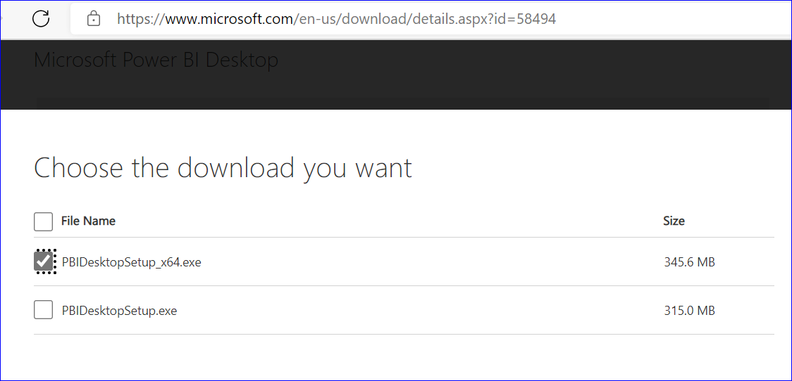

1. Download the 64 bit or 32 bit as per your machine configuration, and install the same.

## Power BI Gateway

1. Go to <https://powerbi.microsoft.com/en-us/gateway/>

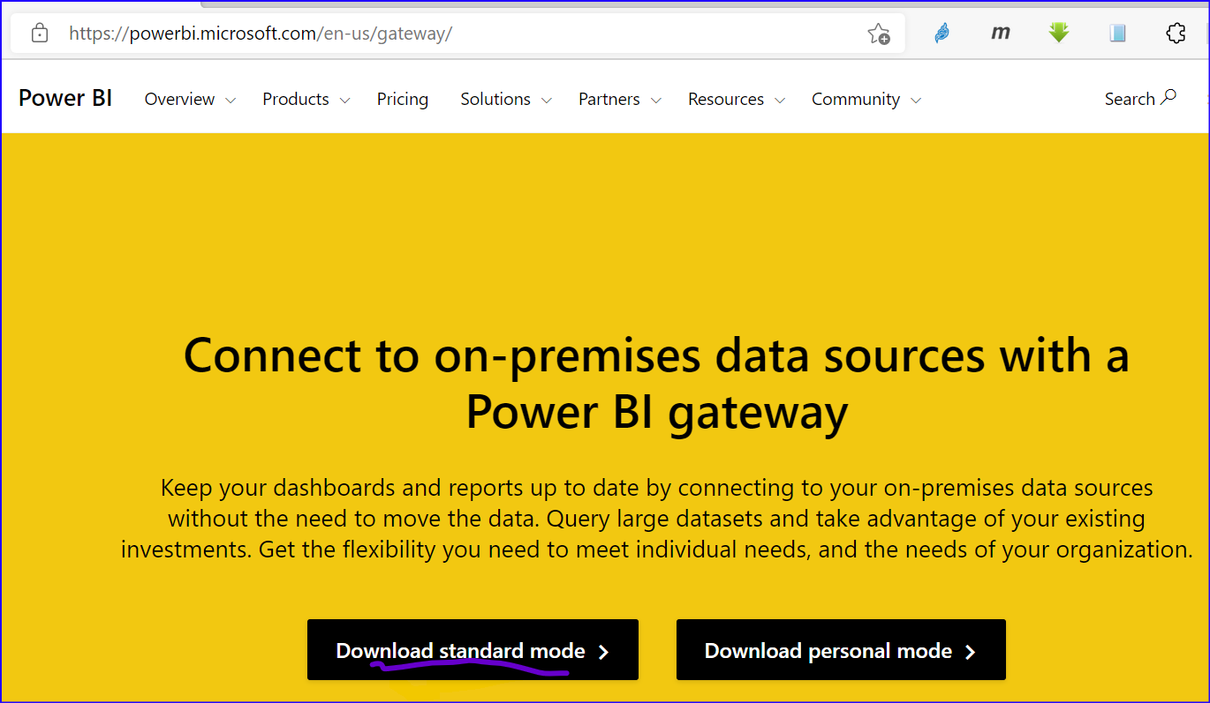

Click on Download Standard Mode, and it will download PowerBIGatewayInstaller.exe

1. Run the installer and install the Gateway
2. After installation is done, it will ask for configuring the gateway  
   Enter the credentials. Here, in my case username is: munish@bestorgz.onmicrosoft.com  
   So, enter the details as follows

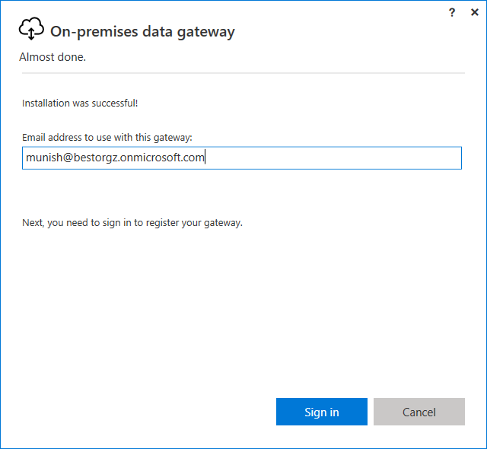

Click on Sign in, and enter the credentials

1. After sign-in it will show the screen

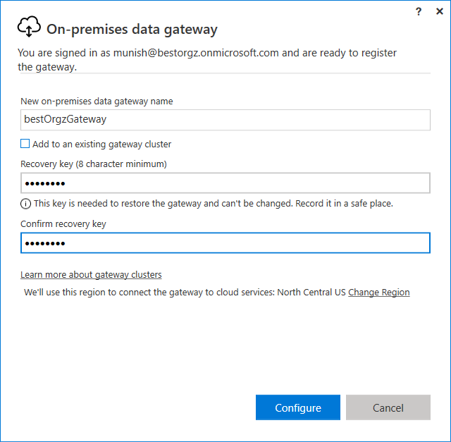

Enter the details, and click on Configure button, and configure the gateway, and it will show the screen as follows

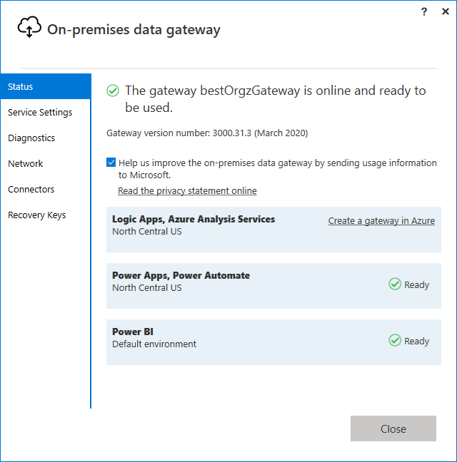

# Lab Files

1. Download and install git from <https://git-scm.com/book/en/v2/Getting-Started-Installing-Git>
2. Open the command prompt, and
   1. navigate to d drive
   2. Execute the following command

git clone https://github.com/AroraMunish/Steria.PowerBI PowerBI

It will show the screen as follows

D:\>git clone https://github.com/AroraMunish/Steria.PowerBI PowerBI

Cloning into 'PowerBI'...

remote: Enumerating objects: 146, done.

remote: Counting objects: 100% (146/146), done.

remote: Compressing objects: 100% (103/103), done.

remote: Total 146 (delta 7), reused 146 (delta 7), pack-reused 0

Receiving objects: 100% (146/146), 41.33 MiB | 3.62 MiB/s, done.

Resolving deltas: 100% (7/7), done.

* 1. And It will create the folder on d drive as shown below

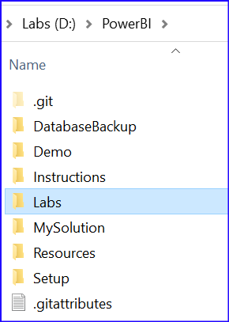

# Software

## Excel

64 bit Excel 2010 or later

## SQL Server

## SQL Server and SQL Server Management Studio

1. Download and install
   1. SQL Server Developer Edition from <https://www.microsoft.com/en-gb/sql-server/sql-server-downloads>
   2. SQL Server Management Studio from <https://docs.microsoft.com/en-us/sql/ssms/download-sql-server-management-studio-ssms?view=sql-server-2017>

## Databases

* 1. Restore the databases downloaded in step 2.  
     Following are steps for same

1. Login to SQL Server Management Studio
2. Right click on Databases | Restore Database

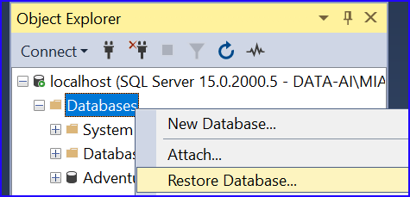

And it will show the screen as follows

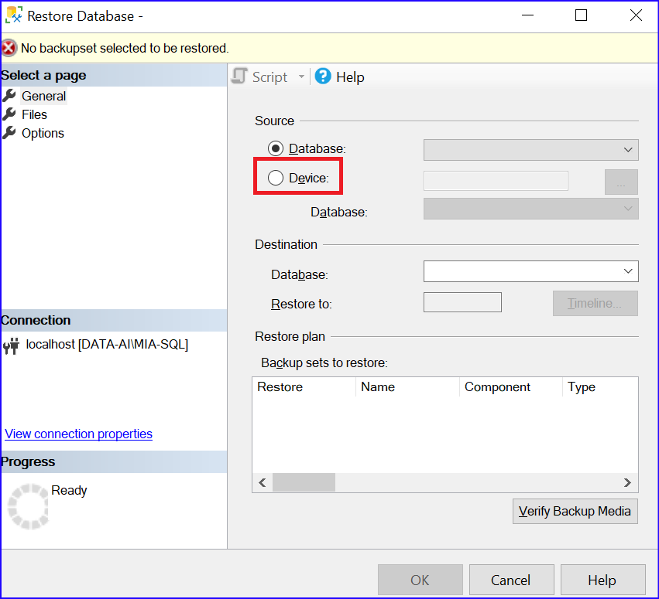

Click on Device

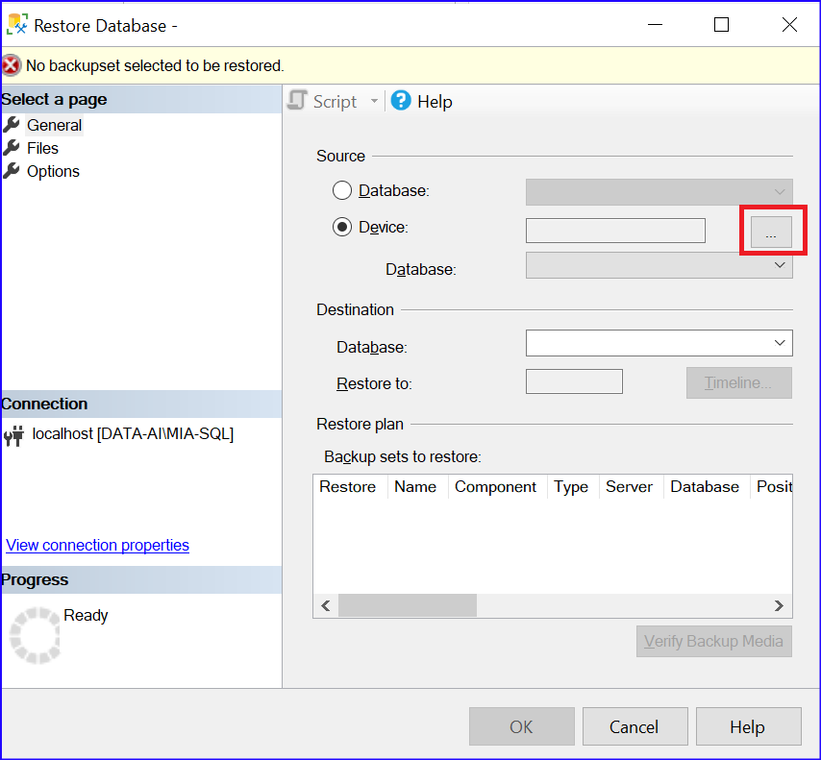

And it will appear as follows

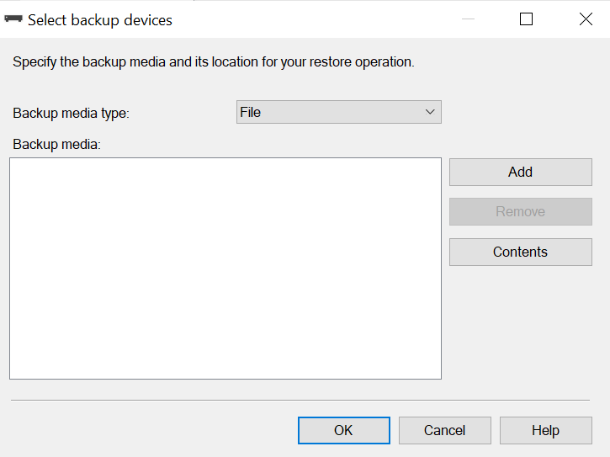

Click on Add button, and select the database AdventureWorksDW2020.bak available at D:\DA100\DatabaseBackup

And it will appear as follows

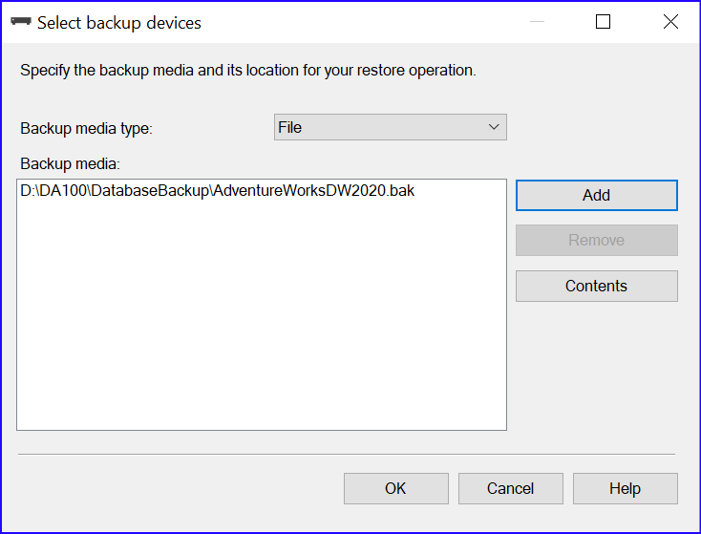

Click on OK button, and it will appear as follows

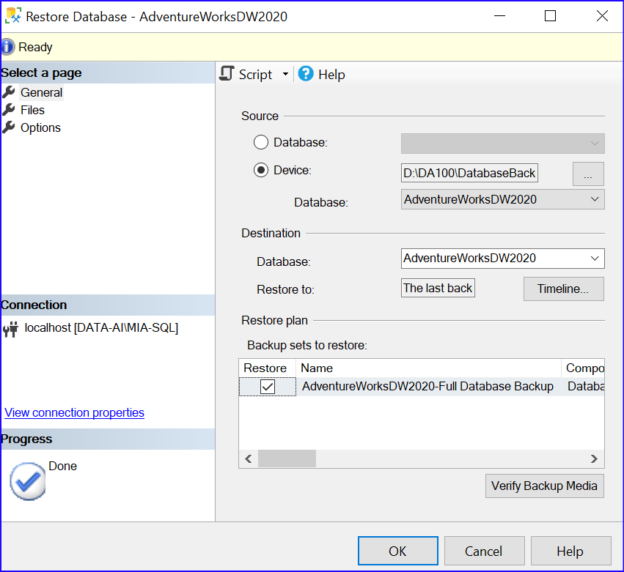

Click on OK, and database will be restored.

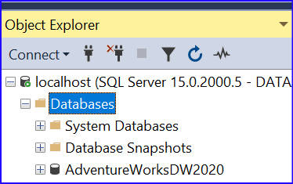

1. Similarly, restore the other database TailspinToys2020-US.bak, and it will appear as follows

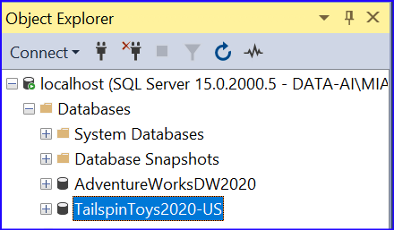

1. If installation of SQL Server is not possible, you will be able to connect to SQL Server databases deployed in Azure.

Server: 20.242.71.95,1433  
username:powerbi

Password:powerbi