Before We Knew It
An Empirical Study of Zero-Day Attacks In The Real World

ABSTRACT
Identified 18 vulnerabilities exploited before disclosure, of which 11 were not known to have been employed in attacks.
Typical zero-day attack lasts for 312 days on average.
After public disclosure, volume of attacks exploiting them increases by up to 5 orders o magnitude.

study of zero-day attacks between 2008–2011
Table1: Summary of findings:
Findings | Implicaitons
Zero day attacks more frequent than thought: 11 out of 18 | Zero-day attacks are serious threats that may have  a significant impact on the organizations affected.
ZD-attacks last between 10 days and 30 months, median 8 months, average 10 months | Zero-day attacks are not detected in a timely man-  ner using current policies and technologies.
Most affect few hosts, with exception of few high-profile attacks. (e.g., Stuxnet) | Most zero-day vulnerabilities are employed in tar-  geted attacks.
58% of the anti-virus signatures are still active at the time of writing | Data covering 4 years is not sufficient for observing  all the phases in the vulnerability lifecycle.
After disclosure, number of malware variants increase by 183-85,000 times and number of attacks by 2-100,000 times | The public disclosure of vulnerabilities is followed by an increase of up to five orders of magnitude in the volume of attacks.
Exploits for 42% of all vulnerabilities employed in host-based threats are detected in field data within 30 days after the disclosure date. | Cyber criminals watch closely the disclosure of new vulnerabilities, in order to start exploiting them.

Lifecycle of Vulnerabilities:
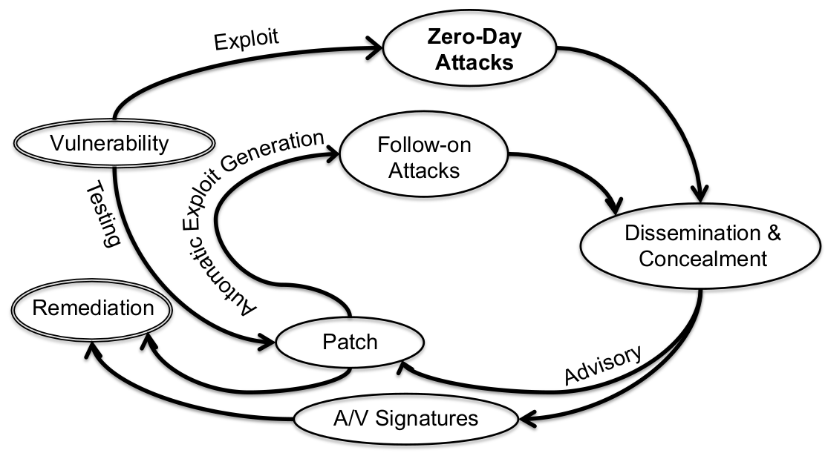
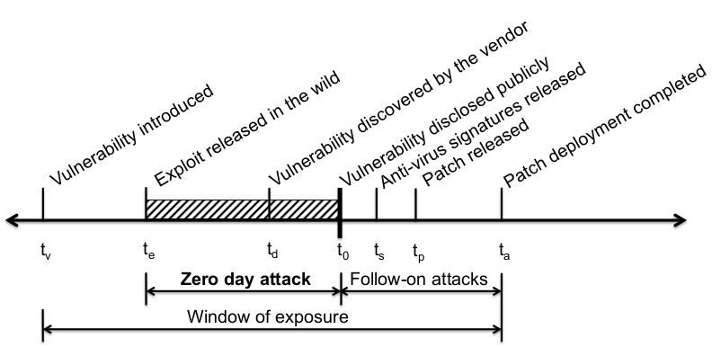

An Empirical Analysis of Software Vendors’ Patch Release Behavior:
Impact of Vulnerability Disclosure
results suggest that disclosure accelerates patch release
probability of releasing the patch rises by nearly two and a half times because of disclosure
Opensource vendors release patches more quickly than closed source vendors.
Vendors are more responsive to more severe vulnerabilities. We also find that vendors respond more slowly to vulnerabilities not disclosed by CERT

