**COMSATS Degree Programme**

**COMSATS University Islamabad, Lahore Campus**

**Fall 2020**

**Assignment # 2**

|  |  |  |  |  |  |  |  |  |  |
| --- | --- | --- | --- | --- | --- | --- | --- | --- | --- |
| Course Title: | Data Communication and Computer Networks | | | | Course Code: | | CSC339 | Credit Hours: | 4(3,1) |
| Course  Instructor/s: | Muhammad Junaid Anjum | | | | Programme Name: | | BS Software Engineering | | |
| Semester: | 5th | Batch: | FA18-BSE- | Section: | A | | Due Date | 19 Nov 2020 11:59PM | |
| Student’s Name: | **Arose Niazi** | | | | Reg. No. | FA18-BSE-010 | | | |
| 1. **Read the below instructions carefully** | | | | | | | | | |

Question # 1: You are to create a network scenario of your choice. It should be based on an actual network (examples can be taken from the Internet). Using the network, you have to recreate the network in NS-2. However, a few things should be taken into consideration

1. You should create a word file which would have a brief description of the network that you have created, the code and an image showing the traffic flowing in NAM.
2. In the code, where you write “set nf [open out.nam w]”, you are to write your roll number in place of the file name. Such that the code line would result as “set nf [open 012.nam w].
3. The choice of traffic protocols and applications are completely up to you.
4. **Please do not try to take the code off the internet, as it would result in 0 marks.**
5. **Also, please, do not try to cheat between yourselves as it would result in both parties getting 0 marks.**

Answer:

I have created a network of Askari Heights, Askari 11. Each building has cameras installed, which are connected with a switch of each street. Each building is connected to 2 hubs, in case one of it goes down the data would still have a path to flow. This allows a lot of routes to be possible in case any of the routes go down.

1. Buildings
   1. Color blue.
   2. Shape Square
   3. Connected to the side by streets.
   4. Protocol UDP, live video stream.
2. Streets
   1. Color orange.
   2. Shape hexagon.
   3. Buildings are connected to the street.
   4. Streets are connected with offices
      1. Security Office.
      2. Complaint Office.
3. Complaint Office
   1. Color pink
   2. Shape circle.
   3. Connected with the main office.
   4. Connected with streets.
   5. Protocol: TCP, need to make sure data isn’t lost.
4. Security Office
   1. Color red.
   2. Shape circle.
   3. Connected with the main office.
   4. Connected with streets.
   5. Protocol: TCP, need to make sure data isn’t lost.
5. Main Office
   1. Color dark green.
   2. Shape circle.
   3. Connected with both the complaint office.
   4. Connected with the security office.
   5. Protocol: TCP, need to make sure data isn’t lost.
6. Wires
   1. Light blue
      1. Simplex 50Mbps.
      2. Just used to transfer the data from buildings to the street.
   2. Hot pink
      1. Duplex 500Mbps
      2. Used to transfer from streets to complaint office, if needed or link between streets and security goes down (extra security measure).
   3. Yellow
      1. Duplex 500 Mbps
      2. Used to transfer data from streets to complaint office, can be used to transfer data from security -> streets -> complaint -> main office in case connections are down.
   4. Green
      1. Duplex 1,000 Mbps
      2. The main office, getting information from all the other offices.
   5. Red
      1. The connection is down.
7. Routing Protocol: LS (Sir you already know the reason)
8. Events
   1. 0.1 Second
      1. Start sending data from buildings.
   2. 0.5 Second
      1. Start sending data from the complaint office to the main office.
   3. 1.0 Second
      1. Start sending data from the security office to the main office.
   4. 1.5 Second
      1. The link between street 2 and the security office goes down.
   5. 2.0 Second
      1. The link between street 3 and the security office goes down.
      2. Start sending data from the main office to the complaint office.
   6. 2.5 Second
      1. Start sending data from the main office to the security office.
   7. 9.0 Second
      1. Finish all.

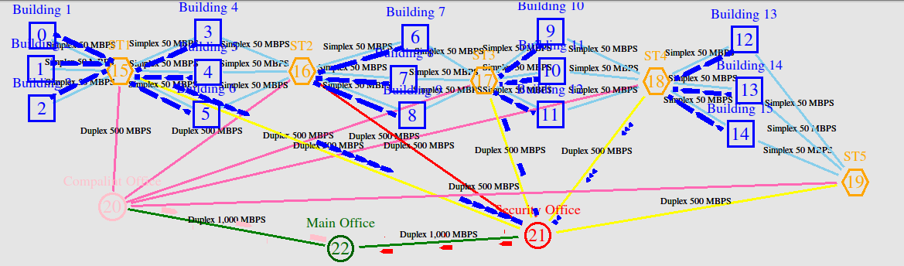

The code is in the “Assignmnet.tcl” file.